Supplementary Materials
Manuscript: Strict Unseen-Domain Evaluation of Pressure-Based Smart-Mat Temperature and Humidity Estimation against Simple Level Baselines
Note: Tables S1–S44 are provided in full, at full precision, in the accompanying workbook Supplementary_Tables_S1-S44.xlsx (one worksheet per table part; the worksheet names are listed below). Table S19, a reproduction record, is reproduced in this document. Figures S1–S4 follow. No calendar date is included.

Supplementary Tables
- Table S1. Strict LOSO per seed and training-mean predictor per fold (worksheets S01a_p3_tcn_outer_by_seed, S01b_p3_training_mean_by_fold).
- Table S2. Strict LOSO device and phase strata (worksheets S02_p3_secondary_strata).
- Table S3. Selected configurations and inner-selection score ranges (selection records) (worksheets S03a_p3_selected_configs, S03b_p4_selected_configs, S03c_p4_inner_score_range).
- Table S4. Feature families per seed (worksheets S04_p4_outer_by_seed).
- Table S5. Feature families versus the training-mean predictor (worksheets S05_p4_vs_training_mean).
- Table S6. Feature families: per-subject summary, versus RAW and the pre-declared comparisons A-E (worksheets S06a_p4_vs_raw, S06b_p4_incremental_effects, S06c_p4_seed_consistency, S06d_p4_primary_summary).
- Table S7. Bias and offset by feature family (worksheets S07_p4_bias_offset).
- Table S8. Feature-family device and phase strata (worksheets S08_p4_secondary_strata).
- Table S9. Adaptation gain and error decomposition (worksheets S09_p5_adaptation_gain).
- Table S10. Personalization RMSE and bias by budget (worksheets S10a_p5_primary_rmse, S10b_p5_primary_bias).
- Table S11. Personalization on the per-budget later span (secondary) (worksheets S11_p5_later_span_mae).
- Table S12. Personalization per seed (worksheets S12_p5_by_seed).
- Table S13. Budgets, nights and windows (night ordinals) (worksheets S13_p5_budget_counts).
- Table S14. User02 mat strata and User01 sensor-phase strata (worksheets S14a_p5_user02_device_strata, S14b_p5_user01_sensor_phase).
- Table S15. Temporal level mismatch (post hoc, descriptive) (worksheets S15a_p5_level_diagnostic, S15b_p6_level_mismatch_consiste, S15c_p6_level_mismatch_spans, S15d_p6_level_mismatch_trajecto).
- Table S16. Night-level bootstrap of RMSE and bias, and seed sensitivity (worksheets S16a_p6_bootstrap_rmse, S16b_p6_bootstrap_bias, S16c_p6_bootstrap_seed_sensitiv).
- Table S17. Start-span sensitivity (post hoc) (worksheets S17_p6_drift_sensitivity).
- Table S18. User02 device, quality-phase and heater-context strata (worksheets S18a_p6_user02_device_context, S18b_p6_user02_device_context_b).
- Table S19. Reproduction record (P7 report §6, §8–§10) (this document).
- Table S20. Post-hoc calibration comparators A–E on the primary span (seed summary) (worksheets S20_p8_calibration_main).
- Table S21. Post-hoc calibration comparators per seed (worksheets S21_p8_calibration_by_seed).
- Table S22. User02 per-mat calibration diagnostic (post hoc, added after the primary results were known) (worksheets S22_p8_calibration_user02_per_m).
- Table S23. Residual variation: target SD, error SD and R (post hoc) (worksheets S23_p8_residual_variation).
- Table S24. Initialization control at b = 14 (post hoc) (worksheets S24_p8_initialization_control).
- Table S25. Night-level bootstrap of the comparator differences, all budgets and seeds (post hoc) (worksheets S25_p8_comparator_bootstrap).
- Table S26. Pre-registered interpretation map: cases per subject, target and budget (post hoc) (worksheets S26_p8_interpretation_cases).
- Table S27. Dynamic-signal diagnostic: R, Q, pooled and within-night correlations, oracle ratio (seed summary; second-order post hoc) (worksheets S27_p8_dynamic_summary).
- Table S28. Dynamic-signal diagnostic per seed (second-order post hoc) (worksheets S28_p8_dynamic_by_seed).
- Table S29. Dynamic-signal diagnostic: night-cluster bootstrap of the correlations (second-order post hoc) (worksheets S29_p8_dynamic_bootstrap).
- Table S30. Retrospective oracle affine ratio and the affine-calibration trigger (second-order post hoc) (worksheets S30a_p8_dynamic_oracle_affine, S30b_p8_dynamic_trigger).
- Table S31. Pre-registered dynamic-signal cases J1–J8 and headlines (second-order post hoc) (worksheets S31a_p8_dynamic_cases, S31b_p8_dynamic_headlines).
- Table S32. Additional external validation: source reconciliation coverage and windows (post hoc) (worksheets S32a_p9_user03_qa_coverage, S32b_p9_user03_qa_nights, S32c_p9_user03_qa_totals).
- Table S33. Additional external validation: results per predictor, configuration and seed (post hoc) (worksheets S33a_p9_user03_summary, S33b_p9_user03_by_seed).
- Table S34. Additional external validation: per-night results and the pre-registered interpretation (post hoc) (worksheets S34a_p9_user03_per_night_summar, S34b_p9_user03_interpretation).
- Table S35. Median constants, strict leave-one-subject-out and primary span (exploratory) (worksheets S35a_p10_loso_constants, S35b_p10_loso_metrics, S35c_p10_rq2_constants, S35d_p10_rq2_summary).
- Table S36. Point-estimate counts of constants versus networks (exploratory) (worksheets S36_p10_point_counts).
- Table S37. Endpoint availability by history (exploratory) (worksheets S37_p10_history_availability).
- Table S38. Pressure-summary models on the common endpoints: all histories, ridge regression, bias, R and correlations, night-level intervals, selections and the pre-specified reading; the RAW-TCN trained on all 40-s windows as a training-pool sensitivity reference (exploratory) (worksheets S38a_p10_history_metrics, S38b_p10_history_bootstrap, S38c_p10_history_interpretation, S38d_p10_history_selection, S38e_p11_model_comparison_train).
- Table S39. RAW-TCN retrained on the common endpoints: per seed and seed mean, epoch selection and pool counts (exploratory) (worksheets S39a_p11_tcn_per_seed, S39b_p11_tcn_seed_mean, S39c_p11_epoch_selection, S39d_p11_pool_counts).
- Table S40. RAW-TCN retrained on the common endpoints: night-level paired bootstrap against the constants, the boosted models and the network trained on all 40-s windows, and the pre-specified reading (exploratory) (worksheets S40a_p11_bootstrap, S40b_p11_interpretation).
- Table S41. Heater-context diagnostic: control-code audit and heater-context coverage by state, span and mat (post hoc, descriptive) (worksheets S41a_p12_code_audit, S41b_p12_context_counts).
- Table S42. Heater-context diagnostic: target level by heater context (post hoc, descriptive) (worksheets S42_p12_target_summary).
- Table S43. Heater-context diagnostic: eta squared for both targets, raw, night-centred and night × mat-centred, three states and on/off only, both spans, with night-level intervals (post hoc, descriptive) (worksheets S43_p12_eta_squared).
- Table S44. Heater-context diagnostic: heater-conditioned source constant on both spans, night-level paired bootstrap, source composition, pre-specified reading, and errors of the constants and pressure models by heater context (post hoc, descriptive) (worksheets S44a_p12_constant_metrics_full, S44b_p12_constant_metrics_commo, S44c_p12_bootstrap_full, S44d_p12_bootstrap_common, S44e_p12_source_composition, S44f_p12_interpretation, S44g_p12_errors_by_context).

Reproduction Record (Table S19)
Verbatim copy of sections 6 and 8–10 of the P7 reproducibility report (docs/P7_REPRODUCIBILITY_PUBLIC_RELEASE_REPORT.md): release manifest and checksums, core and extended reproduction, and clean-checkout results. Commit identifiers refer to the version-controlled research repository.

6. Release manifest and checksums
File | Bytes | SHA-256 (first 16)
windows.parquet | 29,955,714 | 79fdf6cd80eb2cac
splits/v1.0_loso/outer_folds.csv | 128,717 | 6f2fc7d22925d9a3
splits/v1.0_loso/inner_folds.csv | 182,258 | a25e6efa9b1aa740
splits/v1.0_personalization/chronological.csv | 243,641 | 129c37e6c0e63752
control_events.csv | 13,309 | 63a1ec18e2f6a4c0
p5_plan_public.yaml | 17,083 | ff769d7673ad2a78
reference_digests.json | 24,295 | 8ebb401ec26760ec
schema.json | 16,063 | 7bf0919fdb3fc1f6
excluded_sources.csv | 486 | 954c468953687d11
README.md | 5,567 | 4c6685c8b7c7b2c2
manifest.json | 8,186 | 72ac8cf347696d92
- The manifest records:
- release version, protocol version and hash, split hashes and the split manifest hash;
- source-dataset identity (canonical_v1 primary content and file hashes);
- base tag p6-robustness → 16980ae, builder commit 402c1ff and the builder file hashes;
- P5 plan hash, window rule, subjects, streams and counts;
- target, pressure, time, split and window-set representation;
- excluded sources with reason, confirmation and decision (DATA_POLICY §5.4);
- the public/private primary-window digests, the equivalence result, the privacy checks passed;
- the SHA-256 of every other file.
- Determinism: an in-place rebuild and a rebuild into a fresh directory are byte-identical for all 11 files, including the manifest.
- Byte-exact Git storage: .gitattributes keeps data/release/** free of line-ending conversion. Two of the CSVs use CRLF (write_csv), and a Windows checkout with core.autocrlf=true would otherwise change their bytes.
- Builder fixes found while building and reproducing. Each was committed before the rebuild that used it, so the manifest records a clean builder commit:
- the public plan's description now mentions the removed run ids; split copies are verified on load (ad97599);
- a stale manifest in the output directory entered the build checks (33c68f8), and its deletion now goes through io_guard (b8b6696);
- the public plan had lost its integer budget and seed keys through a JSON round trip, which would have broken every public P5 run; a new build check compares the public plan with the private plan key by key (2e9ec9c);
- the manifest's excluded-source list gains exclusion_confirmed_by (5ff6a52);
- the validator scans for secrets (402c1ff). Every fix left windows.parquet and the other data files byte-identical.

8. Core reproduction workflow
python scripts/reproduce_public_release.py --data data/release/public_release_v1 --tier core:
- Release: the privacy/integrity validator and the manifest hashes (24 checks). Nothing runs if one fails.
- Public mode (src/evaluation/public_reproduction.py):
- The unchanged P3/P4/P5/P6 code reads the release through PublicSession.
- canonical_v1, the raw data and the private split files raise if touched.
- Runs and tables go under outputs/p7/reproduction/.
- Every run passes the public leakage gate before training. This is the P2 gate on the public split copies: split-level L2/L4/L5/L6/L8, run-level L1/L3/L4/L9/L10/L11, and the release manifest in place of the canonical-data check L7.
- P3:
- training-mean for folds 1–3;
- the 9 RAW-TCN finals from the committed P3 selection;
- prediction digests, and weights against the P5 plan's base-checkpoint digests;
- P3 tables.
- P5:
- the reproduced P3 models reload and predict bitwise;
- the 45 runs from the public plan (b = 0 base evaluation; b > 0 fine-tuning with the frozen recipe);
- prediction digests;
- aggregation, the level diagnostic, and the P5 tables and figures.
- P6: the unchanged analysis on the reproduced P5 tables and predictions, then the P6 tables and figures.
- Comparison: every paper table against the committed one (§5 rule). The figures are compared for information. The summary goes to outputs/p7/reproduction/p7_reproduction_summary.json.
- Not reproduced by design (D-050): the inner searches. p3_selected_configs.csv, p4_selected_configs.csv and p4_inner_score_range.csv are selection records; the frozen selections are inputs of both tiers.
Local core result (release manifest of de590f9; data files identical to the final release):
Stage | Checks | Result
release | 24 | pass
P3 | 3 training-mean + 9 final prediction digests, 9 weight digests, 4 tables | 25/25
P5 | base reload 9/9, 45 prediction digests, 12 tables | 58/58
P6 | 11 tables | 11/11
total |  | 118/118 PASS
figures (information) | 9 PNG | 9/9 byte-identical
- Tables: 25 of 28 are byte-identical. The other 3 are identical except for night-key cells (§5).
- Run time: 467 s (P3 256 s, P5 201 s, P6 9 s).

9. Extended P4 reproduction
--tier extended runs the core tier, skipping complete runs but re-checking everything, and then the P4 stage:
- Runs: the 45 P4 finals (5 families × 3 folds × 3 seeds) from the committed P4 selection, in public mode with the public gate. The derived MOVEMENT/CONTACT inputs are computed from the released pressure values by the committed feature code.
- Checks:
- every prediction file against its reference digest;
- p4_ablation.aggregate on the reproduced P4 runs, with the RAW reference taken from the reproduced P3 tables (not the committed ones);
- the 8 P4 result tables compared with the committed tables.
Local extended result (release manifest of 96f78a8; data files identical to the final release):
Stage | Checks | Result
release, P3, P5, P6 | as in §8 | 24 + 25/25 + 58/58 + 11/11
P4 | 45 prediction digests, 8 tables | 53/53
total |  | 171/171 PASS
figures (information) | 9 PNG | 9/9 byte-identical
- Tables: all 8 P4 tables are byte-identical: p4_primary_summary, p4_outer_by_seed, p4_vs_raw, p4_vs_training_mean, p4_incremental_effects, p4_seed_consistency, p4_bias_offset, p4_secondary_strata.
- Run time: P4 stage 1,808 s. The core stages took 44 s because their runs were already complete and only re-checked.

10. Clean-checkout results
- Setup:
- a detached git worktree at 59f903e: the final release metadata, manifest 72ac8cf3…, builder 402c1ff;
- windows.parquet copied into data/release/public_release_v1/ (the manifest verifies it);
- nothing else: no canonical_v1, no raw data (only data/raw/README.md), no outputs/.
- To prove the private split files are not needed, the committed data/splits/v1.0_* files were deleted from the worktree before the runs. That is a working-tree deletion only, which is why the run records a dirty tree.
- Sequence: full test suite → public validator → --tier core → --tier extended, into the worktree's own outputs/p7/reproduction/.
Step | Result | Time
pytest | 328 passed, 8 skipped (tests that need raw data or canonical_v1) | 49 s
validate_public_release.py | 24/24 PASS | —
core: release / P3 / P5 / P6 | 24 / 25/25 / 58/58 / 11/11 → 118/118 PASS | 469 s (P3 260, P5 198, P6 9)
extended: core stages re-checked, then P4 | 24 / 25 / 58 / 11 / 53/53 → 171/171 PASS | 1,873 s (P4 1,829)
figures (information) | 9/9 PNG byte-identical, in both tiers | —
- Across local and clean runs, every one of the 102 frozen prediction files (3 P3 training-mean, 9 P3 final, 45 P4 final, 45 P5) matched its reference digest bitwise, and the 9 P3 weight digests equal the frozen P5 plan.
- All 35 compared tables pass (4 P3, 8 P4, 12 P5, 11 P6). 32 are byte-identical, and 3 differ only in night-key cells, under one consistent day shift per subject.
- The public-mode guards (§8) would have raised on any access to canonical_v1 or the private splits. None was raised.

Supplementary Figures
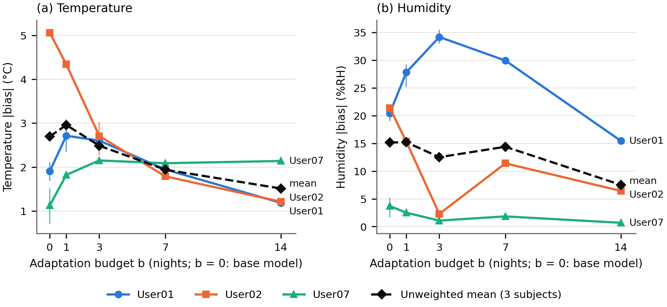
Figure S1. Absolute bias versus the adaptation budget b: (a) temperature, (b) humidity
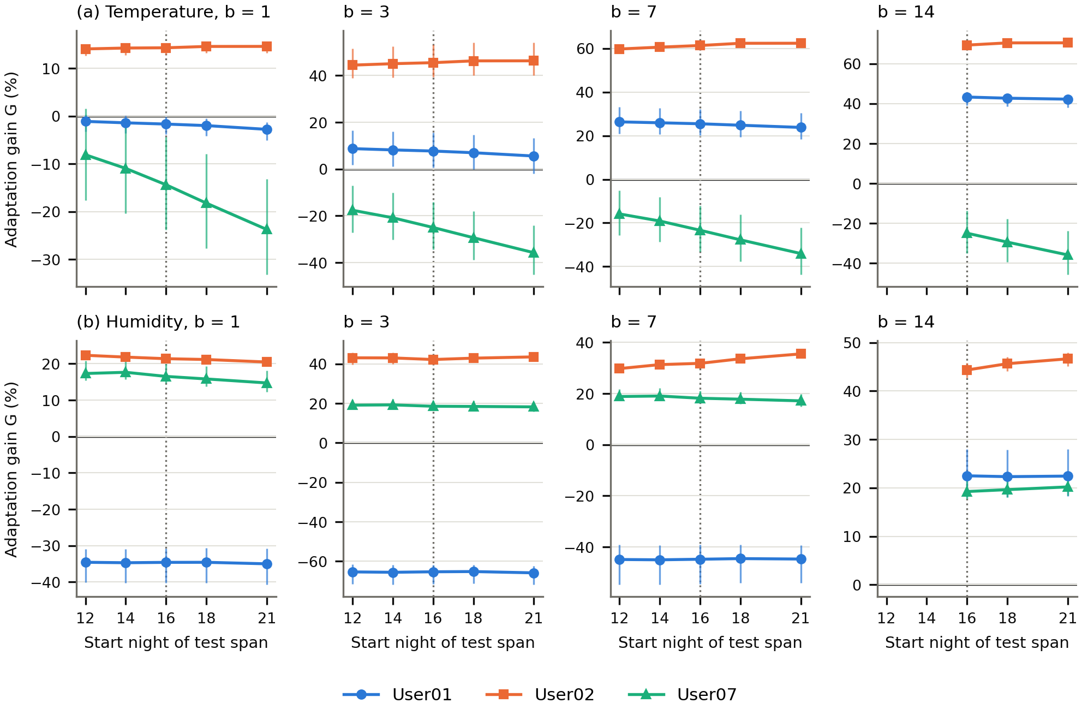
Figure S2. Start-span sensitivity of the adaptation gain, post hoc: (a) temperature, (b) humidity, for b = 1, 3, 7 and 14 (for b = 14 only start nights ≥ 16 are defined)
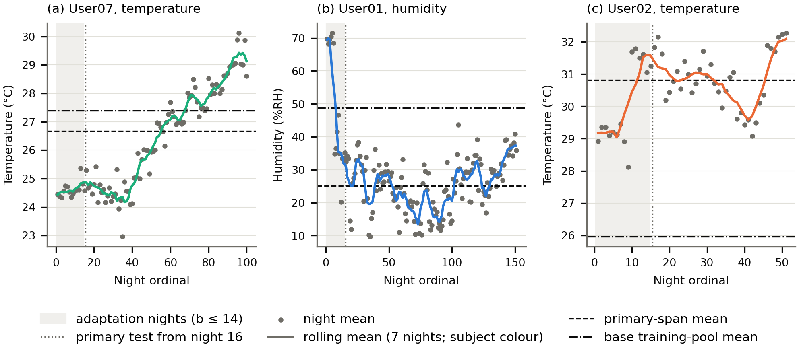
Figure S3. Target-level trajectories over night ordinals for User07 temperature, User01 humidity and User02 temperature, post hoc and descriptive
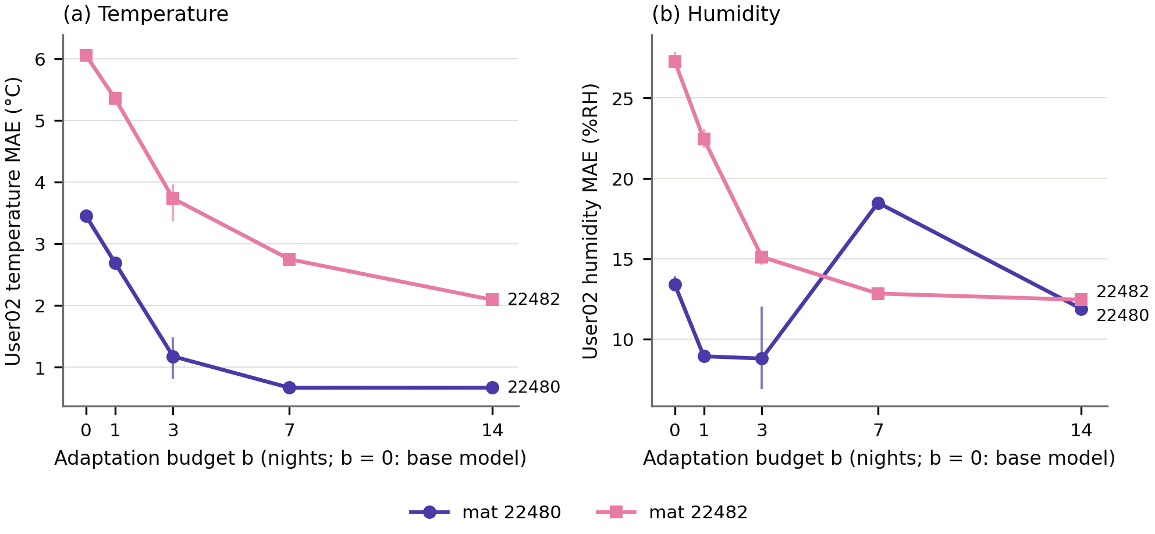
Figure S4. User02 MAE by mat (22480, 22482) versus the adaptation budget b: (a) temperature, (b) humidity

