Kelp Wrack Data Summary

Data collected at Bandon Beach from 2018-2021

David Bilderback, Oregon Institute of Marine Biology

Ross Whippo, NOAA - NCCOS

Created: 2022-04-01 ; (Updated: 2023-11-08)

Table of Contents

# Abstract

Hi Dave, here’s an updated version of some of the visualizations. I have put the newer figures that you requested toward the top.

## Keywords

here.

# Introduction

We can’t see *Nereocystis* recruits below the water because they don’t break the surface and can’t be quantified by drones, or other imagery techniques. In addition, SCUBA and ROV surveys may provide more information, but are still highly geographically constrained. Monitoring intact sporophyte wrack can provide a minimum value for recruitment, particularly when abiotic conditions including currents, tides, upwelling, and wave pressure is know. Common variables that are monitored in the majority of locations where *Nereocystis* is found.

There is a long-standing debate over the life history of *Nereocystis*. Is it an annual (as is typically said) or is it a perennial? Maybe it’s something in between, a semi-annual. It’s known that *Nereocystis* can overwinter, and very large individuals may be observed during early portions of the year when there is no way they could have grown up so quickly (R. Whippo pers. obs., and others). There could be two potential reasons for this: 1) *Nereocystis* are highly reproductive in the fall, leading to spring recruitment observations, but they also may be reproductive in the spring (dependent upon initial recruitment of the parent sporophyte), and thus provide an addition influx of gametophytes that result in late-summer sporophytes. Alternatively, as gametophytes can lie dormant (according to some experiments), it could be that latent gametophytes will then result in sporophytes in late summer.

What would these ‘idealized’ conditions be that would trigger gametophytes to reproduce and create this second wave of sporophytes? Is there an abiotic parameter in the data that correlates with higher late-summer recruitment? Temperature? Upwelling? It may also be a delayed reaction. What mid- or early-summer conditions might trigger gametophytes to reproduce?

We could address the first hypothesis by using the sorus data that was collected and relating that to the presumed delay between sorus production and sporophyte recruitment. Do the timelines make sense? Alternatively, are there specific abiotic conditions in the data that correlate with the late-summer recruitment? This may lend credence to the ‘seed bank’ hypothesis.

The ‘seed bank’ problem is the the most wicked of all the *Nereocystis* questions.

Kelp gametophytes can persist for up to 18 months, and may not produce gametes immediately (Dieck 1993, Dobkowski et al. 2019).

Distance to rocky reef, strength of upwelling, and their interaction have been found to positively correlate with wrack biomass (Reimer et al. 2018).

Here we provide evidence of a bimodal recruitment strategy in the semi-annual kelp *Nereocystis luetkeana*.

# Methods

## Study site

The beach at Bandon State Natural Area is located approximately 4 km south of the town of Bandon, OR and the Coquille River outflow. It is part of the larger Klamath Mountain province and the shoreline is dominated by an uplifted marine terrace forming seaside cliffs, and sandy beaches that are interspersed with rocky cliffs, offshore stacks and rocks, and submerged rocky reefs, except at the Coquille River discharge (Oregon Territorial Sea Plan - Appendix H 1994). The coast is subject to strong seasonal upwelling, and experiences frequent storms in the late autumn through early spring with average significant wave heights of 3.5 m and reaching a mean maximum wave height of 7 m (Huyer 1983, Komar & Allan 2000). Two kelp beds lie 741 and 528 m off the coast of Bandon, the larger with a surface area of about 355 m² and the smaller with a surface area of about 30 m². The next nearest kelp beds to the north and south of these beds are about 13 and 28 km, respectively.

## Field surveys

### Sampling Transect

Preliminary observations indicated that Nereocystis sporophytes of all ages wash up on the beach at Bandon. The beach is a high energy one with a wide surf zone consisting of three or more sand bars and troughs and a low sloping, wide beach of fine, mature sand. Waves break on the sand bars, thereby dissipating their energy as they move more gently over the low gradient beach. The beach experiences a semidiurnal tide with two high tides of unequal sizes each day.

A one km long sampling transect centered at N 43.08380, W 124.43471 was established on the beach approximately 2 km south of the Bandon kelp beds. The width of the sampling transect varied with the tidal phase. During the summer, the width of the transect could be as wide as 255 m while during the winter the width of the beach could be as narrow as 8 m. The number of days that the transect was sampled in 2018, 2019, 2020, 2021 and 2022 were 181, 328, 369, 349 and 150, respectively.

### Data collection

Sporophytes with stipes ranging from 0.5 to 180 cm. To investigate the recruitment of young sporophytes of Nereocystis, all small sporophytes with at least a holdfast, stipe and bulb (pneumatocyst) were collected from the beach each survey day and brought to the laboratory to be measured. From 4/8/2018 to 12/31/2021, the length of the stipe was measured to the nearest mm from the attachment with the holdfast to the base of the bulb, the type of substrate was determined and the associated cospecies of algae were identified. Whether a young sporophyte was a single individual or a member of an association of Nereocystis sporophytes was noted. From 7/12/2018 to 12/31/2021, the bulb diameter was determined to the nearest mm with a caliper. From 6/30/2019 to 12/31/2021, the diameter of the holdfast was measured to the nearest mm. From 7/11/2019 to 12/31/2021, the widest blade on the young sporophyte was measured to the nearest mm.

On October 20, 21, 24 and 26, 2018; November 3 and 4, 2018 and May 10, 15, 17, 18 and 21, 2019, all young intact and partial sporophytes were counted on the beach. Partial sporophytes could lack a holdfast or a holdfast and a portion of the stipe. Stipes that were either physically snapped or subjected to herbivory were noted.

Immature and reproductively mature sporophytes with stipes longer than 180 cm. Only intact, untangled Nereocystis sporophytes were measured. Only a few reproductively mature sporophytes had stipes less than 180 cm in length. Initially, the study focused on the production of reproductive sori by Nereocystis but was expanded to include Nereocystis sporophyte stipe lengths, widest blade widths and bulb (pneumatocyst) diameters. From 4/18/2018 to 7/10/2021, the number of maturing sori, the number of sori releasing propagules and the number of abscised sori on the widest blade on each Nereocystis sporophyte was recorded. The presence and type of epiphytes and/or epizootics on the Nereocystis stipes also was noted. After 6/14/2018 the length of the stipe of the intact Nereocystis sporophyte was recorded to the nearest cm. Because the boundaries between the stipe and bulb were ill-defined, the stipe was measured from the holdfast to 15 cm below blade attachment to the bulb. By 7/4/2018 the width of the widest blade of the sporophyte to a tenth of a cm was consistently recorded. On 7/13/2018 the circumference of the bulb to a tenth of a cm was noted in the field and transformed to a bulb diameter using a Circumference Calculator created by Bonga Szyk and Mateusz Muncha at omnicalculator.com. This full array of data was recorded in an Excel file until the conclusion of this portion of the study on 7/10/2021.

To investigate the complexity of Nereocystis canopy, sporophytes were randomly selected on February 25, March 4, 5 and 13, 2020, and the number of blades of each sporophyte were counted, and the longest and widest blade of each sporophyte were measured. From March 22 to March 31, 2021, 10 sporophytes were randomly selected, and the length of each stipe was recorded. For each of these sporophytes, the number of fertile blades with sori and sterile blades without sori were counted and the width of every fertile blade was noted. For each blade, the number of sori, the number of sori releasing or having released propagules and the number of abscised sori were noted. Also, for each fertile blade, the length and width of the fertile zone of sori, the length and width of zone with a sorus releasing or having released propagules, and the distance from proximal end of the fertile zone to the petiole attachment were recorded.

The canopy wet weight of the blades and bulb of randomly selected sporophytes was determined by excising the blades and bulb from the stipe 15 cm below the attachment of the blades to the bulb on May 5, 6, 7 and 9, 2019, washing them in sea water to remove sand, draining off the excess sea water and weighing them with a Modern Step hanging scale.  
To determine the nature of the propagules produced by Nereocystis sori, portions of ripe sori from freshly stranded Nereocystis were collected in plastic bags with cold sea water on 12/28-29/2019 and 1/11/2020. A sorus and sea water were transferred to a finger bowl. More cold sea water was added to the finger bowl and set aside at room temperature. Occasionally, the sorus was washed with sea water from a pipette. After a green film formed on the bottom of the finger bowl, a sample was pipetted onto a slide and a cover slip applied. The sample was examined with a compound scope and photographed.

Preliminary observations indicated that reproductive sori are initiated at the tip of the blade. These sori are long, narrow and tapered at their tips (Type 1). Subsequent sori are initiated proximally, and those formed midblade are wide and rectangular (Type 2). As soral initiation approaches 20 cm of the base of the blade, the sori become smaller and square in shape (Type 3). To investigate sorus sequencing and development, data was gathered on all individual, maturing or mature Nereocystis from 4/11/2021 to 5/28/2022. Each sporophyte was assessed whether it had overwintered or began development in the current year. Overwintering sporophytes have epiphytes and epizootics on the holdfast, a dull, dark brown stipe and usually, a heavy load of epiphytes on the stipe. The blades of overwintering sporophytes also may be large and wide. Sporophytes that began development during the current year have little or no epiphytes and epizootics on the holdfast, a glossy, olive-green stipe with little or no epiphytes on the stipe. The presence and the type of epiphytes on the stipe were noted. The presence of blades with Type 1, 2 or 3 sori on the sporophyte was noted, and the width of the widest blade with each type of sorus was recorded. For the widest blade with each type of sorus, the number of sori, the number of sori releasing propagules and the number of abscised sori was recorded. For blades with Type 3 sori, the distance from the proximal end of the fertile zone to the base of the petiole was measured as well as the length and width of the fertile zone. For immature sporophytes the width of the widest blade was noted .

To determine why sporophytes wash up on the beach, the basal portion of every untangled sporophyte was examined from 4/7/2021 to 4/19/2022. The number of stipes with an intact holdfast, the number of stipes with an intact holdfast with haptera subjected to herbivory and/or burrowing, the number of stipes with only a portion of the holdfast and the number of stipes without a holdfast were recorded. Evidence of urchin (Strongylocentrotus purpuratus) herbivory also was noted.

## Data Analysis

GOES HERE.

# Results

## When are the recruitment pulses for the different cohorts of sporophytes across the year?

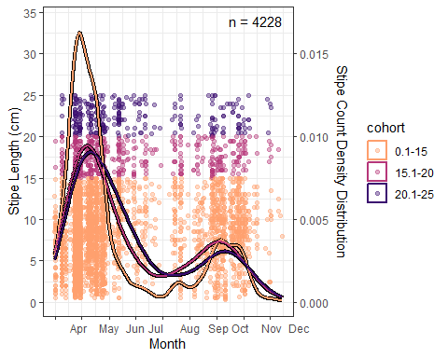

## How does this compare to mature wrack?

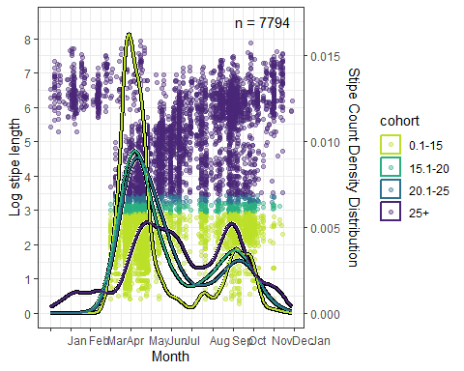

## What does this look like in different years?

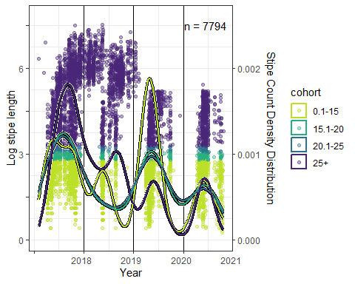

## What is the total flux on intact kelp sporophyte wrack?

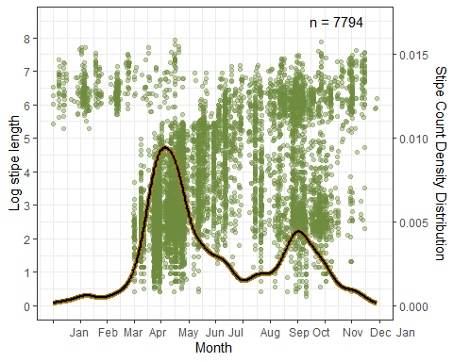

## When do we see ‘secondary recruits’?

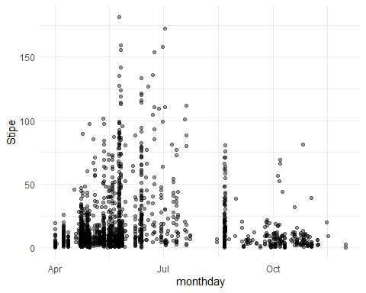

## Is there a relationship between stipe length and bulb diameter?

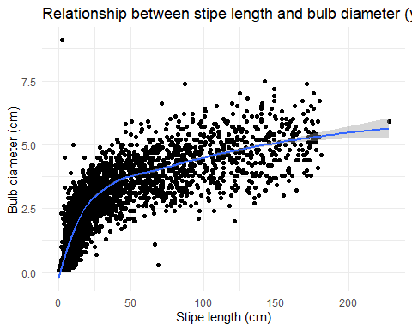

## What is the mean diameter of holdfasts?

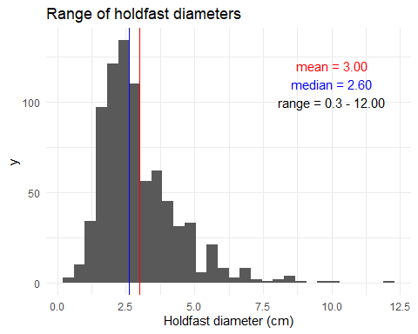

## Is there a relationship between stipe length and blade width?

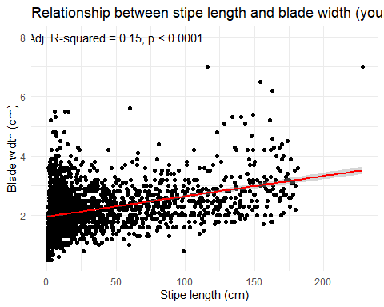

# What are the SST for each month?

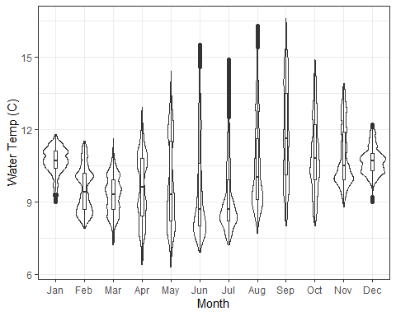

Integrated monthly SST temperatures from 2018-2021 measured at the NOAA National Ocean Service Water Level Observation Network station PORO3-9431647 in Port Orford, OR, approximately 38 km south of the study site.

# How are temperatures different across years?

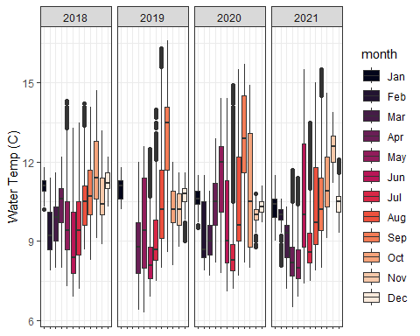

Monthly SST temperatures from 2018-2021 measured at the NOAA National Ocean Service Water Level Observation Network station PORO3-9431647 in Port Orford, OR, approximately 38 km south of the study site.

## What are the monthly patterns of upwelling and downwelling?

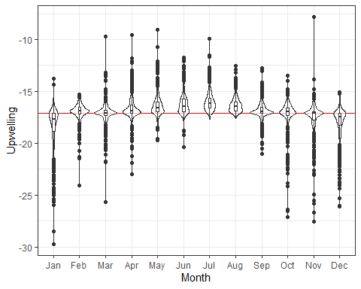

Integrated monthly upwelling indices from 2018-2021 derived from the NOAA ERDDAP server. The red line indicates net-zero water movement, with upwelling above the line, and downwelling below. Values are cube-root transformed and inverted for ease of interpretation.

## How are patterns of upwelling and downwelling different across years?

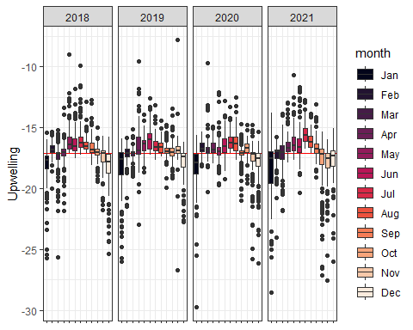

Monthly upwelling indices from 2018-2021 derived from the NOAA ERDDAP server. The red line indicates net-zero water movement, with upwelling above the line, and downwelling below. Values are cube-root transformed and inverted for ease of interpretation.

## For each of the four years, how many days was the beach transect surveyed for young sporophytes?

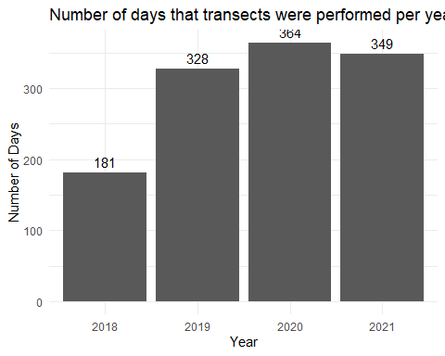

## For each of the four years how many days were young sporophytes found on the transect?

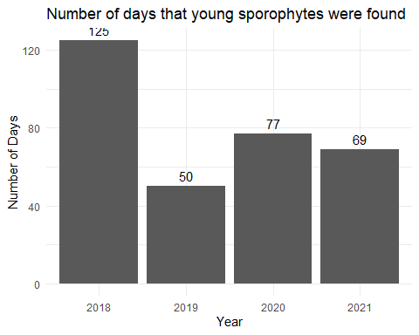

## For each year, how many sporophytes were singular, and how many were clusters?

## # A tibble: 8 × 3  
## # Groups: year [4]  
## year Single `length(year)`  
## <chr> <chr> <int>  
## 1 2018 multiple 774  
## 2 2018 single 1571  
## 3 2019 multiple 464  
## 4 2019 single 290  
## 5 2020 multiple 1234  
## 6 2020 single 618  
## 7 2021 multiple 699  
## 8 2021 single 401

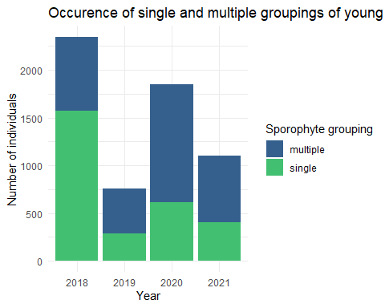

## What is the count and percentage of each substrate type?

## # A tibble: 30 × 3  
## Substrate total percent  
## <chr> <int> <dbl>  
## 1 Nereocystis luetkeana 2380 39.8   
## 2 unknown 1736 29.0   
## 3 Barnacles-Balanus crenatus 605 10.1   
## 4 Laminaria setchellii 587 9.81   
## 5 Myriogramme variegata 502 8.39   
## 6 Pterygophora californica 38 0.635  
## 7 rock 35 0.585  
## 8 shell 20 0.334  
## 9 mussel-Mytilus califorianus 14 0.234  
## 10 Cystoseira osmundacea 9 0.150  
## # ℹ 20 more rows

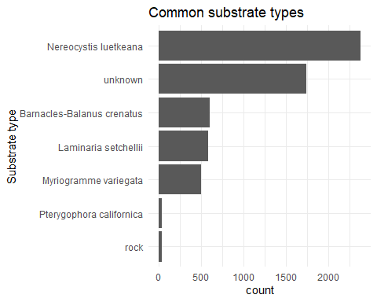

## How common were cospecies? Numbers and percentages.

## # A tibble: 33 × 3  
## Cospecies total percent  
## <chr> <int> <dbl>  
## 1 none 3810 63.2   
## 2 Laminaria setchellii 1459 24.2   
## 3 Callophyllis crenulata 192 3.18   
## 4 Desmarestia linglata 162 2.69   
## 5 Alaria marginata 76 1.26   
## 6 Callophyllis pinnata 59 0.979  
## 7 Callophyllis fabellulata 57 0.945  
## 8 hydroid 39 0.647  
## 9 Hymenena flabelligera 35 0.581  
## 10 Polyneura latissima 17 0.282  
## # ℹ 23 more rows

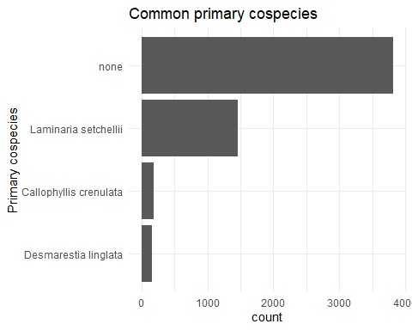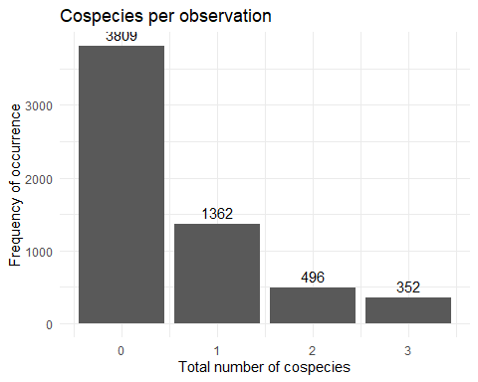

# References

Amsler CD, Neushul M (1989) Diel Periodicity of Spore Release from the Kelp Nereocystis Luetkeana (Mertens) Postels Et Ruprecht. Journal of Experimental Marine Biology and Ecology 134:117–127.

Collins R, Wendell F, Kalvass P, Ota B, Kashiwada J, Tanaguchi I, King A, Larson M, Gross J, Wright N, O’Brien J, Bedford D, Veisze P (2001) [Giant and Bull Kelp Commercial and Sport Fishing Regulations](https://nrm.dfg.ca.gov/FileHandler.ashx?DocumentID=34384). California Department of Fish; Game, Sacramento, CA, USA.

Dieck I tom (1993) Temperature Tolerance and Survival in Darkness of Kelp Gametophytes (Laminariales, Phaeophyta): Ecological and Biogeographical Implications. MARINE ECOLOGY-PROGRESS SERIES 100:253–253.

Dobkowski KA, Flanagan KD, Nordstrom JR (2019) [Factors Influencing Recruitment and Appearance of Bull Kelp, *Nereocystis Luetkeana* (Phylum Ochrophyta)](https://doi.org/10.1111/jpy.12814). Journal of Phycology 55:236–244.

Foreman RE (1970) PHYSIOLOGY, ECOLOGY, AND DEVELOPMENT OF THE BROWN ALGA, NEREOCYSTIS LUETKEANA (MERTENS) p. & r. University of California, Berkeley.

García-Reyes M, Thompson SA, Rogers-Bennett L, Sydeman WJ (2022) [Winter Oceanographic Conditions Predict Summer Bull Kelp Canopy Cover in Northern California](https://doi.org/10.1371/journal.pone.0267737). PLOS ONE 17:e0267737.

Huyer A (1983) [Coastal Upwelling in the California Current System](https://doi.org/10.1016/0079-6611(83)90010-1). Progress in Oceanography 12:259–284.

Komar PD, Allan J (2000) Analyses of extreme waves and water levels on the pacific northwest coast. Citeseer.

LTER SBC, Bell TW, Cavanaugh KC, Siegel DA (2017) SBC LTER: Time Series of Quarterly NetCDF Files of Kelp Biomass in the Canopy from Landsat 5, 7 and 8, 1984-2016 (Ongoing).

Maxell BA, Miller KA (1996) [Demographic Studies of the Annual Kelps Nereocystis Luetkeana and Costaria Costata (Laminariales, Phaeophyta) in Puget Sound, Washington](https://doi.org/10.1515/botm.1996.39.1-6.479). Botanica Marina 39.

Miller KA, Estes JA (1989) [Western Range Extension for Nereocystis Luetkeana in the North Pacific Ocean](https://doi.org/10.1515/botm.1989.32.6.535). botm 32:535–538.

[Oregon Territorial Sea Plan - Appendix H](https://www.oregonocean.info/index.php/territorial-sea-planning) (1994) Ocean Policy Advisory Council.

Picard MMM, Johnson LE, Côté IM (2022) [Effects of Sediment on Spore Performance as a Potential Constraint on Kelp Distribution](https://doi.org/10.1016/j.marpolbul.2022.114336). Marine Pollution Bulletin 185:114336.

Reimer J, Hacker S, Menge B, Ruggiero P (2018) [Macrophyte Wrack on Sandy Beaches of the US Pacific Northwest Is Linked to Proximity of Source Habitat, Ocean Upwelling, and Beach Morphology](https://doi.org/10.3354/meps12565). Marine Ecology Progress Series 594:263–269.

Springer Y, Hays C, Carr M, Mackey M, Bloeser J (2007) Ecology and Management of the Bull Kelp, Nereocystis Luetkeana. Lenfest Ocean Program, Washington, DC.

Springer YP, Hays CG, Carr MH, Mackey MR (2010) Toward Ecosystem-Based Management of Marine Macroalgae — The Bull Kelp, Nereocystis Luetkeana.

Weigel BL, Small SL, Berry HD, Dethier MN (2023) [Effects of Temperature and Nutrients on Microscopic Stages of the Bull Kelp ( *Nereocystis Luetkeana* , Phaeophyceae)](https://doi.org/10.1111/jpy.13366). Journal of Phycology:jpy.13366.