**Simulated OS**

**CMSC 312**

**Will Russell | Ibrahim Ramadan | Abduallah Hashmi**

**Running the simulator:**

* Open up the OpSysSim folder in and IDE of your choice. Then go to src/Sys/User_space/GUI and run the GUI.java file. Then the GUI screen should pop up.

**Commands Used on GUI:**

* PROC: Shows all unfinished processes.
* MEM: Shows total amount of memory left.
* LOAD (Job.job): Loads a job into the simulator
* EXE (numberOfCycles): Lets user specify number of cycles, so the simulator can run on its own.
* RESET: All unfinished processes are terminated, clock returns to 0 and GUI is cleared.
* EXIT: Terminates the simulator

**Jobs and Programs:**

* Browser.pgrm
* newjob.job
* testjob.job

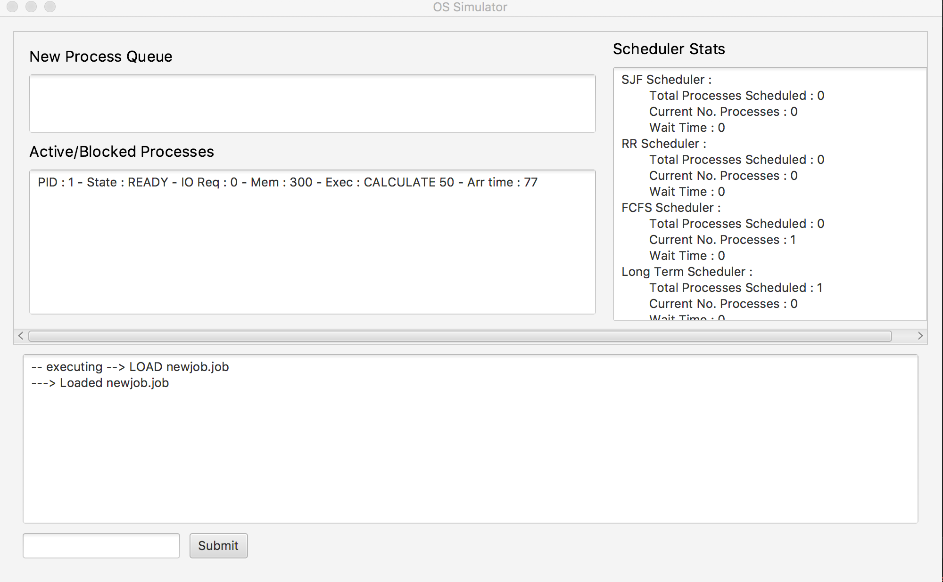**GUI:**