Unified Clinical Practice + Health ATM
Platform
Development Pack
Functional Requirements Document, Architecture Blueprint, Data Model Summary, and Baseline Schema
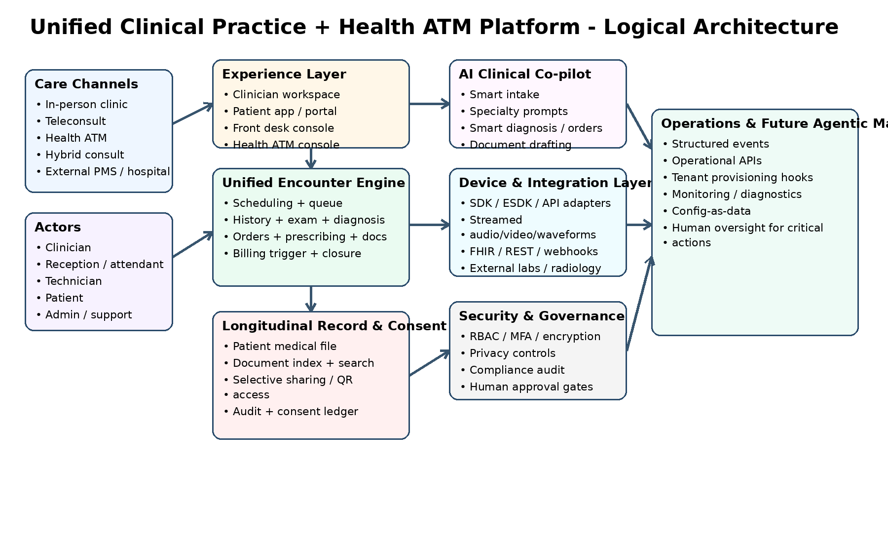
Prepared for | Axonic Health / Health ATM-enabled clinical platform
Document purpose | Master development pack for product, design, engineering, and implementation teams
Version | Draft v1.0
Date | 2026-04-07

Contents
1. Executive summary
2. Objectives and product principles
3. Scope
4. User roles
5. Supported care modes
6. Specialty-specific experience framework
7. Functional requirements
8. Interoperability requirements
9. Architecture overview
10. Data model summary
11. Security, privacy and compliance
12. Future agentic management readiness
13. Recommended delivery phases
14. Architecture appendix
15. Core schema appendix

1. Executive Summary
This development pack defines a unified, multilingual, voice-enabled clinical platform that brings together clinic consultations, teleconsultations, Health ATM encounters, hybrid care, patient longitudinal records, diagnostic device integration, AI-assisted workflows, billing, insurance support, and patient-controlled record sharing.
The product is designed around a single encounter engine with a deliberately simple clinician interface. Complexity is handled behind the scenes by structured workflows, configurable specialty packs, device adapters, interoperability services, consent controls, and future automation hooks.
The solution must be capable of operating as a standalone practice management and clinical workflow system, while also being ready to integrate with external PMS, HIS, EHR, LIS, RIS, and payer systems through FHIR and other APIs.

2. Objectives and Product Principles
The platform shall:
1. Give clinicians an elegant, low-friction workspace that is easy to learn and fast to use.
2. Support one unified encounter engine across in-person, teleconsult, Health ATM, and hybrid consultations.
3. Maintain a longitudinal patient medical file that is searchable across case sheets, reports, prescriptions, images, billing artifacts, and communications.
4. Allow patients to decide exactly what to share from the patient app, including selective withholding of sensitive information.
5. Support specialty-specific user experiences without fragmenting the product into separate applications.
6. Ingest and display data from external clinical devices using a pragmatic mix of normalization and raw vendor outputs.
7. Generate high-quality structured documentation from underlying encounter data.
8. Remain interoperable by design, with FHIR and API-based external integration capability.
9. Be architected for later agentic management of sales, deployment, support, configuration, and operations with human oversight of critical actions.

3. Scope
In scope:
- registration and enterprise patient identity
- scheduling, slot publication, queueing, check-in, and walk-in management
- unified encounter workflow
- clinician workspace
- specialty-specific experience packs
- Health ATM workflows
- AI-assisted intake, diagnosis support, orders, prescribing, advice, and summary drafting
- longitudinal record management
- patient app and secure sharing controls
- device integration and streamed examination workflows
- documentation engine
- billing and insurance support
- interoperability layer
- security, privacy, audit, and consent
- operations and automation hooks
Out of scope for the core application:
- autonomous sales/marketing/support agent platform itself
- generic enterprise CRM outside application touchpoints
- broad non-health software management
These remain separate future workstreams, but the application must expose the interfaces and telemetry needed to support them later.

4. User Roles
Primary roles:
- patient
- clinician / doctor
- receptionist / front desk
- Health ATM attendant
- technician
- nurse / clinical assistant
- lab / radiology operator
- billing executive
- insurer / claim-support role
- organisation admin
- super admin
- integration administrator
- support / implementation role
- compliance / audit role
Access to data and functions shall be role-based, organisation-aware, and auditable.

5. Supported Care Modes
The platform shall support four consultation modes using one encounter engine:
- In-person clinic consultation
- Teleconsultation
- Health ATM consultation
- Hybrid consultation
Mode-specific overlays may surface different tools, but the underlying clinical data model, encounter lifecycle, audit, and documentation patterns shall remain consistent.

6. Specialty-Specific Experience Framework
The platform shall use a core-plus-configuration model.
Core platform:
- patient identity
- schedule and queue
- encounter lifecycle
- longitudinal file
- billing
- documents
- interoperability
- audit and consent
Specialty configuration layer:
- specialty-specific navigation and default tabs
- specialty-specific summary cards
- history templates and question sets
- examination structures
- diagnosis and order-set suggestions
- favourite prescriptions and procedures
- device prominence rules
- specialty document styles
- AI workspace / prompt pack mapping
- specialty terminology and labels
Governance model:
- global defaults
- specialty profiles
- organisation overrides
- constrained doctor-level preferences
This allows cardiology, dermatology, ophthalmology, paediatrics, surgery, psychiatry, and other specialties to experience highly tailored workflows without creating separate codebases for each specialty.

7. Functional Requirements
Patient identity and registration:
- Create and manage a unique patient record with multiple linked identifiers.
- Support duplicate detection, merge workflows, and organisation-aware identity matching.
- Persist communication preferences, consent settings, and insurance linkages.
Scheduling and queue management:
- Publish clinician slots by organisation, location, channel, and specialty.
- Support bookings by patients, staff, attendants, and call-center users.
- Support check-in, token management, rescheduling, cancellation, and no-show handling.
Pre-consult intake:
- Capture history via avatar, app, portal, voice flow, WhatsApp/email link, or staff-assisted intake.
- Produce structured specialty-aware summaries and identify missing information.
- Allow clinicians to trigger smart follow-up questions.
Encounter execution:
- One encounter model for all channels.
- Capture history, exam, assessments, diagnosis, orders, prescribing, advice, procedures, billing triggers, and documents.
- Allow remote clinician-directed exam support through Health ATM staff and devices.
Health ATM:
- Support registration, appointment creation, intake, doctor connection, assisted remote examination, technician scans, test execution, payments, output delivery, and closure.
- Let attendants support registration, payments, device setup, and workflow progression.
- Let technicians acquire ultrasound and Doppler studies for remote interpretation.
AI co-pilot:
- Smart intake summarization
- smart diagnosis suggestions with ICD mapping support
- smart order sets and prescribing suggestions
- smart advice, referral, and summary drafting
- configurable AI modes: suggestion-only or pre-populate with clinician approval
Longitudinal medical file:
- Searchable record timeline across case sheets, results, imaging artifacts, prescriptions, invoices, and communication history.
- Clinician, patient, and permitted external access views.
Patient-controlled sharing:
- Share at document, episode, category, summary, or date-range level.
- Withhold sensitive items.
- Use QR or secure links.
- Track grant, expiry, revocation, and access logs.
Billing and insurance:
- Consultation, procedure, diagnostic, package, and ATM-service charging.
- Invoices, receipts, payments, payer linkages, and claim-support workflows.
Interoperability:
- Import/export patient, encounter, appointment, observation, document, diagnostic, medication, and billing information via APIs and FHIR mappings.
- Support standalone deployment or coexistence with external PMS/HIS.
Security and audit:
- Encryption, RBAC, organisation partitioning, audit logs, consent ledger, and admin traceability.

8. Interoperability Requirements
The system shall be integration-ready from first release, even if all connectors are phased.
Capabilities:
- secure REST APIs for internal and external integrations
- webhooks for operational events
- FHIR-aligned resource mapping for patient, practitioner, appointment, encounter, observation, diagnostic report, document reference, medication request, service request, invoice, and coverage contexts
- adapter model for external PMS/HIS/LIS/RIS systems
- import pipelines for summaries, reports, and external documents
- export controls respecting consent and share scopes

9. Architecture Overview
The target architecture uses modular services around a unified clinical core.
Layers:
1. Experience layer
- clinician workspace
- patient app / portal
- front desk console
- Health ATM console
2. Clinical workflow layer
- scheduling and queue orchestration
- encounter engine
- order/prescription/document services
- longitudinal record index
- patient sharing and consent services
3. Intelligence layer
- AI orchestration
- specialty prompt packs
- suggestion acceptance tracking
- rule engine and configurable pathways
4. Integration layer
- device adapters
- streaming and file ingest services
- external system adapters
- FHIR/API gateway
- event bus
5. Control and governance layer
- identity and access
- audit and monitoring
- billing and insurance services
- configuration service
- operations hooks for future agents

Figure 1. Logical architecture.

10. Data Model Summary
The data model shall separate core identity, scheduling, encounters, clinical content, documents, sharing, integrations, and billing while preserving strong referential traceability.
Key entities:
- patient
- patient_identifier
- consent_profile
- appointment
- channel
- clinician
- encounter
- encounter_note
- problem_list_item
- diagnosis
- order_item
- prescription_item
- device
- device_result
- observation
- document
- document_access_tag
- share_grant
- share_access_log
- billing_invoice
- billing_line_item
- payer / coverage
- integration_event
- audit_event
- specialty_profile
- ui_widget_profile
- ai_prompt_pack
The supplied SQL file provides a robust relational baseline that can be adapted to PostgreSQL or another enterprise RDBMS.
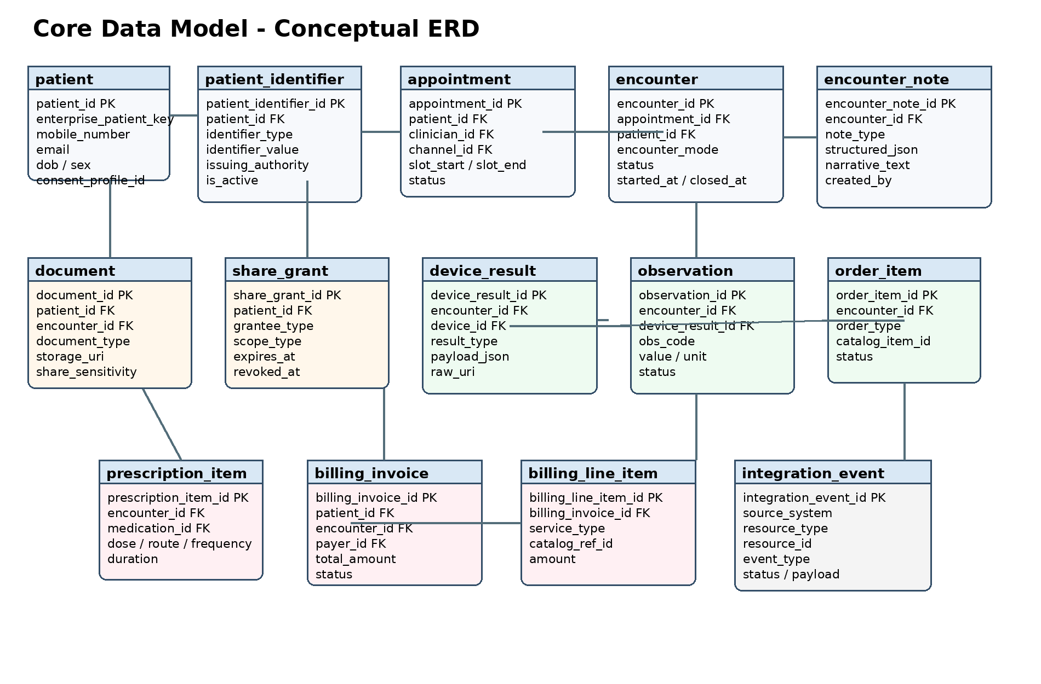
Figure 2. Conceptual core ERD.

11. Security, Privacy and Compliance
The platform must be designed for healthcare-grade privacy, security, and auditability.
Mandatory principles:
- least-privilege access
- tenancy and organisation scoping
- encryption in transit and at rest
- role-aware document visibility
- explicit patient sharing control
- sensitive-document tagging
- immutable audit events for critical actions
- environment and integration traceability
- human approval gates for high-risk administrative actions

12. Future Agentic Management Readiness
The future autonomous operations framework is a separate project. To prepare for it, the application must expose:
- machine-readable audit events
- operational APIs for tenant setup, config, diagnostics, and status
- event-driven notifications for deployment, integration, support, billing, and health issues
- configuration-as-data instead of hard-coded business rules
- approval-gated admin actions
- structured logs and correlation identifiers
- health endpoints and diagnostic bundles
- environment manifests and feature flags
This will allow future agents to observe the application, recommend changes, perform low-risk actions, and escalate high-risk operations for human approval.

13. Recommended Delivery Phases
Phase 1:
- patient identity
- scheduling and queue
- unified encounter engine
- clinician workspace
- AI intake and summary
- orders, prescriptions, and core documents
- longitudinal file
- patient app basics
- core sharing controls
- core billing and audit
Phase 2:
- Health ATM console
- attendant workflow
- streaming exam panel
- first-wave device integrations
- technician workflow for ultrasound / Doppler
Phase 3:
- advanced sharing controls
- insurance workflows
- external lab/radiology routing
- hospital/PMS interoperability
- richer analytics and monitoring
Phase 4:
- enhanced operations APIs
- automation hooks
- tenant templating
- deployment automation
- future agent framework integration

14. Architecture Appendix

Core architectural style
• Recommended starting point: a modular monolith or service-oriented backend with clear domain boundaries, so product speed is preserved while domain separation remains strong.
• Use PostgreSQL for transactional data, object storage for documents and raw device files, and a search index for fast retrieval across the longitudinal record.
• Use an event broker for workflow notifications, monitoring signals, and future autonomous operations hooks.

Experience applications
• Clinician workspace: specialty-aware encounter console with patient summary, notes, AI actions, device panel, and document outputs.
• Front desk console: booking, queue, token management, registration, payments, and patient routing.
• Health ATM console: attendant workflow, device coordination, remote doctor link, payment assistance, and output delivery.
• Patient app and portal: records, prescriptions, reports, invoices, notifications, and sharing controls.

Core backend services
• Scheduling service for slots, channel publication, and queue progression.
• Encounter service for unified clinical lifecycle across in-person, teleconsult, Health ATM, and hybrid encounters.
• Documentation service for note generation, summaries, letters, prescriptions, and patient-facing outputs.
• Consent and sharing service for QR/link grants, scope rules, expiry, and revocation.
• Billing and insurance service for invoices, line items, payer linkage, and claim-support artifacts.

Clinical intelligence services
• AI orchestrator to call specialty workspaces and manage prompt packs.
• Clinical rules service for guardrails, red flags, and configurable pathways.
• Suggestion tracker to store what AI suggested, what the clinician edited, and what was finally approved.

Integration and device services
• Device adapter framework to integrate streamed audio/video, waveforms, images, and file-based outputs.
• FHIR and REST gateway for external PMS, HIS, LIS, RIS, payer, and partner integrations.
• Integration event service for inbound/outbound traffic, retries, failures, and operational visibility.

Agent-readiness controls
• Operational APIs for tenant setup, template rollout, diagnostics, and monitoring.
• Structured events and logs with correlation IDs so future agents can observe and act safely.
• Human approval gates for high-risk changes such as production deployment, integration activation, pricing changes, and security policy edits.

15. Core Schema Appendix
The full baseline schema is supplied separately as db_schema.sql. The table below summarizes the primary domains and anchor tables.
Domain | Key tables | Purpose
Identity & access | organization, facility, clinician, patient, patient_identifier, consent_profile | Enterprise identity, org scoping, clinician linkage, consent defaults
Scheduling | channel, appointment | Slot publishing, booking, and channel-aware care routing
Clinical encounter | encounter, encounter_note, diagnosis | Unified clinical workflow and structured / narrative content
Orders & prescribing | service_request, medication_request | Investigations, procedures, and medication plans
Devices & observations | device, device_result, observation | Integrated device outputs, waveforms, measurements, and interpreted data
Longitudinal file & sharing | document, share_grant, share_access_log | Persistent record archive plus patient-controlled sharing
Commercial | payer, coverage, billing_invoice, billing_line_item | Billing, payer data, and claim-support artifacts
Operations & governance | integration_event, audit_event | Interoperability events, supportability, and compliance traceability

Pack notes
This package is intended as a strong starting point. Before build kickoff, it should be expanded into module-level requirements, screen specifications, FHIR mapping definitions, migration scripts, and specialty pack definitions.

