**Physically-Based Shading at Disney.(迪士尼的物理着色。
)**

by Brent Burley, Walt Disney Animation Studios.

# 1 Introduction.(1导言。 )

Following our success with physically-based hair shading on Tangled [27], we began considering physicallybased shading models for a broader range of materials.(在我们成功地实现了基于物理的头发着色之后，我们开始考虑更广泛材料的基于物理的着色模型。
) With the physically-based hair model, we were able to achieve a great degree of visual richness while maintaining artistic control.( 有了基于物理的发型，我们能够在保持艺术控制的同时获得很大程度的视觉丰富性。
) However, it proved challenging to integrate the lighting of the hair with the rest of the scene which had still used traditional “ad-hoc” shading models and punctual lights.(然而，事实证明，将头发的照明与场景的其余部分结合起来是很有挑战性的，因为场景的其余部分仍然使用传统的“特殊”阴影模型和准时灯。
) For subsequent films we wanted to increase the richness of all of our materials while making lighting responses more consistent between materials and environments and also wanted to improve artist productivity through the use of simplified controls.( 对于后续的电影，我们希望增加我们所有材料的丰富性，同时使照明反应在材料和环境之间更加一致，还希望通过使用简化的控制来提高艺术家的生产力。
)

When we began our investigation it wasn’t obvious which models to use or even how physicallybased we wanted to be.(当我们开始调查的时候，我们并不清楚要使用哪种模型，甚至不清楚我们想成为什么样的物理模型。
) Should we be perfectly energy conserving? Should we favor physical parameters like index-of-refraction?.(我们应该完全节约能源吗？ 我们应该偏爱折射率这样的物理参数吗？
)

For diffuse, Lambert seemed to be the accepted norm, while specular seemed to get most of the attention in the literature.(对于漫反射而言，Lambert似乎是公认的标准，而高光似乎得到了大部分的文学关注。
) Some models such as Ashikhmin-Shirley (2000) [3] aimed to be intuitive and practical while physically plausible, while others such as He et al.(一些模型，如Ashikhmin-Shirley(2000)[3]的目标是直观和实用，但在物理上似乎可行，而另一些模型，如He et al等。
) (1991) [12] provided a more comprehensive physical model.(（1991）[12]提供了一个更全面的物理模型。
) Still others aimed at improved data fitting [15, 14, 22, 17, 4], but few of these are appropriate for direct manipulation.( 还有一些目标是改进数据拟合[15、14、22、17、4]，但其中很少一部分适合直接操作。
) We could have implemented several models and let the artists choose and combine them, but then we’d have been back to the parameter explosion we were trying to get away from.(t改进的数据拟合[15，14，22，17，4]，但其中很少有适合于直接操作的数据拟合[15，14，22，17，4]。 我们可以实现几个模型，让艺术家选择和组合它们，但我们会回到我们试图摆脱的参数太多。
)

One study of a large variety of measured materials was Ngan et al.( Ngan et al对大量被测材料进行了研究。
) (2005) [21] which compared five popular models.(（2005）[21]比较了五种流行模式。
) Some models fared better than others overall, but interestingly, there was a strong correlation between the models’ performances – some materials were well represented by all the models, and for others, no model proved suitable.(一些模型的总体表现要好于其他模型，但有趣的是，模型的性能之间存在着很强的相关性——一些材料被所有模型很好地表示出来，而对于另一些模型来说，没有模型被证明是合适的。
) Adding an additional specular lobe helped in only a few of the cases.(增加一个额外的镜片只在少数情况下有帮助。
) This begs the question, what is not being represented in the difficult materials?( 这就引出了一个问题:在这些难表现的材料中，什么是没有表现出来的？
)

To answer this question and to evaluate BRDF models more intuitively we developed a new BRDF viewer that could display and compare both measured and analytic BRDFs.(为了回答这个问题并更直观地评估BRDF模型，我们开发了一个新的BRDF查看器，它可以显示和比较测量的和分析的BRDF。
) We discovered new, intuitive ways to view measured BRDF data and we found interesting features in the measured materials that weren’t well-represented by known models.( 我们发现了新的直观的方法来查看测量的BRDF数据，并且我们发现了测量的材料中有趣的特性，这些特性没有被已知的模型很好地表示出来。
)

In these course notes we will share observations from studying measured materials along with insights we’ve gleaned about which models fit the measured data and where they fall short.(在这些课程笔记中，我们将分享从研究测量材料中获得的观察结果，以及我们所收集到的关于哪些模型适合测量数据以及它们在哪里不足的见解。
) We will then present our new model which is now being used on all current productions.(然后，我们将介绍我们的新模式，现在正在被我们所用。
) We will also describe our experience of adopting this new model in production and discuss how we were able to add the right level of artistic control while preserving simplicity and robustness.( 我们还将描述我们在生产中采用这种新模型的经验，并讨论我们如何能够在保持简单性和健壮性的同时增加正确的艺术控制水平。
)

# 2 The microfacet model.(2微面模型。 )

We will define our BRDF and compare with measured materials in terms of the microfacet model [30, 7, 33].(我们将定义我们的BRDF，并根据微面模型与测量的材料进行比较[30，7，33]。
) The microfacet model postulates that if a surface reflection can occur between a given light vector *l* and view vector *v*, then there must exist some portion of the surface, or microfacet, with a normal aligned halfway between the *l* and *v* vectors.( 微刻面模型假定，如果表面反射可以发生在指定的光矢量L和视向量V之间，则一定存在表面的某个部分，或微刻面，在L和V矢量之间法线对齐。
) This “half-vector”, sometimes referred to as the microsurface normal, is thus defined as *h* 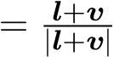. (载体。 这个“half-vector”，有时被称为微表面法线，因此被定义为h。
) A general form of the microfacet model for isotropic materials is:(各向同性材料微面模型的一般形式是:
)

*f*(*l,v*) = diffuse +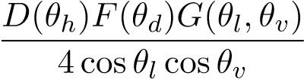

The diffuse term is a function of unknown form.(diffus是未知形式的函数。
) Lambert diffuse is often assumed and is represented by a constant value.(Lambert diffuse常被假定为常数。
) For the specular term, *D* is the microfacet distribution function and is responsible for the shape of the specular peak, *F* is the Fresnel reflection coefficient, and *G* is the geometric attenuation or shadowing factor.( 对于specular term，d是微面分布函数，并负责镜面峰的形状，f是菲涅耳反射系数，g是几何衰减或阴影因子。
)

*θl* and *θv* are the angles of incidence of the *l* and *v* vectors with respect to the normal, *θh* is the angle between the normal and the half-vector, and *θd* is the “difference” angle between *l* and the half-vector (or, symmetrically, *v* and *h*).(*θl* 和*θv* 是L和V向量相对于法线的入射角，*θh*是法线和半向量之间的角度，*θd* 是L和half-vector之间的“差”角（或，对称地，VdotH）。
)

Most physically plausible models not specifically described in microfacet form can still be interpreted as microfacet models in that they have a distribution function, a Fresnel factor, and some additional factor which could be considered a geometric shadowing factor.(大多数物理上看似合理的模型（没有以微面形式具体描述）仍然可以被解释为微面模型，因为它们具有分布函数、菲涅耳因子和一些可被认为是几何遮蔽因子的附加因子。
) The only real difference between microfacet models and other models is whether they include the explicit  factor that comes from the microfacet derivation.( 微面模型与其他模型之间唯一的真正区别在于它们是否包含来自微面派生的显式因子。
) For models that don’t include this factor, an implied shadowing factor can be determined by multiplying the model by 4cos*θl* cos*θv* after factoring out the D and F factors.( 对于不包含此因子的模型，在分解出D和F因子后，可通过将模型乘以4cos*θl* cos*θv* 来确定隐含的阴影因子。
)

# 3 Visualizing measured BRDFs ( 可视化测量BRDF )

# 3.1 The “MERL 100”.

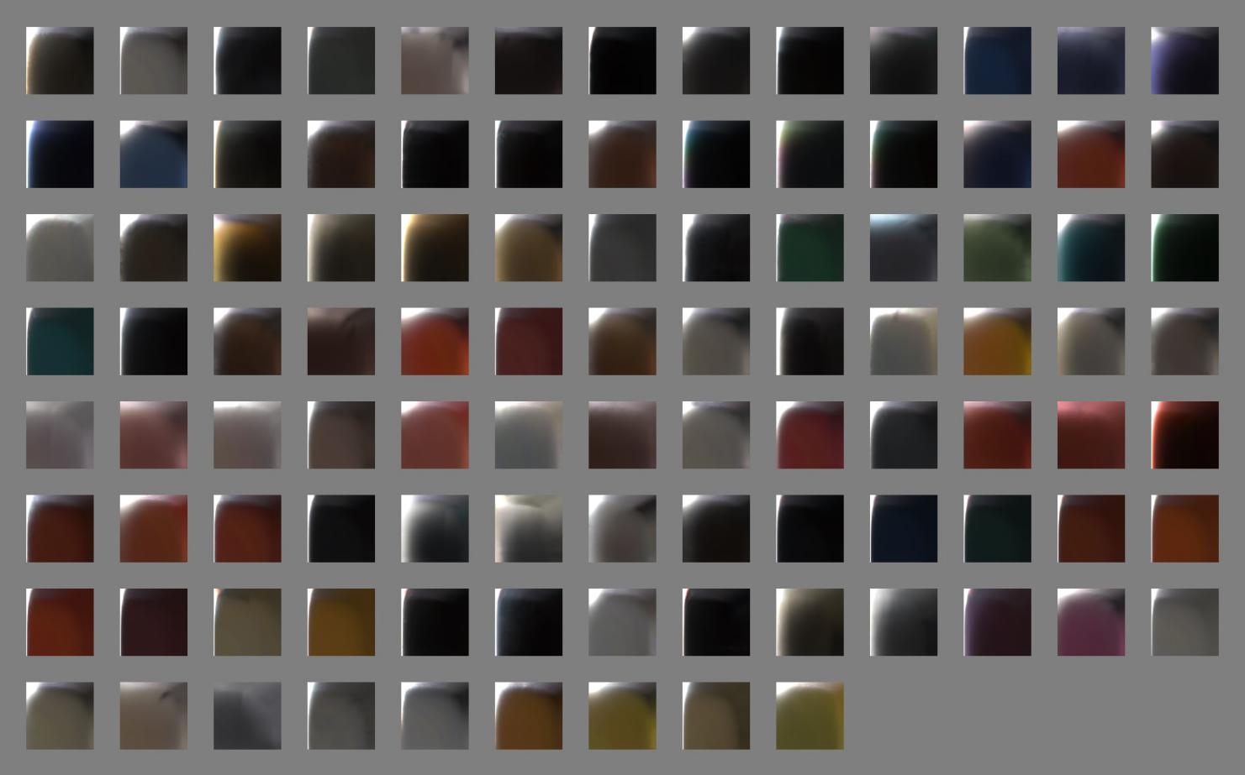

Figure 1: Images slices of MERL 100 BRDFs.

A set of 100 isotropic BRDF material samples was captured by Matusik et al.(Matusik等人采集了一组100个各向同性BRDF材质样品。
) in 2003 [18] covering a wide range of materials including paints, woods, metals, fabric, stone, rubber, plastic, and other synthetic materials.(Matusik等人采集了一组100个各向同性BRDF材料样品。 2003年，[18]涵盖广泛的材料，包括油漆、木材、金属、织物、石头、橡胶、塑料和其他合成材料。
) This data set is freely available from Mitsubishi Electric Research Laboratories at www.merl.com/brdf and is commonly used for evaluating new BRDF models. 该数据集可从三菱电气研究实验室免费获得，网址为www.merl.com/brdf，通常用于评估新的brdf模型。
) Slices of these BRDFs are shown in Figure 1.(这些BRDF的切片如图1所示。
)

Each BRDF in the MERL 100 is densely sampled into a 90 by 90 by 180 cube along the *θh*, *θd*, and *φd* axes respectively.(MERL100中的每个BRDF分别沿*θh*、*θd*和*φd*轴密集采样为90×90×180立方体。
) These correspond to 1 degree increments except for the *θh* axis which was warped to concentrate data samples near the specular peak.(分别为轴。 这对应于1度增量，除了*θh*轴被扭曲以在镜面峰值附近集中数据样本之外。
) The measurements have been filtered and extrapolated as needed so that there are no holes in the data.(测量值已根据需要进行了滤波和外推，以便在数据中不存在空洞。
) This is good in that the data is easy to use, but it’s not clear how accurate the data is, particularly near the horizon.( 这很好，因为数据易于使用，但不清楚数据的准确性，尤其是在地平线附近。
) Because of this, some researchers discard data near the horizon when performing fitting, but this data is still useful to consider as it can have a profound effect on the material appearance.(正因为如此，一些研究人员在进行拟合时丢弃了地平线附近的数据，但是这些数据仍然是有用的，因为它可以对材料的外观产生深远的影响。
)

## 3.2 BRDF Explorer.

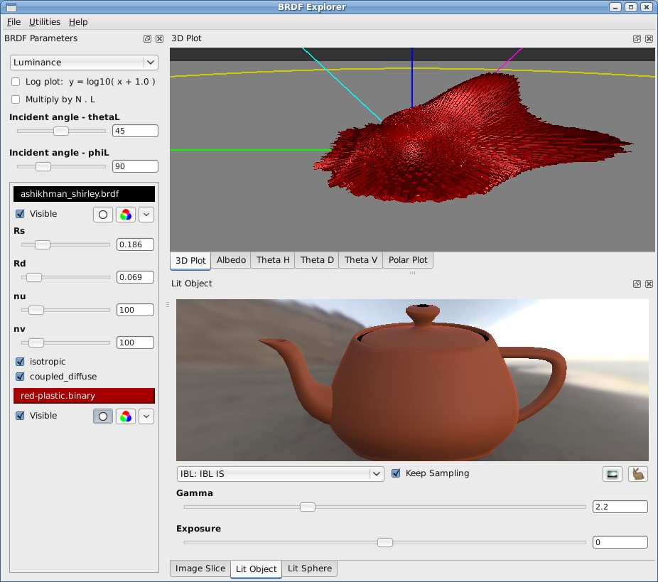

Figure 2: Disney BRDF Explorer.(图2:迪士尼BRDF浏览器。
)

To examine the MERL measured materials and compare with analytic models, we developed a new tool, the BRDF Explorer, shown in Figure 2.(为了检查MERL测量的材料并与分析模型进行比较，我们开发了一个新工具，BRDF Explorer，如图2所示。
) It is available as open source at github.(它可以在GitHub上作为开放源码获得。
)com/wdas/brdf and has the following features:( 并具有以下功能:
)

* Ability to load multiple analytic BRDFs written in GLSL.(能够加载用GLSL编写的多个分析BRDF。
  )
* Ability to load measured BRDFs, including the anisotropic material samples captured by Ngan et al.(加载测量的BRDF的能力，包括由Ngan等捕获的各向异性材料样品。
  ) [21].([21]见附件。
  )
* Multiple data plots (3d hemispherical view, polar plot, and various cartesian plots).(多个数据绘图（3D半球视图、极地绘图和各种笛卡尔绘图）。
  )
* Computed albedo plot (i.e. directional-hemispherical reflectance).(计算的反照率图（即方向半球反射率）。
* Image slice view with exposure controls.(带有曝光控制的图像切片视图。
  )
* Lit object view with importance-sampled IBL lighting.(使用重要性采样的IBL照明照明的照明对象视图。
  )
* Lit sphere view.(照明球面视图
  )
* Dynamic UI controls for parametric models.(参数模型的动态UI控件。
  )

This tool has been invaluable in comparing measured materials with existing analytic models as well as in developing our new model.(这一工具在将测量的材料与现有的分析模型进行比较以及开发我们的新模型方面具有无价的价值。
) Surprisingly, it has also proven very useful for artists as an interactive BRDF editor, giving them a deeper understanding of the model parameters and BRDF space.(出人意料的是，作为一个交互式BRDF编辑器，它还被证明对艺术家非常有用，使他们对模型参数和BRDF空间有了更深入的了解。
)

## 3.3 Image slice.(3.3图像切片。 )



*h.(h。
)*

*l.(我。
)*

*v.(v。
)*

*θ.(θ。
)*

*h.(h。
)*

*θ.(θ。
)*

*d.(d。
)*

*l=h=v.(L=H=V。
)*

*h.(h。
)*

*l.(我。
)*

*v.(v。
)*

*h.(h。
)*

*l.(我。
)*

*v.(v。
)*

*h.(h。
)*

*l.(我。
)*

*v.(v。
)*

*l=h=v.(L=H=V。
)*

*l=h=v.(L=H=V。
)*

*θ.(θ。
)*

*l.(我。
)*

*,θ.(，θ。
)*

*v.(v。
)*

*specular peak.(镜面峰
)*

*Fresnel peak.(菲涅耳峰
)*

*diffuse.(散开。
)*

*grazing.(吃草。
)*

*retro-reflection.(倒影。
)*

*red-plastic.(红塑料。
)*

*red-specular-plastic.(红色镜面塑料。
)*

Figure 3: BRDF images slices for *red-plastic* and *specular-red-plastic* shown along with schematic view of “slice space.(图3:红色塑料和镜面红色塑料的BRDF图像切片，以及“切片空间”的示意图。
)”.

One of the simplest, most intuitive ways to visualize a measured material is to simply view it as a stack of images, and we’ve found this to be a very powerful tool to gain an intuition about the data.(最简单、最直观的可视化测量材料的方法之一是简单地将其视为一堆图像，我们发现这是获得数据直观性的一个非常强大的工具。
) As it turns out, all of the interesting features in the MERL 100 materials are visible in the *φd* = 90 slice.(最简单、最直观的可视化测量材料的方法之一是简单地将其视为一堆图像，我们发现这是获得数据直观性的一个非常强大的工具。 事实证明，MERL100材料中所有有趣的特性都可以在φD=90切片中看到。
) A schematic view of this space along with two material samples is shown in Figure 3.(该空间的示意图以及两个材料样品如图3所示。
) Other slices are roughly just warped versions of that slice as shown in Figure 4.(其他切片大致只是该切片的扭曲版本，如图4所示。
) This observation has been exploited in recent work such as Romeiro (2008) [26] and Pacanowsi (2012) [24] as the basis for simplified isotropic BRDF models of the form *f*(*θh,θd*).(=90片。 该空间的示意图以及两个材料样品如图3所示。 其他切片大致只是该切片的扭曲版本，如图4所示。 最近的工作，如Romeiro(2008)[26]和Pacanowsi(2012)[24]利用了这一观测结果，作为简化的各向同性BRDF模型f(θh，θd)的基础。
)

In the image slice, the left edge represents the specular peak, and the top edge represents the Fresnel peak.(在图像切片中，左边缘表示镜面峰值，上边缘表示菲涅耳峰值。
) Note that along the bottom edge, the light and view vectors are coincident; thus the bottom.(在图像切片中，左边缘表示镜面峰值，上边缘表示菲涅耳峰值。 注意，沿着底部边缘，光和视图向量是一致的； 因此是底部。
)

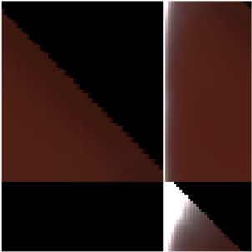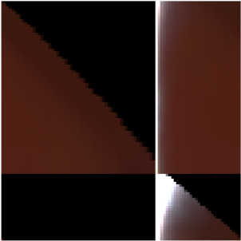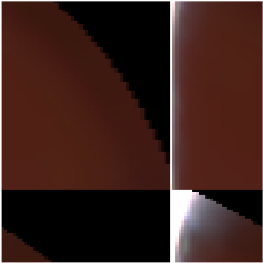

0.(0。
)

30.(30岁。
)

60.(60岁。
)

90.(90岁。
)

Figure 4: Slices of *specular-red-plastic* for different values of *φd*, the azimuthal rotation of *l* around the half-vector.(图4:不同φd值的镜面红塑切片，L绕半矢量的方位角旋转。
) The black region in the upper right corner represents a portion of the BRDF domain where either the *l* or *v* vector is below the horizon.(在半矢量附近。 右上角的黑色区域表示BRDF域的一部分，其中L矢量或V矢量位于地平线以下。
)

edge represents retroreflection.(EDGE表示回射。
) The lower-right corner in particular represents grazing retroreflection.(EDGE表示回射。 右下角尤其代表掠入射回射。
) Diffuse reflectance is exhibited over the entire BRDF space, but the middle of the image is generally isolated to the diffuse response.(漫反射在整个BRDF空间上显示，但图像的中间部分通常与漫反射隔离。
)

The schematic image in Figure 3 also includes an isoline of *θl* or *θv*.(图3中的示意图还包括θL或θV的等值线。
) Many diffuse effects tend to follow this contour.(许多扩散效应倾向于遵循这一轮廓。
) Note that these isolines straighten as *φd* approaches zero, and comparing *φd* slices can give insight about which parts of the material response are due to diffuse reflection and which are specular.(轮廓。 请注意，当φd接近零时，这些等值线变直，比较φd切片可以了解材料响应的哪些部分是漫反射引起的，哪些是镜面反射引起的。
) Another hint is of course color; diffuse reflectance is due to subsurface scattering and absorption which results in a visible tint, whereas specular reflectance comes from the surface and is not tinted (unless the surface is metallic, in which case there is no diffuse component).(切片可以让我们了解材料响应的哪些部分是由于漫反射引起的，哪些是镜面反射引起的。 另一个暗示当然是颜色； 漫反射是由于次表面的散射和吸收导致可见的色调，而镜面反射率来自表面并且不着色（除非表面是金属的，在这种情况下没有漫反射成分）。
)

# 4 Observations from MERL materials.(4 MERL材料的观察。 )

## 1 Diffuse observations.(4.1扩散观测。 )



*alumina-oxide.(氧化铝。
)*

*light-red-paint.(浅红油漆。
)*



*gold-paint.(金漆。
)*

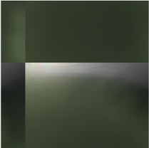

*green-latex.(绿色乳胶。
)*

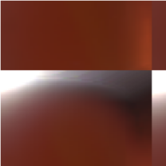

*orange-paint.(橙色颜料。
)*

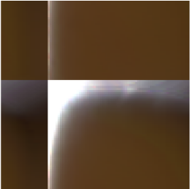

*yellow-matte-.(黄色-哑光。。。
)*

*plastic.(塑料的。
)*

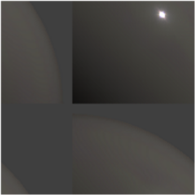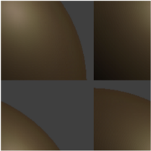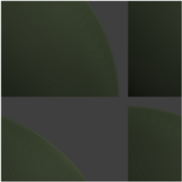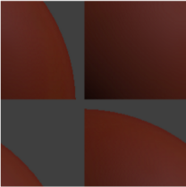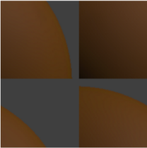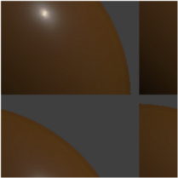

Figure 5: Materials exhibiting diffuse color variation.(图5:显示扩散颜色变化的材料。
) Top row: point-light responses on rendered spheres; bottom row: BRDF image slices.(顶层行:渲染球面上的点光源响应； 底部行:BRDF图像切片。
)

Diffuse reflectance represents light that is refracted into the surface, scattered, partially absorbed, and re-emitted.(漫反射率表示折射到表面、散射、部分吸收和再发射的光。
) Given that some of the light is absorbed, the diffuse response will be tinted with the surface color, and any portion of a non-metallic material that is tinted can be considered to be diffuse.(假设一些光被吸收，漫射响应将被表面颜色着色，并且被着色的非金属材料的任何部分都可以被认为是漫射的。
)

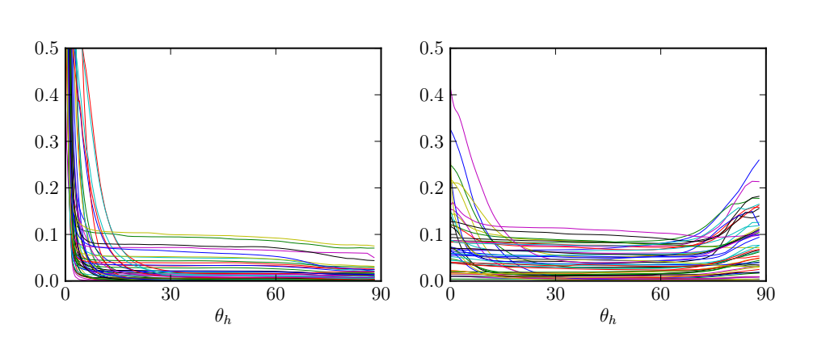

Figure 6: Retroreflective responses of MERL 100 materials.(图6:MERL100材料的回射响应。
) Left: 50 smooth materials (*f*(0) *>* 0*.(图6:MERL100材料的回射响应。 左:50光滑材料(F(0)>0。
)*5); right: 50 rough materials (*f*(0) *<* 0*.(。5）；右图:50块毛坯(F(0)<0。
)*5).(。5）。
) The peak near *θh* = 0 is the specular peak, and the peak (or drop) near *θh* = 90 represents grazing retroreflection.(5)θh=0附近的峰值为镜面峰值，θh=90附近的峰值（或下降）为掠入射后向反射。
)

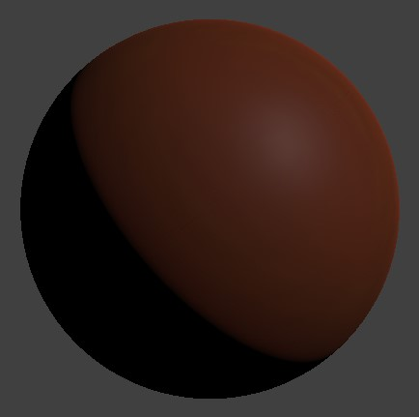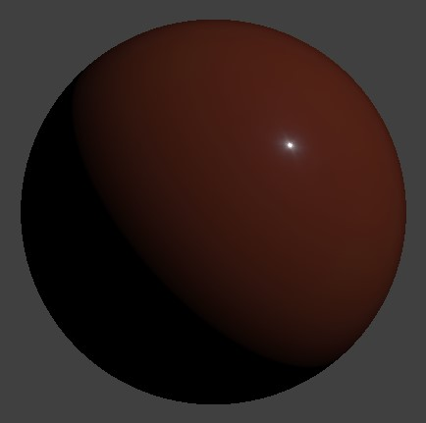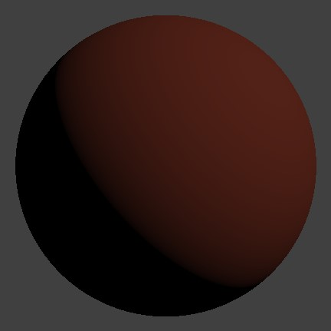

Figure 7: Point light response of *red-plastic*, *specular-red-plastic*, and Lambert diffuse.(图7:红塑料、镜面红塑料和兰伯特漫射的点光源响应。
)

The Lambert diffuse model assumes that the refracted light has scattered enough that it has lost all directionality and thus the diffuse reflectance is constant.(Lambert漫射模型假设折射光已经散射到足够的程度，已经失去了所有的方向性，因此漫反射系数是恒定的。
) However, it can be seen in the various image slices in Figures 1 and 5 that very few materials exhibit a Lambertian response.(Lambert漫射模型假设折射光已经散射到足够的程度，已经失去了所有的方向性，因此漫反射系数是恒定的。 然而，在图1和图5中的各种图像切片中可以看到，很少有材料表现出朗伯响应。
) [Note: a Lambert *shader* includes an *n* · *l* factor, but that’s part of the lighting integral, not the BRDF.(表现出兰伯特式的反应。 [注意:Lambert着色器包含一个N·L因子，但这是照明积分的一部分，而不是BRDF。
)].(]。
)

As shown in Figure 6, many materials show a drop in grazing retroreflection, and many others show a peak.(如图6所示，许多材料显示出掠入射回射的下降，而许多其他材料显示出峰值。
) This appears to be a diffuse phenomenon due to the apparent tinting in the image slices.(如图6所示，许多材料显示出掠入射回射的下降，而许多其他材料显示出峰值。 由于图像切片中的明显着色，这似乎是一种扩散现象。
) Notably, this is strongly correlated to roughness – smooth surfaces, i.(值得注意的是，这是与粗糙光滑表面，即。
)e.(e。
) those with a higher specular peak, tend to have a shadowed edge, and rough surfaces tend to have a peak instead of a shadow.(由于在图像切片中的明显着色，S成为扩散现象。 值得注意的是，这与粗糙光滑表面（即，具有较高镜面峰值的那些表面）倾向于具有阴影边缘，并且粗糙表面倾向于具有峰值而不是阴影。
) This correlation can be seen in the retroreflective response curves and also in the rendered spheres in Figure 7.(这种相关性可以在回射响应曲线中看到，也可以在图7所示的渲染球中看到。
)

The grazing shadow for smooth surfaces is predicted by the Fresnel equations: at grazing angles, more energy is reflected from the surface and less is refracted into the surface to be diffusely re-emitted.(用菲涅耳方程预测了光滑表面的掠入射阴影:在掠入射角度下，表面反射的能量较多，而折射到表面的能量较少。
) However, diffuse models don’t generally consider the effect of surface roughness on Fresnel refraction and either assume a smooth surface or ignore the Fresnel effect.(然而，扩散模型一般不考虑表面粗糙度对菲涅耳折射的影响，要么假设表面光滑，要么忽略菲涅耳效应。
)

The Oren-Nayar model (1995) predicts a retroreflective increase for rough diffuse surfaces that.(Oren-Nayar模型（1995）预测粗糙扩散表面的回射增加。
)

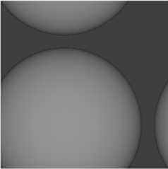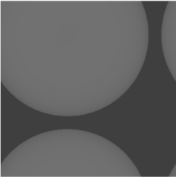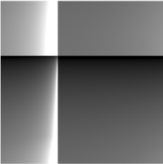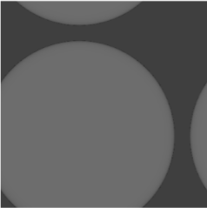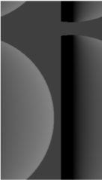

Lambert.(兰伯特。
)

Oren-Nayar.(奥伦-纳亚尔。
)

Hanrahan-Krueger.(汉拉汉-克鲁格。
)

Figure 8: BRDF slices and point-light responses of Lambert, Oren-Nayar, and Hanrahan-Krueger diffuse models.(图8:Lambert、Oren-Nayar和Hanrahan-Krueger扩散模型的BRDF切片和点-光响应。
)

flattens the diffuse shape.(使扩散形状变平。
) However, this retroreflective peak isn’t as strong as the measured data and the rough measured materials don’t generally exhibit flattening of the diffuse.(然而，该回射峰不像测量数据那样强，并且粗略测量的材料通常不表现出漫射的平坦化。
) The Hanrahan-Krueger model (1993), derived from subsurface scattering theory, also predicts a flattening of the diffuse shape, but doesn’t have a strong enough peak at the edge.(使扩散形状变平。 然而，该回射峰不像测量数据那样强，并且粗略测量的材料通常不表现出漫射的平坦化。 从地下散射理论导出的Hanrahan-Krueger(1993)模型也预测了扩散形状的平坦化，但在边缘处没有足够强的峰值。（2）
) In contrast to Oren-Nayar, this model assumes a perfectly smooth surface.(与Oren-Nayar模型不同的是，该模型假设了一个完美光滑的表面。
) The Oren-Nayar and Hanrahan-Krueger models are compared in Figure 8.(图8比较了Oren-Nayar和Hanrahan-Krueger模型。
)

Besides the retroreflective peak, additional diffuse variation can be seen in the image slices in Figure 5.(除了回射峰值之外，在图5中的图像切片中还可以看到额外的漫射变化。
) Both intensity and color variation can be seen that follows the *θl* / *θv* isolines.(在图5中的图像切片中可以看到回射峰值、额外的漫射变化。 在θL/θV等值线之后可以看到强度和颜色的变化。
) This may be due in some cases to layered subsurface scattering.(这可能是由于在某些情况下，分层地下散射。
) However, even layered subsurface scattering models generally consider the surface to be smooth and don’t produce a strong retroreflective peak.(等值线。 这可能是由于在某些情况下，分层地下散射。 然而，即使是分层的地下散射模型通常也认为表面是光滑的，并且不产生强的反向反射峰。
)

## 4.2 Specular D observations.(4.2D镜观测。 )

The microfacet distribution function, *D*(*θh*), can be observed from the retroreflective responses of the measured materials as shown in Figure 6.(微面分布函数D(θH)可从所测材料的回射响应中观察到，如图6所示。（
) The materials were divided into two groups based on the height of the peak which can be seen as an indication of surface roughness.(根据峰的高度将材料分为两组，峰的高度可被视为表面粗糙度的指示。
) The highest peak, from *steel*, was more than 400.(测量材料的Es如图6所示。 根据峰的高度将材料分为两组，峰的高度可被视为表面粗糙度的指示。 来自钢铁的最高峰是400多座。
) Once the peak flattens out, the remaining portion of the curve is likely due to diffuse reflectance.(，是四百多个。 一旦峰值变平，曲线的剩余部分可能是由于漫反射。
)

The vast majority of the MERL materials have specular lobes with tails that are much longer than traditional specular models.(绝大多数MERL材料都具有比传统镜面模型长得多的镜面叶和尾部。
) An example is the *chrome* sample shown in Figure 9.(绝大多数MERL材料都具有比传统镜面模型长得多的镜面叶和尾部。 一个示例是图9所示的Chrome示例。
) The specular response of this material is typical for smooth, highly polished surfaces, with a specular peak only a couple of degrees wide and a specular tail that is many times wider.(示例如图9所示。 这种材料的镜面响应对于光滑、高度抛光的表面是典型的，镜面峰值仅有几度宽，镜面尾部宽很多倍。
) Curiously, the traditional Beckmann, Blinn Phong, and Gaussian distributions are nearly identical at this width and cannot represent either the peak or the tail well.(这种材料的镜面响应对于光滑、高度抛光的表面是典型的，镜面峰值仅有几度宽，镜面尾部宽很多倍。 奇怪的是，传统的Beckmann、Blinn Phong和Gaussian分布在此宽度几乎相同，不能很好地表示峰和尾。
)

The need for a wider tail was the motivation for the GGX distribution introduced by Walter et al.(Walter等人提出的GGX分布的动机是需要更宽的尾部。
) (2007) [33]; GGX has a much longer tail than other distributions but still fails to capture the glowy.(Walter等人提出的GGX分布的动机是需要更宽的尾部。 （2007）[33]； GGX的尾巴比其他分布的长得多，但仍然不能捕获发光。
)

0.(0。
)

5.(5。
)

10.(10。
)

0.(0。
)

*.(好吧。
)*

01.(01。
)

1.(1。
)

*.(好吧。
)*

0.(0。
)

100.(100美元。
)

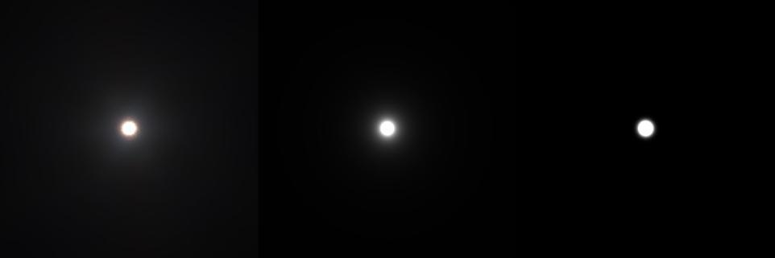

Figure 9: Several specular distributions fit to MERL chrome.(图9:适用于MERL铬合金的几种镜面分布。
) Left: log-scale plots of specular peak vs *θh* (degrees); black = chrome, red = GGX (*α* = 0*.(图9:适用于MERL铬合金的几种镜面分布。 左:镜面峰值对θh（度）的对数标度图； 黑色=铬，红色=GGx(α=0。
)*006), green = Beckmann (*m* = 0*.(。006），Green=Beckmann（m=0。
)*013), blue = Blinn Phong (*n* = 12000).(。013），Blue=Blinn Phong（n=12000）。
) Right: (clipped) point light responses from chrome, GGX, and Beckmann.(右图:（剪辑）来自Chrome、GGX和Beckmann的点光源响应。
)

highlight of the chrome sample.(铬样品的突出显示。
) The importance of modeling the tail response for fitting measured materials was also the basis of two recent models, L¨ow et al.(铬样品的突出显示。 尾部响应模型对拟合被测材料的重要性也是最近两个模型的基础，Léow等人。
) (2012) [17] and Bagher et al.(（2012年）[17]和Bagher等人。
) (2012) [4].(（2012年）[4]。
) Both of these models add an additional parameter to control the tail separately from the peak.(这两种模型都增加了一个附加参数，以分别控制尾部和峰值。
) Another option for modeling the tail is the use of a second wider specular peak added to the first as suggested by Ngan [21].(两个最新模型的基础，Léow等人。 （2012年）[17]和Bagher等人。 （2012年）[4]。 这两种模型都增加了一个附加参数，以分别控制尾部和峰值。 尾部建模的另一种选择是使用第二个更宽的镜面峰，该第二个镜面峰被添加到第一个镜面峰上，如Ngan[21]所建议的。
)

## 4.3 Specular F observations.(4.3镜面F观测。 )

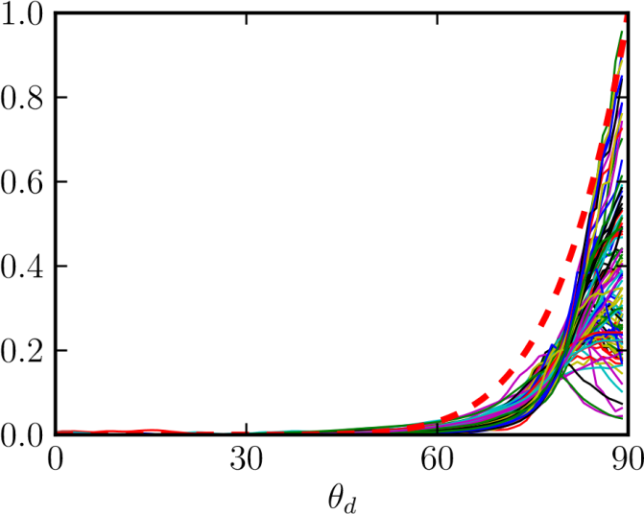

Figure 10: Normalized Fresnel responses of MERL 100 materials plotted at vs *θd*.(图10:MERL100材料的归一化菲涅耳响应在VSθD处绘制。
) Responses were averaged over *θh* from 1 to 4 degrees, the incident response was subtracted off, and the curves were then normalized over *θd* from 45 to 80 degrees for comparison of shape.(在θh范围内1°～4°平均反应，减去入射反应，然后在θd范围内45°～80°归一化曲线以比较形状。
) Dashed line = theoretical Fresnel response.(虚线=理论菲涅耳响应。
)

The Fresnel reflection factor, *F*(*θd*), represents the increase in specular reflection as the light and view vectors move apart and predicts that all smooth surfaces will approach 100% specular reflection at grazing incidence.(菲涅耳反射因子f(θd)表示随着光和视向量分开，镜面反射的增加，并预测所有光滑表面在掠入射时都将接近100%镜面反射。（2）当光和视向量分开时，镜面反射增加。
) For rough surfaces, 100% specular reflection will not be achieved, but reflectance will still become increasingly specular.(对于粗糙表面，不能实现100%镜面反射，但反射率仍将变得越来越镜面。
)

Fresnel response curves for the MERL materials are shown in Figure 10.(MERL材料的菲涅耳响应曲线如图10所示。
) The curves were offset and scaled to compare the overall shape of their response.(这些曲线被偏移和缩放以比较其响应的整体形状。
) Every material shows some increase in reflectance near *θd* = 90.(MERL材料如图10所示。 这些曲线被偏移和缩放以比较其响应的整体形状。 在θd=90附近，每种材料的反射率都有一定程度的提高。
) This can also be seen along the top edges of the image slices in Figure 1.(这也可以沿着图1中的图像切片的顶部边缘看到。
)

Notably, the steepness of many of the curves near grazing angles is greater than predicted by the Fresnel effect.(值得注意的是，许多靠近掠食角的曲线的陡度比菲涅耳效应所预测的要大。
) This observation was in fact the motivation of the Torrance-Sparrow (1967) [30] microfacet model to explain the “off-specular peak” witnessed at higher incidence angles.(值得注意的是，许多靠近掠食角的曲线的陡度比菲涅耳效应所预测的要大。 这一观察结果实际上是Torrance-Sparrow(1967)[30]微面模型的动机，以解释在较大入射角下观察到的“非镜面峰”。
) Note that the  factor in the microfacet model goes to infinity at grazing angles.(Parrow(1967)[30]微面模型来解释在较大入射角下观察到的“非镜面峰”。 请注意，微面模型中的因子在掠入射角处变为无穷大。
) The reason that this is not a problem (both in the model and the real world) is that grazing reflectance is reduced by shadowing effects of the microsurface.(微面模型中的因子在掠入射角处趋于无穷大。 这不是一个问题（无论是在模型中还是在现实世界中）的原因是微表面的阴影效应降低了掠射反射率。
) The *G* factor represents the shadowing of the light vector and, symmetrically, the masking of the view vector, and keeps the grazing reflectance in check.(G因子表示光矢量的阴影，对称地表示视图矢量的遮蔽，并且保持放牧反射率不变。
) But even though the *G* factor represents shadowing, the combination of *G* with 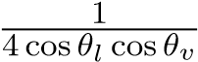 effectively amplifies the Fresnel effect.(因子表示光矢量的阴影，对称地表示视图矢量的遮蔽，并保持放牧反射率不变。 但即使g因子代表阴影，g与有效放大菲涅耳效应的组合。
)

4.4 Specular G (and albedo) observations.(4.4镜面G（和反照率）观测。
)

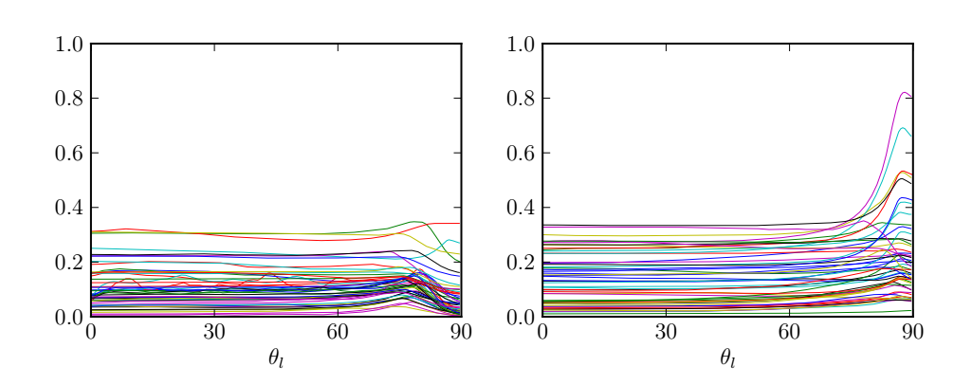

Figure 11: Albedo plots of MERL 100 materials.(图11:MERL100材料的反照率曲线图。
) Left: 50 smooth materials; right: 50 rough materials.(左:50平滑材质； 右图:50块毛料。
)

It is difficult to isolate *G* in the measured data as it requires accurate estimation of the *D* and *F* factors as well as isolation of specular from diffuse.(在测量数据中分离g是困难的，因为它需要精确地估计d和f因子以及分离镜面和漫射面。
) However, the effect of *G* can be seen indirectly in its effect on the directional albedo.(以及镜面与漫射的隔离。 然而，G的影响可以间接地表现在它对方向反照率的影响上。
)

Albedo is the ratio of total reflected energy to total incident energy.(反照率是总反射能量与总入射能量之比。
) In broad terms, it is representative of the color of a surface and must be less than 1 for all wavelengths.(广义地说，它代表一个表面的颜色，对于所有波长，它必须小于1。
) Albedo can also be considered for light coming from a single direction, such as from the sun, in which case the albedo becomes a directional function dependent on incident angle, and must be less than 1 for all angles and wavelengths.( 反照率也可被认为是来自单个方向的光，例如来自太阳的光，在这种情况下，反照率成为依赖于入射角的方向函数，并且对于所有角度和波长，反照率必须小于1。
)

The directional albedo of most materials is relatively flat for the first 70 degrees as seen in Figure 11, and the albedo at grazing angles is strongly correlated with surface roughness.(大多数材料的方向反照率在前70度内相对平坦，如图11所示，掠入射角处的反照率与表面粗糙度密切相关。
) Smooth materials show a slight increase around 75 degrees followed by a drop towards 90.(光滑的材料显示出大约75度的轻微上升，然后是接近90度的下降。
) Rough surfaces increase, often significantly, all the way to the grazing incidence.(粗糙的表面通常会显著增加放牧率。
) Notably, the albedo values overall are fairly low, with few materials having an albedo above 0.(S与表面粗糙度密切相关。 光滑的材料显示出大约75度的轻微上升，然后是接近90度的下降。 粗糙的表面通常会显著增加放牧率。 值得注意的是，反照率值总体上相当低，只有少数材料的反照率高于0。
)3.(3。
)

The grazing retro-reflection exhibited by many rough materials also contributes significantly to this gain, as evidenced by a chromatic tint in the albedo.(许多粗糙材料表现出的掠入射回射也对这一增益有很大贡献，反射率的色调就是明证。
)

The albedo response corresponding to a selection of modeled G factors is shown in Figure 12 for both a very smooth and a very rough surface.(对于非常光滑的表面和非常粗糙的表面，对应于选定的建模g因子的反照率响应如图12所示。
) Notably, omitting G and 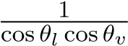 entirely, referred to as the “No G” model, results in an overly dark response at grazing angles.(对于非常光滑的表面和非常粗糙的表面，建模后的g因子的选择如图12所示。 值得注意的是，省略g和完全省略（称为“no g”模型）会导致在掠食角处的过度暗响应。
) The important point here.(这里重要的一点是。
)

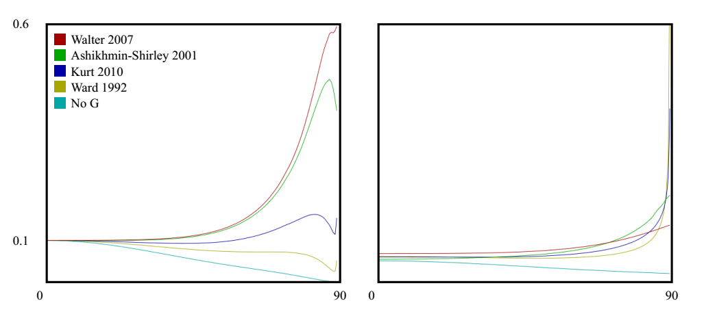

Figure 12: Albedo plots comparing several specular G models.(图12:比较几种镜面G模型的反照率曲线图。
) All plots use the same D (GGX/TR) and F factors.(所有地块使用相同的D（GGx/Tr）和F因子。
) Left: smooth surface (*α* = 0*.(图12:比较几种镜面G模型的反照率曲线图。 所有地块使用相同的D（GGx/Tr）和F因子。 左:光滑表面(α=0。
)*02); right: rough surface (*α* = 0*.(。02）；右:粗糙表面(α=0。
)*5).(。5）。
) The “no G” model excludes the G and 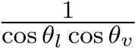 factors.(5）“无G”模型不包括G和因子。
)

is that the choice of the G function has a profound effect on the albedo which in turn has a profound effect on surface appearance.(G函数的选择对反照率有深远的影响，反过来又对表面形貌有深远的影响。
)

Several specular models have been developed specifically with the goal of producing a more plausible albedo response curve [30, 29, 19, 20, 8, 9, 33, 10, 14].(几个镜面模型已经被专门开发出来，目的是产生一个更合理的反照率响应曲线[30，29，19，20，8，9，33，10，14]。
) For some of these, the intent is to make the albedo perfectly flat to maintain energy balance.(对于其中的一些，目的是使反照率完全平坦，以保持能量平衡。
) Based on the albedo plots of the Merl data in Figure 11, this is not an unreasonable target though most of the materials do show some sort of grazing gain.(产生更合理的反照率响应曲线[30，29，19，20，8，9，33，10，14]。 对于其中的一些，目的是使反照率完全平坦，以保持能量平衡。 根据图11中MERL数据的反照率图，这不是一个不合理的目标，尽管大多数材料确实显示出某种放牧增益。
) Even then, some of the grazing gain is likely due to non-specular effects.(即便如此，部分掠入射增益也可能是由于非镜面效应造成的。
)

With a few simplifying assumptions, it’s possible to derive the shadowing function from the microfacet distribution, D, following the method of Smith [29].(通过一些简化的假设，可以按照Smith的方法从微面分布D导出阴影函数。
) This was the approach used by Walter (2007) and Schick (1994).(这是Walter(2007)和Schick(1994)使用的方法。
) As can be seen in Figure 12, the grazing reflectance of the Smith model from Walter increases significantly for smooth surfaces, an effect that is not seen in the measured data.(ET分布，D，遵循Smith方法[29]。 这是Walter(2007)和Schick(1994)使用的方法。 如图12所示，对于光滑表面，Smith模型从Walter获得的掠入射反射率显著增加，这种影响在测量数据中看不到。
) For rougher values, the response seems more plausible.(对于较粗糙的值，响应似乎更合理。
) Note that the Smith G has an analytic form for only a small number of functions and a tabular integration or some other approximation is often used.(请注意，Smith G仅对少数函数具有解析形式，并且经常使用表格积分或其他一些近似。
)

A recent empirical model from Kurt et al.(Kurt等人最近提出的一个经验模型。
) (2010) [14] takes a different approach and proposes a data-fitting model with a free parameter.(（2010）[14]采用了不同的方法，提出了一个带有自由参数的数据拟合模型。
) Figure 12 shows the Kurt model using *α* = 0*.(Kurt等人的海盗模型。 （2010）[14]采用了不同的方法，提出了一个带有自由参数的数据拟合模型。 图12显示了使用α=0的Kurt模型。
)*25; other values of *α* can produce a wide range of albedo responses.(。25； α的其他值可以产生范围广泛的反照率响应。
) Of concern though is that the Kurt albedo diverges near grazing angles, significantly for rough distributions.(可以产生范围广泛的反照率响应。 然而，令人关注的是，库尔特反照率在放牧角附近发散，这对于粗略的分布是很重要的。
) Another option is to just use one of the Smith G derivations from Walter, or even the simpler one from Schlick, and decoupling the G roughness as a free parameter.(另一种方法是使用Walter的Smith G导数之一，或者Schlick的更简单的导数，并将G粗糙度解耦为一个自由参数。
)

## 4.5 Fabric.(4.5织物。 )

Many of the fabric samples in the MERL database exhibit a specular tint at grazing angles and also have a Fresnel peak that is stronger than with materials of comparable roughness.(MERL数据库中的许多织物样品在掠入射角处呈现镜面色调，并且具有比具有可比粗糙度的材料更强的菲涅耳峰。
) Examples of these are shown in Figure 13.(这些示例如图13所示。
)

The tinted grazing response could be explained by the fact that cloth often has transmissive fibers which pick up the material color near object silhouettes.(这种有色的掠食反应可以用织物通常具有透射纤维来解释，透射纤维在物体轮廓附近拾取材料的颜色。
) This could also explain additional gain for cloth at grazing angles beyond what is predicted by the microfacet model.(这种有色的掠食反应可以用织物通常具有透射纤维来解释，透射纤维在物体轮廓附近拾取材料的颜色。 这也可以解释在微面模型预测之外，织物在掠入射角度下的额外增益。
)

*black-fabric.(黑色织物。
)*

*blue-fabric.(蓝色布料。
)*

*green-fabric.(绿色织物。
)*

*pink-fabric2.(粉红色织物2。
)*

*red-fabric2.(红色织物2。
)*

*white-fabric.(白色织物。
)*

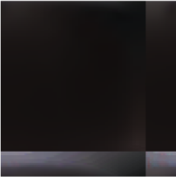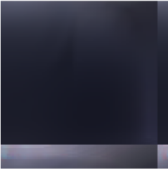

Figure 13: BRDF image slices of various fabric samples.(图13:不同织物样品的BRDF图像切片。
)

While many fabrics can have very complex material response, the MERL fabrics seem relatively easy to model.(虽然许多织物可能具有非常复杂的材料响应，但MERL织物似乎相对容易建模。
)

## 4.6 Iridescence.(4.6彩虹色。 )

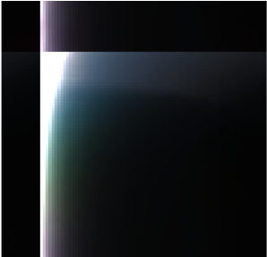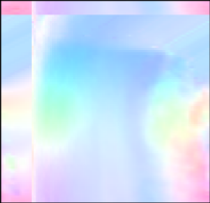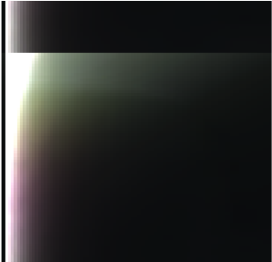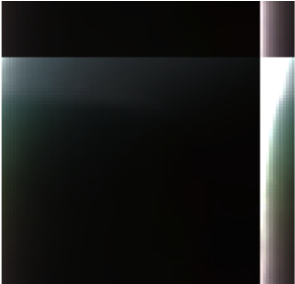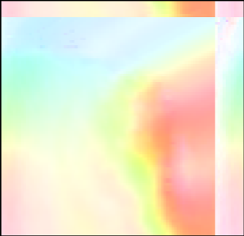

Figure 14: BRDF image slices of *color-changing-paint-1*, *2*, and *3*.(图14:Color-Changing-Paint-1、2和3的BRDF图像切片。
) Top row: original data; bottom row: corresponding chroma images generated by scaling by 1*/max*(*r,g,b*) per pixel.(。上一行:原始数据； 底部行:每像素缩放1/max（r，g，b）生成的对应色度图像。
)

Three color changing paints, shown in Figure 14, exhibit coherent patches of color across the (*θh,θd*) space with minimal dependence on *φd*.(三种变色涂料（如图14所示）在(θH，θD)空间内呈现相干色斑，对φD的依赖性极小。
) This appears to be a completely specular phenomenon given that there’s very little reflectance away from the specular peak.(这似乎是一个完全镜面现象，因为远离镜面峰值的反射率很小。
) This could be modeled simply by modulating the specular hue as a function of *θh* and *θd* perhaps with a small texture map.(离镜面峰值的反射率很小。 这可以简单地通过调制镜面色调作为θh和θd的函数来建模，也许可以使用一个小的纹理映射。
)

## 4.7 Data anomalies.(4.7数据异常。 )

Some anomalies in the MERL data are shown in Figure 15.(MERL数据中的一些异常如图15所示。
)

* Some of the very shiny materials, particularly the metals, exhibit asymmetric highlights suggestive of lens flare or perhaps anisotropic surface scratches.(一些非常有光泽的材料，特别是金属，表现出不对称的突显，暗示着透镜耀斑或者可能是各向异性的表面划痕。
  )
* Data past about 75 degrees appears to be extrapolated.(过去大约75度的数据似乎是外推的。
  )
* The grazing response of the fabrics often has strange discontinuities, possibly due to the fabrics being stretched over spheres during capture and wrinkled near the edges.(织物的掠入射响应通常具有奇怪的不连续性，这可能是由于织物在捕获过程中在球体上被拉伸，并且在边缘附近起皱。
  )
* Some of the woods exhibit specular modulation patterns along *θd* that might be due to wood grain.(一些木材沿θd呈现镜面调制模式，这可能是由于木纹造成的。
  )

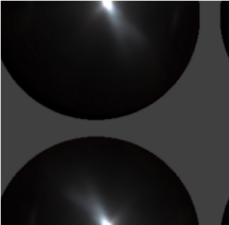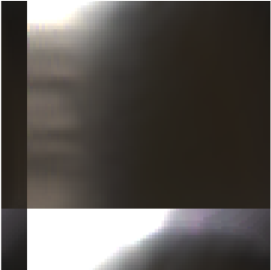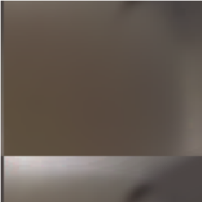

Figure 15: Anomalies in the MERL data.(图15:MERL数据中的异常。
) From left to right: the point-light response of *steel* exhibits an asymmetric highlight, a chroma plot of *color-changing-paint1* shows extrapolated grazing data (visible in all materials), *white-fabric* exhibits shadowing near grazing suggestive of a wrinkle, and *fruitwood-241* (shown as stored, in warped-*θh* space) exhibits specular variation suggestive of wood grain.(图15:MERL数据中的异常。 从左到右:钢的点光响应呈现不对称的高光，变色油漆1的色度图显示外推的放牧数据（在所有材料中都可见），白色织物显示接近放牧的阴影，暗示有皱纹，果木-241（显示为存储在翘曲的-θh空间中）显示暗示有木纹的镜面变化。
)

* Subsurface scattering effects are baked in.(地下散射效应被烘烤。
  )

These are not criticisms of the data or the capture process but rather just a caution to not overfit or overinterpret the data.(这些并不是对数据或捕获过程的批评，而是警告不要过度拟合或过度解释数据。
) It’s also potentially part of the answer to the question posed earlier about why some materials are hard to fit.(这也可能是之前提出的问题的部分答案，为什么有些材料很难适合。
)

# 5 Disney “principled” BRDF.(5迪士尼“原则性”BRDF。 )

## 5.1 Principles.(5.1原则。 )

In developing our new physically-based reflectance model, we were cautioned by artists that we need our shading model to be art-directable and not necessarily physically correct.(在开发我们新的基于物理的反射模型时，艺术家提醒我们，我们需要我们的阴影模型是艺术指导的，而不一定是物理上正确的。
) Because of this, our philosophy has been to develop a “principled” model rather than a strictly physical one.(在开发我们新的基于物理的反射模型时，艺术家提醒我们，我们需要我们的阴影模型是艺术指导的，而不一定是物理上正确的。 因此，我们的哲学是发展一个“原则性的”模式，而不是一个严格的物理模式。
) These were the principles that we decided to follow when implementing our model:.(这些是我们在实施我们的模式时决定遵循的原则。
)

1. Intuitive rather than physical parameters should be used.(应该使用直观的参数而不是物理参数。
   )
2. There should be as few parameters as possible.(应该有尽可能少的参数。
   )
3. Parameters should be zero to one over their plausible range.(参数在其合理范围内应为0到1。
   )
4. Parameters should be allowed to be pushed beyond their plausible range where it makes sense.(应该允许参数超出其合理的范围。
   )
5. All combinations of parameters should be as robust and plausible as possible.(所有参数的组合都应尽可能稳健和合理。
   )

We thoroughly debated the addition of each parameter.(我们对每个参数的添加进行了彻底的辩论。
) In the end we ended up with 1 color parameter and 10 scalar parameters described in the following section.(最后，我们得到了1个颜色参数和10个标量参数，如下所述。
)

## 5.2 Parameters.(5.2参数。 )

* *baseColor* - the surface color, usually supplied by texture maps.(基本颜色-表面颜色，通常由纹理地图提供。
  )
* *subsurface* - controls diffuse shape using a subsurface approximation.(次表面-使用次表面近似控制扩散形状。
  )
* *metallic* - the metallic-ness (0 = dielectric, 1 = metallic).( 金属性（0=电介质，1=金属性）。
  ) This is a linear blend between two different models.(这是两个不同模型之间的线性混合。
  ) The metallic model has no diffuse component and also has a tinted incident specular, equal to the base color.( 金属模型没有扩散成分，也有一个有色的入射镜面，等于基本颜色。
  )
* *specular* - incident specular amount.(入射*specular*
  ) This is in lieu of an explicit index-of-refraction.(这代替了明显的折射率。
  )
* *specularTint* - a concession for artistic control that tints incident specular towards the base color.(让美术可以调节specular。
  ) Grazing specular is still achromatic.(Grazing specular仍然是消色差的。
  )
* *roughness* - surface roughness, controls both diffuse and specular response.(表面粗糙度，控制扩散和镜面响应。
  )
* *anisotropic* - degree of anisotropy.(各向异性-各向异性程度。
  ) This controls the aspect ratio of the specular highlight.(这控制镜面高光的纵横比。
  ) (0 = isotropic, 1 = maximally anisotropic).(（0=各向同性，1=最大各向异性）。
  )
* *sheen* - an additional grazing component, primarily intended for cloth.(光泽-一种附加的放牧成分，主要用于布料。
  )
* *sheenTint* - amount to tint sheen towards base color.(sheentint-相当于对基本颜色的淡色光泽。
  )
* *clearcoat* - a second, special-purpose specular lobe.(*clearcoat* -第二，特殊用途的specular lobe.。
  )
* *clearcoatGloss* - controls clearcoat glossiness (0 = a “satin” appearance, 1 = a “gloss” appearance).(*clearcoatGloss*-控制透明涂层的光泽度（0=“缎面”外观，1=“光泽”外观）。
  ) Rendered examples of the effect of each of our parameters are shown in Figure 16.(-控制透明涂层光泽度（0=“缎面”外观，1=“光泽”外观）。 我们每个参数的效果的呈现示例如图16所示。
  )

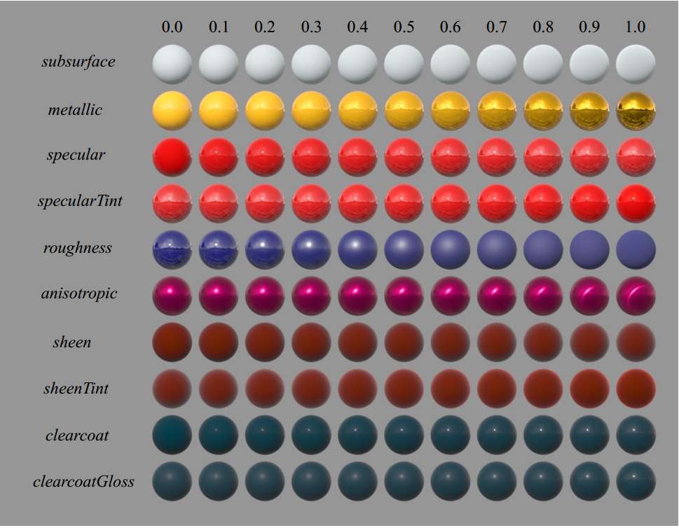

Figure 16: Examples of the effect of our BRDF parameters.(图16:我们的BRDF参数的效果示例。
) Each parameter is varied across the row from zero to one with the other parameters held constant.(每一个参数在行中从0到1变化，而其他参数保持不变。
)

## 5.3 Diffuse model details.(5.3扩散模型详细信息。 )

Some models include a diffuse Fresnel factor such as:(一些模型包括扩散菲涅耳因子，例如:
)



where *F*(*θ*) is the Fresnel factor for reflection.(其中f(θ)是反射的菲涅耳因子。
)

[Note: from the Fresnel law for refraction, and to preserve Helmholtz reciprocity, it’s necessary to account for refraction twice, once on the way in and once on the way out of the surface.([注:从菲涅耳折射定律出发，为了保持Helmholtz reciprocity，有必要考虑两次折射，一次在入射时，一次在出射时。
)].

As seen in the measured data observations, and based on our past studio experience, the Lambert diffuse model is often too dark on the edges, and adding a Fresnel factor to make it more physically plausible only makes it darker.(从测量的数据观察中可以看出，根据我们过去的工作室经验，Lambert diffuse model的边缘往往太暗，加上一个菲涅耳因子使它在物理上更合理，只会使它更暗。
)

Based on our observations, we developed a novel empirical model for diffuse retroreflection that transitions between a diffuse Fresnel shadow for smooth surfaces and an added highlight for rough surfaces.(基于我们的观察，我们建立了一个新的diffuse mode，该模型在光滑表面的漫反射菲涅耳阴影和粗糙表面的附加高光之间转换。
) A possible explanation for this effect may be that for rough surfaces light enters and exits the sides of micro-surface features causing an increase in refraction at grazing angles.( 对这种效应的一种可能的解释可能是，对于粗糙表面，光进入和离开微表面特征的侧面，导致在掠入射角处的折射增加。
) In any event, our artists like it, and it is similar to features we used to have in our ad-hoc model except that it is now more plausible and has a physical basis.(在任何情况下，我们的艺术家都喜欢它，它与我们过去在我们的ad-hoc模型中所具有的功能相似，除了它现在更合理了，并且有了物理基础。
)

In our model, we ignore the index of refraction for the diffuse Fresnel factor and assume no incident diffuse loss.(在我们的模型中，我们忽略了扩散菲涅耳因子的折射率，并且假设没有入射扩散损失。
) This allows us to directly specify the incident diffuse color.(这允许我们直接指定事件漫射颜色。
) We use the Schlick Fresnel approximation and modify the grazing retroreflection response to go to a specific value determined from roughness rather than zero.( 我们使用Schlick Fresnel近似，修改入射光线的反射强度，使其达到由粗糙度而不是零确定的特定值。
) Our base diffuse model is:(我们的基本扩散模型是:
)

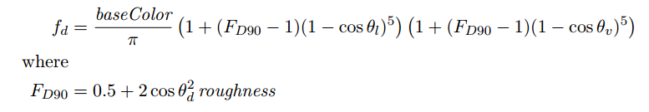

This produces a diffuse Fresnel shadow that reduces the incident diffuse reflectance by 0.5 at grazing angles for smooth surfaces and increases the response by up to 2.5 for rough surfaces.(这会产生漫反射的菲涅耳阴影，在入射角处将入射漫反射降低0.5，以获得光滑的表面，并使粗糙表面的强度增加2.5。)

This seems to provide a reasonable match to the MERL data and was also found to be artistically pleasing.(这似乎提供了一个合理的匹配MERL数据，也被发现是艺术上令人愉快的。
) BRDF image slices of our model for various roughness values are shown in Figure 17.( 不同粗糙度值的模型的BRDF图像切片如图17所示。
)



0.(0。
)0.(0。
)

0.(0。
)2.(2。
)

0.(0。
)4.(4。
)

0.(0。
)6.(6。
)

0.(0。
)8.(8。
)

1.(1。
)0.(0。
)

Figure 17: BRDF images slices of our model for various roughness values.

Our subsurface parameter blends between the base diffuse shape and one inspired by the HanrahanKrueger subsurface BRDF [11].(我们的次表面参数混合了基本的diffuseshape和受Hanrahankrueger的次表面BRDF [11]。
) This is useful for giving a subsurface appearance on distant objects and on objects where the average scattering path length is small; it’s not however a substitute for doing full subsurface transport as it won’t bleed light into the shadows or through the surface.( 这对于在远距离物体上和在平均散射路径长度小的物体上给出次表面外观是有用的； 然而，它并不能代替完全的地下运输，因为它不会将光线渗入阴影或穿过地表。
)

## 5.4 Specular D details.(5.4镜面D细节。 )

Of the popular models, GGX has the longest tail.(在流行的模型中，GGX的比较出众。
) This model is in fact equivalent to the TrowbridgeReitz (1975) [31] distribution favored by Blinn (1977) [6] for its ability to match experimental data.(该模型实际上等价于Trowbridgereitz(1975)[31]分布，Blinn(1977)[6]对实验数据的拟合能力较强。
) However, this distribution still does not have a long enough tail for many materials.(然而，对于许多材料，这种分布仍然没有足够长的尾巴。
)

Trowbridge and Reitz compared their distribution function along with several other distributions to measurements of ground glass.(Trowbridge和Reitz比较了他们的分布函数以及其他几种分布与ground glass的关系。
) One of the other distributions, from Berry (1923), has a very similar form but with an exponent of 1 instead of 2 resulting in an even longer tail.( Berry（1923）的另一个分布形式非常相似，但指数为1，而不是2，因此尾巴更长。
) This suggests a more general distribution with a variable exponent, introduced here and dubbed Generalized-Trowbridge-Reitz, or GTR:.(这意味着一个更一般的分布，它有一个变量指数，这里引入了广义-Trowbridge-Reitz或GTR:。
)

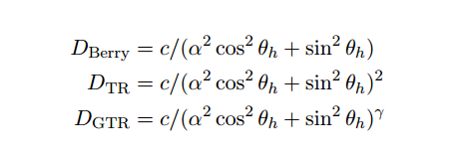

In each of these distributions, *c* is a scaling constant, and *α* is a roughness parameter with values between zero and one; *α* = 0 produces a perfectly smooth distribution (在这些分布中，c是一个标度常数，α是一个粗糙度参数，其值介于0和1之间； α=0产生一个完全光滑的分布
)(i.e. a delta function at *θh* = 0) （即 *θh* = 0时的δ函数） and *α* = 1 produces a perfectly rough or uniform distribution.( 而α=1产生一个完全粗糙或均匀的分布。
)

0.(0。
)

5.(5。
)

10.(10。
)

15.(15。
)

20.(20。
)

25.(25岁。
)

30.(30岁。
)

*θ.(θ。
)*

*d.(d。
)*

GTR.(大写。
)

*γ.(γ射线。
)*

=1.(=1。
)

GTR.(大写。
)

*γ.(γ射线。
)*

TR/GGX.(tr/ggx。
)

=2(.(=2（。
)

).(）。
)

GTR.(大写。
)

*γ.(γ射线。
)*

=10.(=10。
)

Beckmann.(贝克曼。
)

Figure 18: GTR distribution curves vs *θh* for various *γ* values:(图18:不同γ值下GTR分布曲线与 *θh* 的关系:
)

Preliminary fitting results suggest typical values of *γ* between 1 and 2.(初步拟合结果表明γ的典型值在1和2之间。
) Interestingly, GTR with  is equivalent to the Henyey-Greenstein phase function for *θ* = 2*θh*; ( 有趣的是，*θ* = 2*θh*时，GTR  等价于Henyey-Greenstein 函数；
) doubling of *θh* can be viewed.as extending the distribution from the hemisphere to the sphere.(可以看到*θh*加倍，从而扩展了从半球到球体的分布。
)

A plausible microfacet distribution must be normalized, and for efficient rendering it must also support importance sampling.(一个看似合理的微面分布必须被归一化，为了有效的渲染，它还必须支持重要性采样。
) Both require the distribution to be integrable over the hemisphere.(两者都要求分布在半球上是可积的。
) Fortunately, this function has a simple closed-form integral.(一个看似合理的微面分布必须被归一化，为了有效的渲染，它还必须支持重要性采样。 两者都要求分布在半球上是可积的。 幸运的是，这个函数有一个简单的闭式积分。
) Normalization and importance sampling functions as well as an efficient anisotropic form are derived in Appendix B.(在附录B中导出了归一化和重要抽样函数以及有效的各向异性形式。
)

For our BRDF, we chose to have two fixed specular lobes, both using the GTR model.(对于我们的BRDF，我们选择有两个固定的specular lobes，都使用GTR模型。
) The primary lobe uses *γ* = 2, and the secondary lobe uses *γ* = 1.( 第一个lobe 使用γ=2，第二个lobe 使用γ=1。
) The primary lobe represents the base material and may be anisotropic and/or metallic.(主lobe 表示基本材质，并且可以是各向异性的和/或金属的。
) The secondary lobe represents a clearcoat layer overtop the base material, and is thus always isotropic and non-metallic.(次lobe 代表在基材之上的透明涂层，因此总是各向同性的和非金属的。
)

For roughness, we found that mapping *α* = roughness2 results in a more perceptually linear change in the roughness.(对于粗糙度，我们发现映射*α* = roughness2导致粗糙度的更明显的线性变化。
) Without this remapping, very small and non-intuitive values were required for matching shiny materials.(如果没有这种重新映射，则需要非常小的非直观值来匹配有光泽的材料。
) Also, interpolating between a rough and smooth material would always produce a rough result.( 而且，在粗糙和光滑的材料之间进行插值总是会产生一个粗糙的结果。
) The resulting interpolation is shown in Figures 16 and 19.(结果插值如图16和19所示。
)

In place of an explicit index-of-refraction, or ior, our *specular* parameter determines the incident specular amount.(我们的*specular* 参数决定入射specular amount，而不是显式的折射率或ior。
) The normalized range of this parameter is remapped linearly to the incident specular range [0*.*0*,*0*.*08].(
此参数的标准化范围将线性重新映射到事件镜面反射范围[0.0,0.08]) This corresponds to ior values in the range [1*.*0*,*1*.*8], encompassing most common materials.(这对应于[1.0,1.8]范围内的ior值，包括最常见的材料。
) Notably, the middle of the parameter range corresponds to an ior of 1.5, a very typical value, and is also our default.(特别要注意的是，参数范围的中间对应于1.5的IOR，这是一个非常典型的值，也是我们的默认值。
) The *specular* parameter may be pushed beyond one to reach higher ior values but should be done with caution.(镜面参数可能会被推到1以上以达到更高的IOR值，但应谨慎执行。
) This mapping of the parameter has helped greatly in getting artists to make plausible materials given that real-world incident reflectance values are so unintuitively low.( 由于现实世界的入射反射率值如此之低，这个参数的映射极大地帮助了艺术家们制作合理的材料。
)

For our clearcoat layer, we use a fixed ior of 1.5, representative of polyurethane, and instead allow artists to scale the overall strength of the layer using the *clearcoat* parameter.(对于我们的透明涂层，我们使用1.5的固定IOR，representative of polyurethane，而是允许艺术家使用透明涂层参数缩放该层的整体强度。
) The normalized parameter range corresponds to an overall scale of [0*,*0*.*25].(归一化参数范围对应于[0,0.25]的整体尺度。
) This layer, even though it has a large visual impact, represents a relatively small amount of energy so we don’t subtract any energy from the base layer.(这一层，即使它有很大的视觉影响，代表一个相对较小的能量，所以我们不从基层减去任何能量。
) When set to zero, the clearcoat layer is effectively disabled and incurs no cost.(当设置为零时，透明涂层被有效地禁用，不产生任何成本。
)

## 5.5 Specular F details.(5.5镜面F细节。 )

For our purposes, the Schlick Fresnel approximation [28] is sufficient and substantially simpler than the full Fresnel equations; the error introduced by the approximation is significantly less than the error due to the other factors.(就我们的目的而言，Schlick Fresnel近似[28]是充分的，并且实质上比全Fresnel方程更简单； 近似所引入的误差明显小于其他因素所引起的误差。
)

*F*Schlick = *F*0 + (1 − *F*0)(1 − cos*θd*)5.(fSchlick=f0（1−f0）（1−cosθD)5。
)

The constant, *F*0, represents the specular reflectance at normal incidence and is achromatic for dielectrics and chromatic (常数f0表示垂直入射时的镜面反射率，对于电介质是消色差的，而色度)(i.e. tinted) for metals.( 用于金属。
) The actual value depends on the index of refraction.(，表示垂直入射时的镜面反射率，对于电介质是消色差的，对于金属是彩色的（即有色的）。 实际值取决于折射率。
) Note that specular reflection comes from microfacets and thus *F* depends on *θd*, the angle between the light vector and the micronormal (i.(e实际值取决于折射率。 请注意，镜面反射来自微面，因此f取决于θd，即光矢量与微法线之间的角度（即，
)e.(e。
) the half-vector), not the angle of incidence with the surface normal.(，光矢量与微法线（即半矢量）之间的夹角，而不是与表面法线的入射角。
)

The Fresnel function can be seen as interpolating (non-linearly) between the incident specular reflectance and unity at grazing angles.(菲涅耳函数可以看作是在入射镜面反射率和掠入射角的单位之间的插值（非线性）。
) Note that the response becomes achromatic at grazing incidence as all light is reflected.(注意，当所有的光都被反射时，响应在掠入射时变得消色差。
)

## 5.6 Specular G details.(5.6镜面G细节。 )

For our model, we took a hybrid approach.(对于我们的模型，我们采用了混合方法。
) Given that the Smith shadowing factor is available for the primary specular, we use the G derived for GGX by Walter but remap the roughness to reduce the extreme gain for shiny surfaces.(假设Smith阴影因子可用于主镜面，我们使用Walter为GGX导出的g，但重新映射粗糙度以降低光亮表面的极端增益。
) Specifically, we linearly scale the original roughness from the [0*,*1] range to a reduced range, [0*.(r我们的模型采用了混合方法。 假设Smith阴影因子可用于主镜面，我们使用Walter为GGX导出的g，但重新映射粗糙度以降低光亮表面的极端增益。 具体地，我们将原始粗糙度从[0，1]范围线性缩放到缩小的范围[0。
)*5*,*1], for the purposes of computing G.(。5，1]，以计算G。
) Note: we do this before squaring the roughness as described earlier, so the final *αg* value is (0*.(1]，用于计算G。注意:我们在如上所述平方粗糙度之前这样做，因此最终的αg值是（0。
)*5 + roughness*/*2)2.(。5粗糙度/2）2。
)

This remapping was based on comparisons with measured data as well as artist feedback that the specular was just “too hot” for small roughness values.(这种重新映射是基于与测量数据的比较以及艺术家的反馈，即镜面对于小的粗糙度值来说“太热了”。
) This gives us a G function that varies with roughness, is at least partially physically-based, and seems plausible.(这种重新映射是基于与测量数据的比较以及艺术家的反馈，即镜面对于小的粗糙度值来说“太热了”。 这给出了一个G函数，它随粗糙度而变化，至少部分基于物理因素，而且似乎是合理的。
) For our clearcoat specular we don’t have a Smith G derivation and simply use the GGX G with a fixed roughness of 0.(对于透明涂层镜面，我们没有Smith G的推导，只需使用具有固定粗糙度0的GGX G。
)25, found to be plausible and artistically pleasing.(25，被认为是可信的和艺术上令人愉快的。
)

## 5.7 Layering vs parameter blending.(5.7分层与参数混合。 )

Once we settled on our new model we needed to decide how to integrate it into our shaders.(一旦我们确定了我们的新模型，我们就需要决定如何将它集成到我们的着色器中。
) The first question was which parameters needed to be spatially varying, and the answer was all of them; if an artist simply wants to put two different materials on a surface and mask between them, then they will need to interpolate between all of the parameters.(来决定如何将它集成到我们的着色器中。 第一个问题是哪些参数需要在空间上变化，答案是所有这些参数； 如果一个艺术家只是想在一个表面上放置两种不同的材料，然后在它们之间进行掩模，那么他们将需要在所有参数之间进行插值。
) Also, the mask will be filtered and at at the blurred edge of the mask the material response must remain plausible.(此外，掩模将被过滤，并且在掩模的模糊边缘处，材料响应必须保持合理。
)

One benefit of our design principles in making all the parameters normalized and at least perceptually linear is that materials generally interpolate in a very intuitive way.(我们的设计原则在使所有参数归一化和至少感知上线性化方面的一个好处是，材料通常以非常直观的方式进行插值。
) An example of this is shown in Figure 19.(这方面的一个示例如图19所示。
)

Once we realized we could interpolate robustly, we wondered whether we could achieve all spatial variation through masks.(一旦我们意识到我们可以鲁棒地插值，我们就想知道我们是否可以通过掩码实现所有的空间变化。
) The idea is that the artist would choose a list of material presets and.(这个想法是艺术家会选择一系列的材料预设和。
)

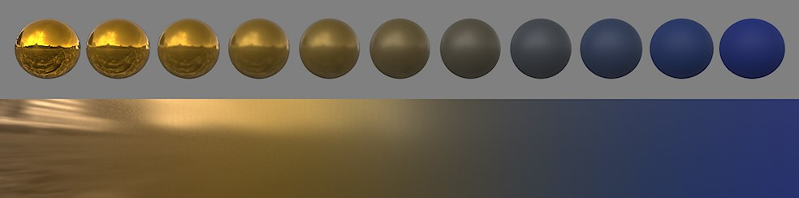

Figure 19: Interpolating between two very different materials, shiny metallic gold and blue rubber, using our model.(图19:使用我们的模型在两种非常不同的材料（闪亮的金属金和蓝色橡胶）之间进行插值。
)

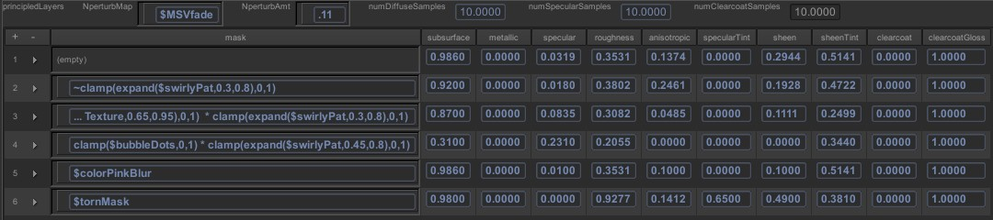

Figure 20: A screenshot of our shader editor showing material layers.(图20:显示材质层的着色器编辑器的屏幕截图。
) The variables in the mask expressions refer to spatially varying shader modules, typically texture maps.(掩模表达式中的变量指的是空间变化的着色器模块，通常是纹理映射。
)

then simply blend between them using texture masks.(然后使用纹理掩模简单地在它们之间混合。
) This turned out to be phenomenally successful, greatly simplifying workflow, improving material consistency, and making our shader evaluation extremely efficient.(然后使用纹理掩模简单地在它们之间混合。 这被证明是非常成功的，极大地简化了工作流程，提高了材料的一致性，并使我们的着色器评估非常高效。
) Our shader UI is shown in Figure 20.(我们的着色器UI如图20所示。
)

# 6 Production experience on Wreck-It Ralph.(6。拉尔夫号残骸的生产经验。 )

We deployed our “Principled Layers” shader on Wreck-It Ralph and used it on virtually every material except for hair (which still uses the model developed for Tangled).(我们把我们的“原则性层”着色器部署在Ralph的残骸上，除了头发（它仍然使用为缠结而开发的模型）之外，几乎所有的材质都使用了它。
) A variety of materials can be seen in Figure 21.(在图21中可以看到各种材料。
) Note that a separate normal was often used for the specular components to produce the sparkle effect seen here on the ground, carpet, and other granulated materials.(PLED层“着色器上的残骸拉尔夫，并使用它几乎所有的材料，除了头发（它仍然使用模型开发的纠缠）。 在图21中可以看到各种材料。 请注意，镜面组件通常使用单独的法线，以在地面、地毯和其他颗粒状材料上产生闪光效果。
)

In conjunction with our new material model, we also introduced new sampled area lights and IBLs which are critical for making plausible materials look good; if you make a plausible shiny material and light it with a point light your highlight will be a tiny dot, and allowing lighters to adjust material properties, such as increasing roughness to fake an area light response, destroys the entire physically based shading paradigm.(结合我们的新材料模型，我们还引入了新的采样区域灯和IBLS，它们对于使貌似合理的材料看起来更好至关重要； 如果你制作了一种看似合理的有光泽的材料，并用点光源照明，你的亮点将是一个小点，并且允许打火机调整材料属性，例如增加粗糙度以伪造一个区域光响应，这会破坏整个基于物理的着色范例。
) The good news is that the lighters really like area lights and IBLs for their controllability and also appreciate having a consistent material response.(好消息是，打火机真的喜欢区域灯和IBLS的可控性，并赞赏有一个一致的物质反应。
) It’s also worth noting that the new material model was both a motivator and an enabler in the switch to sampled lights in that with our previous ad-hoc shading model it would have been to expensive for each reflectance module to perform its own sampled light integration.(基于阴影的范例。 好消息是，打火机真的喜欢区域灯和IBLS的可控性，并赞赏有一个一致的物质反应。 同样值得一提的是，新的材质模型既是切换到采样光源的激励因素，也是一个使能因素，因为在我们以前的ad-hoc阴影模型中，每个反射模块执行自己的采样光源集成的成本都很高。
)

Based on the success on Wreck-It Ralph, our next shows are already using or planning to use our new shading model without modification.(基于Ralph在Reck-it上的成功，我们的下一个节目已经在使用或计划使用我们的新着色模型而不需要修改。
)

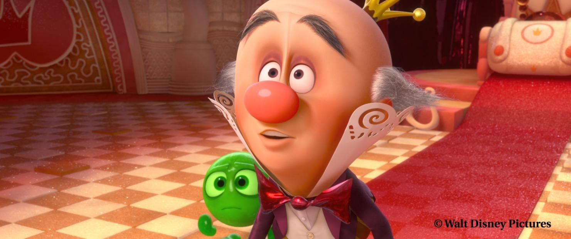

Figure 21: Production still from Wreck-It Ralph.(图21:Ralph仍然从残骸中生产。
)

## 6.1 Look development.(6.1外观开发。 )

One benefit of having a single BRDF on everything is that it simplified the development of our interactive material editor.(拥有一个BRDF的好处之一是它简化了交互式材料编辑器的开发。
) Our “Material Designer” renders out a g-buffer containing normals, object IDs, and material layer masks.(我们的“材料设计器”渲染出一个包含法线、对象ID和材料层掩码的G缓冲区。
) Using these channels, it quickly performs image-based relighting while allowing all BRDF parameters to be interactively edited.(拥有一个BRDF的好处之一是它简化了交互式材料编辑器的开发。 我们的“材料设计器”渲染出一个包含法线、对象ID和材料层掩码的G缓冲区。 使用这些通道，它可以快速执行基于图像的重新排列，同时允许交互式编辑所有BRDF参数。
) Artists can rotate IBLs in real-time and see the full effect of all parameters and layers in full context on production models.(艺术家可以实时旋转IBLS，并在完整的上下文中看到所有参数和层对生产模型的全部影响。
)

Another benefit of the unified model is that it facilities a very simple material library consisting of a set of presets saved out from the Material Designer.(统一模型的另一个好处是，它提供了一个非常简单的材料库，该库由一组从材料设计器保存下来的预设组成。
) A material can be picked from the library and added to a shader as an additional layer and then blended in with a mask.(可以从库中选取材料，并将其作为附加层添加到着色器中，然后与掩模混合。
) Layers can thus be quickly built up like a Photoshop layer stack.(IED模型是指它提供了一个非常简单的材料库，该库由一组从材料设计器中保存下来的预设组成。 可以从库中选取材料，并将其作为附加层添加到着色器中，然后与掩模混合。 因此，可以像Photoshop层堆栈一样快速构建层。
)

To judge a material fully, it’s critical to light it from all angles.(要充分判断一种材料，关键是要从各个角度对其进行照明。
) As part of the switch to our new material model we started proofing all elements using a variety of IBLs and all turntables include both element and lighting rotations.(要充分判断一种材料，关键是要从各个角度对其进行照明。 作为切换到新材料模型的一部分，我们开始使用各种IBL对所有元素进行校对，所有转盘包括元素旋转和照明旋转。
)

The end result of our new shader system is greatly improved productivity in look development, much shorter training time for new artists, and more consistently high-quality results.(我们的新着色系统的最终结果是大大提高了外观开发的生产力，大大缩短了新艺术家的培训时间，并获得了更加一致的高质量的结果。
) Notably, most of our look development artists were able to roll off of the show early due to the lack of the need for material re-do’s in lighting.(我们的新着色系统的最终结果是大大提高了外观开发的生产力，大大缩短了新艺术家的培训时间，并获得了更加一致的高质量的结果。 值得一提的是，我们大多数的外观发展艺术家都能够提前推出的节目，因为缺乏材料重做的照明。
) This was unprecedented.(这是前所未有的。
)

## 6.2 Lighting.(6.2照明。 )

As mentioned earlier, a different approach to lighting was needed to work with the new material model.(如前所述，需要一种不同的照明方法来处理新的材料模型。
) This required a large learning curve.(这需要很大的学习曲线。
) It was also a challenge adding back in artistic controls to lighting without overly compromising the physically-based model.(这也是一个挑战，在不过度损害基于物理的模型的前提下，增加对照明的艺术控制。
)

One of the biggest changes in lighting was the move to using IBLs as local fill lights.(照明领域最大的变化之一是将IBLS用作本地填充灯。
) Most IBLs are used with light linking to specific elements in the shot and many have distance cutoffs.(照明领域最大的变化之一是将IBLS用作本地填充灯。 大多数IBL都与镜头中特定元素的光链接一起使用，许多IBL都有距离截止点。
) These were a big improvement over previous environment maps which largely ignored the material characteristics.(这些都是一个很大的改进，以前的环境地图，在很大程度上忽视了材料的特点。
) Area lights were also a well received addition.(STIBLS用于与镜头中的特定元素进行光连接，许多都有距离截止点。 这些都是一个很大的改进，以前的环境地图，在很大程度上忽视了材料的特点。 区域照明灯也是一个广受欢迎的补充。
)

One of the biggest challenges for lighters initially was working with realistic light intensity values and falloff.(打火机最初面临的最大挑战之一是如何处理逼真的光强值和衰落。
) We eventually developed a non-physical falloff control that works by making the light source virtually more distant while automatically adjusting the intensity to achieve the desired exposure at a given distance, however controlling light intensity and falloff remins a challenge for lighters.(打火机最初面临的最大挑战之一是如何处理逼真的光强值和衰落。 我们最终开发了一种非物理衰减控制，它通过使光源实际上更远，同时自动调整强度以在给定距离处实现期望的曝光来工作，然而，控制光强度和衰减提醒打火机的一个挑战。
)

Another challenge for lighting is the fact that specular highlights now require some sort of tone mapping.(照明的另一个挑战是，镜面高光现在需要某种色调映射。
) Highlights on shiny materials can reach into the hundreds and simply clipping the values appears harsh, introduces banding as each color channel clips at a different location, and forces the core to always go to white.(闪亮材料上的高光可以达到数百个，简单的剪辑值看起来很刺眼，当每个颜色通道在不同的位置剪辑时会引入分带，并迫使核心始终变为白色。
) We developed a new global tone mapping operator that preserves color values for most of the display range and rolls off the top end while preserving color and contrast.(地图。 闪亮材料上的高光可以达到数百个，简单的剪辑值看起来很刺眼，当每个颜色通道在不同的位置剪辑时会引入分带，并迫使核心始终变为白色。 我们开发了一种新的全局色调映射运算符，它在大部分显示范围内保持颜色值，并在保持颜色和对比度的同时从顶端滚动。
) We have a default setting that works reasonably in most cases but adjust the final values per shot during color grading.(一个映射运算符，它保留大部分显示范围的颜色值，并在保留颜色和对比度的同时滚动到顶端。 我们有一个默认设置，可以在大多数情况下合理地工作，但在颜色分级过程中调整每个镜头的最终值。
)

In the end though, the materials behave predictably which is a huge benefit to lighters and gives them a starting place that is physically plausible.(但最终，这些材料的行为是可预测的，这对打火机是一个巨大的好处，并给他们一个物理上看似可行的起点。
)

## 6.3 Future work.(6.3今后的工作。 )

One of the biggest issues currently is the lack of a intuitively controllable subsurface model.(目前最大的问题之一是缺乏直观可控的地下模型。
) A key aspect of this is BRDF integration.(这方面的一个关键方面是BRDF集成。
) Ideally there would be a match between the BRDF and the subsurface model such that the BRDF model could be used for distant objects, achieving equivalent results.(理想情况下，BRDF和次表层模型之间应该匹配，这样BRDF模型就可以用于远距离物体，从而获得等同的结果。
) Also, an artist should be able to increase the mean-free path from zero to add a subsurface effect to an object without changing the overall exposure – just the shape of the diffuse should change (and light should bleed into the shadows if diffusion is enable).(表面模型 这方面的一个关键方面是BRDF集成。 理想情况下，BRDF和次表层模型之间应该匹配，这样BRDF模型就可以用于远距离物体，从而获得等同的结果。 此外，艺术家应该能够从零开始增加无均值路径，从而在不改变整体曝光的情况下增加物体的次表面效果——只是漫射的形状应该改变（如果允许漫射，光线应该渗入阴影中）。
)

We would like to go further with modeling cloth reflectance.(我们想更进一步与模型布反射率。
) We know we can add a special shader to render cloth using captured reflectance data for particularly complicated cloth models, but we would like to investigate direct modeling of a wider range of cloth materials.(我们知道我们可以添加一个特殊的着色器来渲染布料使用捕获的反射率数据为特别复杂的布料模型但我们想要研究更广泛的布料直接建模
) We don’t currently have a show that is driving this need though.(织物反射率模型 我们知道我们可以添加一个特殊的着色器来渲染布料使用捕获的反射率数据为特别复杂的布料模型但我们想要研究更广泛的布料直接建模 我们目前还没有一个节目是推动这一需求的。
)

We’ve also received requests to add iridescence to our model.(我们还收到了向我们的模型添加彩虹色的请求。
) This should be as simple as adding specular color variation as previously discussed.(这应该像前面讨论的那样简单，添加镜面颜色变化。
)

## Acknowledgments.(致谢。 )

First and foremost, I would like to thank Chuck Tappan who co-developed our new material parameterization and championed our new look development pipeline.(首先，我要感谢Chuck Tappan，他共同开发了我们的新材料参数化和支持我们的新外观开发管道。
) I would also like to thank Christian Eisenacher for his work on the Material Designer, and Greg Nichols and Jared Johnson for their work on the Disney BRDF Viewer.(ChuckTappan，他共同开发了我们的新材料参数化，并支持我们的新外观开发管道。 我还要感谢克里斯蒂安·艾森纳赫在材料设计师方面所做的工作，以及格雷格·尼科尔斯和杰瑞德·约翰逊在迪斯尼BRDF观众方面所做的工作。
) And I would like to thank the Ralph Look and Lighting crew for their patience and support.(我要感谢拉尔夫外观和照明团队的耐心和支持。
) Finally I would like to thank Stephen Hill, Naty Hoffman, and Pete Shirley for their valuable input, and Stephen in particular for suggesting the projected half-vector formulation in equation (14) in Appendix B.(E迪士尼BRDF查看器。 我要感谢拉尔夫外观和照明团队的耐心和支持。 最后，我要感谢Stephen Hill，Naty Hoffman和Pete Shirley的宝贵意见，特别是Stephen在附录B等式（14）中提出的投影半矢量公式。
)

# References.(推荐信。 )

1. Michael Ashikhmin.(迈克尔·阿希克明。
   ) Distribution-based brdfs.(基于分布的BRDF。
   ) Technical report, 2007.(2007年技术报告。
   )
2. Michael Ashikhmin, Simon Prem˘oze, and Peter Shirley.(Michael Ashikhmin，Simon Prem Oze和Peter Shirley
   ) A Microfacet-Based BRDF generator.(一种基于微刻面的BRDF发生器
   ) In Sheila Hoffmeyer, editor, *Proceedings of the Computer Graphics Conference 2000 (SIGGRAPH00)*, pages 65–74, New York, July 23–28 2000.(Michael Ashikhmin，Simon Prem Oze和Peter Shirley 一种基于微刻面的BRDF发生器 在希拉霍夫迈尔，编辑，程序的计算机图形学会议2000年(SIGGRAPH00)，第65-74页，纽约，2000年7月23日-28日。
   ) ACMPress.(请按。
   )
3. Michael Ashikhmin and Peter Shirley.(Michael Ashikhmin和Peter Shirley
   ) An anisotropic Phong BRDF model.(各向异性Phong BRDF模型
   ) *Journal of Graphics Tools: JGT*, 5(2):25–32, 2000.(彼得·雪莉。 各向异性Phong BRDF模型 《图形工具杂志》:JGT，5（2）:25-32，2000。
   )
4. M.(M。
   ) M.(M。
   ) Bagher, C.(Bagher，C。
   ) Soler, and N.(Soler和N。
   ) Holzschuch.(霍尔兹舒克。
   ) Accurate fitting of measured reflectances using a shifted gamma micro-facet distribution.(使用偏移的伽马微面分布精确拟合测量的反射率。
   ) *Computer Graphics Forum*, 31(4):1509–1518, 2012.(M。M。Bagher，C。Soler和N。Holzschuch。 使用偏移的伽马微面分布精确拟合测量的反射率。 计算机图形学论坛，31（4）:1509-1518，2012。
   )
5. P.(P。
   ) Beckmann and A.(Beckmann和A。
   ) Spizzichino.(辣椒。
   ) *The scattering of electromagnetic waves from rough surfaces*.(P。Beckmann和A。Spizzichino。 电磁波从粗糙表面的散射。
   ) MacMillan, 1963.(麦克米伦，1963年。
   )
6. James F.(詹姆斯F。
   ) Blinn.(布林。
   ) Models of light reflection for computer synthesized pictures.(计算机合成图像的光反射模型
   ) volume 11, pages 192–198, July 1977.(第11卷，第192-198页，1977年7月。
   )
7. R.(R。
   ) L.(L。
   ) Cook and K.(库克和K。
   ) E.(E。
   ) Torrance.(托伦斯。
   ) A reflectance model for computer graphics.(计算机图形学的反射率模型
   ) *Computer Graphics*, 15(3):307–316, 1981.(库克和托伦斯。 计算机图形学的反射率模型 计算机图形学，15（3）:307-316，1981。
   )
8. Arne Du¨r.(阿恩·杜尔。
   ) An improved normalization for the Ward reflectance model.(Ward反射率模型的改进归一化
   ) *Journal of graphics, gpu, and game tools*, 11(1):51–59, 2006.(阿恩·杜尔。 Ward反射率模型的改进归一化 图形，图形处理器和游戏工具杂志，11（1）:51-59，2006。
   )
9. Dave Edwards, Solomon Boulos, Jared Johnson, Peter Shirley, Michael Ashikhmin, Michael Stark, and Chris Wyman.(大卫爱德华兹，所罗门布洛斯，杰瑞德约翰逊，彼得雪莉，迈克尔阿希克明，迈克尔斯塔克和克里斯怀曼。
   ) The halfway vector disk for brdf modeling.(BRDF建模的中间矢量盘
   ) *ACM Trans.(、所罗门·布洛斯、贾里德·约翰逊、彼得·雪莉、迈克尔·阿希克明、迈克尔·斯塔克和克里斯·怀曼。 BRDF建模的中间矢量盘 ACM传输
   ) Graph.(图表。
   )*, 25(1):1–18, January 2006.(ACM传输 图25（1）:2006年1月1-18日。
   )
10. David Geisler-Moroder and Arne Du¨r.(大卫·盖斯勒-莫罗德和阿恩·杜埃尔。
    ) A new Ward BRDF model with bounded albedo.(大卫·盖斯勒-莫罗德和阿恩·杜埃尔。 一个新的有界反照率的Ward BRDF模型
    ) *Comput.(埃德·阿贝多。 电脑。
    ) Graph.(图表。
    ) Forum*, 29(4):1391–1398, 2010.(电脑。 图表。 论坛，29（4）:1391-1398，2010。
    )
11. Pat Hanrahan and Wolfgang Krueger.(帕特·汉拉汉和沃尔夫冈·克鲁格。
    ) Reflection from layered surfaces due to subsurface scattering.(由于次表面散射而从分层表面反射。
    ) In *Proceedings of the 20th annual conference on Computer graphics and interactive techniques*, SIGGRAPH ’93, pages 165–174, New York, NY, USA, 1993.(帕特·汉拉汉和沃尔夫冈·克鲁格。 由于次表面散射而从分层表面反射。 《计算机图形学与交互技术第20届年会论文集》，Siggraph'93，第165-174页，纽约，纽约，美国，1993年。
    ) ACM.(ACM。
    )
12. Xiao D.(小D。
    ) He, Kenneth E.(肯尼思·赫
    ) Torrance, Francois X.(弗朗索瓦·托伦斯
    ) Sillion, and Donald P.(Sillion和Donald P。
    ) Greenberg.(格林伯格。
    ) A Comprehensive Physical Model for Light Reflection.(光反射的综合物理模型
    ) In *Computer Graphics (ACM SIGGRAPH ’91 Proceedings)*, volume 25, pages 175–186, July 1991.(作者声明:by Greener；by Greener；James D。He；Kenneth E。Torrance；Francois X。Sillion； 光反射的综合物理模型 计算机制图学（ACM Siggraph'91会议录），第25卷，第175-186页，1991年7月。
    )
13. Csaba Kelemen, Laszlo Szirmay-Kalos, and L´aszl´o Szirmay-kalos.(Csaba Kelemen，Laszlo Szirmay-Kalos和L'aszl'o Szirmay-Kalos。
    ) A microfacet based coupled specular-matte brdf model with importance sampling.(一种基于微平面的重要抽样耦合镜面-哑光BRDF模型
    ) Eurographics Short Presentations, 2001.(Eurographics简短介绍，2001年。
    )
14. Murat Kurt, L´aszl´o Szirmay-Kalos, and Jaroslav Kˇriv´anek.(Murat Kurt、L'aszl'o Szirmay-Kalos和Jaroslav K Riv'anek。
    ) An anisotropic brdf model for fitting and monte carlo rendering.(各向异性BRDF模型的拟合与蒙特卡罗绘制
    ) *SIGGRAPH Comput.(阿内克。 各向异性BRDF模型的拟合与蒙特卡罗绘制 Siggraph计算机
    ) Graph.(图表。
    )*, 44(1):3:1–3:15, February 2010.(Siggraph计算机 图，44（1）:3:1-3:15，2010年2月。
    )
15. Eric P.(埃里克·P。
    ) Lafortune, Sing-Choong Foo, Kenneth E.(Lafortune，Sing-Choong Foo，Kenneth E。
    ) Torrance, and Donald P.(Torrance和Donald P。
    ) Greenberg.(格林伯格。
    ) Nonlinear approximation of reflectance functions.(Eric P。LaFortune，Sing-Choong Foo，Kenneth E。Torrance和Donald P。Greenberg。 反射函数的非线性逼近
    ) In *Computer Graphics (ACM SIGGRAPH ’97 Proceedings)*, volume 31, pages 117–126, 1997.(S。in Computer Graphics（ACM Siggraph'97Proceedings），第31卷，第117-126页，1997年。
    )
16. Robert R.(罗伯特·R。
    ) Lewis.(刘易斯。
    ) Making Shaders More Physically Plausible.(使着色器在物理上更合理。
    ) In *Fourth Eurographics Workshop on Rendering*, number Series EG 93 RW, pages 47–62, Paris, France, June 1993.(罗伯特·R·刘易斯。 使着色器在物理上更合理。 在第四次欧洲图形绘制研讨会上，编号系列EG93RW，第47-62页，法国巴黎，1993年6月。
    )
17. Joakim L¨ow, Joel Kronander, Anders Ynnerman, and Jonas Unger.(Joakim Léow、Joel Kronander、Anders Yynerman和Jonas Unger。
    ) Brdf models for accurate and efficient rendering of glossy surfaces.(BRDF模型用于精确有效地绘制光滑表面。
    ) *ACM Trans.(Joakim Léow、Joel Kronander、Anders Yynerman和Jonas Unger。 BRDF模型用于精确有效地绘制光滑表面。 ACM传输
    ) Graph.(图表。
    )*, 31(1):9:1–9:14, February 2012.(ACM传输 图，31（1）:9:1-9:14，2012年2月。
    )
18. Wojciech Matusik, Hanspeter Pfister, Matt Brand, and Leonard McMillan.(Wojciech Matusik，Hanspeter Pfister，Matt Brand和Leonard McMillan。
    ) A data-driven reflectance model.(Wojciech Matusik，Hanspeter Pfister，Matt Brand和Leonard McMillan。 数据驱动的反射率模型
    ) *ACM Transactions on Graphics*, 22(3):759–769, July 2003.(ATA驱动的反射率模型 ACM图形交易，22（3）:759-769，2003年7月。
    )
19. L´aszl´o Neumann, Attila Neumann, and L´aszl´o Szirmay-Kalos.(L'aszl'o Neumann，Attila Neumann和L'aszl'o Szirmay-Kalos。
    ) Compact metallic reflectance models.(紧凑型金属反射率模型
    ) *Computer Graphics Forum*, 18(3):161–172, September 1999.(L'aszl'o Neumann，Attila Neumann和L'aszl'o Szirmay-Kalos。 紧凑型金属反射率模型 计算机图形学论坛，18（3）:161-172，1999年9月。
    ) ISSN 1067-7055.(ISSN1067-7055。
    )
20. L´aszl´o Neumann, Attila Neumann, and L´aszl´o Szirmay-Kalos.(L'aszl'o Neumann，Attila Neumann和L'aszl'o Szirmay-Kalos。
    ) Reflectance models by pumping up the albedo function.(通过泵浦反照率函数建立反射率模型。
    ) In *Machine Graphics and Vision*, pages 3–18, 1999.(L'aszl'o Neumann，Attila Neumann和L'aszl'o Szirmay-Kalos。 通过泵浦反照率函数建立反射率模型。 机器制图和视觉，第3-18页，1999年。
    )
21. Addy Ngan, Fr´edo Durand, and Wojciech Matusik.(Addy Ngan，Fr'edo Durand，和Wojciech Matusik
    ) Experimental analysis of BRDF models.(BRDF模型的实验分析
    ) In Kavita Bala and Philip Dutr´e, editors, *Eurographics Symposium on Rendering*, pages 117–126, Konstanz, Germany, 2005.(Addy Ngan，Fr'edo Durand，和Wojciech Matusik BRDF模型的实验分析 在Kavita Bala和Philip Dutr'e，编辑，Eurographics Symposium on Rendering，pages117-126，Konstanz，Germany，2005。
    ) Eurographics Association.(欧洲制图协会
    )
22. Ko Nishino and Stephen Lombardi.(西野子和袁绍。
    ) Directional statistics-based reflectance model for isotropic bidirectional reflectance distribution functions.(西野子和袁绍。 基于方向统计的各向同性双向反射分布函数的反射模型
    ) *J.(电抗分布函数 J。
    ) Opt.(选择
    ) Soc.(SOC。
    ) Am.(是啊。
    ) A*, 28(1):8–18, Jan 2011.(J。选择。 SOC。 2011年1月8日至18日，上午，第28（1）段。
    )
23. Michael Oren and Shree K.(Michael Oren和Shree K。
    ) Nayar.(纳亚尔。
    ) Generalization of lambert’s reflectance model.(Lambert反射率模型的推广
    ) In *SIGGRAPH*, pages 239–246.(Michael Oren和Shree K。Nayar。 Lambert反射率模型的推广 在Siggraph，第239-246页。
    ) ACM, 1994.(ACM，1994年。
    )
24. Romain Pacanowski, Oliver Salazar Celis, Christophe Schlick, Xavier Granier, Pierre Poulin, and Annie Cuyt.(罗曼·帕卡诺夫斯基、奥利弗·萨拉查·塞利斯、克里斯托弗·施利克、泽维尔·格拉尼耶、皮埃尔·波林和安妮·库伊特。
    ) Rational brdf.(理性BRDF。
    ) *IEEE Transactions on Visualization and Computer Graphics*, 99(PrePrints), 2012.(我是格拉尼耶，皮埃尔·波林，安妮·库伊特。 理性BRDF。 IEEE关于可视化和计算机图形学的交易，99（预印本），2012年。
    )
25. Bui-T.(比-特。
    ) Phong.(凤。
    ) Illumination for computer generated pictures.(计算机生成图片的照明。
    ) *Communications of the ACM*, 18(6):311–317, June 1975.(比-特。 凤。 计算机生成图片的照明。 ACM通信，18（6）:311-317，1975年6月。
    )
26. Fabiano Romeiro, Yuriy Vasilyev, and Todd Zickler.(法比亚诺·罗梅罗，尤里·瓦西里耶夫，托德·齐克勒。
    ) Passive reflectometry.(被动反射法
    ) In *Proceedings of the 10th European Conference on Computer Vision: Part IV*, ECCV ’08, pages 859–872, Berlin, Heidelberg, 2008.(法比亚诺·罗梅罗，尤里·瓦西里耶夫，托德·齐克勒。 被动反射法 《第十届欧洲计算机视觉会议论文集:第四部分》，ECCV'08，第859-872页，柏林，海德堡，2008年。
    ) Springer-Verlag.(斯普林格-弗拉格。
    )
27. Iman Sadeghi, Heather Pritchett, Henrik Wann Jensen, and Rasmus Tamstorf.(Iman Sadeghi、Heather Pritchett、Henrik Wann Jensen和Rasmus Tamstorf。
    ) An artist friendly hair shading system.(一个艺术家友好的头发遮光系统。
    ) In *ACM SIGGRAPH 2010 papers*, SIGGRAPH ’10, pages 56:1–56:10, New York, NY, USA, 2010.(K Wann Jensen和Rasmus Tamstorf 一个艺术家友好的头发遮光系统。 ACM Siggraph2010年论文，Siggraph'10，pages56:1-56:10，New York，NY，USA，2010。
    ) ACM.(ACM。
    )
28. Christophe Schlick.(克里斯托弗·施利克。
    ) An Inexpensive BRDF Model for Physically-Based Rendering.(一种廉价的基于物理绘制的BRDF模型
    ) *Computer Graphics Forum*, 13(3):233–246, 1994.(克里斯托弗·施利克。 一种廉价的基于物理绘制的BRDF模型 计算机图形学论坛，13（3）:233-246，1994。
    )
29. B.(B。
    ) Smith.(史密斯。
    ) Geometrical shadowing of a random rough surface.(随机粗糙表面的几何阴影。
    ) *IEEE Trans.(B。史密斯。 随机粗糙表面的几何阴影。 IEEE Trans。
    ) Ant.(蚂蚁。
    ) and Propagation*, AP-15(5):668–671, September 1967.(IEEE Trans。 蚂蚁。 和繁殖，AP-15（5）:668-671，1967年9月。
    )
30. K.(K。
    ) Torrance and E.(Torrance和E。
    ) Sparrow.(麻雀。
    ) Theory for off-specular reflection from roughened surfaces.(粗糙表面的非镜面反射理论
    ) *J.(K。Torrance和E。Sparrow。 粗糙表面的非镜面反射理论 J。
    ) Optical Soc.(光学系统芯片
    ) America*, 57:1105–1114, 1967.(J。光学SOC。 美国，57:1105-1114，1967。
    )
31. S.(S。
    ) Trowbridge and K.(Trowbridge和K。
    ) P.(P。
    ) Reitz.(莱兹。
    ) Average irregularity representation of a rough ray reflection.(粗糙射线反射的平均不规则性表示。
    ) *Journal of the Optical Society of America*, 65(5):531–536, May 1975.(S。Trowbridge和K。P。Reitz。 粗糙射线反射的平均不规则性表示。 美国光学学会杂志，65（5）:531-536，1975年5月。
    )
32. Bruce Walter.(布鲁斯·沃尔特。
    ) Notes on the Ward BRDF.(关于沃德BRDF的说明。
    ) Technical Report PCG-05-06, Cornell Program of Computer Graphics, 2005.(布鲁斯·沃尔特。 关于沃德BRDF的说明。 技术报告PCG-05-06，康奈尔大学计算机图形学程序，2005年。
    )
33. Bruce Walter, Stephen R.(史蒂芬·布鲁斯·沃尔特
    ) Marschner, Hongsong Li, and Kenneth E.(Marschner，Hongsong Li和Kenneth E。
    ) Torrance.(托伦斯。
    ) Microfacet models for refraction through rough surfaces.(粗糙表面折射的微面模型
    ) In *Proceedings of the Eurographics Symposium on Rendering*, 2007.(布鲁斯·沃尔特、斯蒂芬·R·马施纳、李宏松和肯尼思·E·托伦斯。 粗糙表面折射的微面模型 2007年欧洲图形绘制研讨会论文集。
    )
34. Gregory J.(格雷戈里J。
    ) Ward.(沃德。
    ) Measuring and modeling anisotropic reflection.(各向异性反射的测量和建模
    ) In Edwin E.(在Edwin E。
    ) Catmull, editor, *Computer Graphics (SIGGRAPH ’92 Proceedings)*, volume 26, pages 265–272, July 1992.(格雷戈里·J·沃德。 各向异性反射的测量和建模 在Edwin E.Catmull，编辑，计算机制图（1992年会议录），第26卷，第265-272页，1992年7月。
    )
35. L.(L。
    ) B.(B。
    ) Wolff, S.(Wolff，S。
    ) K.(K。
    ) Nayar, and M.(Nayar和M。
    ) Oren.(奥伦。
    ) Improved diffuse reflection models for computer vision.(L。B。Wolff，S。K。Nayar和M。Oren。 改进的计算机视觉漫反射模型
    )

*International Journal of Computer Vision*, 30(1):55–71, October 1998.(《国际计算机视觉杂志》，30（1）:55-71，1998年10月。
)

# A Selected history of BRDF models used in graphics.(作为图形中使用的BRDF模型的选定历史。 )

* Beckmann 1963 [5] provided a model for scattering from rough surfaces based on a Gaussian distribution of surface slopes.(Beckmann1963[5]提出了一种基于表面斜率高斯分布的粗糙表面散射模型。
  )
* Torrance and Sparrow 1967 [30] introduced the microfacet model.(Torrance和Sparrow1967[30]提出了微面模型。
  ) A Gaussian distribution of microfacet angles was assumed and a microfacet shadowing factor was derived from simplified geometric assumptions.(假设微面角的高斯分布，并从简化的几何假设中推导出微面遮蔽因子。
  )

Smith 1967 [29] derived a shadowing function from the microfacet distribution.(Smith1967[29]从微面分布导出了一个阴影函数。
) Notably, this shadowing function varied with surface roughness.(值得注意的是，这种阴影函数随表面粗糙度而变化。
)

* Phong 1975 [25] proposed a computationally simple model of a specular highlight using an exponentiated cosine.(Phong1975[25]提出了一个利用指数余弦的镜面高光的计算简单模型。
  )
* Trowbridge and Reitz 1975 [31] derived a new microfacet distribution based on average surface irregularity of curved microsurfaces derived from an ellipsoid of revolution.(Trowbridge和Reitz1975[31]基于旋转椭球曲面的平均表面不平整度导出了一种新的微面分布。
  ) They fit their model to measured data for rough glass and compared their results with Gaussian, Beckmann, Sirohi, and Berry distributions.(Owbridge和Reitz1975[31]基于旋转椭球曲面的平均表面不平整度导出了一种新的微面分布。 他们将模型与粗玻璃的测量数据进行了拟合，并将其结果与高斯分布、Beckmann分布、Sirohi分布和Berry分布进行了比较。
  )
* Blinn 1977 [6] implemented the Torrance-Sparrow model with the Trowbridge-Reitz distribution (chosen for its computational efficiency as well as its physical basis).(Blinn1977[6]采用Trowbridge-Reitz分布实现了Torrance-Sparrow模型（根据其计算效率和物理基础选择）。
  ) Blinn also proposed a microfacet distribution based based on the Phong model, commonly referred to as “Blinn Phong,” by adapting it to the more physically-correct half-vector formulation.(Blinn1977[6]采用Trowbridge-Reitz分布实现了Torrance-Sparrow模型（根据其计算效率和物理基础选择）。 Blinn还提出了一种基于Phong模型的微刻面分布，通常称为“Blinn Phong”，通过使其适应物理上更正确的半矢量公式。
  )
* Cook and Torrance 1981 [7] implemented the Torrance-Sparrow model with the Beckmann distribution and studied spectral shifts due to the Fresnel factor.(Cook和Torrance在1981年[7]中实现了Beckmann分布的Torrance-Sparrow模型，并研究了Fresnel因子引起的光谱漂移。
  )
* He, Torrance, Sillion, and Greenberg 1991 [12] presented a model that included specular, directional diffuse, and uniform diffuse components.(He，Torrance，Sillion和Greenberg1991[12]提出了一个包括镜面、定向扩散和均匀扩散分量的模型。
  ) The model is derived for polarized light and simplified for unpolarized light.(He，Torrance，Sillion和Greenberg1991[12]提出了一个包括镜面、定向扩散和均匀扩散分量的模型。 该模型对偏振光进行了推导，对非偏振光进行了简化。
  )
* Ward 1992 [34] presented an anisotropic specular model derived from the Beckmann distribution.(Ward1992[34]提出了一个由Beckmann分布导出的各向异性镜面模型。
  ) Walter 2005 [32] provided a more efficient exact implementation.(Walter2005[32]提供了更有效的精确实现。
  )
* Lewis 1993 [16] proposed a “modified Phong” model that included a normalization term for energy conservation.(Lewis1993年[16]提出了一个“修正的Phong”模型，其中包括一个节能归一化项。
  )
* Hanrahan and Krueger 1993 [11] developed a diffuse BRDF model that approximates subsurface transport.(Hanrahan和Krueger于1993年[11]发展了一个近似地下运输的扩散BRDF模型。
  )
* Oren and Nayar 1994 [23] derived a diffuse model for rough surfaces based on Lambertian microfacets.(Oren和Nayar1994年[23]导出了基于Lambertian微面的粗糙表面扩散模型。
  )
* Schlick 1994 [28] developed rational approximations to the various components of the microfacet model.(Schlick1994[28]发展了微面模型各组成部分的有理逼近。
  ) The Schlick Fresnel approximation is widely used.(Schlick菲涅耳近似被广泛应用。
  ) Also, Schlick recognized the discontinuity in the Torrance-Sparrow shadowing term and suggested an approximation of the Smith shadowing function as an alternative.(微面模型各组成部分的有理逼近。 Schlick菲涅耳近似被广泛应用。 同时，Schlick也认识到了Torrance-Sparrow阴影项的不连续性，并提出了Smith阴影函数的一种近似方法。
  ) Schlick also presented an approximation to the Beckmann distribution.(Schlick也给出了Beckmann分布的一个近似。
  )
* Lafortune 1997 [15] proposed using a sum of arbitrarily-oriented Phong lobes as the basis for a general model.(LaFortune1997[15]建议使用任意取向的Phong叶之和作为一般模型的基础。
  )
* Wolff, Nayar and Oren 1998 [35] developed an improved diffuse model for very smooth surfaces which are darker at grazing angles than Lambert diffuse due to the Fresnel effect.(Wolff，Nayar和Oren1998年[35]提出了一个改进的扩散模型，该模型适用于非常光滑的表面，由于菲涅耳效应，这些表面在掠入射角处比Lambert扩散更暗。
  ) This model is also combined in an approximate form with the Oren Nayar model to represent a continuum of smooth to rough diffuse surfaces.(Wolff，Nayar和Oren1998年[35]提出了一个改进的扩散模型，该模型适用于非常光滑的表面，由于菲涅耳效应，这些表面在掠入射角处比Lambert扩散更暗。 该模型还以近似形式与Oren Nayar模型相结合，以表示光滑到粗糙的连续扩散表面。
  )
* Neumann et al.(Neumann等人
  ) 1999 [19] proposed a “stretched Phong” model intended for metallic surfaces that has an albedo that becomes flat as the surface becomes shiny.(1999年，[19]提出了一种“伸展Phong”模型，用于金属表面，其反照率随着表面变得发亮而变平。
  )

Neumann et al.(Neumann等人
) 1999b [20] proposed a process to “pump up” the albedo of arbitrary BRDFs to improve energy balance.(Neumann等人 1999b[20]提出了一种“提高”任意BRDF反照率的方法，以改善能源平衡。
) Previous models were shown to have an albedo that falls off too quickly with incident angle (except for the Ward model which is shown to diverge at grazing incidence).(以前的模型表明，反照率随入射角变化太快（Ward模型除外，该模型在掠入射时发散）。
) Each iterative pump-up divides the BRDF by a measured correction factor making the albedo progressively flatter.(使用“泵起”任意BRDF的反照率来改善能量平衡。 以前的模型表明，反照率随入射角变化太快（Ward模型除外，该模型在掠入射时发散）。 每次迭代泵浦将BRDF除以测量的校正因子，使反照率逐渐变平。
)

* Ashikhmin, Premoˇze, and Shirley 2000 [2] derived a shadowing function from numeric integration of arbitrary microfacet distributions.(Ashikhmin，Premoče和Shirley2000[2]从任意微面分布的数值积分中导出了一个阴影函数。
  )
* Ashikhmin and Shirley 2000 [3] presented a anisotropic Phong model that included a Fresnelweighted diffuse and energy conservation guarantees.(Ashikhmin和Shirley2000[3]提出了一个各向异性的Phong模型，该模型包含了一个新的加权扩散和能量守恒保证。
  )
* Kelemen and Szirmay-Kalos 2001 [13] proposed an alternative shadowing term that approximates the Torrance-Sparrow shadowing function with a differentiable form.(Kelemen和Szirmay-Kalos在2001年[13]中提出了一个替代的阴影项，它用可微形式逼近Torrance-Sparrow阴影函数。
  ) A coupled-diffuse model is also proposed such that the total albedo is always 1.(本文还提出了一个耦合扩散模型，使得总反照率始终为1。
  )
* Du¨r 2006 [8] improved the energy balance of the Ward model.(Duér2006[8]改进了Ward模型的能量平衡。
  )
* Edwards et al.(爱德华兹等人
  ) 2006 [9] proposed the “halfway vector disk” as a new domain for modeling specular distributions with the goal of perfect energy conservation (albedo = 1).(爱德华兹等人 2006年，[9]提出了“半矢量盘”这一新的领域来模拟镜面分布，其目标是达到完美的能量守恒（反照率=1)。
  ) An alternate non-conservative form is also presented for data fitting.(本文还提出了另一种非保守形式的数据拟合方法。
  )
* Ashikhmin and Premoˇze 2007 [1] presented the “distribution BRDF” which smooths out the discontinuity in the shadowing term of Ashikhmin Shirley.(Ashikhmin和Premoče2007[1]提出了“分布BRDF”，它平滑了Ashikhmin Shirley的遮蔽项中的不连续性。
  ) A simple method for estimating specular distributions from backscattering images (such as from a single flash-lit photograph) is also provided.(还提供了一种根据后向散射图像（例如，从单个闪光照相）估计镜面分布的简单方法。
  )
* Walter et al.(Walter等人
  ) 2007 [33] derived Smith shadowing functions for the Phong and GGX distributions and provided an approximation of Smith shadowing for the Beckmann distribution.(Walter等人 2007[33]导出了Phong分布和GGX分布的Smith阴影函数，并给出了Beckmann分布的Smith阴影逼近。
  ) Note: GGX is equivalent to the Trowbridge-Reitz distribution.(注意:ggx等价于trowbridge-reitz分布。
  )
* Romeiro et al.(Romeiro等人
  ) 2008 [26] showed than the MERL materials are well-represented by a simple bivariate form, *ρ*(*θh,thetad*) and exploited this fact to proposed a simplified BRDF capture method.(Romeiro等人 2008年[26]表明，MERL材料具有很好的二元表示形式ρ(θh，θd)，并利用这一事实提出了一种简化的BRDF捕获方法。
  )
* Geisler-Moroder and Du¨r 2010 [10] further refined this model to restore Helmholtz reciprocity and guarantee energy conservation.(Geisler-Moroder和Duér2010[10]进一步完善了这一模型，以恢复亥姆霍兹互惠并保证节能。
  )
* Kurt et al 2010 [14] extended the Beckmann distribution to anisotropic form and proposed a new parameterized shadowing function giving control over albedo and improving fitting for some materials.(Kurt等人在2010年[14]将Beckmann分布推广到各向异性形式，提出了一种新的参数化阴影函数，可以控制反照率并改善对某些材料的拟合。
  ) Two specular lobes are suggested for fitting many of the MERL materials.(Kurt等人在2010年[14]将Beckmann分布推广到各向异性形式，提出了一种新的参数化阴影函数，可以控制反照率并改善对某些材料的拟合。 建议使用两个镜面波瓣来拟合许多MERL材料。
  )
* Nishino and Lombardi 2011 [22] proposed the “hemispherical exponential power distribution” or “Hemi-EPD” which has an additional degree of freedom to improve fitting power.(Nishino和Lombardi在2011年[22]提出了“半球指数功率分布”或“半EPD”，它具有提高拟合功率的附加自由度。
  ) The HemiEPD is used as a basis for the entire BRDF and parameters are fit to individual *θd* slices and interpolated.(Nishino和Lombardi在2011年[22]提出了“半球指数功率分布”或“半EPD”，它具有提高拟合功率的附加自由度。 HemiEPD用作整个BRDF的基础，参数适合单个θD切片并进行插值。
  ) Additionally, multiple lobes per *θd* slice are required for many materials.(切片和插值。 此外，对于许多材料，每个θD片需要多个波瓣。
  )
* L¨ow et al.(Léow等人
  ) 2012 [17] proposed a new “ABC” microfacet distribution inspired by Rayleigh-Rice smooth-surface scattering theory.(2012年，[17]在Rayleigh-Rice光滑表面散射理论的启发下，提出了一种新的“ABC”微面分布。
  ) Additionally, the “projected deviation vector” is presented as an alternative to the half-vector parameterization for data fitting.(Léow等人 2012年，[17]在Rayleigh-Rice光滑表面散射理论的启发下，提出了一种新的“ABC”微面分布。 此外，“投影偏差向量”被提出作为半向量参数化的数据拟合的替代方案。
  )
* Pacanowski et al.(Pacanowski等人
  ) 2012 [24] developed a framework for fitting rational functions to general isotropic BRDFs over the (*θh,θd*) domain.(Pacanowski等人 2012年[24]制定了一个框架，用于将有理函数拟合到(θh，θd)域上的一般各向同性BRDF。
  ) An anisotropic form is also proposed as a simple scaling of the isotropic form with respect to *φh*.(还提出了各向异性形式作为各向同性形式相对于φh的简单标度。
  )

Bagher et al.(Bagher等人
) 2012 [4] proposed a new “shifted gamma” or “SGD” microfacet distribution derived to fit the range of observed slopes in the MERL database.(2012年[4]提出了一种新的“移位的伽马”或“SGD”微面分布，以适应MERL数据库中观测到的坡度范围。
) An approximation of the Smith shadowing function for the SGD distribution is provided.(Bagher等人 2012年[4]提出了一种新的“移位的伽马”或“SGD”微面分布，以适应MERL数据库中观测到的坡度范围。 给出了SGD分布的Smith阴影函数的一种近似。
) Additionally, the Fresnel term is modified with a correction term providing an additional degree of freedom, improving fitting ability.(此外，菲涅耳项用提供附加自由度的校正项修改，提高了拟合能力。
)

# B GTR Microfacet Distribution.(BGTR微面分布 )

## B.(B。 )1 Microfacet distribution review.(B.1微面分布审查。 )

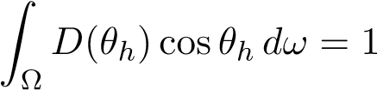A plausible microfacet distribution must be normalized over the hemisphere such that the projected area of the microfacets is 1 [33]: or in spherical coordinates:.(一个看似合理的微面分布必须在半球上归一化，使得微面的投影面积为1[33]:或在球坐标系中:。
)

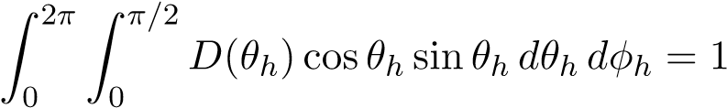

For importance sampling, it is convenient to choose *pdfh* = *D*(*θh*)cos*θh* given that it is already normalized.(对于重要抽样，如果PDFH已归一化，则可方便地选择PDFH=D(θH)cosθH。（2）
) Note, *pdfh* is the density with respect to the half-vector; the density with respect to the light vector *l* is:.(因为它已经正常化了。 注意，pdfh是相对于半矢量的密度； 相对于光矢量L的密度为:。
)

*pdfh.(PDFH。
)*

*pdfl* = 4(*l* · *h*).(PDFL=4(L·h)。
)

To generate samples over the hemisphere, the pdf is split into spherical components, *pdfh* = *pdfθhpdfφh*.(为了在半球上生成样本，PDF分为球形分量，PDFH=PDFθHPDFφH。
) For isotropic distributions this factorization is trivial as the distribution has no dependence on *φh* and *pdf*.(对于各向同性分布，由于该分布不依赖于φh和pdf，因此该分解是平凡的。
) For anisotropic distributions, the factorization is accomplished by integrating out *θh* to get:.(对于各向异性分布，通过积分出θh来完成因式分解，得到:。
)

*pdf.(pdf。
)*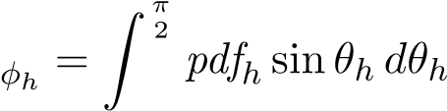

0 *pdfφh.(0pdfφh。
)*

*pdfθh* = *pdfh.(PDFθH=PDFH。
)*

Each component pdf is then integrated to form a cdf and then inverted to form a corresponding sampling function:.(然后对每个分量PDF进行积分以形成CDF，然后进行反相以形成相应的采样函数:。
)

*cdf(x) .(CDF（x）。
)*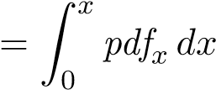

*x* = *cdf*−1(*ξ*).(x=CDF−1(ξ)。
)

Given the two sampling functions and uniform random variables *ξ*1 and *ξ*2, *θh* and *φh* can be computed and projected to the coordinate frame around the normal *n*, tangent *x*, and bitangent *y* to form the half-vector *h*.(给定两个抽样函数和均匀随机变量ξ1和ξ2，θh和φh可以计算并投影到法线N、切线X和双切线Y周围的坐标系上，形成半矢量H。
) Finally, given a *v* vector, *l* can be computed by reflecting *h* across *v*:.(最后，给定一个V向量，可以通过将H反射到V:上来计算L。
)

*h* = sin*θh* cos*φhx* + sin*θh* sin*φhy* + cos*θhn.(h=sinθhcosφhxsinθhsinφhycosθhn。
)*

*l* = 2(*v* · *h*)*h* − *v.(L=2（V。h）h−V。
)*

## B.(B。 )2 GTR.(B.2>r。 )

Following the above derivations, the normalized GTR distribution and sampling equations are:.(在上述推导之后，归一化的GTR分布和采样方程为:。
)

*D*GTR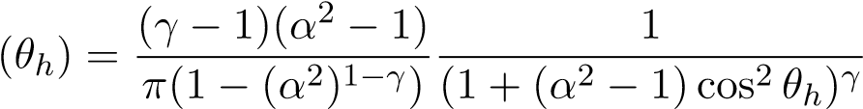 (1).(总务主任（1）。
)

*φh* = 2*πξ*1 (2).(φh=2πξ1（2）。
)

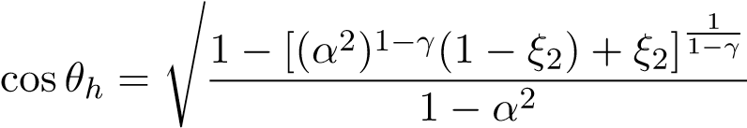 (3).(（3）。
)

This distribution is valid for any *γ >* 0, however, at *γ* = 1 there is a singularity.(该分布对任何γ>0都是有效的，但当γ=1时，存在奇异性。
) Taking the limit as *γ* → 1 produces this alternate form:.(=1存在奇点。 取极限为γ→1，得到了如下的另一种形式:。
)

*D*GTR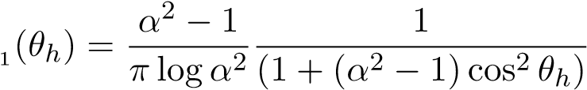 (4).(总务主任（4）。
)

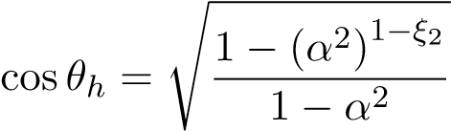 (5).(（5）。
)

The values of *γ* = 3*/*2 and *γ* = 2 have simplified forms, the latter being equivalent to GGX:.(γ=3/2和γ=2具有简化形式，后者等价于ggx:。
)

*D*GTR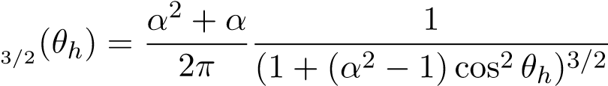 (6).(总务主任（6）。
)

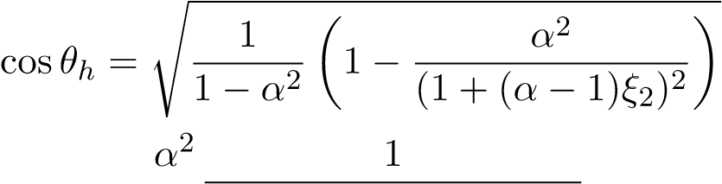 (7).(（7）。
)

*D*GTR2(*θh*) = *π* (1 + (*α*2 − 1)cos2 *θh*)2 (8).(DGTR2(θH)=π(1(α2−1）COS2θH)2(8)。
)

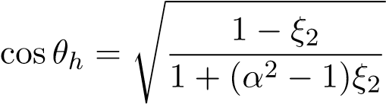 (9).(（9）。
)

To form an anisotropic distribution, the roughness is varied with *φ* by replacing  with 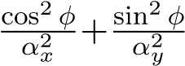.(为了形成各向异性分布，粗糙度通过替换为φ而随φ而变化。
)

For *γ* = 2 this results in:.(对于γ=2，这导致:。
)

*D*GTR2aniso 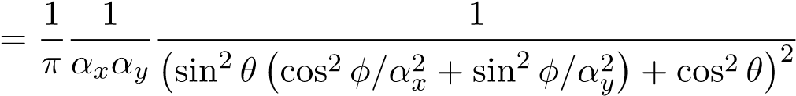 (10).(DGTR2ANISO（10）。
)

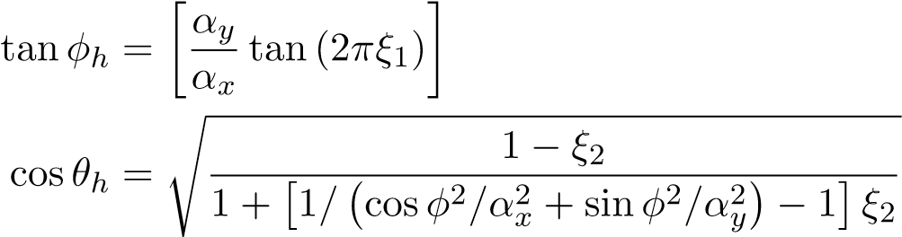(11).(（11）。
)

(12).(（12）。
)

Substituting these vector identities.(替换这些载体身份。
)

*h* · *x* = sin*θh* cos*φh h* · *y* = sin*θh* sin*φh h* · *n* = cos*θh.(h·x=sinθh cosφh·y=sinθh sinφh·n=cosθh。
)*

into equation (10) produces an efficient alternate form:.(等式（10）给出了一种有效的替代形式:。
)

*D*GTR2aniso 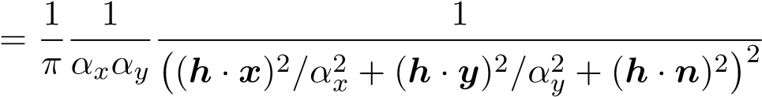 (13).(DGTR2ANISO（13）。
)

Further, factoring tan*φh* from equation (11) into sin*φh* and cos*φh*, avoids special handling for the quadrants of *φh* and also allows *h* to be calculated more directly:.(此外，将方程（11）中的tanφh分解为sinφh和cosφh，避免了对φh的象限的特殊处理，还允许更直接地计算h:。
)

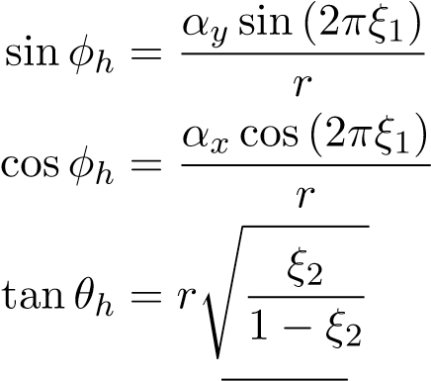

*h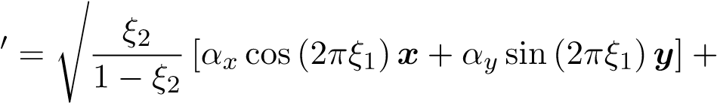n* (14).(HN（14）。
)

*h* 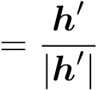 (15).(H（15）。
)

Note: *h*0 is the *projected* half-vector, tan*θh* cos*φhx* + tan*θh* sin*φhy* + *n*, and *r* is a normalization factor that can be ignored due to cancellation.(注:H0为投影半矢量，tanθh cosφhx tanθh sinφhy n，r为因消除而可忽略的归一化因子。
)

For arbitrary values of *γ*, the normalization of the anisotropic distribution unfortunately does not have a closed form.(对于任意的γ值，各向异性分布的归一化不幸不具有闭合形式。
)