Screen-space subsurface scattering rendering.(屏幕空间次表面散射渲染 )

# Abstract.(摘要。 )

Existing subsurface scattering rendering algorithms try to reproduce the phenomenon aiming at physically accurate results.(现有的地下散射体绘制算法试图再现这种现象，目的是获得物理上精确的结果。 ) Recent research has demonstrated that in some scenarios, to make some assumptions about the way we perceive translucency helps us speeding up calculus achieving real-time results.(最近的研究表明，在某些情况下，假设我们感知半透明的方式有助于我们加速微积分实现实时结果。 ) In this paper we present a new algorithm based on previous perceptual studies general enough to work with measured and user-de ned data.(本文在前人感知研究的基础上，提出了一种新的算法，该算法具有足够的通用性，能够处理测量数据和用户定义的数据。 ) The results obtained make the algorithm interesting in scenarios were a plausible appearance of translucency is enough.(所得到的结果使该算法在场景中显得很有趣，一个看似半透明的外观就足够了。 )

# Introduction.(导言。 )

Translucency is a challenging phenomenon to simulate due to its complex subsurface light transport.(半透明是一种具有挑战性的现象，由于其复杂的亚表面光传输。 ) In the last decade, breakthroughs were presented [JMLH01], making the problem more a ordable and enabling its simulation in e cient ways.(在过去的十年中，取得了突破性的进展[JMLH01]，使问题变得更加合理，并使其模拟成为可能。 ) Due to the results obtained with o ine rendering techniques, recent research in the area has focused on trying to reproduce them in real-time.(由于o ine渲染技术所获得的结果，最近该领域的研究集中在尝试实时再现它们。 ) In this case, we can nd two main groups: approaches that try to nd representations and data structures which help to speed up rendering times, and approaches that try to simulate subsurface scattering in a more perceptual way.(在这种情况下，我们可以分为两大类:一类是试图增加表示和数据结构以加快绘制时间的方法，另一类是试图以更直观的方式模拟地下散射的方法。 )

this paper we are going to focus in the last group.(这篇论文我们将使用后一种。 )

We leverage the fact that the human visual system is not good calculating inverse optics, instead of this we perceive translucency based on image heuristics and visual cues .(我们利用人类视觉系统不是很好地计算逆光学的事实，而不是基于图像启发和视觉线索来感知半透明 ) This enable us to calculate subsurface scattering more e ciently by cheating our brain with physically plausible renders.(这使我们能够通过用物理上合理的渲染欺骗我们的大脑来更准确地计算地下散射。 ) Inspired by the work of Jimenez et al.(受到Jimenez等人工作的启发。 ) , we present a screen-space rendering technique looking for a more general solution, allowing the use of general di usion pro les and enabling the simulation of a wide range of materials apart from skin.(我们提出了一种屏幕空间渲染技术，它寻找一种更通用的解决方案，允许使用通用的dission proles，并允许模拟除皮肤之外的各种材料。 )

Our approach is based on irradiance convolutions over a multi-layered representation of the object, which is general enough to obtain plausible depictions of translucent objects based on the di usion approximation.(我们的方法是基于物体的多层表示上的辐照度卷积，这对于基于衍射近似的半透明物体的合理描述是足够普遍的。 ) Our goal is not a real-time algorithm, instead we are exploring the extendability of current real-time techniques to more general scenarios.(我们的目标不是实时算法，而是探索当前实时技术对更一般场景的可扩展性。 ) Thus, our algorithm is implemented in CPU leaving the door opened for future improvements and GPU implementations, if possible.(因此，我们的算法是在CPU中实现的，如果可能的话，为将来的改进和GPU实现打开了大门。 )

The results obtained show that this technique is general enough to work with both measured data from previously publications [JMLH01, NGD*06] and user-de ned materials.(计算结果表明，该方法具有较好的通用性，既可用于以往文献 的测量数据，又可用于用户设计的材料。 )

# Previous work.(以前的工作。 )

Rendering: The dipole method is one of the most popular techniques for simulating the appearance of subsurface scattering for translucent materials [JMLH01].(渲染: dipole法是模拟半透明材料表面下散射现象最常用的技术之一 。 ) This approach formulates a BSSRDF by combining an exact solution for single scattering with a dipole point source di usion approximation to simulate multiple scattering.(该方法通过将单次散射的精确解与偶极子源扩散近似相结合来模拟多次散射，从而形成BSSRDF。 ) We use this and subsequent work extending the original model [DJ05], as the basis of our translucent material model.(我们使用这个和后续的工作扩展原始模型[DJ05]，作为我们的半透明材料模型的基础。 ) A number of realtime algorithms to simulate the appearance of translucency exploit consumer level graphics hardware, however restrict the types of di usion pro les possible [dLE07, CLH*08, JSG09, JWSG09].(许多模拟半透明外观的实时算法利用了消费级图形硬件，然而限制了可能的分割类型 。 ) We aim to e ciently simulate more general di usion pro les compared to these earlier methods.(我们的目标是与这些早期的方法相比，更清晰地模拟更一般的讨论过程。 )

Visual Perception: A parallel line of research into how humans visually perceive shape and material properties shows that while humans have a good intuition for natural lighting, they cannot establish the exact correspondence between shape, re ectance and patterns of lighting [BKY99, FDA03, OCS05].(视觉感知:对人类视觉感知形状和材料特性的平行研究表明，虽然人类对自然光有良好的直觉，但他们无法在形状、反射率和照明模式之间建立精确的对应关系[BKY99，FDA03，OCS05]。 ) A detailed study of the cues that a ect human perception of translucency concludes that objects composed of such material appear more realistic if they present specular highlights [FB05].(一项关于ECT人类对半透明的感知的线索的详细研究得出结论，由这种材料组成的物体如果呈现出镜面的高光，则显得更逼真[FB05]。 ) Further, specularity aids shape perception of translucent materials, which would otherwise lose visual detail due to the softening e ects of sub-surface scattering.(此外，镜面有助于半透明材料的形状感知，否则，由于次表面散射的软化效应，半透明材料将失去视觉细节。 )

# Subsurface scattering rendering.(地下散射渲染 )

Our algorithm is based on the di usion approximation [JMLH01] which de nes multiple subsurface scattering as:.(我们的算法是基于Dision近似[JMLH01]，它将多重次表面散射定义为:。 )

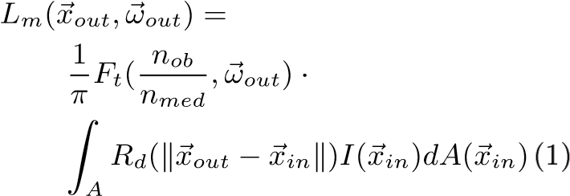

where *Lm* is the exitant radiance, *Ft* is the Fresnel transmission term, *A* de nes the surface area of the object, *~xin* and *~xout* de ne the incident and exitant point of light respectively, *ωin* and *ωout* de ne the incident and outgoing light directions and *nob* and *nmed* dene the indices of refraction of the object and the medium.(其中Lm为出射辐射，ft为菲涅耳透射项，a为物体表面积，~xin和~xout分别为入射光点和出射光点，ωin和ωout分别为入射光方向和出射光方向，nob和nmed分别为物体和介质的折射率。 ) *Rd* is a one-dimensional function called di usion pro le that de nes the properties of the material regarding subsurface scattering.(否认物体和介质的折射率。 Rd是一维函数，称为diision prole，它描述材料关于次表面散射的性质。 ) Several models for this function can be found in di erent works, such as the dipole model [JMLH01], which will be chosen in order to use their captured materials.(在不同的工作中，可以找到几种用于该函数的模型，例如偶极子模型[JMLH01]，为了使用其捕获的材料，将选择该偶极子模型。 ) *I* de nes the irradiance, that can be computed as follows:.(是一个一维函数，称为扩散方程，它描述了材料关于次表面散射的性质。 在不同的工作中，可以找到几种用于该函数的模型，例如偶极子模型[JMLH01]，为了使用其捕获的材料，将选择该偶极子模型。 我定义了辐照度，它可以计算如下:。 )

## I(.(我（。 )

where Ω refers to the whole hemisphere of incident light, *L* represents incident radiance and.(其中Ω表示入射光的整个半球，L表示入射光亮度和。 )

*~nin* is the normal of the surface at *~xin*.(~nin是~xin处曲面的法线。 ) This is computed for all color channels (RGB).(这是为所有颜色通道(RGB)计算的。 )

We assume that the object is optically thick, an assumption that has been done before [XGLJH07, JSG09].(我们假设物体是光学厚度的，这个假设在[XGLJH07，JSG09]之前就已经做过了。 ) Single scattering in optically thick materials is negligible compared to multiple scattering, and therefore Equation 1 models all subsurface scattering for such materials.(我们假设物体是光学厚度的，这个假设在[XGLJH07，JSG09]之前就已经做过了。 与多次散射相比，光学厚度材料中的单次散射可以忽略不计，因此等式1为此类材料的所有次表面散射建模。 ) As it is shown further in the text, this simple assumption enables us to simulate light transport by means of image convolutions.(如本文进一步所示，这个简单的假设使我们能够通过图像卷积来模拟光传输。 )

We rst de ne a set of equally spaced parallel planes that cut the object along its volume.(我们发现了一组等间距的平行平面，它们沿着物体的体积切割物体。 ) Although our algorithm works for a generic orientation of those planes, the best results are achieved when these are parallel to the projection plane of the camera.(虽然我们的算法适用于这些平面的一般方向，但当这些平面平行于摄像机的投影平面时，可以获得最佳的结果。 ) From now on, we consider that the orientation of these planes is the optimal one and therefore we work on screen space.(从现在起，我们认为这些平面的方向是最佳的，因此我们工作在屏幕空间。 )

All the irradiance that is incident along the surface of the object is stored at the closest layers, and then light transport is calculated by considering the di usion pro le and performing convolutions between layers.(沿物体表面入射的所有辐照度都存储在最近的层上，然后通过考虑漫射率和进行层间卷积计算光传输。 ) Then the nal result integrates the contributions from all layers.(NAL结果综合了各层的贡献。 ) This algorithm is su ciently general that it can also be used with measured scattering data [JMLH01, NGD*06], and several user-de ned di usion pro les by setting up absorption and extinction coe cients and using the dipole model.(通过建立吸收系数和消光系数，并利用偶极子模型，该算法还可用于测量散射数据[JMLH01，NGD*06]和几种用户使用方案。 )

3.(3。 )1 Algorithm.(3.1算法。 )

For the de nition of this algorithm, the coordinate system is the one of the camera, where the *x* and *y* axis are horizontal and vertical axis, and *z* axis represents the direction perpendicular to the projection plane.(对于该算法，坐标系是摄像机坐标系，其中x轴和y轴是水平轴和垂直轴，z轴表示垂直于投影面的方向。 ) We subdivide the scene by de ning a series of *nl* layers equally spaced along the *z* axis of the shape of the object, and parallel to the image plane.(轴表示垂直于投影面的方向。 我们将场景细分为一系列NL层，这些NL层沿着物体形状的Z轴等间距地平行于图像平面。 ) Each layer is then located at a distance *zl* given by:.(物体形状的轴，并平行于图像平面。 然后，每一层位于由下式给出的距离ZL处。 )

*zl* = min(*z*) + *l*∆*z* (3).(ZL=最小(z)l∨z(3)。 )

where ∆*z* = (max(*z*) − min(*z*))*/*(*nl* − 1), *l* = 0*.(其中，½Z=（MAX(Z)−MIN(Z))/(NL−1），L=0。 ).(好吧。 )nl* − 1 and min(*z*) and max(*z*) represent the limits of the bounding box of the object in the *z* axis.(..nl−1和min(z)及max(z)表示对象在z轴上的边界框的限制。 ) Visually pleasing results are achieved with *nl* varying between 4 and 8, more layers increase accuracy but di erences are not perceived.(轴心国。 当NL在4到8之间变化时，可以获得令人愉悦的视觉效果，更多的层提高了精确度，但是没有察觉到差异。 ) Our di usion approximation is similar in spirit to the work of Donner and Jensen [DJ05].(我们的讨论近似与Donner和Jensen的工作在精神上是相似的[DJ05]。 ) Assuming that all interactions between pairs of layers are due to multiple scattering, we rely on convolution to compute the contribution between them.(更多的层增加了精确度，但没有察觉到差异。 我们的讨论近似与Donner和Jensen的工作在精神上是相似的[DJ05]。 假设所有层对之间的相互作用都是由于多次散射造成的，我们依靠卷积来计算它们之间的贡献。 ) Note that in Donner and Jensen’s approach they attempt to simulate multilayered materials by assuming that they are di erentially parallel, although the surface of the corresponding object might not be plane.(请注意，在Donner和Jensen的方法中，他们试图通过假设多层材料在方向上是平行的来模拟多层材料，尽管相应对象的表面可能不是平面。 )

At each of this layers, we de ne its corresponding incident irradiance map *Iinl* .(在每一层中，我们确定其相应的入射辐照度图IInl。 ) Working in screen space, our results show that a resolution between 4 and 8 times smaller than the resolution of the resulting image is a good compromise between nal image quality and computation times, depending on the properties of the material (the di usion pro le) and on the geometry of the object.(在屏幕空间中，我们的结果表明，分辨率小于所得图像分辨率的4～8倍，是NAL图像质量和计算时间之间的良好折衷，这取决于材料的性质（讨论部分）和对象的几何形状。 ) We rst choose points on the surface as Jensen et al.(我们首先选择表面上的点，如Jensen等人。 ) [JB02].([JB02]。 ) Next, we calculate irradiance at those points (methods will depend on the kind of source lights in the scene).(接下来，我们计算这些点的辐照度（方法取决于场景中光源的种类）。 ) Finally, for every layer, we distribute the irradiance along the corresponding incident irradiance maps (see Figure 1, left):.(最后，对于每一层，我们沿着相应的入射辐照度图分布辐照度（见图1，左侧）: )

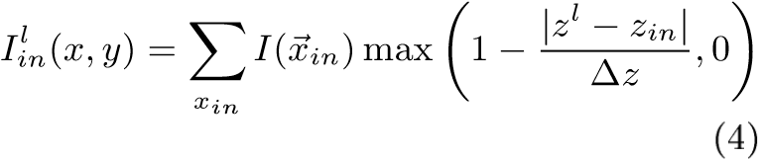

where *I*(*~xin*) is obtained from Equation 2.(其中I(~xin)由等式2求出。 )

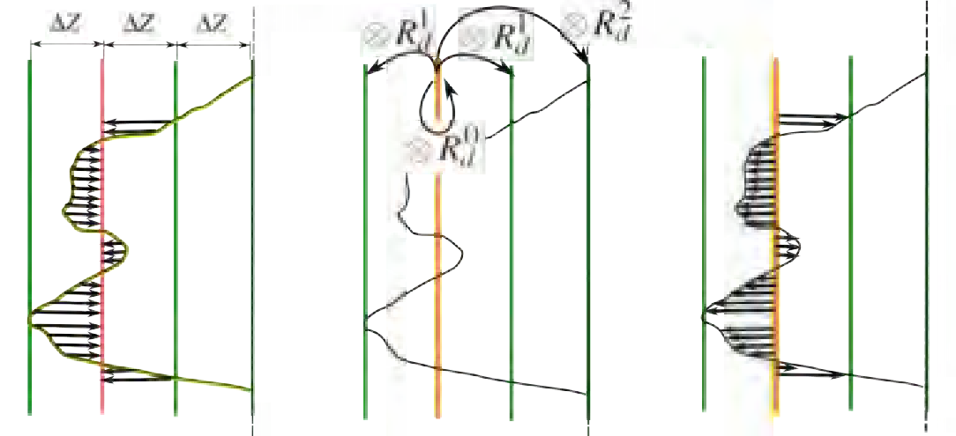

Figure 1: From left to right: Projecting the incoming irradiance onto one layer; Irradiance transfer between layers by convolutions; Projecting the outgoing irradiance of a layer back onto the object.(图1:从左到右:将输入的辐照度投影到一个层上； 层间辐照度的卷积传递； 将一层的出射辐照度投射回物体上。 )

We generate *nl* convolution maps *Rde*, each one representing the e ect of the incoming irradiance at a speci c layer, on the outgoing radiance at a layer at distance *e* = *m*∆*Z* with *m* = 0*,.(我们生成NL卷积图RDE，每个卷积图代表特定层处入射辐照度对距离为e=m∨z且m=0的层处出射辐照度的影响。 ).(好吧。 ).(好吧。 )nl* − 1.(，。。。NL−1。 ) These convolution maps are generated from the function *Rd*:.(这些卷积图由函数rd:生成。 )



where *w* and *h* represent the width and height of the down-sampled incoming irradiance maps.(其中w和h表示下采样的入射辐照度图的宽度和高度。 ) *kx* and *ky* are scale factors that relate the size of the irradiance maps with the size of the geometry of the object.(表示下采样输入辐照度图的宽度和高度。 kx和ky是将辐照度图的大小与对象的几何尺寸相关联的比例因子。 ) The outgoing irradiance map at each layer (*Ioutl* ) is then obtained by convolving it with each (see Figure 1, middle), yielding:.(是将辐照度图的大小与对象几何形状的大小相关联的比例因子。 然后，将每一层的出射辐照度图（IOUTL）与每一层卷积（见图1，中间），得到:。 )

*Ioutl* (*x,y*) = X *Iini* (*x,y*) ⊗ *Rde*(*x,y*) (6).(IOUTL（x，y)=x iini（x，y)∨rde(x，y)(6)。 )

∀*i,e*=|*i*−*l*|.(？I，E=I−L。 )

For e ciency reasons, this convolution is computed using the discrete fast Fourier method implemented in the FFTW library [FJ05].(为了方便起见，使用在FFTW库中实现的离散快速傅立叶方法来计算该卷积[FJ05]。 ) In Fourier space convolutions become per-pixel complex multiplications, which are by far much more e cient than computing the whole convolution.(在傅立叶空间中，卷积变成每像素的复乘法，这比计算整个卷积要方便得多。 )

|  |
| --- |
| Figure 2: Overview of the rendering algorithm.(图2:呈现算法概述。 ) |

The nal outgoing radiance at any point *xout* is computed by using Equation 1 as follows:.(任意点XOUT处的NAL出射辐射通过公式1计算，如下所示:。 )

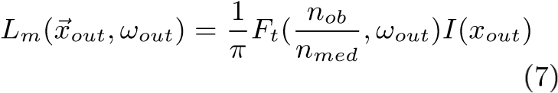

where the exitant irradiance *I*(*xout*) is computed from trilinear interpolation, considering the four closest pixels of the two outgoing irradiance maps from the two closest layers (see Figure 1, right).(其中，考虑两个最接近层的两个出射辐照度图中最近的四个像素（见图1，右侧），通过三线性插值计算出出出射辐照度I（xout）。 )

Specular highlights are included afterwards by simply adding the corresponding specular Phong addend in order to enhance the perception of translucency [FB05].(之后，通过简单地添加相应的镜面Phong Addend来包括镜面高光，以增强半透明的感知[FB05]。 ) We can see the complete pipeline in Figure 2.(我们可以在图2中看到完整的管道。 )

# Results and discussion.(结果和讨论。 )

The technique presented in this paper is versatile enough to model a wide variety of materials.(本文提出的技术具有足够的通用性，可以对各种材料进行建模。 ) Figure 4 shows buddhas made of ketchup and low fat milk, renders are illuminated with U zi Gallery environment [YDMH99].(图4显示了由番茄酱和低脂牛奶制成的佛像，渲染器是用乌兹画廊环境[YDMH99]照明的。 )

Rendering takes around 6 seconds for a 1024x1024 input image, with irradiance layer maps at 256x256 and with four layers involved.(对于1024x1024输入图像，渲染大约需要6秒，其中256x256处有辐照度层映射，涉及四个层。 ) We have applied the photographic tone-mapping operator [RSSF02] to all the images for display purposes.(为了显示目的，我们对所有图像应用了照相色调映射运算符[RSSF02]。 )

By changing RGB absorption and extinction coe cients in the dipole function, or entirely replacing the *Rd* model, we can create completely new material appearance.(通过改变偶极子函数中的RGB吸收和消光系数，或者完全取代RD模型，可以创造出全新的材料形貌。 ) Figure 5 show a user-de ned jade-like buddha illuminated from behind with a directional light.(图5示出了用户设计玉佛从后面用定向灯照明。 ) Another example can be found in the same gure, in this case a user-de ned marble-like dragon rendered in Galileo’s Tomb environment [YDMH99].(另一个例子可以在相同的Gure中找到，在本例中是一个用户定义的大理石般的龙，在伽利略的坟墓环境中呈现[YDMH99]。 )

Finally, we show another example of application in Figure 3.(最后，我们展示了图3中的另一个应用程序示例。 ) In this case, our rendering algorithm has been applied over estimated geometry yielding better results than [KRFB06] and similar to other renders with real 3D geometry.(在这种情况下，我们的渲染算法已经被应用到估计几何上，产生了比[KRFB06]更好的结果，并且类似于具有真实3D几何的其他渲染。 )

|  |
| --- |
| Figure 3: Demonstration of our method in an image-based editing context.(图3:在基于图像的编辑上下文中演示我们的方法。 ) From left to right: original image and translucency simulation from [KRFB06] (images and geometry courtesy of the authors), marble, jade and wax simulation with our method.(从左到右:从[KRFB06]（作者提供的图像和几何图形）、大理石、玉石和蜡的原始图像和半透明模拟用我们的方法。 ) Note that [KRFB06] cannot simulate any speci c material, while we use both measured data (marble, from [JMLH01]) and new user-de ned materials.(请注意，[KRFB06]不能模拟任何特定的材料，而我们同时使用测量数据（大理石，来自[JMLH01])和新用户设计的材料。 )  Figure 5: Two additional results, showing user-.(图5:两个附加结果，显示用户-。 )  de ned jade and marble simulations.(翡翠和大理石的模拟。 ) |

Figure 4: Two renders of buddhas made of measured ketchup [JMLH01] and low fat milk [NGD*06].(图4:由量好的番茄酱[JMLH01]和低脂牛奶[NGD*06]制成的两个佛像。 )

# Limitations and future work.(局限性和今后的工作。 )

Current limitations of our method are relative to rendering times.(我们的方法目前的局限性是相对于渲染时间而言的。 ) Due to our CPU implementation, convolutions take a big part of the rendering time, so we use a lower resolution for the irradiance layer maps in order to accelerate this step.(由于我们的CPU实现，卷积占用了渲染时间的很大一部分，因此我们对辐照度层映射使用较低的分辨率来加速这一步。 ) This down-sampling a ects the nal appearance of the render and this could be a problem with fast decaying di usion pro les, where the softening e ects of our approach could yield a visible loss of detail.(这种下采样会影响渲染的外观，这可能是快速衰减扩散过程中的一个问题，我们的方法的软化效应会导致细节的明显损失。 ) Using layers with variable resolution and distribution depending on the geometry could be studied.(可以研究使用根据几何形状而具有可变分辨率和分布的层。 )

Recent FFT GPU implementations [GBDSM08] could be used to speed up calculus, this could reduce greatly rendering times, and while real-time could still be a challenge, performance gains would give us more interactivity.(最近的FFT GPU实现[GBDSM08]可以用来加速演算，这可以大大减少渲染时间，虽然实时性仍然是一个挑战，但是性能的提高将给我们带来更多的交互性。 )

Also, our tests are restricted to the dipole model and optically-thick materials.(此外，我们的测试仅限于偶极子模型和光学厚度的材料。 ) It would be interesting the simulation of optically thin materials.(光学薄材料的模拟将是有趣的。 )

Finally, we have seen in Figure 3 that our algorithm can work with estimated geometry.(最后，我们在图3中看到，我们的算法可以处理估计的几何图形。 ) It would be interesting to study the applicability of our rendering method with existing shape estimation techniques, as this could extend the current repertoire of image-based editing tools.(利用现有的形状估计技术来研究我们的渲染方法的适用性是很有意义的，因为这可以扩展当前基于图像的编辑工具的范围。 )

# Conclusions.(结论。 )

We have presented a new rendering algorithm for translucency that works on screen-space and is general enough to work with a wide range of measured and user-de ned materials.(我们提出了一种新的半透明渲染算法，该算法适用于屏幕空间，并具有足够的通用性，可以处理广泛的测量和用户设计的材料。 ) Despite the approximations and assumptions made in our simulations, they succeed on reproducing a satisfying appearance of translucency.(我们提出了一种新的半透明渲染算法，该算法适用于屏幕空间，并具有足够的通用性，可以处理广泛的测量和用户设计的材料。 尽管在我们的模拟中做了近似和假设，他们成功地再现了令人满意的半透明外观。 ) We think that our work could inspire future real-time algorithms or imagebased editing tools.(我们认为我们的工作可以启发未来的实时算法或基于图像的编辑工具。 )

# Acknowledgements.(致谢。 )

This research has been partially funded by the Spanish Ministry of Science and Technology (TIN2007-63025) and the Gobierno de Aragon (projects OTRI 2009/0411 and CTPP05/09).(这项研究得到西班牙科学技术部(TIN2007-63025)和Gobierno de Aragon（项目OTRI2009/0411和CTPP05/09)的部分资助。（ ) Jose I.(何塞一世。 ) Echevarria was funded by a research grant from the Instituto de Investigacion en Ingenieria de Aragon.(Echevarria的经费来自阿拉贡天才研究研究所的一笔研究补助金。 )