Title
The title of the paper or thesis.666

Authors
A few other authors and I.

Abstract
The abstract for this paper. These sections become separate latex files in the paperaj folder. Include them in the appropriate places in the main latex file. See the main.tex for example. Please note that headers are in italics. Italicized H1 headers split latex files.

Keywords
Some, key, words

Content

Introduction
You can cite an article like this \‎cite{Eapen2020}. This citation is inserted by Zotero using the style provided with the paperaj template here https://github.com/dermatologist/paperaj/blob/master/word2latex-pandoc.csl. You can just insert citation in the above format. Table number and title should be at the top of the table and can be referred inline like Table_1.
Table 1: Ranking according to the lesion count
Rank | Numeric | Lesion count
Mild | 1 | 0-5
Moderate | 2 | 6-20
Severe | 3 | 21-50
Very severe | 4 | >50

Figure 1: Multimodal machine learning with kedro-multimodal.
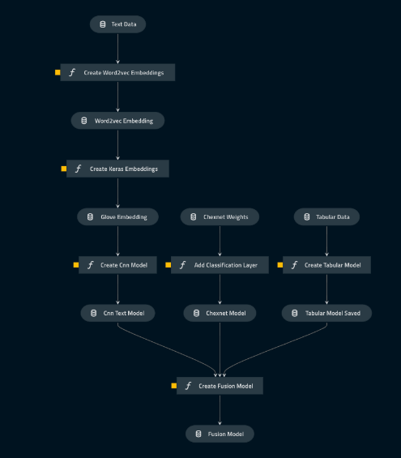

Figures should also have the number and title at the top and can be cited inline like Figure_1.

Chapter 1

Italicized H1 headings will split the generated latex into serially numbered files.

Heading
The above is an H1 heading.

Subheading
More content.

Chapter 2

This will go into a different latex file.

Acknowledgements
An italicized subheading like ‘References’ below splits the content into serially numbered latex files. This helps in discarding the Zotero generated bibliography in word document and use latex bibliography. You can use the same template for large documents like a thesis and separate each chapter as a latex file.

References

Automatic citation updates are disabled. To see the bibliography, click Refresh in the Zotero tab.

