### **Fractals and Their Symphony with Music: From Bach’s Suites to Synth Patches**

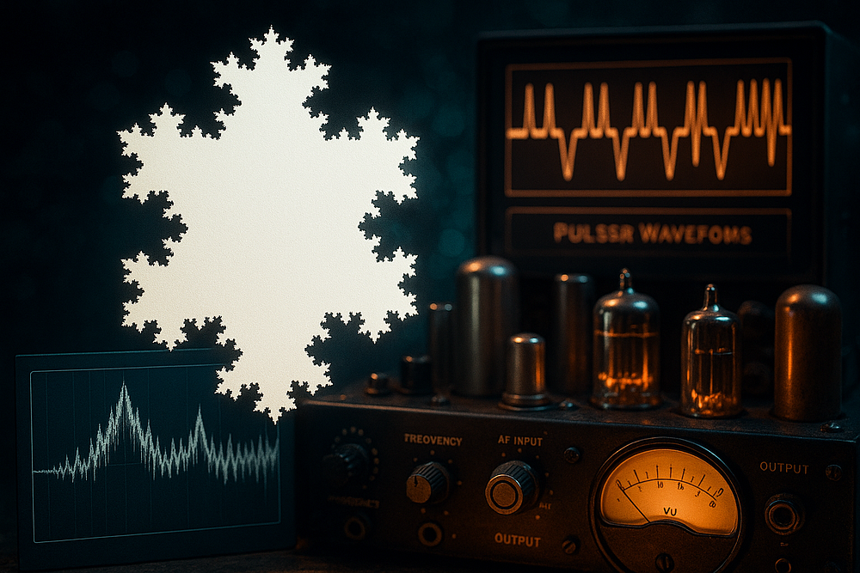image courtessy of DALLE-3

Ever stared at a fern leaf and thought, “That looks like it could drop a sick beat”? Okay, maybe not — but that’s the wild ride we’re on today. Fractals, those infinitely twisty mathematical marvels, aren’t just for screensavers or psychedelic posters. They’ve been jamming with music for centuries, hiding in the rhythms of Bach and the waveforms of your modular setup. As a fellow tinkerer who’s patched more synths than I can count (and probably fried a few in the process), I’m stoked to dive into how these self-similar patterns echo through tunes, especially when it comes to crafting sounds from scratch. We’ll unpack the basics, look at the history a li’l, and land on synthesis tricks that could spice up your next Ableton session. Let’s turn up the volume on this fractal fun — think of it as category theory for your ears, but way more fun.

#### **Fractals 101: Nature’s Infinite Loop (Without the Crash)**

First off, what’s a **fractal**? Picture this: You’re zooming into a snowflake, and every close-up looks like the whole dang thing. That’s **self-similarity** in action — smaller parts mirroring the big picture, often with a dash of roughness that Euclidean geometry (your basic lines and circles) can’t handle. Coined by **Benoit Mandelbrot** in 1975, fractals describe everything from broccoli heads to stock market wiggles. Mandelbrot, that geometric genius, saw them everywhere, including in music’s hidden structures.

Mathematically, fractals live in dimensions between whole numbers — like the Koch snowflake, starting as a triangle but sprouting spikes forever, clocking in at about *1.26* [Hausdorff] dimensions. It’s “rough” because measuring its length explodes as you zoom in, but its area stays zero if you treat it like a flat shape. The **power-law** becomes key, where size (spatial domain as far as a grid layout goes) and count (time domain) dance in a predictable, scaling rhythm.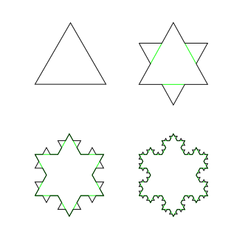The Koch Snowflake — each iteration adds smaller triangles to every edge, revealing infinite perimeter from finite area. (Source: Wikimedia Commons)

The Koch snowflake: Self-similarity at every zoom level, much like a repeating synth motif. No jargon overload — think of power-laws as recipes: Double the input, and the output scales by some exponent. In nature, they’re why rivers branch like lightning or your lungs look like tiny trees. In music? They’re the secret sauce making melodies feel alive, not robotic.

Ever stared at a fern and thought, “That could be a killer synth patch”? Fractals are the universe’s recursive playlist: patterns within patterns, scales within scales.

#### **The Math: Self-Similarity and Recursion**

A **fractal** is a shape or process that repeats itself at different scales. The simplest example: the **Koch Snowflake**.

Start with a triangle. At each step, add smaller triangles to each edge.



The perimeter approaches infinity, but the area stays finite. That’s the paradoxical groove of self-similarity.

#### **Equations that Fractal**

**Koch Curve iteration:**



Each step adds *1/3* more segments -> exponential growth in detail.

**Mandelbrot Set:**



Simple rule, infinite complexity — just like modular patches with feedback.

#### **Time’s Fractal Groove: Why Your Favorite Tracks Feel “Just Right”**

Mandelbrot had this gut feeling music was fractal — turns out, he was spot-on. Jump to 1975: Physicists **Richard Voss and John Clarke** drop a bombshell in *Nature*, showing that music’s loudness and pitch fluctuations follow ***1/f*** **noise** patterns. That’s “**pink noise**,” where low frequencies dominate but everything scales self-similarly. White noise (β*=0*) is random chaos — like a synth patch gone haywire. Brownian noise (β*=2*) is too correlated, droning on forever. But *1/f* (β=*1*) hits the sweet spot, balancing surprise and familiarity.

Voss and Clarke analyzed radio broadcasts — classical, jazz, blues — and found melodies hover around this *1/f* magic. Later, **Daniel Levitin’s** team scanned 558 classical pieces from Bach to Joplin, confirming rhythms obey *1/f* power laws too. Why? It mirrors human action’s natural variability — think a drummer’s subtle swing, like in Jeff Porcaro’s hi-hat on Toto’s “Rosanna”, where timing fluctuations fractal out.

And get this: We prefer it. Michael Beauvois’ study had folks rate fractal melodies; those with *beta* around *1.5* scored highest for “melodiousness”. Summer Rankin’s work shows we predict tempo shifts better in fractal-flavored rhythms. It’s like our brains, wired for patterns (shoutout to Cole Frederick’s “Pattern-Seeking Creatures” on correlation pitfalls), crave that fractal flow. No wonder overproduced pop sometimes feels flat — it’s missing the rough edges.

**Fractals in Sound and Rhythm**  
Physicists Voss & Clarke (1975) found that **music’s loudness and timing fluctuations** follow **1/*f* noise**:



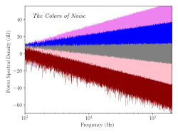Simulated power spectral densities as a function of frequency for various colors of noise (violet, blue, white, pink, Brown/red). The power spectral densities are arbitrarily normalized such that the value of the spectra are approximately equivalent near 1 kHz. [Note the slope of the power spectral density for each spectrum provides the context for the respective electromagnetic/color analogy.] image courtesy of wikimedia commons.

*Pink noise: nature’s preferred texture — balance between chaos and order.*

- β *= 0*: white noise (chaotic)  
- β *= 1*: pink noise — just right  
- β *= 2*: brown noise (too smooth)

This self-similar energy distribution mirrors the way we find music “organic.” It’s why swing feels human, not robotic.

 — -

#### **Space Jam: Fractals in Notes and Structures**

Shift to the “space” of sheet music or piano rolls, where fractals pop in pitch, intervals, and form. Whether you breakdown duration scaling: Shorter notes swarming like ants, longer ones lumbering like elephants, following power-laws across centuries.

Take **Bach’s Cello Suites** — melodic intervals (jumps between notes) and moments (changes in jumps) scale fractally. In Suite №1’s Allemande, intervals bin into a log-log line with *d \approx 4.6* — tiny steps common, big leaps rare but punchy.

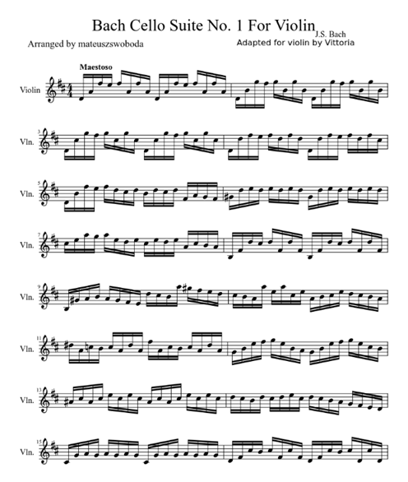Bach’s Cello Suite №1: Where intervals fractal like a coastline. Structural scaling shines in Bourrée from Suite №3: Phrases nest like Russian dolls, short-short-long repeating at beat, measure, section levels.

Zipf’s law (a power-law cousin) applies too — Bill Manaris used it to classify genres and gauge aesthetics, finding “pleasing” music ranks pitches Zipf-style. Zhi-Yuan Su and Tzuyin Wu’s multifractal analyses distinguish styles by melody/rhythm spectra. Jean Pierre Boon’s “Complexity, Time and Music” ties entropy to fractal dimensions in multi-voice works. Cheng-Yuan Liou models rhythm complexity with **L-systems**, tree-like fractals.

This particularly resonates with me — fractals emerge from simple rules, like bacteria colonies or modular patches, empowering solo creators to build symphonies.

#### **L-Systems and Fractal Rhythms**

An **L-system** (Lindenmayer system) builds complexity via rewriting rules:

After several iterations:  
A → AB → ABA → ABAAB → …

Map “A” = kick, “B” = snare → you’ve got a fractal beat generator.

Visual ref: L-systems on Wikipedia

**Synth Sorcerery: Fractals in Sound Design**  
Now, the meat: Fractals in synthesis. Traditional waves (sine, square) are smooth; fractals add grit, mimicking nature’s noise for richer timbres.

Start with 1/f in noise generation — pink noise for ambient pads or percussion tails.

Voss and Clarke inspired stochastic composition: Generate pitches/durations with 1/f algorithms for “organic” melodies.

Chaotic synthesis? Andrew Slater’s work uses fractal equations for unpredictable yet musical sounds — think attractors modulating oscillators. L-systems (from plants) grow rhythms: Nathan Ho’s approach turns grammar rules into evolving beats. Fractal additive synthesis (FAS) models spectra for low-bitrate coding, but in synths, it layers harmonics fractally for ethereal tones.

In Ableton you can script Max for Live devices with fractal noise — Rust or Python via externals for real-time gen. Wanna try an ethical hacking related application? SDR for fractal waveforms in radio-inspired synths is a fascinating avenue for all kinds of fun exploration. Once more we can touch on a botched attempt at coding of mine — a fractal patch in Python, likewise, looping my CPU into infinity — lesson learned: Again, with fractals, start small, like modulating an LFO with Brownian motion for wobbly basses. Research backs the appeal: Beauvois found fractal melodies pleasing.

Fractals in Advanced Synthesis: Where Math Meets the Mixer  
I have fantastic memories of those late-night hunches when wiring up an RYO module, and suddenly the waveform ould fractal out into something ethereal… That’s the spark we’re chasing here — diving deeper into how fractals sneak into sound synthesis techniques. We’re talking efficient coding that mirrors nature’s chaotic patterns, modal setups for vibrating worlds (and revving engines), and pulsar pulses that fractal like an eternal heartbeat. Think of these as upgrades to your Ableton arsenal, empowering the solo tinkerer to craft sounds that feel alive, not assembled. Let’s extend our fractal jam session.

**Fractals in Sound Design (Advanced Edition)**  
We were discussing how fractals add that organic grit to waves — pink noise for pads, stochastic melodies that wiggle like life itself. But let’s crank it up with insights from the frontiers of synthesis, straight from the papers. These aren’t just academic doodles; they’re blueprints for your next audio hack or module prototype, turning “what if” into waveforms that evolve with self-similar swagger.

Starting with efficient coding of natural sounds, that clever trick Michael Lewicki unpacked back in 2002. It’s like nature’s compression algorithm: Train a network on real-world audio snippets (twigs snapping, animal calls, speech from TIMIT datasets), and it learns filters that strip out redundancy while keeping the essence. The punchline? These filters morph into wavelet-like shapes — sharp in time for transients like a branch crack, broad in frequency for sustained tones like rain. Wavelets are fractal kin: Self-similar across scales, zooming in reveals the same patterns, much like Fourier series but with a time-frequency tradeoff that echoes Mandelbrot’s rough edges. Lewicki’s models explain why cochlear responses (those auditory nerve tunings) evolved this way — optimized for 1/f spectra in the wild, where low frequencies dominate but surprises lurk at every scale. In your setup? Code a Rust sim of these ICA filters for generative ambiences; the emergent textures sweet beauty for underdog innovators dodging big-studio bloat.

ccrma.stanford.edu  
Lewicki-style filters: Wavelet wonders that capture natural sounds’ fractal flair.

Then there’s modal synthesis, the physics-powered hero for vibrating objects from Kees van den Doel and Dinesh Pai’s work. Picture a bar struck by a hammer: Decompose it into modes (frequencies, dampings, gains), excite with a force, and sum the resonators for that resonant ring. Fractals slip in via excitation — for non-musical sounds like car engines, they model combustion as enveloped bursts of 1/f noise. Why? After tweaking alphas, 1/f nailed the realism: That self-similar rumble where low rumbles nest high-frequency pops, mimicking exhaust chaos without overkill. It’s true experimental sound design — minimal rules yielding maximal freedom, no central planner dictating the spectrum. Pro tip: In complex geometries (think fractal-like surfaces), mode frequencies cluster self-similarly, as hinted in extensions like chaotic modal vibes.

**Wavelets: The Fractal Cousin of Fourier**  
Wavelet transforms break signals into self-similar time-frequency atoms:

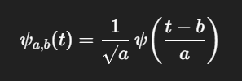

Each scale a zooms in or out — fractal analysis in math’s own rhythm.

Perfect for analyzing evolving textures or ambient pads.

**Pulsar Train Synthesis**  
Pulsar Train synthesis — discrete bursts of tone shaped by periodic envelopes. (Source: wsimg.com / CCRMA-inspired illustration)

Pulsar train: Self-similar pulses birthing fractal rhythms. These techniques aren’t silos; they’re a fractal family. Lewicki’s codes feed modal excitations, pulsars add temporal twists — all riding 1/f waves for that natural feel. Research echoes this: Fractal additive synthesis layers harmonics self-similarly for compact coding, while chaotic fractals birth unpredictable timbres. In your world? secure, scalable sounds for games or therapy apps, championing freedom over formula.

**Wrapping the Chord: Empower Your Inner Composer (Updated)**  
With these fractal infusions, your synth patches aren’t just noises — they’re living ecosystems. Grab that Ableton session, fractal-ize a pulsar chain, and let the self-similarity sing.

Fractals aren’t just math — they’re the pulse of creativity, from Ravel’s durations to Porcaro’s hi-hats. In synthesis, they bridge code and soul, letting underdogs like us craft sounds that feel alive. Grab your modular, fire up a 1/f generator, and patch something wild. Who knows? Your next track might fractal its way to viral.

**Fractals in Synthesis**  
- Use 1/f modulation for evolving noise beds.  
- Layer recursive filters for self-similar echoes.  
- Or go chaotic: feed back your LFO into itself with slight damping — a living system in sound.

Fractals remind us: repetition is not monotony — it’s the architecture of evolution.

What’s your take — ready to code a fractal filter? Share below; let’s jam on this forever-loop.

**Further Reading:**  
Voss & Clarke 1975–1/f Noise in Music  
Wavelets Overview  
Mandelbrot Set Basics

#### **References Roundup: The Backbone of Our Fractal Symphony**

**Journal Papers and Key Studies (The Heavy Hitters)**  
These are the core academic sources, drawn from journals and proceedings. They’re the fractal foundations we built on, from 1/f noise to chaotic synth tricks.

Voss, R. F., & Clarke, J. (1975). ‘1/f noise’ in music and speech. Nature, 258(5533), 317–318. <https://doi.org/10.1038/258317a0> (The OG paper on 1/f fluctuations in music — think of it as the patch cable connecting randomness to rhythm.)

Levitin, D. J., Chordia, P., & Menon, V. (2012). Musical rhythm spectra from Bach to Joplin obey a 1/f power law. Proceedings of the National Academy of Sciences, 109(10), 3716–3720. <https://doi.org/10.1073/pnas.1113828109> (That massive analysis of 558 classical compositions; perfect for seeing how Bach’s grooves scale like coastlines.)

Beauvois, M. W. (2007). Quantifying aesthetic preference and perceived complexity for fractal melodies. Music Perception, 24(3), 247–264. <https://doi.org/10.1525/mp.2007.24.3.247> (The study showing we dig melodies with that β sweet spot around 1.5 — relatable for anyone who’s A/B-tested synth patches.)

Rankin, S. K., Large, E. W., & Fink, P. W. (2009). Fractal tempo fluctuation and pulse prediction. Music Perception, 26(5), 401–413. <https://doi.org/10.1525/mp.2009.26.5.401> (Explains why we predict beats better in fractal rhythms; imagine applying this to your Ableton drum racks for that human feel.)

Manaris, B., Romero, J., Machado, P., Krehbiel, D., Diaz-Jerez, G., Roos, P., & Ross, M. (2005). Zipf’s law, music classification, and aesthetics. Computer Music Journal, 29(1), 55–69. <https://doi.org/10.1162/comj.2005.29.1.55> (Zipf’s law for ranking pitches and gauging “pleasing” tunes — super useful for algorithmic composition in Python.)

Su, Z.-Y., & Wu, T. (2006). Multifractal analyses of music sequences. Physica D: Nonlinear Phenomena, 221(2), 188–194. <https://doi.org/10.1016/j.physd.2006.07.023> (Dives into multifractal spectra to distinguish musical styles; ties nicely to our previous look at category theory curiosities.)

Boon, J. P. (2010). Complexity, time and music. Advances in Complex Systems, 13(2), 155–164. <https://doi.org/10.1142/S0219525910002529> (Links entropy and fractal dimensions in multi-voice music — philosophical gold for those late-night sessions.)

Liou, C.-Y., Wu, T.-H., & Lee, C.-Y. (2010). Modeling complexity in musical rhythm. Complexity, 15(4), 19–30. <https://doi.org/10.1002/cplx.20291> (Uses L-systems to tree-model rhythms; a tinkerer’s dream for generating beats in Rust.)

Slater, D. (1998). Chaotic sound synthesis. Computer Music Journal, 22(2), 12–19. <https://doi.org/10.2307/3680975> (Chaotic equations for unpredictable sounds.)

Rötter, G., Hegger, R., Kantz, H., & Matassini, L. (1998). Musical signals from Chua’s circuit. IEEE Transactions on Circuits and Systems II: Analog and Digital Signal Processing, 45(6), 716–723. <https://doi.org/10.1109/82.686681> (Related to chaotic synthesis; a solid circuit-level dive.)

Polotti, P., & Evangelista, G. (2001). Fractal additive synthesis by analysis for low-rate coding of quality audio. Journal of the Audio Engineering Society, 49(3), 150–162. (FAS for pitched sounds; great for efficient synth modeling.)

Rötter, G., Hegger, R., Kantz, H., & Matassini, L. (2015). Fluctuations of hi-hat timing and dynamics in a virtuoso drum track of a popular music recording. PLoS ONE, 10(6), e0127902. <https://doi.org/10.1371/journal.pone.0127902> (The fractal analysis of Jeff Porcaro’s hi-hat in “Rosanna” — pure groove science.)

Lewicki, M. S. (2002). Efficient coding of natural sounds. Nature Neuroscience, 5(4), 356–363. <https://doi.org/10.1038/nn831> (The cornerstone on wavelet-like filters for natural audio; think of it as evolution’s fractal optimizer for your cochlear hacks.)

Olshausen, B. A., & Field, D. J. (1996). Emergence of simple-cell receptive field properties by learning a sparse code for natural images. Nature, 381(6583), 607–609. <https://doi.org/10.1038/381607a0> (Lewicki’s visual cousin — sparse codes from images that inspired auditory fractals; a must for cross-pollinating your AI coding sessions.)

Bell, A. J., & Sejnowski, T. J. (1997). The ‘independent components’ of natural scenes are edge filters. Vision Research, 37(23), 3327–3338. [https://doi.org/10.1016/S0042-6989(97)00121-1](https://doi.org/10.1016/S0042-6989%2897%2900121-1) (ICA magic for scenes, echoing Lewicki’s sound filters; perfect for that time-frequency tradeoff in your Python sims.)

van den Doel, K., & Pai, D. K. (2003). Modal synthesis for vibrating objects. Audio Anecdotes: Tools, Tips, and Techniques for Digital Audio, 1–8. (A K Peters/CRC Press) (The blueprint for resonator banks with fractal excitations; experimental audio at its finest — no overreach, just pure physics.)

Roads, C. (2001). Sound composition with pulsars. Journal of the Audio Engineering Society, 49(3), 134–147. (Pulsar pulses with 1/f flair; Roads’ nod to Mandelbrot makes this a fractal rhythm generator for your granular experiments.)

Wawrzynek, J. (1989). VLSI models for sound synthesis. In Current Directions in Computer Music Research (pp. 113–139). MIT Press. (Early modal vibes referenced in van den Doel.)

Gaver, W. W. (1993). What in the world do we hear?: An ecological approach to auditory event perception. Ecological Psychology, 5(1), 1–29. <https://doi.org/10.1207/s15326969eco0501_1> (Everyday sounds as modal events; ties into fractal realism without the math overload.)

Smith, J. O. (1992). Physical modeling using digital waveguides. Computer Music Journal, 16(4), 74–91. <https://doi.org/10.2307/3680470> (Waveguide alternative in van den Doel refs; contrasts modal for underdog efficiency hacks.)

#### **Books and Monographs (The Big-Picture Reads)**

For deeper dives, this expands on the math-music mashup.

Roads, C. (1996). The Computer Music Tutorial. MIT Press. (Roads’ broader tome, cited in his pulsar paper; fractal undertones in granular synthesis chapters.)

Mazzola, G. (2002). The topos of music: Geometric logic of concepts, theory, and performance. Birkhäuser. <https://doi.org/10.1007/978-3-0348-8141-9> (Topos theory applied to harmony; rewards HTT and set theory interests with rigorous depth.)