A Deep Dive Into The Mathematics Of Quantum Gates

Understand Quantum gates like a pro by grokking the mathematics behind them.



Dr. Ashish Bamania
Apr 13, 2025
∙ Paid
14

2

2

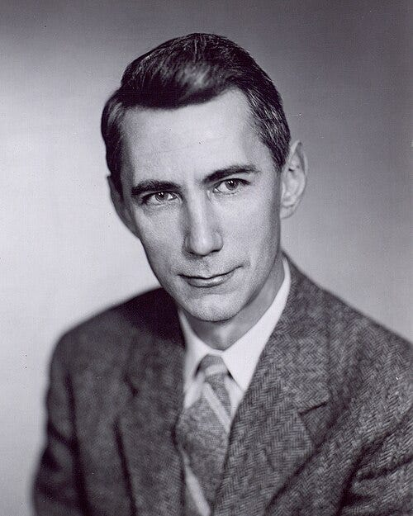
Photograph of Claude Shannon, called “the Father of Information theory”, who pioneered the concept of using Boolean logic in electrical circuits, laying the foundation for modern computing. (Source)
You must be familiar with logic gates if you've been programming computers.
George Boole first introduced Boolean logic in the 19th century.
Into Quantum is a reader-supported publication. To receive new posts and support my work, consider becoming a free or paid subscriber.
Top of Form
Subscribe
Bottom of Form
Claude Shannon later applied Boolean functions to electrical components as part of his master’s thesis, A Symbolic Analysis of Relay and Switching Circuits.
These logic gates NOT, AND, OR and their combinations are now ubiquitous and used to create all computational circuits in modern-day computers.
Similar to these, Quantum computers are formed using Quantum circuits composed of Quantum gates that manipulate qubits and perform computations.
Given a qubit, Quantum gates can perform the following operations:
- Flipping qubit stat…

Keep reading with a 7-day free trial
Subscribe to Into Quantum to keep reading this post and get 7 days of free access to the full post archives.
Start trial
Already a paid subscriber? Sign in
PreviousNext
© 2025 Dr. Ashish Bamania
Privacy ∙ Terms ∙ Collection notice
Start writingGet the app
Substack is the home for great culture

