Open Up, Quantum!-How Open Quantum Systems Are Shaking the Foundations of Quantum Mechanics

# The study of non-Hermitian

**quantum systems can be seen not as a departure from traditional quantum theory, but as an extension**

Paolo Molignini, PhD Following

17 min read

•

4 days ago Listen Share More

Artistic illustration of a quantum system interacting with its surroundings. Image by Author.

A profound question that I have received a few times from laypeople when explaining my work as a theoretical quantum physicist is the role of mathematics in my field. Is math merely an instrument we develop to explain experimental evidence, or is it

something more fundamental - something that underlies the Universe itself, something we "discover" when we look closely enough?

The answer to this chicken-and-egg

conundrum is far from simple. Often, it is puzzling new experimental results that trigger the development of fresh mathematical frameworks. A novel formalism becomes necessary to extend the old paradigm, allowing it to encompass recent data *andto* describe the physical system self-consistently under a broader theory. However, as science advances and the energy scales we explore become larger and harder to penetrate (I'm looking at you, LHC!), we increasingly find ourselves developing mathematical frameworks without the immediate guidance or confirmation of

experimental data.

When we research the fundamental fabric of reality, the lines between math and physics (and philosophy!) become even blurrier. **Quantum mechanics** is an excellent example of that.

The first hints that our classical worldview was incomplete - or even *incompatible* - with the architecture of the smallest scales came from unexpected experimental

results at the turn of the 19th century, involving phenomena such as black­ body radiation, the photoelectric effect, and the spectral lines of atomic gases. For example, classical physics predicted the "ultraviolet catastrophe" in the case of black-body radiation. A black body is an idealized object that absorbs all incoming radiation. An insulated hollow

sphere with a tiny aperture that lets light in is often taken as a good example of a black body, since all the light that enters from the small hole is very unlikely to escape again. But depending on the circumstance, even stars can be approximated as black bodies.

When a black body reaches thermal

equilibrium with its surroundings, the radiation it reemits follows a frequency distribution that depends on its temperature. However, if this distribution is derived using classical arguments, the energy emitted at short wavelengths (corresponding to ultraviolet light) diverges. This "ultraviolet catastrophe" puzzled physicists for a long time, as the emission of an infinite amount of energy was neither observed nor made any

intuitive sense.

In 1900, Max Planck solved this problem by tweaking the math used in the derivation. He assumed that the electromagnetic energy could only be emitted or absorbed in discrete packets, or quanta. This assumption - which is often regarded as the birth of quantum mechanics - seemed really strange at the time. The new math did indeed eliminate the ultraviolet catastrophe, but it wasn't clear how it could be justified physically.

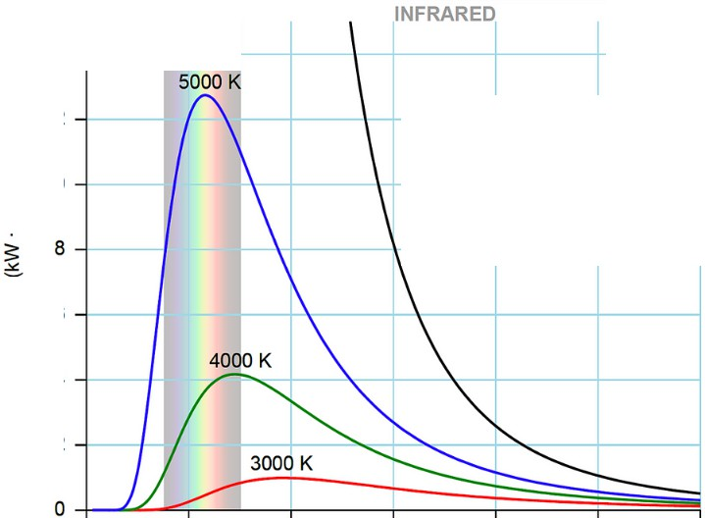

UV VISIBLE

14

f 12

C

Classical theory (5000 K)

E 10

'i..

"'

Q)

0

*ii*

!!!

a.

*Cf)*

6

4

2

0 0.5 1 1.5 2 2.5 3

Wavelength (µm)

The spectrum of black body radiation

for various temperatures, according to the correct derivation by Planck (colored curves) vs the classical result showing the ultraviolet catastrophe (black curve). Source: Wikimedia Commons. Image by Darth Kule.

Five years later, Albert Einstein turned

mathematics into physics by suggesting that Planck's quanta were the consequence of light itself being made of particles - what we now

call photons. This revelation not only

naturally fit into Planck's mathematical framework but also explained other experimentally observed phenomena, most notably the photoelectric effect.

The photoelectric effect occurs when electrons are ejected from a metal surface after exposure to high-energy radiation (typically X-rays). Classical

wave theory predicted that the energy of these electrons should depend on the light's intensity (how much light is absorbed), but experiments showed that it depended only on the

light's *frequency.* Einstein's idea that

light is made of discrete photons explained this perfectly: only photons with enough energy (proportional to their frequency) and matching the energy needed to excite an electron into the continuum could release electrons

- no matter how intense the light beam

was.

# From Quanta to Formalism

Quantization alone was not enough to capture the vast phenomenology that quantum mechanics would come to reveal. A growing number of

experiments in the early 20th century showed that the quantum world follows rules fundamentally different from those of classical physics. Landmark studies included the Stern-Gerlach

experiment and the double-slit experiment by Davisson and Germer and Thomson and Reid. Although very different in their setup, both

experiments demonstrated an

unprecedented behavior of microscopic matter: the properties of quantum particles are strongly affected by the act of measurement itself.

In the Stern-Gerlach experiment, a

beam of silver atoms passing through differently oriented magnetic fields split into distinct, separate rays, revealing that properties like angular momentum are quantized and assume definite

**values only when measured. In the double-slit experiment, electrons fired at a barrier with two narrow slits produced an interference pattern when left unobserved, behaving like waves.**

**However, when their path was measured (for example, by blocking one slit), they behaved like classical particles, demonstrating that the very act of observation fundamentally alters the behavior of quantum systems.**

classically expected result

beam of

**---===-jsilver** atoms

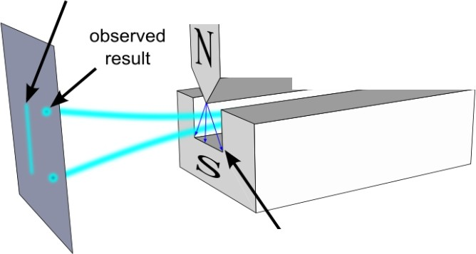

*\@]@J,.*

furnace

inhomogeneous magnetic field

double­ slit

screen

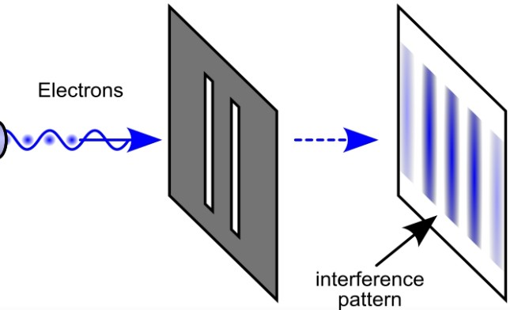

electron beam gun

Top: schematics of the Stern-Gerlach experiment. Bottom: schematics of the double-slit experiment. Partially reworked images from the Wikimedia Commons. Original authors: Theresa Knott and Johannes Kalliauer.

The results of these experiments

pointed toward the existence of quantum states in *superposition* - that is, the simultaneous coexistence of multiple possible states, with outcomes realized - or at least strongly influenced

- by observers in a probabilistic

manner. The same studies also revealed unexpected limitations to the amount of information that can be extracted from quantum systems. Our ability to measure certain quantities appears to be capped by intrinsic rules governing complementary observables, such as

position and momentum or different orientations of angular momentum. This is the famous "uncertainty principle" formulated by Heisenberg.

As the experimental outlines of the quantum world took shape, a more rigorous mathematical framework had to be developed to accommodate these strange but undeniable features of nature, weaving together quantum states, measurement, and a probabilistic description of outcomes.

Incorporating the observer - an

external, seemingly classical entity - directly into the mathematical structure of a physical theory posed profound conceptual and technical challenges.

How could a theory of nature be

complete if the mere act of observing influenced the behavior of the system

under study?

These efforts culminated in the "Copenhagen interpretation," a collection of mathematical postulates that captured the essential principles governing quantum systems and their interactions with measurements. These postulates work astonishingly well in practice, but they are not universally accepted. Many physicists continue to explore alternative formulations,

from Everettian many-worlds

interpretations to nonlocal Bohmian mechanics, in the ongoing search for a more intuitive or complete description of reality.

# The Rulebook of the

**Quantum Game**

So, what are the mathematical

postulates of the Copenhagen interpretation? Here they are:

### The states of a quantum system are

**described by vectors in a complex Hilbert space.**

A Hilbert space is an algebraic structure that generalizes our familiar three­ dimensional Euclidean space to an arbitrary number of dimensions. It is equipped with an inner product, an operation that allows us to define geometric concepts such as lengths, angles, and distances. For example, this enables us to determine whether two quantum states are close to or far from each other. Another important feature is that the vectors in Hilbert space can have complex components - that is, they can include imaginary numbers.

This is crucial because it allows

quantum states to exhibit interference effects, like those seen in the double-slit experiment, where the relative phases between different components play a fundamental role in determining the outcomes of measurements.

* **Observables** - **the things we can**

**measure** - **are represented by Hermitian operators acting on the Hilbert space. The outcome of a measurement corresponds to one of the operator's eigenvalues.**

Operators on a Hilbert space can always be represented as matrices, and their action on a quantum state is equivalent to matrix-vector multiplication, which produces another vector - that is, another state. The term "Hermitian" means that these matrices remain unchanged under the combined

operations of complex conjugation (replacing the imaginary unit iwith -,) and transposition (swapping rows and columns).

This choice is not arbitrary; it is closely tied to the postulate that measurement outcomes correspond to the operator's eigenvalues. You can think of the operator as a hand, and each eigenvalue as a unique fingerprint that reveals which of the hand's fingers was involved in its actions. The eigenvalues thus uniquely characterize the intrinsic behavior of the observable.

The spectral theorem guarantees that

Hermitian matrices always have real eigenvalues, which is crucial because physical measurements must yield real numbers - such as positions, energies, or spin components - not imaginary or

complex values that have no direct physical interpretation (i.e. we cannot measure complex numbers). Hermitian operators thus ensure that the mathematical formalism of quantum mechanics remains consistent with the reality of experimental observations.

* **The act of measurement collapses**

**the quantum state into one of the possible eigenvectors of the operator (eigenstates). The probability of each measurement outcome is given by the Born rule: it depends on how much the current quantum state "overlaps" with the eigenstate corresponding to the measured observable. After the state collapses due to measurement, the system evolves deterministically and continuously until the next**

### measurement takes place.

If the eigenvalues are the fingerprints of an operator, then the eigenstates are the fingers that left that trace - the physical objects that constitute the hand.

The Born rule then is the mechanism that dictates which finger will leave which fingerprint: it connects the abstract vectors of Hilbert space (the eigenstates) to real-world outcomes (the eigenvalues) by assigning concrete probabilities to each possible result, using the internal "distance measure" provided by the inner product. This preserves the fundamental idea that quantum mechanics, at its core, is a theory of measurement.

### The time evolution of a quantum

**state is governed by the Schrodinger equation, a differential equation that**

**links the derivative of the state vector to the Hamiltonian** - **the operator representing the total energy of the system.**

The Schrodinger equation ensures that, in the absence of measurement, the evolution of the quantum state is continuous, deterministic, and reversible. In mathematical terms, we say that the time evolution operator of quantum systems is *unitary.* This unitary structure is essential for preserving probabilities during time evolution, or realizing the deep connection between symmetries and conservation laws, as encoded in Noether's theorem. This smooth, predictable evolution stands in stark contrast to the abrupt,

probabilistic changes that occur during

measurement, highlighting the dual

nature of quantum dynamics: a continuous unfolding when left undisturbed, and a sudden jump when observed.

i1i!£J'11(t)) = .HJ\Jl(t))

*dt*

The Schrodinger equation - the fundamental equation that governs the time evolution of (closed) quantum systems.

## Let's Take it Outside

The standard postulates of quantum mechanics emerged from the coalescence of many empirical findings accumulated over the years, and they have stood the test of time as we continued to gather data on the microscopic world of fundamental particles - even in the context of higher­ energy theories like quantum field

theory. They also form the foundation of all modern quantum technologies, from quantum computers to atomic clocks.

And yet, these postulates rest on a fundamental assumption that is seldom fulfilled in practical quantum setups: they assume that the quantum system is self-contained - that there is nothing beyond it, and that the quantum states describe the entirety of the setup. In other words, the quantum state is assumed to represent the state of the entire "Universe." Of course, physical qubits in a quantum computer are far from being "the Universe." They are embedded in dilution refrigerators, exposed to background electromagnetic radiation in the lab, and connected to control gates and measurement

devices, which in turn are linked to

voltage sources and external computers. Moreover, when we define real experiments at the nanoscale, the boundary between "the quantum system" and "the environment"

becomes increasingly blurred, and we must confront a fundamental truth: no quantum system is truly isolated. In practice, we can access, control, and measure only a small part of our quantum setup - only a fraction of the full unitary and Hermitian "Universe"

that the standard postulates describe. In

these cases, we need a framework that can make predictive statements about a quantum system that interacts - even subtly - with an external environment.

This leads us to the study of **open**

**quantum systems.**

The study of open quantum systems is

almost as old as quantum theory itself. Early pioneers like John von

Neumann and Lev Landau already

grappled with how to describe systems interacting with their surroundings, introducing the concept of the density matrix to capture statistical mixtures and partial knowledge about a quantum state. As our capacity to control quantum systems expanded, so did the need for a theory that can explain how they are coupled to their surroundings.

Nowadays, the theory of open quantum

systems sits squarely between the need for practical predictions on how quantum technologies operate and the foundational questions of how to describe reality. The interaction with an environment can act as an effective "measurement," causing decoherence

and collapsing the state of a quantum system. At the same time, it raises profound theoretical questions about how measurement intertwines with quantum dynamics, how the macroscopic unidirectionality of time (the fact that time flows from past to future) emerges from a time-reversal­ invariant quantum description, and how information propagates at the microscopic scale.

# A Quantum Bed, Bath, and Beyond

One way to develop a framework for open quantum systems while retaining the core postulates of quantum mechanics is to simply zoom out. Even if we do not have access to the full system, we can still consider it as part

of a larger, unitary, and Hermitian "Universe" obeying the usual laws of quantum mechanics. By applying these laws to the full system, we can derive an effective description of the smaller subsystem of interest. This procedure assumes the existence of three separate Hamiltonians: one for the system we can measure, one for its environment (often called a "bath"), and one for the interaction between the two. Of course, this approach relies on having at least some knowledge of how the bath behaves. This may not always be available, and sometimes it has to be assumed with an educated guess.

Moreover, it cannot be applied to the

entire (real) Universe, because by definition there would be nothing external for it to couple to. Thus, this

method is rather aimed at describing practical experiments rather than providing a fundamental description of nature.

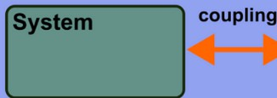

**Universe**

**Bath**

An open quantum system might not follow unitary dynamics because it couples dispersively to a bath. An effective description in terms of quantum master equations can be derived by considering the "Universe" - the combination of system, bath, and their coupling, as a greater quantum system obeying the standard postulate of quantum mechanics. Image by Author.

There are different ways to account for

- or neglect - the action of the bath.

Mathematically, we can restrict our Hilbert space to states that remain confined within the system by "tracing out" all external (bath) degrees of freedom. This procedure leads to mathematical descriptions known as quantum master equations, a framework pioneered by physicists such as Goran Lindblad and E. Brian Davies.

Among these, what is known as

the *Gorini-Kossakowski-Sudarshan­ Lindblad (GKSL} master equation* - or simply the *Lindblad master equation* - stands out because it captures the most general form of evolution that preserves certain desirable properties. In particular, it ensures that probabilities remain well-behaved and that the system's future evolution depends only on its present state, not its entire history

- a feature known as Markovianity that is also assumed for other stochastic processes like Brownian motion.

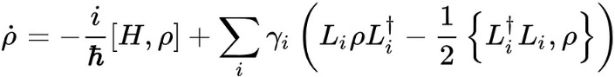•

The Lindblad master equation, which determines the time evolution of an open quantum system. The system is described by the density matrix p which generalizes the notion of quantum states to ensembles. The right hand side of the equation contains a part that stems from unitary evolution with the system Hamiltonian H, and a dissipative part that describes the effect of the bath on the system via jump operators L. Solving Lindbladians to determine the evolution of dissipative quantum systems is nowadays a standard approach in fields like quantum optics,

where the interactions between lasers and atoms can easily lead to energy being pumped in and out of the system.

# Using Two Hands Make

**Things More Complex**

We have seen that when a quantum system is coupled to an environment, energy and information can leak out, and many of the mathematical properties woven into the postulates - such as unitarity and conservation laws

- no longer strictly apply. So why not

relax these postulates from the start and try to formulate a more general theory of quantum mechanics from scratch? After all, history offers numerous examples where bold mathematical leaps eerily anticipated eventual physical realizations.

One approach that is increasingly gaining traction in the physics community is to abandon the requirement that Hamiltonians (or other operators) must be Hermitian. This idea is already familiar in classical physics, where dissipative systems - such as those involving friction or other nonconservative forces - are routinely described using non-Hermitian operators to account for energy gain and loss.

When we work with non-Hermitian

Hamiltonians in quantum mechanics, however, the spectral theorem no longer applies, and there is no guarantee that eigenvalues will remain real. Instead, eigenvalues typically become complex: the real part corresponds to the observable energy, while the imaginary

part encodes decay or amplification rates. If the imaginary part is negative, the corresponding quantum state tends to decay over time; if positive, it grows.

This simple modification already leads to fascinating phenomena, such as the **non-Hermitian skin effect,** where

states accumulate at the boundaries of a system. This already occurs for the simplest models, for example a chain in which particles only move to the left or the right - a system known as

the Hatano-Nelson model. When the

chain is coupled to an environment, we can induce nonreciprocity in the movement of particles, for example because particles are pumped in or leak out in one direction more than in the other. As a result, on average, they preferentially move in one direction (e.g.

towards the left) than the other, which leads to an accumulation of all the states at the boundaries of the system, as the simulation below shows. This is not just an interesting conceptual model. The accumulation of a macroscopic number of states at one end can be engineered and visualized in real photonic waveguides. Moreover, the extreme sensitivity to boundary conditions of non-Hermitian Hamiltonians has been shown to lead to an exponential response to perturbations that can be exploited to create highly sensitive sensors.

Right eigenvector localization for *N* = 50 sites and}t = *1.0,}R* = 1.0

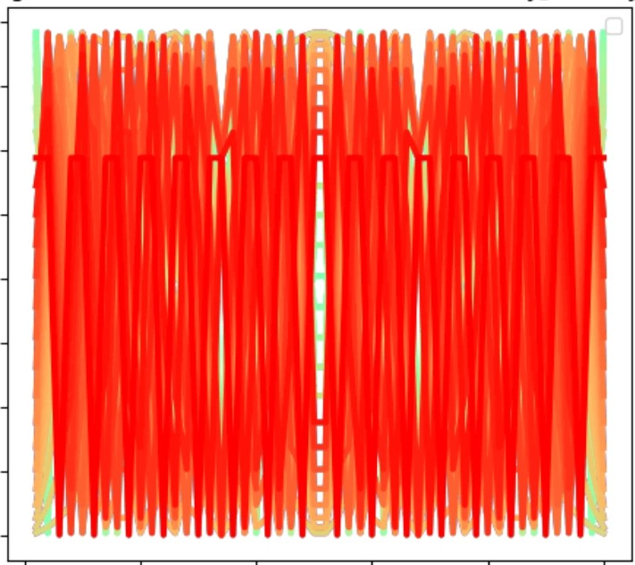0.040

0.035

0.030

0.025

N

S 0.020

* ::l-

1/150

0.0 l 5



0.010

0.005

0.000

0 10 20 30 **40** 50

site *j*

1/11

Visualization of the non-Hermitian skin effect, where a macroscopic number of eigenstates pile up at the boundary of the system. Video by Author.

However, using non-Hermitian Hamiltonians like the Hatano-Nelson model to represent quantum systems requires a fundamental reevaluation of the standard postulates of quantum mechanics, particularly those involving measurement and the definition of observables. Three main challenges arise when dealing with non-Hermitian

quantum mechanics.

First, the energies (eigenvalues) become complex, and we must find a way to reconcile this with the fact that measurements can only yield real quantities.

Second, the eigenstates are no longer

uniquely defined. Earlier, we used the metaphor of a hand performing actions to describe an operator, with each finger representing an eigenstate. In Hermitian quantum mechanics, a single hand is sufficient to perform all actions. For non­ Hermitian operators,

however, *two* distinct "hands" are

needed: a left eigenstate and a right eigenstate. A complete characterization requires both, and we must establish new, self-consistent rules for how observables and probabilities are

defined when two hands are involved. Third, the time evolution governed by the Schrodinger equation becomes non­ unitary, meaning that probabilities are no longer automatically conserved. To restore physical consistency, we must either continuously renormalize the evolving quantum state or redefine the notion of probability to account for the system's loss or gain over time.

Physicists like Dorje C. Brody and Carl

Bender have worked extensively on establishing a more general mathematical framework that circumvents the breakdown of the standard quantum mechanics postulates. In their approach - dubbed **biorthogonal quantum mechanics** - they construct

observables and probability amplitudes

by considering both the left and right eigenstates simultaneously. There are also ways of retaining real eigenvalues under certain conditions, such as PT **symmetry** (parity-time symmetry), where the combined operations of spatial reflection and time reversal leave the Hamiltonian invariant.

## Mind the Jumps!

A natural question to ask at this point is whether there is a rigorous connection between the two complementary approaches we have encountered: quantum master equations and non­ Hermitian quantum mechanics.

First of all, the Lindblad master equation itself already encodes non-Hermiticity, and can be recast in a form where this feature becomes more apparent. This is

achieved through a procedure known as Choi-Jamiofkowski isomorphism, where the density matrix - originally an operator - is reinterpreted as a state vector in a larger Hilbert space. In other words, the matrix is "unraveled" into a

vector form. This is particularly practical because the right-hand side of the master equation, describing both the coherent and dissipative dynamics, can then be represented as the action of an effective **superoperator** - an operator acting on other operators - with a matrix structure similar to that in ordinary quantum mechanics. Crucially, the dissipative terms of the Lindblad equation endow this superoperator with a non-Hermitian character: the presence of loss and decoherence processes introduces non-unitary contributions

that explicitly break Hermiticity.

But besides this mathematical reformulation that yields non-Hermitian quantities, we can also obtain an effective non-

Hermitian *Hamiltonian* directly from the master equation if we neglect certain terms. Recall that the Lindblad master equation contains two main contributions: a coherent part, given by the commutator with the system Hamiltonian, and a dissipative part that represents stochastic processes induced by the bath. But not all dissipative terms are created equal. One contribution corresponds to

random **quantum jumps** - sudden events where the system transitions between different states due to interactions with the environment, such

as an atom spontaneously emitting a photon. These jumps are incompatible with the smooth evolution generated by a Hamiltonian; instead, they resemble effective "measurements" performed by the bath, collapsing the quantum state.

However, there is another contribution that describes **decoherence:** a continuous loss of probability amplitude from certain states. This smooth

loss *can* be captured by an effective non­ Hermitian term in the Hamiltonian, leading to a gradual decay of the system's norm over time. These considerations provide a second natural link between quantum master equations and non-Hermitian quantum mechanics.

If we only retain the terms describing the smooth loss of amplitude - neglecting the stochastic jump terms -

we can describe the full time evolution with an effective non-Hermitian Hamiltonian:

* 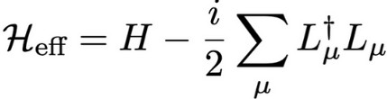

This approximation is valid when we are interested in the system's

behavior *conditional* on no jump occurring, leading to the so-called **"no­ jump approximation".** In the no-jump approximation, the system evolves under the Schrodinger equation generated by the effective non­ Hermitian Hamiltonian, where the non­ Hermitian part directly reflects the loss of probability and the deviation from purely unitary dynamics. This approach is widely used in quantum optics to model quantum systems that are continuously monitored. It provides an

intuitive picture: between jumps, the system evolves smoothly under a non­ Hermitian Hamiltonian, with the probability of a jump increasing as the state's norm shrinks.

Beyond the no-jump

approximation, **Naimark dilations** offer a third - and perhaps more fundamental

- link between open quantum systems and non-Hermiticity. The idea is similar to the starting point used in deriving master equations: we enlarge the Hilbert space, introduce an ancillary system (which plays the role of the environment), and interpret any non­ Hermitian evolution as the effective evolution of a subsystem within a larger, fully Hermitian and unitary framework.

This approach not only justifies non­

Hermitian models within standard

quantum mechanics but also provides a blueprint for 1:1 experimental realizations of non-Hermitian dynamics in engineered systems, where the environment is *designedto* impose the desired non-Hermitian dynamics on the subsystem of interest.

Taken together, these three perspectives trace a smooth narrative: starting from the density matrix description, moving through the Lindblad superoperator framework, and culminating in effective non-Hermitian dynamics, they suggest a broader framework where standard quantum theory naturally opens up into decoherence-driven, non-Hermitian formulations.

Physical system

**Universe**

**coupling**

T**racing over**

th**e environment**

,,

**Naimark dilations**

**Choi-Jamiolkowski isomorphi**.**s**

...  ***~~r~~***

**No-jump approximation**

. \.

**Non-Hermitian**

**0 perators**

**Quantum master equations**

I-

•

Descriptions

**A summary of the main approaches to describe open quantum systems. Image by Author.**

**The Bigger Theory Waiting**

**Outside**

We **have seen that there are numerous ways to formalize quantum theories that incorporate the effects of the environment, provided we are willing to relax some of the postulates anchored in the Copenhagen interpretation. But a more foundational question remains: Is the intrinsic description of the quantum realm non-Hermitian? Probably not.**

After all, we have always derived effective theories for open quantum systems by assuming the existence of a larger, "standard" quantum Universe governed by unitary dynamics.

Nevertheless, non-Hermitian phenomena are not merely mathematical constructs. They have concrete and measurable effects. The study of non-Hermitian quantum systems can therefore be seen not as a departure from traditional quantum theory, but as an extension of it - one that broadens our ability to describe, control, and understand the complex

interplay between quantum systems and

their surroundings. Quantum Physics Science

•