# Python Radio 19: Thor Mode

[Simon Quellen Field](https://medium.com/@simon.field_37276?source=post_page---byline--e087e368f3aa---------------------------------------)

[Simon Quellen Field](https://medium.com/@simon.field_37276?source=post_page---byline--e087e368f3aa---------------------------------------)

Follow

7 min read

·

Sep 6, 2024

Listen

Share

More

The best of both worlds…

Press enter or click to view image in full size

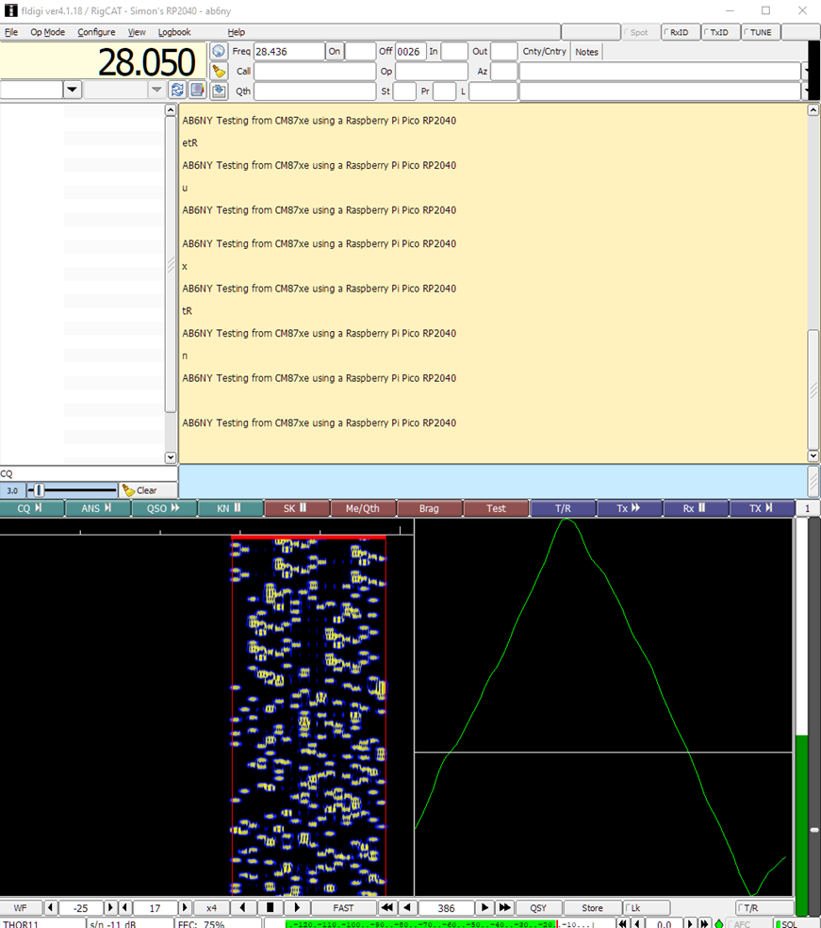

Image by the author

What if we combined the forward error correction of MFSK with the robustness and ease of tuning of FSQ and DominoEX?

We would get Thor.

The screenshot above shows Thor11, the 11 baud mode that gave us trouble in DominoEX.

The random characters in between the lines of perfect copy are noise from the radio during the periods when we weren’t sending.

Thor uses the same varicode as MFSK. It also has a shorter Thor varicode that is used to send callsigns when the system is idling. That looks like this:

thor_varicode = [  
 0b101110000000, # 032 - <SPC>   
 0b101110100000, # 033 - !   
 0b101110101000, # 034 - ’   
 0b101110101100, # 035 - #   
 0b101110110000, # 036 - $   
 0b101110110100, # 037 - %   
 0b101110111000, # 038 - &   
 0b101110111100, # 039 - ‘   
 0b101111000000, # 040 - (   
 0b101111010000, # 041 - )   
 0b101111010100, # 042 - *   
 0b101111011000, # 043 - +   
 0b101111011100, # 044 - ,   
 0b101111100000, # 045 - -   
 0b101111101000, # 046 - .   
 0b101111101100, # 047 - /   
 0b101111110000, # 048 - 0   
 0b101111110100, # 049 - 1   
 0b101111111000, # 050 - 2   
 0b101111111100, # 051 - 3   
 0b110000000000, # 052 - 4   
 0b110100000000, # 053 - 5   
 0b110101000000, # 054 - 6   
 0b110101010100, # 055 - 7   
 0b110101011000, # 056 - 8   
 0b110101011100, # 057 - 9   
 0b110101100000, # 058 - :   
 0b110101101000, # 059 - ;   
 0b110101101100, # 060 - <   
 0b110101110000, # 061 - =   
 0b110101110100, # 062 - >   
 0b110101111000, # 063 - ?   
 0b110101111100, # 064 - @   
 0b110110000000, # 065 - A   
 0b110110100000, # 066 - B   
 0b110110101000, # 067 - C   
 0b110110101100, # 068 - D   
 0b110110110000, # 069 - E   
 0b110110110100, # 070 - F   
 0b110110111000, # 071 - G   
 0b110110111100, # 072 - H   
 0b110111000000, # 073 - I   
 0b110111010000, # 074 - J   
 0b110111010100, # 075 - K   
 0b110111011000, # 076 - L   
 0b110111011100, # 077 - M   
 0b110111100000, # 078 - N   
 0b110111101000, # 079 - O   
 0b110111101100, # 080 - P   
 0b110111110000, # 081 - Q   
 0b110111110100, # 082 - R   
 0b110111111000, # 083 - S   
 0b110111111100, # 084 - T   
 0b111000000000, # 085 - U   
 0b111010000000, # 086 - V   
 0b111010100000, # 087 - W   
 0b111010101100, # 088 - X   
 0b111010110000, # 089 - Y   
 0b111010110100, # 090 - Z   
 0b111010111000, # 091 - [   
 0b111010111100, # 092 - \   
 0b111011000000, # 093 - ]   
 0b111011010000, # 094 - ^   
 0b111011010100, # 095 - _   
 0b111011011000, # 096 - `   
 0b111011011100, # 097 - a   
 0b111011100000, # 098 - b   
 0b111011101000, # 099 - c   
 0b111011101100, # 100 - d   
 0b111011110000, # 101 - e   
 0b111011110100, # 102 - f   
 0b111011111000, # 103 - g   
 0b111011111100, # 104 - h   
 0b111100000000, # 105 - i   
 0b111101000000, # 106 - j   
 0b111101010000, # 107 - k   
 0b111101010100, # 108 - l   
 0b111101011000, # 109 - m   
 0b111101011100, # 110 - n   
 0b111101100000, # 111 - o   
 0b111101101000, # 112 - p   
 0b111101101100, # 113 - q   
 0b111101110000, # 114 - r   
 0b111101110100, # 115 - s   
 0b111101111000, # 116 - t   
 0b111101111100, # 117 - u   
 0b111110000000, # 118 - v   
 0b111110100000, # 119 - w   
 0b111110101000, # 120 - x   
 0b111110101100, # 121 - y   
 0b111110110000 # 122 - z   
]

The thor_config.py module looks familiar by now:

from thor import THOR  
from time import sleep_ms, sleep  
from machine import Timer  
from radio import Radio  
  
class ThorConfig:  
 def __init__(self, baud, frq, call, location):  
 self.dds = Radio()  
 self.dds.on()  
 self.dds.send()  
  
 self.radio_timer = Timer()  
  
 self.baud = baud  
 self.message = ''  
 self.frequency = frq  
 self.usb_offset = 1133  
 self.all_done = False  
 self.call = call  
 self.location = location  
  
 self.r = THOR(self.radio_timer, self.send_tone, self.report_all_done)  
  
 self.r.set_call(call)  
 self.r.set_location(location)  
 self.r.set_frequency(float(frq))  
 self.r.symbits = 4  
 self.r.depth = 10  
 self.r.numtones = 18  
 self.r.preamble = 4  
  
 if baud == 2: # 2.0 baud  
 self.r.samplerate = 8000.0  
 self.r.symlen = 4000.0  
 self.r.doublespaced = 1  
 self.r.depth = 4  
 elif baud == 4: # 3.90625 baud  
 self.r.samplerate = 8000.0  
 self.r.symlen = 2048.0  
 self.r.doublespaced = 2  
 elif baud == 5: # 5.38330078125 baud  
 self.r.samplerate = 11025.0  
 self.r.symlen = 2048.0  
 self.r.doublespaced = 2  
 elif baud == 8: # 7.8125 baud  
 self.r.samplerate = 8000.0  
 self.r.symlen = 1024.0  
 self.r.doublespaced = 2  
 elif baud == 11: # 10.7666015625 baud  
 self.r.samplerate = 11025.0  
 self.r.symlen = 1024.0  
 self.r.doublespaced = 1  
 elif baud == 16: # 15.625 baud  
 self.r.samplerate = 8000.0  
 self.r.symlen = 512.0  
 self.r.doublespaced = 1  
 elif baud == 22: # 21.533203125 baud  
 self.r.samplerate = 11025.0  
 self.r.symlen = 512.0  
 self.r.doublespaced = 1  
  
 self.r.tonespacing = self.r.samplerate / self.r.symlen  
  
 self.r.init_params()  
  
 print(”Frequency:”, self.frequency)  
 print(”Symbits is”, self.r.symbits)  
 print(”Depth is”, self.r.depth)  
 print(”Bandwidth is”, (self.r.numtones - 1) * self.r.tonespacing)  
 print(”Symbol length is”, self.r.symlen)  
 print(”Baud is”, self.r.samplerate / self.r.symlen)  
 print(”Bit length is”, self.r.bit_length)  
 print(”Tonespacing is”, str(self.r.tonespacing))  
  
 def get_radio(self):  
 return self.dss  
  
 def set_message(self, msg):  
 self.r.set_message(msg.format(self.call, self.location))  
 self.dds.on()  
 self.dds.send()  
 self.r.send_code()  
  
 def send_code(self):  
 self.r.send_code()  
   
 def send_tone(self, tone):  
 self.f = float(float(self.frequency) + self.usb_offset + float(tone))  
 self.dds.set_freq(0, self.f)  
 self.dds.on()  
 self.dds.send()  
  
 def report_all_done(self):  
 self.all_done = True  
 print(”All done!”)

As with DominoEX, most of the code is just setting up the different baud rates.

The real work is done in the thor.py module:

from thor_varicode import thor_varicode  
from mfsk_varicode import mfsk_varicode  
from machine import Timer  
  
class THOR:  
  
 NASA_K = 7  
 POLY1 = 0x6D  
 POLY2 = 0x4F  
  
 def __init__(self, timr, send_tone, report_message_end=None):  
 self.timer = timr  
 self.send_tone = send_tone  
 self.report_message_end = report_message_end  
 self.QUEUE_LENGTH = 80  
  
 #  
 # Default is THOR MICRO  
 #  
 self.symbits = 4  
 self.symlen = 4000  
 self.samplerate = 8000  
 self.depth = 4  
 self.doublespaced = 1  
 self.basetone = 256  
 self.numtones = 18  
 self.preamble = 10  
 self.timer_running = False  
 self.bandwidth = 0  
 self.tonespacing = 0  
 self.secondary = False  
 self.previous_tone = 0  
  
 self.frequency = 7104000.0  
 self.call = ''  
 self.location = ''  
 self.message = "{} {} "  
 self.count_tabs = 0  
 self.has_bits = False  
 self.sym_queue = []  
  
 # Initialization for the forward error correction  
 self.encoder_output = [0] * (1 << self.NASA_K)  
 self.mask = (1 << self.NASA_K) - 1  
 self.encode_state = 0  
 self.bit_count = 0  
 self.bit_state = 0  
  
 # Code for the forward error correction  
 def init_encoder(self):  
 self.interleave_table = [8] * (self.symbits * self.symbits * self.depth)  
 for x in range(1 << self.NASA_K):  
 self.encoder_output[x] = (self.parity(self.POLY1 & x) | (self.parity(self.POLY2 &x) << 1))  
 self.flush_interleave_table()  
  
 # Hamming weight (the number of bits that are ones)  
 def hamming_weight(self, w):  
 w = (w & 0x55555555) + ((w >> 1) & 0x55555555)  
 w = (w & 0x33333333) + ((w >> 2) & 0x33333333)  
 w = (w & 0x0F0F0F0F) + ((w >> 4) & 0x0F0F0F0F)  
 w = (w & 0x00FF00FF) + ((w >> 8) & 0x00FF00FF)  
 w = (w & 0x0000FFFF) + ((w >> 16) & 0x0000FFFF)  
 return w  
  
 def parity(self, w):  
 return self.hamming_weight(w) & 1  
  
 def encode(self, bit):  
 self.encode_state <<= 1  
 if bit == “1”:  
 self.encode_state |= 1  
  
 return self.encoder_output[self.encode_state & self.mask]  
  
 def set_call(self, call):  
 self.call = call  
  
 def set_baud(self, baud):  
 self.baud = float(baud)  
  
 def set_bit_length(self, len):  
 self.bit_length = 1000000.0 / float(self.baud)  
  
 def set_frequency(self, frequency):  
 self.frequency = float(frequency)  
  
 def set_location(self, location):  
 self.location = location  
  
 def set_message(self, message):  
 self.message = “\r” + chr(2) + “\r” + message + “\r” + chr(0) + “\r”  
 self.message += chr(0) + chr(0) + chr(0) + chr(0) + chr(0) + chr(0) + chr(0)  
 self.message += chr(0) + chr(0) + chr(0) + chr(0) + chr(0) + chr(0) + chr(0)  
 self.has_bits = True  
  
 def init_params(self):  
 self.set_baud(self.samplerate / self.symlen)  
 self.tonespacing = self.samplerate * self.doublespaced / self.symlen  
 self.bandwidth = (self.numtones - 1) * self.tonespacing  
 self.basetone = int(1500.0 * self.symlen / self.samplerate + 0.5)  
 self.bit_length = 1000000.0 / float(self.baud)  
  
 def bit(self):  
 for letter in self.message:  
 code = mfsk_varicode[0]  
 if self.secondary:  
 if ord(letter) >= 0 and ord(letter) < 256:  
 code = thor_varicode[ord(letter) & 255]  
 else:  
 code = mfsk_varicode[ord(letter) & 255]  
  
 for bit in bin(code)[2:]:  
 yield bit  
  
 def stop(self):  
 self.timer.deinit()  
 self.timer_running = False  
  
 def send_code(self):  
 self.init_params()  
 self.init_encoder()  
  
 self.is_done = False  
 self.clearbits()  
 self.gen = self.bit()  
 if self.timer_running == False:  
 self.timer.init(period=int(self.bit_length/1000), mode=Timer.PERIODIC, callback=self.next_tone)  
 self.timer_running = True  
 self.reported_end = False  
 self.has_bits = True  
  
 # Send 64 zero bits to flush the receive decoder  
 for x in range(16):  
 self.bit_state = 0  
 self.send_symbol()  
  
 while self.has_bits:  
 bit = self.get_bit()  
 self.send_bit(bit)  
  
 self.flush_tx(self.preamble)  
  
 def get_bit(self):  
 try:  
 bit = next(self.gen)  
 except StopIteration as e:  
 self.has_bits = False  
 return None  
 return bit  
  
 def send_bit(self, bit):  
 try:  
 data = self.encode(bit)  
 for x in range(2):  
 self.bit_state = (self.bit_state << 1) | ((data >> x) & 1)  
 self.bit_count += 1  
  
 if self.bit_count == self.symbits:  
 self.interleave()  
 self.send_symbol()  
 self.bit_count = 0  
 self.bit_state = 0  
 except Exception as e:  
 print(”Error:”, e)  
  
 def clearbits(self):  
 data = self.encode(0)  
 for x in range(1400):  
 for y in range(2):  
 self.bit_state = (self.bit_state << 1) | ((data >> x) & 1)  
 self.bit_count += 1  
 if self.bit_count == self.symbits:  
 self.interleave()  
 self.bit_count = 0  
 self.bit_state = 0  
  
 def interleave_get(self, x, y, z):  
 index = self.symbits * self.symbits * x + self.symbits * y + z  
 return self.interleave_table[index]  
  
 def interleave_put(self, x, y, z, val):  
 index = self.symbits * self.symbits * x + self.symbits * y + z  
 self.interleave_table[index] = val  
  
 def symbols(self):  
 for x in range(self.depth):  
 for y in range(self.symbits):  
 for z in range(self.symbits - 1):  
 self.interleave_put(x, y, z, self.interleave_get(x, y, z + 1))  
  
 for y in range(self.symbits):  
 self.interleave_put(x, y, self.symbits-1, self.syms[y])  
  
 for y in range(self.symbits):  
 self.syms[y] = self.interleave_get(x, y, self.symbits - y - 1)  
  
 def interleave(self):  
 self.syms = []  
 for x in range(self.symbits):  
 self.syms.append(self.bit_state >> ((self.symbits - x - 1)) & 1)  
  
 self.symbols()  
  
 self.bit_state = 0  
 for x in range(self.symbits):  
 self.bit_state = (self.bit_state << 1) | self.syms[x]  
  
 def flush_interleave_table(self):  
 for x in range(len(self.interleave_table)):  
 self.interleave_table[x] = 0  
  
 def flush_tx(self, preamble):  
 for x in range(preamble):  
 self.sendidle();  
 self.bit_state = 0  
 self.is_done = True  
 self.report_message_end()  
  
 def send_symbol(self):  
 from time import sleep_ms  
 sym = self.bit_state  
 while len(self.sym_queue) > self.QUEUE_LENGTH:  
 sleep_ms(int(self.bit_length / 50000)) # Needed so ^C works  
 self.sym_queue.append(sym)  
  
 def sendchar(self, letter, secondary):  
 code = mfsk_varicode[0]  
 if self.secondary:  
 if ord(letter) >= 0 and ord(letter) < 256:  
 code = thor_varicode[ord(letter) & 255]  
 else:  
 code = mfsk_varicode[ord(letter) & 255]  
  
 for bit in bin(code)[2:]:  
 self.send_bit(bit);  
  
 def sendidle(self):  
 for x in range(8):  
 self.sendchar(chr(0), 0);  
  
 def next_tone(self, unused):  
 if self.sym_queue:  
 sym = self.sym_queue.pop(0)  
 tone = (self.previous_tone + 2 + sym) % self.numtones  
 self.previous_tone = tone  
 self.send_tone(self.basetone + tone * self.tonespacing)

A lot of the code is the NASA 7 forward error correction code borrowed from MFSK. Then we have our bit() generator and our send_code() method.

The send_code() method is a little bit larger than we are used to, since it has to worry about flushing the receiver’s decoder before sending real bits, and then sending the idle preamble.

Because of the forward error correction, the symbols are placed in a queue for sending, which is what send_symbol() manages. The send_char() method sends from either the Thor or the MFSK varicode tables, depending on its argument.

[Amateur Radio](https://medium.com/tag/amateur-radio?source=post_page-----e087e368f3aa---------------------------------------)

[Python Programming](https://medium.com/tag/python-programming?source=post_page-----e087e368f3aa---------------------------------------)