# Python Radio 11: Power

[Simon Quellen Field](https://medium.com/@simon.field_37276?source=post_page---byline--461507945221---------------------------------------)

[Simon Quellen Field](https://medium.com/@simon.field_37276?source=post_page---byline--461507945221---------------------------------------)

Follow

6 min read

·

Aug 28, 2024

Listen

Share

More

Let’s get some watts out…

Press enter or click to view image in full size



MidJourney

The Raspberry Pi Pico (RP2040) delivers about 3.8 milliwatts of power to a pin (when transmitting at about 7 megahertz). You can (as we will see later) do some amazing things with only this small amount of power. The ARRL has an award you can win called the 1,000 miles per watt award, as does the NAQCC. This is often won by reducing power to levels the RP2040 can reach. Connect your RP2040 to a cheap end-fed half-wave antenna and contact someone 4 miles away and you win.

But many people would like more power. This is where an amplifier comes in handy.

CW is one of the easiest modes to amplify since it is not picky about fidelity. We can use a Class C amplifier and get efficiencies between 75% and over 90%, making it easier on batteries if we go portable.

To make our amplifier, we will be using an RF power transistor. Specifically, a cheap 2SC2078 transistor.

We will use our transistor as a switch. Our transistor has three pins, called the base, the collector, and the emitter. The collector is connected to the positive side of the battery. The emitter is connected to the negative side of the battery. If we put a small positive voltage on the base (such as the 3.3 volts from an RP2040 pin), the transistor will turn on, and get quite hot as it shorts out the battery. So we won’t do that.

Instead, we will use an inductor and a capacitor (or two) to make a resonant circuit tuned to the frequency range we are interested in (in this case, the range of 7.0 MHz to 7.3 MHz, known as the 40-meter band for the length of its waves).

If we send a brief pulse of current into our resonant circuit, it will ring like a bell, making waves at 7 MHz that quickly die out. This is like giving a child on a swing just one push. This will not be the happiest kid in the playground.

However, if we give the swing a push every time it comes back to us, we get a steady rhythm whose frequency is determined mostly by the length of the ropes, but also to some extent by exactly how often we push.

We can set up our circuit like this:

Press enter or click to view image in full size

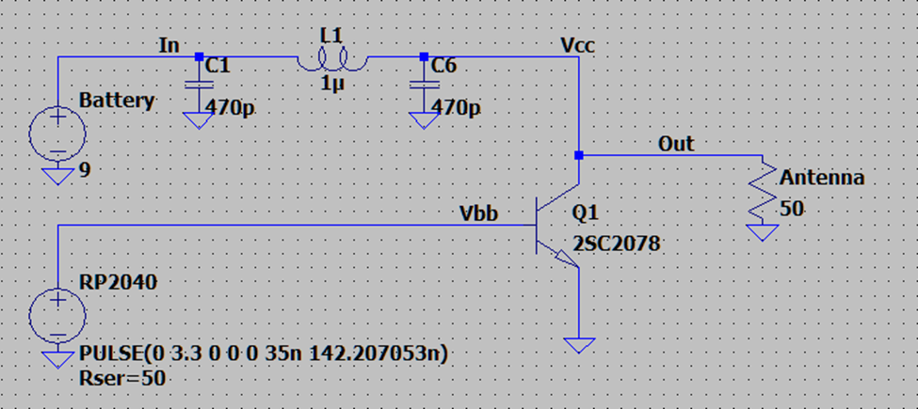

Image by author

This schematic was taken from the free software package LTSpice from Linear Technologies. It allows us to simulate our circuit on the computer and test our assumptions and fine-tune our understanding.

The coil and two capacitors up at the top should be familiar. That is our low-pass filter. When the transistor is turned on (by getting a 3.3-volt pulse from the RP2040) the capacitors charge and the coil builds up a magnetic field. When the transistor switches off, the field collapses, inducing a current in the coil that is aided by the capacitors that are now discharging.

That current now goes out to the antenna, since the transistor looks like an open switch when its base is at zero volts.

What is interesting is that because the current from the coil and the capacitors is added to the current from the battery, the voltage at the antenna is almost twice the battery voltage. In the simulation, we get 5.6 watts out to the antenna, instead of the 3.8 milliwatts we previously got from the RP2040.

In our previous transmitter, we sent a square wave to the antenna. If we sent a square wave to our amplifier, the transistor would be turned on half the time. The efficiency would only be about 25%, and we would be dissipating almost 20 watts in the transistor, and getting about 11 watts out. Our battery would last seconds, and it and the transistor would get dangerously hot.

Instead, we only turn the transistor on for a quarter of the time. In this case, the period of the pulses is 142.207053 nanoseconds (7032000 hertz), and the pulse width is 35 nanoseconds.

Things are looking good so far. But our waveform doesn’t look like the nice clean sine wave we need before we connect our transmitter to an antenna:

Press enter or click to view image in full size

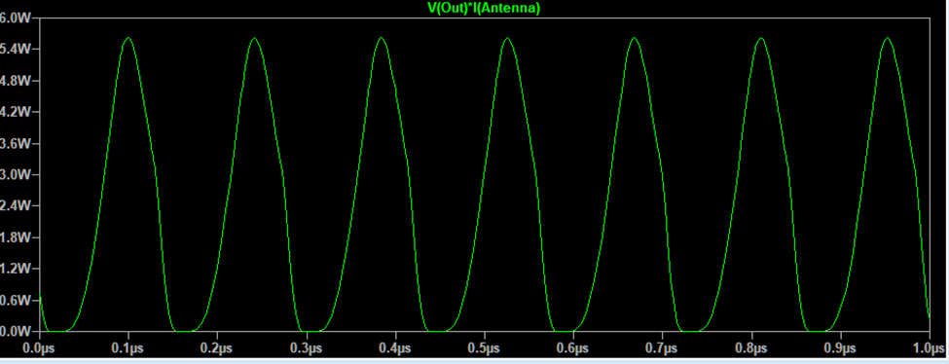

Image by author

The tops of the peaks are sharp points, and the bottoms are flattened at zero.

The distortion is even easier to see when we look at it in the frequency domain, after doing a fast Fourier transform:

Press enter or click to view image in full size

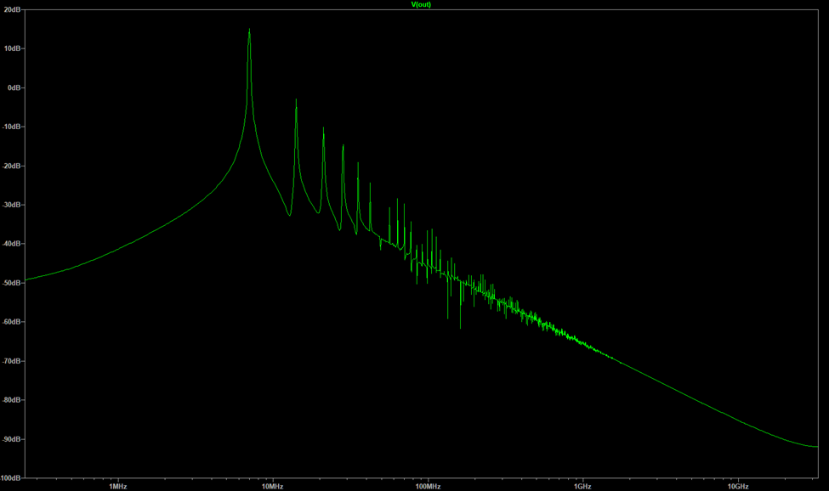

Image by author

We want to see a single peak at the fundamental frequency (7032000 hertz), without all those peaks at the harmonic frequencies. People listening to all of those other frequencies don’t want to hear us.

Let’s see what we can do to fix that.

For one thing, we have an impedance mismatch between the RP2040 and the base of the transistor. The RP2040 has an output impedance of around 50 ohms (I measured 46 ohms, which is close enough). The transistor base would like to see about 11 ohms.

We can use a pi network filter to fix that. There are pi network impedance matching calculators on the web, and they tell us that a 0.66 Henry coil, an 820 picofarad capacitor, and a 1,000 picofarad capacitor will give us the proper match:

Press enter or click to view image in full size

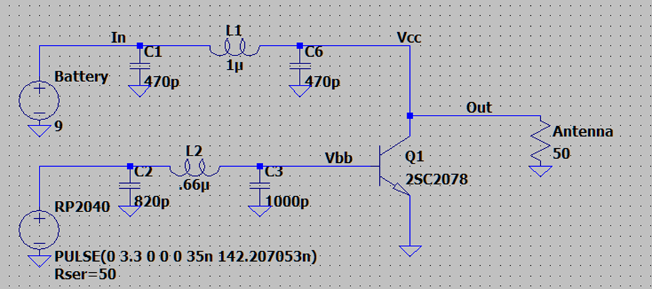

Image by author

Our output power just jumped from 5.62 watts and 16.86% harmonic distortion to 6.81 watts and 13.89% distortion. Better, but still not something we want on the air. Since our efficiency is still up at almost 90%, it is time to sacrifice some of that output power for spectral purity. We’ll aim for about 3 watts, and settle for 70% efficiency. We’ll start by looking at the output impedance of the transistor, and match it to the antenna.

The output impedance is the voltage squared divided by twice the output power in watts. The voltage is 9 volts, which is 81 when squared. The output power we said would be 3 watts, so 81 divided by 6 is 13.5 ohms of output impedance. If we use a transformer to match the impedance to the antenna, we would want a 1:3.7 ratio for the inductances in each coil. By running different numbers through the simulation, we find that a 1:2.3 ratio gives us the highest power (3.25 watts) but something like 1:0.6 gives us better spectral purity. So we get to choose, trading off power for beauty.

The FCC is happy if our second harmonic is 43 dB down from the first. If I pick a 1:2 ratio for the transformer and follow it with a 5-pole filter, I get my 3 watts, and my harmonics are over 47 dB down, giving us room for component values that might be off by 5% or more when we actually build the device.

The simulation shows a beautiful sine wave:

Press enter or click to view image in full size

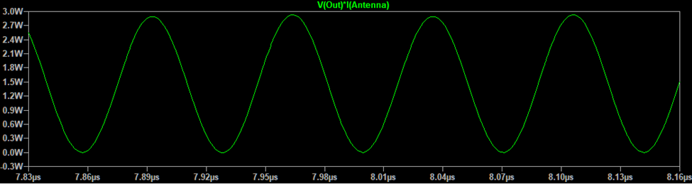

Image by author

and a very clean spectral plot:

Press enter or click to view image in full size

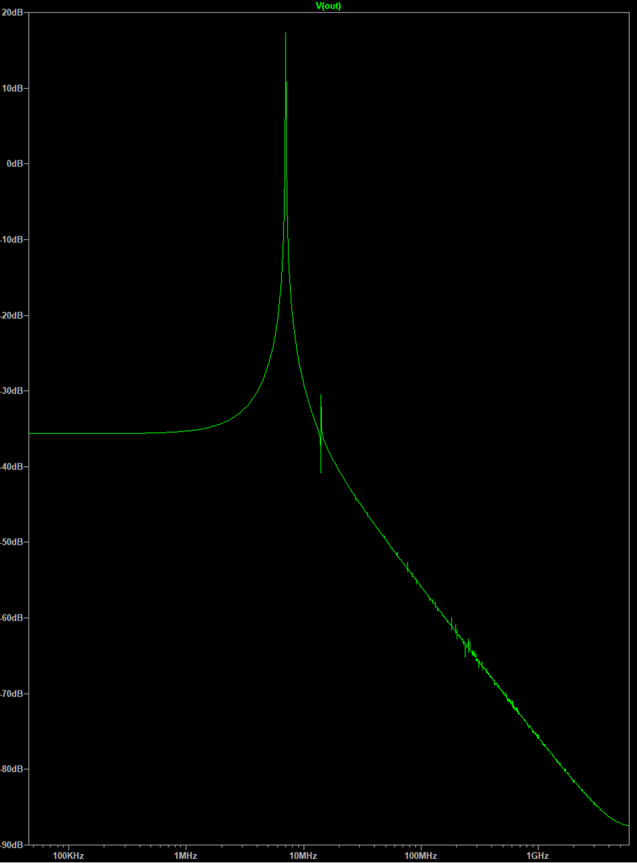

Image by author

Our final schematic looks like this:

Press enter or click to view image in full size

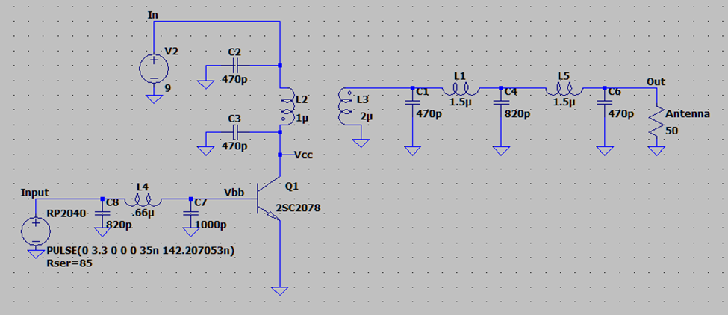

Image by author

[Radio Transmitter](https://medium.com/tag/radio-transmitter?source=post_page-----461507945221---------------------------------------)

[Rp2040](https://medium.com/tag/rp2040?source=post_page-----461507945221---------------------------------------)

[Rf Power Amplifiers](https://medium.com/tag/rf-power-amplifiers?source=post_page-----461507945221---------------------------------------)

[Rf Filters](https://medium.com/tag/rf-filters?source=post_page-----461507945221---------------------------------------)