# RF Survival Guide — Part 2

## **S-Parameters Demystified**

[](https://medium.com/@armando_rodrigues?source=post_page---byline--a7e7510d6dd4---------------------------------------)

[Armando Rodrigues](https://medium.com/@armando_rodrigues?source=post_page---byline--a7e7510d6dd4---------------------------------------)

Follow

5 min read

·

Apr 16, 2025

Listen

Share

More

Press enter or click to view image in full size

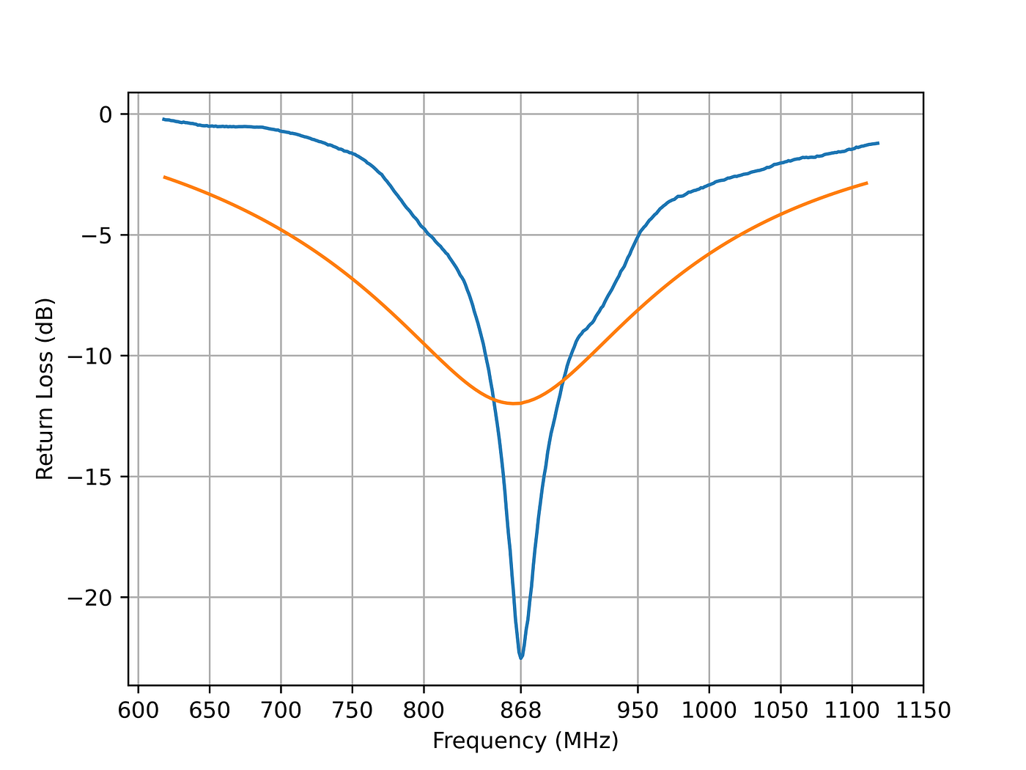

Generic input reflection coefficient measurements for LoRa antennas.

Welcome back, RF hobbyists!  
In Part 1 of the RF Survival Guide, we explored the chaotic beauty of RF jargon. Today, we dive into a deceptively simple yet powerful tool in any RF engineer’s toolbox: scattering parameters.

If you’ve ever used a VNA (Vector Network Analyzer) spitting out a bunch of curves labeled S11, S21, and thought, “this must be sorcery,” you’re not alone! But fear not — by the end of this guide, you’ll see that S-parameters are just a clever way of describing how RF components behave.

## What Are S-Parameters?

S-parameters, or scattering parameters, tell you how signals scatter when they hit a device. In plain terms:

* How much of each input signal gets reflected back?
* How much of each input signal gets transmitted through to each output?

For a 2-port device (like an amplifier, filter, or cable), you typically see:

* **S11:**Input reflection coefficient at port 1 (input return loss);
* **S21:**Transmission coefficient from port 1 to port 2 (forward gain/forward loss/isolation)
* **S12** : Transmission coefficient from port 2 to port 1 (reverse gain/reverse loss/reverse isolation)
* **S22:**Output reflection coefficient at port 2 (output return loss)

## Using S-Parameters to Check Antenna Matching

Let’s say you just designed a tiny antenna for your latest IoT project. You hook it up to a Vector Network Analyzer (VNA), and it gives you a plot of S11 across frequencies. So, how do you know if the antenna is matched?

S11 represents how much of the power sent into port 1 is reflected back. So:

* If |S11| is close to 0 (or in dB,-10 dB or lower), that means very little is being reflected, which is what we want. It means the antenna is well matched to the system impedance (typically 50 ohms) at that frequency.
* If |S11| is close to 1 (or 0 dB), it means almost all the power is bouncing back. Not great!

But where does the power go if it isn’t reflected?

In a simple case (like an antenna directly connected to the VNA), any power that isn’t reflected is either radiated into space or lost as heat. Since antennas are meant to radiate, a low S11 typically means most power is radiating effectively. Also, if your antenna goes through a matching network, part of that power might be lost in resistive componentsor reflected back by mismatched stages. S11 doesn’t tell you where the power goes — only how much is reflected. The rest could be radiated, lost, or absorbed. That’s why we combine S-parameter analysis with efficiency or gain measurements when testing antennas. When we measure the realized gain of an antenna, we can actually know how much of that unreflected power is actually radiated.

### A Few Examples

In the images shown below, you can see the difference in S11 between a narrow-band Printed Inverted-F Antenna, tuned for 868MHz, with around 50MHz bandwidth and a sharp resonance:

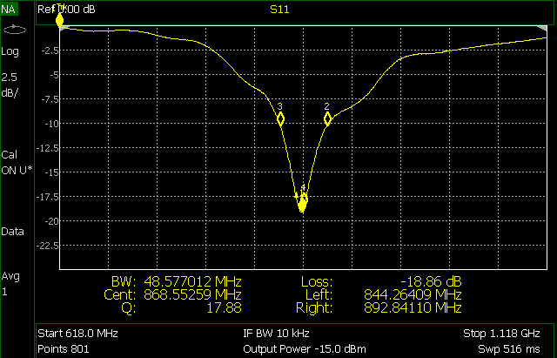

And a very wideband log-periodic antenna that can work well in the complete frequency range that is shown, having at least 500MHz bandwidth:

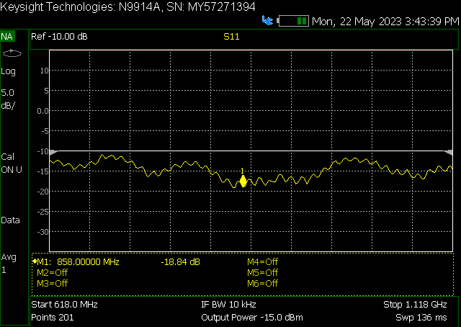

## Using S-Parameters to Get Cable Loss

Whether you’re working with short interconnects inside a device or long coaxial runs in automotive or aerospace systems, knowing how much signal you’re losing is crucial. Fortunately, S-parameters can give us that information directly — no need for guesswork or rule-of-thumb estimations.

To measure cable loss, you typically look at S21, the forward transmission coefficient. In an ideal, lossless cable, S21 would be 0 dB across your frequency of interest, meaning all your power gets through. But, real cables introduce attenuation, and that shows up as a drop in the S21 magnitude. The difference from 0 dB gives you the insertion loss introduced by the cable.

You can also use S11 to check for mismatches or reflections. A well-matched cable should have an S11 close to -20 dB or lower. High reflection could indicate poor connectors, improper termination, or even physical damage to the cable.

### One Example

Looking at the S21 of this random cable, you can see it has an insertion loss of around 0.3–0.5 dB:

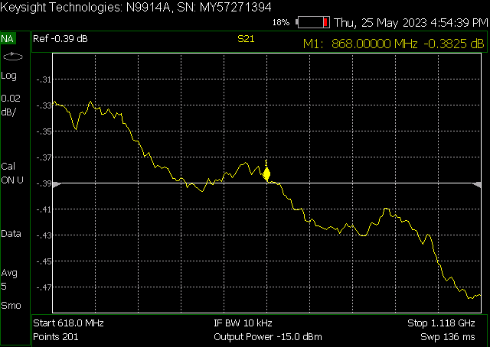

## Using S-Parameters to Analyze Amplifiers

Amplifiers are one of the most common — and most critical — components in RF systems. Whether you’re boosting a signal before transmission or cleaning up a weak one after reception, you want to be sure your amplifier is doing what it’s supposed to do. S-parameters can help you check some of the most important amplifier parameters:

* **S21 (Gain):** This is the star of the show. The magnitude of S21 (in dB) tells you how much gain your amplifier provides across the frequency range. A flat and high S21 is usually what you’re after.
* **S11 (Input Match):**This shows how well the amplifier input is matched to the system impedance, typically 50 ohms. Poor input match leads to reflections, which can reduce system efficiency or even cause instability.
* **S22 (Output Match):** Same concept, but at the output. If the amplifier is going to drive another stage or a transmission line, you want minimal reflection here too.
* **S12 (Reverse Isolation):** In a perfect world, an amplifier should be unilateral, meaning no signal should leak from output back to input. S12 gives you an idea of how much reverse signal is getting through. Low S12 (-30 dB) is ideal and helps prevent oscillations in cascaded systems.

When working with amplifiers, one should look at stability circles, gaincompression, intermodulation and noise figure, but S-parameters alone are not enough to check all of these parameters. They help me flag issues early, long before building or testing anything physical. If you’re designing LNA stages or evaluating power amplifiers in a transmission chain, starting with S-parameters gives you a solid foundation. For more details about RF amplifiers, make sure you stick around for future parts of this RF survival guide!

[Rf](https://medium.com/tag/rf?source=post_page-----a7e7510d6dd4---------------------------------------)

[Engineering](https://medium.com/tag/engineering?source=post_page-----a7e7510d6dd4---------------------------------------)

[Electronics](https://medium.com/tag/electronics?source=post_page-----a7e7510d6dd4---------------------------------------)