# RF Survival Guide — Part 3

## **PCB Transmission Lines**

[](https://medium.com/@armando_rodrigues?source=post_page---byline--297ed180134e---------------------------------------)

[Armando Rodrigues](https://medium.com/@armando_rodrigues?source=post_page---byline--297ed180134e---------------------------------------)

Follow

3 min read

·

Aug 1, 2025

Listen

Share

More

Unless your antenna is very, very close to your RF feed source, you will always need a transmission line to carry high-frequency signals from one place to another. Outside PCB boards, you can use already-made cables and waveguides, which are specifically designed for that purpose. But if working with PCBs, you need to design these transmission lines yourself!

This article covers some basic types of PCB transmission lines and the pros and cons of each, to help you decide on which to use for your next RF PCB project!

## Coplanar Waveguides

Press enter or click to view image in full size



**CPWG Example -> H:**Substrate Thickness; **εᵣ:** Relative Permittivity; **G:** Trace-GND Gap; **W:**Trace width; **T:**Copper Thickness

Coplanar waveguides are so common that they can even be implemented at an IC level!

A Coplanar Waveguide (CPW) is a type of transmission line where the signal conductor and the return paths (ground planes) are all printed on the same side of the PCB. The signal trace runs in the middle, flanked by two ground planes with a consistent gap. Beneath the substrate, an optional ground plane can be added to improve shielding and lower loss, forming what’s often referred to as a coplanar waveguide with ground (CPWG).

The characteristic impedance is determined by the trace width and thickness, substrate height and dielectric constant and the gap to the ground planes.

## Stripline

Press enter or click to view image in full size

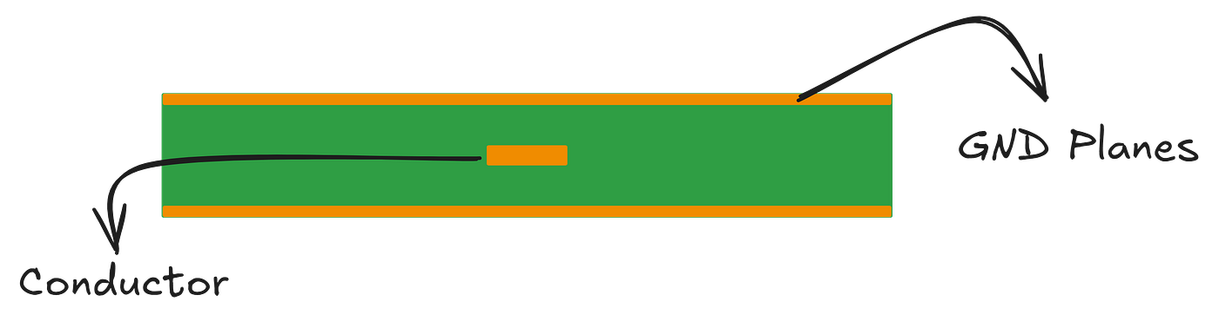

Very simple sketch I made, describing a stripline implementation on a PCB.

A stripline consists of a conductor sandwiched between two ground planes. The characteristic impedance is determined by the strip width, the substrate thickness, and the substrate’s relative permittivity.

Like in many other PCB transmission lines, via stitching can be used to short the two ground planes along the edges of the planes, avoiding propagation of unwanted modes. Striplines are more expensive than other transmission lines, as they require 3-layer PCBs, but they provide better isolation due to the conductor being encapsulated inside metallic planes.

## Microstrip

Press enter or click to view image in full size



Simples visualization of a microstrip transmission line.

A microstrip does not necessarily need to be implemented on a PCB, but it most commonly is. It is a type of transmission line where a conductor is placed on top of a ground plane and separated by a dielectric. By carefully designing the thickness of the dielectric and the conductor, the width of the conductor and the dielectric constant of the dielectric, one can tune the transmission line to have the intended characteristic impedance.

Micro strips only require 2-layer PCBs, making them more compact, lighter and cheaper than stripline technology. However, due to not being enclosed, microstrips are more susceptible to crosstalk and can easily radiate if they are close in length to the guided wavelength.

## Designing a PCB Transmission Line

Press enter or click to view image in full size

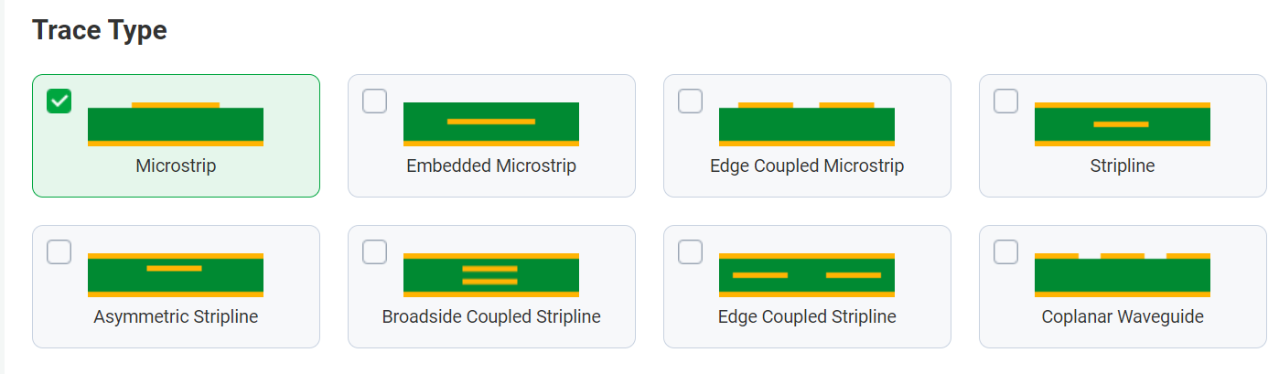

All tx line types available at PCB Way’s online calculator.

While professional tools like Keysight ADS or Ansys HFSS offer advanced simulation and tuning capabilities, most hobbyist and low-complexity projects can rely on online calculators or tools provided by PCB manufacturers, such as [this one](https://www.pcbway.com/pcb_prototype/impedance_calculator.html) from PCBWay.

[Rf](https://medium.com/tag/rf?source=post_page-----297ed180134e---------------------------------------)

[Pcb Design](https://medium.com/tag/pcb-design?source=post_page-----297ed180134e---------------------------------------)

[Pcb](https://medium.com/tag/pcb?source=post_page-----297ed180134e---------------------------------------)