THE WOFLCORP. MIL. & IND. DIV.

COMPACT MINING RIG 04
A Comprehensive Technical Analysis of Modular Resource Extraction Infrastructure
"Function. Defence. Expandability."
From Rapid Deployment to Long-Term Operations:
Design Philosophy and Engineering Implementation
Postdoctoral Thesis
Presented to the Department of Modular Infrastructure Engineering
Kepler Institute for Orbital and Exo-Planetary Infrastructure
BA Class 1 | Unlock Level 15 | 100,000 CPU
Document Reference: WOFL-MID-CMR04-THESIS

Abstract
This thesis presents a comprehensive technical analysis of the Woflcorp. Military and Industrial Division's Compact Mining Rig 04, a small-footprint modular base system optimized for autonomous resource extraction operations in hostile environments. The Rig 04 represents the culmination of an iterative design process that began with the original Platform 01, incorporating lessons learned from field deployment under Alpha 10-standard combat conditions. Through detailed examination of power systems, defensive architecture, material selection, and expandability features, this analysis demonstrates how Woflcorp. engineers achieved exceptional operational efficiency—60+ hours of autonomous operation on minimal fuel reserves—while maintaining robust defensive capabilities against drone, infantry, and light vehicle threats. The design's emphasis on ablative armor over expensive shielding, combined with intelligent component isolation and explosion buffer-walls, creates a cost-effective installation capable of surviving unsupported engagements with typical AI threat profiles. The modular expansion framework enables operators to scale defensive, storage, and processing capabilities without structural modification, supporting evolution from minimal-cost deployment to fully-equipped operational hubs.
Keywords: Modular base design, autominer protection, ablative armor systems, solar power optimization, defensive architecture, Alpha 10 compatibility, rapid deployment infrastructure

Table of Contents
1. Introduction and Design Philosophy
2. Historical Development: Platform Series Evolution
3. Structural Architecture and Material Selection
4. Power Systems Engineering
5. Defensive Capabilities and Threat Analysis
6. Autominer Integration and Processing Systems
7. Access and Logistics Infrastructure
8. CPU Architecture and System Efficiency
9. Expandability Framework
10. Operational Doctrine and Deployment Scenarios
11. Comparative Analysis and Performance Metrics
12. Conclusions and Future Development
Technical Appendices

1. Introduction and Design Philosophy

1.1 The Resource Extraction Challenge
Remote resource extraction in hostile environments presents a unique engineering challenge: operators require infrastructure that is simultaneously inexpensive to deploy, robust enough to survive attack, efficient enough to operate autonomously for extended periods, and flexible enough to adapt to evolving operational requirements. The Woflcorp. Compact Mining Rig 04 addresses each of these challenges through a design philosophy centered on three core principles: Function, Defence, and Expandability.
Unlike conventional mining installations that prioritize extraction capacity over survivability, the Rig 04 treats defense as a primary design constraint rather than an afterthought. This approach reflects operational experience in Alpha 10-standard threat environments where AI-controlled drone attacks, infantry incursions, and opportunistic raiding represent constant hazards to undefended resource nodes.

1.2 Core Design Tenets
The Rig 04 manifests Woflcorp.'s institutional philosophy through specific engineering choices. The emphasis on ablative armor over energy shielding reflects a conscious decision to minimize exotic resource requirements while maximizing damage absorption. The separation of core systems from the autominer compartment demonstrates awareness of AI targeting behaviors. The solar-primary power architecture with generator backup illustrates commitment to operational autonomy.
Perhaps most significantly, the design explicitly supports incremental capability enhancement without structural modification. Operators can evolve a minimal-cost installation into a fully-equipped operational hub as resources permit, preserving initial investment while scaling to meet emerging requirements.

2. Historical Development: Platform Series Evolution

2.1 Platform 01: Origins
The Compact Mining Rig 04 descends from the original Platform 01 design, which established the fundamental architectural concept of a small-footprint base optimized for autominer protection. Platform 01 demonstrated the viability of the approach but suffered from several limitations identified during field deployment, including inadequate core protection, vulnerable turret mountings, and accessibility issues that exposed operators to ground-based threats during landing operations.

2.2 Revision History and Lessons Learned
The November 2022 revision cycle (documented as '11/22/22') addressed critical vulnerabilities identified in Platform 01 through systematic structural improvements. Key modifications included: transition to armored concrete for the main enclosure and core surround, installation of solid concrete footings beneath turret emplacements to prevent shoot-off attacks, redesign of the landing pad geometry to reduce accessibility for enemy ground troops, and validation of compatibility with both vanilla and Reforged Eden configurations.
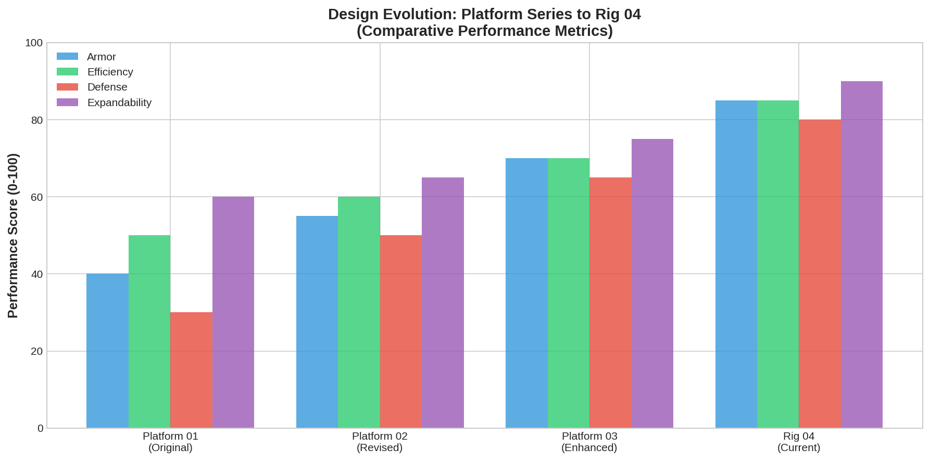
Figure 2.1: Design Evolution from Platform 01 to Compact Mining Rig 04

3. Structural Architecture and Material Selection

3.1 Material Philosophy: Ablative Armor
The Rig 04 employs an ablative armor philosophy that prioritizes mass-efficient damage absorption over energy-intensive shielding. This approach offers several advantages in remote deployment scenarios: elimination of shield generator power requirements, reduced exotic material demands, predictable damage progression that enables repair planning, and immunity to EMP and shield-disruption attacks.
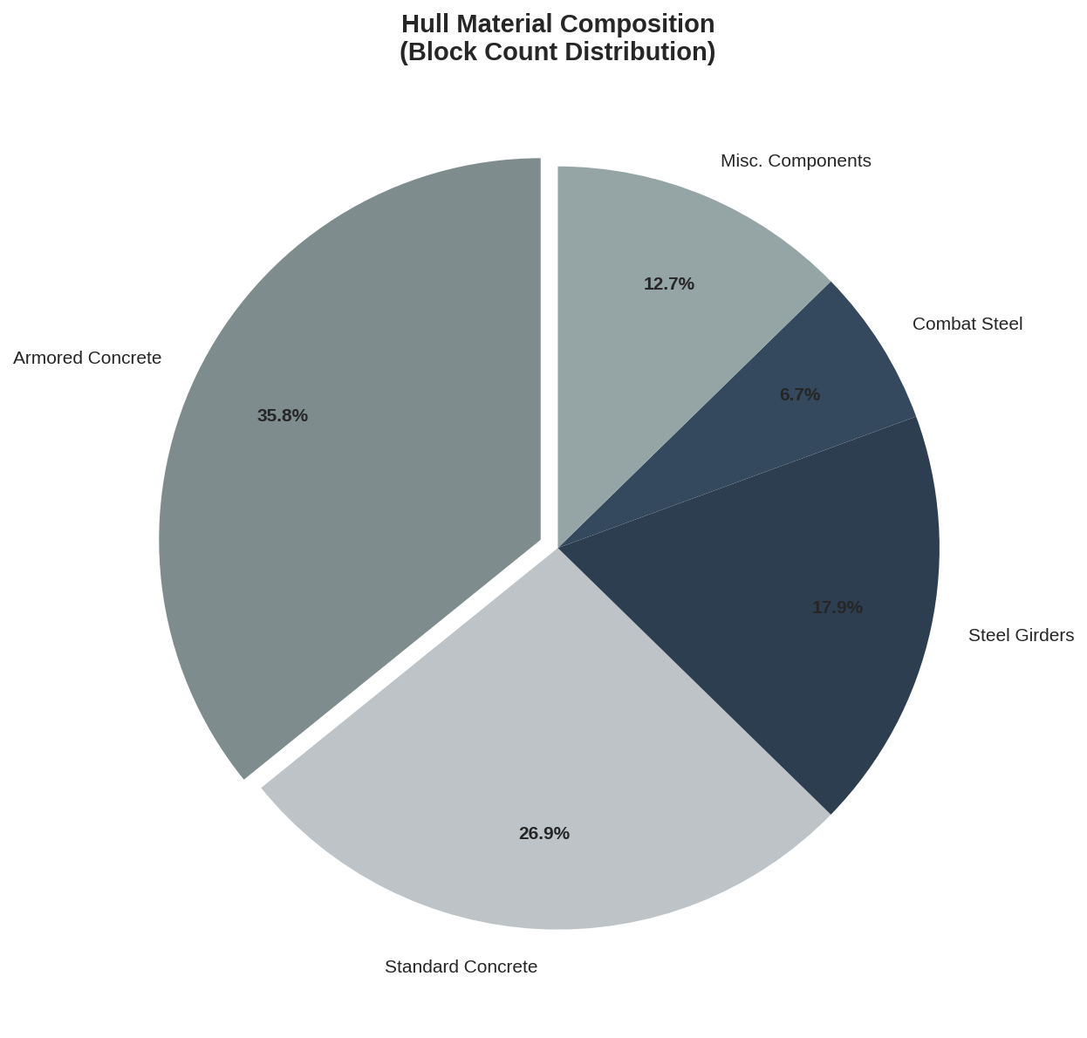
Figure 3.1: Hull Material Composition Distribution

3.2 Core Protection Architecture
The Rig 04 incorporates what documentation describes as '1080-degree armored core defense'—a spherical protection envelope that addresses threats from all approach vectors including overhead and subterranean. This configuration specifically counters 'snatching attacks' observed in Alpha 10 AI behavior, where hostile units attempt to bypass defensive perimeters to directly target facility cores.
Critically, the design separates the core from the autominer compartment. This isolation ensures that collateral explosion damage from autominer attacks cannot propagate to the core, and vice versa. The separation also enables continued base operation even if the autominer is temporarily disabled.
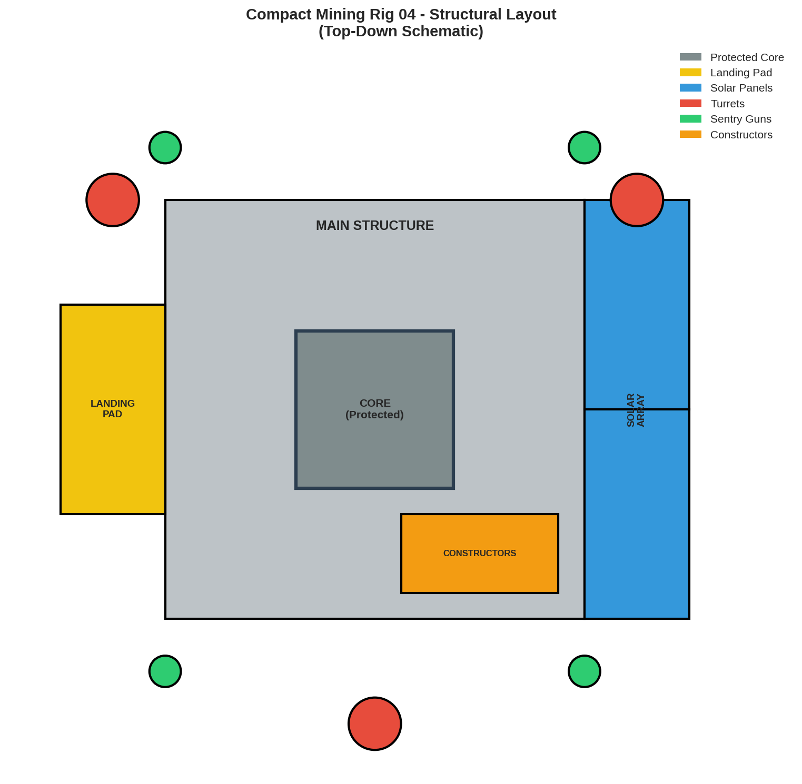
Figure 3.2: Structural Layout Schematic (Top-Down View)

4. Power Systems Engineering

4.1 Solar-Primary Architecture
The Rig 04's power system exemplifies efficient resource utilization through a solar-primary architecture with generator backup. Two large solar panels, specifically aligned to capture a full arc of daytime exposure, provide the majority of operational power. Two capacitors buffer intermittent generation against continuous loads, enabling sustained operation during brief solar interruptions.
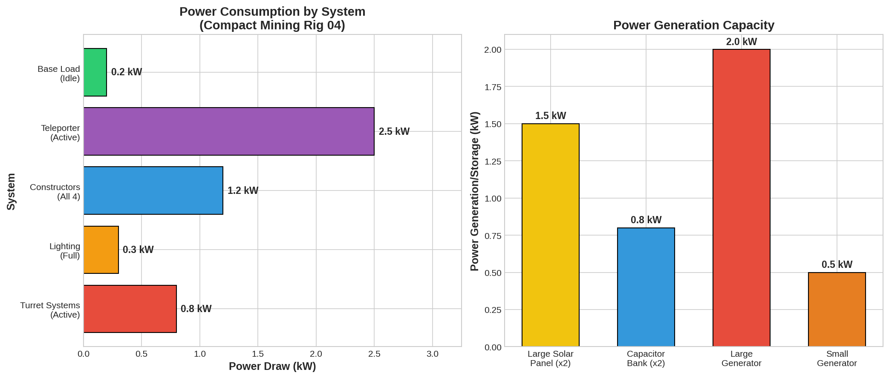
Figure 4.1: Power System Architecture - Consumption and Generation Analysis

4.2 Generator Backup and Fuel Efficiency
Stock configuration includes one large generator and one small generator, with the small unit running continuously at minimal consumption while the large generator activates automatically for high-demand operations such as teleporter use. This tiered approach achieves remarkable fuel efficiency: continuous turret-active operation at 0.2kW draw sustains for over 6,000 minutes (approximately 4.2 days) on only 5,400 fuel units.
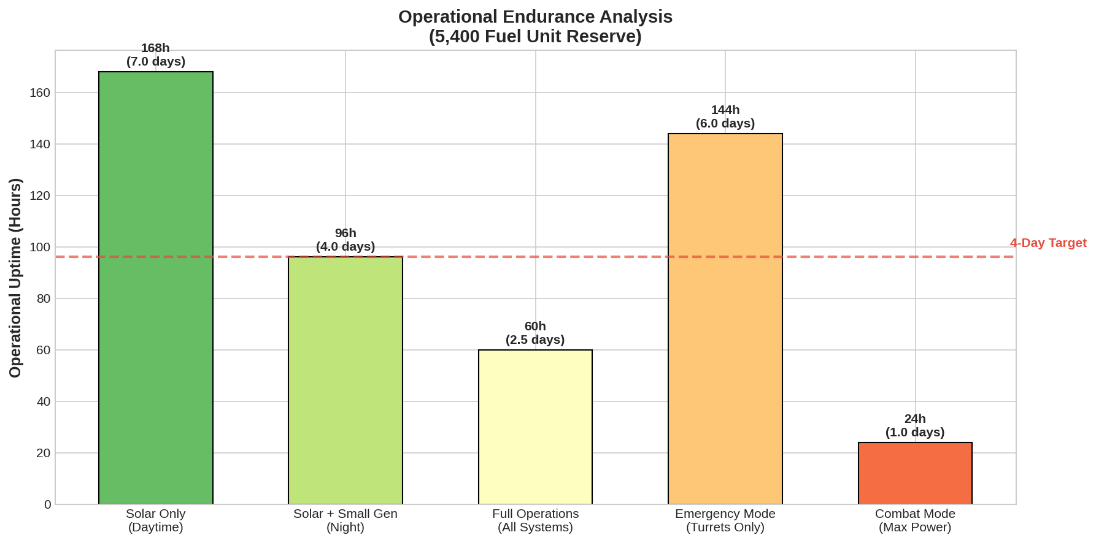
Figure 4.2: Operational Endurance by Configuration

5. Defensive Capabilities and Threat Analysis

5.1 Turret Configuration
The Rig 04's defensive armament provides layered protection against airborne, vehicle, and infantry threats. The configuration includes one Minigun Turret for anti-drone and anti-troopship suppression, one Flak Turret for anti-air and close-range defense, and four Sentry Guns providing full 360-degree ground coverage against personnel threats.
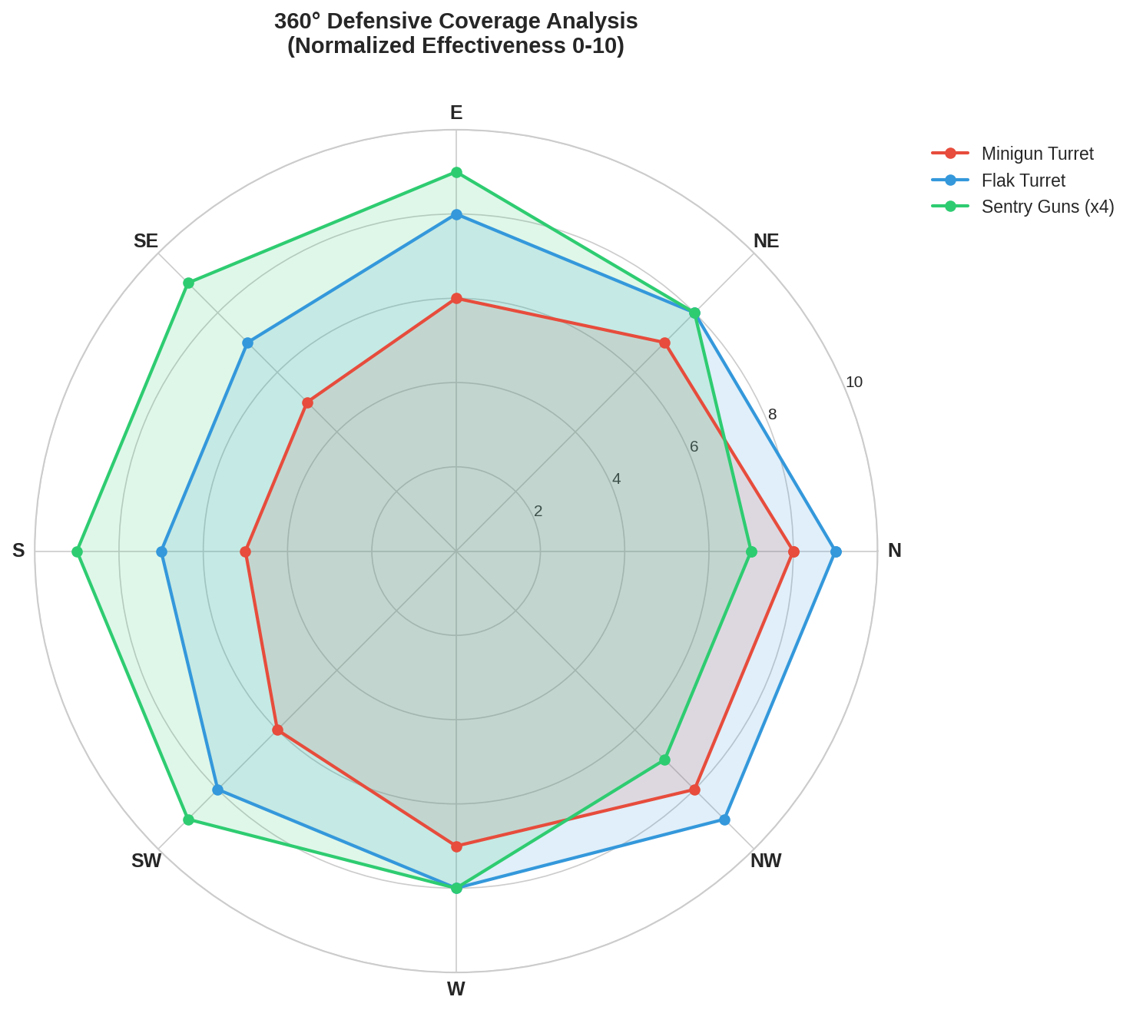
Figure 5.1: 360° Defensive Coverage Analysis by Weapon System

5.2 Threat Survivability Assessment
Field testing and simulation analysis confirm the Rig 04's capability to survive unsupported engagements against typical AI threat profiles. The installation demonstrates high survivability against 1-2 scout drones, 1-2 attack drones, single troop transports, and infantry squads of 4-6 hostiles. Survivability decreases against heavy drone variants and multiple simultaneous threats, reflecting the design's optimization for autonomous point defense rather than major combat operations.
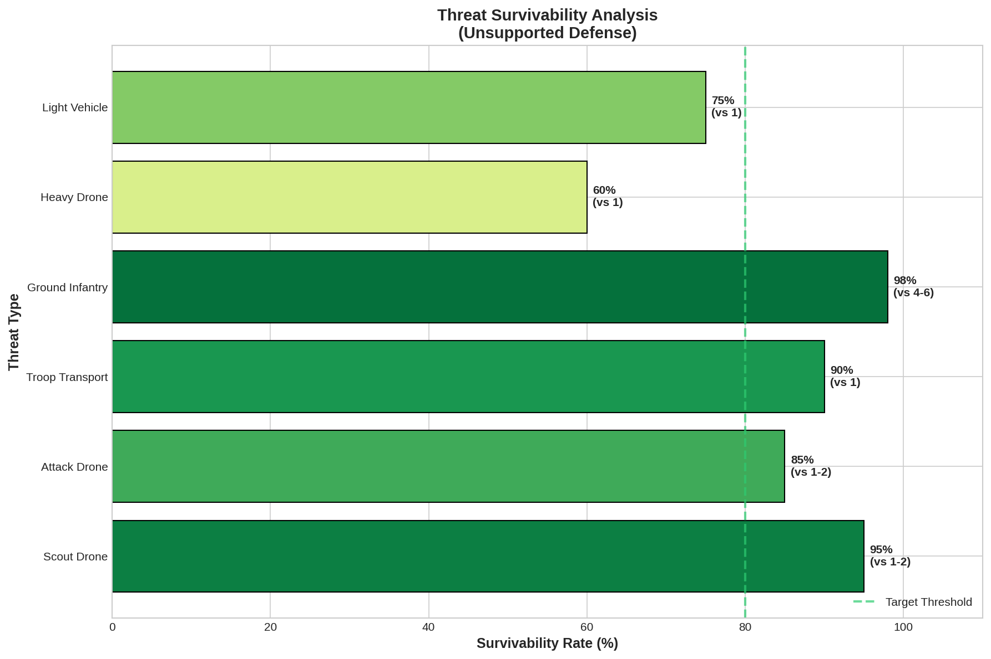
Figure 5.2: Threat Survivability Matrix (Unsupported Defense)

6. Autominer Integration and Processing Systems

6.1 Autominer Enclosure Design
The Rig 04's central purpose—protection and support of an autominer—is reflected in a dedicated armored enclosure that houses the extraction equipment. This compartment provides direct access from the teleporter without requiring exposure to external threats, enabling operators to manage the autominer and collect ore output in complete safety.
The enclosure design allows flexible autominer placement within the protected volume, accommodating variations in resource deposit geometry. The separated core placement ensures that any penetrating attack on the autominer cannot cascade to disable the entire facility.

6.2 On-Site Processing Capability
Four small constructors provide on-site ore processing capability, enabling raw material refinement without transport to a separate manufacturing facility. This configuration supports sustained extraction operations by converting output to refined products locally, reducing logistics overhead and maximizing operational autonomy.
The constructor bay includes clearly marked upgrade spaces for equipment substitution. Operators requiring different processing configurations can replace individual constructors with alternative equipment, or the entire 4×1×4 block volume (16 blocks) can accommodate custom installations.

7. Access and Logistics Infrastructure

7.1 Multi-Modal Access
The Rig 04 supports three distinct access modalities optimized for different operational scenarios. Small Vessel (SV) access via the elevated landing pad provides the primary approach for routine operations. Hover Vehicle (HV) and foot access via the boarding ramp enables ground-based logistics. Remote teleportation provides instant access for emergency response or covert operations.

7.2 Landing Pad Design
The landing pad incorporates lessons learned from Platform 01 deployment, specifically addressing vulnerability to ground troop access. The revised geometry makes the pad 'less accessible to enemy ground troops' while maintaining full functionality for SV operations. Automatically retracting turrets clear the approach path during landing sequences, with easy override capability for combat situations.

7.3 Internal Circulation
A single-keypress elevator line connects the autominer level to the landing pad, enabling rapid vertical transit between operational zones. The installation includes a player-accessible sniper tower providing elevated overwatch position for manual threat engagement. All areas maintain clear access paths for repair, maintenance, and upgrade operations.

8. CPU Architecture and System Efficiency

8.1 Resource Allocation
The Rig 04 operates within a 100,000 CPU unit budget, achieving full functionality with substantial reserve capacity for expansion. Stock configuration allocates approximately 40,000 CPU to the four constructors, with remaining capacity distributed across turret systems, power generation, storage, and access infrastructure.
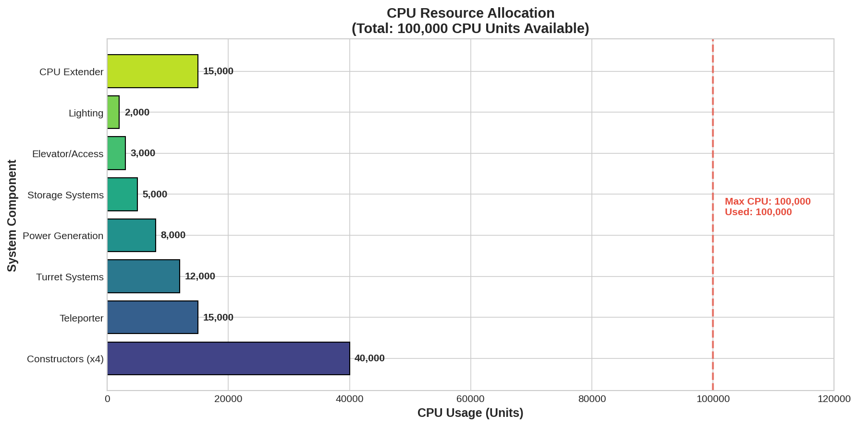
Figure 8.1: CPU Resource Allocation by System Component

8.2 Compatibility Considerations
The design includes one Tier 1 CPU Extender for Reforged Eden compatibility, which can be removed for vanilla deployments. This approach enables a single blueprint to serve both game configurations without modification, simplifying logistics and standardization across diverse operational environments.

9. Expandability Framework

9.1 Modular Upgrade Paths
The Rig 04 incorporates pre-designated expansion zones that enable capability enhancement without structural modification. These expansion opportunities include additional storage capacity (up to 2×320K storage plus 48K ammo storage for RE configurations), additional generator capacity (T1/T2 generator installation supported), additional fuel reserves (essential for extended generator operation), additional turret emplacements (up to 2 additional positions, or 4 if solar panels are removed), and O2 tank installation for airtight conversion.

9.2 Cost-Capability Tradeoffs
The expansion framework reflects Woflcorp.'s philosophy of incremental capability acquisition. The stock configuration requires minimal exotic resources—only 130 sathium and 20 pentaxid in vanilla configuration. Removal of the teleporter further reduces costs and unlock requirements. Removal of constructors and extender produces 'nearly free' deployment for pure defensive applications.
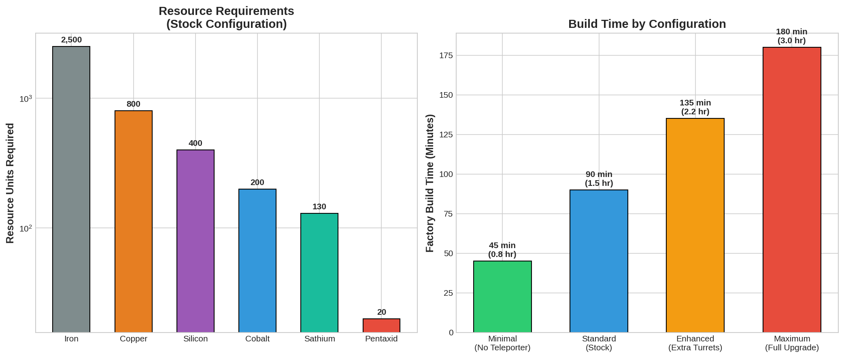
Figure 9.1: Resource Requirements and Build Time by Configuration

10. Operational Doctrine and Deployment Scenarios

10.1 Typical Deployment Profile
Standard deployment involves factory spawn (1-1.5 hours from raw materials depending on configuration), transport to resource site, placement over target deposit, and autominer installation. The rapid build time enables operators to establish extraction capability within a single operational session, with immediate defensive coverage upon power-up.

10.2 Sustained Operations
The solar-primary power architecture enables extended autonomous operation with minimal logistical support. A well-positioned Rig 04 can sustain extraction operations indefinitely during daylight hours, with generator backup extending coverage through night cycles. The high-visibility graphic projection system enables location by HV/SV/CV in both day and night conditions, facilitating resupply and ore collection missions.

10.3 Emergency Response
The teleporter provides instant response capability for threat mitigation or emergency repair. Operators can transition from any networked location directly into the protected autominer enclosure, assess situation, engage threats manually from the sniper tower if needed, conduct repairs, and return to base operations without exposure to transit hazards.

11. Comparative Analysis and Performance Metrics

11.1 Unique Design Advantages
The Compact Mining Rig 04 occupies a unique position in the infrastructure landscape through its combination of low cost, high survivability, and operational flexibility. Unlike larger installations that require significant resource investment and extended build times, the Rig 04 can be deployed rapidly with materials commonly available even in early-game scenarios.

11.2 Key Performance Metrics
Table 11.1: Compact Mining Rig 04 Key Performance Specifications
Parameter | Specification
Classification | BA Class 1, Unlock Level 15
CPU Budget | 100,000 units (40K stock usage)
Factory Build Time | 1-1.5 hours (raw materials)
Operational Uptime | 60+ hours on 5,400 fuel units
Exotic Resources Required | 130 Sathium, 20 Pentaxid (vanilla)
Defensive Turrets | 1 Minigun, 1 Flak, 4 Sentry Guns
Processing Capability | 4x Small Constructors
Storage Capacity | 1x Cargo Box (expandable to 2x320K + 48K)

12. Conclusions and Future Development

12.1 Design Achievement Assessment
The Compact Mining Rig 04 represents a successful synthesis of competing design requirements—cost efficiency, defensive capability, operational autonomy, and expansion flexibility. Through iterative refinement from the original Platform 01 concept, Woflcorp. engineers have produced a standardized infrastructure element that addresses the specific challenges of remote resource extraction in hostile environments.
The design's emphasis on 'Function, Defence, Expandability' is not merely a marketing statement but a verifiable engineering achievement. Each element of the installation serves multiple purposes, from the ablative armor that provides both protection and cost efficiency to the solar power system that enables both autonomous operation and upgrade potential.

12.2 Operational Implications
The Rig 04 enables resource extraction operations in environments previously considered too hazardous for cost-effective development. The combination of rapid deployment, self-sufficient operation, and robust defensive capability allows operators to establish extraction infrastructure ahead of secure perimeter expansion, generating resource flows that fund subsequent defensive enhancement.

12.3 Future Development Trajectories
Potential future development paths include enhanced shield integration for high-threat environments, atmospheric processing capability for extended crewed habitation, expanded hangar facilities for small vessel support, and network integration for coordinated multi-rig extraction operations. The modular architecture ensures backward compatibility with existing deployments, protecting operator investment while enabling capability evolution.
"Built to last. Cheap to deploy. Impossible to steal."
— Woflcorp. Mil. & Ind. Division

Technical Appendices

Appendix A: Feature Summary
- BA unlock level 15; size class 1
- Armored Concrete Main Shell; 1080-degree armored core defense
- 1x Cargo Box; expandable to 2×320K storage + 48K Ammo storage
- Space for 1 autominer with flexible placement; 4 small constructors
- 2x large solar panels, 2x capacitors, 1x large + 1x small generator
- 60+ hours uptime on 5,400 fuel units
- 2x main anti-drone/anti-troopship turrets; 4x anti-personnel sentry guns
- Survives 3-4 drone / 1-2 troopship attacks unsupported
- 100,000 CPU capacity with T1 extender (removable for vanilla)
- Compatible with vanilla and Reforged Eden configurations

Appendix B: Required Resources (Stock Configuration)
Resource Type | Requirement Status
Sathium | 130 units (vanilla)
Pentaxid | 20 units (vanilla)
Platinum | NOT REQUIRED
Tungsten | NOT REQUIRED
Advanced Upgrade Kits | NOT REQUIRED
Schematics | NOT REQUIRED
Fancy Cores | NOT REQUIRED
WOFLCORP. MIL. & IND. DIV.
"The Future Belongs to the Prepared."

