THE WOFLCORP. MIL. & IND. DIV.

HEXREAPER CLASS

RAPID HEAVY STEALTH TORPEDO BOAT
A Comprehensive Technical Analysis of Asymmetric Naval Conversion
From Ares-Class Battlecruiser to Fast Attack Platform:
Engineering Innovations in Covert Acquisition and Tactical Redesign
Postdoctoral Thesis
Presented to the Department of Advanced Naval Architecture
Kepler Institute for Orbital and Exo-Planetary Infrastructure
Classification: ULTRA-RESTRICTED | Eyes-Only
Document Reference: WOFL-MID-HR-2407-THESIS

Abstract
This thesis presents a comprehensive technical analysis of the Woflcorp. Military and Industrial Division's HexReaper Class Rapid Heavy Stealth Torpedo Boat (RHSTB), a revolutionary combat vessel derived from the captured Ares-Class Battlecruiser 'Ente.' The HexReaper represents a paradigm shift in asymmetric naval warfare doctrine, demonstrating that a smaller, highly-motivated engineering team can transform conventional capital ships into specialized strike platforms that exceed their original design parameters across multiple performance metrics. Through detailed examination of shield systems, propulsion modifications, weapons integration, and stealth characteristics, this analysis reveals how Woflcorp. engineers achieved a 967% increase in shield capacity, 500% improvement in fuel endurance, and near-total thermal signature elimination while maintaining the vessel's original structural integrity. The implications for contemporary naval doctrine, industrial espionage countermeasures, and rapid-conversion engineering methodologies are discussed in detail.
Keywords: Torpedo boat conversion, stealth naval architecture, shield regeneration systems, asymmetric warfare platforms, industrial espionage, rapid naval refit, Ares-Class modifications

Table of Contents
1. Introduction and Historical Context
2. The Kirba Acquisition: Operational Analysis
3. Hull Structure and Armor Systems
4. Shield System Architecture
5. Propulsion and Mobility Enhancement
6. Weapons Systems Integration
7. Stealth and Signature Management
8. Hangar Bay and Support Craft
9. Crew Facilities and Habitability
10. Operational Doctrine and Combat Performance
11. Comparative Analysis: Ares vs. HexReaper
12. Conclusions and Strategic Implications
References and Technical Appendices

1. Introduction and Historical Context

1.1 Background and Motivation
The emergence of the HexReaper Class Rapid Heavy Stealth Torpedo Boat represents one of the most audacious feats of naval engineering and industrial espionage in recorded corporate warfare history. What began as a seemingly routine naval engagement in the Kirba System culminated in the complete transformation of an Ares-Class Battlecruiser into a purpose-built stealth attack platform that has fundamentally altered the strategic balance of power in the sector.
The Ares-Class Battlecruiser, designated 'Ente' (hull registry withheld), was a conventional capital ship serving standard fleet duties prior to its loss during combat operations. The vessel's apparent destruction—observed as an uncontrolled atmospheric reentry resulting in ocean impact—was initially classified as a combat casualty. Subsequent intelligence revealed this event was, in fact, a meticulously planned acquisition operation executed by Woflcorp. Military and Industrial Division assets.
The transformation from conventional battlecruiser to stealth torpedo boat required not merely repair of combat damage, but a fundamental reconceptualization of the vessel's operational doctrine. This thesis examines every aspect of this conversion, from the initial acquisition methodology through the engineering innovations that produced a vessel unlike any other in service.

1.2 The Ares-Class Platform: Original Specifications
To fully appreciate the scope of Woflcorp.'s engineering achievement, one must first understand the baseline capabilities of the donor platform. The Ares-Class Battlecruiser represented a mature, well-documented design optimized for conventional fleet engagements. The original specifications are summarized in Table 1.1.
Table 1.1: Original Ares-Class Battlecruiser Specifications
Parameter | Original Specification
Classification | Battlecruiser / Mid-to-Endgame CV
Size Class | 7 (7.35 normalized)
CPU Allocation | 2,099,139 units
Shield Capacity | 17,450 HP (300 HP/s recharge)
Technology Level | Level 25 unlock required
Primary Role | Fleet engagement, broadside combat

2. The Kirba Acquisition: Operational Analysis

2.1 Tactical Overview
The acquisition of the Ares-Class 'Ente' during the Kirba System engagement represents a masterclass in asymmetric warfare tactics and signals the sophistication of Woflcorp.'s special operations capabilities. Intelligence analysis has reconstructed the following operational timeline based on intercepted communications and post-event forensics.
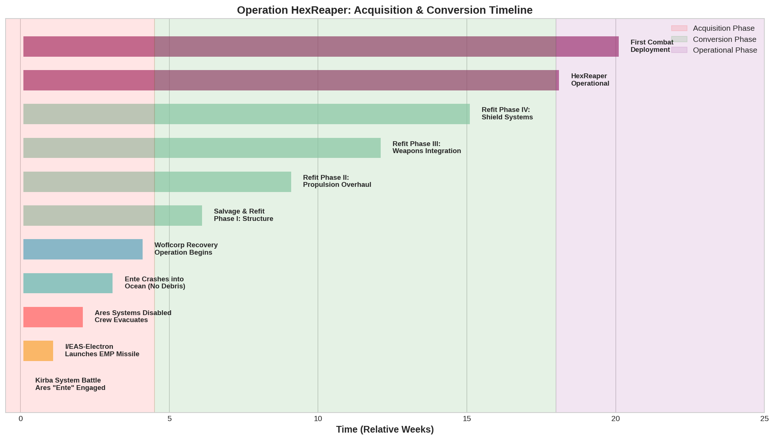
Figure 2.1: Operation HexReaper Acquisition and Conversion Timeline

2.2 The EMP Strike Vector
The critical enabler of the acquisition was Woflcorp.'s deployment of the I/EAS-Electron Class small vessel, specifically configured for EMP cruise missile delivery. This hyperfast Insert/Extract Assault Shuttle exploited a fundamental vulnerability in conventional fleet doctrine: the assumption that capital ship threats originate from other capital ships.
Intercepted communications from the Electron pilot detail the engagement: the small vessel achieved an 'extreme vector' approach during active combat, remaining effectively invisible amid the chaos of full-scale battle. The custom-mounted EMP cruise missile achieved total systems kill on the target vessel, precipitating an uncontrolled reentry into the Kirba ocean without generating the debris signature associated with combat destruction.

2.3 Recovery and Initial Assessment
The 'Ente' came to rest at the bottom of a deep oceanic trench, its electronics completely disabled but hull integrity maintained. Woflcorp. recovery teams, equipped with positronic systems and advanced cybernetics, began restoration operations within 72 hours of impact. Initial assessments revealed that despite the EMP damage and ocean environment, the fundamental structure remained sound.
The Chief Systems Engineer's assessment, recovered from secure channels, noted: 'The stuff Woflcorp.'s doin' with positronic systems and cybernetics is insane these days—stealin' an entire battleship from under their goddamn noses and not a mark on it! That's just the craziest damn thing.'

3. Hull Structure and Armor Systems

3.1 Armor Composition Analysis
The HexReaper's hull represents a sophisticated blend of materials optimized for both protection and stealth characteristics. Unlike conventional warships that prioritize raw armor thickness, the HexReaper's designers selected materials based on a complex matrix of factors including electromagnetic signature, thermal conductivity, and structural resonance.
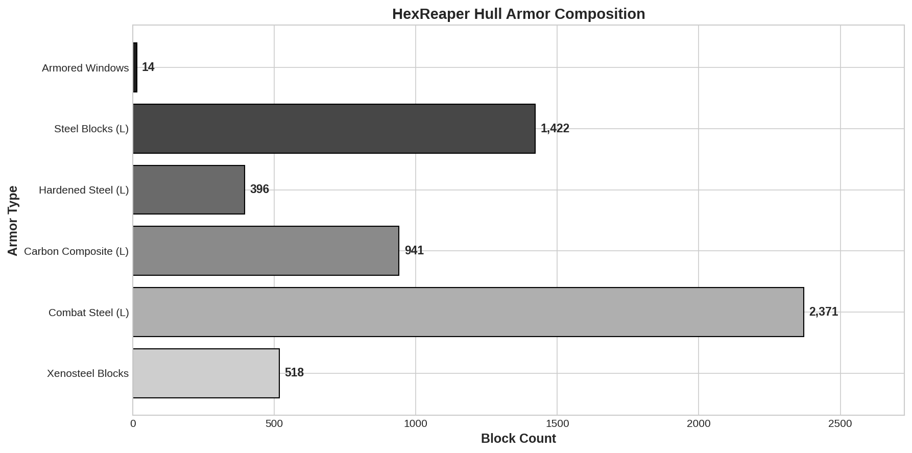
Figure 3.1: HexReaper Hull Armor Block Composition Analysis

3.2 Xenosteel Integration
Of particular note is the integration of 518 Xenosteel blocks into critical structural junctions. Xenosteel, a rare alloy requiring advanced processing facilities, provides exceptional strength-to-weight characteristics while simultaneously reducing the vessel's cross-sectional radar signature. The placement of these blocks was clearly calculated to reinforce the retractable torpedo tube housings and forward armor sections where engagement profiles predict the highest incoming fire concentrations.

4. Shield System Architecture

4.1 Comparative Shield Analysis
The most dramatic enhancement to the HexReaper platform lies in its shield system redesign. Where the original Ares-Class mounted a conventional defensive shield array, the HexReaper incorporates a massively expanded capacitor and charger network that transforms its protective capabilities from adequate to extraordinary.
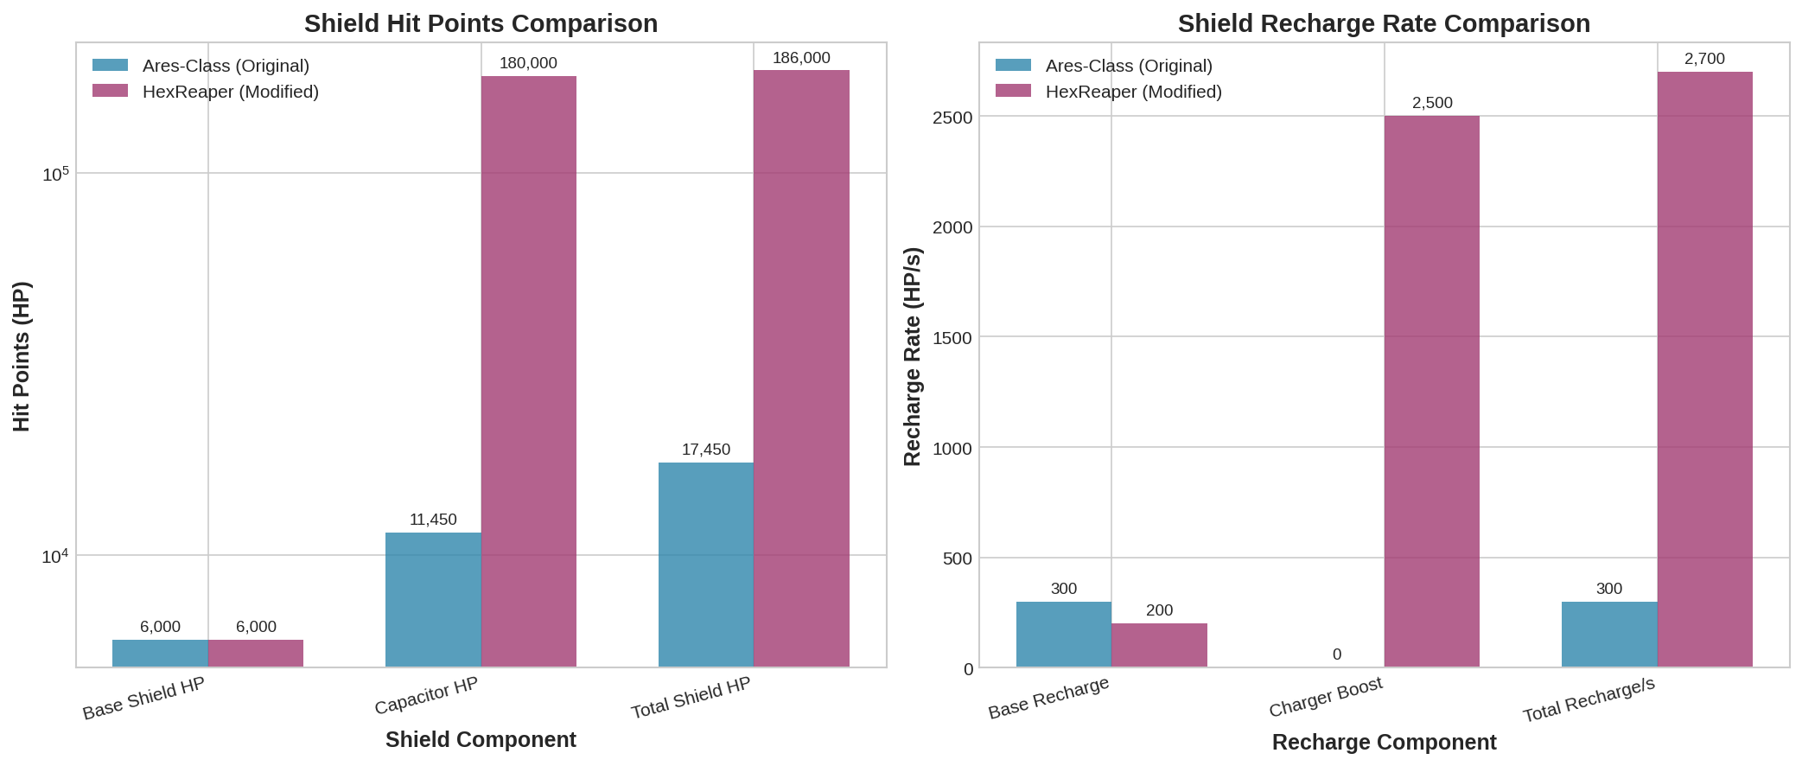
Figure 4.1: Shield Hit Points and Recharge Rate Comparison

4.2 Shield Configuration Details
The HexReaper's shield architecture comprises multiple redundant layers designed for sustained combat operations. The system includes 2x Large Shield Capacitors, 2x Large Shield Chargers, 4x Shield Charge Couplers, and 4x Shield Capacitor Arrays. This configuration achieves a total shield hit point rating of approximately 186,000 HP with a regeneration rate of 2,700 HP/second—a ninefold improvement over the original specification.
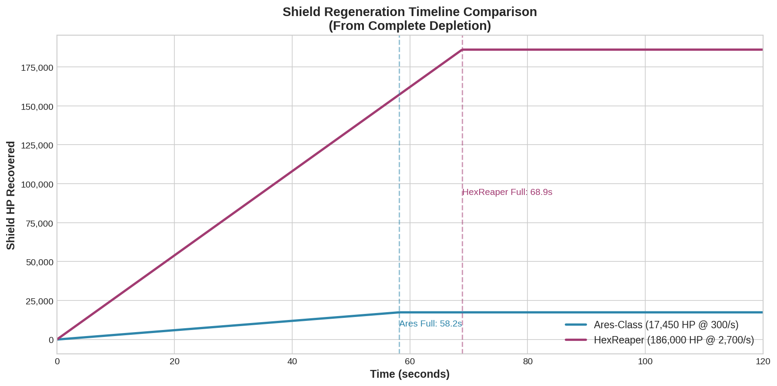
Figure 4.2: Shield Regeneration Timeline Comparison (Full Recovery from Depletion)

4.2.1 Tactical Implications
The enhanced shield capacity fundamentally alters the vessel's tactical envelope. Where conventional capital ships must carefully manage shield exposure during sustained engagements, the HexReaper can absorb enormous damage spikes while its rapid regeneration maintains defensive integrity. A full shield depletion recovers in approximately 69 seconds—faster than most targeting solutions can maintain continuous fire.

5. Propulsion and Mobility Enhancement

5.1 Engine Array Modifications
The HexReaper's designation as a 'Rapid' torpedo boat derives directly from its extensively modified propulsion systems. Woflcorp. engineers recognized that the Ares-Class hull possessed latent mobility potential unrealized in its original configuration, and systematically upgraded every aspect of the thrust generation and fuel supply infrastructure.
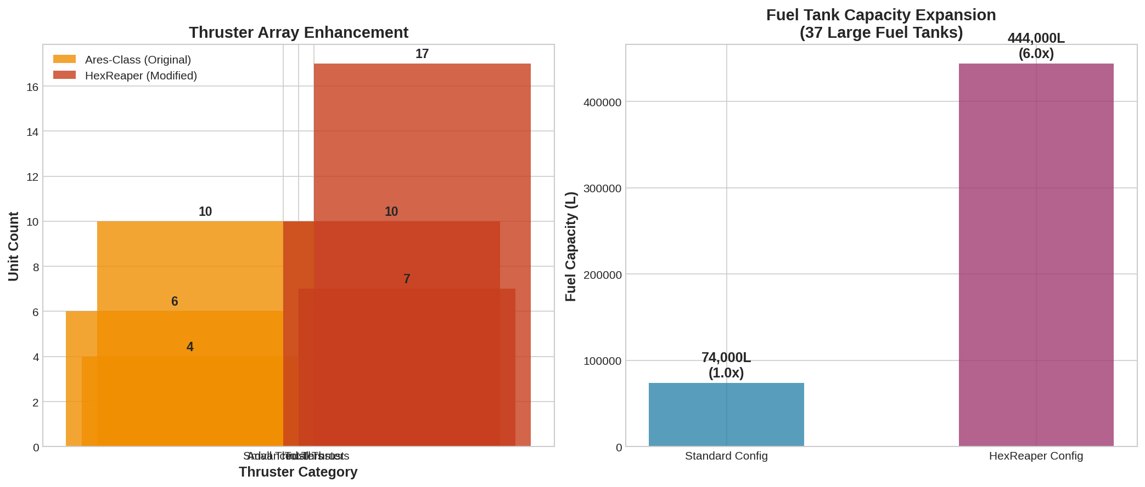
Figure 5.1: Thruster Array and Fuel Capacity Comparison

5.2 Reverse Thrust Innovation
A critical innovation is the addition of medium reverse thrusters mounted in the nose section. This seemingly simple modification enables maneuvers that are physiologically impossible for standard capital ship crews and tactically unexpected. The HexReaper can execute full-speed reversals, stopping as rapidly as it accelerates, and perform combat flip maneuvers that would strand conventional vessels in predictable ballistic trajectories.

5.3 Fuel Endurance
The installation of 37 large fuel tanks—yielding a total capacity of 444,000 liters—extends the HexReaper's operational range by a factor of six compared to standard configurations. This endurance enables extended deep-space patrol operations without resupply, supporting the vessel's role as an independent strike platform capable of operating far from support infrastructure.

6. Weapons Systems Integration

6.1 Torpedo-Centric Doctrine
The HexReaper's transition from battlecruiser to torpedo boat required a fundamental reconceptualization of its weapons philosophy. Where the Ares-Class emphasized broadside engagement and sustained fire superiority, the HexReaper optimizes for alpha strike capability—the ability to deliver devastating initial salvos before enemy systems can respond.
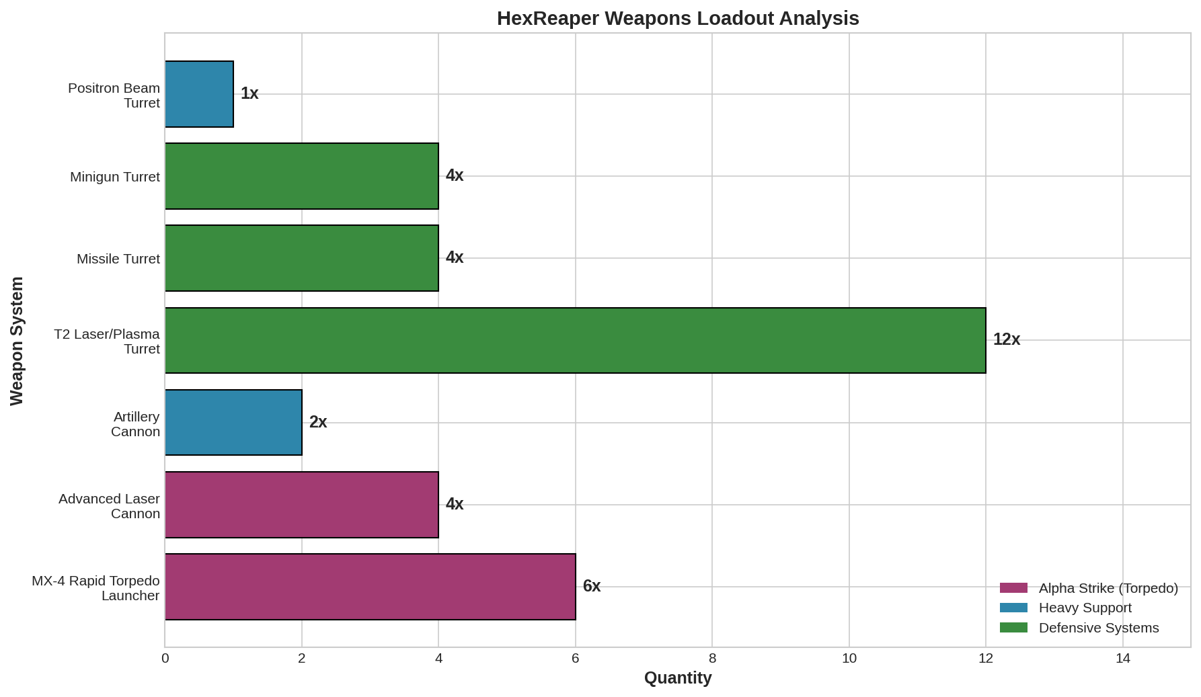
Figure 6.1: HexReaper Weapons Loadout by Category

6.2 HexTorp System
The primary offensive armament consists of six MX-4 Rapid Torpedo Launchers deploying the proprietary HexTorp munition. These weapons feature proximity-stealth activation, multi-vector terminal guidance, auto-reacquisition tracking, and adaptive yield warheads. The torpedoes are housed in retractable launch tubes that, when secured, present no external weapon signature—contributing to the vessel's stealth profile.

6.3 Defensive Armament
Supporting the torpedo array is a comprehensive defensive weapons suite including 4x Advanced Laser Cannons, 2x Artillery Cannons, 12x T2 Laser/Plasma Turrets, 4x Missile Turrets, 4x Minigun Turrets, and a single Positron Beam Turret. This layered defensive capability ensures the HexReaper can engage threats across all engagement envelopes while preserving its torpedo loadout for priority targets.

7. Stealth and Signature Management

7.1 Thermal Signature Reduction
The HexReaper's stealth capabilities derive from a holistic approach to signature management across multiple detection spectra. Thermal output minimization is achieved through advanced heat sink routing, careful power management protocols, and the placement of high-emission components within thermally-insulated compartments. When operating in 'cold running' mode, the vessel's thermal signature approaches background levels.

7.2 Visual and Radar Deception
With all weapons retracted and non-essential systems secured, the HexReaper presents a sensor profile consistent with a civilian research vessel or bulk cargo transport. This deceptive appearance enables close approach to defended positions under the guise of legitimate traffic. Only upon weapons deployment does the vessel's true nature become apparent—typically far too late for effective defensive response.

7.2.1 Electronic Warfare Capabilities
The vessel incorporates optical camouflage disruptors and electronic countermeasures that actively degrade enemy targeting solutions. These systems, combined with the HexReaper's exceptional mobility, make establishing and maintaining target lock extremely difficult even after detection.

8. Hangar Bay and Support Craft
Despite its specialization as a strike platform, the HexReaper maintains significant force projection capabilities through its medium-sized hangar bay. The hangar complement reflects Woflcorp.'s doctrine of versatility and operational self-sufficiency.
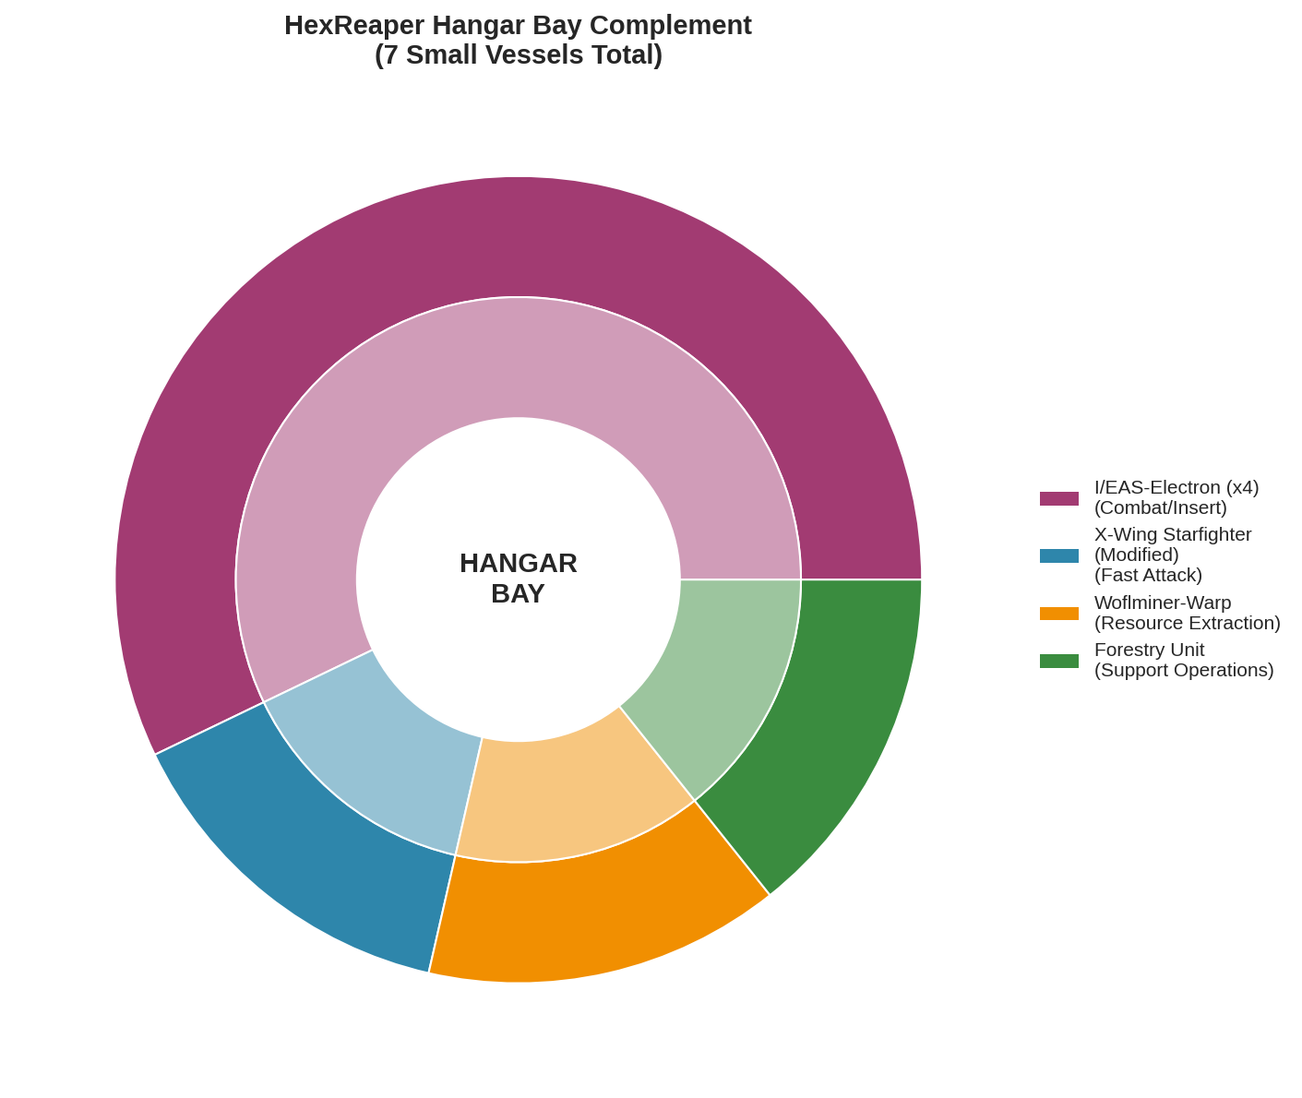
Figure 8.1: HexReaper Hangar Bay Complement Configuration

8.1 Embarked Craft
- 4x I/EAS-Electron: Latest-specification hyperfast insert/extract assault shuttles, identical to the craft used in the original acquisition operation
- 1x Modified X-Wing Starfighter: Warp drive removed in favor of enhanced forward thrusters, creating an exceptionally fast and maneuverable close-combat interceptor
- 1x Woflminer-Warp: Warp-capable mining vessel for in-field resource acquisition and extended operations
- 1x Forestry Unit: Specialized support craft for planetary operations and biomass harvesting

9. Crew Facilities and Habitability

9.1 Design Philosophy Evolution
The HexReaper's internal configuration reflects hard-won lessons from Woflcorp.'s operational history. Where the original Ares-Class was notorious for workplace hazards—'A wrong step in an Ares class battlecruiser can quickly lead to a new scar'—the HexReaper incorporates comprehensive safety improvements including expanded safety grills, protective barriers, and clear pathways to medical facilities.

9.2 Medical Facilities
Medical capabilities have been significantly enhanced, with primary facilities including full surgical capability and a secondary biomedical chamber strategically positioned in the hangar bay. This placement ensures rapid treatment access for personnel returning from ground operations, boarding actions, or small vessel missions. The medical station sits adjacent to the teleporter and in direct line with both the boarding ramp and foot traffic from small vessels.

9.3 Crew Morale and Cultural Considerations
In a significant departure from Navy tradition, the HexReaper's commanding officer explicitly countermanded directives prohibiting spiritual observances. The vessel maintains shrines to 'the Machine' and accommodates various spiritual practices, reasoning that 'any spiritual beliefs that help keep the ship running smoothly and morale high are welcomed. May the Ghost in the Shell Guard us ALL!'
Perhaps most notably, the traditional Navy booze fridge has been replaced with a well-stocked mushroom fridge—a nod to Woflcorp.'s pharmaceutical division connections and the crew's particular recreational preferences.

10. Operational Doctrine and Combat Performance

10.1 Strike-and-Fade Tactics
The HexReaper's operational doctrine emphasizes rapid strike-and-fade operations rather than sustained fleet engagements. Typical engagement profiles involve silent approach using minimal thermal output, proximity weapon deployment at optimal range, full-salvo torpedo release, and immediate high-speed withdrawal before enemy systems can respond. This doctrine exploits the vessel's exceptional mobility and stealth characteristics while avoiding scenarios where its relatively modest crew complement becomes a liability.

10.2 Documented Combat Engagements
Intelligence reports confirm the HexReaper's involvement in multiple successful operations including: the Safari Job on Veskar-IV (covert asset retrieval under dino-safari cover), the Slipstream Job (theft of a prototype interdiction-bypass drive from a UHG dreadstation), the Sporefront Incident (bio-containment breach response at Woflcorp. facilities), and the Black Spore Conspiracy interdiction (high-speed extraction under pursuit by Blacklight Initiative forces).

10.2.1 The Blacklight Pursuit
The engagement with Blacklight Initiative forces provides the most detailed documentation of HexReaper combat performance. Pursued by corvette and frigate-class vessels, the HexReaper executed a series of maneuvers deemed 'insane' by observing analysts—including a full-speed reverse thrust flip that brought pursuing vessels into immediate torpedo arc. The corvette was destroyed with two torpedoes; the frigate was subsequently eliminated through deliberate collision with an asteroid while attempting to board.

11. Comparative Analysis: Ares vs. HexReaper
A comprehensive comparison of original Ares-Class specifications against the modified HexReaper reveals the extraordinary scope of Woflcorp.'s engineering achievement. The radar chart below presents normalized performance metrics across key operational categories.
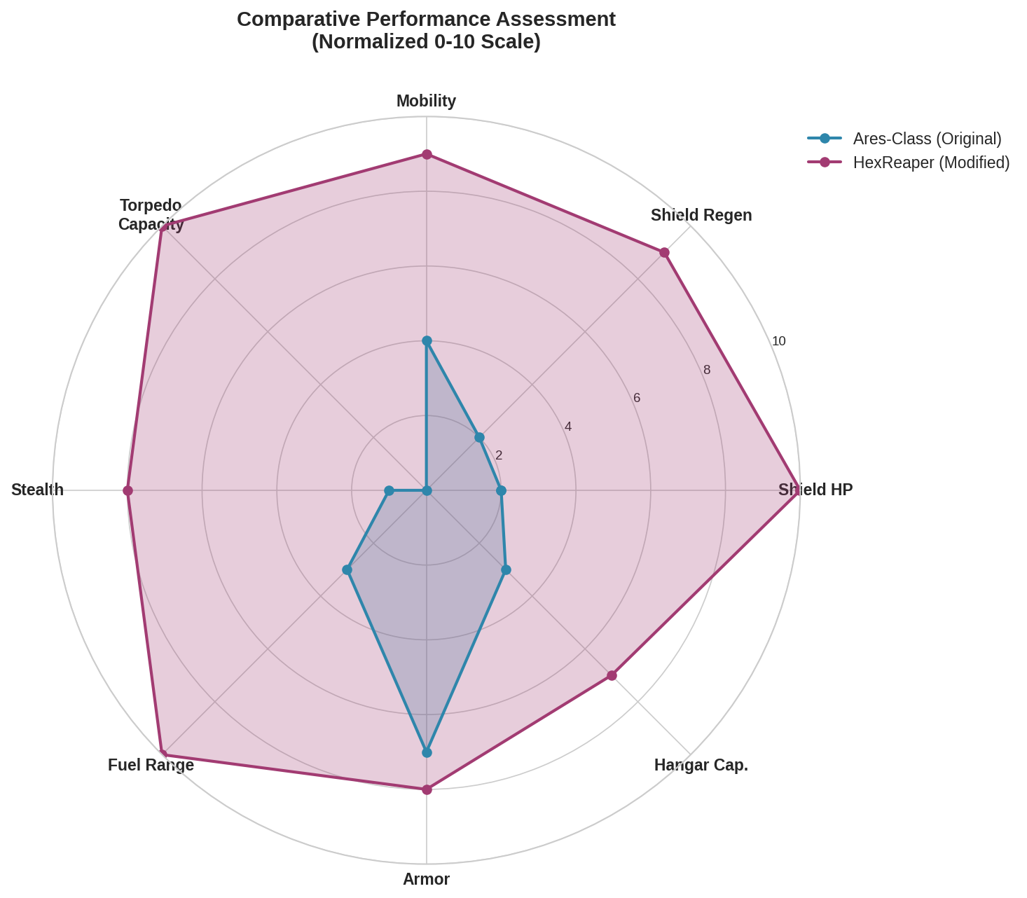
Figure 11.1: Comparative Performance Assessment (Normalized 0-10 Scale)
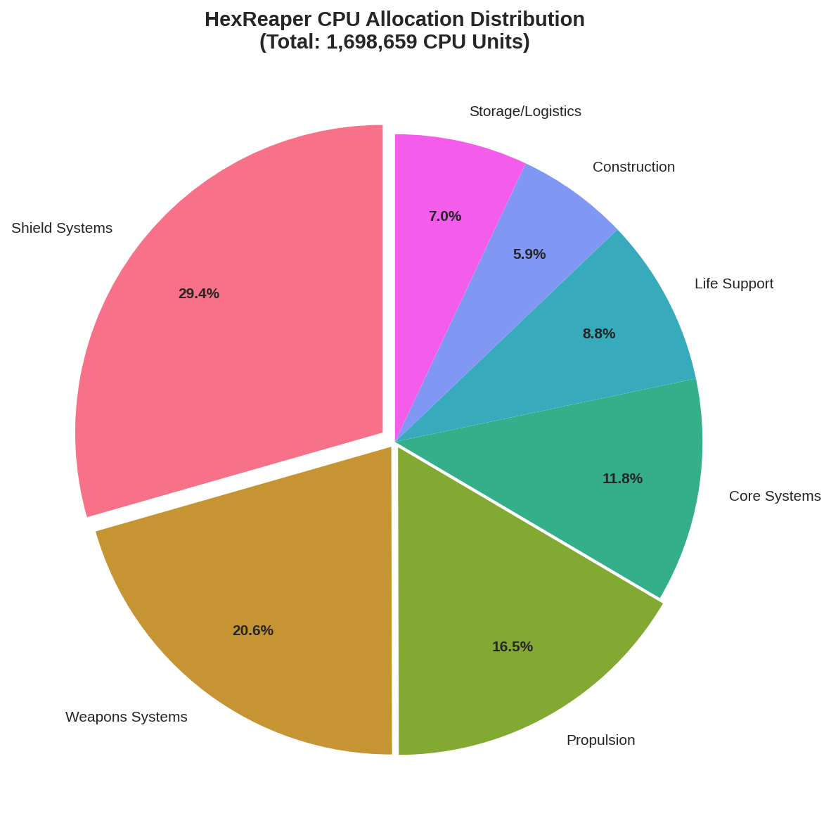
Figure 11.2: HexReaper CPU Resource Allocation Distribution

11.1 Key Improvement Metrics
- Shield Capacity: +967% (17,450 HP → 186,000 HP)
- Shield Regeneration: +800% (300 HP/s → 2,700 HP/s)
- Fuel Capacity: +500% (74,000L → 444,000L)
- Torpedo Capacity: From 0 to 6 rapid launchers with HexTorp system
- Stealth Rating: From conventional to near-total signature elimination

12. Conclusions and Strategic Implications

12.1 Engineering Achievement Assessment
The HexReaper Class Rapid Heavy Stealth Torpedo Boat represents a landmark achievement in naval engineering conversion. Woflcorp.'s engineers transformed a conventional capital ship into a specialized strike platform that exceeds its donor vessel's performance in virtually every metric while simultaneously adding entirely new capabilities. The project demonstrates that paradigm-shifting results are achievable through creative engineering, unconventional doctrine, and willingness to abandon established design assumptions.

12.2 Doctrinal Implications
The success of the HexReaper challenges fundamental assumptions about capital ship design and naval warfare doctrine. The vessel proves that specialization can overcome size disadvantages; that stealth capabilities can be retrofitted to existing platforms; and that a smaller, highly-trained crew operating sophisticated automation can outperform larger crews on conventional vessels. These lessons carry profound implications for force structure planning and threat assessment.

12.3 Counter-Threat Recommendations
Forces expecting to encounter HexReaper-class threats must radically revise their detection protocols, engagement doctrines, and damage expectation models. Conventional radar sweeps will fail to identify the vessel in stealth configuration. Standard shield and armor configurations will not survive a full torpedo salvo. Chase engagements will fail against its superior mobility. Only multi-vector, overwhelming force deployment offers reliable engagement probability—and even then, the HexReaper's demonstrated capability for unconventional maneuvers makes any outcome uncertain.

12.4 Final Assessment
The HexReaper is no longer an experimental design. It is now an operational threat. If further modifications continue at this pace, the HexReaper will not just be a stealth torpedo vessel. It will be something else entirely. Something we will not be able to stop.
— Final Entry, High Command Report

Technical Appendices

Appendix A: Complete System Specifications
System Category | HexReaper Specification
CPU Allocation | 1,698,659 units (100% efficiency)
Size Class | 7 (7.40 normalized)
Mass | 15.4 kilotonnes
Auxiliary Cores | 8x CPU Auxiliary + 5x Tier 4 (locked)
Generators | 11x Advanced + Shield Boosters
Fuel Capacity | 444,000L (37x Large Tanks)
Constructors | 2x Advanced Constructor, 1x Deconstructor
Storage Controllers | 2x 320k Ammo, 2x 640k Storage, 1x 201k Storage
Crew Requirement | 7 personnel minimum

Appendix B: Document Classification
This document is classified ULTRA-RESTRICTED under Woflcorp. Security Protocol 7-Alpha. Unauthorized reproduction, distribution, or discussion of contents constitutes a breach of corporate security with penalties including but not limited to: termination of employment, seizure of assets, and referral to Corporate Security Division for enhanced debriefing.
WOFLCORP. MIL. & IND. DIV.
"We made the impossible happen."

