Scores for Social Software
Revision 02 video receipt + timecoded screenplay
Review cut · 02:21 · 1080 × 1920 vertical · prepared 27 July 2026
Watch the revision 02 review video
Open the final article source + Casey edit log
Open the published article: The Keymap Is the Score

How to review
Comment on the words or image you want changed and include the stable scene ID—for example, SSF-04. Scene IDs persist even when later edits move the timestamps.

What changed since revision 01
- SSF-02: corrected Æther Cavendish’s Vigil Score to the matte-black folded packet visible in the film.
- SSF-04: replaced the provisional Jordan Silver description with the observed single-sheet layout, printed columns, large numbers, typewritten commands, and spiral diagram.
- SSF-11: replaced “every contribution asks the same question” with a close that preserves the distinct entry offered by every contribution.
- Re-timed all scenes and rebuilt the lower information panel with exact captions, current artist/work labels, and a chapter timeline.

Timecoded screenplay
SSF-00 · Introduction 00:00–00:18
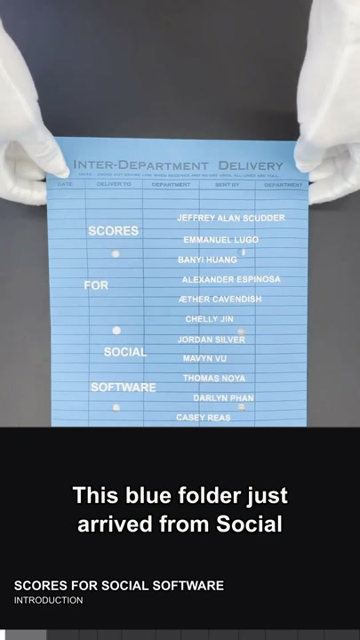 | Narration  This blue folder just arrived from Social Software at UCLA. Inside is Scores for Social Software, a spring 2026 edition of sixty-four. The copy in my hands is number fifty-one, assembled after ten weeks of making, testing, and performing together.  Requested changes  Add a comment here and name SSF-00.
SSF-01 · Jeffrey Alan Scudder — Notepat 00:18–00:31
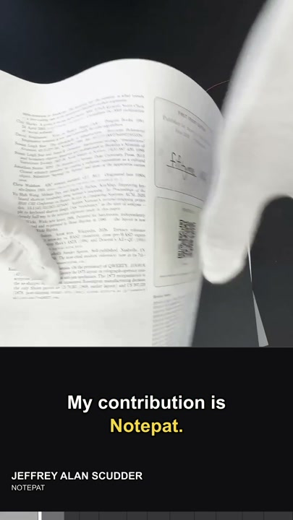 | Narration  My contribution is Notepat. A folded white user manual opens into a pointed shape, combining an illustrated player, a QR code, instructions, and circular keyboard diagrams.  Requested changes  Add a comment here and name SSF-01.
SSF-02 · Æther Cavendish — Vigil Score 00:31–00:38
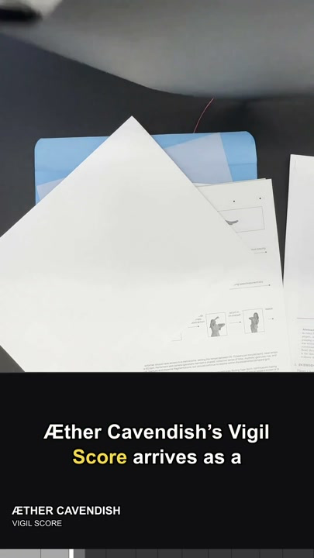 | Narration  Æther Cavendish’s Vigil Score arrives as a matte-black folded packet, closed with a small circular silver seal.  Requested changes  Add a comment here and name SSF-02.
SSF-03 · Chelly Jin — Software as a Choreography 00:38–00:48
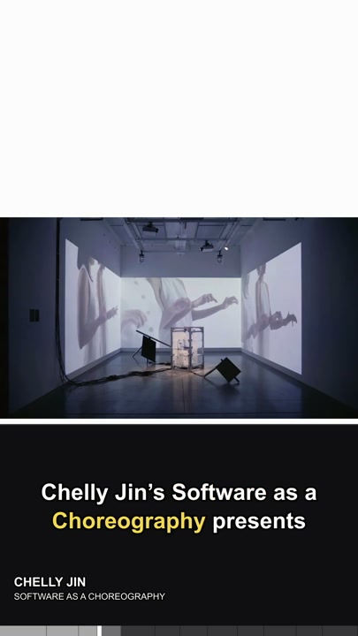 | Narration  Chelly Jin’s Software as a Choreography presents a grid of silhouetted hands and arms, pairing each gesture with marks for timing and movement.  Requested changes  Add a comment here and name SSF-03.
SSF-04 · Jordan Silver — Sonic Architecture 00:48–01:01
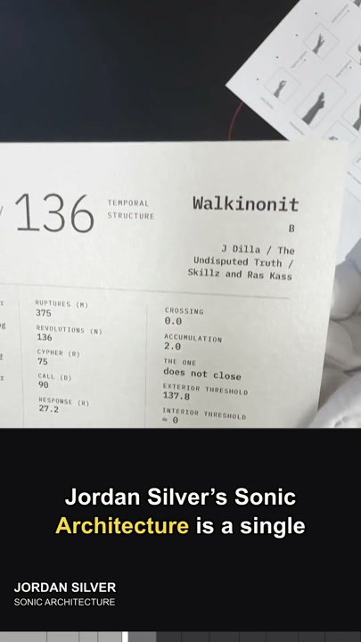 | Narration  Jordan Silver’s Sonic Architecture is a single sheet of printed columns, large numbers, and typewritten commands, anchored by a looping spiral diagram for inhabiting and measuring space through sound.  Requested changes  Add a comment here and name SSF-04.
SSF-05 · Em Lugo — Cues for Losing Direction 01:01–01:11
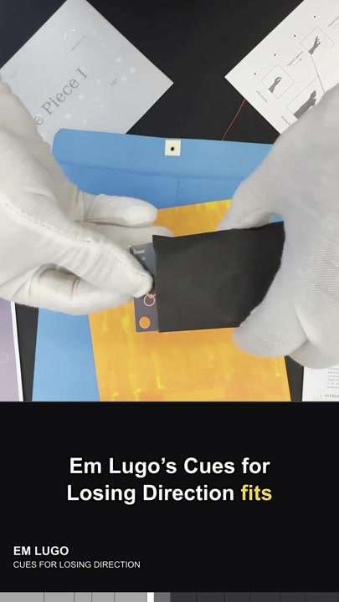 | Narration  Em Lugo’s Cues for Losing Direction fits on a small black card, its title set in pale condensed type like a portable instruction carried in the hand.  Requested changes  Add a comment here and name SSF-05.
SSF-06 · Darlyn Phan — Line Piece 1 01:11–01:22
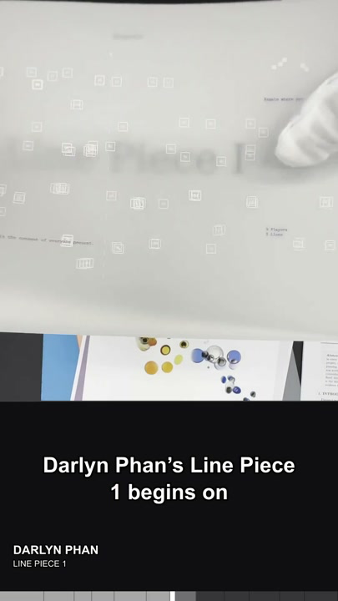 | Narration  Darlyn Phan’s Line Piece 1 begins on translucent white paper. Its faint rainbow cast and minimal title let the page behave like a line or veil.  Requested changes  Add a comment here and name SSF-06.
SSF-07 · Thomas Noya — Biophonía 01:22–01:34
 | Narration  Thomas Noya’s Biophonía is a branching field of blue, yellow, black, and beige organic forms. In the video, these cell-like clusters drift and reorganize.  Requested changes  Add a comment here and name SSF-07.
SSF-08 · Banyi Huang — A Cosmographic Score… 01:34–01:44
 | Narration  Banyi Huang’s A Cosmographic Score for Folding Back into the Kernel centers a luminous circle and a small diagram of connected nodes inside a lavender field.  Requested changes  Add a comment here and name SSF-08.
SSF-09 · Alexander Espinosa — Music for World Computers 01:44–01:57
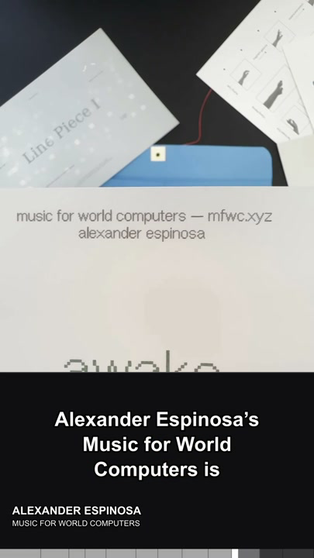 | Narration  Alexander Espinosa’s Music for World Computers is a white typographic score: awake, expand, decrease, oxygen, forest, junk, cinnamon, hammer.  Requested changes  Add a comment here and name SSF-09.
SSF-10 · Mavyn Vu — The Radio Is an Altar: Portal 01:57–02:07
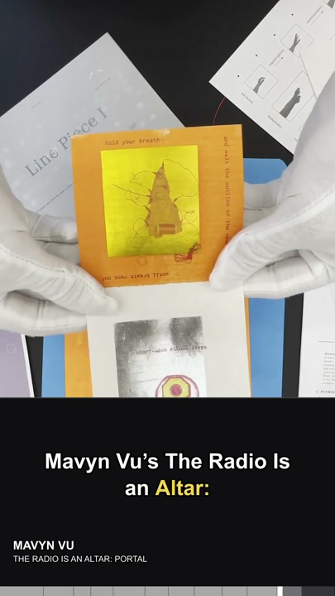 | Narration  Mavyn Vu’s The Radio Is an Altar: Portal combines translucent blue and white score cards, a target-like radio image, small figures, and instructions arranged around their edges.  Requested changes  Add a comment here and name SSF-10.
SSF-11 · Closing 02:07–02:21
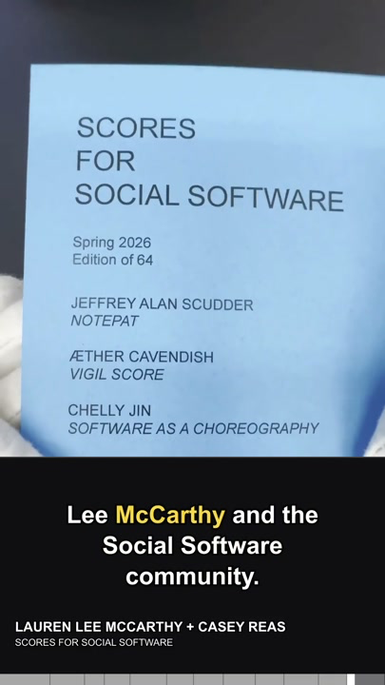 | Narration  Casey Reas facilitated the cycle, with Lauren Lee McCarthy and the Social Software community. Together, the contributions open many paths through a question: if software organizes behavior, what else can we ask it to organize?  Requested changes  Add a comment here and name SSF-11.

Revision chain: comment → accepted note → revised scene → new receipt. Accepted comments are copied to accepted-feedback.md under the same scene ID before revision 03 begins.

