***Winning Division*** – Write a program that determines which of a company’s four divisions (Northeast, Southeast, Northwest, and Southwest) had the greatest sales for a quarter. It should include two functions that are called by main: getSales and findHighest.

**Design:** First use an IPO chart to design your program. Your chart should contain three separate sections, one for each function. See attached blank IPO chart.

**Modularity:**

main – will call the getSales function 4 times, passing it the division name, each time getting the quarterly sales from a different division. It will then call the findHighest function, passing it the four sales figures, which will determine and display the highest.

getSales – will accept input of the quarterly sales from the user, using the division name passed by main to prompt the user. It will return the quarterly sales amount to main. **Input validation** – Validate that the sales amount entered is greater than zero.

findHighest – will accept the four sales figures from each division as parameters and determine which is the highest of the four. It will display the division name and amount that is the highest.

**Sample Dialog/Output**

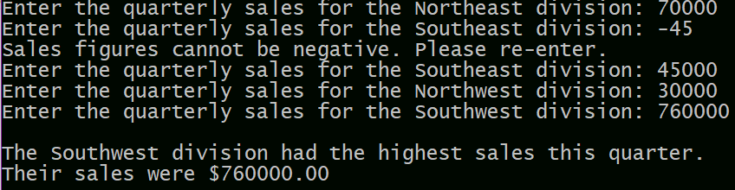

**NOTE:** In addition to programming style requirements in Blackboard, use named constants for numeric literals in the program and do not use global variables.

You should have 2 files to turn in. Your program file *yourlastname*.Ch6Lab.cpp and *yourlastname*.IPO.docx