AZ-104 Load Balancing
Consolidated Notes and Screenshots
Prepared for exam review and GitHub documentation
Section status | Load Balancer section completed; full lab not yet completed
Primary goal | Consolidate notes and screenshots before lab work
Best next action | Start/continue daily practice questions; run a small targeted lab only if needed
Cost rule | Avoid expensive resources unless the lab is planned and cleanup is same day

1. Core Load Balancing Concept
A load balancer distributes traffic across multiple backend resources. It acts like a traffic controller that sends requests to healthy servers behind it. This helps avoid relying on one VM for a critical workload.
- Scale up: increase the size of one VM.
- Scale out: add more backend instances and distribute traffic.
- For availability, scale out with multiple instances is usually stronger than relying on one large VM.

2. Public vs Internal Load Balancer
- Public Load Balancer: internet-facing frontend IP used for public web apps, APIs, or services.
- Internal Load Balancer: private frontend IP used for internal Azure traffic and backend services.
- Azure Load Balancer is a regional Layer 4 service that works with TCP/UDP traffic.

3. Backend Pools, Rules, and Health Probes
- Backend pool: group of VMs, VMSS instances, NICs, or IP configurations that receive load-balanced traffic.
- Load balancing rule: connects a frontend IP/port to backend pool targets.
- Health probe: checks whether backend instances are healthy enough to receive traffic.
- If a backend fails health probes, traffic is no longer sent to that instance until it recovers.
- Inbound NAT rule: maps a frontend IP/port to a specific backend VM IP/port for direct access.

4. Layer 4 vs Layer 7 Decision Rules
Service | Layer | Best Use
Azure Load Balancer | Layer 4 | TCP/UDP traffic, VM/VMSS backend distribution
Application Gateway | Layer 7 | HTTP/HTTPS, path-based routing, web application traffic
Azure Front Door | Layer 7 global | Global HTTP/S entry point, acceleration, global routing
Traffic Manager | DNS-based | DNS routing across endpoints; not a packet-level load balancer

5. Availability and SLA Notes
- A single VM is usually not enough for a critical workload.
- Availability zones and zone-redundant configurations are used to improve resiliency.
- Load balancers should be deployed in the same region as the backend resources they serve.
- Standard SKU is the current production-oriented Azure Load Balancer option to remember for most AZ-104 scenarios.

6. AZ-104 Exam Takeaways
- Azure Load Balancer = Layer 4 TCP/UDP.
- Application Gateway = Layer 7 HTTP/HTTPS.
- Health probes control whether backend resources receive traffic.
- Backend pools contain targets that receive the traffic.
- Public load balancer uses a public frontend IP; internal load balancer uses a private frontend IP.
- NAT rules are for direct inbound mapping to specific backend resources.
- Use questions to identify whether a full lab is necessary.

7. Screenshot Review
Figure 1: Load balancing architecture / traffic distribution diagram
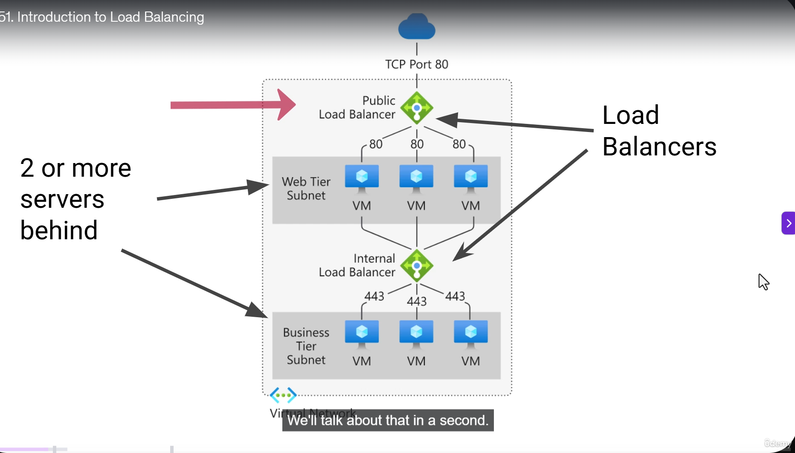
Figure 2: When to use Azure load balancing services
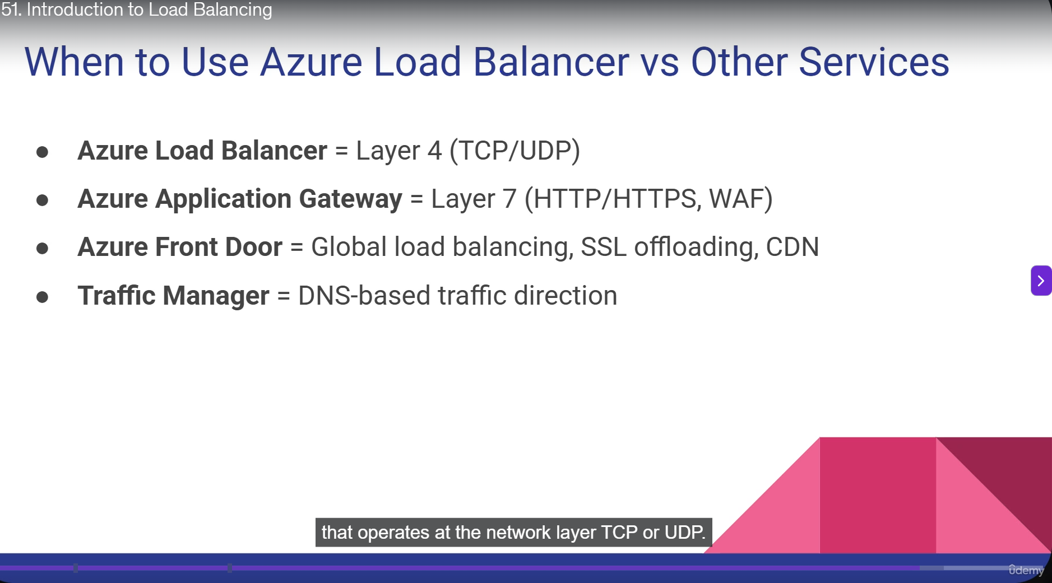
Figure 3: Azure Load Balancer SKU comparison
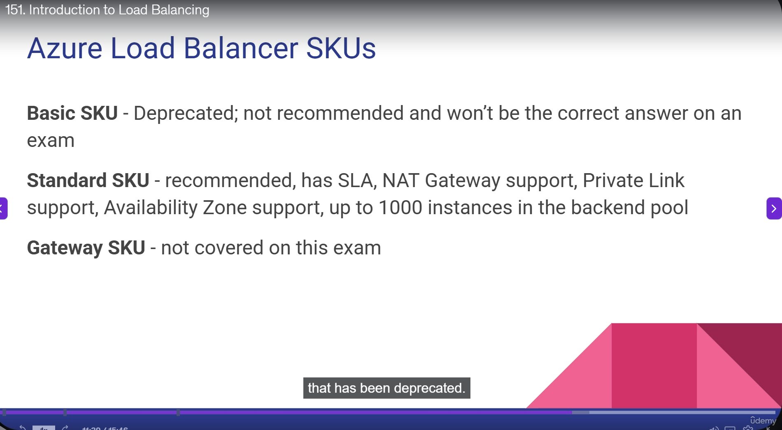
Figure 4: Health probe settings
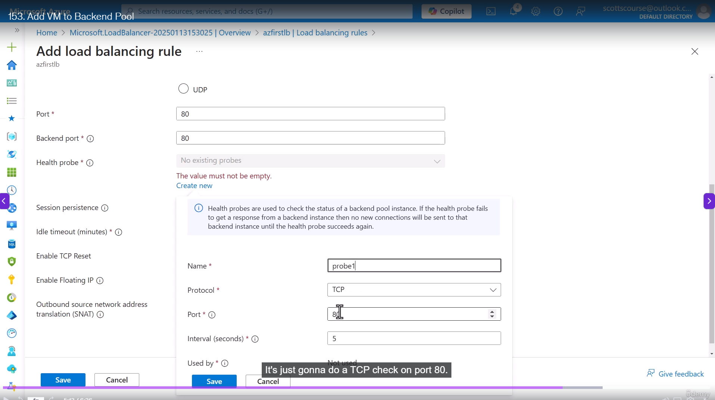
Figure 5: Health probe alert rule configuration
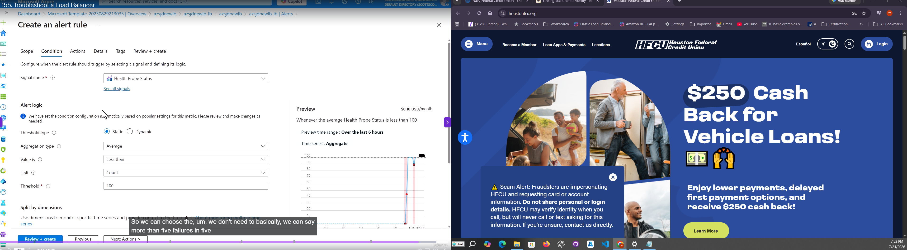
Figure 6: Availability zone SLA / high availability reference
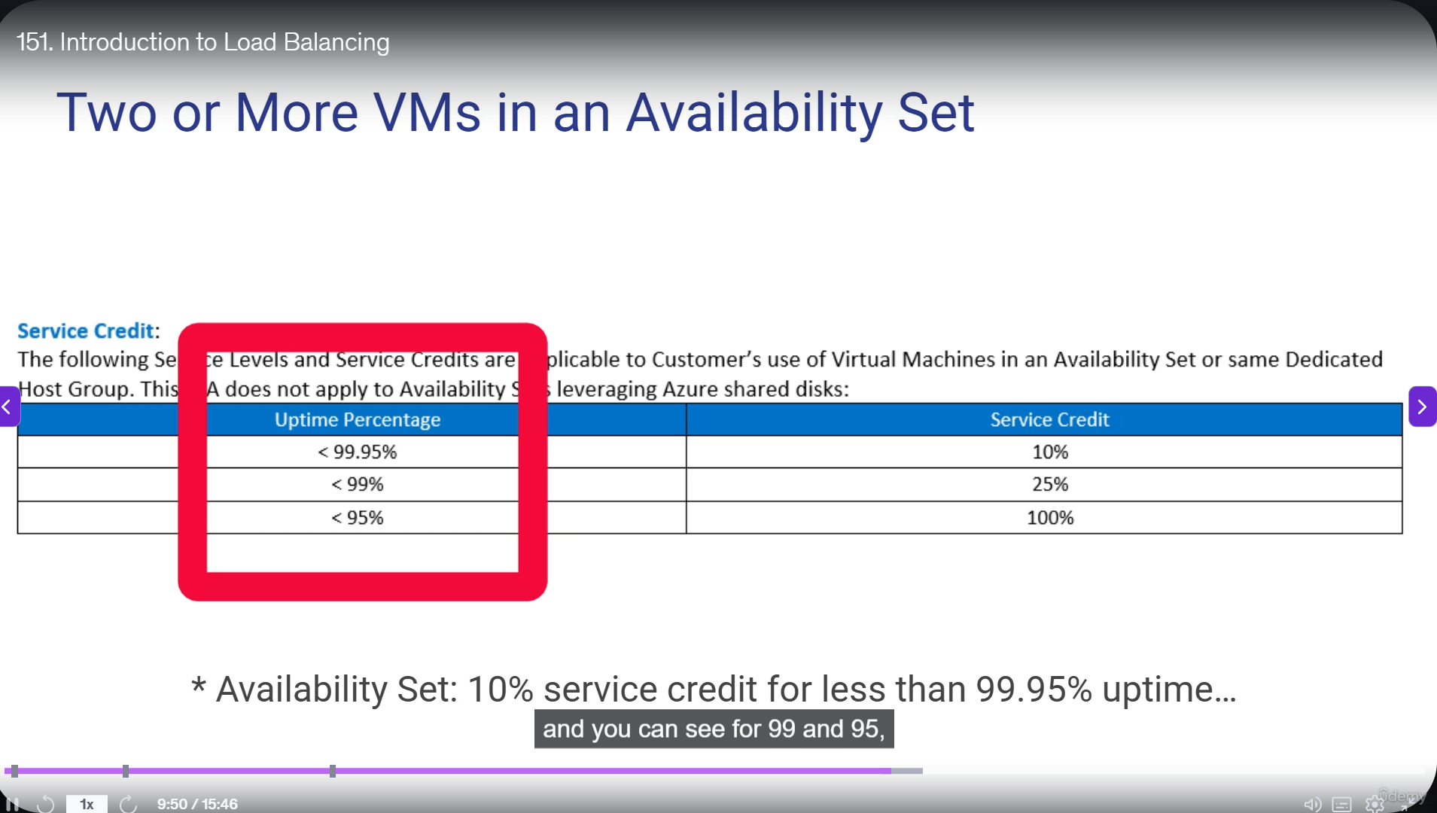
Figure 7: Virtual machine SLA reference
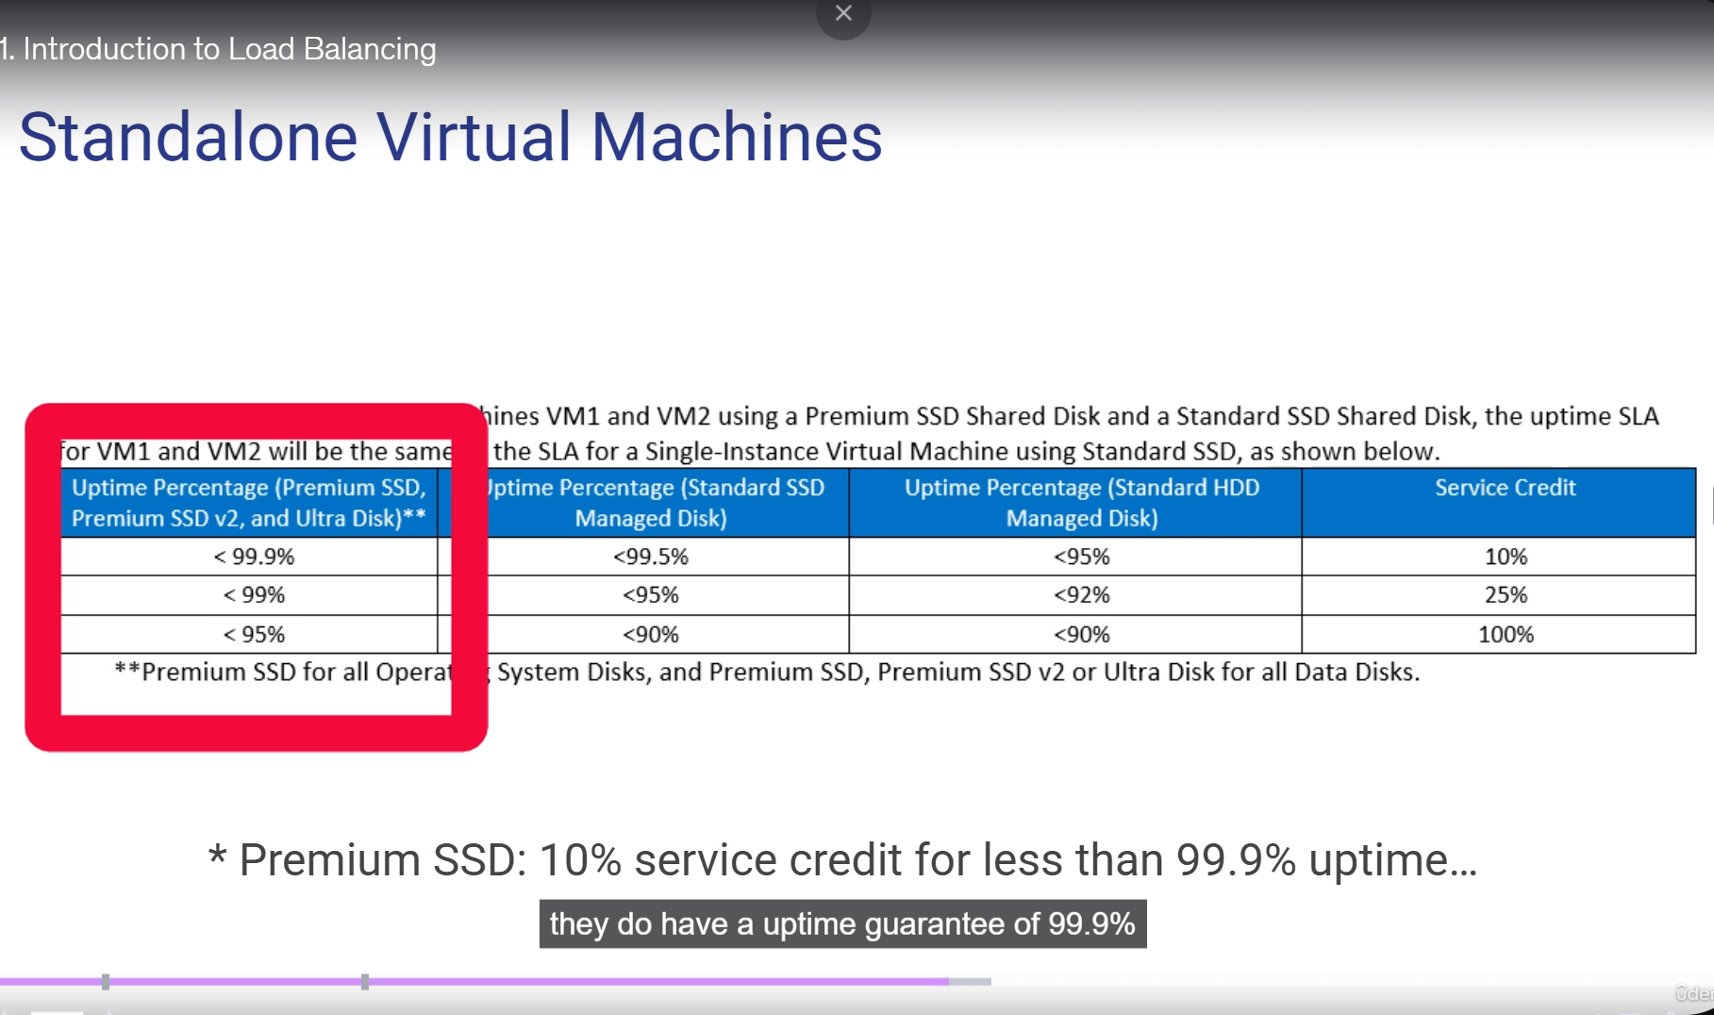

8. Recommended GitHub Structure
load-balancing/
README.md
load-balancer-notes.md
commands.md
screenshots/
01-load-balancer-diagram.png
02-when-to-use-load-balancers.png
03-azure-load-balancer-skus.png
04-health-probe-settings.png
05-health-probe-alert-rules.png
06-availability-zone-sla.png
07-vm-sla-reference.png

9. Suggested Next Step
- Do 10 AZ-104 practice questions daily.
- If load balancing questions reveal confusion, perform one small cost-controlled lab.
- Avoid Application Gateway or extra public resources unless the lab specifically requires them.
- Document and delete any lab resource group the same day.

