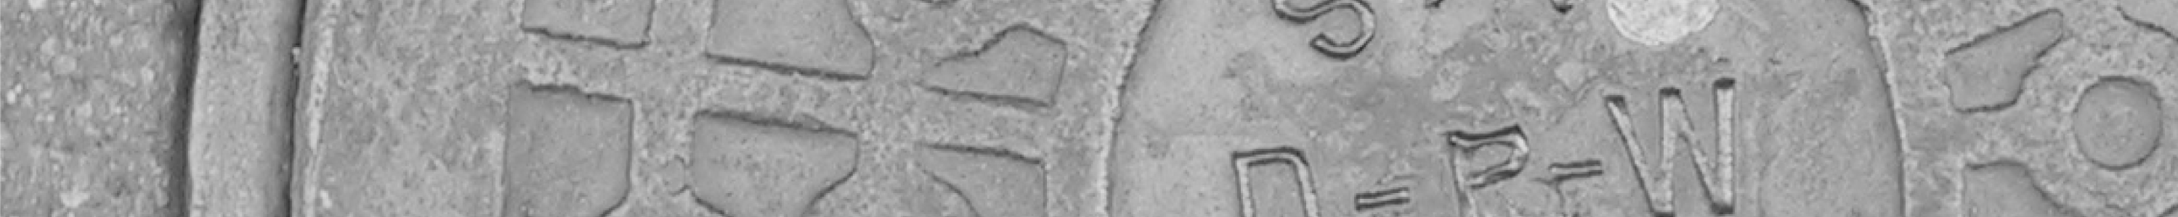

Document Title | CMtest Install Guide
Products Affected | All product manufactured ??
Document Part Number | TST-00001
Revision and Date | 01 04/18/07
Status | Preliminary
Author | Joe White

This is an uncontrolled copy when in printed form.

REQUIRED APPROVAL SIGNATURE DATE

TEST ENGINEERING Joe White 05/22/17

MANUFACTURING ENGINEERING __

NEW PRODUCT INTRODUCTION __

REVISION HISTORY

REVISION | REVISION DESCRIPTION | ECO # | DATE | ORIGINATOR
01 | Initial release. |  | 4/18/07 | Joe White
02 | Added Detail about Backup Crons |  | 08/07/12 | Joe White
03 | Made Generic |  | 0522/17 | Joe White

TABLE OF CONTENTS

1.0 Introduction 3
1.1 Scope 4
1.2 Affected Products Table: 4
1.3 References 5
2.0 Hardware Requirements 5
3.0 Software Requirements 5
4.0 Install Procedure 6
4.1 Install Fedora – Dual Boot System 6
4.2 Setup Linux 6
4.3 Configure Remote VPN/firewalls 8
4.4 Mount a distribution master image 8
4.5 Run mkhost 9
4.6 Add CRON JOBs to maintain logs 10
4.7 Edit test ctrl.cfg 10
4.8 Configure minicom for serial ports 10
4.9 Configure Telnet server 11
4.10 Configure APC controller 12
4.11 Configure ftp and tftp server 12
4.12 Configure Backups for logging directories 13
4.13 Configure Printer 13
4.14 Maintenance 14
5.0 Appendix 14
5.1 Example Install Samba 15
5.2 Example SSH Config 15
5.3 Example - MFG .bashrc 16
5.4 Example Httpd Config 16
5.5 Unix Notes 17

Introduction

This Procedure defines the installation of CMTEST when used to test Products. Separate test procedures are created for actual test process...
This process requires intimate knowledge of the UNIX operating system. The CMTEST is installed with on a Fedora core version or equivalent of Linux. For the propose of this procedure Unix will refer to Fedora Linux . It is highly recommended to have a IS professional available for the low level installation and networking configuration. Some adjustments may need to be made based on Net work Topology. This procedure is not a definitive example of the installation process but merely a guide. The end user should be prepared, to make adjustments as necessary.
Perl Experience Required as installations will need modifications from time to time for new Linux versions
CMTEST and its installation/use and procedures are based on the work provided by Paul Tindle. He can be contacted at Paul@Tindle.org. All aspects of this work except proprietary information as it applies to the operation of the PRODUCT are considered open source. In this procedure the CMTEST Installation guide and the installation requirements have been merged.
The CMTEST system will typically consist of one or more Site Servers that can also serve as test systems and 1 or more Client systems with mounts back to the Site server. Remote sites may be connected by a VPN tunnel.

Scope
This procedure applies to the following departments:
- Test Engineering
- Subcontractors.

This document is divided in the following section:
- Hardware Requirements
- Software Requirements
- Procedure
- Appendix

Affected Products Table:
Part Number | Description
0000?-0X | Decription1
00???-0X | Description2

References
CMTEST Installation guide by Paul Tindle Version 1b0 - 10/12/2005

Hardware Requirements

The following hardware items are needed to perform this procedure:
- Windows PC with at least one serial port and one Ethernet port
- Additional PCI serial port cards, if additional serial ports are needed, instead of using a Terminal server
- APC AP7900 Power controller if required. Other power control can be used, but will integration of command structure
- NetScreen or equivalent firewall to provide remote access from to remote sites
- Cyclades Terminal server or equivalent if not using internal PC serial

Software Requirements

The following software is needed to perform this procedure:
- RedHat Linux 7.2+ , MandrakeLinux 10.1+ , Fedora 3.x or 4.X
- Perl 5.8+
- Perl::Tk and Perl::Expect modules
- Internet access to install Perl extensions in cpan
- TexPad software or other Windows editor/file viewer
- Optiperl, or equivalent Perl IDE Recommended for CMTEST development
- Tera Term, Putty or other Windows terminal software.

Install Procedure

Install Fedora – Dual Boot System
Notes from Paul Tindle CMTEST installation guide for Dual boot systems:
If a dual bootable system is required, a proven method is as follows:

- Using Partition Magic, shrink the existing windows partition to give at lease 5GB of free space. Using the automatic partitioning in the Fedora setup. You'll probably end up with something like:

Partition | Label | Type | Desc | Size
1 | /boot | Linux Ex3 | Primary, bootable | 50 Mb
2 | (Windows) | FAT32/NTFS | Primary | 6Gb or 80%
3 | / | Linux Ex2 | Primary | 2Gb of 20%
4 | /swap | Linux swap | Primary | 512 Mb or 2x

- Change the 2nd boot image name that appears in the boot loader window to 'WinXP' or so.
- Select custom install and choose:
  - KDE and/or Gnome
  - Development tools
  - If a server, NFS, Samba and Web

- Select ‘minimum security’ option
- Reboot the system, select each O/S in turn and make sure it boots

Setup Linux
Notes from Paul Tindle CMTEST installation guide
1) Installation
Select custom install. Then Select:
Desktop:
- You choice between Gnome and KDE (or both)
- Applications
- All defaults except:
- Editors: [1 of 6] vim-enhanced
- Servers
- Server Config Tools: [ 8 of 11]
- Windows File Server [ 3 of 3 ]
- Development Tools: [52 of 65]

2) Dual Boot Volume Sharing
If this is a dual boot system, and you chose FAT32 for your windows file system, you can access this from Linux by:

Creating and entry in /etc/fstab:

/dev/hda2 /mnt/winxp vfat rw 0 0

mkdir /mnt/winxp
mount /mnt/winxp

3) Define Host domain names by editing /etc/sysconfig/network.

4) Volume Sharing for Dual boot systems
Notes from Paul Tindle CMTEST installation guide
If this is a dual boot system, and you chose FAT32 for your windows file system, you can access this from Linux by:

Creating and entry in /etc/fstab:

/dev/hda2 /mnt/winxp vfat rw 0 0

mkdir /mnt/winxp
mount /mnt/winxp

5) Define Host/Domain names by editing /etc/sysconfig/network.

6) Setup Samba and Apache(Server Systems Only)
6.1) Samba - Copy the file /etc/samba/smb.cong from a know host to this system. Edit the Server String entry. Restart smb from the Services Control window, and make sure samba starts.

6.2) Apache - Edit /etc/httpd/conf/httpd.conf
Server Admin
Server name

- Start Services
Notes from Paul Tindle CMTEST installation guide
Boot Linux and log in as root
[RH6 – RH9]Go to the K-start App icon, select System, select Service Control
[FC3] Menu::Applications:Systems Setting:Server Settings:Service
For all systems, turn on:
    - Ntpd
    - rlogin
    - rsh
    - telnet [or krb5-telnet]
For site servers, also turn on:
    - httpd
    - nfs
    - smb

Save changes before exiting.

- Add User
Default for all systems User: mfg password: password. Local user only, not linked to any existing corporate accounts. This is the account users will log onto individual machines to run tests

- SSH Authority for Root
Notes from Paul Tindle CMTEST installation guide, Additional information in appendix
[RH9 tested only! No idea on FD3!]

Copy roots public key to enable transparent ssh/scp:

On the 'from' machine:

Type:
ssh-keygen -t rsa
<Return><Return><Return> [for defaults]

cat .ssh/id_rsa.pub

mark/copy: or just copy

On the 'to' machine:

Type: [if necessary]
cd
mkdir .ssh
chmod 700 .ssh

Type:
cd .ssh
vi authorized_keys2
chmod 600 authorized_keys2
paste data (above)
save

ssh/scp away

Configure Remote VPN/firewalls
uses a NetScreen 5GT or equivalent firewall to provide remote access from to remote site. IS department needs to provide a Fixed IP address with direct access to the Internet. No access to the companies internal network is required. This allows to remotely monitor/administer and control PCs and tests. Access from the remote site to can be achieved by a VPN connection. Current configuration of the firewall is located at \\harp\www-int\ops\Test\TestEquipmentsetup\Firewall\.

Mount a distribution master image
- If it doesn’t already exist, type:

mkdir /mnt/dist

(First time only)

Choose a distribution method

NFS mount: (use this to build from a cvs archive)
- Type:
mount<sp> <server>:<dist_path><sp>/mnt/dist

eg mount shasta:/var/xxx/cmtest /mnt/dist

Floppy disk master:
- Insert the floppy diskette into the drive
- Type:
mount<sp>/dev/floppy<sp>/mnt/dist

CD master:
- Insert the CD into the drive
- Type:
mount<sp>/dev/cdrom<sp>/mnt/dist

Run mkhost
Notes from Paul Tindle CMTEST installation guide

      - Type: /mnt/dist/mkhost –h
if required to list available options to mkhost

      - Type: /mnt/dist/mkhost -<option> -<option>

      - Actions:
- Checks and, if necessary creates all:
- Cyclic code distrubution buckets
- Log file paths, where all cfg, event and test logs are to be stored
- Stats file paths, to be used by the cgi monitoring scripts
- IPC paths
- Runs push, using the above /mnt/dist path as a source, to this new host (only).
- Creates the symbolic run-time links as necessary

      - -s switch
The –s switch declares if this system is to be used as a site server. If so, the web services and nfs packages will be checked/installed, as well as copying all the cgi scripts to the web-root cgi-bin.

WARNING!!! ??? If this switch is used on a system that has already been configured and possibly used as a regular test controller client system, configurations could be overwritten!

As part of this process cpan/rpm will be called to install perl extensions needed. WWW access is required for this process.
Package Managers:
RedHat:
rpm –qa : List all installed packages
rpm –qa | grep Perl :
rpm –U <package> : Install/Upgrade package
CPAN: < Use this one, but as su!!
perl –MCPAN –eshell : CPAN module interactive shell
or
perl -MCPAN -e 'install Bundle::Tk'

Add CRON JOBs to maintain logs

Log into user account
Type crontab –e
Insert the following:
#Delete all log files older than 30 days
0 0 * * * find ~/tmp/s*/* -ctime +90 –depth –print -exec rm -r {} \; > ~/tmp/delete_$USER.log 2>&1

0 0 * * * find /var/local/cmtest/stats/*txt -ctime +90 –depth –print -exec rm -r {} \; > ~/tmp/delete_$USER.log 2>&1

/var/log/httpd ????

Save and exit.

Cron will run at 12 AM each day to deleate files older than 30 days

Root Crontabs ( Backup of and remote sites)
crontab -l
*/2 * * * * /etc/local/keepalive.sh > /dev/null
cat /etc/local/keepalive.sh
#!/bin/sh

ping -c 2 172.16.24.1
0 1 * * * /etc/local/cmlogsync.sh > /dev/null
Backup script:
cat /etc/local/cmlogsync.sh
#!/bin/sh
#Test if mounted
if [ ! -d "/media/OPS/Buffalo Backup" ]
then
echo "Mounting OPS"
#mount -t smbfs -o username=joe,password=changeme,rw //atlantis/Operations /media/OPS
# mount mfg-lws11:/var/local/cmtest /media/mfg-lws11/
echo "Log backup Failed on `date` Atlantis not mounted"|Mail -s"Log backup Failed on `date` Atlantis not mounted" joe@.com a
morgan@.com
exit
else
echo "Already mounted"
fi

LOGINFO=/tmp/synclog.txt

echo "------------------------------------------------" >> $LOGINFO
echo "[ mfgsvr1 ]...Backing up..." >> $LOGINFO
#rsync -avS /a/cmtest/logs /media/OPS/Buffalo\ Backup/cmlog/mfg-svr1/ >> $LOGINFO;
tar cjvf /media/OPS/Buffalo\ Backup/mfg-svr1-logs-bk.tar.bzip /a/cmtest/logs >> $LOGINFO;
echo "[ mfg-lws1 ]...Backing up..." >> $LOGINFO
#rsync -avS mfg-lws1:/a/cmtest/logs /media/OPS/Buffalo\ Backup/cmlog/mfg-lws1/ >> $LOGINFO
ssh root@mfg-lws11 "tar cjvf /var/local/cmtest/mfg-lws11-logs-bk.tar.bzip /var/local/cmtest/logs" >> $LOGINFO
if [ ! -d /media/mfg-lws11/logs ]
then
echo "Log backup Failed on `date` mfg-lws1 not mounted"|Mail -s"Log backup Failed on `date` Atlantis not mounted" joe@.com a
morgan@.com
exit
fi
rsync -avS /media/mfg-lws11/mfg-lws11-logs-bk.tar.bzip /media/OPS/Buffalo\ Backup/ >> $LOGINFO
echo "-------------------------------------------------------------" >> $LOGINFO
echo " NOTE: Backup log files can be found at \\atlantis\Operations\Buffalo Backup\*.tar.bzip" >> $LOGINFO
echo "-------------------------------------------------------------" >> $LOGINFO
cat /tmp/synclog.txt | Mail -s "Log backup results on `date`" joe@.com amorgan@.com
rm $LOGINFO

Edit test ctrl.cfg
Testctrl.cfg is located at /usr/local/cmtest/testctrl.cfg. This is the controller configuration files that describes the ip address used, serial and telnet ports used by the controller. This file is uniqe to each controller. A separate list of ip addresses used is maintained at \\harp\www-int\ops\Test\TestEquipmentsetup\IP_Assignments

Configure minicom for serial ports
CMtest uses a combination of telnet servers and direct serial ports. At this time the telnet server is used for Burn-in only. An example of configuring a Serial port is show below:

joe@mfg-svr1:[~]> minicom 1 -s

lqqqqq[configuration]qqqqqqk
x Filenames and paths x
x File transfer protocols x
x Serial port setup x
x Modem and dialing x
x Screen and keyboard x
x Save setup as 6 x
x Save setup as.. x
x Exit x
x Exit from Minicom x
mqqqqqqqqqqqqqqqqqqqqqqqqqqj

lqqqqqqqqqqqqqqqqqqqqqqqqqqqqqqqqqqqqqqqqqqqqqqqqqqqqqqqqqqqqqqqqqqqqqqqk
x A - Serial Device : /dev/ttyS47 x
x B - Lockfile Location : /var/lock x
x C - Callin Program : x
x D - Callout Program : x
x E - Bps/Par/Bits : 9600 8N1 x
x F - Hardware Flow Control : No x
x G - Software Flow Control : No x
x x
x Change which setting? x
mqqqqqqqqqqqqqqqqqqqqqqqqqqqqqqqqqqqqqqqqqqqqqqqqqqqqqqqqqqqqqqqqqqqqqqqj

lqqqqq[configuration]qqqqqqk
x Filenames and paths x
x File transfer protocols x
x Serial port setup x
x Modem and dialing x
x Screen and keyboard x
x Save setup as 6 x
x Save setup as.. x
x Exit x
x Exit from Minicom x
mqqqqqqqqqqqqqqqqqqqqqqqqqqj

In the case above serial device /dev/ttyS47 is configured to minicom device 6, This would correspond to Session 6 in CMTEST.

Configure Telnet server
Entries should be made in the testctrl.cfg to reflect the IP/Ports used on the telnet server. Note a system can use a combination of serial ports and Telnet server ports.

Configure APC controller
Configuration(Follows Web page setup structure typically a apc-xxxx or ip address):
Switched Rack PDU->Configuration->Coldstart Delay->Never
Switched Rack PDU->Scheduling-><Nothing>
Outlets->Configuration->Default State->off
Outlets->Configuration->Power On Delay-> Immediate
Outlets->Configuration->Power Off Delay-> Immediate
Network->System IP-> 172.17.25.19
Network->Subnet Mask-> 255.255.255.0
Network->Default Gateway-> 172.17.24.1
Network->Host Name-> apc-mfg1
Network->Domain Name-> .com
Network->DNS-><Not Used>
Network->FTP Server-> Enabled, Port 21
Network->Telnet/SSH->Access->Enabled
Network->Telnet/SSH->Protocol->Telnet
Network->Telnet/SSH->Telnet Port->23
Network->Telnet/SSH->SSH Port->22
Network->SSH Configs-> <Defaults, not used by >
Network->SNMP->Enabled
Network->SNMP->Access Control-><Defaults>
Network->EMAIL-><Defaults, Not used by >
Network->Syslog-><Enabled, <Defaults for remainder>
Network->Web/SSL/TLS->Enabled
Network-> Web/SSL/TLS->Protocol->HTTP, <Defaults for remainder>
Network->WAP Access->Disabled
System->User Manager-><Defaults>
System->Outlet manager-><Defaults>
System->Radius-><Defaults>
System->Identification-><Defaults>
System->Date&Time->Set manually, <Defaults for remainder>
System-><Remainder of configuration is default
Typical login user:apc password:apc

Configure ftp and tftp server
This should point to a tftpboot directory. For the current installations tftpboot resides on /a/tftpboot. ftp server is enabled but not in use for testing. FTP is used as an additional method to get files on and off site servers.

Configure Backups for logging directories
These are Hourly/Daily backups made to the data collection points for CMTEST. These are doen at the Site servers, currently mfg-lws1 for the CM and mfg-svr1 for corporate.
CMTEST data collection points:
Example: The current configuration is:
mfg-svr1: /var/local/cmtest/logs (Everything under this directory)
goes to \\bigocean\mfgbackup\mfg-svr1\
mfg-lws1: /var/local/cmtest/logs (Everything under this directory)
goes to \\bigocean\mfgbackup\mfg-lws1\

Configure Printer
The printer is currently only used during the Configuration test the final test before shipment to a customer. Printing will only occur is properly setup in the testctrl.cfg file.
- This configuration currently uses a Dell 1700n Printer, PostScript/PCL capable printer
- Printer Configuration:
Configure printer with IP, Gateway and Name – See Printer documentation
Example:
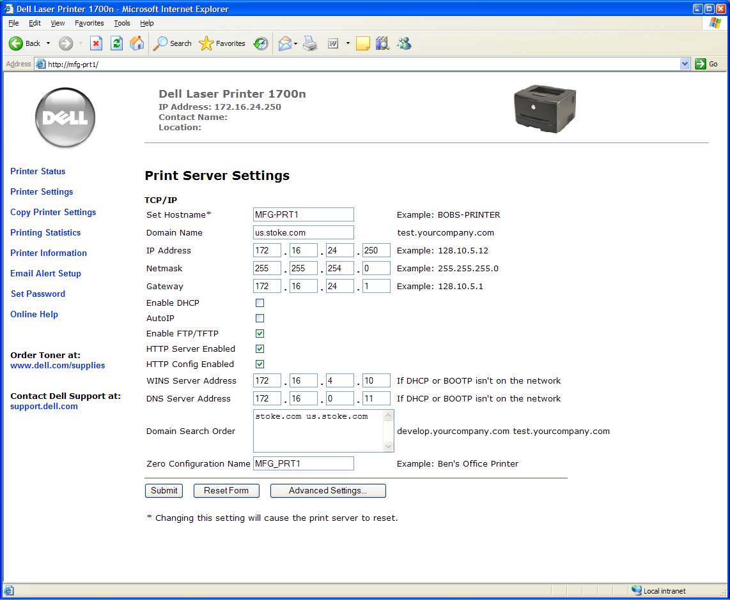
Figure 1
- On the Unix machine: In Hardware Setup->Printer choose Quetype: Networked JetDirect, Enter Printer IP used above.
- In the Printer Driver Configuration chose PostScript Printer,
- Driver Options: Convert Text to PostScript.
- You may have to change Default margins on the page to get text to print correctly. Example: Right/Left/Top/Bottom margins set to 25pts(1 pt =1/72in).
- In the unix box in /usr/local/cmtest/testctrl.cfg add/modify:
# Printer setup
# # no printer name defined will default to "none" and disable all
# #print functions
# Printer = [noprint,<printer_name>]
Printer = mfg-prt1 # or IP address of printer

Maintenance
Notes from Paul Tindle CMTEST installation guide, More information to be provided in the CMTEST developer guide.
There are 4 separate utilities performing these different functions, some of which are duplicated. The table below describes there functions, and which utility is cabable of each, and how:

Function | mkhost | push | update | switch | <cls>
Create local source buckets | Yes |  |  |  | [def]
Get distribution master from SCCS tree | Yes |  |  |  | -x -X
Create distribution floppy master |  | Yes |  |  | -f
Create <cmd> -> <cmd>.pl links (deprecated) | No | No | No |  | [def]
Create / configure expansion serial ports | Yes |  |  |  | -E
Copy master files to local bins | Yes | Yes | Yes |  | [def]
Distribute (new) master files to all known hosts |  | Yes |  |  | -a
Update ‘Production Release’ pointer | Yes |  | Yes [-s] | Yes | [def]
Gets master files from NFS mount |  | Yes | Yes
Gets master files from floppy |  |  | Yes
Pointer control to prior / future releases |  |  |  | Yes | many
Switch approve release control |  |  |  | Yes | -a

Appendix

Example Install Samba
Login: mfg
Password:
Last login: Wed Sep 27 17:56:30 from conch..com
mfg@mfg-lws1:[~]> su
Password:
root@mfg-lws1:[/usr/home/mfg]> more smb.conf
smb.conf: No such file or directory
root@mfg-lws1:[/usr/home/mfg]> cd /etc/samba/
root@mfg-lws1:[/etc/samba]> ls
lmhosts secrets.tdb smb.conf smbpasswd smbusers
root@mfg-lws1:[/etc/samba]> more smb.conf
# Samba config file created using SWAT
# from 192.168.2.87 (192.168.2.87)
# Date: 2005/11/15 17:58:12

# Global parameters
[global]
server string = MFG ProWork local SMB server
guest account = guest
log file = /var/log/samba/%m.log
max log size = 50
socket options = TCP_NODELAY SO_RCVBUF=8192 SO_SNDBUF=8192
dns proxy = No
ldap ssl = no
idmap uid = 16777216-33554431
idmap gid = 16777216-33554431
hosts allow = 172.16.24., 192.168., 127.
cups options = raw

[homes]
comment = Home Directories
read only = No
browseable = No

[printers]
comment = All Printers
path = /var/spool/samba
printable = Yes
browseable = No

[CMTest]
path = /a/cmtest
root@mfg-lws1:[/etc/samba]> ls
lmhosts secrets.tdb smb.conf smbpasswd smbusers
root@mfg-lws1:[/etc/samba]> more smbusers
# Unix_name = SMB_name1 SMB_name2 ...
root = administrator admin
nobody = guest pcguest smbguest
root@mfg-lws1:[/etc/samba]> ls

Example SSH Config
- Cat /etc/ssh/ssh_config
Host *
GSSAPIAuthentication yes
# mode correctly we set this to yes.
ForwardX11Trusted yes
- Cat sshd_config
PasswordAuthentication yes
ChallengeResponseAuthentication no
GSSAPIAuthentication yes
GSSAPICleanupCredentials yes
UsePAM yes
X11Forwarding yes
# override default of no subsystems
Subsystem sftp /usr/libexec/openssh/sftp-server

Example - MFG .bashrc
root@mfg-lws4:[/usr/home/mfg]> cat .bashrc
#
# .bashrc CM Test version 2
#

# remove /usr/games and /usr/X11R6/bin if you want
export PATH=/sbin:/bin:/usr/sbin:/usr/bin:/usr/local/sbin:/usr/local/bin:/usr/X11R6/bin:$HOME/bin

BLOCKSIZE=K; export BLOCKSIZE
EDITOR=vi; export EDITOR
PAGER=more; export PAGER

# file permissions: rwxr-xr-x
umask 022

# set ENV to a file invoked each time sh is started for interactive use.
ENV=$HOME/.shrc; export ENV

# Netscreen Issue.
export FTP_PASSIVE_MODE=YES

# macro ()
# {
# Command here
# }

#Add your entry here
# -----------------------------------------

# CMTest aliases / variable declarations

. /usr/local/cmtest/.aliases
. /usr/local/cmtest/.cmtestrc

# -----------------------------------------
# for NFS resource don't remove
#
if [ "`uname`" = "Linux" ]; then
if [ -e /auto/opt/etc/profile ]; then
. /auto/opt/etc/profile
fi
fi

Example Httpd Config
- Ls /etc/httpd]> ls -als
4 drwxr-xr-x 4 root root 4096 Aug 13 2005 .
16 drwxr-xr-x 84 root root 12288 Dec 4 14:23 ..
4 drwxr-xr-x 2 root root 4096 Aug 17 2005 conf
4 drwxr-xr-x 2 root root 4096 Aug 13 2005 conf.d
0 lrwxrwxrwx 1 root root 19 Aug 13 2005 logs -> ../../var/log/httpd
0 lrwxrwxrwx 1 root root 27 Aug 13 2005 modules -> ../../usr/lib/httpd/modules
0 lrwxrwxrwx 1 root root 13 Aug 13 2005 run -> ../../var/run
- View /etc/httpd/conf/httpd.conf
Following change applied to default:
ServerAdmin Paul@Tindle.org
- HTML root at /var/www/html

Unix Notes
1) Restarting the X-server
In case the X-server has to be restarted (e.g a black screen when XDM starts, etc) try typing:
<Ctrl>-Alt>-<BackSpace>

2) Network:
Reconfigure the network (Static IP vd DHCP)
Type:
Netconfig

3) ZipDrive:
USB version of the Zip drive is not suitable for Linux at this time. A driver is under development though.
4) Find
find . -name test\* (no need for the –print!)
5) Flash Drive - tbd

