Introduction:

The beer run is a tongue in cheek problem where runners meet at one bar in a chosen neighborhood and matriculate through all bars in that neighborhood and return to the original location, of course having a beer at each.  The traveling salesmen problem (TSP) asks the question that, given a list of cities (i.e. loci, or bars), what is the shortest possible route that visits each location and returns to the original location.  Using a brute force solution to the TSP, this program solves the shortest route between points.  Enterprises interested in this data solution would be those who would save time and money (gas, wear on vehicles, etc.) by being able to calculate the shortest distance between known points.  (i.e. delivery or repair company, political canvassing, etc.).

Data:

 The Toronto neighborhood Pandas database developed earlier in the course will be used to identify neighborhoods and bars (i.e. venues) and their respective geodata.  These data will serve as input into the FourSquare API which outputs the latitude and longitude coordinates of each identified bar.  This then serves as input to the TPS algorithm which is solved in a brute force fashion (i.e. all possible distance are calculated and shortest is output).

Methodology:

Neighborhood data from Toronto were derived from Wikipedia (<https://en.wikipedia.org/wiki/List_of_postal_codes_of_Canada:_M>).  These data were used to generate a database and from this dataset, a Folium map of all Neighborhoods within central Toronto.  Neighborhoods within this area were identified and inputted into the FourSquare API to identify those neighborhoods with more than two bars (for the TSP defined above).  Once a neighborhood with three (or more bars were identified), the latitude / longitude data were placed into a Python formatted list and inputted into the TSP algorithm.

Results:  In this example, three bars were identified in the ‘Adelaide, King, Richmond’ neighborhood of Central Toronto and from the TPS algorithm, the shortest distance to visit all three bars is the output.

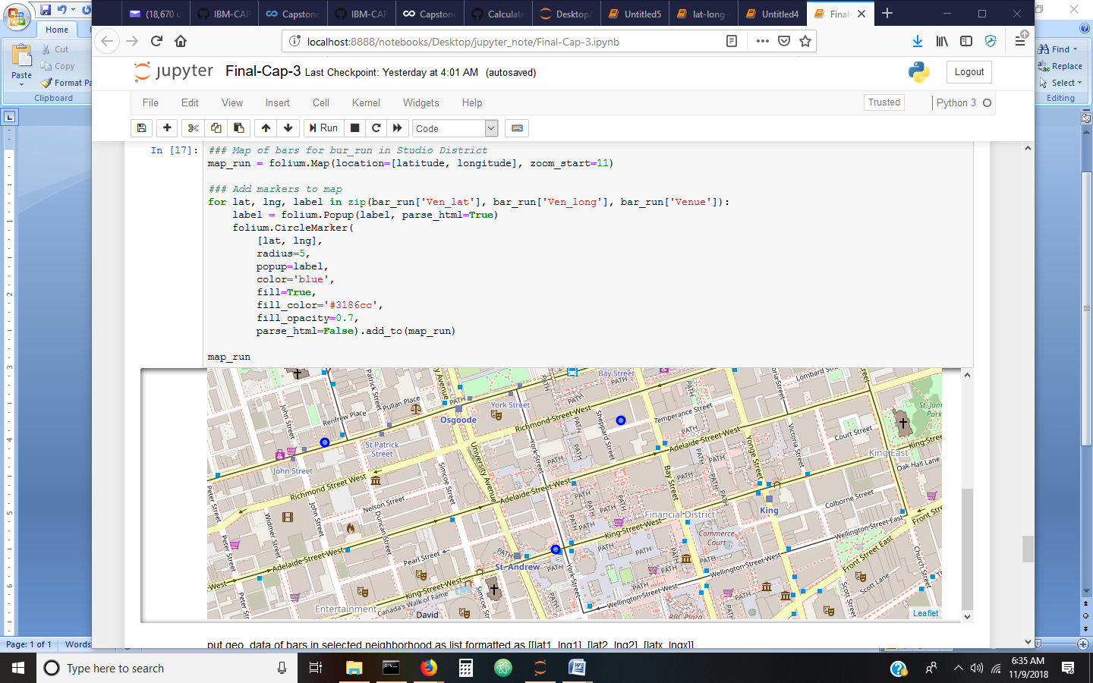

The three bars identified are: Boxcar Social Temperance ( 43.650557 -79.381956), Earls Kitchen & Bar (43.647923 -79.383789) and Queen St. Warehouse (43.650117 -79.390316). Starting at Boxcar Social Temperance, the shortest route is between all bars in this neighborhood is 0.91 mi.

Discussion:

 The TSP algorithm uses the haversine formula, which takes into account distance between points based in latitude / longitude coordinates, for calculating the distance between two geo-coordinates in miles.  The TSP algorithm cannot take into account ‘road distance’ (i.e. travel only on traffic grid) between points but outputs the actual distance between points (without respect to structures, traffic right-of-way, etc.) so the calculated shortest distance may need to be verified with city street maps.

Conclusion:

The TSP algorithm may be used to calculate the shortest distance between points from geodata derived from APIs; however, it is literally the shortest distance between points and does not take into account traffic right of ways or physical structures/barriers.