8-Oct

Shortcuts –

* main + ctrl + space + enter = public static void main(String[] args) { }
* sysout + ctrl + space = System.out.println()
* ctrl + shift + o = import all the required classes

***Inheritance***

Concept of inheritance is used to avoid code repetition.

Remember, while using concept of Inheritance we always create the object of junior most Child Class.

***Access Modifiers***

1) Protected – A protected property can be accessed within the package by all the classes but outside the package only child classes can access the protected property.

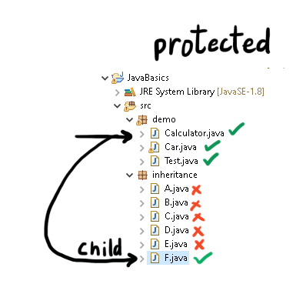

2) Default – a default property cannot be accessed by any class outside the package. Within the package it is accessible to all the classes.

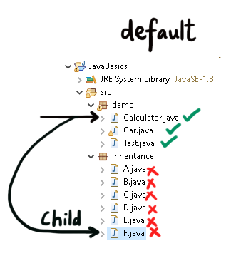

11-Oct

Q- What is the difference between Test Scenario and Test Cases?

A – Test scenario – it talks about what to test in an application. For e.g. I am going to test Login functionality of Facebook login page.

Test case – it is a step by step procedure describing how an application will be tested.

For e.g. To test login functionality of facebook, following test case will be created.

1. Open the browser
2. Navigate to application
3. Enter an valid username
4. Enter an valid password
5. Click on login button
6. Validate the user has logged in successfully.



In a QA Team, we follow these steps to test an application –



Test Scenarios > Test Cases > Test Execution



Q- What is Regression Testing?

A- It is the type of testing where old features of the software are tested in a new version of the software to make sure that the newly added feature/fixed bug does not impact the existing features of the software.

12-Oct









Explicit Wait

WebDriverWait wait = **new** WebDriverWait(driver,60);

wait.until(ExpectedConditions.*visibilityOfElementLocated*(By.*locator*("value")));

Q- What is the difference between Explicit Wait and Fluent Wait?

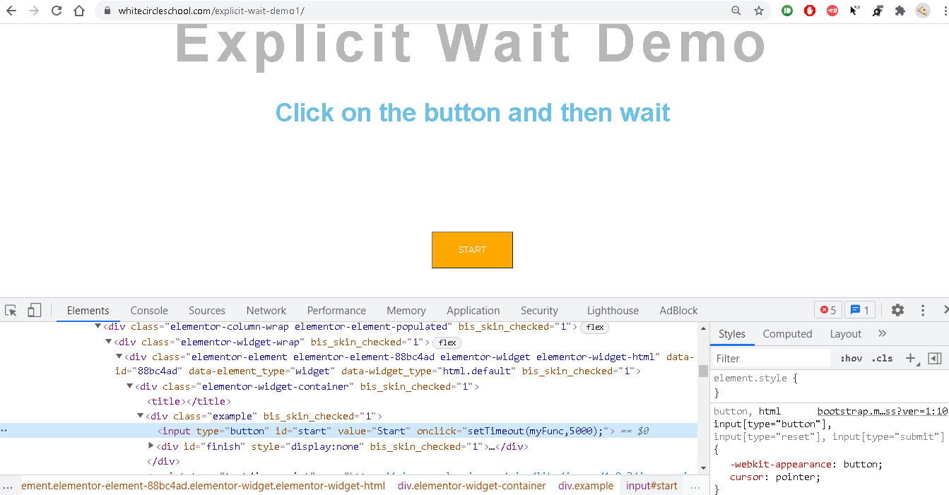



Explicit Wait is used to wait for an even to occur on the visible section of the page.

On the other hand, Implicit wait is used to wait for an event to occur on DOM.

Q- What is the difference between Explicit Wait and Fluent Wait?

A- Fluent Wait is exactly similar to Explicit Wait in functionality. It has just one extra feature – in fluent wait polling time is configurable whereas in Explicit wait it is not.

13-Oct

Drop-down

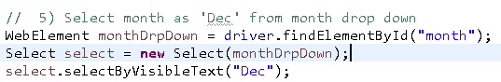

Web-Table

Structure -



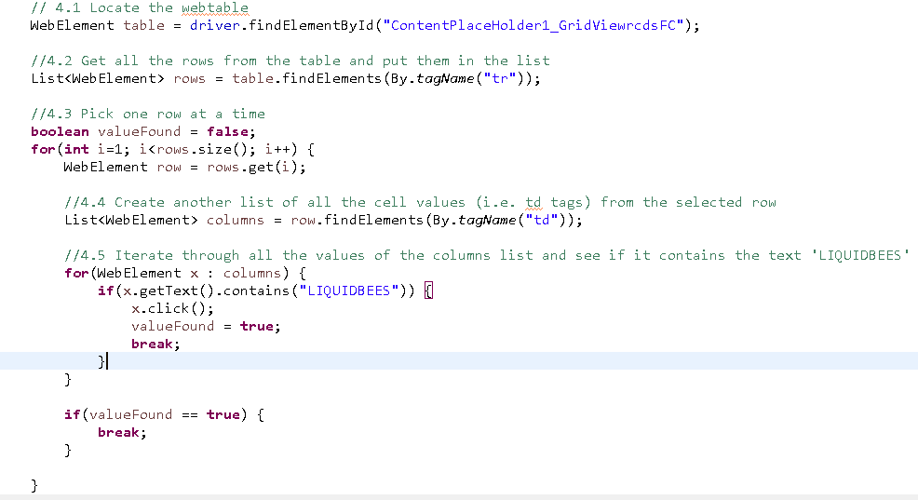



Alert Box





**Switching Windows**

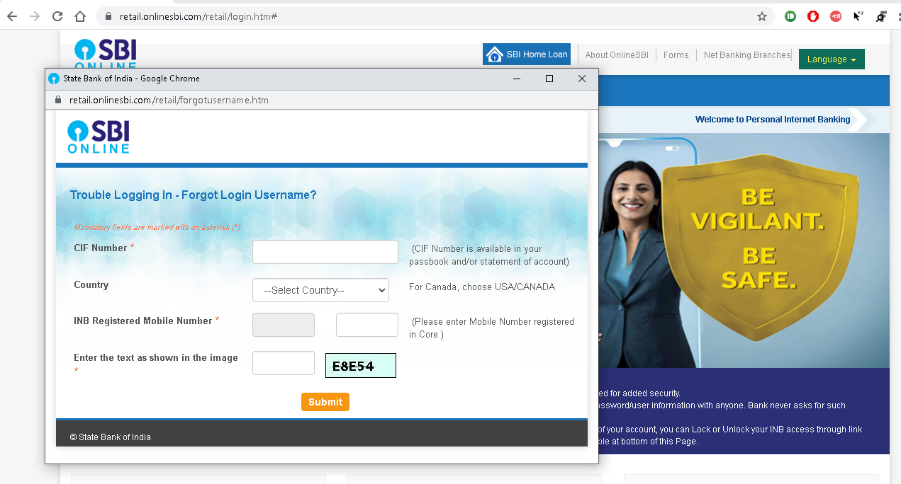



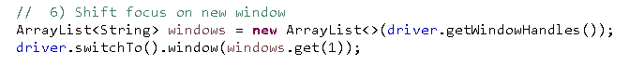

Frames



Mouse Hovering

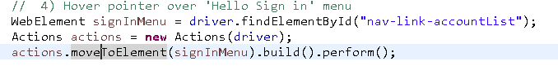

Screenshot

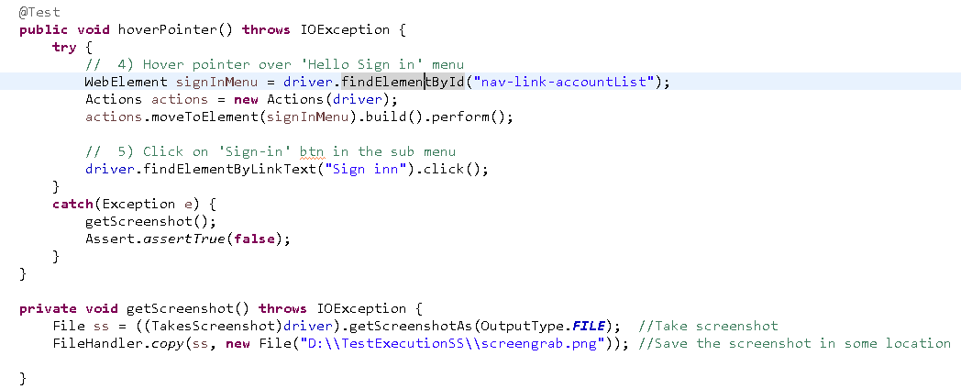

Browser Profiling

* It means changing the default behaviour of the browser.
* In the below code we are disabling notification feature of Chrome browser due to which it shows push notifications.

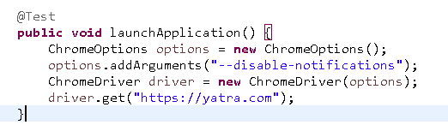

**Pre-defined classes to be remembered**

1. ChromeDriver 2) WebDriverWait



3) ExpectedConditions 4) Select



5) Actions



6) ChromeOptions

