Mohammed Rafi  Senior Manager- Quality Engineering  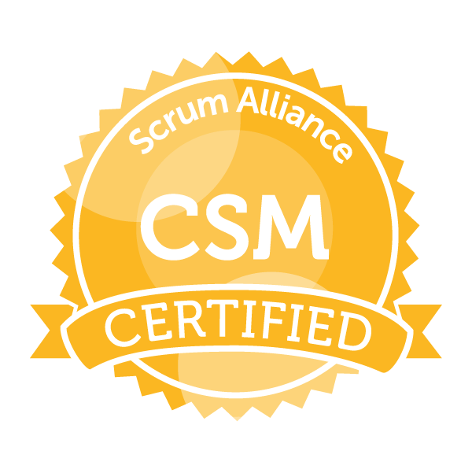  Certificate ID: 001542729 | Phone: +91 9884310792  Address: Chennai  Email: rafi862003@gmail.com

Profession Overview:

Experienced QA Professional with 16 years of experience in leading multiple teams on various projects through SDLC using Agile Framework such as Scrum, performed multiple roles in the last decade such as Senior Manager- Quality Engineering, QA Manager, QA Lead & Certified Scrum Master.

Experience Highlights:

- 16 years of experience for the implementation of enhanced product development for Organizations like Royal Bank of Canada., Citibank and Memento Security.
- 10+ Years of QA Manager Experience in Agile Environment heading Multiple QA Teams.
- Currently working as Senior Manager- Quality Engineering in Royal Bank of Canada (RBC).
- Domain expertise includes Banking, Security & Capital Markets (Credit Risk, Market Risk, Trade Compliance), Fraud Management- Banking.
- Performed different kind of Software testing especially Web, Data Warehousing/ETL Testing, Database testing, API Testing and BI report testing Projects.
- Currently handling a 15 member QA Team, across 3 different Line of Applications.
- Identify Risk, dependencies, bottle necks in QA process and escalate/flag to right target audience/Directors/Business Owners in early stage of STLC.
- Rich Experience in requirement management tools like Jira, Confluence and Test Management tools like HP-ALM, Qtest.
- Organise, Plan, Conduct UAT testing and publish Results to various Business Stakeholders.
- Created Custom Framework with Pytest which can handle API, ETL & Web Applications.
- Strong Experience in Python Programming (Pandas for ETL, Request for API Selenium for Web), Pytest and Allure Test Reporting.
- Demonstrated rich experience in handling large scale Data Migration Projects from Legacy systems to Public Cloud (AZURE) / BI reporting (Tableau) technological stack.
- Used popular Data Comparison tools like Query Surge, Beyond Compare to validate Large Scale data movement from On-Premise to CLOUD environments.
- Responsible for preparing Test Plan, Test Estimation, Test Approach document & Traceability documents
- Periodic status calls with QA Directors to share QA Cycle progress, Defect triaging, preparing weekly Metrics for defects/Test Execution
- Leading teams on Allocated task, Tracking QA tickets status, highlight risk’s/dependencies to respective team which has potential blocker for testing.
- Responsible for preparing weekly/Monthly metrics for projects across account level and report KPI’s, Retro Takeaways, Issues in Test Cycle in the Sprint.
- Engage with multiple IT vendors for QA resource hiring for Onshore/Offshore QA teams.

Professional Experience:
Organization Royal Bank of Canada
ETL Tools Azure data Factory, Azure data bricks
Database Azure SQL Server
Program Legacy Modernization Track
Project/Program FIVE- Migration of Legacy Batch Process to ADF/Azure Data Bricks
Duration Aug 2022 to Till Date
Domain Securities and Capital Market (Market risk)
Role Senior Manager- Quality Engineering

Project Description:

Fixed Income Var Engine (FIVE) is a Market Risk application which calculates VAR (Value at Risk) for the trades which holds Fixed income products. The Var model uses a Taylor series Method to compute VAR. The systems sources Position data through a REST API from an upstream Front Office trade processing product called Polypath and API jobs are scheduled through cron jobs in OCP containers which will fetch the data from Polypath and load it into Five Database. Five also market data from various Stake holders like Bloomberg, Mark IT and S&P for its VAR calculation process. This Migration project includes moving away from Legacy .net Batch process which sources data from Upstream systems and to Use more Modern Docker based approach to source the data. This Migration activity includes migrating more than 350 + Inhouse data feeds and 30+ External third-party data feeds from vendors like Bloomberg, Mark IT, S&P.

Roles and Responsibilities:

- Develop and maintain automation test strategy and framework
- Collaborate with development and QA teams to identify and prioritize test cases for automation
- Design and implement automated test scripts using various tools and technologies
- Manage and maintain automation test environments and infrastructure
- Analyze and report on test results and provide recommendations for improvement
- Train and mentor team members on automation testing best practices and techniques
- Ensure compliance with industry standards and regulations related to automation testing
- Participate in project planning and estimation activities
- Continuously evaluate and improve automation testing processes and tools
- Stay up-to-date with emerging trends and technologies in automation testing.
- Organized and facilitated overall Release and Sprint planning - including daily stand-ups, reviews/demos, and retrospectives.
- Periodic status calls with QA directors, Program Managers and Business Stakeholders for sharing program milestones.
- Coordinate with various Upstream, downstream stakeholders who are part of Migration program and facilitate QA team with all required information for testing.
- Conduct defect triage calls with multiple teams who are part of Migration Program.
- Coordinate with Upstream, Third-Party vendors for Test data required for QA cycle.
- Responsible for Presenting Test result to Change Advisory board for implementing PRD releases.
- Responsible for overlooking the QA team builds robust, scalable Automation Framework.
Client Royal Bank of Canada
Organization Cognizant Technology Solutions Canada Inc.
Tools and Technology Used Microsoft SQL server, Python, Jenkins
Project FIVE – Fixed Income Var Engine
Duration Sep 2018 to May 2022
Domain Securities and Capital Market (Market risk)
Project Management Tool Jira
Role QA Manager

Project Description:

Fixed Income Var Engine is a Market Risk application which calculates VAR (Value at Risk) for the trades which holds Fixed income products. The Var model uses a Taylor series Method to compute VAR. The systems sources Position data through a REST API from an upstream trading product called Polypath and gets market data from various Stake holders like Bloomberg, Mark IT and S&P. The API results are parsed and transformed by DataStage and fed into Data ware house from where OBIEE pulls the data for Reporting.

Roles and Responsibilities:

- Managed 3 Scrum teams. Collaborated with cross-functional teams to raise ROI by 25% in 2.5 years, increasing revenue by $1.2M per year.
- Act as a Single Point of Contact to RBC’s Senior Management.
- Facilitated meetings to iron out blockers, conducted JAD sessions with the Product owner and other stakeholders on regular basis and helped the team to make better use of these time and estimate more effectively, thus ensuring a healthy sprint progress.
- Kept the teams focused on the sprint’s priorities, business values, and protecting team from over-committing
- Communicated team status/progress via Release/Sprint Burndown charts, Story Acceptance rate and defects and make sure the stakeholders are aware of what is going on.
- Involved in Data Reconciliation, Data Transformation, Report Calculation types of testing.
- Prepare SQL queries to verify correctness of ETL Filtration logic, Data Transformation, Data Conversion and business calculations.
- Write Python scripts to validate large dataset for ETL transformation logic and data comparison
- Verify the correctness of Mapping of incoming feeds to the table
- Taking Ownership of complex business modules in the project on Test Execution & Test design
- UAT lead for the application to ensure test design, Test execution and signoff.
- Responsible for Preparing Test plans, Test Strategy and Requirement Traceability Matrix.

Client | Royal Bank of Canada
Organization | Cognizant technology Solution India
Tools and Technology Used | SQL Server 2019, Tableau
Project | Security Finance Risk Reporting System
Duration | June 2014 to August 2018
Project Management Tool | Jira
Role | QA Manager
Domain | Securities and Capital Market (Credit Risk)
Project Description:

Security Finance Reporting System [SFRS] is a Tableau reporting system which calculates credit risk exposures and supplies it to its downstream system. The Exposure is mainly calculated on three parameters namely Account Stress Limit, Gross Portfolio limit & Credit risk limit. The Exposure are reported in OBIEE internally in SFRS

Roles and Responsibilities:

- Involved in Data Reconciliation, Data Transformation, Report Calculation types of testing.
- Column Mapping between source and target databases.
- Verifying the ETL data in target database.
- Prepared SQL queries to verify the data.
- Responsible for review of test cases, test execution, test result verification, Defect validation and Defect Triaging.
- Offshore Point of contact for Client for Status reporting, defect discussion calls, Metrics reporting and complete project deliverables
- Knowledge Gathering of new projects from Client SME
- projects in Account level
- Ensure very minimal defect leakage from UAT to PRD
- Handling QA acceptance and handoff calls.
- Responsible for review of test cases, test execution and test result verification.

Client | Citibank-U. S
Organization | Infosys Technologies India
Tools and Technology Used | Oracle, Mantas, Actimize
Project | Energy Marking the Close
Duration | Nov 2010 to May 2014
Domain  Role | Securities and Capital Market (Trade Compliance)  Senior Test Engineer
Project Description:

Mantas is a Web based application which is used as a compliance tool in Citi to track whether all the trade is executed as per the standards set securities exchange commission and to detect if any unethical activity in trade is being executed. There is various logic which are fed into Mantas through which it monitors the trade happening for a period which is set as threshold. If any deviation from the expected behaviour of the trade is recognized, Mantas immediately identifies it and the detected activity is generated as an alert and it is fed into the case Management tool called Actimize (Citi’s Compliance CMT) for the AML analyst to investigate on them.

Roles and Responsibilities:

- Column Mapping between source and target databases.
- Verifying the ETL data in target database.
- Prepared SQL queries to verify the target data.
- Responsible for review of test cases, test execution, test result verification, Defect validation and Defect Triaging.
- Offshore Point of contact for Client for Status reporting, defect discussion calls, Metrics reporting and complete project deliverables
- Knowledge Gathering of new projects from Client SME
- Data analysis using spread sheet.
- Responsible for review of test cases, test execution, test result verification, Defect validation and Defect Triaging

Educational Details:

- Completed Bachelor of Engineering in Electronics and Telecommunication Engineering from Anna University Chennai, India

