**Analaysis of Public Housing in County Census Tracts and Proximity to CE(s)**

**Original Analysis By: D. White Date: 2019-11-13**

—————————-

KNITR File: Report Logistic Model.Rnw

## [1] "Generated on: 2020-04-16 08:41:46"

Methods: A multi-step data processing routine was performed for each county to integrate spatial and tabular data sets. Census tract data were spatially joined with CEs, Section-8 voucher housing units, and Low-Income Housing Tax Credit (LIHTC) units.

Processing Steps:

HUD Housing Data

1. Section-8 Voucher Data downloaded and aggregated from HUD website for each county (2000-2008)(see Assisted Housing Data.csv)

Section-8 Voucher data are spatially located by census tract. Primary data attributes included a census tract ”CODE”, ”YEAR”, ”NUMBER REPORTED”, and others. Census tract data were a multi-year report for each census tract in the county (2000, 2004, and 2008). Each county was saved as a separate CSV file (COUNTY ABREV HUD.CSV).

1. LIHTC Data downloaded and aggregated from HUD website for each county (2000-2008) (The Low- Income Housing Tax Credit Affordable housing data.csv) LIHTC data are spatially located by address. Primary data attributes included a census tract ”HUD ID Number”, ”Year”, ”Project Name”, ”Project Address”, ”Total Low-Income Units”, ”Total Number of Units”, and others. Data files were modified for GIS processing (attribute labels cleaned up, shortned, characters removed, etc.) and added to a GIS. LIHTC data were geocoded using the ”ArcGIS World Geocoding Service”. A total of 238 nationwide LI- HTC addresses were geocoded. Except for two locations, 236 addresses were positively matched. A separate analysis was performed on the two other locations that were ties. The locations were verified and a final shapefile was created. Using the Select by Attribute tool in ArcGIS, each county was exported as a separate shapefile (County Tax Credit.shp) from the naitonwide data set.

County Census Tracts:

County census tract data were downloaded from the IPUMS/NHGIS (IPUMS.org) for each county from the 2000 Census (see folder ”nghis0045 csv”). A data merge was performed in R using the spatial package (sp:::merge) between Section-8 CSV file and the Census Tract Shapefile for each county to generate a aggre- gated working file using a common census tract code as unique identifier (”GISJoin”). The resulting file in R that was filtered for the maximum available year that was 2008 for each county (Figure 1).

HUD-Aggregated Tables:

Section-8 and LIHTC were aggregated into a common spatial data set. The geocoded LIHTC county shape- file was imported into R and duplicate check was run to remove potential replicate LIHTC HUD IDs. Data were aggregated to the final observed year for each county, unlike Section-8, LIHTC data were summed across time to reflect the final year of available LIHTC units for each county. Section-8 and LIHTC were combined using a spatial join (sf:::st join) in R. The resulting spatial file realized census tract data with a total number of Section-8 housing units and multiple observations of LIHTC units per census tract. Thus, a final data set needed to collapse reported LIHTC into a single observation for each census tract. Further

processing generated ”clean” unique Section-8 and LIHTC summed by county census tract (Figure 2 and 3, repspectively).

The data processing by county can be found in the path below.

C:*\*Users*\*whitedl*\*Documents*\*R Code*\*HUD Project Code*\*CNTYNAME Public Housing CE.R

Results Descriptive Statistics:

Total census tracts per county are presented in Figure 1. With the exception of SAC, all counties had fewer than 100 census tracts. Douglas county had the group minimum of 8. Sacramento had a group maximum of 279. Explanatory variables had high zero counts with respect to prescence per census tract (Figure 4 and 5). Both groups show a large number of zeros, but LIHTC units were generally found in fewer census tracts. Section 8 units were more abundant than LIHTC units (Figures 6 and 7). However, LIHTC appear to have a higher density in census tracts (Figure 8). Sacramento had the largest total number of Section 8 and LIHTC units. Douglas county had the fewest Section 8 units and zero LIHTC units.

Model:

A poisson logistic regression was performed on an all county data set to test the probability of a CE lo- cated in census tract dependent upon HUD housing counts (Tables 1-4). Table 5 presents the results of a zero-inflation model, however, an overdispersion test indicates that overdispersion was not present in the GLM-Poisson model (Table 4), and geneally not an issue for the county models. Tables 6-36 show results of the logistic-poisson model for each individual county. ALB and DGL were included in the county global model, but were not run as discrete county models due to small sample sizes.

Parameter coefficient estimates for the global model (all counties) (CE presence/abscence = LIHTC + Sec 8) were significant (Table 1). A positive coefficent will indicate that an increase in public housing is associated with an increase in the probability of a CE in a given Census Tract. A negative coefficent will imply that increased numbers of public housing units are associated with a decreased probability of a CE in a census tract. Section 8 units had a signficant negative effect (-0.007)(P*<*.01) and LIHTC units had a signficant positive effect (0.002)(P*<*.05). A significant negative constant was reported (-0.738)(P*<*.01). Overdispersion was not indicted (Table 4).

Sacramento and York had significant coefficient estimates for Section 8 and LIHTC units. For Sacra- mento, Section 8 units had a signficant negative effect (-0.016)(P*<*.05) and LIHTC units had a signficant postitive effect (0.003)(P*<*.01). A significant negative constant was reported (-1.970)(P*<*.01) (Table 30). Overdispersion was not indicted (Table 33). For York county, Section 8 units had a signficant negative effect (-0.016)(P*<*.05) and LIHTC units had a signficant postitive effect (0.010)(P*<*.1) (Table 42). A significant negative constant was reported (-0.401)(P*<*.1). Overdispersion was not indicted (Table 44). For all other counties parameter coefficients were found to not be significant.

# Total Census Tracts per County

200

8

16

28

29

32

50

68

82

78

86

90

279

100

Total

0

ALB BLD CHS DGL GVL LDN LEB MES SAC SON WAS YRK

County

Figure 1: Total Census Tracts by County

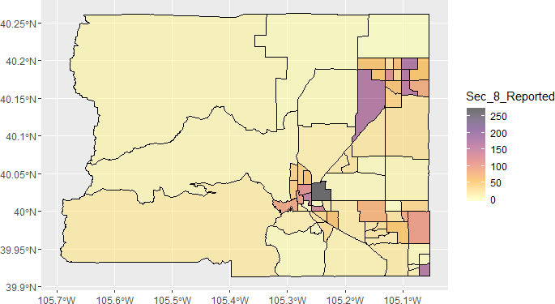

Figure 2: Section 8 Vouchers by Census Tract -Boulder, CO

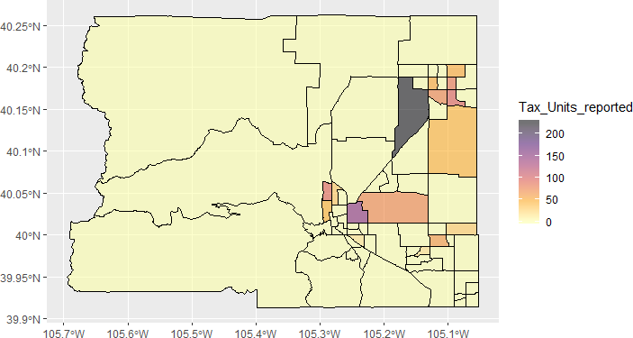

Figure 3: Section 8 Vouchers by Census Tract - Boulder, CO

Histogram for Section 8 Housing

300

200

Count

100

0

0 200 400 600

Section 8 Units

Figure 4: Histogram of Section 8 Units

# Histogram for Low−Income Housing Units Tax Credit (LIHTC)

600

400

Count

200

0

0 500 1000

LIHTC units

Figure 5: Histogram of LIHTC Units

# Section 8 Units Reported by Census Tract

No CE

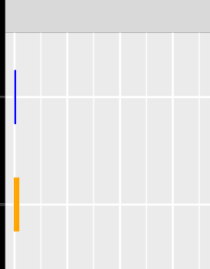

ALB

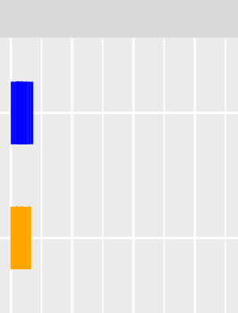

BLD

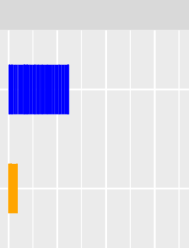

CHS

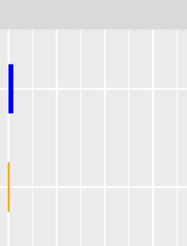

DGL

CE

No CE

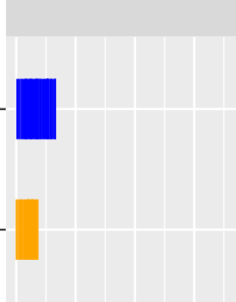

GVL

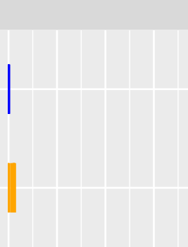

LDN

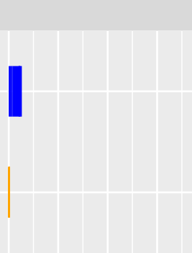

LEB

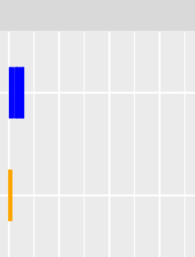

MES

CE

No CE

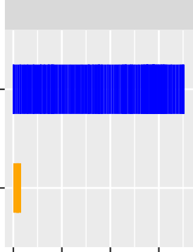

SAC

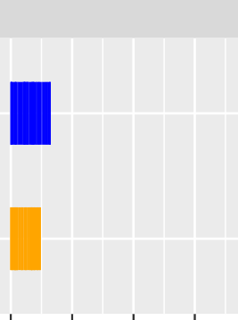

SON

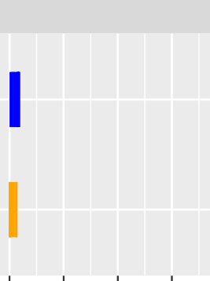

WAS

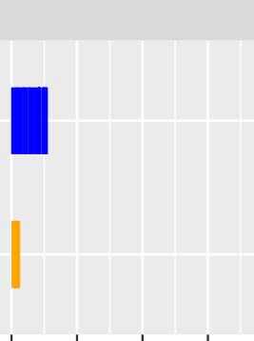

YRK

CE

Counts

Figure 6: Section 8 Units Reported by Census Tract

# Tax Credit Units Reported by Census Tract

No CE

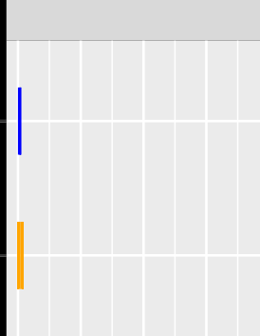

ALB

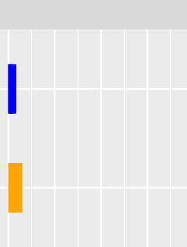

BLD

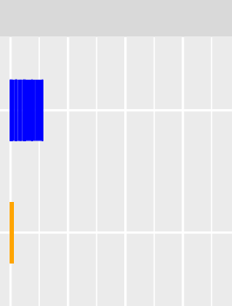

CHS

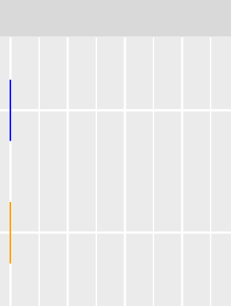

DGL

CE

No CE

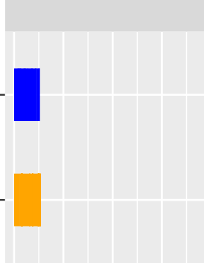

GVL

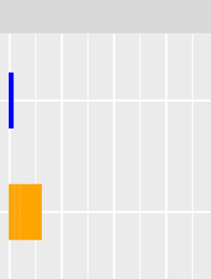

LDN



LEB

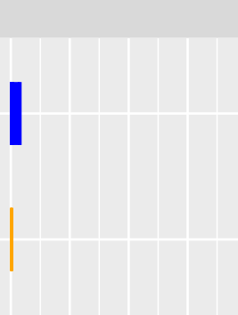

MES

|  |  |  |  |  |  |  |  |
| --- | --- | --- | --- | --- | --- | --- | --- |
|  |  |  |  |  |  |  |  |
|  |  |  |  |  |  |  |  |
|  |  |  |  |  |  |  |  |

CE

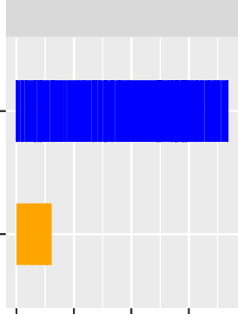

SAC

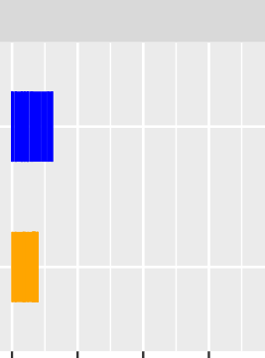

SON

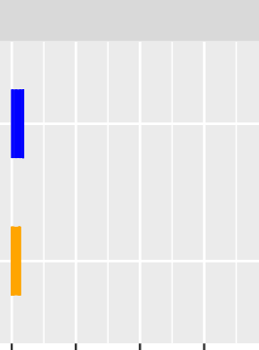

WAS

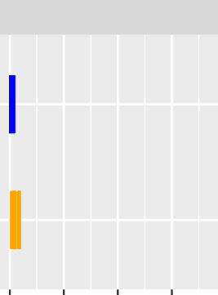

YRK

No CE

CE

Counts

Figure 7: LIHTC Units Reported by Census Tract

# All HUD Housing Units Reported by Census Tract

No CE

ALB

BLD

CHS

DGL

CE

No CE

GVL

LDN

LEB

MES

CE

No CE

SAC

SON

WAS

YRK

CE

Counts

# Housing Units Reported by Census Tract (note: zeros dropped)

1000

ALB

BLD

CHS

DGL

100

10

1

1000

GVL

LDN

LEB

MES

100

Counts

10

1

1000

SAC

SON

WAS

YRK

100

10

1

CE No CE

CE No CE

CE No CE

CE No CE

Table 1: All Counties: Logistic Regression Results (GLM, Poisson) : HUD Housing

*Dependent variable:*

CE Present

Sec 8 Reported -0.007*∗∗∗* (0.001)

Tax Units reported 0.002*∗∗*

(0.001)

Constant -0.738*∗∗∗* (0.070)

Observations 846

Log Likelihood -594.702

Akaike Inf. Crit. 1,195.404

*Note: ∗*p*<*0.1; *∗∗*p*<*0.05; *∗∗∗*p*<*0.01

Table 2: All Counties: Analysis of Deviance

|  |  |  |  |  |  |  |  |
| --- | --- | --- | --- | --- | --- | --- | --- |
| Statistic | N | Mean | St. Dev. | Min | Pctl(25) | Pctl(75) | Max |
| Df | 2 | 1.000 | 0.000 | 1.000 | 1.000 | 1.000 | 1.000 |
| Deviance | 2 | 22.480 | 25.683 | 4.319 | 13.400 | 31.561 | 40.641 |
| Resid. Df | 3 | 844.000 | 1.000 | 843 | 843.5 | 844.5 | 845 |
| Resid. Dev | 3 | 593.830 | 24.805 | 577.404 | 579.563 | 602.043 | 622.364 |
| Pr(*>*Chi) | 2 | 0.019 | 0.027 | 0.000 | 0.009 | 0.028 | 0.038 |

Table 3: All Counties: McFadden Statistic:similar to R2

|  |  |  |  |  |  |
| --- | --- | --- | --- | --- | --- |
| llh | llhNull | G2 | McFadden | r2ML | r2CU |
| -594.702 | -617.182 | 44.960 | 0.036 | 0.052 | 0.067 |

Table 4: Overdisperson Test

statistic p.value estimate null.value alternative method data.name

z -11.262 1 -0.362 0 greater Overdispersion test model1 Poisson

Table 5: All Counties: Logistic Regression Results, Zero Inflation Model (Poisson Distribution): HUD Housing

*Dependent variable:*

CE Present

Sec 8 Reported -0.008*∗∗∗* (0.001)

Tax Units reported 0.003*∗∗∗*

(0.001)

Constant -0.745*∗∗∗* (0.070)

Observations 846

Log Likelihood -592.625

*Note: ∗*p*<*0.1; *∗∗*p*<*0.05; *∗∗∗*p*<*0.01

Table 6: BLD Regression Results: HUD Housing

*Dependent variable:*

CE Present

Sec 8 Reported -0.005

(0.004)

Tax Units reported 0.005

(0.005)

Constant -0.478*∗∗* (0.215)

Observations 68

Log Likelihood -58.659

Akaike Inf. Crit. 123.318

*Note: ∗*p*<*0.1; *∗∗*p*<*0.05; *∗∗∗*p*<*0.01

Table 7: BLD: Analysis of Deviance

|  |  |  |  |  |  |  |  |
| --- | --- | --- | --- | --- | --- | --- | --- |
| Statistic | N | Mean | St. Dev. | Min | Pctl(25) | Pctl(75) | Max |
| Df | 2 | 1.000 | 0.000 | 1.000 | 1.000 | 1.000 | 1.000 |
| Deviance | 2 | 0.859 | 0.250 | 0.682 | 0.770 | 0.947 | 1.036 |
| Resid. Df | 3 | 66.000 | 1.000 | 65 | 65.5 | 66.5 | 67 |
| Resid. Dev | 3 | 44.236 | 0.865 | 43.318 | 43.836 | 44.695 | 45.036 |
| Pr(*>*Chi) | 2 | 0.359 | 0.071 | 0.309 | 0.334 | 0.384 | 0.409 |

Table 8: BLD: McFadden Statistic:similar to R2

|  |  |  |  |  |  |
| --- | --- | --- | --- | --- | --- |
| llh | llhNull | G2 | McFadden | r2ML | r2CU |
| -58.659 | -59.518 | 1.718 | 0.014 | 0.025 | 0.030 |

Table 9: BLD Overdisperson Test

statistic p.value estimate null.value alternative method data.name z -4.550 1.000 -0.544 0 greater Overdispersion test BLD model1

Table 10: CHS Regression Results: HUD Housing

*Dependent variable:*

CE Present

Sec 8 Reported -0.005

(0.004)

Tax Units reported -0.005

(0.011)

Constant -0.931*∗∗∗* (0.260)

Observations 78

Log Likelihood -45.890

Akaike Inf. Crit. 97.780

*Note: ∗*p*<*0.1; *∗∗*p*<*0.05; *∗∗∗*p*<*0.01

Table 11: CHS: Analysis of Deviance

|  |  |  |  |  |  |  |  |
| --- | --- | --- | --- | --- | --- | --- | --- |
| Statistic | N | Mean | St. Dev. | Min | Pctl(25) | Pctl(75) | Max |
| Df | 2 | 1.000 | 0.000 | 1.000 | 1.000 | 1.000 | 1.000 |
| Deviance | 2 | 2.666 | 3.512 | 0.183 | 1.424 | 3.907 | 5.149 |
| Resid. Df | 3 | 76.000 | 1.000 | 75 | 75.5 | 76.5 | 77 |
| Resid. Dev | 3 | 51.618 | 3.027 | 49.780 | 49.872 | 52.537 | 55.112 |
| Pr(*>*Chi) | 2 | 0.346 | 0.457 | 0.023 | 0.185 | 0.508 | 0.669 |

Table 12: CHS: McFadden Statistic:similar to R2

|  |  |  |  |  |  |
| --- | --- | --- | --- | --- | --- |
| llh | llhNull | G2 | McFadden | r2ML | r2CU |
| -45.890 | -48.556 | 5.332 | 0.055 | 0.066 | 0.093 |

Table 13: CHS Overdisperson Test

statistic p.value estimate null.value alternative method data.name z -2.778 0.997 -0.269 0 greater Overdispersion test CHS model1

Table 14: GVL Regression Results: HUD Housing

*Dependent variable:*

CE Present

Sec 8 Reported -0.003

(0.003)

Tax Units reported 0.002

(0.002)

Constant -0.771*∗∗∗* (0.203)

Observations 90

Log Likelihood -69.907

Akaike Inf. Crit. 145.814

*Note: ∗*p*<*0.1; *∗∗*p*<*0.05; *∗∗∗*p*<*0.01

Table 15: GVL: Analysis of Deviance

|  |  |  |  |  |  |  |  |
| --- | --- | --- | --- | --- | --- | --- | --- |
| Statistic | N | Mean | St. Dev. | Min | Pctl(25) | Pctl(75) | Max |
| Df | 2 | 1.000 | 0.000 | 1.000 | 1.000 | 1.000 | 1.000 |
| Deviance | 2 | 0.858 | 0.237 | 0.690 | 0.774 | 0.941 | 1.025 |
| Resid. Df | 3 | 88.000 | 1.000 | 87 | 87.5 | 88.5 | 89 |
| Resid. Dev | 3 | 64.727 | 0.863 | 63.814 | 64.326 | 65.184 | 65.529 |
| Pr(*>*Chi) | 2 | 0.359 | 0.067 | 0.311 | 0.335 | 0.382 | 0.406 |

Table 16: GVL: McFadden Statistic:similar to R2

|  |  |  |  |  |  |
| --- | --- | --- | --- | --- | --- |
| llh | llhNull | G2 | McFadden | r2ML | r2CU |
| -69.907 | -70.764 | 1.715 | 0.012 | 0.019 | 0.024 |

Table 17: GVL Overdisperson Test

statistic p.value estimate null.value alternative method data.name z -4.091 1.000 -0.422 0 greater Overdispersion test GVL model1

Table 18: LDN Regression Results: HUD Housing

*Dependent variable:*

CE Present

Sec 8 Reported 0.001

(0.006)

Tax Units reported 0.001

(0.002)

Constant -0.469*∗* (0.266)

Observations 32

Log Likelihood -30.002

Akaike Inf. Crit. 66.004

*Note: ∗*p*<*0.1; *∗∗*p*<*0.05; *∗∗∗*p*<*0.01

Table 19: LDN: Analysis of Deviance

|  |  |  |  |  |  |  |  |
| --- | --- | --- | --- | --- | --- | --- | --- |
| Statistic | N | Mean | St. Dev. | Min | Pctl(25) | Pctl(75) | Max |
| Df | 2 | 1.000 | 0.000 | 1.000 | 1.000 | 1.000 | 1.000 |
| Deviance | 2 | 0.241 | 0.083 | 0.182 | 0.212 | 0.271 | 0.300 |
| Resid. Df | 3 | 30.000 | 1.000 | 29 | 29.5 | 30.5 | 31 |
| Resid. Dev | 3 | 16.225 | 0.244 | 16.004 | 16.095 | 16.336 | 16.487 |
| Pr(*>*Chi) | 2 | 0.626 | 0.061 | 0.584 | 0.605 | 0.648 | 0.669 |

Table 20: LDN: McFadden Statistic:similar to R2

|  |  |  |  |  |  |
| --- | --- | --- | --- | --- | --- |
| llh | llhNull | G2 | McFadden | r2ML | r2CU |
| -30.002 | -30.243 | 0.483 | 0.008 | 0.015 | 0.018 |

Table 21: LDN Overdisperson Test

statistic p.value estimate null.value alternative method data.name z -4.213 1.000 -0.687 0 greater Overdispersion test LDN model1

Table 22: LEB Regression Results: HUD Housing

*Dependent variable:*

CE Present

Sec 8 Reported -0.032

(0.020)

Tax Units reported 0.017

(0.040)

Constant 0.004

(0.241)

Observations 29

Log Likelihood -22.141

Akaike Inf. Crit. 50.283

*Note: ∗*p*<*0.1; *∗∗*p*<*0.05; *∗∗∗*p*<*0.01

Table 23: LEB: Analysis of Deviance

|  |  |  |  |  |  |  |  |
| --- | --- | --- | --- | --- | --- | --- | --- |
| Statistic | N | Mean | St. Dev. | Min | Pctl(25) | Pctl(75) | Max |
| Df | 2 | 1.000 | 0.000 | 1.000 | 1.000 | 1.000 | 1.000 |
| Deviance | 2 | 5.290 | 7.260 | 0.156 | 2.723 | 7.857 | 10.424 |
| Resid. Df | 3 | 27.000 | 1.000 | 26 | 26.5 | 27.5 | 28 |
| Resid. Dev | 3 | 7.861 | 6.064 | 4.283 | 4.361 | 9.651 | 14.863 |
| Pr(*>*Chi) | 2 | 0.347 | 0.489 | 0.001 | 0.174 | 0.520 | 0.693 |

Table 24: LEB: McFadden Statistic:similar to R2

|  |  |  |  |  |  |
| --- | --- | --- | --- | --- | --- |
| llh | llhNull | G2 | McFadden | r2ML | r2CU |
| -22.141 | -27.431 | 10.580 | 0.193 | 0.306 | 0.360 |

Table 25: LEB Overdisperson Test

statistic p.value estimate null.value alternative method data.name z -6.024 1 -0.690 0 greater Overdispersion test LEB model1

Table 26: MES Regression Results: HUD Housing

*Dependent variable:*

CE Present

Sec 8 Reported -0.009

(0.009)

Tax Units reported 0.003

(0.014)

Constant -0.657*∗* (0.373)

Observations 28

Log Likelihood -19.084

Akaike Inf. Crit. 44.168

*Note: ∗*p*<*0.1; *∗∗*p*<*0.05; *∗∗∗*p*<*0.01

Table 27: MES: Analysis of Deviance

|  |  |  |  |  |  |  |  |
| --- | --- | --- | --- | --- | --- | --- | --- |
| Statistic | N | Mean | St. Dev. | Min | Pctl(25) | Pctl(75) | Max |
| Df | 2 | 1.000 | 0.000 | 1.000 | 1.000 | 1.000 | 1.000 |
| Deviance | 2 | 1.212 | 1.647 | 0.047 | 0.630 | 1.795 | 2.377 |
| Resid. Df | 3 | 26.000 | 1.000 | 25 | 25.5 | 26.5 | 27 |
| Resid. Dev | 3 | 18.992 | 1.386 | 18.168 | 18.192 | 19.404 | 20.592 |
| Pr(*>*Chi) | 2 | 0.475 | 0.498 | 0.123 | 0.299 | 0.652 | 0.828 |

Table 28: MES: McFadden Statistic:similar to R2

|  |  |  |  |  |  |
| --- | --- | --- | --- | --- | --- |
| llh | llhNull | G2 | McFadden | r2ML | r2CU |
| -19.084 | -20.296 | 2.424 | 0.060 | 0.083 | 0.108 |

Table 29: MES Overdisperson Test

statistic p.value estimate null.value alternative method data.name z -2.030 0.979 -0.357 0 greater Overdispersion test MES model1

Table 30: SAC Regression Results: HUD Housing

*Dependent variable:*

CE Present

Sec 8 Reported -0.016*∗∗* (0.007)

Tax Units reported 0.003*∗∗∗*

(0.001)

Constant -1.970*∗∗∗* (0.269)

Observations 279

Log Likelihood -74.861

Akaike Inf. Crit. 155.722

*Note: ∗*p*<*0.1; *∗∗*p*<*0.05; *∗∗∗*p*<*0.01

Table 31: SAC: Analysis of Deviance

|  |  |  |  |  |  |  |  |
| --- | --- | --- | --- | --- | --- | --- | --- |
| Statistic | N | Mean | St. Dev. | Min | Pctl(25) | Pctl(75) | Max |
| Df | 2 | 1.000 | 0.000 | 1.000 | 1.000 | 1.000 | 1.000 |
| Deviance | 2 | 5.541 | 0.895 | 4.908 | 5.224 | 5.857 | 6.173 |
| Resid. Df | 3 | 277.000 | 1.000 | 276 | 276.5 | 277.5 | 278 |
| Resid. Dev | 3 | 109.051 | 5.553 | 103.722 | 106.176 | 111.716 | 114.803 |
| Pr(*>*Chi) | 2 | 0.020 | 0.010 | 0.013 | 0.016 | 0.023 | 0.027 |

Table 32: SAC: McFadden Statistic:similar to R2

|  |  |  |  |  |  |
| --- | --- | --- | --- | --- | --- |
| llh | llhNull | G2 | McFadden | r2ML | r2CU |
| -74.861 | -80.402 | 11.081 | 0.069 | 0.039 | 0.089 |

Table 33: SAC Overdisperson Test

statistic p.value estimate null.value alternative method data.name z -2.778 0.997 -0.269 0 greater Overdispersion test CHS model1

Table 34: SON Regression Results: HUD Housing

*Dependent variable:*

CE Present

Sec 8 Reported -0.004

(0.003)

Tax Units reported -0.001

(0.003)

Constant -0.375*∗* (0.201)

Observations 86

Log Likelihood -74.130

Akaike Inf. Crit. 154.260

*Note: ∗*p*<*0.1; *∗∗*p*<*0.05; *∗∗∗*p*<*0.01

Table 35: SON: Analysis of Deviance

|  |  |  |  |  |  |  |  |
| --- | --- | --- | --- | --- | --- | --- | --- |
| Statistic | N | Mean | St. Dev. | Min | Pctl(25) | Pctl(75) | Max |
| Df | 2 | 1.000 | 0.000 | 1.000 | 1.000 | 1.000 | 1.000 |
| Deviance | 2 | 1.267 | 1.748 | 0.031 | 0.649 | 1.885 | 2.504 |
| Resid. Df | 3 | 84.000 | 1.000 | 83 | 83.5 | 84.5 | 85 |
| Resid. Dev | 3 | 55.115 | 1.454 | 54.260 | 54.276 | 55.543 | 56.795 |
| Pr(*>*Chi) | 2 | 0.487 | 0.528 | 0.114 | 0.300 | 0.674 | 0.860 |

Table 36: SON: McFadden Statistic:similar to R2

|  |  |  |  |  |  |
| --- | --- | --- | --- | --- | --- |
| llh | llhNull | G2 | McFadden | r2ML | r2CU |
| -74.130 | -75.397 | 2.535 | 0.017 | 0.029 | 0.035 |

Table 37: SON Overdisperson Test

statistic p.value estimate null.value alternative method data.name z -5.168 1.000 -0.547 0 greater Overdispersion test SON model1

Table 38: WAS Regression Results: HUD Housing

*Dependent variable:*

CE Present

Sec 8 Reported -0.003

(0.005)

Tax Units reported -0.00005

(0.007)

Constant -0.524*∗∗* (0.223)

Observations 50

Log Likelihood -43.350

Akaike Inf. Crit. 92.700

*Note: ∗*p*<*0.1; *∗∗*p*<*0.05; *∗∗∗*p*<*0.01

Table 39: WAS: Analysis of Deviance

|  |  |  |  |  |  |  |  |
| --- | --- | --- | --- | --- | --- | --- | --- |
| Statistic | N | Mean | St. Dev. | Min | Pctl(25) | Pctl(75) | Max |
| Df | 2 | 1.000 | 0.000 | 1.000 | 1.000 | 1.000 | 1.000 |
| Deviance | 2 | 0.287 | 0.406 | 0.0001 | 0.143 | 0.430 | 0.574 |
| Resid. Df | 3 | 48.000 | 1.000 | 47 | 47.5 | 48.5 | 49 |
| Resid. Dev | 3 | 32.892 | 0.331 | 32.700 | 32.700 | 32.987 | 33.274 |
| Pr(*>*Chi) | 2 | 0.722 | 0.386 | 0.449 | 0.585 | 0.858 | 0.994 |

Table 40: WAS: McFadden Statistic:similar to R2

|  |  |  |  |  |  |
| --- | --- | --- | --- | --- | --- |
| llh | llhNull | G2 | McFadden | r2ML | r2CU |
| -43.350 | -43.637 | 0.574 | 0.007 | 0.011 | 0.014 |

Table 41: WAS Overdisperson Test

statistic p.value estimate null.value alternative method data.name z -3.829 1.000 -0.540 0 greater Overdispersion test WAS model1

Table 42: YRK Regression Results: HUD Housing

*Dependent variable:*

CE Present

Sec 8 Reported -0.016*∗∗* (0.007)

Tax Units reported 0.010*∗*

(0.006)

Constant -0.401*∗∗* (0.180)

Observations 82

Log Likelihood -64.841

Akaike Inf. Crit. 135.683

*Note: ∗*p*<*0.1; *∗∗*p*<*0.05; *∗∗∗*p*<*0.01

Table 43: YRK: Analysis of Deviance

|  |  |  |  |  |  |  |  |
| --- | --- | --- | --- | --- | --- | --- | --- |
| Statistic | N | Mean | St. Dev. | Min | Pctl(25) | Pctl(75) | Max |
| Df | 2 | 1.000 | 0.000 | 1.000 | 1.000 | 1.000 | 1.000 |
| Deviance | 2 | 5.916 | 4.893 | 2.456 | 4.186 | 7.646 | 9.376 |
| Resid. Df | 3 | 80.000 | 1.000 | 79 | 79.5 | 80.5 | 81 |
| Resid. Dev | 3 | 48.446 | 6.244 | 43.683 | 44.911 | 50.827 | 55.515 |
| Pr(*>*Chi) | 2 | 0.060 | 0.081 | 0.002 | 0.031 | 0.088 | 0.117 |

Table 44: YRK: McFadden Statistic:similar to R2

|  |  |  |  |  |  |
| --- | --- | --- | --- | --- | --- |
| llh | llhNull | G2 | McFadden | r2ML | r2CU |
| -64.841 | -70.757 | 11.832 | 0.084 | 0.134 | 0.163 |

Table 45: YRK Overdisperson Test

statistic p.value estimate null.value alternative method data.name z -2.778 0.997 -0.269 0 greater Overdispersion test CHS model1