Task 5

Flowchart

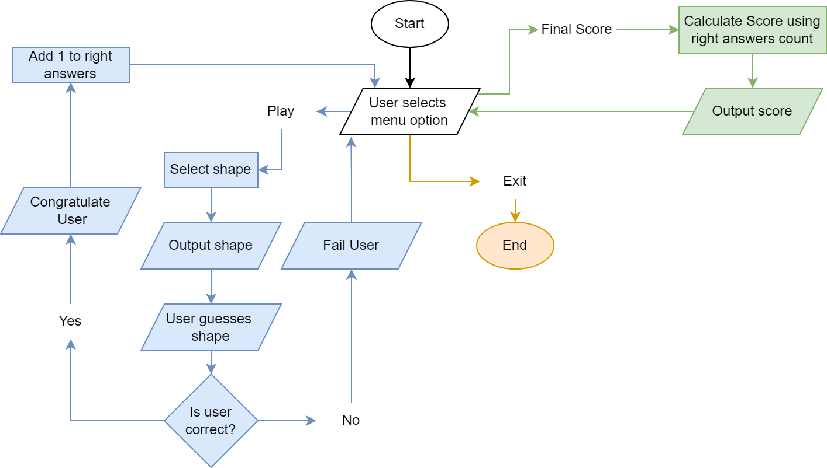

Testing

|  |  |  |
| --- | --- | --- |
| Test | Screenshot | Analysis (If needed) |
| Select play option in main menu |  |  |
| Select final score option in main menu |  |  |
| Select exit option in main menu |  |  |
| Input invalid main menu option |  |  |
| Answer question correctly |  |  |
| Answer question incorrectly |  |  |
| Input invalid question answer |  | Doesn’t create any errors but mentioning that the input was invalid instead of just “Wrong answer” would provide better user feedback. The improved version is to the right. |

Task 6

Flowchart

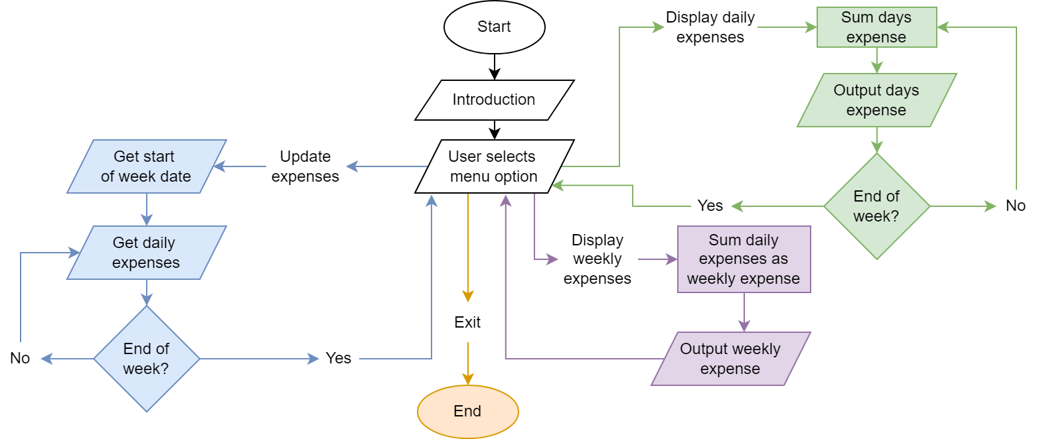

Testing

|  |  |  |
| --- | --- | --- |
| Test | Screenshot | Analysis (If needed) |
| Select Display Daily Expenses option in main menu |  |  |
| Select Update Expenses option in main menu |  |  |
| Select Weekly Expenses option in main menu, after updating them. |  |  |
| Select Quit option in main menu |  |  |
| Enter Invalid first expense date when updating expenses |  |  |
| Enter valid first expense date when updating expenses |  |  |
| Enter correct data into all data fields for updating expenses |  |  |