Design feedback

## Mock-up #1

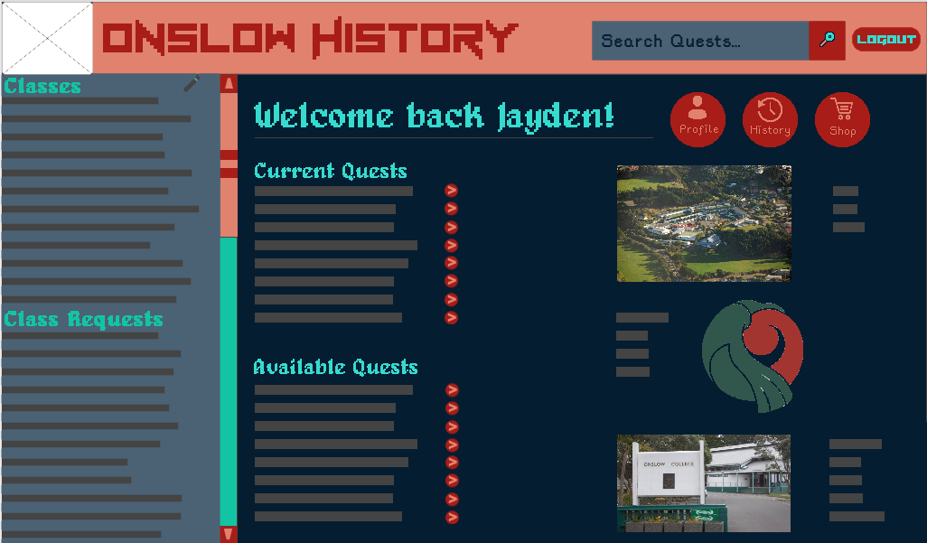

1. Circle/highlight the words that come to mind when you look at the **colour** scheme.

|  |  |  |  |  |  |
| --- | --- | --- | --- | --- | --- |
| Professional | Warm | Childish | Simple | Shambolic | Relaxed |
| Overbearing | Casual | Engaging | Clever | Serious | Cold |
| Sloppy | Trustworthy | Playful | Interesting | Easy | Arrogant |
| Inclusive | Sleek | Detailed | Confident | Chilled | Clinical |
| Authoritative | Exciting | Open | Laid back | Fun | Amateur |
| Supportive | Stuffy | Silly | Helpful | Enthusiastic | Bossy |

1. Circle/highlight the words that come to mind when you look at the **font** scheme.

|  |  |  |  |  |  |
| --- | --- | --- | --- | --- | --- |
| Professional | Warm | Childish | Simple | Shambolic | Relaxed |
| Overbearing | Casual | Engaging | Clever | Serious | Cold |
| Sloppy | Trustworthy | Playful | Interesting | Easy | Arrogant |
| Inclusive | Sleek | Detailed | Confident | Chilled | Clinical |
| Authoritative | Exciting | Open | Laid back | Fun | Amateur |
| Supportive | Stuffy | Silly | Helpful | Enthusiastic | Bossy |

1. Are there any other words that you associate with this mock-up?

|  |
| --- |
|  |

1. What do you think about the choice of:

|  |  |
| --- | --- |
| Background colour |  |
| Text colour(s) |  |
| Text-on-background combination |  |
| Accent colour(s) |  |

1. Circle/highlight any statements you find applicable:

|  |  |  |
| --- | --- | --- |
| The **colours** in the mock-up make text hard to read | The **colours** in the mock-up make it hard to see where I need to interact (click, tap, type, etc.) | The **colours** in the mock-up make it hard to distinguish different sections |
| The **fonts** (including typeface, size, spacing, etc.) in the mock-up make text hard to read | The **fonts** (including typeface, size, spacing, etc.) in the mock-up make it hard to see where I need to interact (click, tap, type, etc.) | The **fonts** (including typeface, size, spacing, etc.) in the mock-up make it hard to distinguish different sections |
| I have not found anything in the mock-up that makes text hard to read | I have not found anything in the mock-up that makes it hard to see where I need to interact | I have not found anything in the mock-up that makes it hard to distinguish different sections |

1. What are the pros about this mock-up?

|  |
| --- |
|  |

1. What do you think could be improved about this mock-up?

|  |
| --- |
|  |

1. Do you have any other feedback?

|  |
| --- |
|  |

## Mock-up #2

1. Circle/highlight the words that come to mind when you look at the **colour** scheme.

|  |  |  |  |  |  |
| --- | --- | --- | --- | --- | --- |
| Professional | Warm | Childish | Simple | Shambolic | Relaxed |
| Overbearing | Casual | Engaging | Clever | Serious | Cold |
| Sloppy | Trustworthy | Playful | Interesting | Easy | Arrogant |
| Inclusive | Sleek | Detailed | Confident | Chilled | Clinical |
| Authoritative | Exciting | Open | Laid back | Fun | Amateur |
| Supportive | Stuffy | Silly | Helpful | Enthusiastic | Bossy |

1. Circle/highlight the words that come to mind when you look at the **font** scheme.

|  |  |  |  |  |  |
| --- | --- | --- | --- | --- | --- |
| Professional | Warm | Childish | Simple | Shambolic | Relaxed |
| Overbearing | Casual | Engaging | Clever | Serious | Cold |
| Sloppy | Trustworthy | Playful | Interesting | Easy | Arrogant |
| Inclusive | Sleek | Detailed | Confident | Chilled | Clinical |
| Authoritative | Exciting | Open | Laid back | Fun | Amateur |
| Supportive | Stuffy | Silly | Helpful | Enthusiastic | Bossy |

1. Are there any other words that you associate with this mock-up?

|  |
| --- |
|  |

1. What do you think about the choice of:

|  |  |
| --- | --- |
| Background colour |  |
| Text colour(s) |  |
| Text-on-background combination |  |
| Accent colour(s) |  |

1. Circle/highlight any statements you find applicable:

|  |  |  |
| --- | --- | --- |
| The **colours** in the mock-up make text hard to read | The **colours** in the mock-up make it hard to see where I need to interact (click, tap, type, etc.) | The **colours** in the mock-up make it hard to distinguish different sections |
| The **fonts** (including typeface, size, spacing, etc.) in the mock-up make text hard to read | The **fonts** (including typeface, size, spacing, etc.) in the mock-up make it hard to see where I need to interact (click, tap, type, etc.) | The **fonts** (including typeface, size, spacing, etc.) in the mock-up make it hard to distinguish different sections |
| I have not found anything in the mock-up that makes text hard to read | I have not found anything in the mock-up that makes it hard to see where I need to interact | I have not found anything in the mock-up that makes it hard to distinguish different sections |

1. What are the pros about this mock-up?

|  |
| --- |
|  |

1. What do you think could be improved about this mock-up?

|  |
| --- |
|  |

1. Do you have any other feedback?

|  |
| --- |
|  |

# Review

1. Overall, which mock-up did you prefer?

|  |
| --- |
|  |

1. Why did you prefer that mock-up over the others?

|  |
| --- |
|  |

1. What suggestions do you have that I could do to **improve** your preferred mock-up?

|  |
| --- |
|  |