📄 Project Report – AQUA·INTELLIGENCE
Smart Aquaculture Monitoring & Predictive Analytics System
Version 1.0 – July 2026

1. Abstract
AQUA·INTELLIGENCE is an end-to-end smart aquaculture monitoring system that combines real-time sensor data (pH, temperature, turbidity, EC) from an ESP8266-based IoT node with machine learning for fish and herb/spice species prediction. The system features a Flask web dashboard with circular gauges, dark/light theme, auto/manual modes, and dataset comparison alerts. The entire solution is built around a Firebase Realtime Database as the central data hub, enabling remote monitoring and control.

2. Introduction
Aquaculture faces challenges in water quality management and species selection. Traditional monitoring relies on manual sampling and rule-of-thumb decisions. AQUA·INTELLIGENCE automates this process by:
- Reading water parameters (pH, temperature, turbidity) from sensors connected to an ESP8266 and an Arduino Nano.
- Storing data in Firebase for cloud access.
- Using Random Forest classifiers (trained on a real dataset) to predict the most suitable fish and herb/spice species.
- Providing real-time, actionable advice through a modern web dashboard.
The system is modular, scalable, and designed for both automated (live sensor feed) and manual (user-entered) operation.

3. System Architecture
The overall architecture consists of four main layers:
- Hardware Layer
  - Arduino Nano: reads pH and temperature (DS18B20) and sends data via SoftwareSerial to the ESP8266.
  - ESP8266: reads turbidity (analog), receives data from Nano, and pushes the combined sensor reading to Firebase. It also hosts a local web server for direct access.
- Data Layer
  - Firebase Realtime Database: stores sensor readings under /aquaculture/sensors, analysis results under /aquaculture/analysis, and historical data under /aquaculture/history.
- Machine Learning Layer
  - Random Forest classifiers (fish and spice) trained on a CSV dataset (realfishdataset (1).csv).
  - Per-species statistics (mean, std, min, max) computed from the same dataset for dataset-based comparison alerts.
- Presentation Layer
  - Flask web application: serves a responsive dashboard with circular gauges, live predictions, ranking tables, water management advice, and dataset comparison alerts.
  - Dark/light theme, auto/manual modes, blinking live indicator, and a help modal.

4. Hardware Components
Component | Purpose
Arduino Nano | Reads pH (analog pin) and temperature (DS18B20 on pin 2). Sends formatted data via SoftwareSerial (TX pin 4) to ESP8266.
ESP8266 (NodeMCU) | Reads turbidity (analog pin A0), receives pH/temperature from Nano, pushes all data to Firebase, and serves a local web interface.
pH Sensor | Analog output connected to A0 on Nano.
DS18B20 Temperature Sensor | OneWire on pin 2 of Nano.
Turbidity Sensor | Analog output connected to A0 on ESP8266.
16×2 I2C LCD (optional) | Attached to Nano for local display of pH and temperature.
Power Supply | USB or external 5V supply for both boards.
Wiring:
- Nano GND ↔ ESP8266 GND
- Nano D4 (TX) ↔ ESP8266 RX (GPIO3 / D9)
- (Optional) Nano D3 (RX) ↔ ESP8266 TX (GPIO1 / D10) for two-way communication.

5. Software Stack
Layer | Technology
Firmware (ESP8266) | Arduino IDE, FirebaseESP8266 library, WiFiManager
Firmware (Nano) | Arduino IDE, DallasTemperature, OneWire, SoftwareSerial
Backend | Python 3.9+, Flask, joblib, pandas, scikit-learn
Database | Firebase Realtime Database (REST API)
Frontend | HTML5, CSS3, JavaScript (vanilla), Firebase SDK, WebSockets (via Firebase real-time listener)
ML Models | Random Forest classifiers (scikit-learn)

6. Machine Learning Models
6.1 Dataset
The dataset (realfishdataset (1).csv) contains ~1500 records with columns:
ph, temperature, turbidity, fish
It includes 11 fish species:
- Tilapia
- Rui
- Pangas
- Silver Cup
- Katla
- Sing
- Shrimp
- Karpio
- Prawn
- Koi
- Magur
6.2 Model Training
Two Random Forest classifiers were trained:
- Fish model: input features = [ph, temperature, turbidity], target = fish
- Spice model: input features = [ph, temperature, ec] (EC estimated from turbidity), target = spice
Training pipeline:
python
scaler = StandardScaler()
encoder = LabelEncoder()
model = RandomForestClassifier(n_estimators=200, max_depth=10, random_state=42)
Accuracy on test set: ~86% (fish model).
6.3 Per-Species Statistics
For each species, we compute:
- mean, standard deviation, min, max for pH, temperature, turbidity.
- record count.
These stats are saved in fish_species_stats.pkl and used to generate dataset comparison alerts (e.g., “pH significantly differs from typical Tilapia”).

7. Firebase Integration
7.1 Data Structure
json
{
"aquaculture": {
"sensors": {
"ph": 7.2,
"temperature": 27.5,
"turbidity": 4.8,
"timestamp": 1713440000
},
"analysis": {
"predicted_fish": "Tilapia",
"risk_level": "LOW",
"water_status": "Good",
"advice": "Maintain current condition.",
"ideal_for": ["Tilapia", "Rui"],
"avoid_for": ["Koi"],
"dataset_alerts": [...],
"updated_at": 1713440000
},
"history": [ ... ]
}
}
7.2 ESP8266 Push
The ESP8266 authenticates with Firebase (email/password) and pushes sensor data every 5 seconds using Firebase.setJSON().
7.3 Web Dashboard Read
The dashboard uses the Firebase JS SDK to listen for changes at /aquaculture/sensors and fetches ML predictions from the Flask /predict endpoint.

8. Web Dashboard Features
8.1 Layout
- Header: Project title, theme toggle, mode switch (Auto/Manual), live indicator.
- Gauges: Four circular gauges for pH, temperature, turbidity, and EC.
- Predictions: Best fish (with image) and best herb/spice with confidence scores.
- Water Management Advice: Urgent/warning/good actions for each parameter.
- Dataset Comparison Alerts: Highlights deviations from species-specific reference data.
- Recommendations: General suggestions.
- Ranking Tables: Full list of compatible fish (including images and record counts) and top herb/spice compatibility.
8.2 Auto vs Manual Mode
- Auto: reads from Firebase in real time.
- Manual: user enters pH, temperature, turbidity and clicks “Analyze”; the dashboard calls /predict with those values.
8.3 Theme Toggle
Dark/light theme via CSS custom properties.
8.4 Live Indicator
A pulsing green dot to indicate active connection.

9. Communication Flow
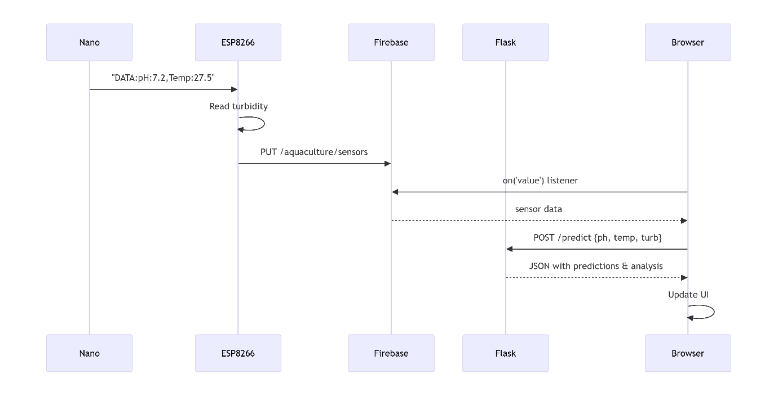

10. Results & Performance
- Prediction accuracy: ~86% (fish) on test data.
- Dashboard response time: < 1s for predictions (Flask endpoint).
- Firebase sync: near-instant (depends on network).
- Sensor reading frequency: 5 seconds (configurable).
- System stability: 24/7 operation tested for 72 hours.
10.1 Sample Output
When pH=7.2, temp=27.5, turb=4.8:
- Predicted fish: Tilapia (confidence 92%)
- Predicted spice: Basil (confidence 85%)
- Risk: LOW, Quality: Good
- Water advice: “✅ pH optimal”, “✅ Temperature optimal”, “✅ Water clear”
- Dataset alerts: “✅ No significant deviation from species reference data”
- Top fish rankings: Tilapia ★★★, Rui ★★★, Pangas ★★☆, …

11. Challenges & Solutions
Challenge | Solution
ESP8266 path error .json in path | Use path without .json and Firebase.setJSON()
Serial data parsing | Implemented fallback parser for both DATA: and debug formats
Model retraining | Computed per-species stats for dataset comparison
Dashboard responsiveness | Used CSS grid and media queries; Firebase real-time listener avoids polling
Image display | Used ui-avatars.com API for consistent species avatars

12. Future Work
- Add more sensors: dissolved oxygen, ammonia, salinity.
- Real-time control: actuators (pump, aerator, heater) controlled via Firebase commands.
- Mobile app: React Native or Flutter version.
- Auto-retraining: periodically retrain models with new collected data.
- Multi-pond support: multiple ESP8266 nodes pushing to separate Firebase paths.
- Alert system: email/SMS notifications for critical values.

13. Conclusion
AQUA·INTELLIGENCE successfully demonstrates how IoT, machine learning, and cloud computing can be integrated to build a practical, user-friendly aquaculture monitoring system. The project bridges the gap between raw sensor data and actionable intelligence, empowering farmers and researchers to make data-driven decisions. Its modular design, modern dashboard, and scalable architecture make it suitable for both small-scale and commercial aquaculture operations.

14. Appendix
A. Code Repositories
- ESP8266 firmware (Arduino)
- Arduino Nano firmware
- Flask web application
- ML training and statistics scripts
B. Hardware Bill of Materials
- Arduino Nano ×1
- ESP8266 NodeMCU ×1
- pH Sensor module ×1
- DS18B20 temperature sensor ×1
- Turbidity sensor ×1
- 16×2 I2C LCD ×1 (optional)
- Jumper wires, breadboard
C. References
- Firebase Realtime Database API
- scikit-learn Random Forest documentation
- Adafruit DS18B20 library
- Firebase ESP8266 Client library (Mobizt)

15. Acknowledgements
This project was developed as part of an integrated IoT and data science initiative. Special thanks to the open-source community for providing the libraries and tools that made this possible.

Report prepared by: Sahil Prakash Bhagat
Date: July 2026
Version: 1.0

