**HW5 (Due date : July.16 PM 19:59, upload in web)**

**Submit the homework named as HW5_이름.doc, HW5_이름.R (코드도 첨부)**

**1. Public data in kaggle**

1.1. Search the data related 'tesla' in kaggle, and download a data 'Tesla stock data from 2010 to 2020'

1.2. Answer the questions

(i) Is monthly data or daily data?

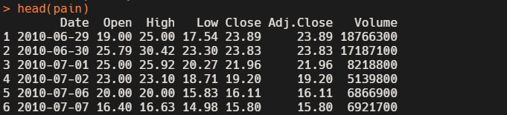

It is a daily data based on date.

(ii) what is the date with the highest price?

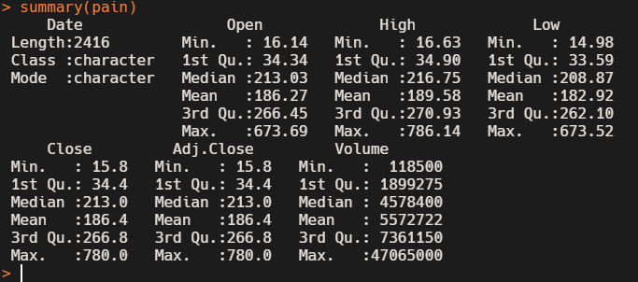

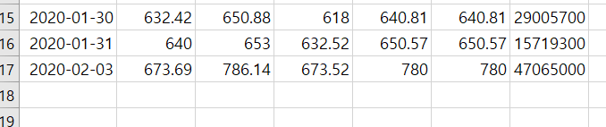

The answer to this question is 2020-02-03. If you look at this Max data in the summary shown in the above, you can see that all of the prices hit the top at this particular date.

(iii) Any trend you find out from the given information in kaggle?

Based on my short knowledge and experience of analyzing big data, I would say that the graph is showing a rightward increase and a major increase in the 2020.

