《数据库原理与应用》实验报告
实验名称 | B/S结构的数据库编程 | 实验序号 |  | 3
实验日期 | 2021.12.1 |  | 实验人 |  | 陈旻杰
- 实验目的
1. 学会在IE浏览器中查看ASP.NET网页的执行结果
2. 掌握ADO.NET技术实现动态网页的制作。

二、实验任务
通过设计ASP.NET网页，实现 “实验一”中的1-11个语句执行结果。

- 关键代码与执行结果截图
  - 求全体学生的学号、姓名和出生年份。
SELECT Sno AS 学号, Sname AS 姓名, YEAR(Sbirth) AS 出生年份 FROM Student;
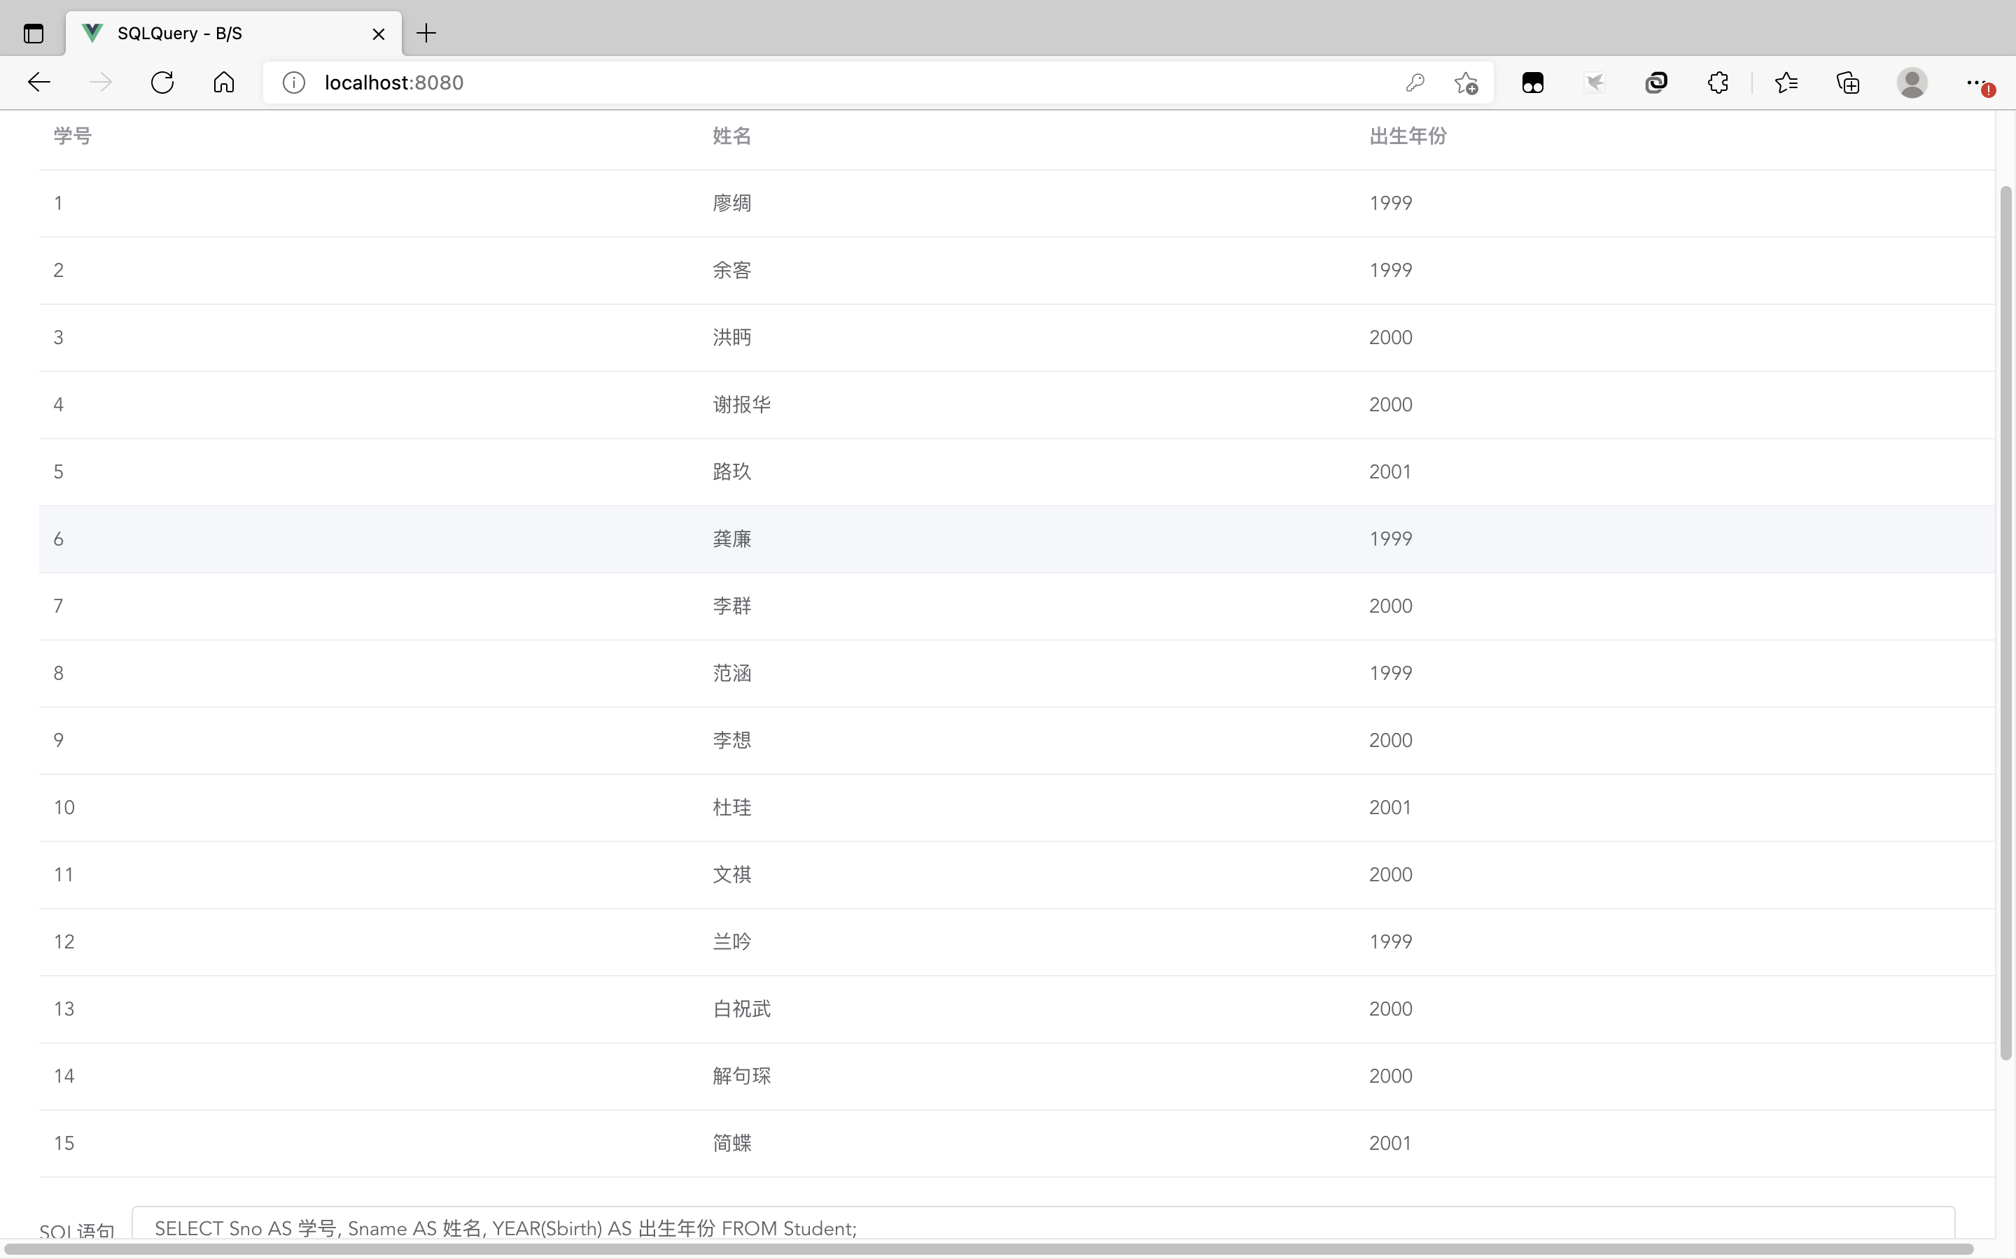

  - 求每个系的学生总人数并按降序排列。
SELECT Dname AS 系, COUNT(*) AS 人数 FROM Student, Department WHERE Department.Dno = Student.Dno GROUP BY Student.Dno ORDER BY COUNT(*) DESC;
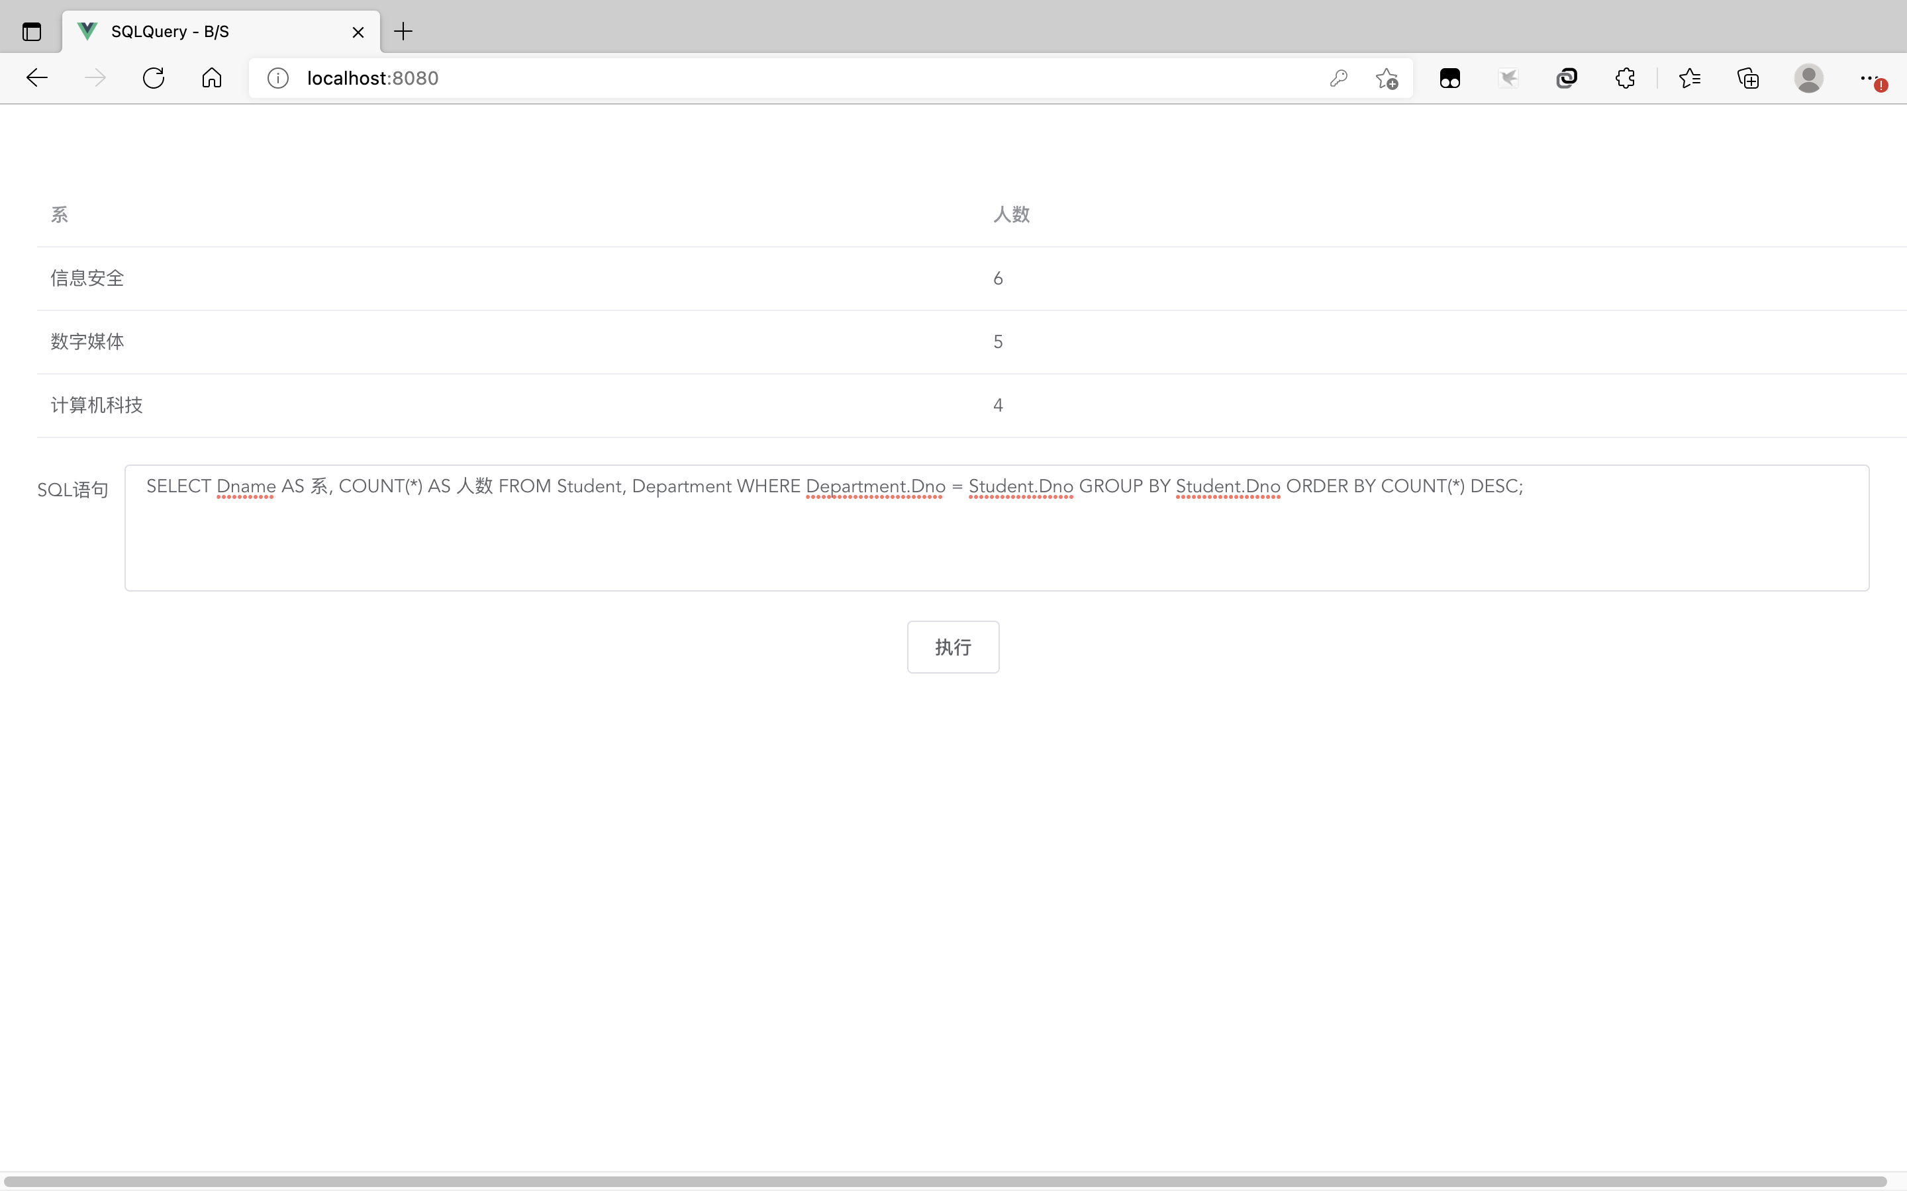

  - 求选修了课程号为002或003的学生的学号、课程名和成绩。
SELECT S.Sno AS 学号, Sname AS 姓名, C.Cname AS 课程名, COgrade AS 成绩 FROM Student AS S, Course AS C, CourseOption AS CO WHERE S.Sno = CO.Sno AND C.Cno = CO.Cno AND (CO.Cno = 2 OR CO.Cno = 3) AND NOT ISNULL(COgrade);
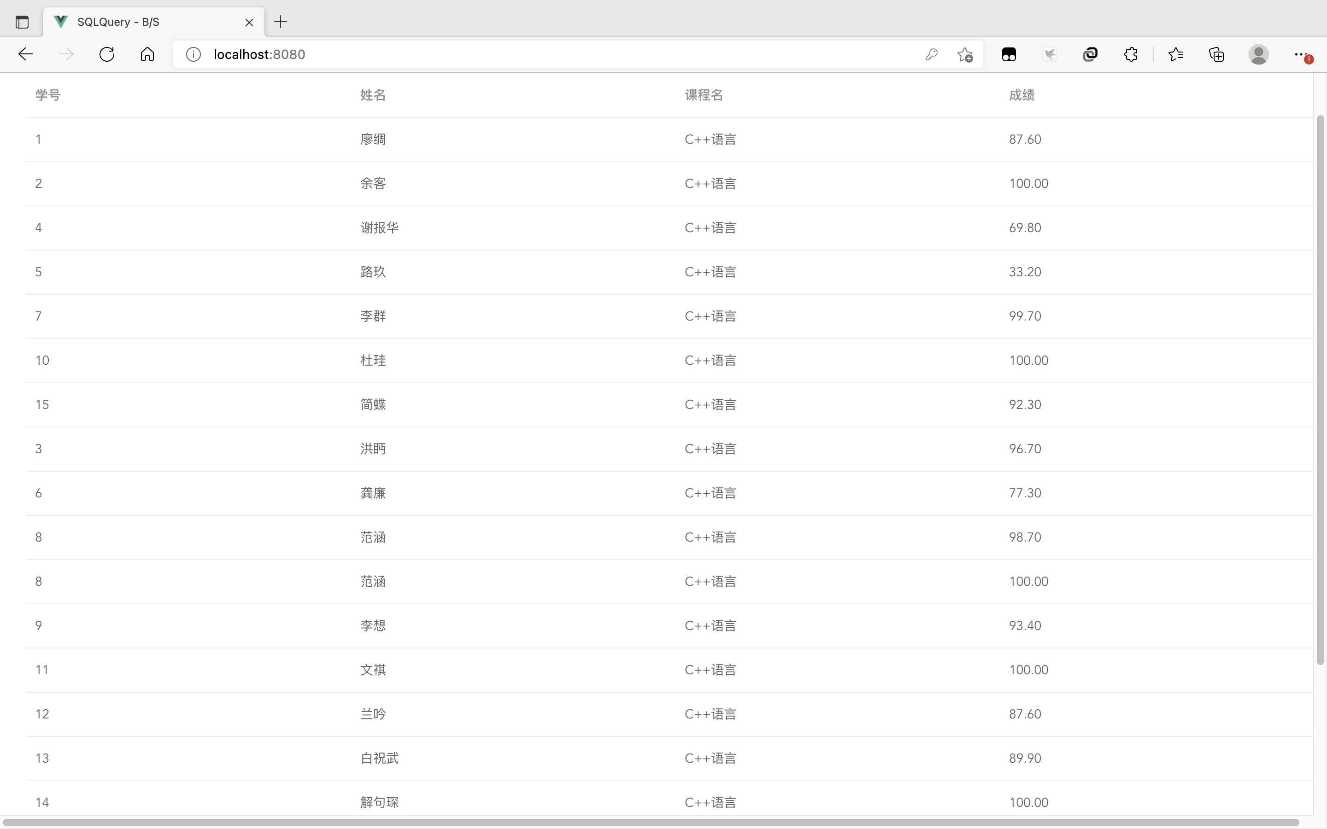

  - 检索选修某课程的学生人数多于3人的教师姓名。
SELECT DISTINCT Tname AS 教师 FROM Teacher AS T, ( SELECT Cno, COUNT(*) AS Camount FROM CourseOption AS CO GROUP BY Cno HAVING COUNT(Cno) > 3 ) AS COstat, TeachingArrangement AS TA WHERE T.Tno = TA.Tno AND COstat.Cno = TA.Cno;
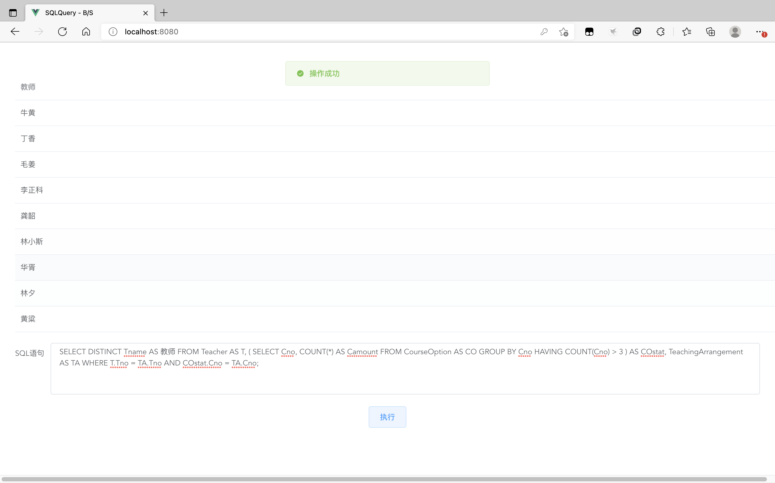

  - 查询所有未选课程的学生姓名和所在系。
SELECT Sname AS 姓名, Dname AS 所属系 FROM Student AS S, Department AS D WHERE S.Dno = D.Dno AND Sno NOT IN ( SELECT DISTINCT Sno FROM CourseOption AS CO WHERE ISNULL(COgrade));
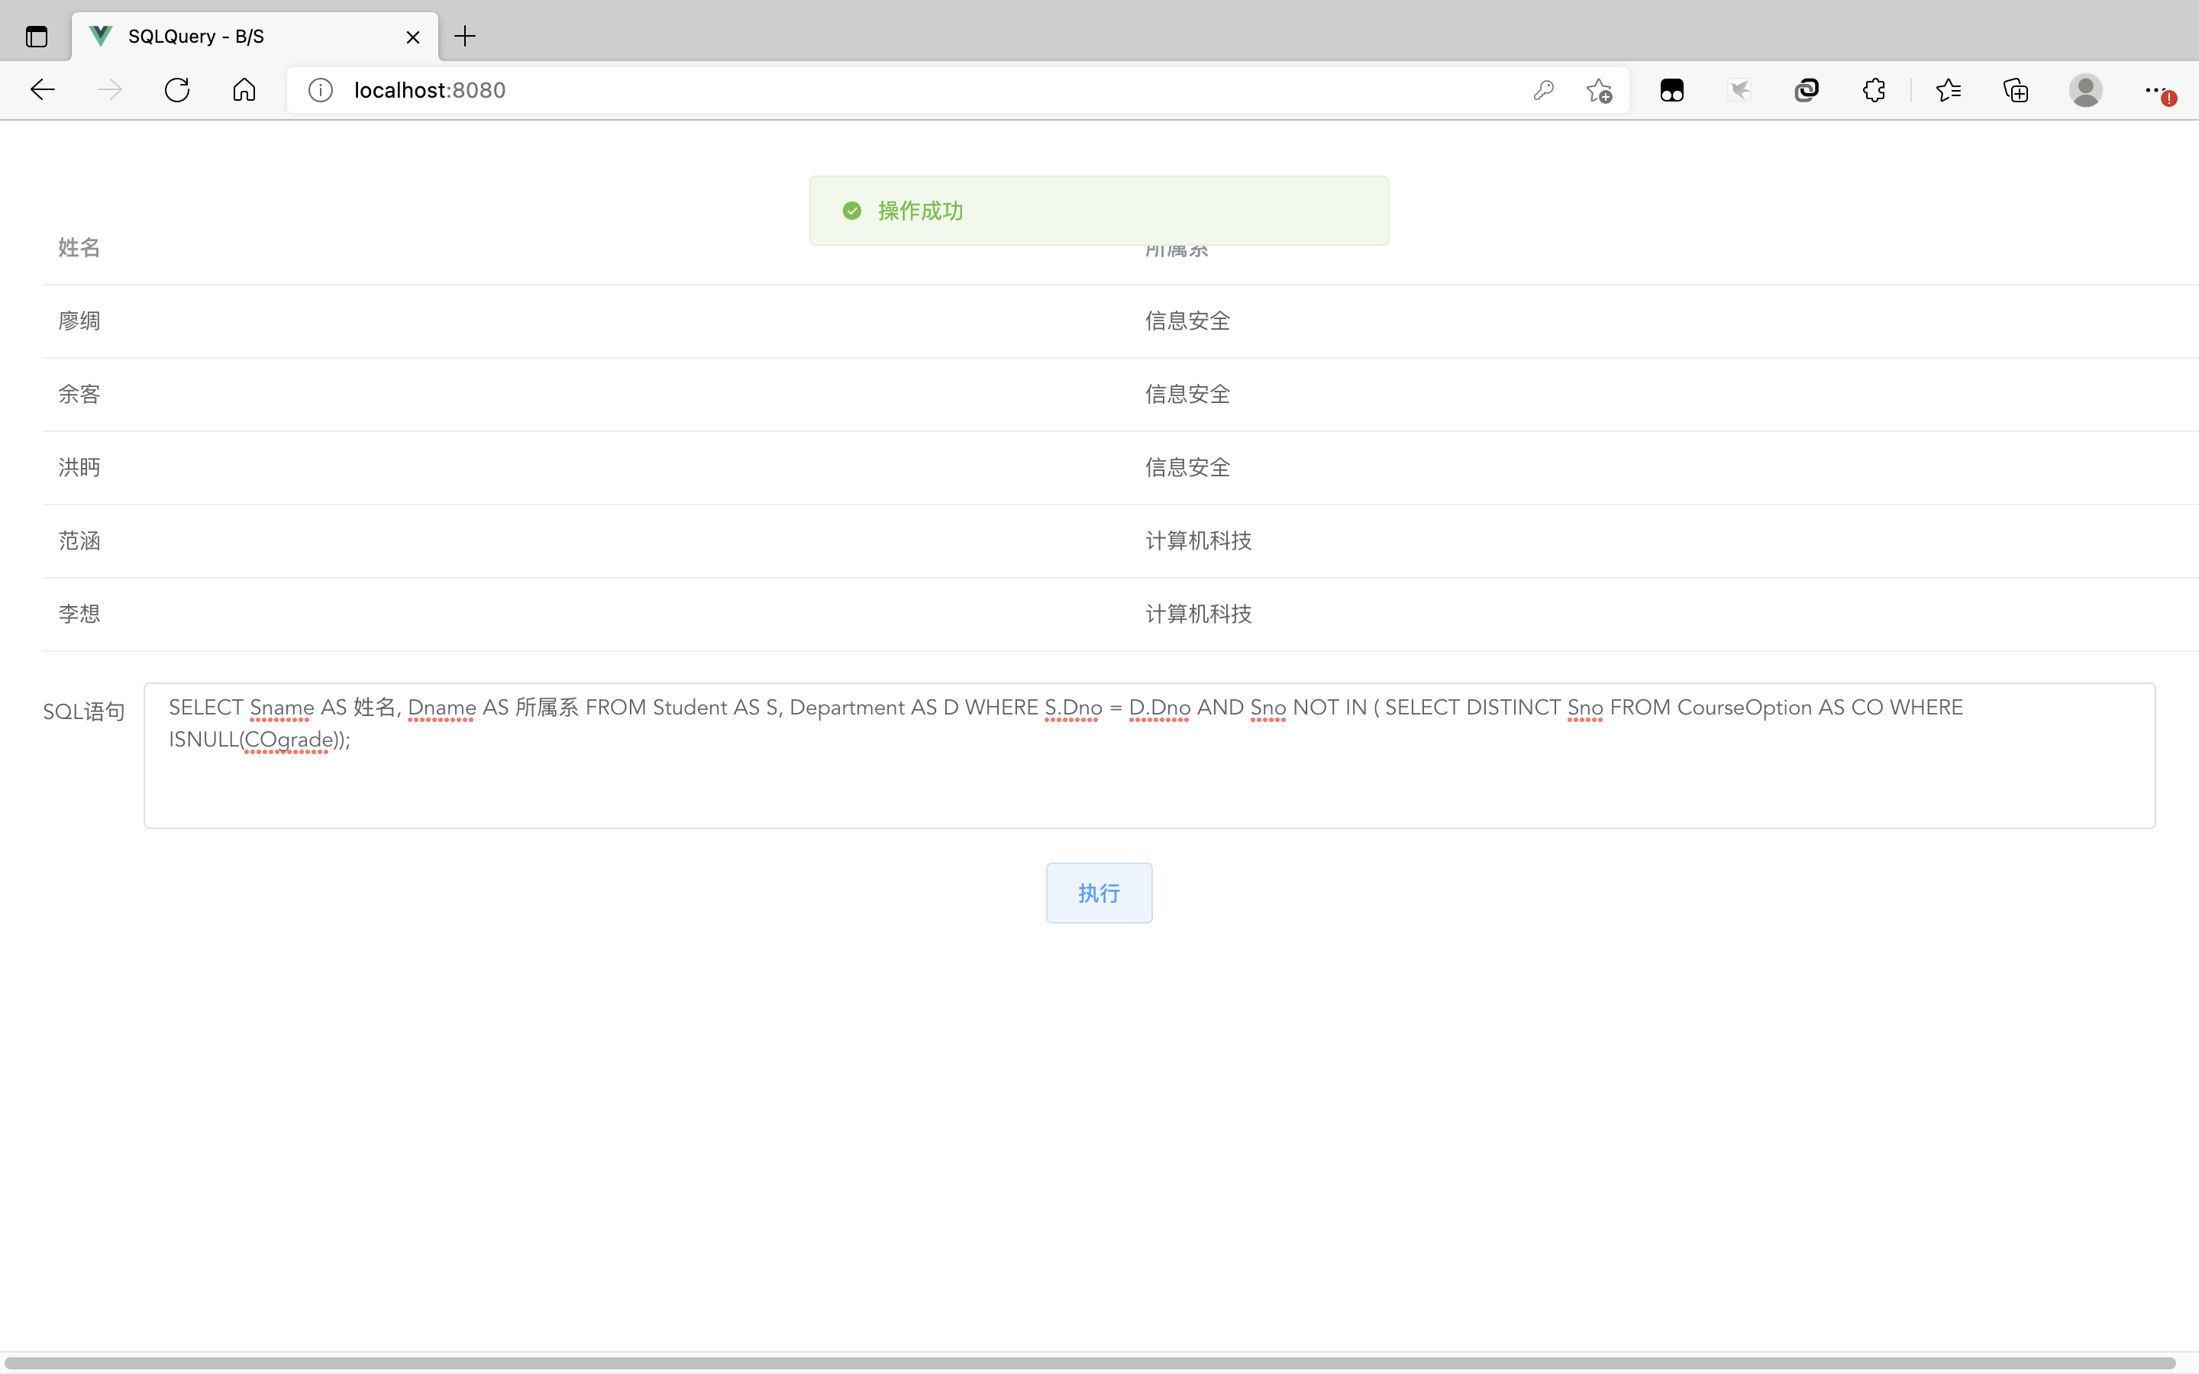

  - 求每个同学的课程成绩的最高分，查询结果项包括：学生姓名、课程号及最高分。
SELECT Sname AS 姓名, C.Cno AS 课程号, Cname AS 课程名, COmax AS 最高分 FROM Student AS S, Course AS C, CourseOption AS CO, ( SELECT Sno, MAX(COgrade) AS COmax FROM CourseOption AS CO GROUP BY Sno ) AS COstat WHERE S.Sno = COstat.Sno AND CO.COgrade = COstat.COmax AND C.Cno = CO.Cno AND CO.Sno = S.Sno;
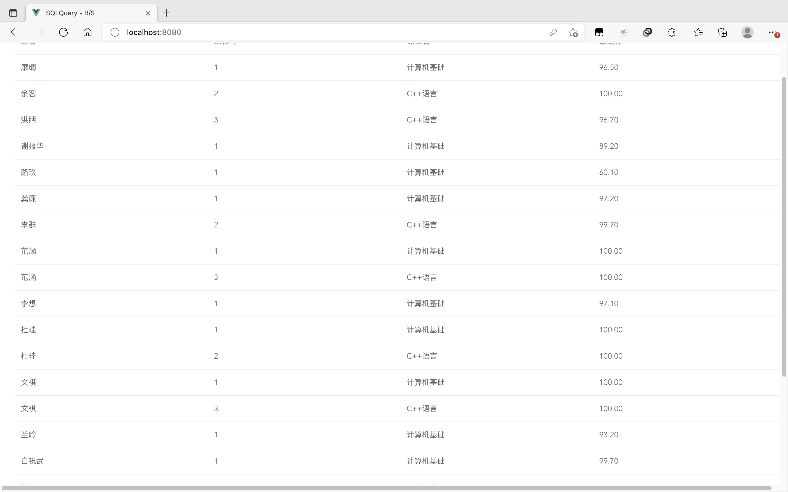

  - 求所有讲授数据结构课程的教师姓名
SELECT DISTINCT Tname AS 教师 FROM Teacher AS T, Course AS C, TeachingArrangement AS TA WHERE T.Tno = TA.Tno AND C.Cno = TA.Cno AND C.Cname = "数据结构";
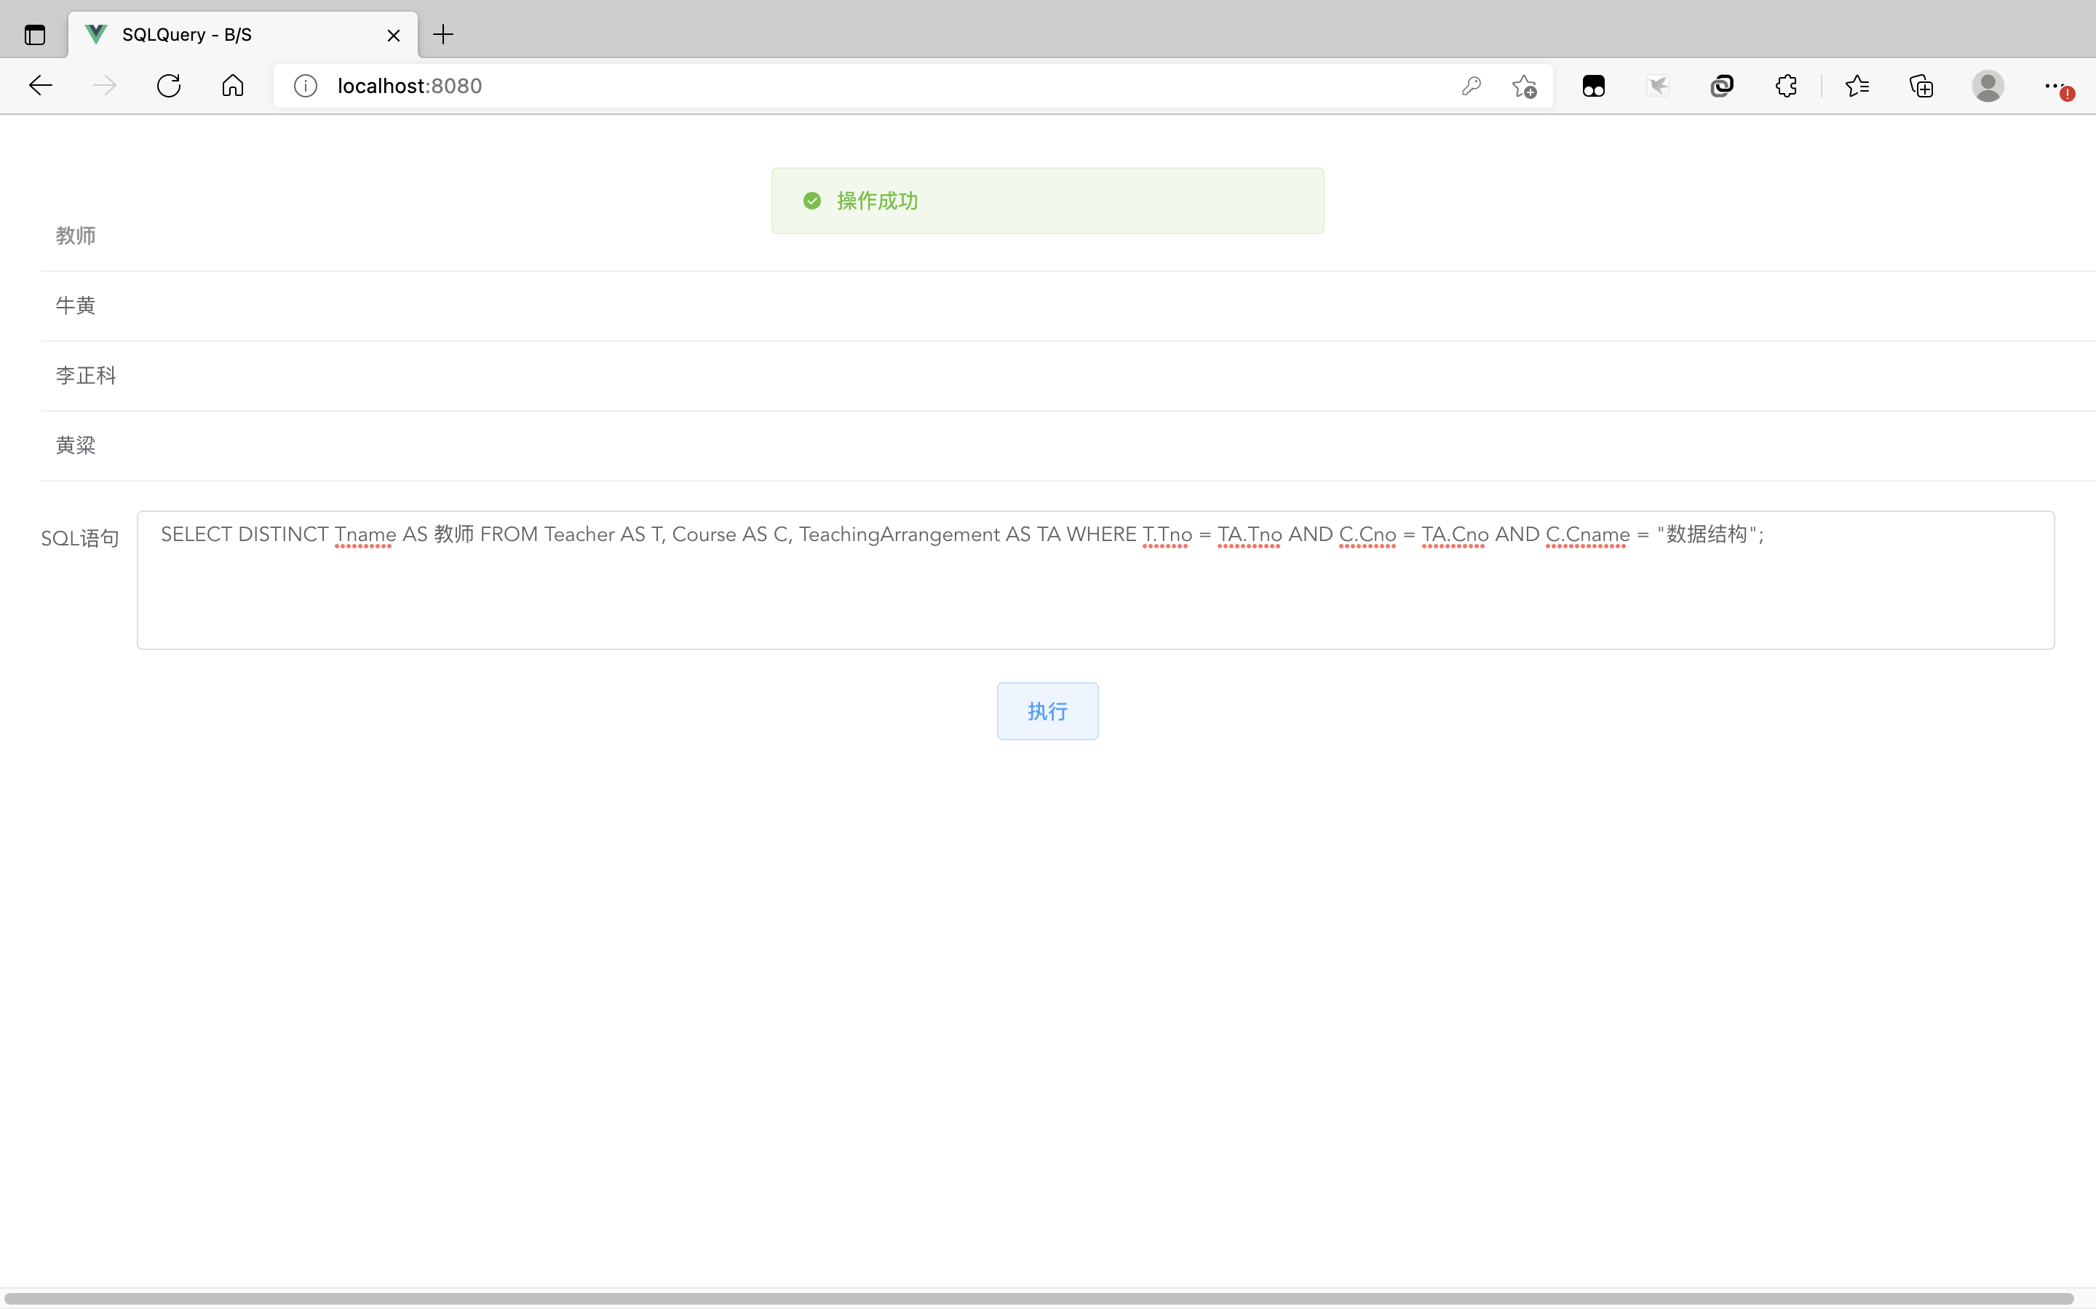

  - 查询所有选修了李正科老师的课程的学生信息
SELECT DISTINCT S.Sno AS 学号, Sname AS 姓名, Sgender AS 性别, Sbirth AS 生日, Dname AS 所属系 FROM Student AS S, Department AS D, CourseOption AS CO, ( SELECT C.Cno FROM Course AS C, Teacher AS T, TeachingArrangement AS TA WHERE T.Tname = "李正科" AND T.Tno = TA.Tno AND TA.Cno = C.Cno ) AS COstat WHERE S.Sno = CO.Sno AND CO.Cno = COstat.Cno AND D.Dno = S.Dno;
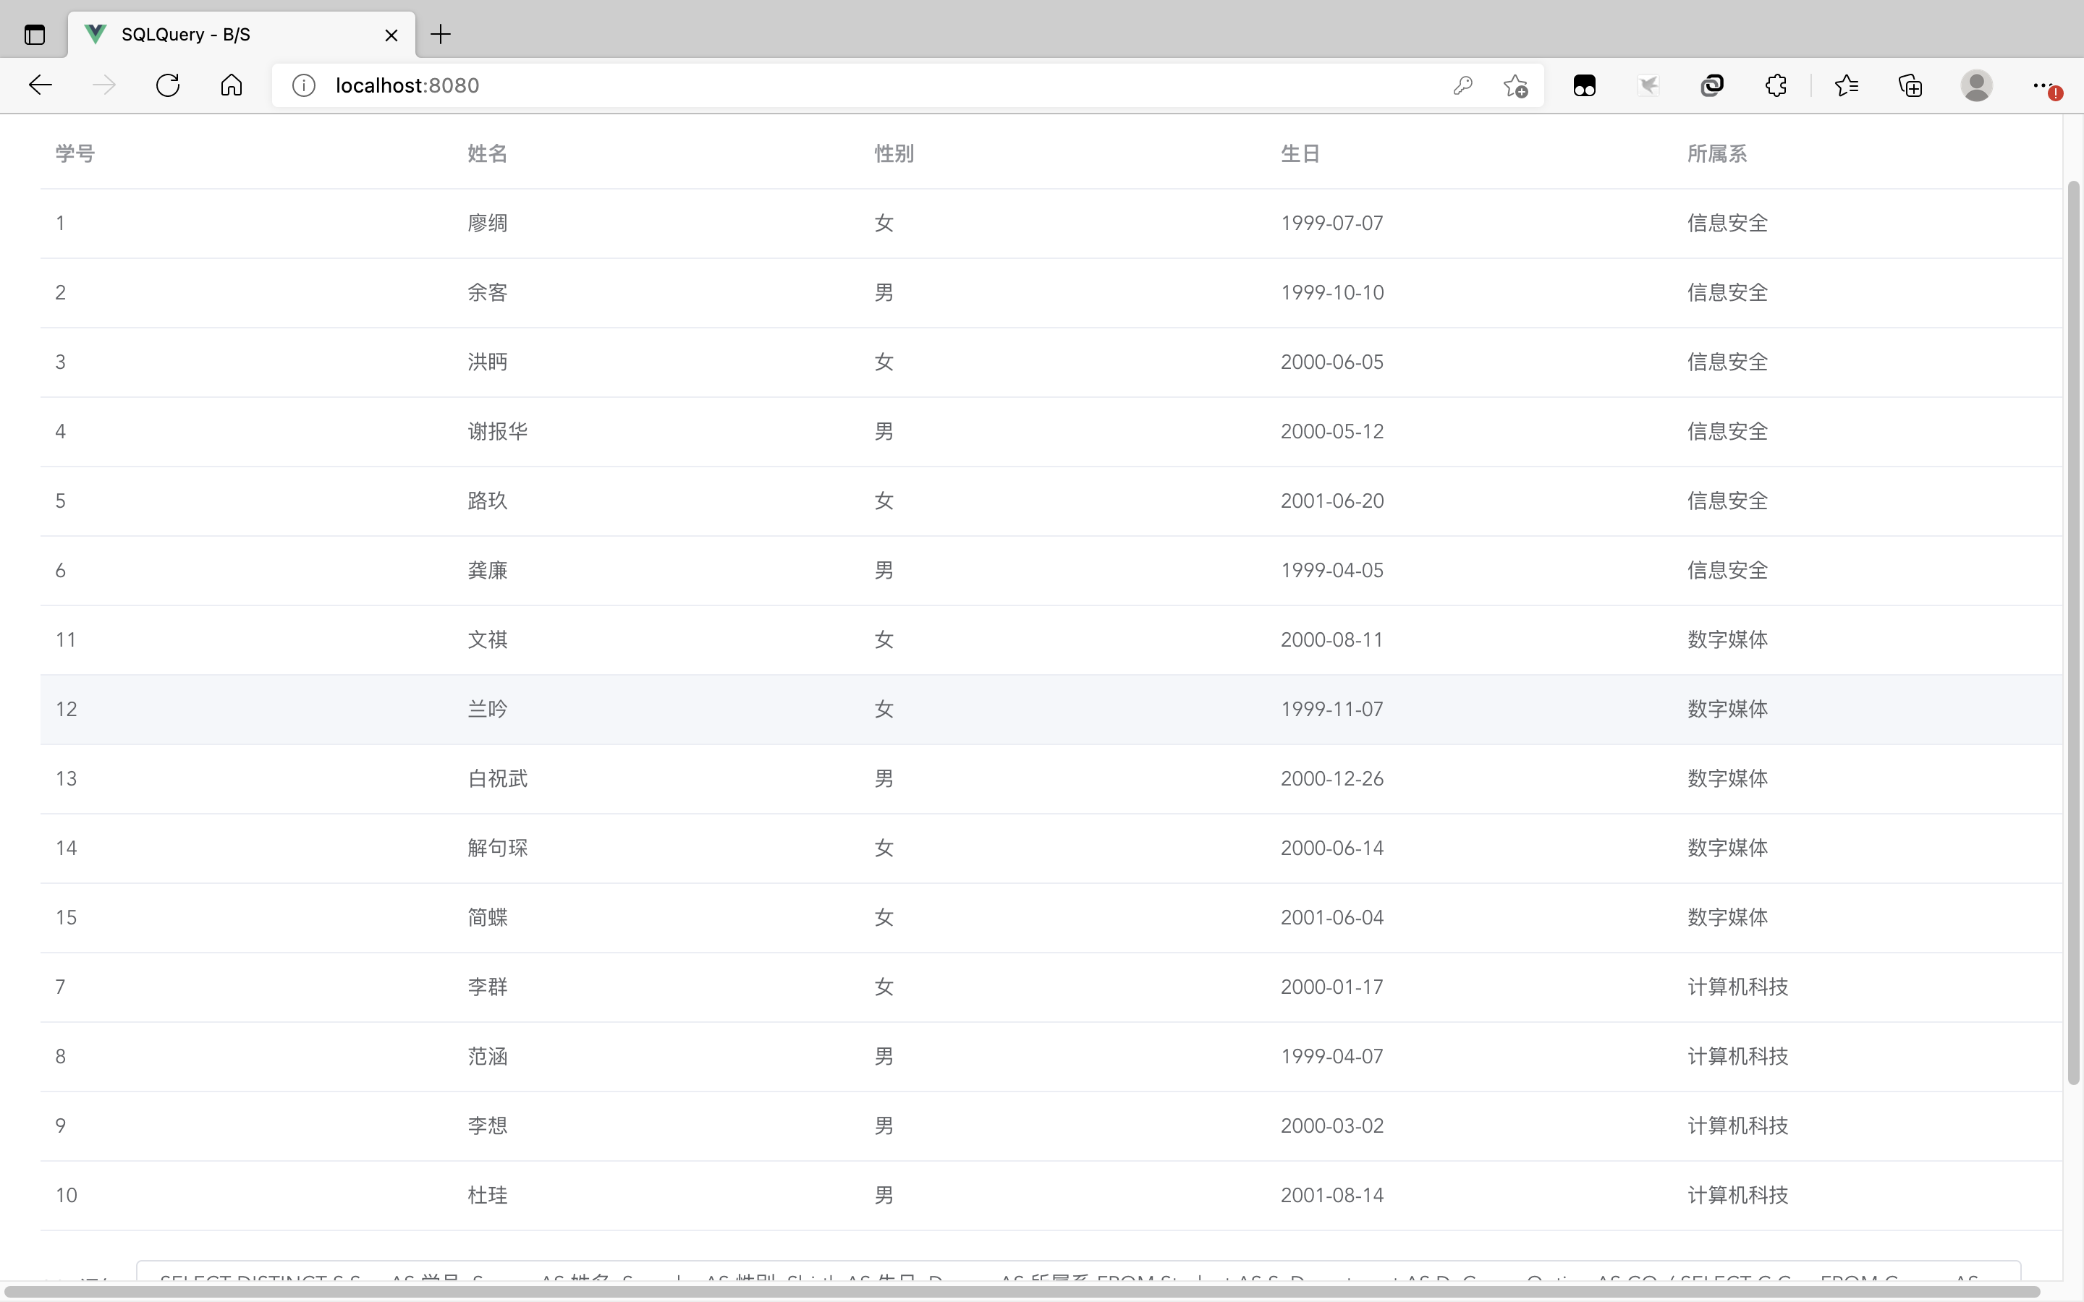

  - 新建一个关系表S1(SNO,SNAME,SD,SA)，其字段类型定义与Student表中的相应字段(SNO,SNAME,SDEPT,SAGE)的数据类型定义相同。将表Student中在计算机系‘CS’的学生数据插入到表S1中。
CREATE TABLE S1 ( SNO BIGINT AUTO_INCREMENT PRIMARY KEY, SNAME VARCHAR(32) NOT NULL, SA DATE NOT NULL, SD BIGINT NOT NULL, FOREIGN KEY (SD) REFERENCES Department(Dno) );

INSERT INTO S1 (SNO, SNAME, SA, SD) SELECT Sno, Sname, Sbirth, S.Dno FROM Student AS S, Department AS D WHERE S.Dno = D.Dno AND D.Dname = "计算机科技";
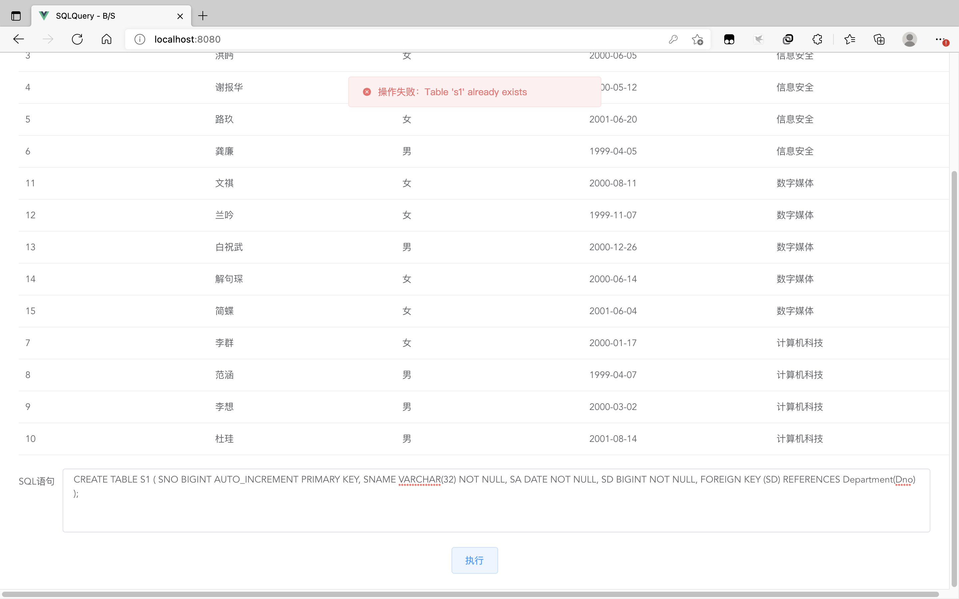

  - 建立计算机系的学生的视图STUDENT_CS。利用视图STUDENT_CS，将学生的001号课程的成绩提高5分。
CREATE VIEW STUDENT_CS AS SELECT S.* FROM Student AS S, Department AS D WHERE S.Dno = D.Dno AND D.Dname = "计算机科技";
UPDATE CourseOption AS CO JOIN STUDENT_CS AS S ON CO.Sno = S.Sno SET COgrade = CASE WHEN COgrade > 95.00 THEN 100.00 ELSE COgrade + 5 END WHERE CO.Cno = 1;

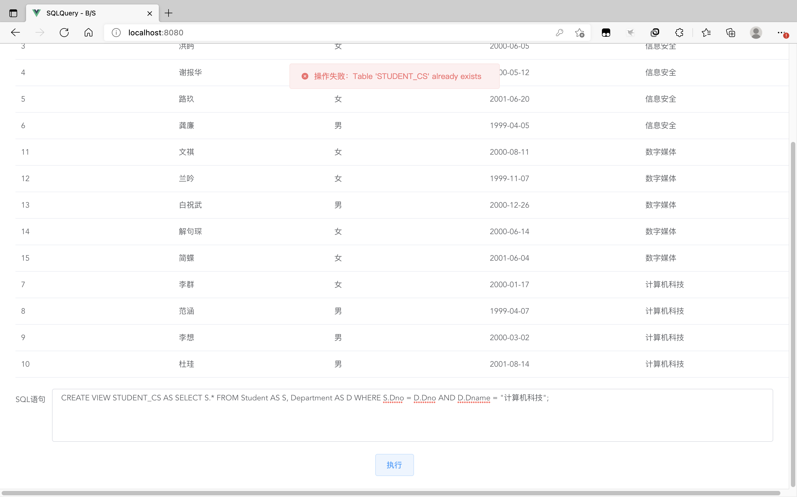

  - 创建一个带参数的存储过程，将数据结构课程的成绩在Low与Hign分数段的学生信息提取出来，查询后的结果包括：姓名、所在的系、成绩。
DELIMITER $$
CREATE PROCEDURE foo( IN low NUMERIC(5,2), IN high NUMERIC(5,2) ) BEGIN SELECT Sname AS 姓名, Dname AS 所属系, COgrade AS 成绩 FROM Student AS S, Department AS D, CourseOption AS CO, Course AS C WHERE S.Sno = CO.Sno AND CO.Cno = C.Cno AND D.Dno = S.Dno AND C.Cname = "数据结构" AND CO.COgrade >= low AND CO.COgrade <= high; END$$
DELIMITER;

CALL foo(60, 80);
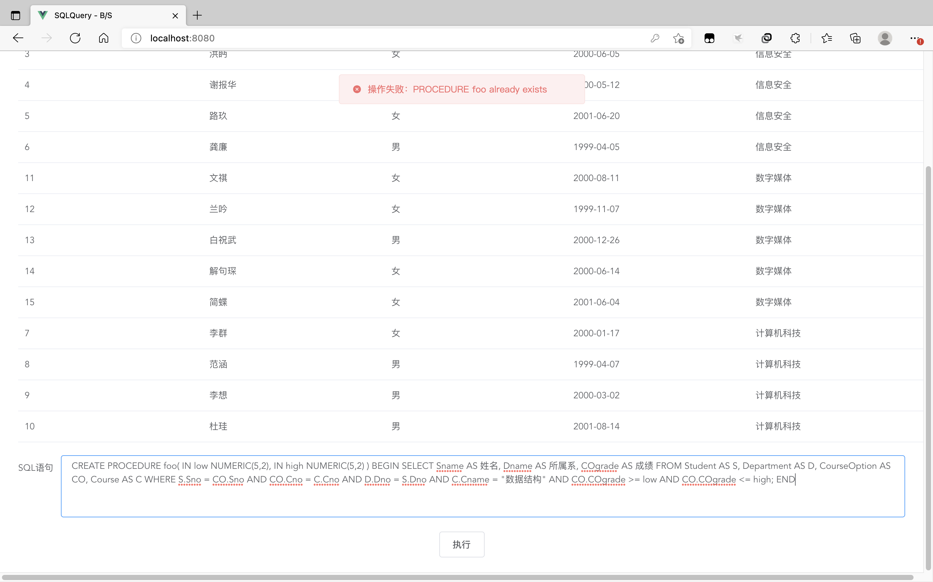
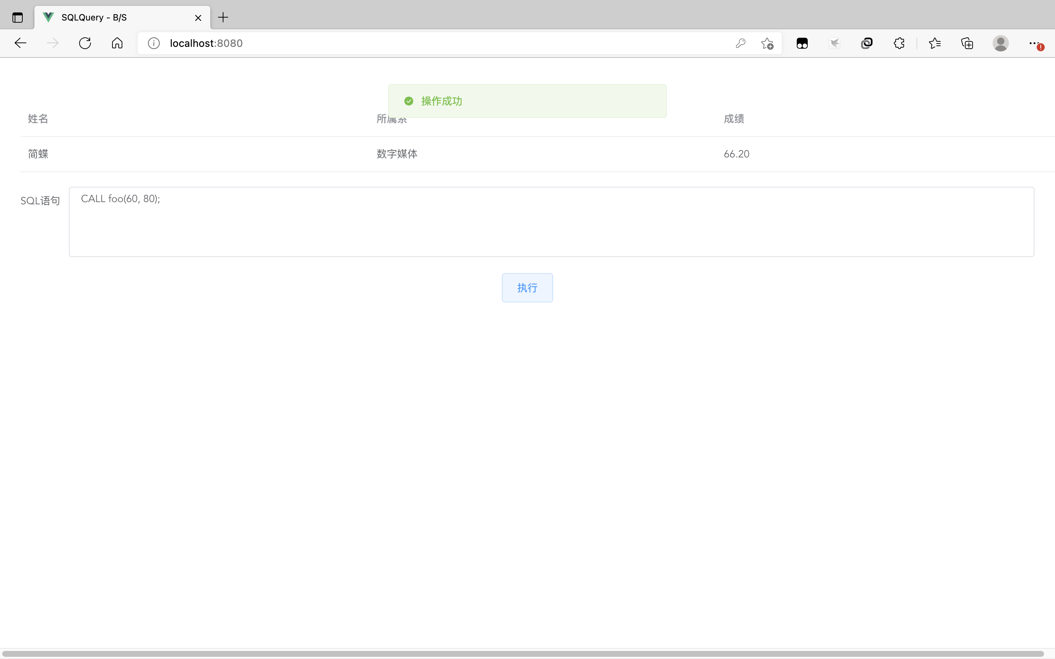

- 实验中的问题及解决方法
1．熟练使用spring-boot和vue框架

- 实验的总结与收获
1．尝试了自己使用spring-boot和vue组件实现B/S架构

