Project152

Title:DemonstratehowtoclearalldatafromlocalstorageusinglocalStorage.clear().

Source code:

<!DOCTYPE html>

<html>

<head>

<title>LocalStorage Clear</title>

</head>

<body>

<h2>Clear all local storage</h2>

<button onclick="clearStorage()">ClearStorage</button>

<script>

function clearStorage(){

localStorage.clear();

alert("Local storage has been cleared!"); }

</script>

</body>

</html>

OUTPUT:

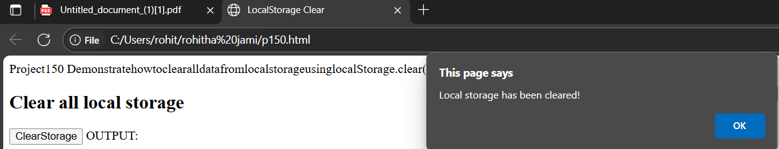

PROJECT-153

Title: Demonstrate how to create a collection in MongoDB

Description: Collections can be created explicitly using db.createCollection(), or implicitly by inserting a document.

Source code: db.createCollection("students")

Output:

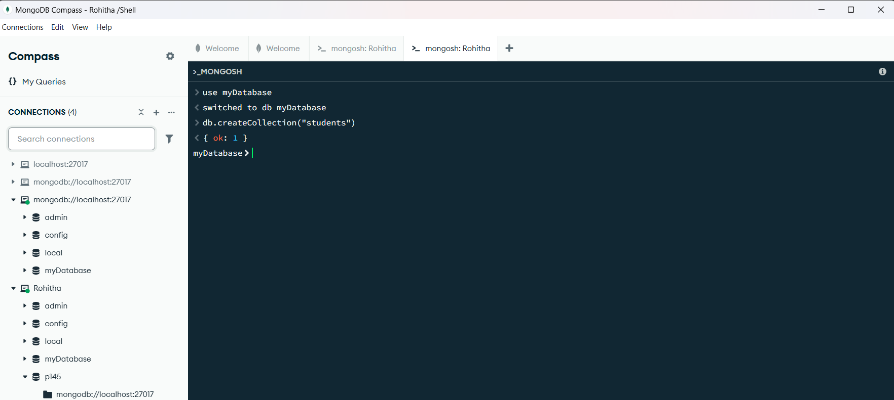

PROJECT-154

Title: Demonstrate how to insert a document into a MongoDB collection

Description: The insertOne() method is used to insert a single document. insertMany() can be used for inserting multiple documents.

Source code: db.students.insertOne({ name: "Sai", course: "BCA", age: 21 })

Output:

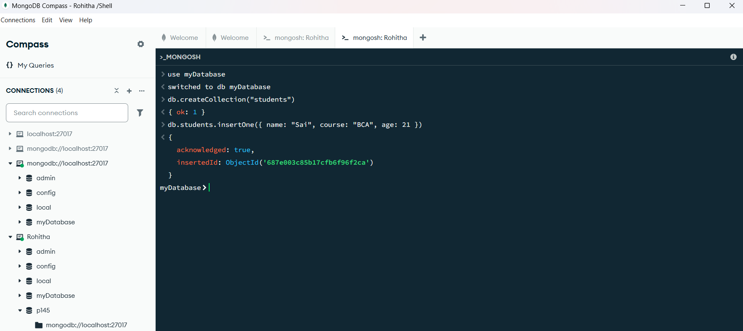

PROJECT-155

Title:Demonstrate how to find documents in a MongoDB collection

Description: The find() method is used to retrieve documents from a collection. You can use it with or without filters.

Source code: db.students.find()

Output:

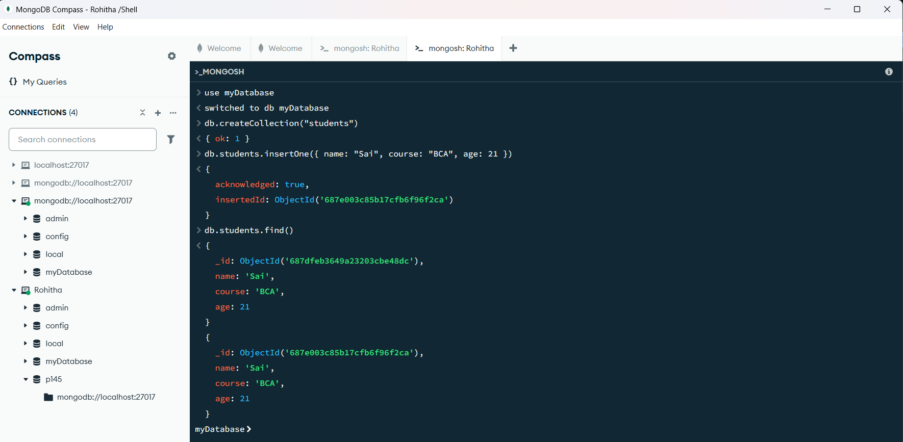

PROJECT-156

Title:Demonstrate how to update a document in MongoDB

Description: The updateOne() method updates the first matching document. Use $set to modify specific fields

Source code: db.students.updateOne( { name: "Sai" }, { $set: { age: 22 }} )

Output:

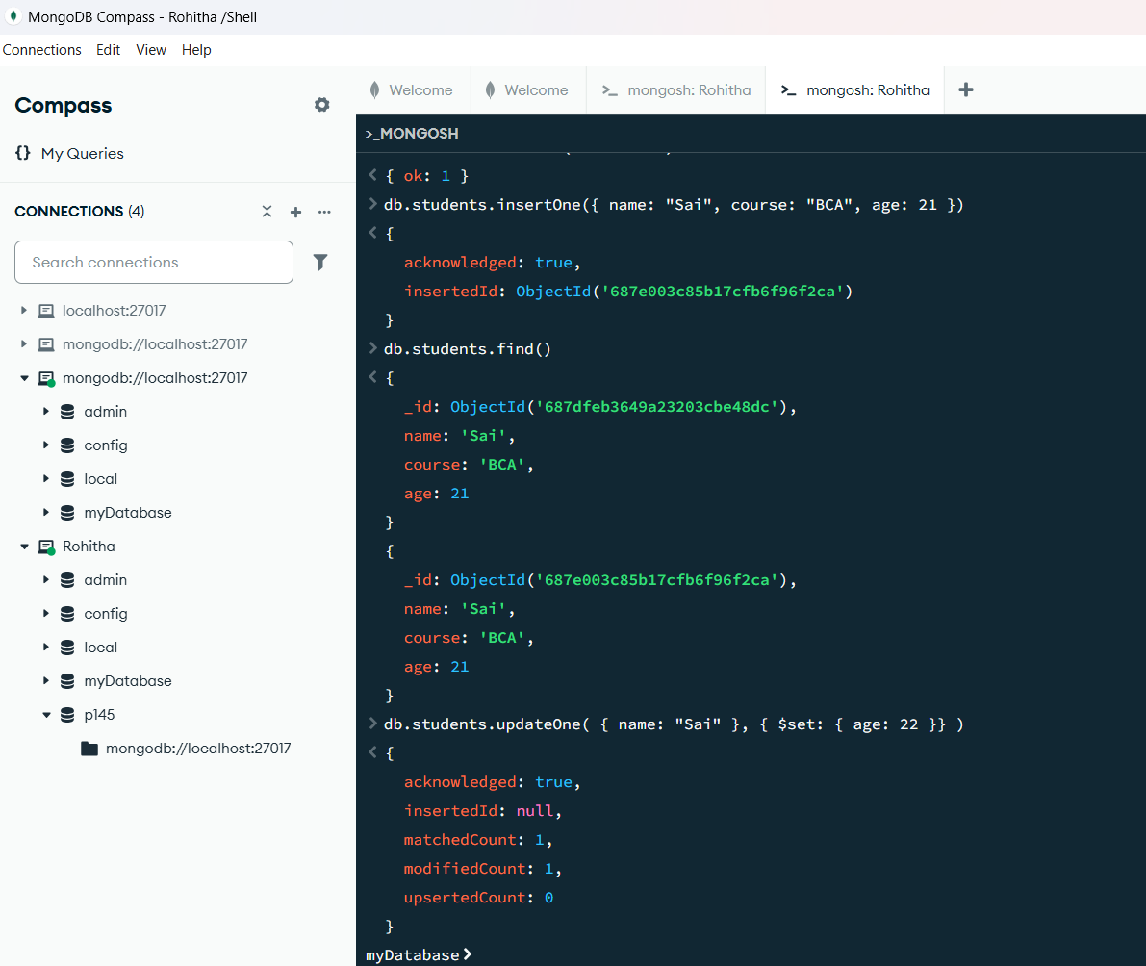

PROJECT-157

Title:Demonstrate how to delete a document in MongoDB

Description: The deleteOne() method deletes the first document that matches the filter. You can use deleteMany() to remove multiple documents.

Source code: db.students.deleteOne({ name: "Rohitha" })

Output:

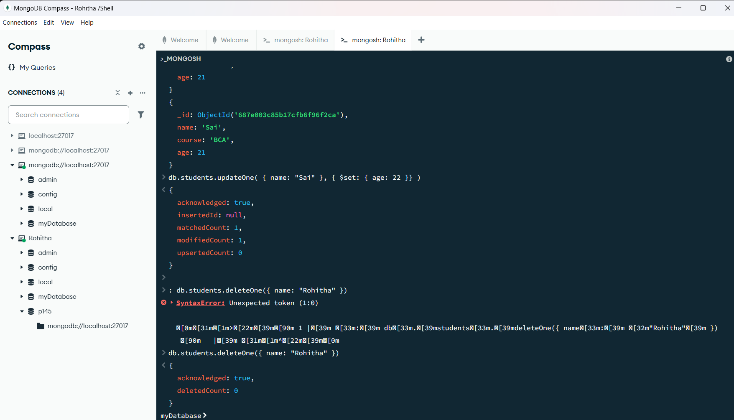

PROJECT-158

Title: Demonstrate how to delete a document in MongoDB

Description: The delete One() method deletes the first document that matches the filter. You can use delete Many() to remove multiple documents.

Source code: db. Students .delete One({ name: "Rohitha" })

Output:

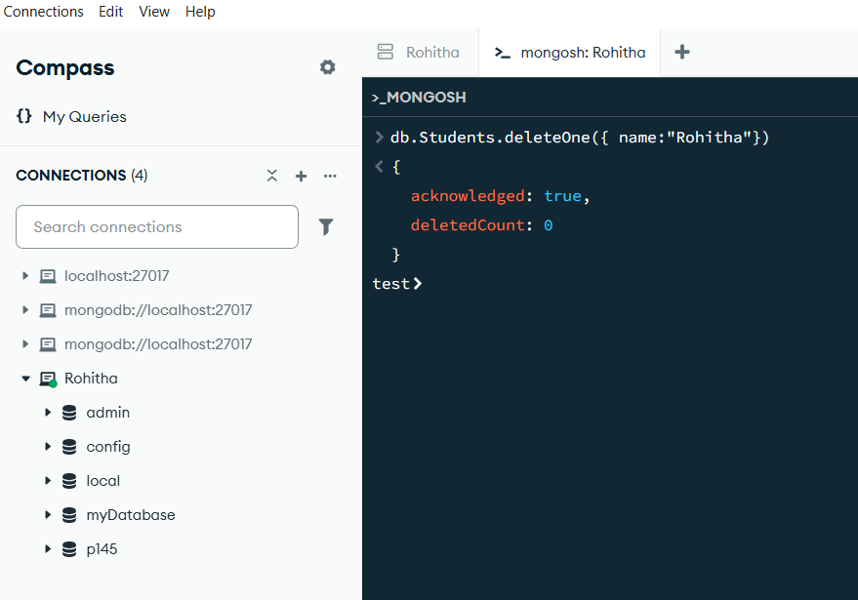

PROJECT-159

Title: Demonstrate how to insert multiple documents using insert Many()

Description: The insert Many() method is used to insert multiple documents into a MongoDB collection in a single operation.

Source code: db.students.insertMany([ { name: "Rohitha", course: "Bsc", age: 20 }, { name: "Shalini", course: "Bsc", age: 20 }, { name: "Hema", course: "BSC", age: 16 } ])

Output:

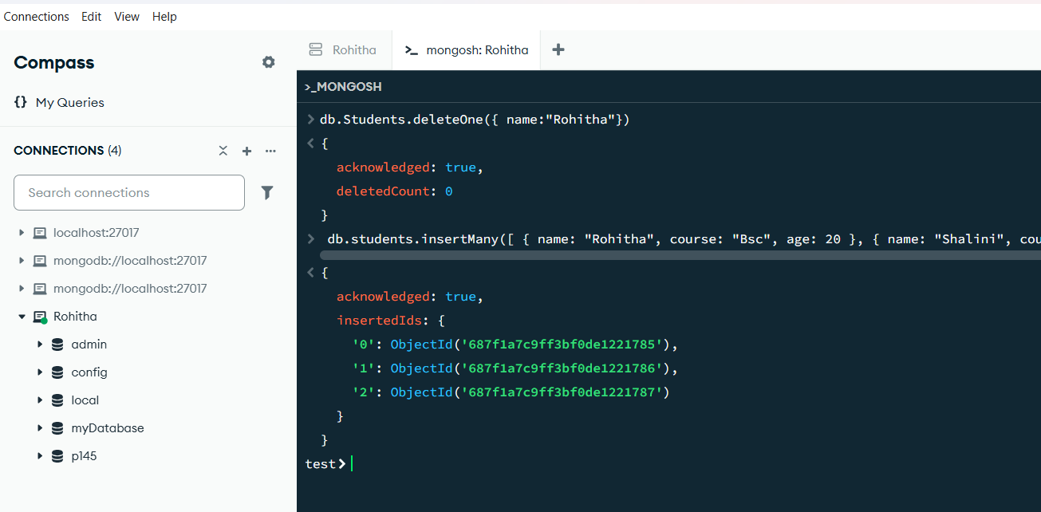

PROJECT-160

Title: Demonstrate how to find documents using a filter in MongoDB

Description: You can apply conditions in the find() method to retrieve documents that match specific criteria.

Source code: db.students.find({ course: "BCA" })

Output:

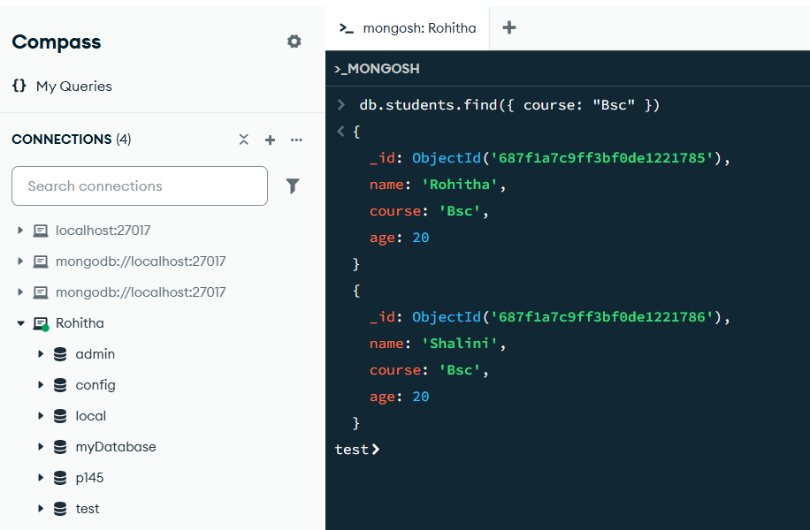

Project-161

Title: Demonstrate how to retrieve all documents using find() Description: Using find() without any filter returns all documents in the collection.

Source code: db.students.find()

Output:

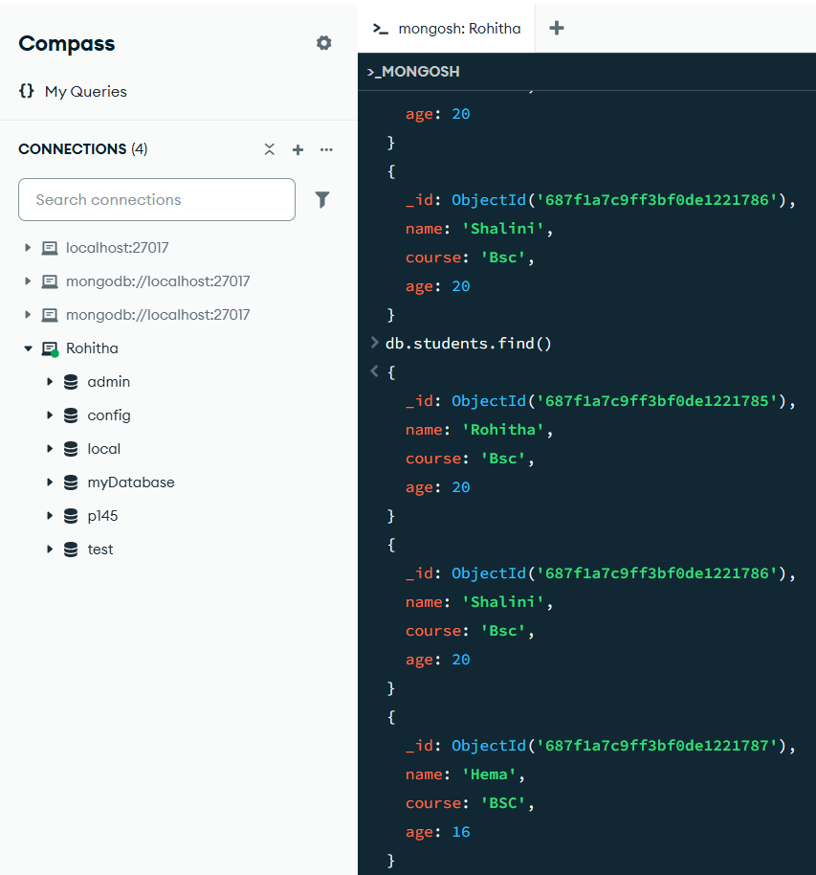

PROJECT-162

Title: Demonstrate how to update multiple documents using update Many()

Description: The updateMany() method is used to update multiple documents that match a given filter.

Source code: db.students.updateMany( { course: "BCA" }, { $set: { status: "active" } } )

Output:

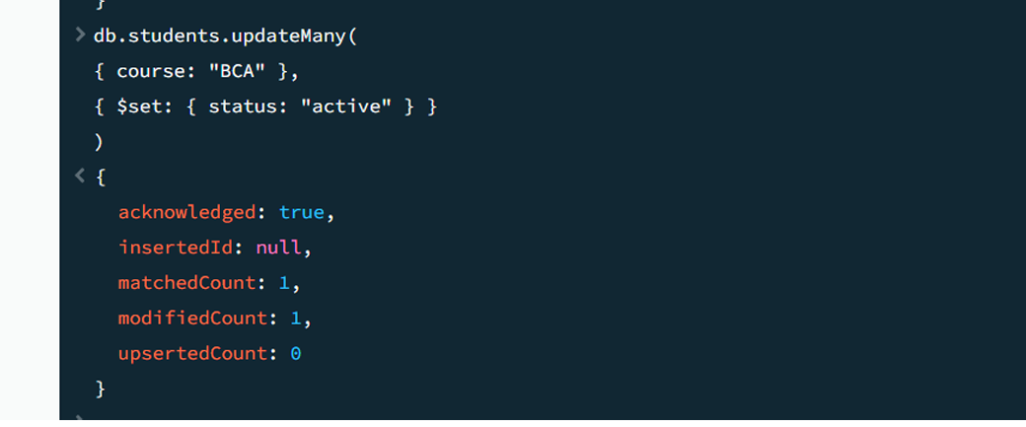

PROJECT-163

Title: Demonstrate how to delete multiple documents using delete Many()

Description: The delete Many() method deletes all documents that match the filter criteria.

Source code: db. students. delete Many({ course: "BCA”})

Output:

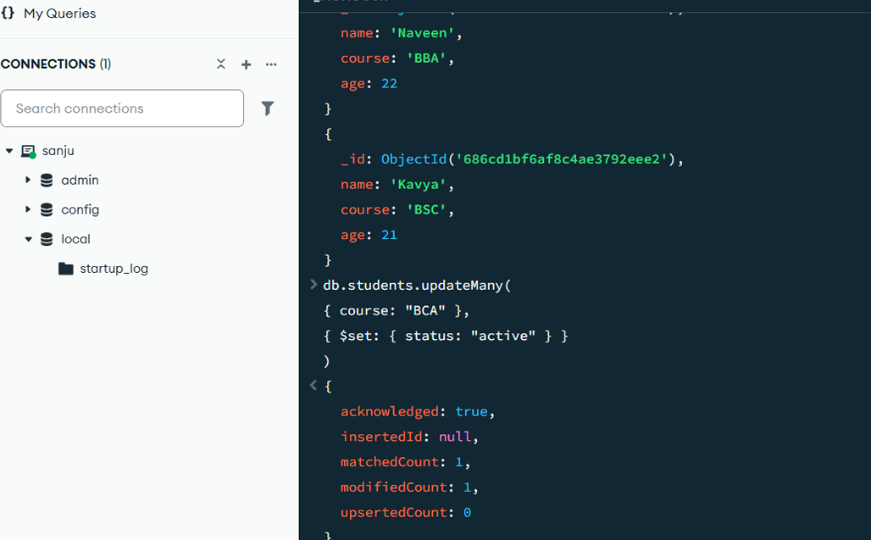

PROJECT-164

Title: Demonstrate how to use the $eq (equal) operator in MongoDB

Description: The $eq operator matches documents where the value of the field is equal to the specified value.

Source code: db.students.find({ age: { $eq: 21 } }) Output:

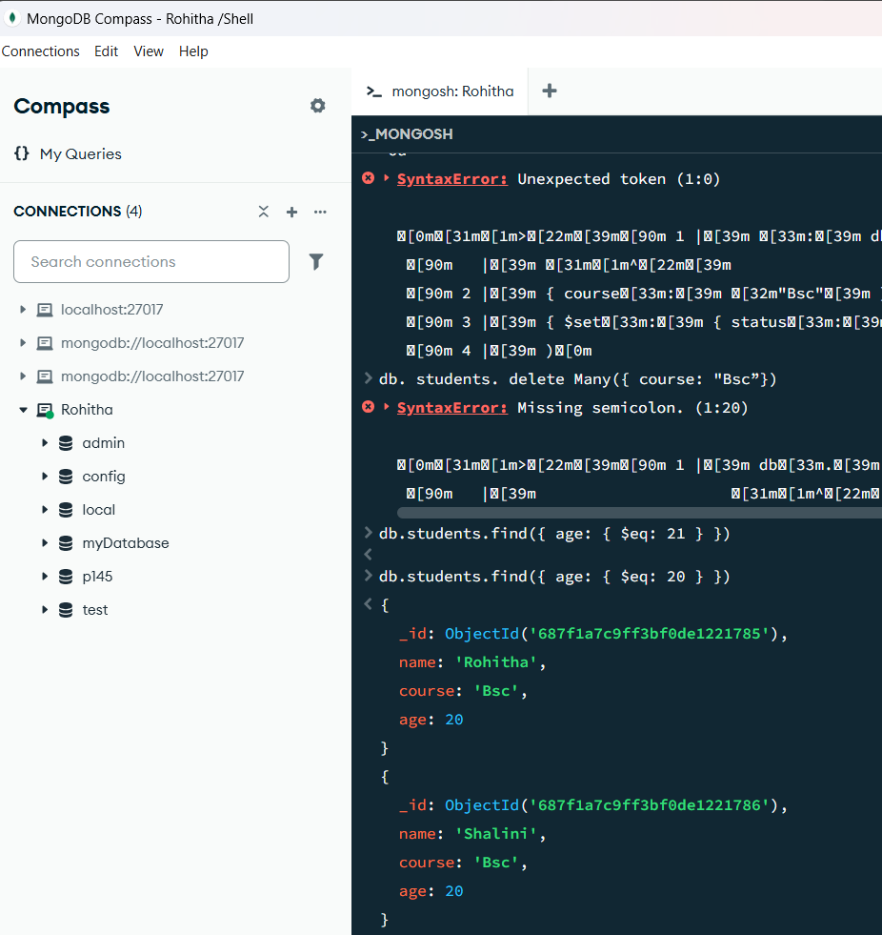

PROJECT-165

Title: Demonstrate how to use the $ne (not equal) operator in MongoDB

Description: The $ne operator matches documents where the value of the field is not equal to the specified value.

Source code: db.students.find({ course: { $ne: "BCA" } }) Output:

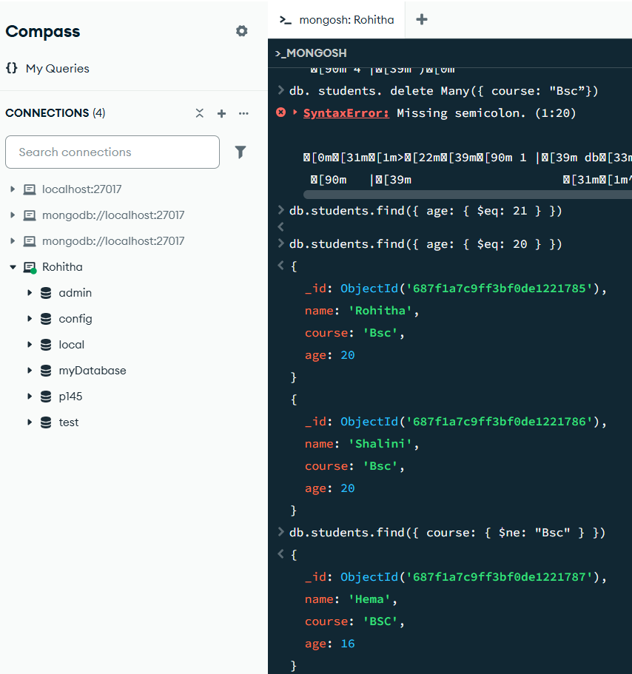

PROJECT-166

Title: Demonstrate how to use the $gt (greater than) operator in MongoDB

Description: The $gt operator matches documents where the value of the field is greater than the specified value.

Source code: db.students.find({ age: { $gt: 20 } })

Output: 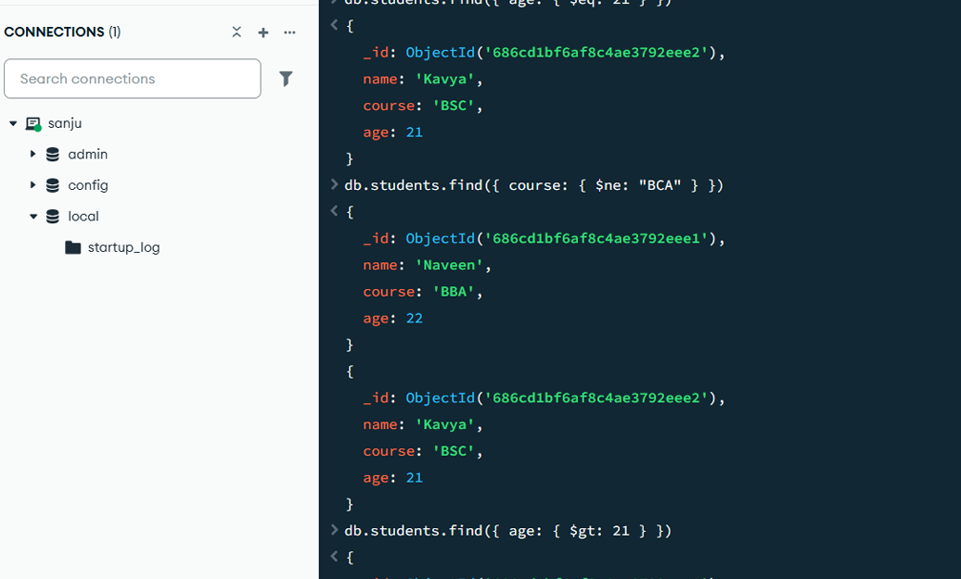

PROJECT-167

Title: Demonstrate how to use the $gte (greater than or equal to) operatorin MongoDB

Description: The $gte operator matches documents where the value of the field is greater than or equal to the specified value.

Source code: db.students.find({ age: { $gte: 21 } }) Output:

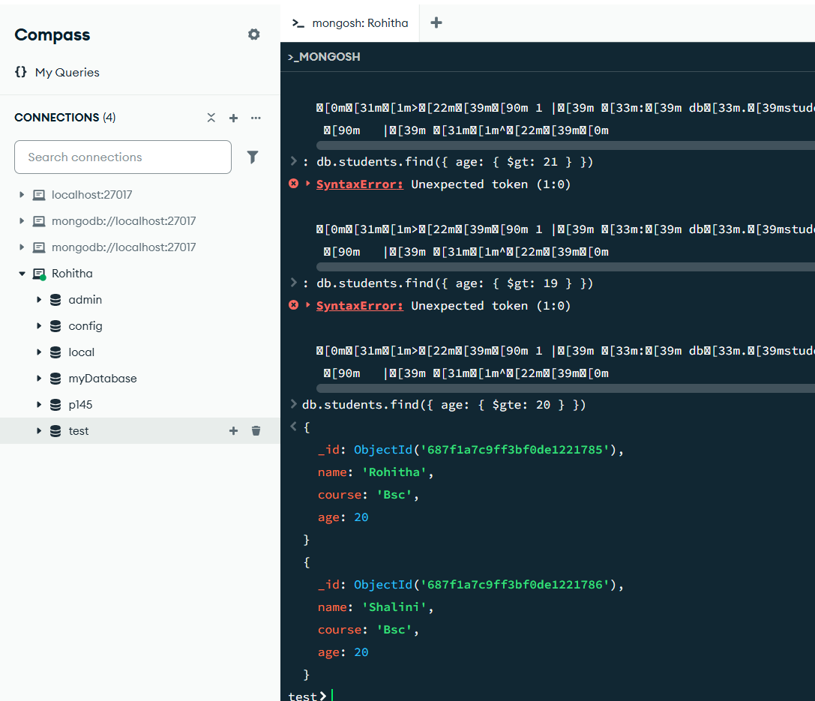

PROJECT-168

Title: Demonstrate how to use the $lt (less than) operator in MongoDB

Description: The $lt operator matches documents where the value of the field is less than the specified value.

Source code: db.students.find({ age: { $lt: 22 } })

Output:

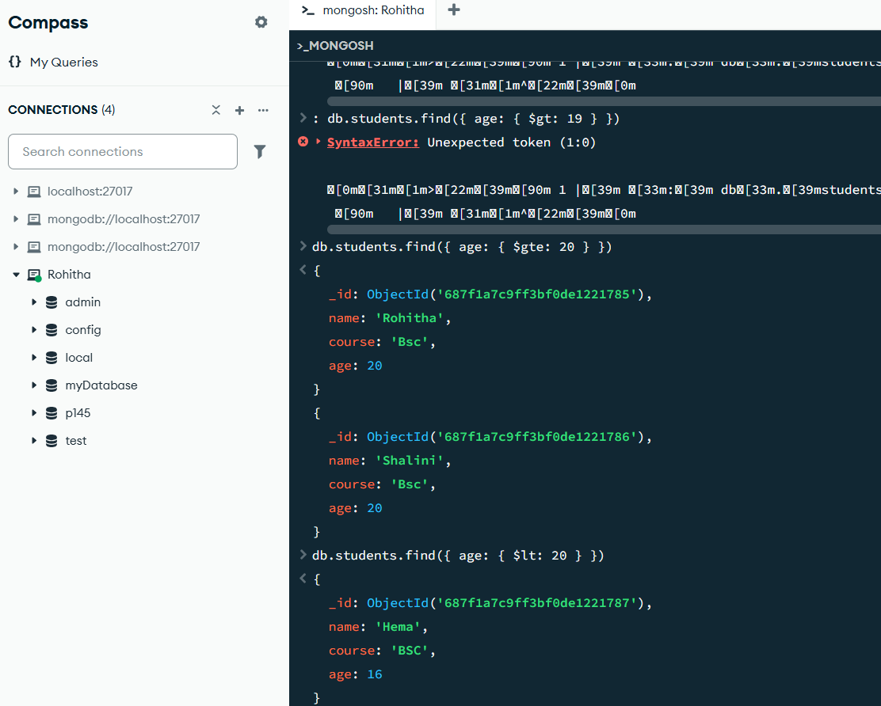

PROJECT-169

Title: Demonstrate how to use the $lte (less than or equal to) operator in MongoDB

Description: The $lte operator matches documents where the value of the field is less than or equal to the specified value.

Source code: db.students.find({ age: { $lte: 21 } }) Output: 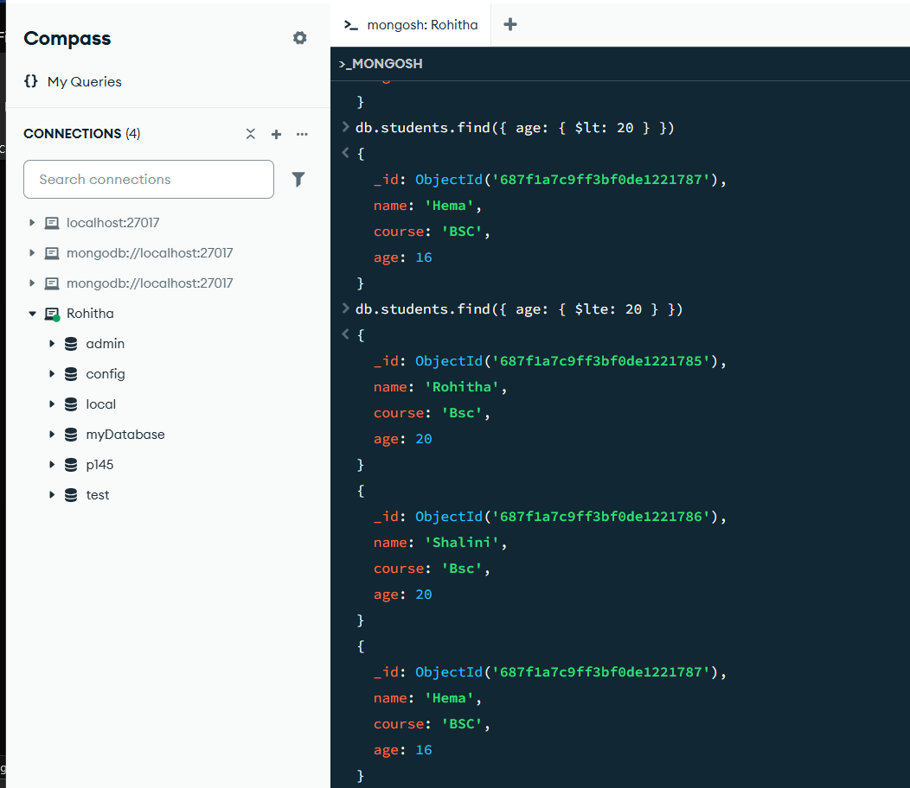

PROJECT-170

Title: Demonstrate how to use the $in operator in MongoDB

Description: The $in operator matches documents where the value of a field equals any value in the specified array.

Source code: db.students.find({ course: { $in: ["BCA", "BSC"] } })

Output:

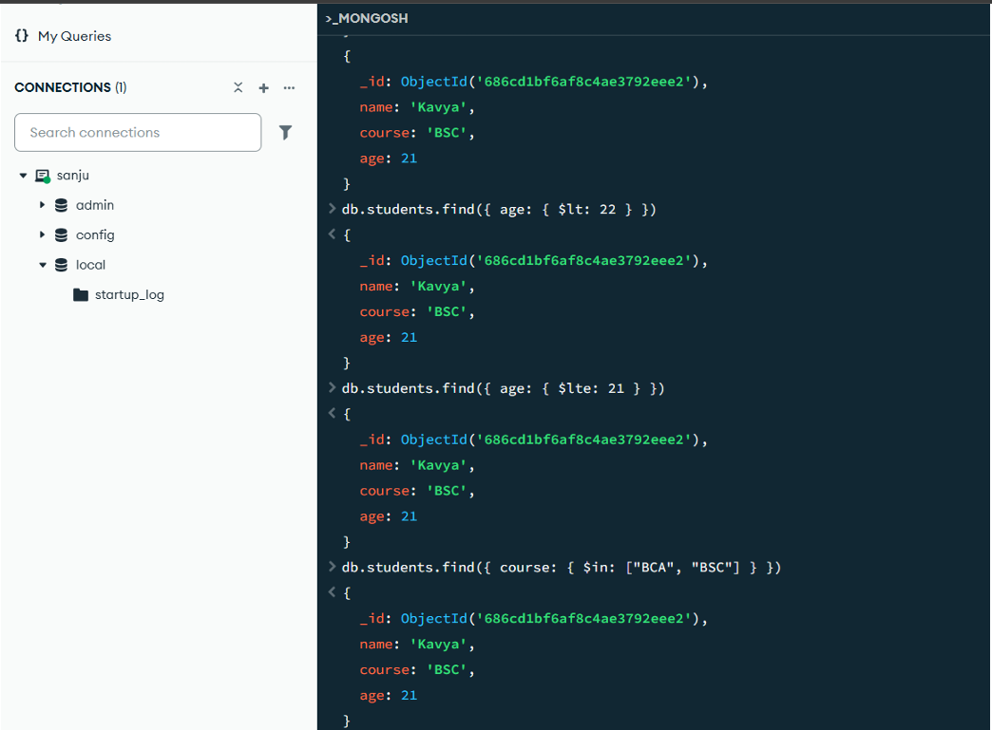

PROJECT-171

Title: Demonstrate how to use the $and logical operator in MongoDB

Description: The $and operator matches documents that satisfy all the specified expressions.

Source code: db.students.find( { $and: [ { age: { $gte: 20 } }, { course: "BCA" }] } )

Output:

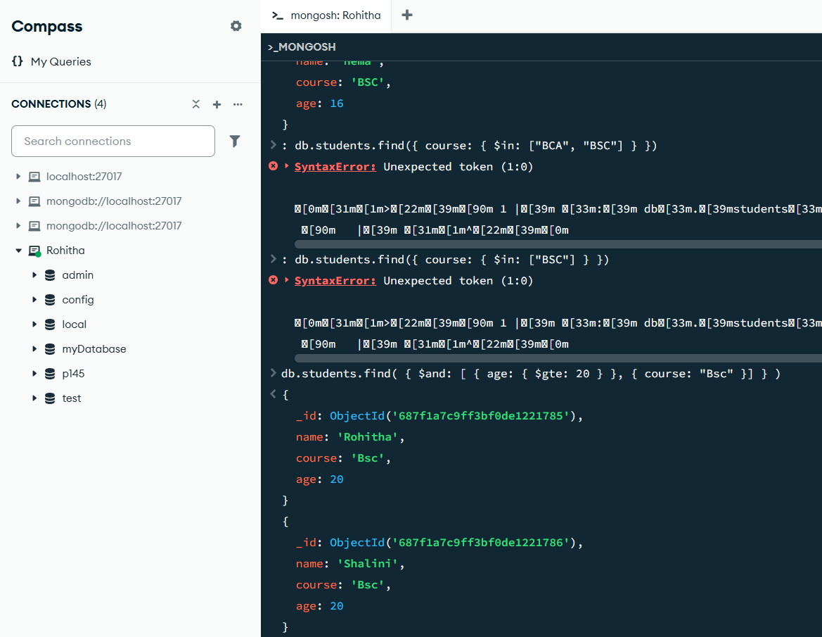

PROJECT-172

Title: Demonstrate how to use the $or logical operator in MongoDB

Description: The $or operator matches documents that satisfy at least one of the specified conditions.

Source code: db.students.find( { $or: [ { course: "BCA" }, { course: "BBA" } ] })

Output:

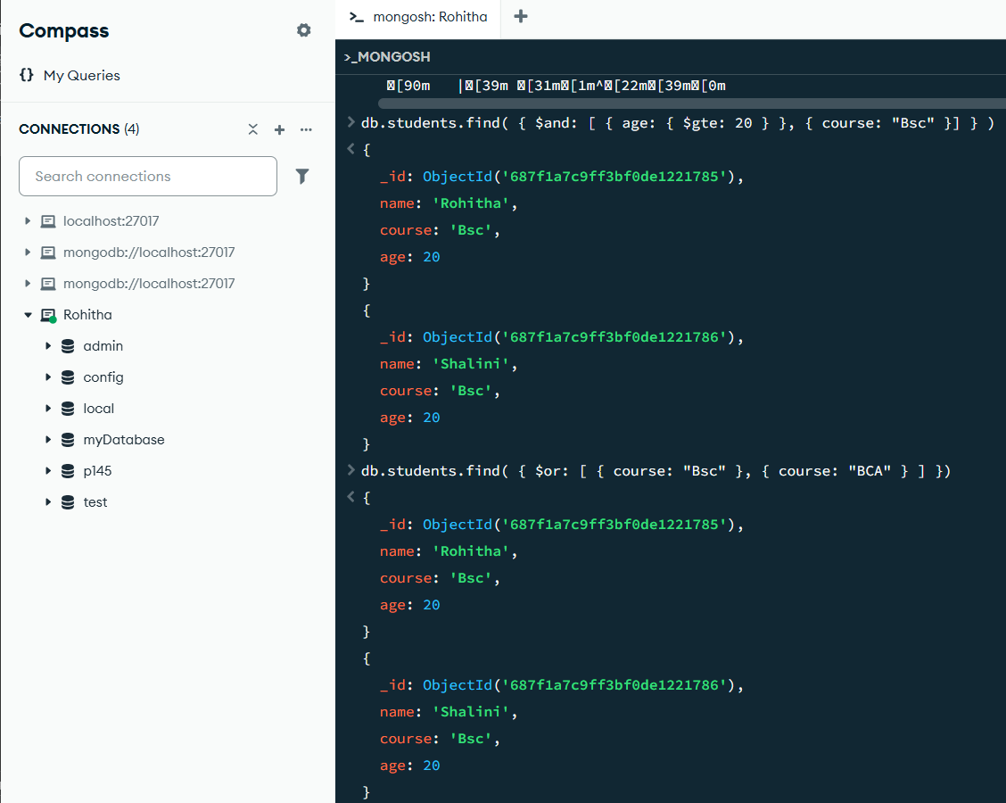

Project-173

Title: Demonstrate how to use the $not logical operator in MongoDB

Description: The $not operator inverts the result of a query expression and returns documents that do not match the condition.

Source code: db.students.find( { age: { $not: { $lt: 21 } } }) Output:

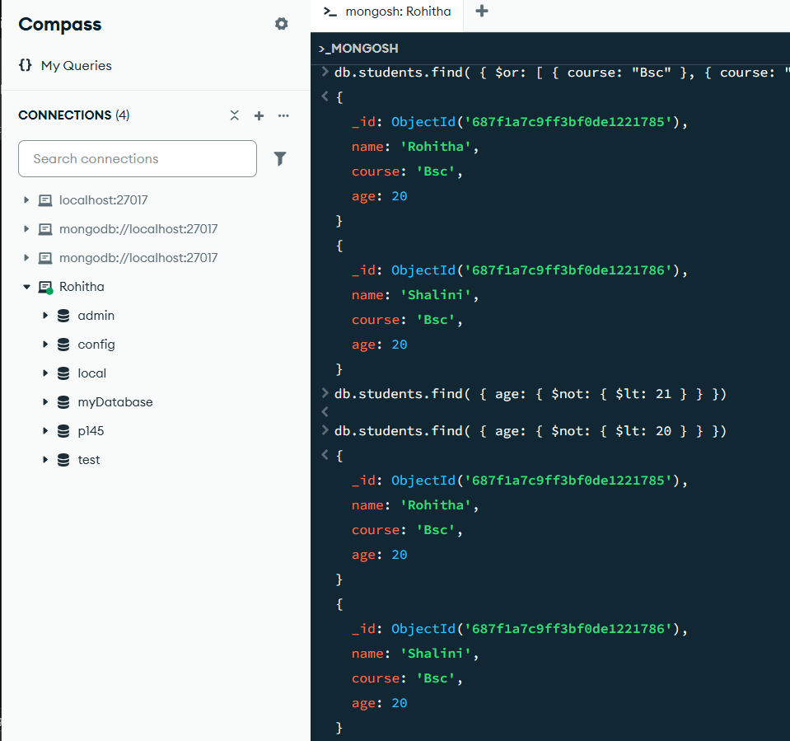

Project-174

Title: Demonstrate how to set up an Express server with MongoDB connection

SOURCE Code:

const express = require('express');

const mongoose = require('mongoose');

const app = express(); const port = 5000;

// Middleware for JSON parsingapp.use(express.json());

// MongoDB Connection mongoose.connect('mongodb://localhost:27017/students') .then(() =>console.log('Connected to MongoDB')) .catch(err =>console.error('MongoDB connection error:', err));

// Basic route to test server

.get('/', (req, res) => { res.send('Server is running');

});

// Start server app.listen(port, () =>

{ console.log(`Server running on port ${port}`);

});

Project-175

Title: Demonstrate how to define a Mongoose schema with validation

SOURCE Code:

Const user Schema = new mongoose

. Schema({ full name: { type: String, required: [true, 'Full name is required'] },

email: { type: String, required: [true, 'Email is required'], unique: true, match: [/.+\@.+\..+/, 'Invalid email format'] },

password: { type: String, required: [true, 'Password is required'],

minlength: [6, 'Password must be at least 6 characters'] } });

const User = mongoose.model('User', userSchema);

Project-176

Title: Demonstrate how to create a signup endpoint with error handling

SOURCE Code:

app.post('/signup', async (req, res) => {

const{ fullname, email, password } = req.body; // Validation 1: Check empty fields if (!fullname || !email || !password)

{ return res.status(400).json({ error: 'All fields are required' }); } try { // Validation 2: Check duplicate email constexistingUser = await User.findOne({ email });

if (existingUser) { return res.status(409).json({ error: 'Email already exists' }); }

// Create and save user constnewUser = new User({ fullname, email, password });

await newUser.save(); res.status(201).json({ message: 'User registered successfully' });

} catch (error) { console.error('Signup error:', error); res.status(500).json({ error: 'Server error during registration' });

} });

Project-177

Title: Demonstrate how to build a signup form with client-side validation

SOURCE Code:

<html>

<form id="sign up Form">

<div>

<label>Full Name:</label>

<input type="text" id="fullname" required minlength="3">

<span class="error" id="nameError"></span>

</div>

<div>

<label>Email:</label>

<input type="email" id="email" required>

<span class="error" id="emailError"></span>

</div>

<div>

<label>Password:</label>

<inputtype="password" id="password" required minlength="6">

<span class="error" id="passwordError"></span>

</div>

<button type="submit">Sign Up</button>

<p id="serverMessage"></p>

</form>

<script>

document.getElementById('signupForm')

.addEventListener('submit', async (e) => { e.preventDefault(); // Client-side validation

constfullname = document.getElementById('fullname').value.trim();

const email = document.getElementById('email').value.trim();

const password = document.getElementById('password').value;

if (!fullname || !email || !password) {

alert('All fields are required'); return; } try {

const response = await fetch('http://localhost:5000/signup', {

method: 'POST',

headers: { 'Content-Type': 'application/json' },

body: JSON.stringify({ fullname, email, password }) });

Const data = await response .j son();

document .get Element By Id('server Message').text Contet=

response .ok ? data .message : data .error;

} catch (error) {

Document.getElementById('serverMessage').textContent ='Network error: ' + error.message; } });

</script>

</html>

Output:

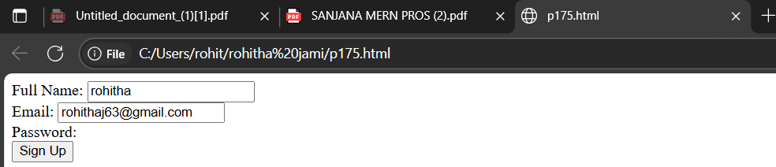

Project-178

Title: Login Frontend and Backend Code

SOURCE Code:

Backend Code (index.js): const express = require('express');

const app = express();

const mongoose = require('mongoose');

constcors = require('cors');

constcookieParser = require('cookie-parser');

constbodyParser = require('body-parser');

app.use(cors()); app.use(cookieParser());

app.use(bodyParser.json()); c

onst port = 5000; mongoose.connect('mongodb://localhost:27017/students') .then(() => { console.log('Connected to MongoDB');

}) .catch((err) => { console.error('MongoDB connection error:', err); });

// User schema without hashing password constuserSchema = new mongoose.Schema({ fullname: { type: String, required: true },

email: { type: String, required: true, unique: true },

password: { type: String, required: true } }); const User = mongoose.model('User', userSchema);

app.post('/signup', (req, res) => { const{ fullname, email, password } = req.body;

if (!fullname || !email || !password) { return res.status(400).send('All fields are required');

} User.findOne({ email: email }) .then(existingUser => { if (existingUser) { return res.status(409).send('Email already exists');

} constnewUser = new User({ fullname: fullname, email: email, password: password });

return newUser.save() .then(() => { res.status(201).send('User registered successfully'); });

}) .catch(error => { console.error('Signup error:', error); res.status(500).send('Server error'); }); });

app.post('/login', (req, res) => { const{ email, password } = req.body;

if (!email || !password) { return res.status(400).send('Email and password are required');

} User.findOne({ email: email, password: password }) // matching plain values .then(user => { if (!user) { return res.status(401).send('Invalid email or password'); }

res.status(200).send('Login successful'); })

.catch(error => { console.error('Login error:', error);

res.status(500).send('Server error'); }); });

app.listen(port() => { console.log('Server is running at port ' + port); });

Pin-to-Pin Explanation Frontend (login.html) 1. DOCTYPE and HTML Setup Declares document type and language. 2. Head Section - ensuresproper character encoding. - sets the page title. - links to external CSS. 3. Navigation Bar - Contains links for navigation to Home, About, Login, and Signup pages. 4. Content Section -

Login

heading. -

form element with an inline event handler to intercept submit event. - Input fields: - Email: - Password: - Submit button: Login - Message paragraph:

to display status or errors. 5. JavaScript: submitLoginForm function - Prevents default form submission (e.preventDefault()) to avoid page reload. - Fetches values of email and password inputs. - Constructs a loginData object containing email and password. - Sends a POST request to http://localhost:5000/login with headers specifying JSON content and stringifies the login data in the body. - Handles the response: - If status is 200, displays success message in green, stores "user":"active" in localStorage for session tracking, and redirects to home page. - If not, reads response text and displays the error message in red. - Catches any network or other errors, showing them in red. Backend (index.js) 1. Imports and Setup - Imports express, mongoose, cors, cookie-parser, and body-parser. - Creates an Express app instance. - Configures middlewares: cors(), cookieParser(), and bodyParser.json() to parse JSON request bodies. 2. MongoDB Connection - Connects to local MongoDB students database. - Logs success or error. 3. UserSchema - Defines the schema userSchema with fields: - fullname (String, required) - email (String, required, unique) - password (String, required) - This schema enforces data structure and validation for users. 4. User Model - Creates User model from the schema representing the users collection in MongoDB. 5. Signup API (POST /signup) - Extracts fullname, email, and password from request body. - Validates presence of all fields; returns 400 if missing. - Checks if a user already exists with the provided email using User.findOne({ email }). - If user exists, returns 409 Conflict status. - If not, creates a new User instance with the provided data. - Saves new user to the database using .save(). - On success, sends 201 Created status with success message. - Catches errors and sends 500 Server error. 6. Login API (POST /login) - Extracts email and password from request body. - Validates both fields; returns 400 if missing. - Uses User.findOne({ email, password }) to find a matching user without password hashing. - If no user found, returns 401 Unauthorized with error message. - If user found, returns 200 OK with success message. - Catches and handles errors with 500 status. 7. Server Listener - Runs server on port 5000 and logs confirmation message.

Project-179

Title: How to fetch all users using a GET endpoint with promise chains?

Source code:

Backend (Express): javascript app.get('/users', (req, res) => { User.find({})

.then(users => { res.status(200).json(users);

}) .catch(error =>

{ res.status(500).json({ error: 'Failed to fetch users' });

}); });

Frontend (Fetch API): Javascript fetch('/users') .then(response =>

{ if (!response.ok) throw new Error('Network error');

return response.json(); }) .then(data =>

{ console.log('All users:', data);

// Render data in UI }) .catch(error =>

{ console.error('Fetch error:', error);

alert('Failed to load users'); });

Project-180

Title:

Sourcecode:

Backend (Express): Javascript app

.put('/users/:id', (req, res) =>

{ const{ id } = req.params; const{ fullname, email } = req.body;

User.findByIdAndUpdate( id, { fullname, email }, { new: true

} // Returns updated document ) .then(updatedUser =>

{ if (!updatedUser) { return res.status(404).json({ error: 'User not found' });

} res.status(200).json(updatedUser); }) .catch(error =>

{ res.status(500).json({ error: 'Failed to update user' }); }); });

Frontend (Fetch API): javascript constuserId = '123'; // Example ID constupdatedData = { fullname: 'Jane Doe', email: 'jane@example.com' };

fetch(`/users/${userId}`, { method: 'PUT', headers: { 'Content-Type': 'application/json' }, body: JSON.stringify(updatedData) }) .then(response =>

{ if (!response.ok) throw new Error('Update failed'); return response.json();

}) .then(data => { console.log('Updated user:', data); alert('User updated successfully!'); })

.catch(error => { console.error('Error:', error); alert('Failed to update user');

});

Project-181

Title: How to delete a user using a DELETE endpoint with promise chains?

Sourcecode:

Backend (Express): javascript app.delete('/users/:id', (req, res) =>

{ const{ id } = req.params;

User.findByIdAndDelete(id)

.then(deletedUser =>

{ if (!deletedUser) { return res.status(404).json({ error: 'User not found' });

} res.status(200).json({ message: 'User deleted successfully' });})

.catch(error => { res.status(500).json({ error: 'Failed to delete user' });

}); });

Frontend (Fetch API): javascript constuserId = '123';

// Example ID fetch(`/users/${userId}`, { method: 'DELETE' })

.then(response =>

{ if (!response.ok) throw new Error('Deletion failed'); return response.json();

}) .then(data =>

{ console.log('Success:', data.message);

alert('User deleted!');

}) .catch(error =>

{ console.error('Error:', error);

alert('Failed to delete user');

});

Project 182

Title:Demonstrate the use of $push to add a value to the end of an array

Source code:

db.students.updateOne( { name: "Akhil" }, { $push: { skills: "MongoDB" } } );

Output:

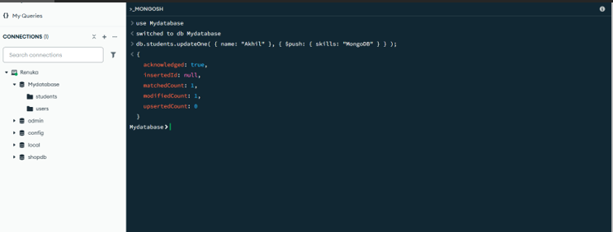

Project 183
Title: the use of upsert in MongoDB to update or insert a document
Source code:
db.students.updateOne( { name: “Kavya” }, { $set: { age: 25,course : "BSc" } }, { upsert: true } );
Output:
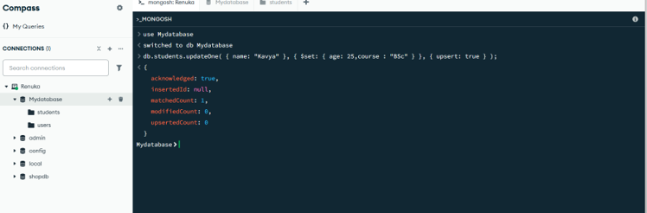

Project 184

Title: Demonstrate the use of `$group` in MongoDB aggregation

Source code:

db.orders.aggregate([ { $group: { _id: "$customerId", totalAmount: { $sum: "$amount" } } } ]);

Output:
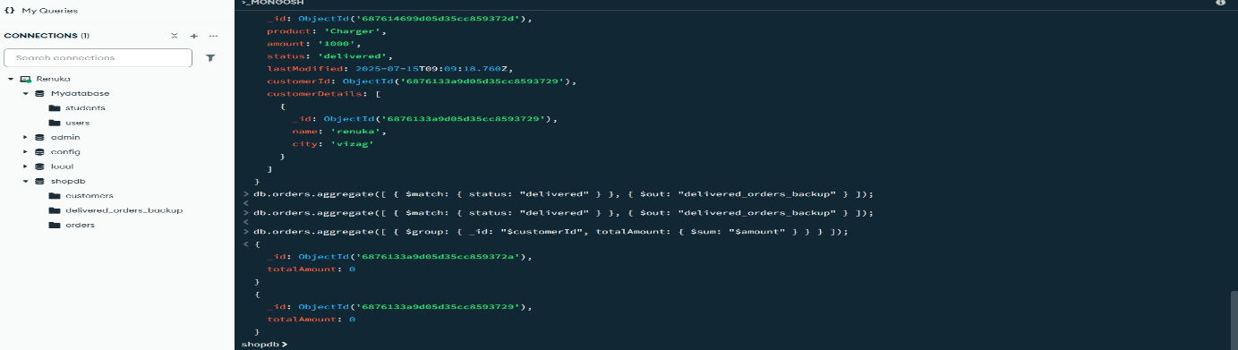

Project 185

Title: Demonstrate the use of `$limit` in MongoDB aggregation

Source code:

db.orders.aggregate([ { $limit: 5 } ]);

Output:

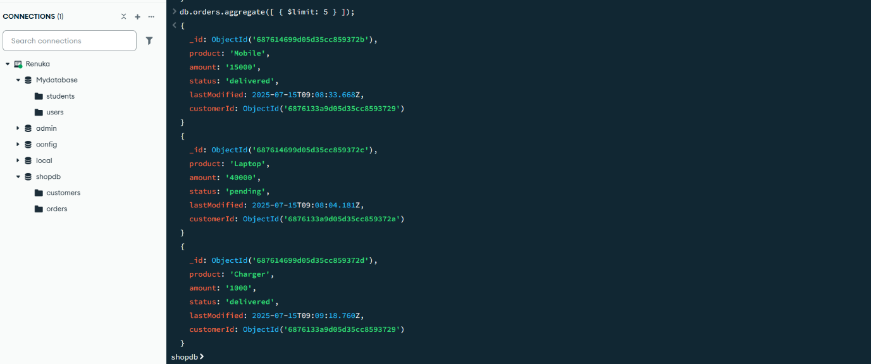

Project 186

Title: Demonstrate the use of `$project` in MongoDB aggregation

Source code: db.orders.aggregate([ { $project: { _id: 0, customerId: 1, amount: 1 } } ]);

Output:
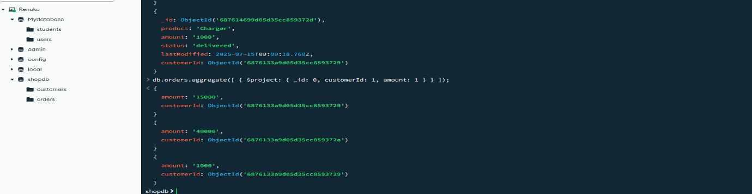

Project 187

Title: Demonstrate the use of `$sort` in MongoDB aggregation

Source code:

db.orders.aggregate([ { $sort: { amount: -1 } } ]);

Output:
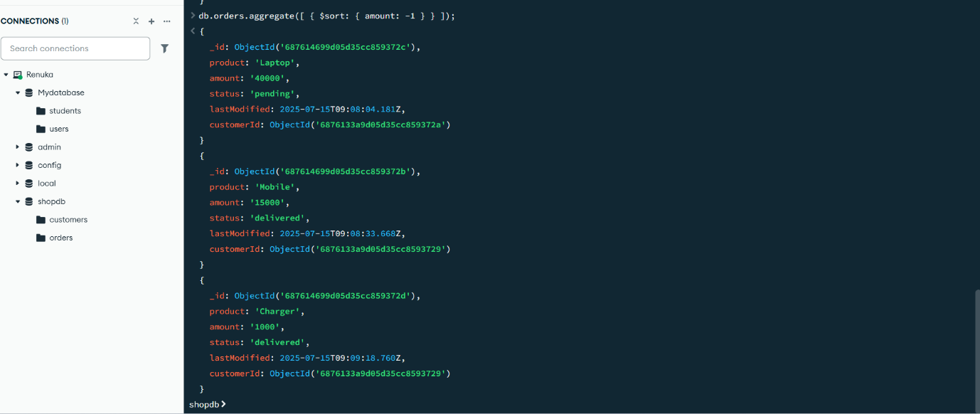

Project 188

Title:Demonstrate the use of `$match` in MongoDB aggregation

Source code:

db.orders.aggregate([ { $match: { status: "delivered" } } ]);

Output:
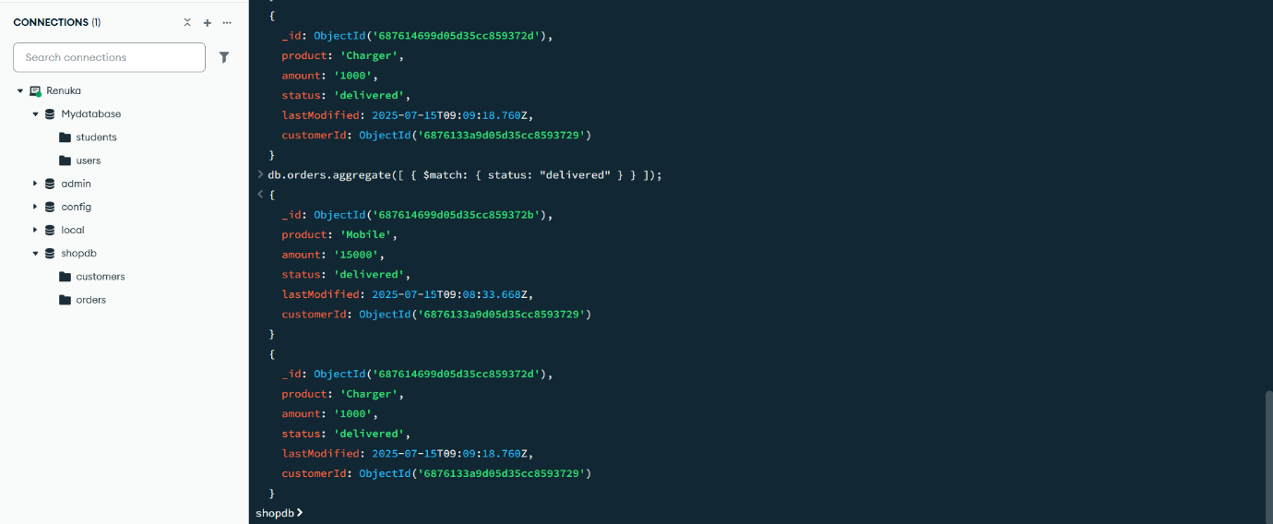

Project 189

Title:Demonstrate the use of `$skip` in MongoDB aggregation

db.orders.aggregate([ { $skip: 1 } ]);

Output:

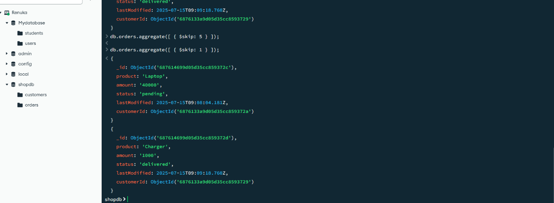

Project 190

Title:Demonstrate the use of `$count` in MongoDB aggregation

Source code:

db.orders.aggregate([ { $match: { status: "delivered" } }, { $count: "totalDelivered" } ]);

Output:


Project 191

Title: Demonstrate the use of `$lookup` in MongoDB aggregation

Source code:

db.orders.aggregate([ { $lookup: { from: "customers", localField: "customerId", foreignField: "_id", as: "customerDetails" } } ]);

Output:
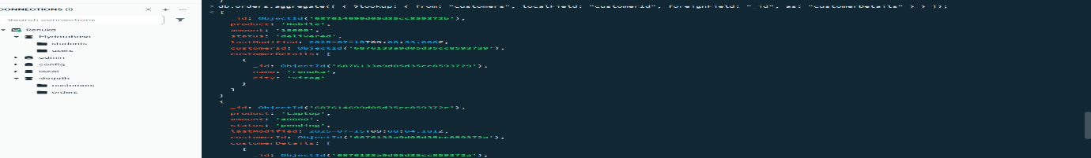
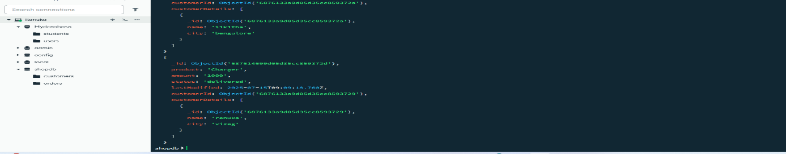

Project 192

Title: Demonstrate the use of `$out` in MongoDB aggregation

Source code:

db.orders.aggregate([ { $match: { status: "delivered" } }, { $out: "delivered_orders_backup" } ]);

Output:

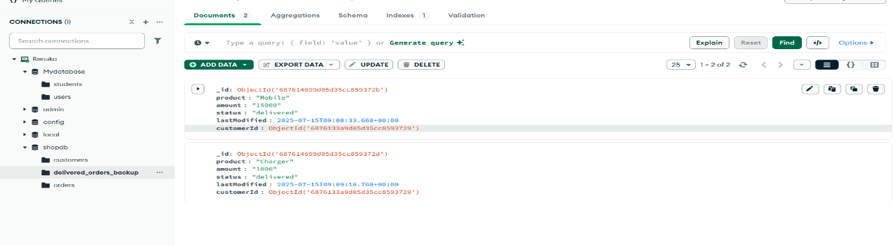

Project 193

Title: Basic MongoDB Connectivity Setup

Question: Write a Node.js script to connect to a local MongoDB database named students using the native mongodb package. Log a message on successful connection

Source code:

const express = require('express');

const bodyParser = require('body-parser');

const cors = require('cors');

const { MongoClient } = require('mongodb');

const app = express();

app.use(cors());

app.use(bodyParser.json());

const url = 'mongodb://localhost:27017';

const dbName = 'students';

async function main() { try {

const client = new MongoClient(url);

await client.connect();

console.log('Connected to MongoDB');

const db = client.db(dbName);

const usersCollection = db.collection('users');

app.get('/', (req, res) => {

res.send('Server is running'); });

app.listen(5000, () => {

console.log('Server running on port 5000'); });

} catch (err) {

console.error('MongoDB connection failed:', err);

process.exit(1);}}main();// Example route

app.get('/', (req, res) => {

res.send('Server is running');});

Output:

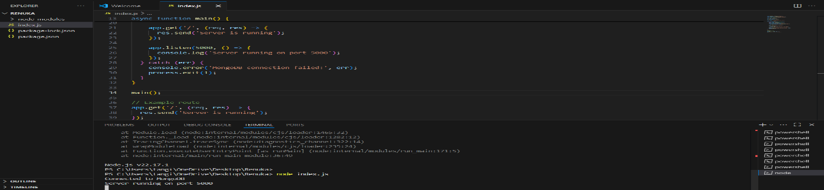

Project 194

Frontend code:

<!DOCTYPE html>

<html lang="en">

<head>

<meta charset="UTF-8">

<meta name="viewport" content="width=device-width, initial-scale=1.0">

<title>Sign up</title>

<style>

body {

font-family: sans-serif;

background-color: whitesmoke;

padding: 20px;

display: flex;

justify-content: center;

overflow: hidden; }

.form-container {

background:white;

padding: 25px;

border-radius: 10px;

width: 100%;

max-width: 400px;

box-shadow: 0 0 10px rgba(0,0,0,0.1); }

h2 {

text-align: center;

margin-bottom: 20px; }

.form-group {

margin-bottom: 15px; }

label {

display: block;

margin-bottom: 6px;

font-weight: bold; }

input[type="text"],

input[type="email"],

input[type="password"],

input[type="number"],

select,

textarea {

width: 90%;

padding: 10px;

border: 1px solid black;

border-radius: 5px;

font-size: 14px; }

textarea {

resize: vertical;

height: 70px; }

button {

width: 100%;

padding: 12px;

background-color: green;

color: white;

font-size: 16px;

border: none;

border-radius: 5px;

cursor: pointer; }

button:hover {

background-color: green; }

</style>

</head>

<body>

<form class="form-container" onsubmit="submitSignupForm(event)">

<h2>Signup Form</h2>

<div class="form-group">

<label for="fullname">Full Name</label>

<input type="text" id="fullname" placeholder="enter full name">

</div>

<div class="form-group">

<label for="email">Email</label>

<input type="email" id="email" placeholder="enter email">

</div>

<div class="form-group">

<label for="password">Password</label>

<input type="password" id="password" placeholder="enter password">

</div>

<div class="form-group">

<label for="year">Year of Study</label>

<select id="year">

<option>Select year</option>

<option>1st Year</option>

<option>2nd Year</option>

<option>3rd Year</option>

<option>4th Year</option>

</select>

</div>

<div class="form-group">

<label for="contact">Contact Number</label>

<input type="text" id="contact" placeholder="contact number">

</div>

<div class="form-group">

<label for="secondary">Secondary Contact Number</label>

<input type="text" id="secondary" placeholder="Optional contact number">

</div>

<div class="form-group">

<label for="address">Address</label>

<textarea id="address" placeholder="enter address"></textarea>

</div>

<button type="submit">Register</button>

</form>

<script>

function submitSignupForm(e) {

e.preventDefault();

var name = document.getElementById('fullname').value;

var email = document.getElementById('email').value;

var password = document.getElementById('password').value;

var year = document.getElementById('year').value;

var contact = document.getElementById('contact').value;

var secondary = document.getElementById('secondary').value;

var address = document.getElementById('address').value;

var data = {

fullname: name,

email: email,

password: password,

year: year,

contact: contact,

secondary: secondary,

address: address };

fetch('http://localhost:5000/signup', {

method: 'POST',

headers: {

'Content-Type': 'application/json' },

body: JSON.stringify(data) })

.then((res) => {

if (res.status === 200) {

alert('User added successfully');

} if (res.status === 300) {

alert('User already exists'); } })

.catch((err) => {

console.error('Error:', err);

alert('An error occurred '); }); }

</script>

</body>

</html>

Backend code:

const express =require('express');

const bodyparser = require('body-parser');

const cookiesparser = require('cookie-parser');

const cors = require('cors');

const app = express();

app.use(bodyparser.json());

app.use(cookiesparser());

app.use(cors({credentials:true}));

const port = 5000;

const {MongoClient} = require('mongodb');

const url = 'mongodb://localhost:27017/'

const dbname = 'students';

const connection = new MongoClient(url);

var signup;

var studentsmarks;

connection.connect().then(()=>{

const database = connection.db(dbname);

signup = database.collection('signupdata');

markslist = database.collection('studentsmarks');

console.log('database has been connected');

}).catch(()=>{

console.log('database has not connected');});

app.post('/signup', (req, res) => {

var { name, email, password,study,contact,secondary,address } = req.body;

const data = { name, email, password,study,contact,secondary,address } ; signup.findOne({email:email}).then((results) => {

if (results) {

res.status(300).send('user already exist') }

else {

signup.insertOne(data).then(() => {

res.status(200).send('user added sucessfully');

}).catch((err) => {

console.log(err);

console.log('error occured ')

res.status(500).send('db error') })

} }).catch((err) => {

console.log(err);

console.log('error occured ')

res.status(500).send('db error'); })

});app.listen(port,()=>{

console.log(`server is running at http://localhost:${port}`);})

Output:

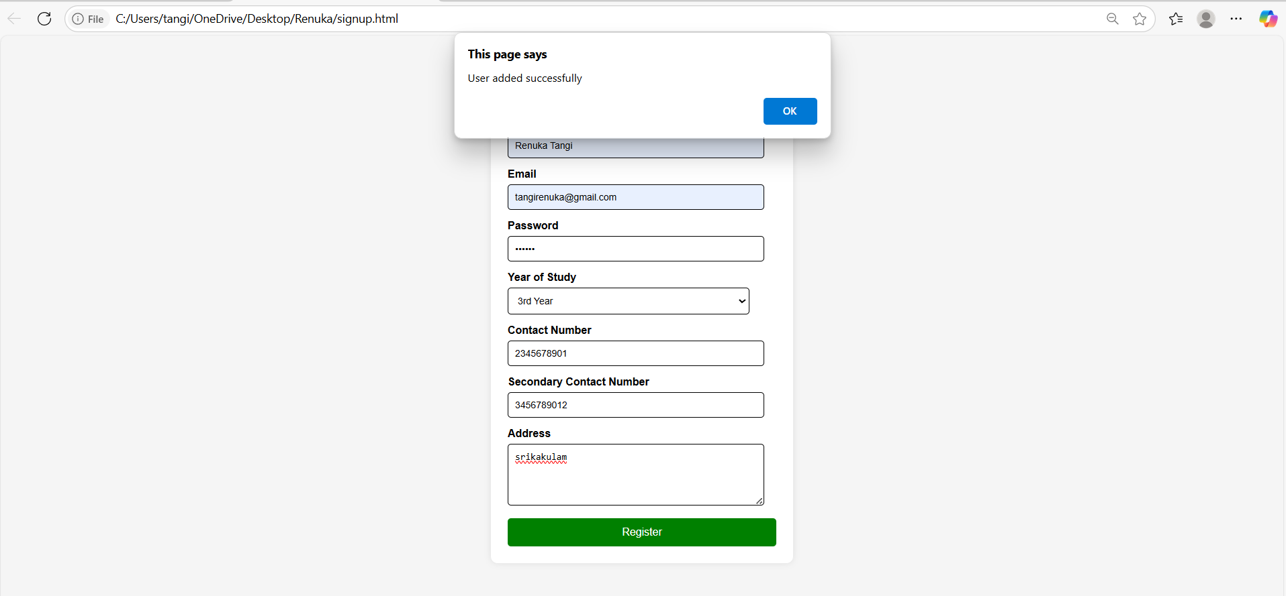

Project 195

Frontend code:

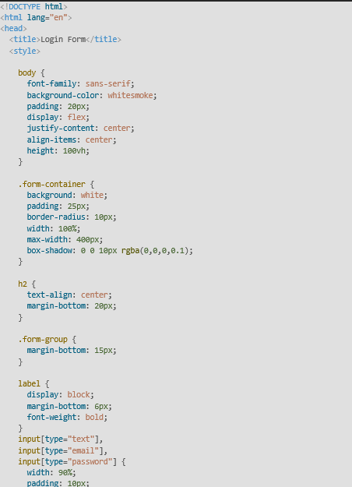

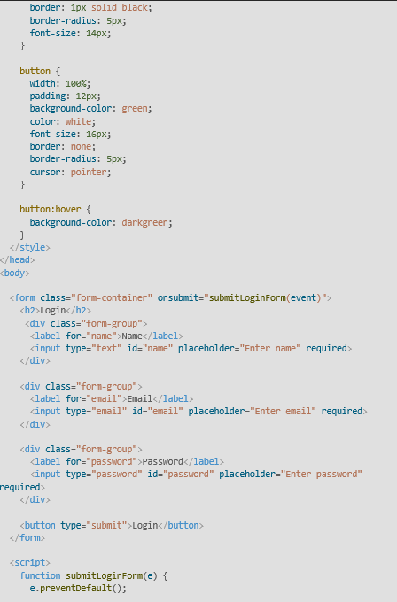

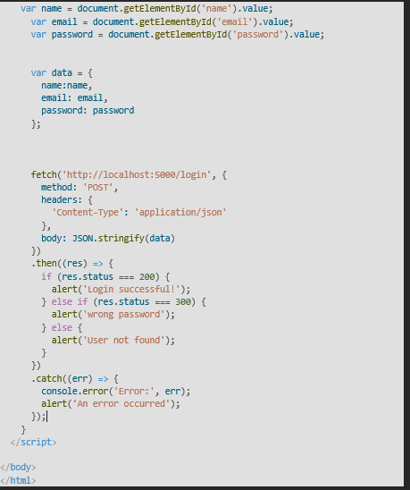

Backend:
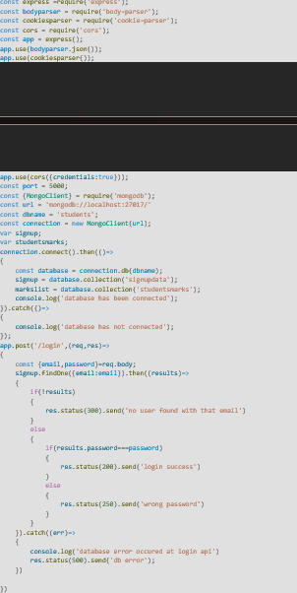

Output:
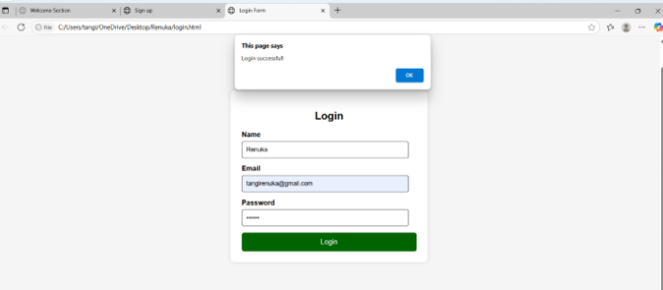

Project-196

.<h2>GetAllUsers</h2>

<buttononclick="getAllUsers()">FetchUsers</button>

<preid="userList"></pre><script>

function getAllUsers() {

fetch(http://localhost:5000/details)

.then(res=>res.json())

.then(data=>{

document.getElementById('userList').textContent=JSON.stringify(data,null,2);});}

<h2>Get User by Email</h2>

<input type="text"id="get Email" placeholder="Enter Email"><button on click="get User By Email()">Fetch User</button>

<preid="singleUser"></pre><script>

Function get User By Email(){

Const email=document.get Element BId('getEmail').value;

fetch(http://localhost:5000/user/${email})

.then(res=>res.json())

.then(data=>{

document.getElementById('singleUser').textContent=JSON.stringify(data,null,2);});}

</script>

OUTPUT:
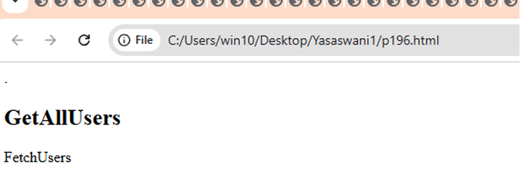

Project-197.

<h2>Get User by Email</h2>

<input type="text"id="get Email" placeholder="Enter Email">

<button on click="get User By Email()">Fetch User</button>

<preid="singleUser"></pre>

<script>

Function get User By Email(){

Const email=document.get Element BId('getEmail').value;

fetch(http://localhost:5000/user/${email})

.then(res=>res.json())

.then(data=>{

document.getElementById('singleUser').textContent=JSON.stringify(data,null,2);});}

</script>

OUTPUT:
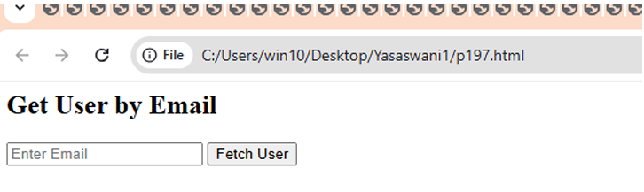

Project-198.

<h2>UpdateUser</h2><input type="text "id="updateEmail"placeholder="EmailtoUpate">

<inputtype="text"id="updateName"placeholder="NewName>

<button onc lick="updateUser()">Update</button>

<script>Function update User() {const email = document.getElementById('updateEmail').value; const name=document.getElementById('updateName').value;

fetch(http://localhost:5000/update/${email},{

method: 'PUT',headers: {'Content-Type':'application/json'}, body: JSON.stringify({ name })})

.then(res=>res.text()).then(alert);}</script>OUTPUT: 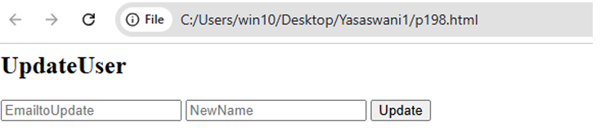

Project-199.

<h2>Delete User</h2><input type="text"id="deleteEmail"placeholder="EmailtoDele

e">

<button on click="deleteUser()">Delete</button>

<script>

Function deleteUser() {

Constemail=document.getElementById('deleteEmail').value; fetch(http://localhost:5000/delete/${email}, {method: 'DELETE'}).then(res=>res.text()).then(alert);}

</script>

OUTPUT:
