- Implemented appIcon, Bootsplash Screen(shows when open app first) functionality.

\*\*Need to change for our app’s unique own appIcon and Bootspalsh Screen.

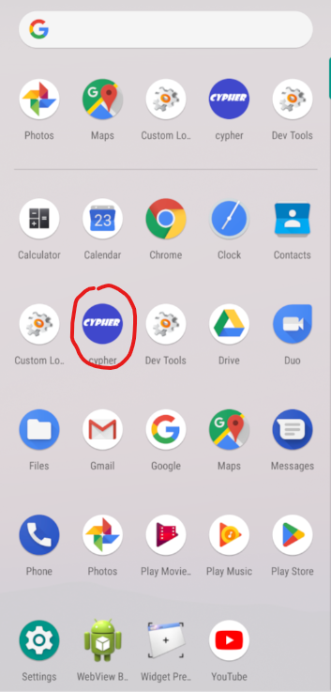 

- Implemented Signup functionality

\* generate private, public key-pairs by using blockchain cryptographic.

\* store private key and password on local storage

\* store public key and username on Firebase store

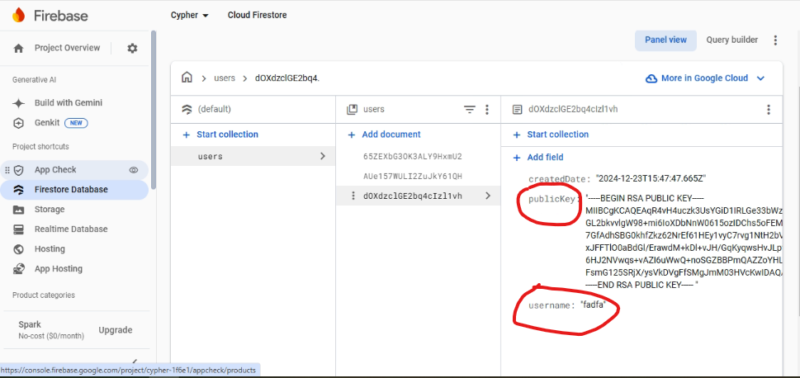

\* Show/Hide password when clicking eyeslash Icon

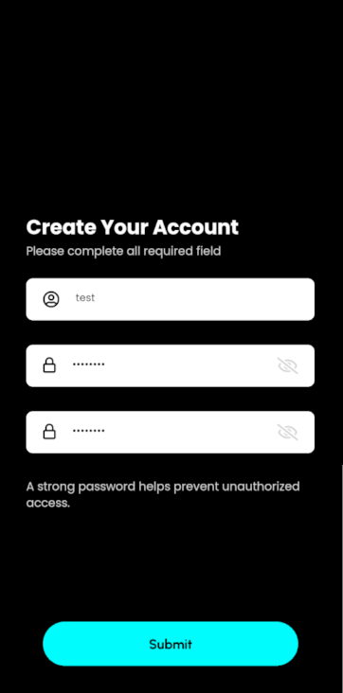 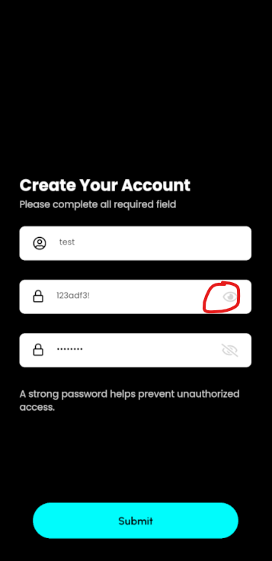

\* Validate Input form values

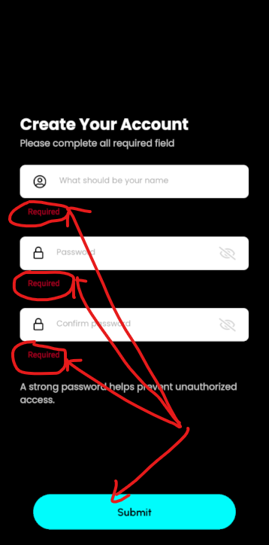 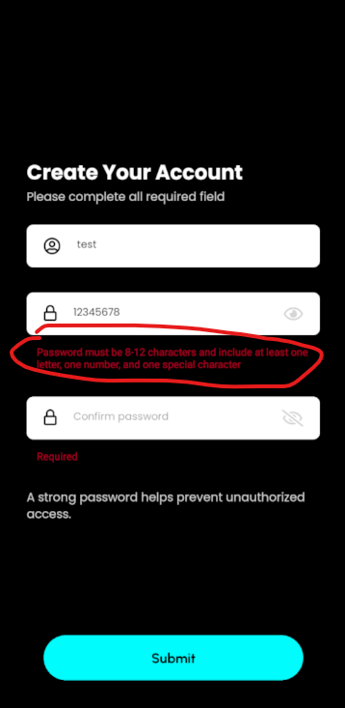 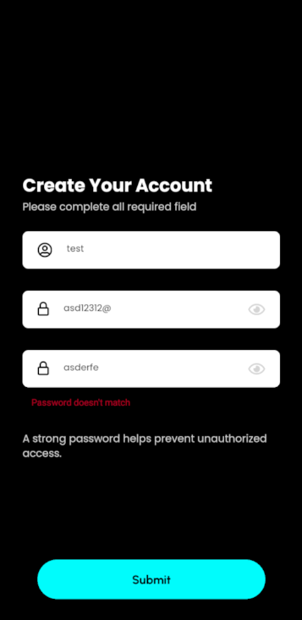

\* After successful Signup, show Account created modal and then go to ‘Login’ screen

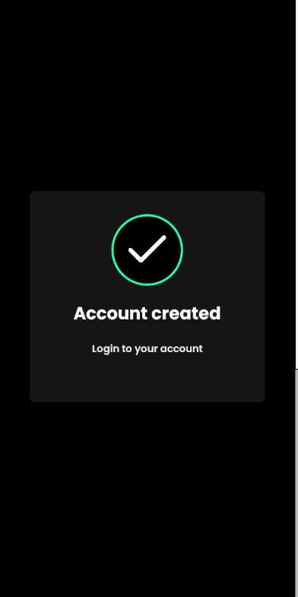 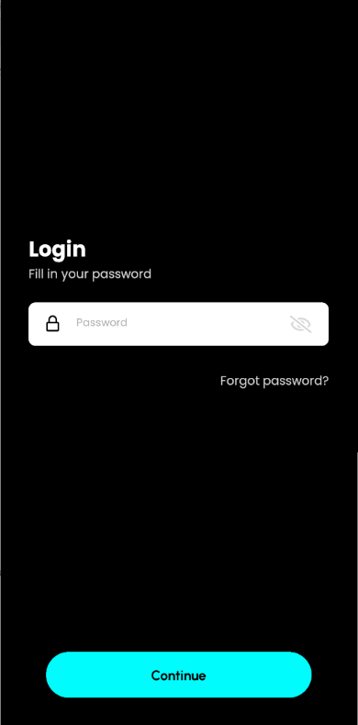

- Implemented Login functionality

\* When login, if not registered, show alert and go to Signup screen

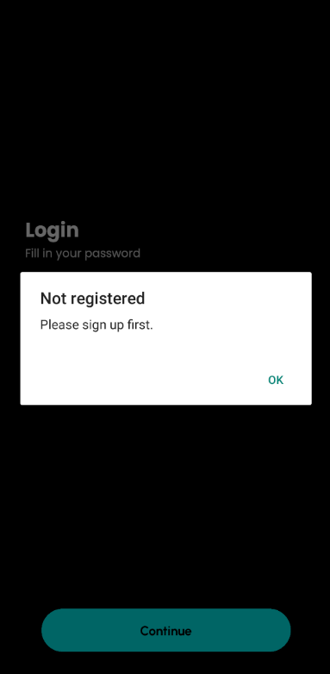

\* Compare user inputed password with password stored on local storage

\*\*If not matched, show alert first and then exceed over 5times, show ‘Incorrect password’ modal

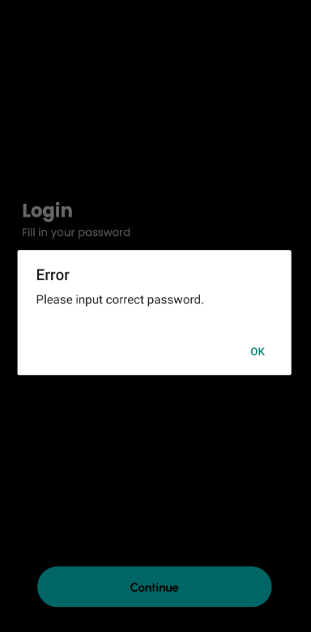 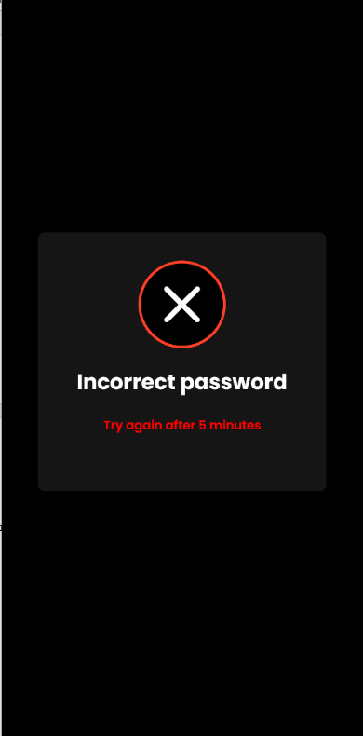  
\*\*and then if matched show Login success modal

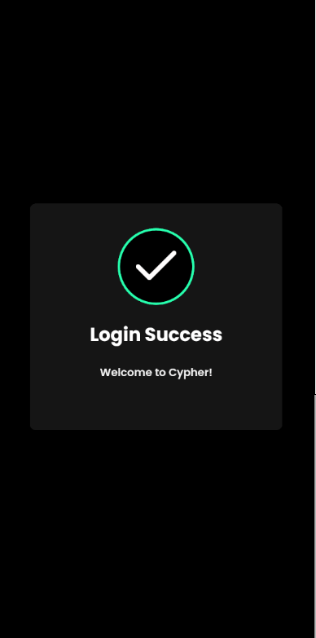

\* Validate Input form values

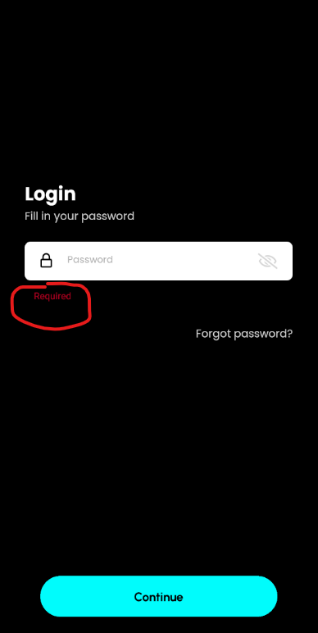

\* When click ‘Forgot password?’, show forgotpassword modal,   
 Then click ‘Cancel’ – close moal, and click ‘Delete’ – delete privatekey and password that stored on local storage and go to ‘Home’ Screen

