**- Fix Homescreen UI/UX issue**

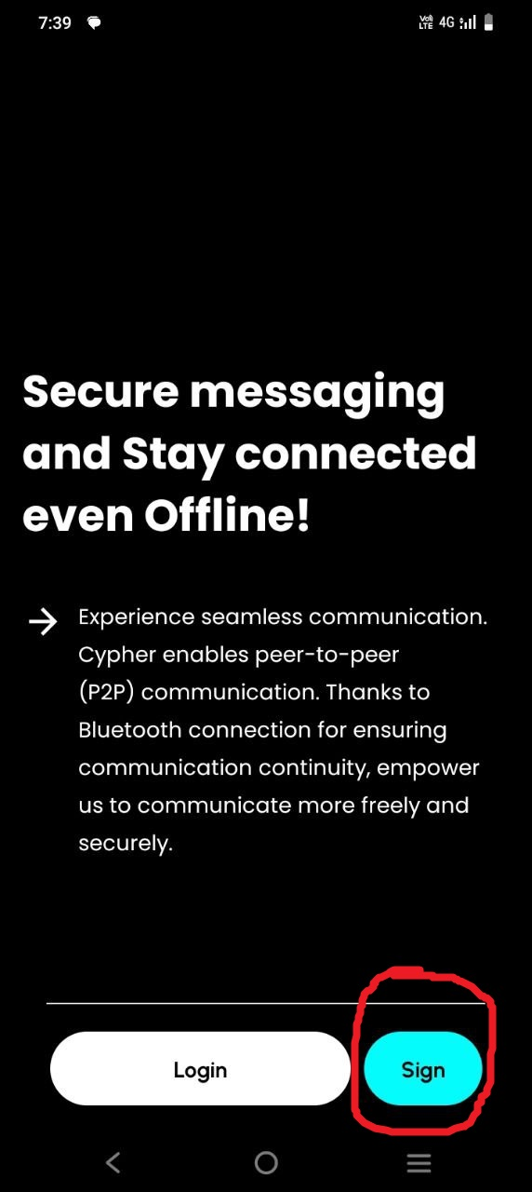

**- Establish a secure connection handshake using public/pribate key pairs**

**- Enable public key sharing via QR codes or links.**

* Not implemented with UI/UX yet(implemented only functionality and checked)

**- Implement Bluetooth and Wi-Fi Direct communication protocols for offline connections.**

* Not implemented with UI/UX yet(implemented only functionality and checked)

**- Implement state management so that track the changes and update immediately**

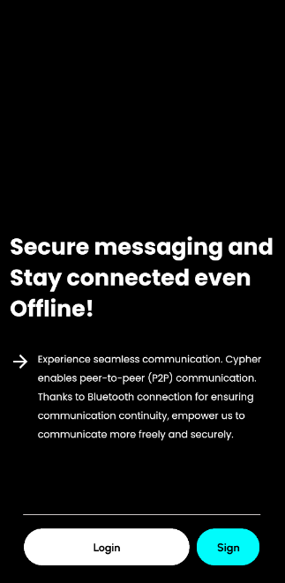 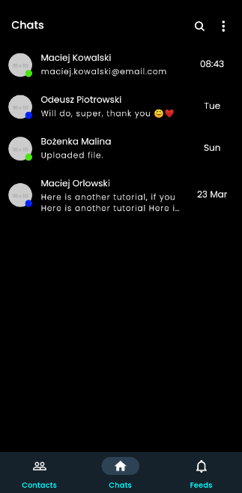

(Home Screen) (Main Screen)

*If user logged in, always go to Main Screen not to go Home screen

*Store user profile info into the state so that track the user info change, and when if changes updates automatically.

**- Implement functionality that shows loading indicator when login and signup.**

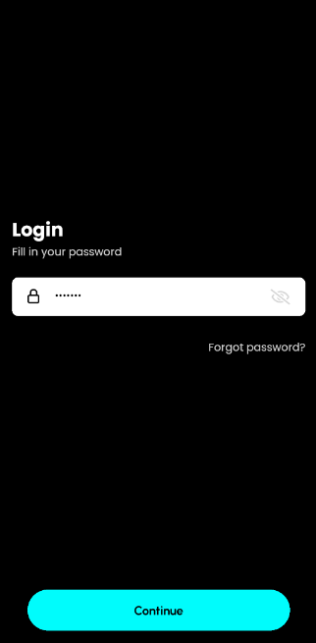 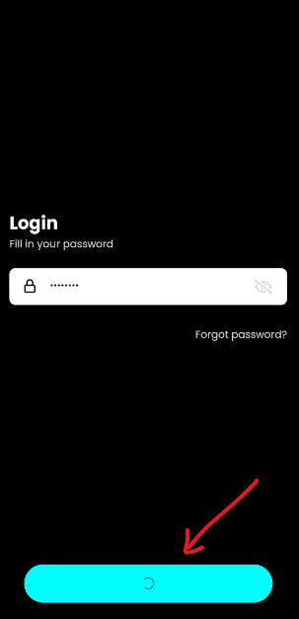

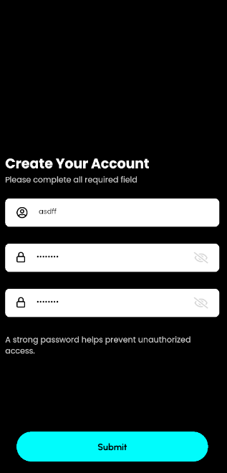 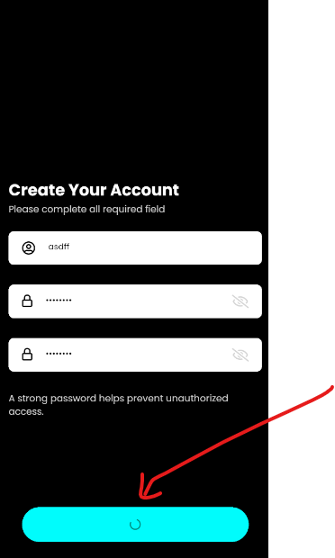

**- Implement Contacts, Chats, Feeds Screen UI/UX with static data**

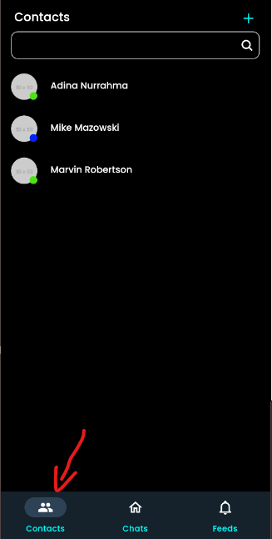 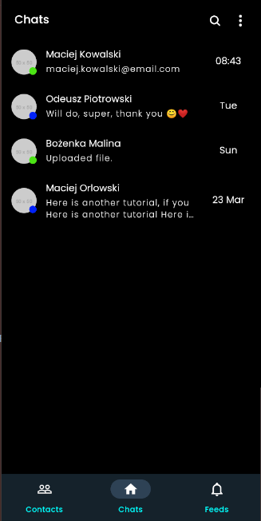

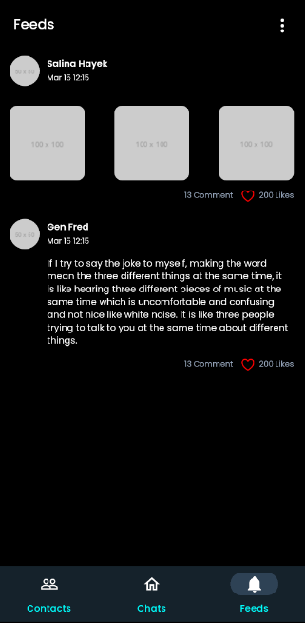

* changes every tab icons(Contacts, Chats, Feeds- filled or outlined icons) when selected or not