**- Fix/ Implement functionality adding contact automatically and also simultaneously on both sides with external link**

**\* AAAA user input the BBBB’s link and click continue(at this time send connect request and wait request received and the other’s send request)**

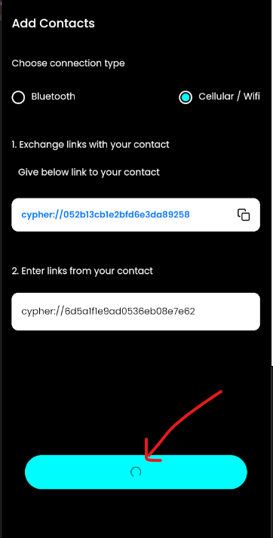

**\* BBBB input the AAAA’s link and click continue(at this time send connect request to AAAA and if receive AAAA’s request received same time, then connect each other)**

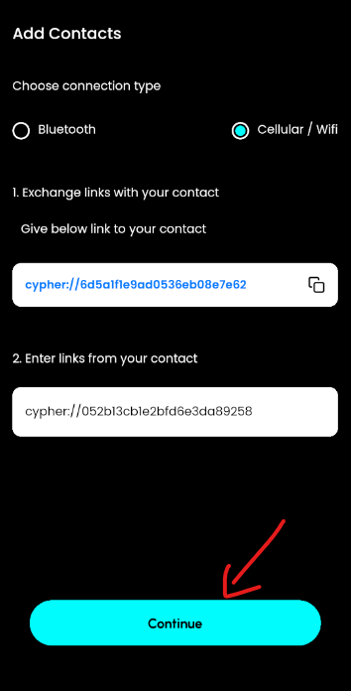

**\* if both aceepted request successfully same time, status changed from ‘pending’ to ‘accepted’, then add user contact in both side.**

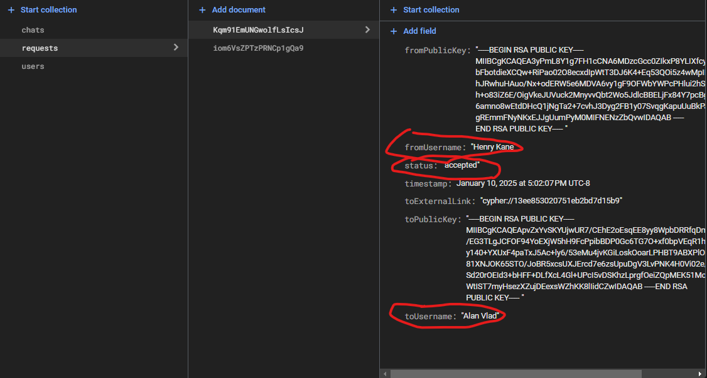 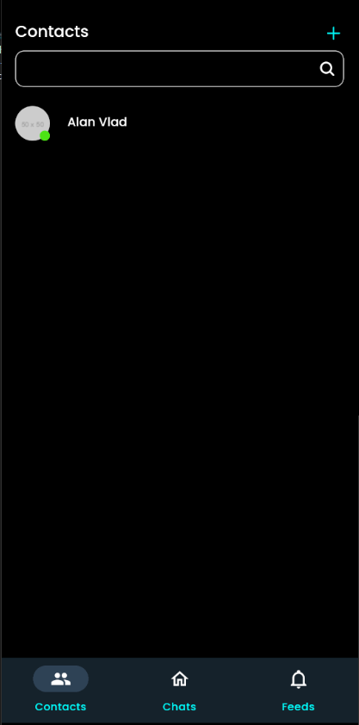

**- Fix Navigator style**

**- Implement functionality real-time chat between users**

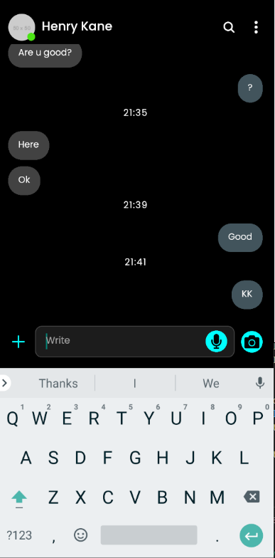

**- Add chats collection on firebase firestore for real-time chat**

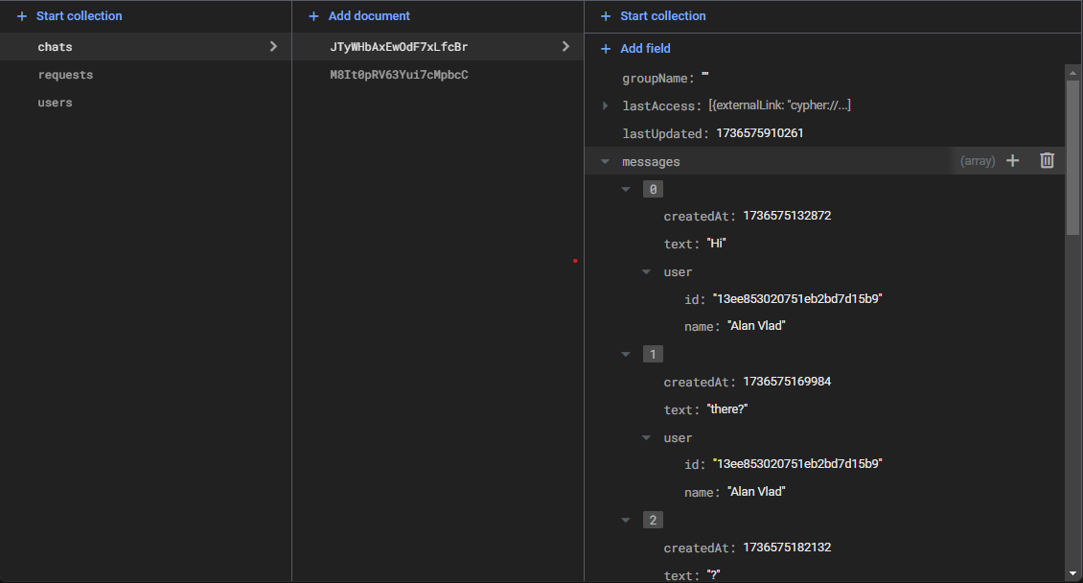

**- fix Main Chats UI/UX with pixel perfect design**

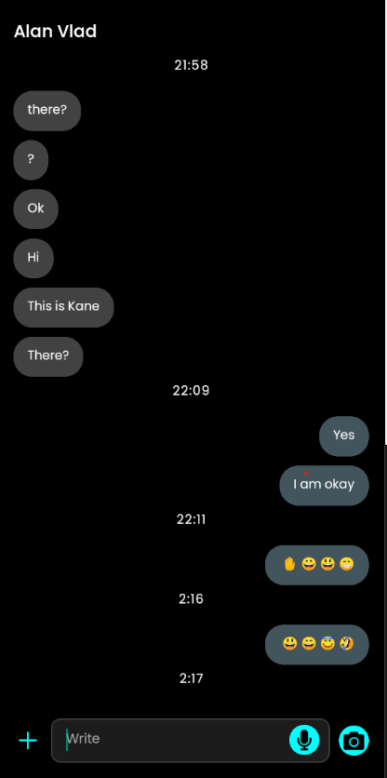

**- Implement emoji modal functionality.**

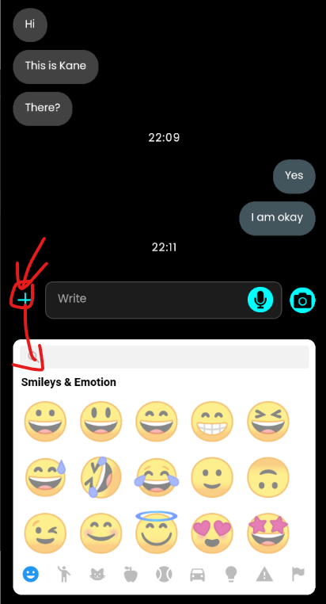 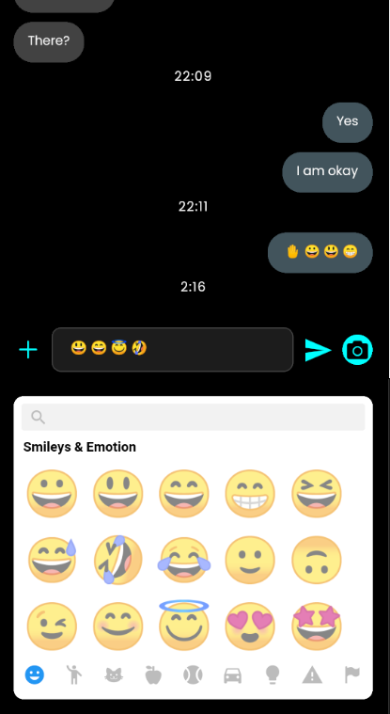 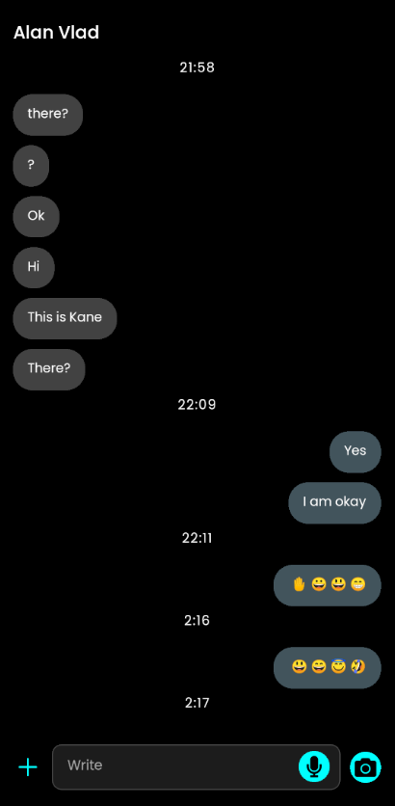

**- Implement unread message functionality if user outside of chatroom, and also show latest message on the chats screen.**

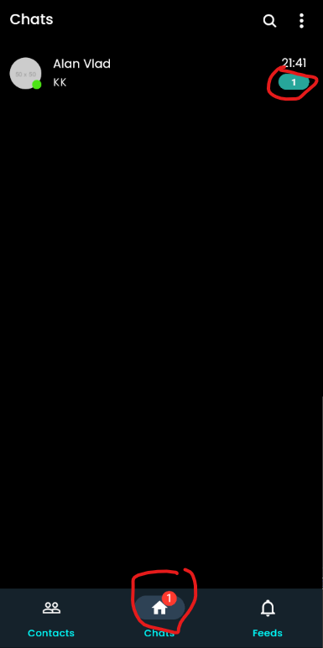 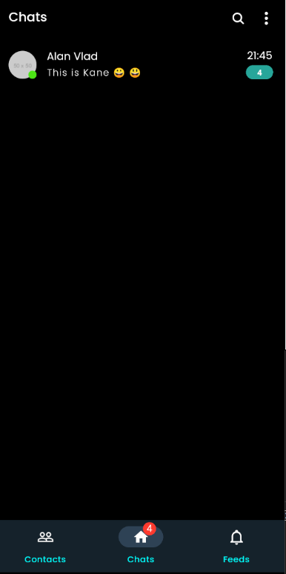

**- Implement functionality add contacts to the group.**

**\* click contact panel long, show select contact and also make group**

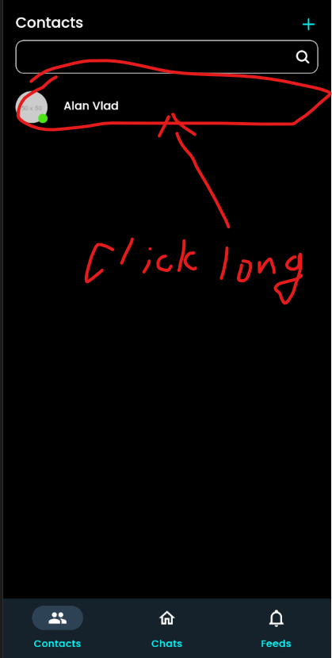 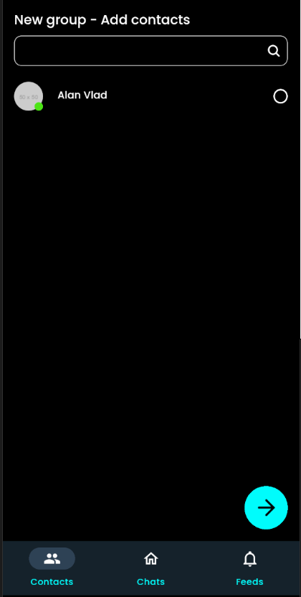

**\* select users and click arrow-right button go to group name screen**

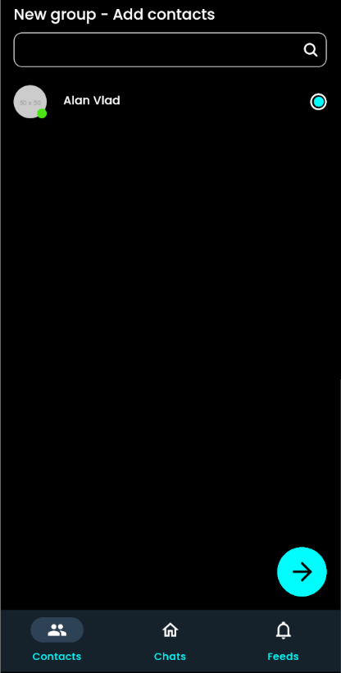 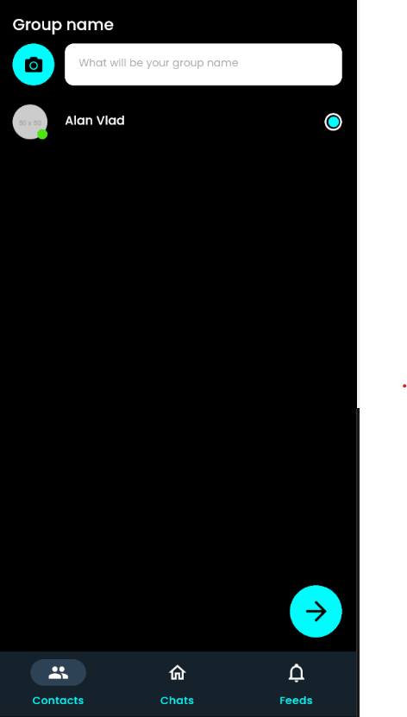

* user didn’t’ input group name, show alert

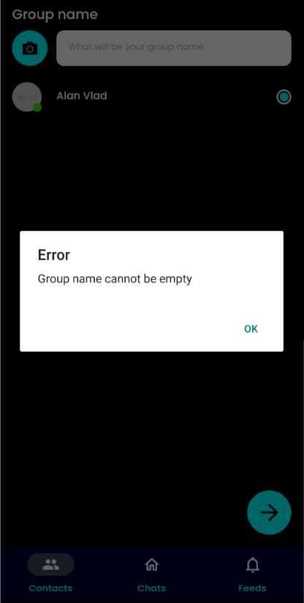

* after this, add group to the chats screen

* group chat room screen is same as individual chat screen.