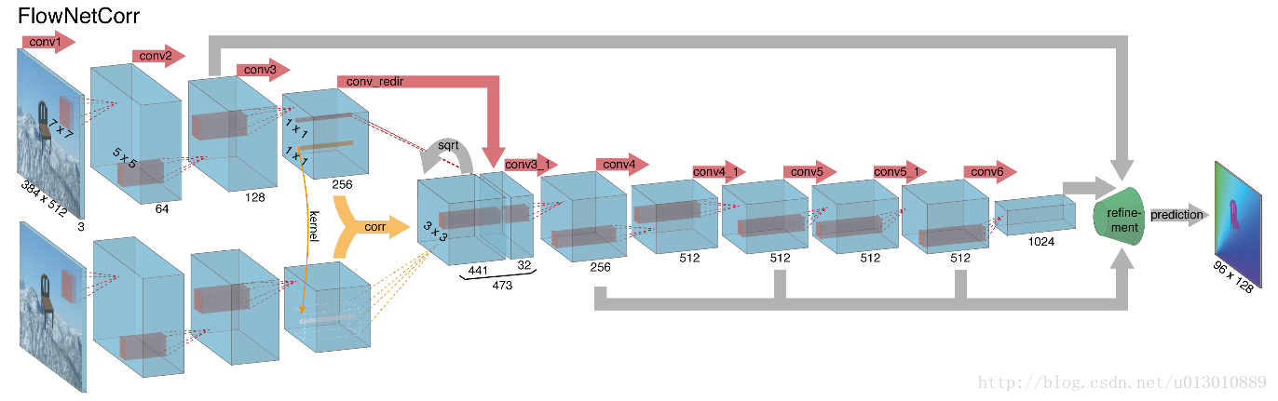

关联层

layer {
name: "corr"
type: "Correlation"
bottom: "conv3a"
bottom: "conv3b"
top: "corr"
correlation_param {
pad: 20
kernel_size: 1
max_displacement: 20
stride_1: 1
stride_2: 2
}
}

