**Tap Changer Optimization**

**Study**

**Enbridge Pipelines**

**Regina Terminal Facility**

**November 2013**





**PowerCore**

**Engineering**

**Prepared by:** *Roman Bulla, P. Eng,*

*Scott Vermeire, B.Eng, EIT*

**Completion:** *November 2013*

**Job Number:** *S2742*

Table of Contents

List of Tables iii

List of Figures iii

1. Introduction 1-1

1.1 Purpose and Objectives 1-1

1.2 Scope 1-1

2. Study Procedure and Observations 2-1

2.1 Capacitor Bank Review 2-1

2.2 Motor Starting Analysis 2-3

2.3 Load Flow Analysis 2-6

2.4 Tap Changer Optimization 2-8

3. Findings Summary 3-1

Capacitor Bank 3-1

Transformer Tap Changer 3-1

4. Recommendations 4-1

4.1 Short Term 4-1

Capacitor Bank: 4-1

Transformer Tap Changer: 4-1

4.2 Long Term 4-2

Capacitor Bank: 4-2

Transformer Tap Changer and Load Flow Analysis Studies: 4-2

5. Paladin DesignBase 5.1 Model 5-1

# List of Tables

Table 2.2.1: Motor Starting Under Half Load 2-3

Table 2.2.2: Motor Starting Under No Load 2-4

Table 2.2.3: Voltage Monitor Connections 2-5

Table 2.3.1: Load Flow Analysis Results Part 1 2-6

Table 2.3.2: Load Flow Analysis Results Part 2 2-7

Table 2.4.1: Voltage Regulation Range for Current Tap Changer Settings 2-8

Table 2.4.2: Voltage Regulation Range for Recommended Tap Changer Settings 2-9

Table 2.4.3: Tap Changer Settings Comparison 2-9

# List of Figures

Figure 2.1: Closing Ladder Logic 2-1

Figure 2.2: Opening Ladder Logic 2-2

Figure 5.1: System Model 5-1

# Introduction

## Purpose and Objectives

The Tap Changer Optimization Study for Enbridge Pipelines was prepared by PowerCore Engineering. The Study was performed as per RFP 41240TR1021-RFP01.

The purpose of this study was to review the operation of the tap changer installed on Transformer 420-TX-2. The tap changer currently experiences an excessive amount of operations as a result of large variations in electrical loads and periodic switching of the capacitor bank 420-PFC-2. Due to these factors the tap changer has been operating on average 58 times per day over the past 2 years. The purpose of this study is to provide a solution that reduces number of operations while still maintaining an adequate voltage regulation throughout the system.

## Scope

Our study included the following equipment:

* Transformer 420-TX-2 - 20/26 MVA, 72:4.16KV, Delta:Wye, GE Transformer
* Transformer 420-TX-2 Tap Changer - ABB Type UZ on-load Tap Changer
* Transformer 420-TX-2 Tap Changer Controller - Beckwith M-2001C
* Capacitor Bank 420-PFC-2 - 2400kVar Capacitor Bank with various ABB Protective/Control Relays
* Pump Induction Motors - Motors on 2-SWGR-2 and 4-SWGR-2 ranging from 2500HP ~ 5000HP

# Study Procedure and Observations

## Capacitor Bank Review

The initial hypothesis was that the excessive tap changer operations were a result of the independent nature of the capacitor bank and tap changer controllers. The belief was that the two control schemes were competing and triggering operations on one another.

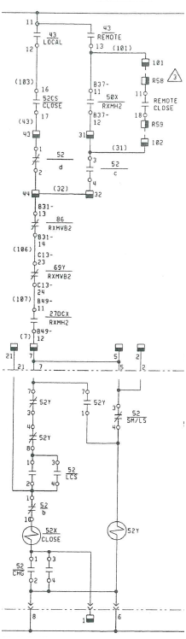Upon reviewing the capacitor bank drawings (D-420-4.03-38481-3-50, D-420-4.03-38482-3-50, D-420-4.03-38483-3-50, D-420-4.03-38484-3-50 and E-420-4.01-21464-26-50), it didn’t appear that the capacitor bank was intentionally setup for constant switching. Figure 2.1.1 depicts three separate relays capable of closing the capacitor bank breaker (Local Close, Remote Close and the 50X Overcurrent Relay) and Figure 2.1.2 (on page 2-2) depicts 5 other relays capable of bringing the capacitor bank offline (Local Trip, Remote Trip, Overvoltage, Undervoltage and Lockout relay). The Local and Remote relays are for controlling the status of the breaker at the capacitor bank enclosure and from a remote location; these functions were considered a non issue as there is no automation behind them. The 50X Overcurrent relay, however, is connected to a current transformer (CT) on the primary side of transformer 420-TX-2 and is utilized to bring the capacitor bank online every time the CT senses 30A at 72kV or 3.7MVA loading on the transformer. Although this Overcurrent relay is capable of reclosing the breaker, it isn’t used to trip the breaker. It appears that the capacitor bank should stay fixed online. The switching issue is caused by a nuisance trip of either of the protective relays that trips the breaker which is then followed by the operation of the reclosing relay.

Figure 2.1: Closing Ladder Logic

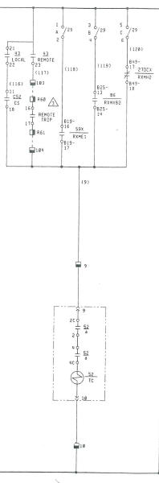Since this system has large fluctuations in voltage, the overvoltage and undervoltage relays are most likely the source of the nuisance tripping. The Lockout Relay (tripped from the MCGG82 Overcurrent Relay) shouldn’t be a concern. The overvoltage relay monitors the line side of the capacitor bank circuit breaker through a 4160V:120V PT and has a pickup of approximately 135V and a delay of 2.2 seconds. The Undervoltage relay uses the same type of relay, but is connected to the 125V DC voltage supply that powers the protection circuits. This undervoltage relay pickup is set to 100V and the delay is set to 0 seconds. If a voltage drop of 20% is experience on the DC control power **this relay will trip instantly**.

In order to determine the maximum voltage drops on the system a motor starting study was executed.

Figure 2.2: Opening Ladder Logic

## Motor Starting Analysis

The motor starting analysis was performed on a model designed in Paladin DesignBase 5.1 (formerly EDSA Technical). The model was generated based on the SKM Arc Flash model provided by Enbridge in April 2013. Data in the model was confirmed with an onsite inspection on July 31, 2013 and August 1, 2013. The model stops at all insignificant loads including transformers below 225KVA. All Transformers below 225KVA were simulated with 50% loading.

Several motor starting scenarios were executed with this system model. The various scenarios consisted of all the different motor starting combinations combined with starting under half load and no load cases. All motor starting scenarios were executed with a fixed tap position of 0.975. This tap position was selected as 0.975 is where the tap changer consistently floats to regulate the voltage. The reasoning to keep the tap position fixed instead of variable was because of the 45 second delay on the tap changer controller. This Time Delay far exceeds the motor starting time. The scenarios and results for the motor starting study are depicted in the following tables, Table 2.2.1 and Table 2.2.2.

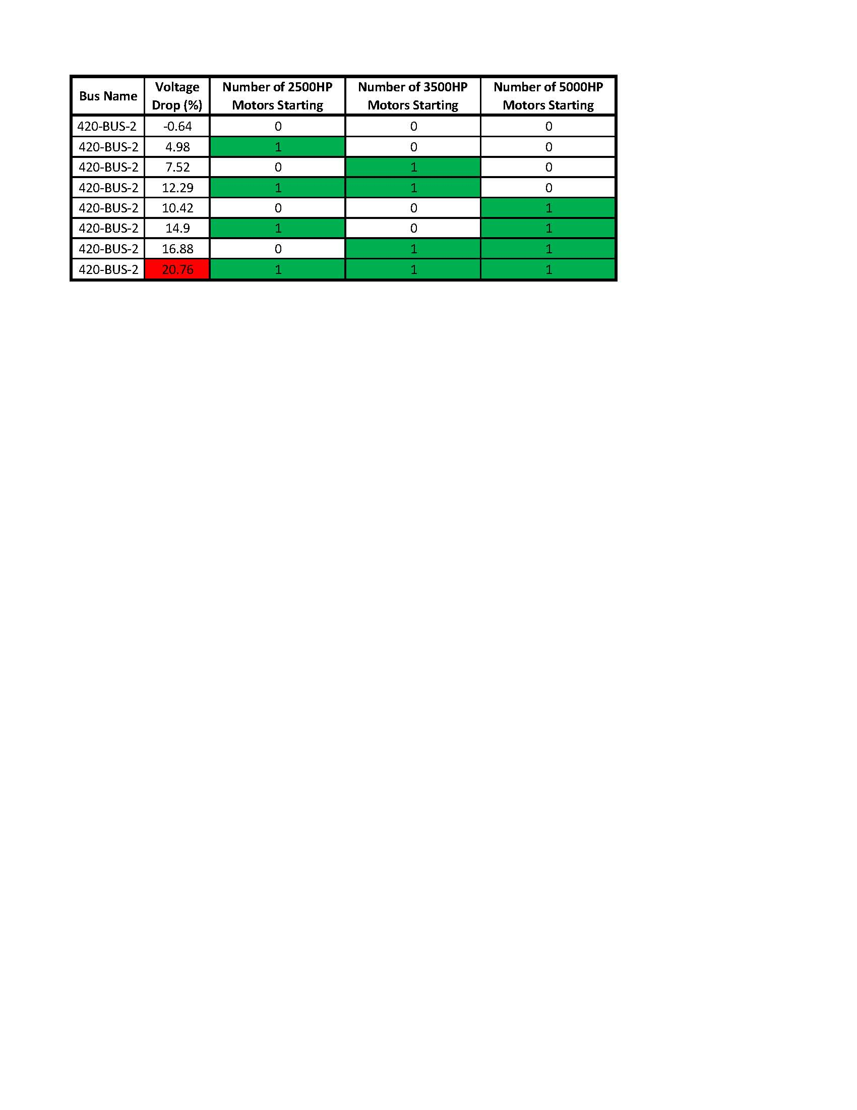

Table 2.2.1: Motor Starting Under Half Load

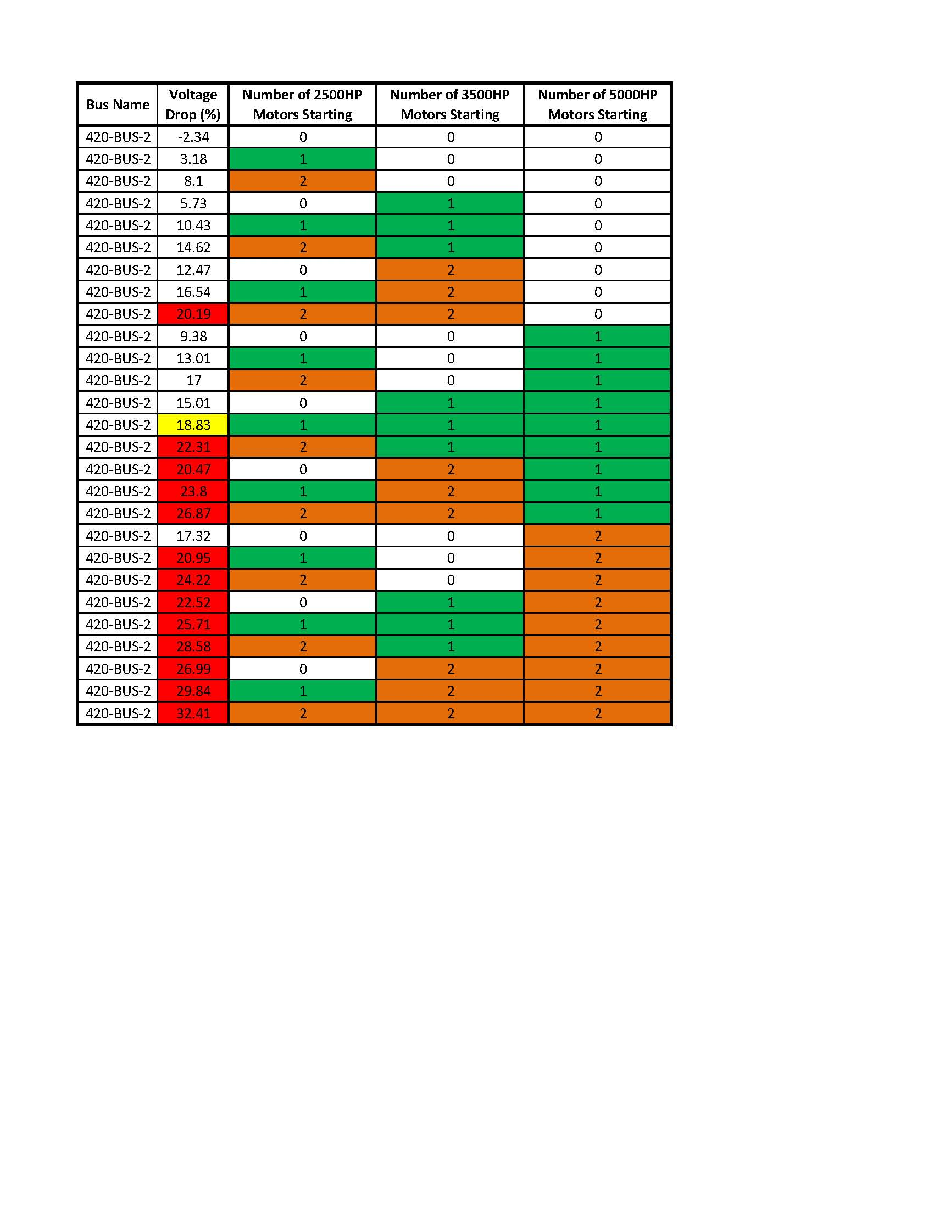

Table 2.2.2: Motor Starting Under No Load

According to the relay settings it would take a 20% voltage drop to trip the capacitor bank Undervoltage relay. That magnitude of voltage drop would only occur during a scenario where three or more motors are started at the same time; these scenarios are highlighted in red.

Even though these conditions aren’t likely to occur, PowerCore still recommends that a voltage monitor be temporarily installed on the 125V DC power bus of the capacitor bank controls and on terminal 9 of the trip circuit (see Table 2.2.3) to log any trips that may occur.

In addition, we recommend replacing the old relays that control and protect the capacitor bank at this facility. These relays are older style devices that don’t provide any event recorder to aid forensic analysis. We recommend replacing all these relays with a single digital capacitor bank control relay such as the Multilin C70 capacitor bank relay. This relay will provide all the protection of the current setup, as well as, added metering, data logging and event recorder features, which will make troubleshooting in the future quicker and simpler.



Table 2.2.: Voltage Monitor Connections

## Load Flow Analysis

Load flow analysis was conducted to determine the voltage drop during the changes in motor load. Since there is a 45 second delay on the tap changer controller, the controller only reacts to the steady-state voltage drop on the system. Therefore the voltage drops resulting from our Load Flow Analysis accurately display the values that the tap changer would react to in order to regulate the voltage. The same model used in the Motor Starting Analysis was utilized in the Load Flow Analysis. This portion of the study also required a number of scenarios to cover every combination of motor loading. See Table 2.3.1 and Table 2.3.2 for the resulting voltage drop of each motor combination.

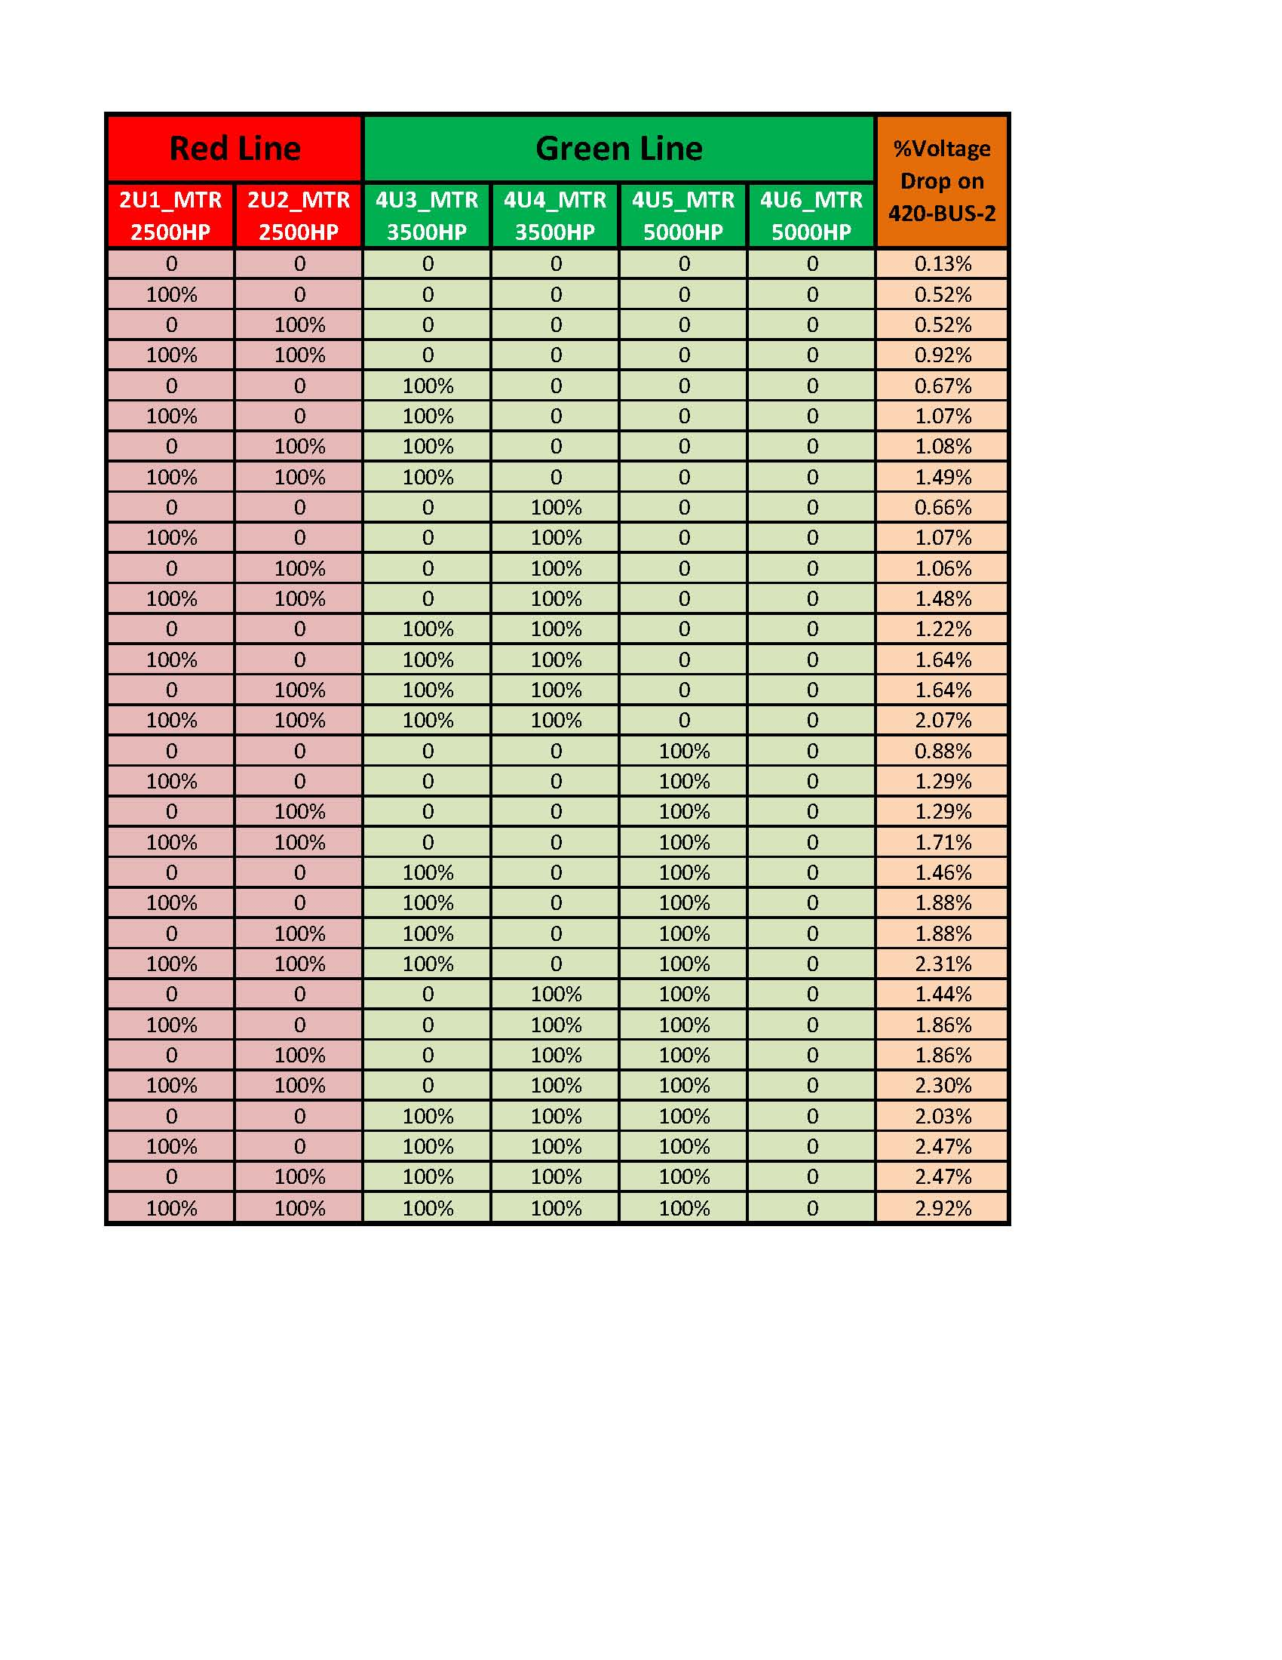

Table 2.3.1: Load Flow Analysis Results Part 1

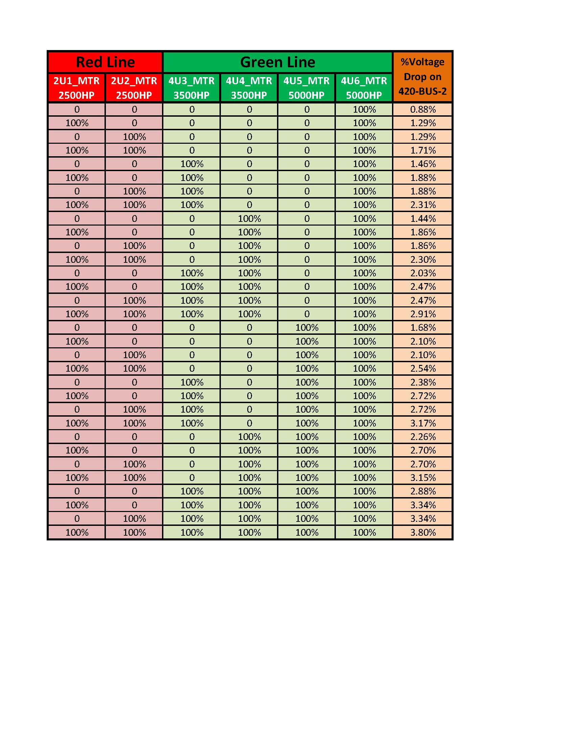

Table 2.3.2: Load Flow Analysis Results Part 2

As seen above, the voltage drop on the 420-BUS-2 bus ranges from 0.13% to 3.80% from minimum to maximum motor loading variations.

Load Flow Analysis was also conducted on the system with capacitor bank switching. It was determined that there is a 0.93% voltage increase when the capacitor bank is online versus when it is offline. This data was vital for judging the tap changer’s settings.

## Tap Changer Optimization

The final portion of the study was the actual tap changer optimization. Using the information from the previous sections and further simulation, we were able to assess the operation of the tap changer.

The Beckwith Tap Changer Controller has three main settings that directly affect the number of tap changer operations; these settings include Band Centre (BC), Bandwidth(BW) and Time Delay. These settings are currently set as follows:

* Band Centre: 123V
* Bandwidth: 3V
* Time Delay: 45 seconds

The current settings basically state that the tap changer is going to regulate the voltage on the 420-BUS-2 bus so that the secondary voltage of the PT falls around 123V with a tolerance of +/-1.5V (half the bandwidth). When the PT voltage is out this range for 45 seconds then the tap changer makes an adjustment until the voltage is returned to 123V +/- 1.5V range. Table 2.4.1 shows what this Voltage regulation translates to downstream in the system.

|  |  |  |  |  |  |  |  |
| --- | --- | --- | --- | --- | --- | --- | --- |
| Tap Changer PT Voltage Band | | 420-BUS-2 Voltage Band | | 2-SWGR-2_SWGR Voltage Band | | 4-SWGR-2_SWGR Voltage Band | |
| Lower Band Limit [V] | Upper Band Limit [V] | Lower Band Limit [V] | Upper Band Limit [V] | Lower Band Limit [V] | Upper Band Limit [V] | Lower Band Limit [V] | Upper Band Limit [V] |
| 121.50 | 124.50 | 4212.00 | 4316.00 | 4206.59 | 4310.59 | 4201.60 | 4305.60 |

Overall the settings regulate the voltage to an acceptable level, but due to the small Bandwidth the controller tolerance band is too low and this is causing the Tap changer to operate too frequently. Increasing the Bandwidth will reduce the number of tap changer operations, but if the Bandwidth is changed without a change in the Band Centre, there is a risk that the downstream equipment could experience issues due to low or high voltages. To avoid this issue, it is recommended to decrease the Band Centre when increasing the Bandwidth. See Excel Workbook “*S2742_VoltageRegulation.xlsx”* for the various Bandwidth and Band Centre combination experimented with.

Table 2.4.1: Voltage Regulation Range for Current Tap Changer Settings

After examining the various settings combinations, the following settings were deemed the most effective:

* Band Centre: 122.4V
* Bandwidth: 4.2V
* Time Delay: 45 seconds

These settings will reduce the number of tap changer operations while maintaining a safe and reliable voltage level. As you can see in Table 2.4.2, these settings have the same upper voltage limit the current setting tolerate and allow the voltage to drop closer to the rated voltage of 4160V.

|  |  |  |  |  |  |  |  |
| --- | --- | --- | --- | --- | --- | --- | --- |
| Tap Changer PT Voltage Band | | 420-BUS-2 Voltage Band | | 2-SWGR-2_SWGR Voltage Band | | 4-SWGR-2_SWGR Voltage Band | |
| Lower Band Limit [V] | Upper Band Limit [V] | Lower Band Limit [V] | Upper Band Limit [V] | Lower Band Limit [V] | Upper Band Limit [V] | Lower Band Limit [V] | Upper Band Limit [V] |
| 120.30 | 124.50 | 4170.40 | 4316.00 | 4164.99 | 4310.59 | 4160.00 | 4305.60 |

Without sacrificing voltage regulation, these new settings will reduce the number of tap changer operations.

Table 2.4.2: Voltage Regulation Range for Recommended Tap Changer Settings

In the past, the settings of 123V for the Band Centre and 4 V for the Bandwidth had been tried at this facility with positive results.  By extending the Bandwidth from 3V to 4V, there would be a large reduction in tap changer operations; however, this would also increase the maximum voltage possible.  With a Band Center of 123V and a Bandwidth of 4V, the voltage range would be 4194V ~ 4333V. The Settings recommended here will increase the Bandwidth further then the trial setting, keep the maximum voltage around the same as it is now and reduce the amount of tap changer operations. See Table 2.4.3 for a comparison of the tap changer settings.

|  |  |  |  |  |  |  |  |  |  |
| --- | --- | --- | --- | --- | --- | --- | --- | --- | --- |
| Band Center | Bandwidth | Tap Changer PT Voltage Band | | 420-BUS-2 Voltage Band | | 2-SWGR-2_SWGR Voltage Band | | 4-SWGR-2_SWGR Voltage Band | |
| Lower Band Limit [V] | Upper Band Limit [V] | Lower Band Limit [V] | Upper Band Limit [V] | Lower Band Limit [V] | Upper Band Limit [V] | Lower Band Limit [V] | Upper Band Limit [V] |
| **122.4** | **4.2** | **120.30** | **124.50** | **4170.40** | **4316.00** | **4164.99** | **4310.59** | **4160.00** | **4305.60** |
| **123.0** | **3.0** | **121.50** | **124.50** | **4212.00** | **4316.00** | **4206.59** | **4310.59** | **4201.60** | **4305.60** |
| **123.0** | **4.0** | **121.00** | **125.00** | **4194.67** | **4333.33** | **4189.26** | **4327.93** | **4184.27** | **4322.93** |

**Legend**

Green: Recommended Settings

Red: Initial Settings

Blue: Trial Settings

Table 2.4.3: Tap Changer Settings Comparison

To determine the effectiveness of these new settings, a tap changer simulation was performed. Enbridge provided motor status data from September 2013 and this was cross-referenced with the load flow data to determine the forcasted voltage drop on the 420-BUS-2 bus at each point in time. This data can be found in the “*S2742_VolageDrop_Sept2013.xlsx”* workbook. The voltage drops on each scenario are a result of the motor loading with the tap changer on the nominal tap and capacitor bank offline.

With the voltage drop data, a tap changer simulation was created to step through the month of September and for every data point determined if the tap changer would operate. This simulation was developed to show the tap changer’s response to the change in motor load. Voltage fluctuations on Sask Power’s incoming high voltage feeder were not considered as there was no data available. Also, due to the uncertain nature of the capacitor bank controls, the effects of the capacitor bank were not simulated either. However, its contribution to the tap changer operations only comes when the voltage is sitting on the edge of the voltage regulation band and the capacitor bank changes state.

The simulation with the current tap changer settings result in 13 operations. This is not close to the 58 times a day that was averaged over the last two years, but the simulation disregardes Sask Power line fluctuations and capacitor bank switching.

When the simulation was re-run with the new settings, only 3 operations were predicted. This equates to a 77% reduction in tap changer operations. This result is consistent with the settings Enbridge has experimented with in the past.

***Note:***

*All tap changer simulations results can be found in the Tap Changer Results Workbooks named with the following format: “S2742-TapSimulation-BC###_BW##.xlsx”.*

# Findings Summary

### Capacitor Bank

The capacitor bank experiences periodic tripping and reclosing. The overcurrent relay "RK-413-141-CD" is responsible for reclosing the circuit and closes the 420-PFC-2 circuit breaker when it senses 30A through the CT on the primary side of Transformer 420-TX-2. The undervoltage and overvoltage relays appear to be operating to trip the capacitor bank. If a Voltage Drop of 20% is experience, the capacitor controls will trip instantaneously on undervoltage. Such a large voltage drop has the potential to occur when three or more motors start in close sequence. On the other hand, if the voltage rises to 4680V for 2.2 seconds the breaker will trip on overvoltage. There is no info pinpointing which protective setting is actually tripping, but it is PowerCore’s hypothesis that the breaker is tripping on the undervoltage trip (Relay 27DCX). The total trip count during the site inspection on August 1, 2013 was 4606, which equates to 2 operations per day on average. This switching is detrimental to the capacitor bank. Moreover, such large capacitive load switching most likely results in voltage ringing waves throughout the entire 4.16kV power distribution system.

### Transformer Tap Changer

The current tap changer settings are set to 123V, 3V and 45 seconds for the Band Centre, Bandwidth and the Time Delay respectively. These settings regulate the voltage to within the range of 4212V~4316V at steady-state and result in an average of 58 Tap changes per day. This large operation count is going to significantly decrease the life of the tap changer and increase the frequency of required maintenance. The estimated life of the tap changer is 500,000 operations which should last 35 years; however, at the current number of operations, the estimated life is around 23 years. In addition, the tap changer needs to be serviced ever 7 years or 100,000 operations, whichever comes first. At the current operations count, the tap changer should be serviced approximately every 5 years.

# Recommendations

Based on the Load Flow and Tap Changer Optimization Study performed for Enbridge Pipelines, we recommend the following:

## Short Term

### Capacitor Bank:

* Perform temporary monitoring and logging on the capacitor bank 125VDC control bus and terminal 9 in the capacitor bank controls circuit to determine the possible cause of erroneous trips. The cause for these erroneous trips has to be determined before suggesting the best course of action.

### Transformer Tap Changer:

* Alter the setting on the M-2001C controller as follows:
  + Band Centre: ~~123V~~ [⇒](http://en.wikipedia.org/wiki/%E2%87%92) 122.4V
  + Bandwidth: ~~3V~~ [⇒](http://en.wikipedia.org/wiki/%E2%87%92) 4.2V
  + Time Delay: 45 seconds

The increase in bandwidth will reduce the number of tap changer operations and the decrease in band centre will keep the maximum voltage limit the same as it is now. The new voltages range that the tap changer will allow on the 420-BUS-2 bus is 4170V ~ 4316V. This adjustment should reduce the tap changer operations by approximately 77%.

* Reset power meters at each motor starter after the tap changer settings are updated. This will track the voltage regulation with the new settings and will provide feedback on the system alterations.

## Long Term

### Capacitor Bank:

* It would be extremely beneficial to replace the old relays that are controlling and protecting the capacitor bank at this facility. These relays are older style devices that provide limited functionality and no event logging to aid forensic analysis. We recommend replacing all these relays with a single digital capacitor bank control relay such as the Multilin C70 capacitor bank relay. This relay will provide all the protection of the current setup, as well as, added metering, data logging and event recorder features, which will make troubleshooting in the future quicker and simpler.

### Transformer Tap Changer and Load Flow Analysis Studies:

* It is recommended that all pumping stations utilizing 4.16kV, and higher, power distribution systems with on load tap changers have load flow and tap changer optimization studies performed to review and streamline their operation through the same process as this study. These studies will result in implementation of system parameters and tap changer settings that will ensure optimal power distribution system performance and minimize unnecessary tap changer operations thereby increasing the life expectancy of equipment.

Thank you for this opportunity to be of service to you. If you have any questions regarding the recommendations in this report or any other matter, please contact our London Engineering Services office at (519) 474-1175

Sincerely,

**PowerCore Engineering**

 

Roman Bulla, P. Eng. Scott Vermeire, B.Eng, EIT

Power Systems Engineer Power Systems Engineer

# Paladin DesignBase 5.1 Model

See drawing S2742 drawing package for detailed Single Line Diagram.

Figure 5.1: System Model