EX NO: 3 | Highlighted tabular dataset &amp; Highlight the Discount earned on each sub-category using colors by using Local Superstore data
Date

Aim:

To visually analyze and compare key metrics such as sales, quantity, and profit across different regions, categories, and time periods using various types of Tableau visualizations

Procedure:

- Load the dataset into Tableau.
- For the Dual axis use dimensions (e.g., Region, Month, Category) to Rows or Columns.
- Use measures (e.g., Sales, Quantity, Deaths) to Label, Color, Size, or Axes.
- Choose appropriate chart types from the Marks card (Bar, Line, Map, Text, etc.).
- Customize colors, tool tips, and formatting for clarity and presentation.
- Use location details such as latitude and longitude to update unlocated areas in map visualization

STEPS:
Dataset Title: Glosaary sales in different region

Dataset Description:
A geographic area (e.g. country, region, or global division) where a company sells its products or services. Companies often break their markets into regions .
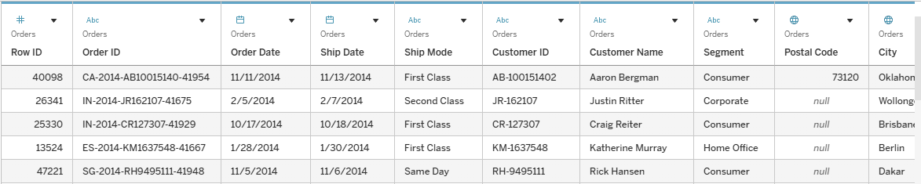

- Chart Name : Dual Axis Chart

Chart Title : Sales vs Quantity by Markets

Steps:

- Steps to Create the Chart (e.g., in Tableau):
- Drag Ship Year to the Columns shelf.
- Drag Sales to the Rows shelf.
- Drag Profit to the Rows shelf (next to Sales) → creates two Y-axes.
- Right-click the second axis (Profit) → select Dual Axis
- Change both mark types to Line or Circle based on preference.
- Format tooltips and legends for clarity.

Chart Description:
This dual-axis chart compares Sales and Profit across different Shipping Years. It helps reveal how revenue and profitability have changed over time, and whether growth in sales also leads to higher profit. Ideal for spotting years with poor profit margins despite strong sales—or years with efficient profit performance.

Chart:

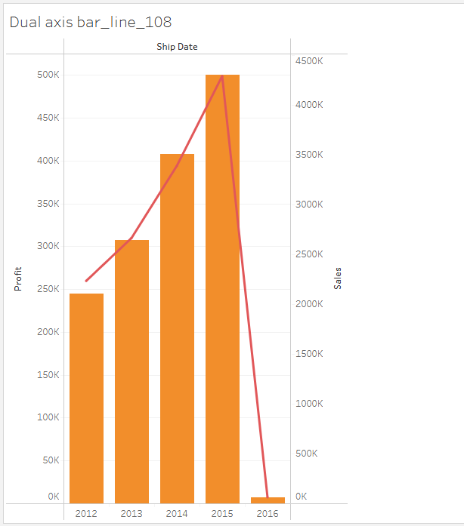

- Chart Name : Dual Axis Chart

Chart:profit,discount vs order date

Drag Order Date to the Columns shelf.

Drag Profit to the Rows shelf.

Drag Discount to the Rows shelf (next to Profit) → two Y-axes will appear.

Right-click the second axis (Discount) → choose Dual Axis.

Change mark types:

Profit: Line (or Circle)

Discount: Bar (or Circle)

Use different colors to visually separate Profit and Discount.

Optionally synchronize axes (Right-click on axis → Synchronize Axis) for aligned scaling.

Add tooltip, legends, and axis titles for better readability.

Chart Description:

This dual-axis chart shows how Profit and Discount change over time based on Order Date. It helps analyze whether high discounts lead to reduced profits or improved sales efficiency. It's useful for identifying time periods with ineffective discount strategies or spotting seasonal trends in profitability and pricing.

Chart:

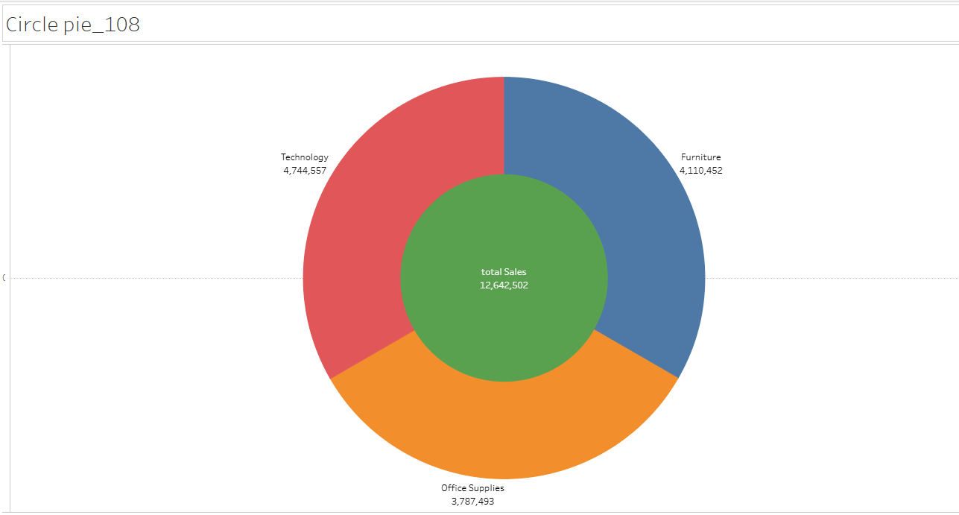

Chart Name : Map Chart.

Chart Title :. Major locations of Tamil Nadu

Steps:
- Load your data (with district names).
- Drag District to the canvas – it creates a map.
- Set Marks type to Circle.
- Drag District to Label to show names.
- Adjust map view to focus on Tamil Nadu.

Chart Description:

This is a district-level map of Tamil Nadu showing major locations marked with dots for easy geographic reference.

Chart:

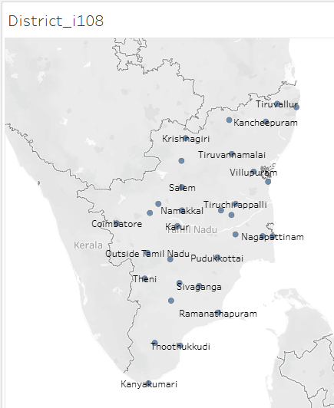

Chart Name : Highlight Table

Chart Title : Highlighted Table by Region and Sub-Category

Steps:

- Load your data (must include Region, Sub-Category, Sales, etc.).
- Drag Region to Rows.
- Drag Sub-Category to Columns.
- Drag Sales to Color, Label, and Size on the Marks card.
- Change Mark type to Square for heatmap style.
- Add Quantity or Discount to Tooltip or Label (optional).
- Adjust color intensity for better visibility.

Chart Description:

This is a heatmap-style table showing sales values across regions and sub-categories, where darker colors represent higher values.

Chart :
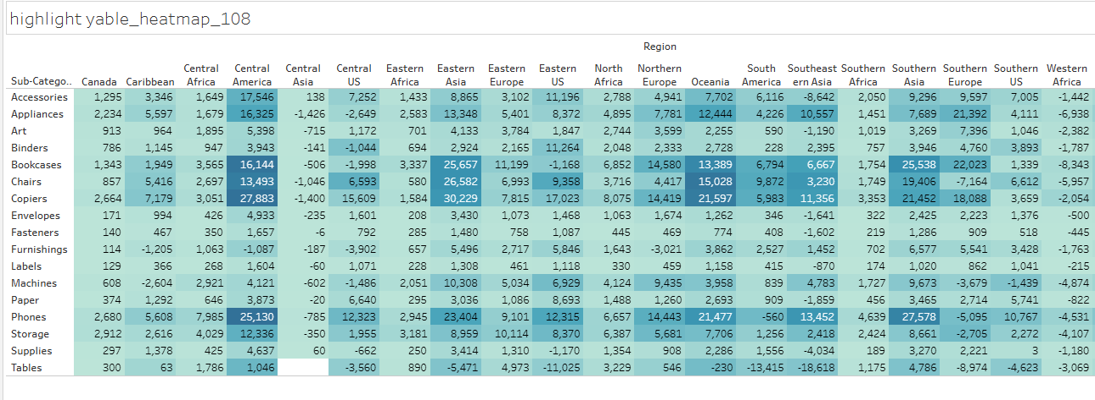
- Chart Name : Word Cloud.

Chart Titles.
Steps:
- Drag Region to Text in the Marks card.
- Drag Sales to Size.
- Drag Sales again to Color (optional for better emphasis).
- From the Marks dropdown → select Text (for word cloud effect).
- Format fonts, colors, and alignment to make it visually appealing.

Chart Description:

This word cloud visually represents sales volume across different regions. The size of each region's name reflects its total sales—larger text means higher sales. This chart is ideal for quickly identifying top-performing regions and visualizing regional sales distribution at a glance.

Chart:
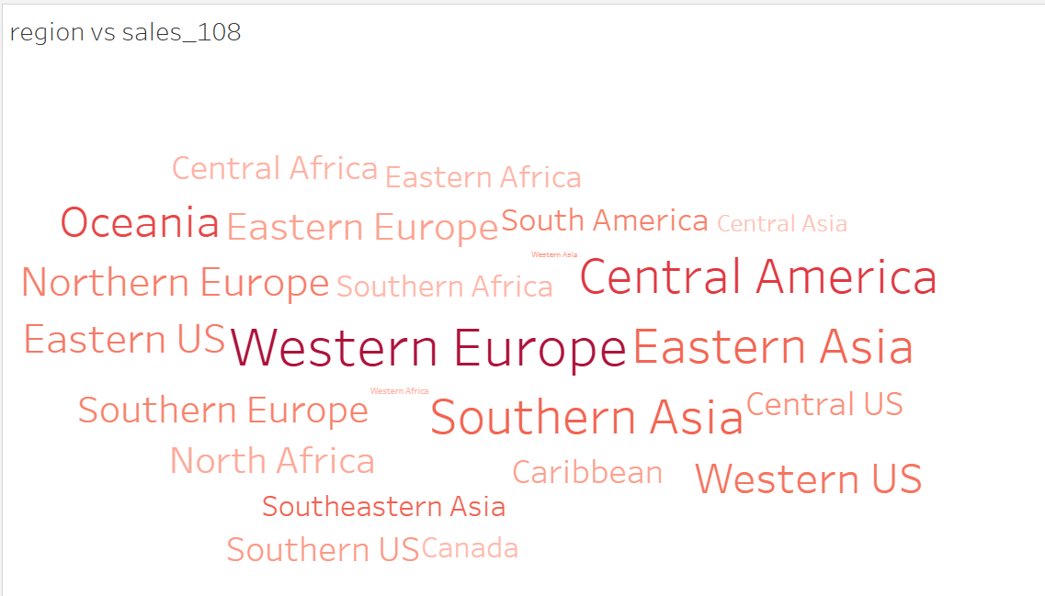

Preparation | 30
Lab performance | 30
Report | 40
Total | 100
Initial of the faculty

RESULT:
Thus the visualizations highlight regional and monthly variations in sales, quantity, and deaths, with clear peaks in certain months and areas.

