EX NO: | PROGRAMS USING CONTROL STRUCTURES AND ARRAYS
DATE : | PROGRAMS USING CONTROL STRUCTURES AND ARRAYS

Aim
To write program for basic operations using control structures and arrays in java

- Question
Write a program that displays a menu with options 1. Add 2. Sub Based on the options chosen, read 2 numbers and perform the relevant operation. After performing the operation, the program should ask the user if he wants to continue. If the user presses y or Y, then the program should continue displaying the menu else the program should terminate. [ Note: Use Scanner class, you can take help from the trainer regarding the same]
Program / Source Code:
package dhanush;
import java.util.Scanner;
public class Calculator {
public static void main(String[] args) {
Scanner scanner = new Scanner(System.in);
char choice;

do {
System.out.println("Menu:");
System.out.println("1. Add");
System.out.println("2. Sub");
System.out.print("Choose an option (1 or 2): ");
int option = scanner.nextInt();
System.out.print("Enter the first number: ");
int num1 = scanner.nextInt();
System.out.print("Enter the second number: ");
int num2 = scanner.nextInt();
switch (option) {
case 1:
System.out.println("Result: " + (num1 + num2));
break;
case 2:
System.out.println("Result: " + (num1 - num2));
break;
default:
System.out.println("Invalid option. Please choose 1 or 2.");
}

System.out.print("Do you want to continue? (y/Y to continue): ");
choice = scanner.next().charAt(0);

} while (choice == 'y' || choice == 'Y');
System.out.println("Program terminated.");
scanner.close();
}
}
Output

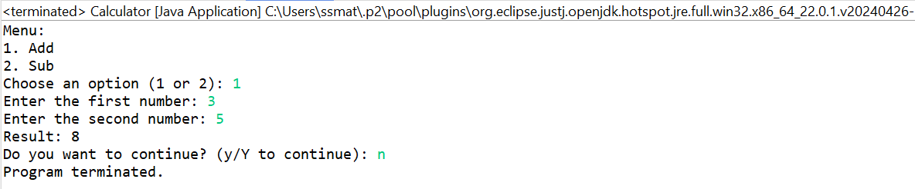

- Question
Write a program to print the sum of the elements of the array with the given below condition. If the array has 6 and 7 in succeeding orders, ignore 6 and 7 and the numbers between them for the calculation of sum. Eg1) Array Elements - 10,3,6,1,2,7,9 O/P: 22 [i.e 10+3+9] Eg2) Array Elements - 7,1,2,3,6 O/P:19 Eg3) Array Elements - 1,6,4,7,9 O/P:10

Program / Source Code:
package dhanush;
import java.util.*;
public class Arraysum {
public static void main (String [] args) {
Scanner sc= new Scanner(System.in);
System.out.println("enter the size:");
int size=sc.nextInt();
int[] arr = new int[size];
for (int i=0; i<size;i++) {
System.out.println("values are");
arr[i]=sc.nextInt();
}
int sum1=0;
for (int i=0; i< arr.length;i++) {
if (arr[i]==6) {
for (int j=i+1;j<arr.length;j++){
if(arr[j]==7) {
i=j+1;
break;
}
}
}
sum1+=arr[i];
}System.out.println("sum "+sum1);
}

}

Output
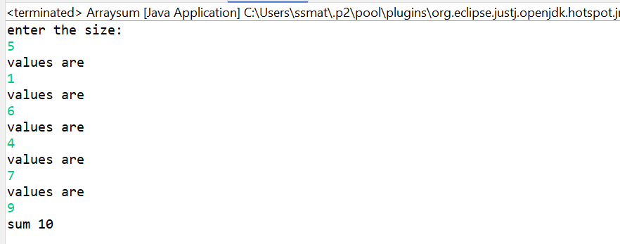
- Question
Create a new class called “Calculator” which contains the following:
• A static method called powerInt(int num1,int num2) that accepts two integers and
• returns num1 to the power of num2 (num1 power num2).
• A static method called powerDouble(double num1,int num2) that accepts one double and one integer and returns num1 to the power of num2 (num1 power num2).
• Call your method from another class without instantiating the class (i.e. call it like Calculator.powerInt(12,10) since your methods are defined to be static) Hint: Use Math.pow(double,double) tocalculate the power.

Program / Source Code:
package dhanush;
class PowerCalculator {
public static int powerInt(int num1, int num2) {
return (int) Math.pow(num1, num2);
}
public static double powerDouble(double num1, int num2) {
return Math.pow(num1, num2);
}
}
public class Main {
public static void main(String[] args) {
int intResult = PowerCalculator.powerInt(2, 3);
double doubleResult = PowerCalculator.powerDouble(2.5, 3);
System.out.println(intResult);
System.out.println(doubleResult);
}
}
Output
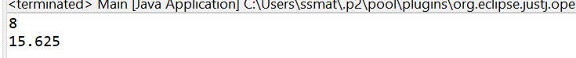

- Question
Consider the following UML class diagram:
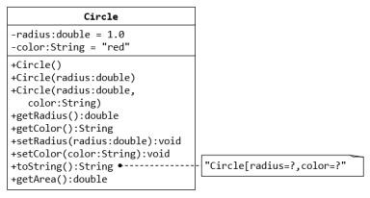

Write a Java class for the Circle class based on the UML class diagram.
• Write a main class TestCircle that creates two objects for the Circle class and invoke all the methods.

Program / Source Code:

public class Circle {
private double radius;
private String color;
public void Circle(){
radius=1.2;
color= "red";
}
public void Circle(double radius,String color){
this.radius=radius;
this.color=color;
}
String getColor(){
return color;
}
double getRadius() { //get method- have to get the value
return radius;
}
double getArea() {
return 3.14*radius*radius;
}
void setColor(String color) { //set method-have to assign the value
this.color=color;
}
void setRadius(double radius) {
this.radius=radius;
}
public String toString() {
return "Circle[radius=" + radius + "," + "color=" + color + "]";
}
}
Public class TestCircle{
public static void main(String[]args) {
Circle c1=new Circle();
Circle c2=new Circle();
c1.setRadius(1.2);
c1.setColor("red");
c1.getRadius();
c1.getColor();
double Area=c1.getArea();
System.out.println("area of c1 = "+ Area +"sq.units");
System.out.println(c1);

c2.setRadius(1.2);
c2.setColor("blue");
c2.getRadius();
c2.getColor();
double area=c2.getArea();
System.out.println("area of c2 = "+ area +"sq.units");
System.out.println(c2);
}
}

Output
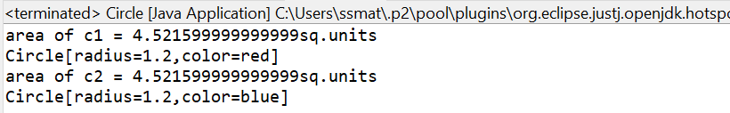
- Question
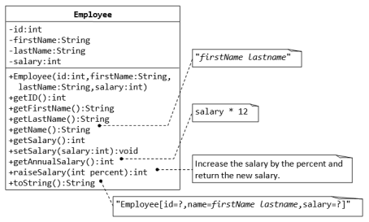
• Write a Java class for the Employee class based on the UML class diagram.
• Write a main class TestEmployee that creates two objects for the Employee class and invoke all the methods.
Program / Source Code:
package dhanush;

public class Employee {
private int id;
private String firstname;
private String lastname;
private int salary;
Employee(int id ,String firstname,String lastname,int salary){
this.id=id;
this.firstname=firstname;
this.lastname=lastname;
this.salary=salary;
}
public int getId() {
return id;
}
public String getFirstName()
{
return firstname;
}
public String getLastName()
{
return lastname;}
public String getName() {
return firstname+" "+lastname;
}
public int getSalary() {
return salary;
}
public void setSalary(int salary) {
this.salary = salary;
}
public int getAnnualSalary() {
return salary * 12;
}
public int raiseSalary() {
return salary * 2/100;
}
public String toString() {
return "Employee[id=" + id + ", name=" + firstname + " " + lastname + ", Salary=" + salary + "]";
}
}

public class TestEmployee {
public static void main(String[] args) {
Employee e1 = new Employee(108,"Dhanush","N",60000);
e1.setSalary(50000);
e1.getAnnualSalary();
e1.raiseSalary();
System.out.println(e1);

e1.setSalary(100000);
System.out.println(e1);
}
}

Output

Result
Thus, the java program was executed successfully and the output was verified.

