Ex no: 4 | Create a Map and assign Geographic locations to the fields for local geographical area
Date:

Aim:

To create a Map and assign Geographic locations to the fields for local geographical area.

Procedure:
- Fetch a dataset and import the data set into the tableau for creating a Geographical map.
- Decide the parameters to create a map.
- Make the visualization to understand the data set through the map.

STEPS:
State Dataset Title: Dote_District codes.
Dataset Description: This datset speaks about the Districts with its DOTE code (shortform).

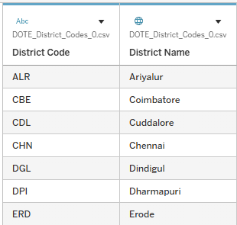

Metro Dataset:

Dataset Description:
This data set speaks about the metro train movements line indicates way to Delhi through the metro path.

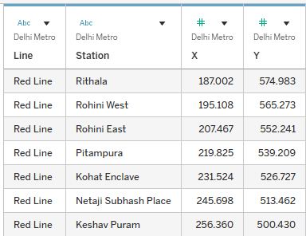

Charts Title :District location map.
Steps:
- Click on the warning icon (⚠️) in the map or sheet to open the Edit Locations window.
- In the Country/Region, select India.
- In the State/Province, select Tamil Nadu (very important!).
- For City, keep your field as District Name.
- Tableau will now recognize most districts.
- For still unrecognized names, fix spelling or match manually using the dropdown.
- Click OK to apply.

Description:
This step helps Tableau recognize Indian district names correctly on the map. By setting the State to Tamil Nadu, Tableau knows where to look. This allows it to map your sales or data accurately by district.

Chart:

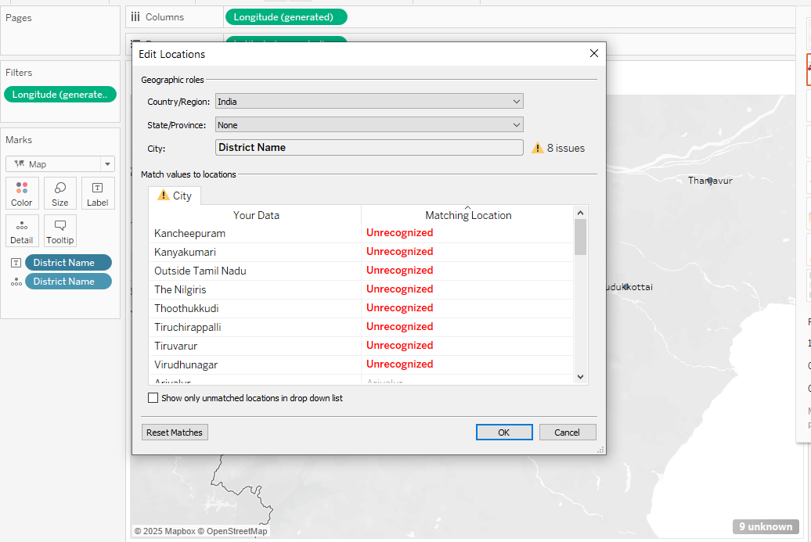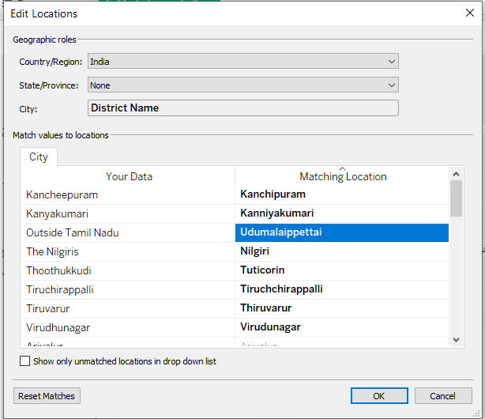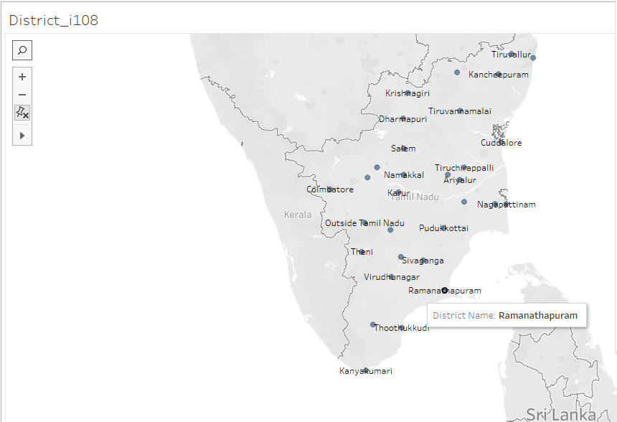

Chart title: Metro railways map

Steps:

Step 1: Add Background Image

Open a new sheet in Tableau.

Go to Map → Background Images → select your data source.

Click Add Image.

Browse and select your Delhi Metro map image (e.g., PNG/JPG).

Set X Range and Y Range based on your data (e.g.:

X Range: from 0 to ~850

Y Range: from 0 to ~600

Adjust according to actual coordinate spread.

Step 2: Plot X and Y

Drag X to Columns.

Drag Y to Rows.

Change mark type to Circle or Shape.

Drag Station to Label (optional).

Drag Line to Color (e.g., Red Line = red, Blue Line = blue, etc.).

Step 3: Adjust Axes and Layout

Fix axes range (right-click on axis → "Edit Axis") to match image dimensions.

Reverse Y-axis if stations look upside-down:

Right-click Y-axis → "Edit Axis" → check Reversed.

Resize circles and adjust transparency if needed.

Description:

You are overlaying metro station data (X/Y coordinates) on a background metro map image. This allows accurate placement of stations (e.g., Rithala, Rohini West) and helps visualize line layouts interactively in Tableau.

Chart:

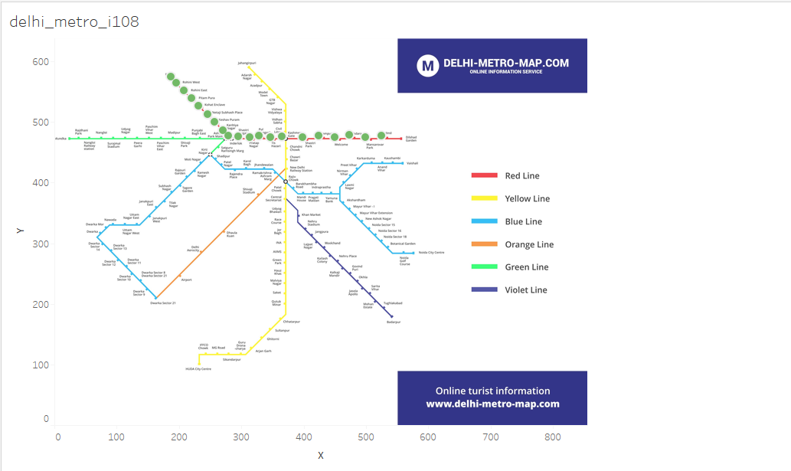

Preparation | 30
Lab performance | 30
Report | 40
Total | 100
Initial of the faculty

RESULT:
A custom Tableau map was created by plotting Delhi Metro Red Line stations using X and Y coordinates. The stations were accurately overlaid on a background image and highlighted with green dots.

