Ex no: 5 | Predicting Visualization for precise future trends for the superstore
Date:

Aim:
To visualization precise future trends for the superstore using tableau.

Procedure:

- Fetch a dataset and import the data set into the tableau for creating a chart
- Decide the parameters with their dimensions
- Creating a forecasting visualization for the superstore data.

Steps:
Data set tittle –Global super store

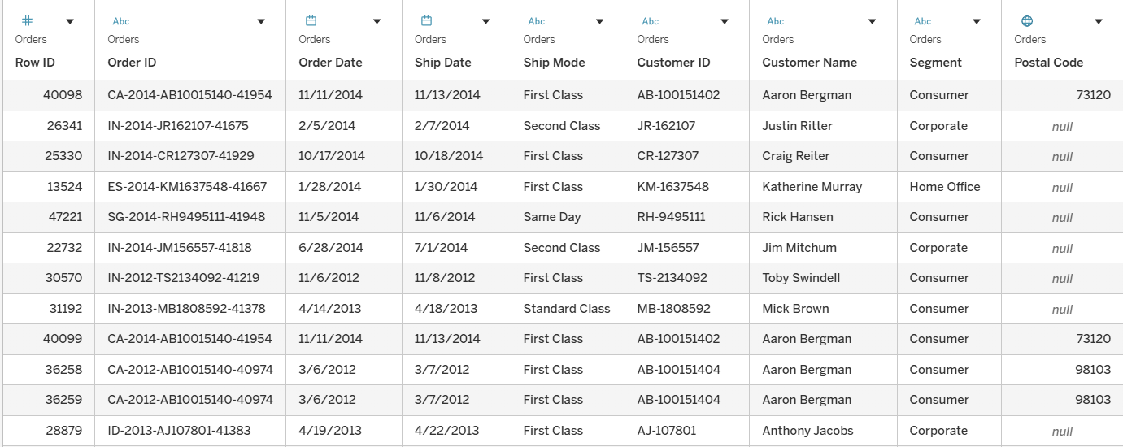

Dataset Description:
A geographic area (e.g. country, region, or global division) where a company sells its products or services. Companies often break their markets into regions .

Charts:

- Chart Name: Filled Map with Custom Rankings
Chart Title: Forecast Sales by Region with Custom Rankings

Steps:

- Drag Country or State (depending on your dataset granularity) to the Detail shelf on the Marks card or Rows/Columns.
- Drag Sales to Color on the Marks card to create a filled map.
- Create a Calculated Field named "Rankings" with the following logic:

IF SUM([Sales]) > 30000 THEN "Premium"
ELSEIF SUM([Sales]) > 20000 THEN "Gold"
ELSEIF SUM([Sales]) > 10000 THEN "Silver"
ELSE "Bronze"
END

- Drag the newly created Rankings field to Color on the Marks card.
- Adjust the Color Legend to clearly differentiate between "Bronze", "Silver", "Gold", and "Premium".
- Drag Sales to Label to show exact sales numbers on each region.
- Format map borders, labels, and tooltips for clarity and visual appeal.

Chart Description:
This filled map visualizes forecasted sales across various regions in India. Each region is color-coded based on a custom "Rankings" logic—categorized into Bronze, Silver, Gold, or Premium tiers according to total sales figures. The map provides a quick and intuitive view of sales performance geographically, helping identify top-performing and underperforming areas at a glance.

Chart:

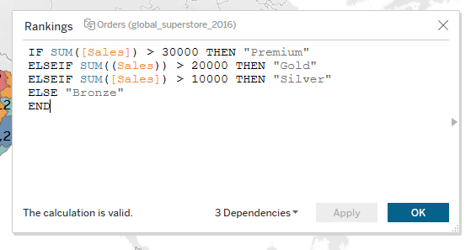
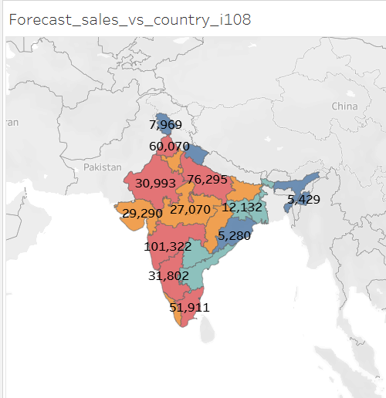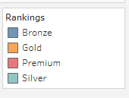

- Chart Name: Forecast Line Chart
Chart Title: Forecasted Profit and Sales Over Time
Steps:
- Drag Order Date to the Columns shelf and change it to Month (Discrete or Continuous as per need).
- Drag Profit to the Rows shelf.
- Drag Sales to the Rows shelf (below Profit) to create two separate line charts (automatic small multiples).
- Click on the Analytics pane, drag Forecast into each of the views (Profit and Sales).
- Tableau will automatically add a forecast line with shaded confidence intervals.
- Adjust the forecast settings:
- Right-click the forecast area → Forecast Options.
- Choose forecast length, model type (Automatic, Linear, etc.), and confidence interval (e.g., 95%).
- Format the line colors (e.g., green for Profit, orange for Sales) for better clarity.
- Add axis labels, title, and tooltips for interactivity.

Chart Description:
This dual-line chart displays historical and forecasted trends for Profit and Sales over time, broken down monthly. The forecast area, shown with shaded confidence bands, provides predictive insights based on past data. The Profit chart highlights seasonal and growth patterns, while the Sales chart indicates a steady upward trend with higher variability. This visualization is useful for identifying performance trends and projecting future business outcomes.
Charts:
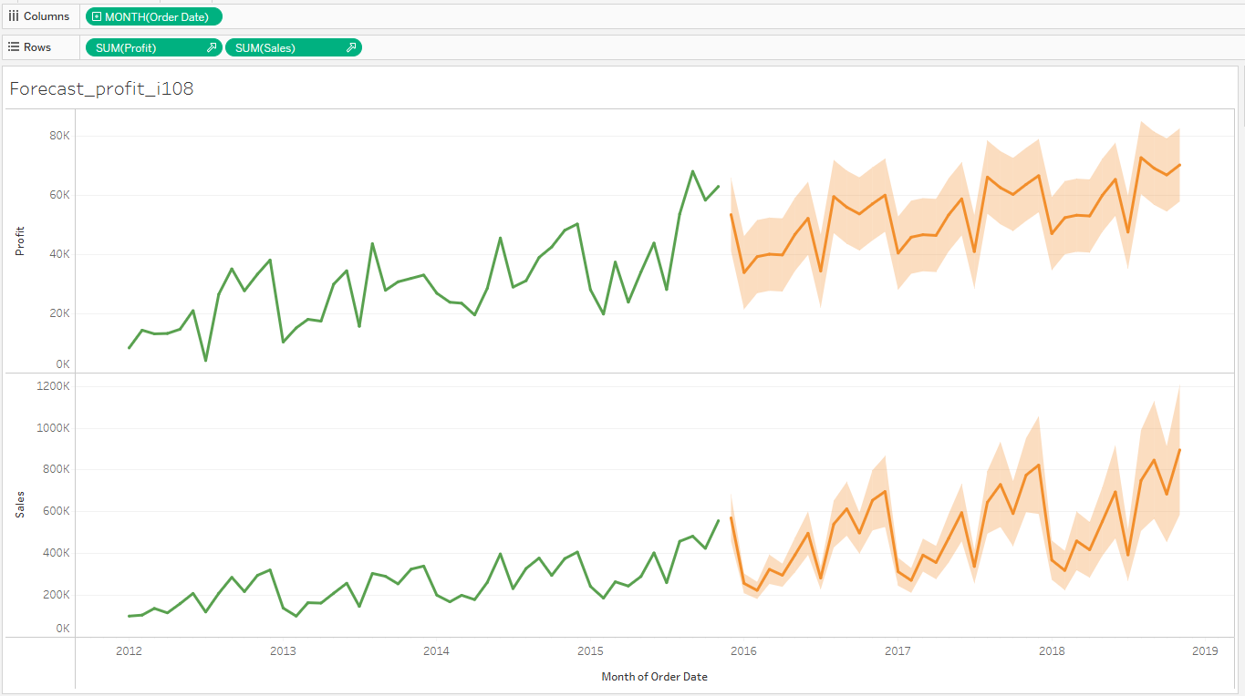
- Chart Name: Bar Chart with Error Bars
Chart Title: Annual Shipping Cost by Year
Steps :
- Drag Ship Date to the Columns shelf → change to Year.
- Drag Shipping Cost to the Rows shelf → use SUM(Shipping Cost).
- Tableau creates a vertical bar chart by default.
- To add error bars:
- Go to the Analytics pane.
- Drag Confidence Interval or Error Bars onto the view.
- Choose SUM(Shipping Cost) when prompted.
- Drag Shipping Cost to Label on the Marks card to show the actual cost values on each bar.
- Adjust color gradient for bars to show progression (optional).
- Format the axis, title, and tooltips for clarity and professionalism.
Chart Description:
This bar chart illustrates the total annual shipping cost from 2012 to 2018, with each bar representing the aggregated shipping cost for a given year. Error bars are included to show the variability or uncertainty in the data, helping identify potential fluctuations. The chart indicates a clear upward trend in shipping costs year over year, suggesting increased shipping volume, rising rates, or expanded operations. The color gradient enhances the visual interpretation of growth.
Chart:
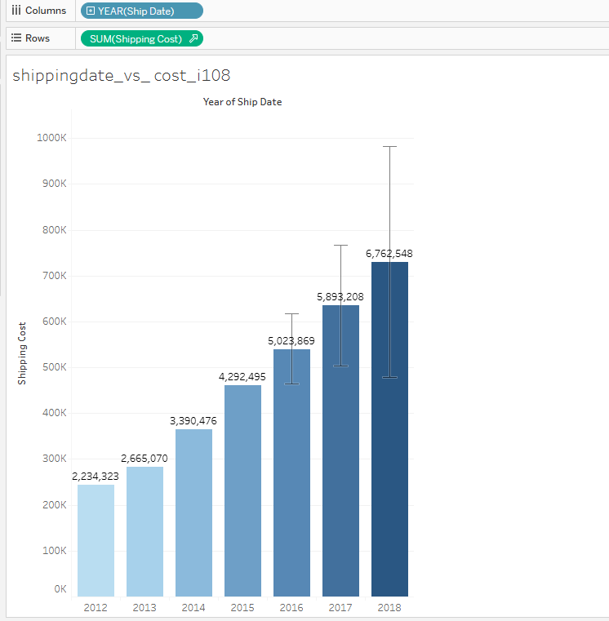

- Chart Name: Grouped Bar Chart by Category and Sub-Category
Chart Title: Top 5 Sales by Category and Sub-Category
Steps :
- Drag Category and Sub-Category to the Columns shelf (Sub-Category should follow Category).
- Drag Sales to the Rows shelf → Tableau generates a bar chart.
- To show top 5 sub-categories by Sales:
- Create a Set or Filter on Sub-Category:
- Right-click Sub-Category → Create → Set.
- In the set dialog, choose Top tab → By field: Top 5 by SUM(Sales).
- Drag this set to the Filter shelf (optional, if chart needs to focus on top performers only).
- Customize the Colors to differentiate performance intensity.
- Add Labels (drag Sales to Label on the Marks card) for clearer insight.
- Adjust axis labels, font size, and category formatting for clarity.
Chart Description:
This grouped bar chart breaks down sales performance by Category and Sub-Category, visually representing which areas contribute the most to overall sales. Within each main category—Furniture, Office Supplies, and Technology—the sub-categories are displayed with corresponding sales values.
Chart:
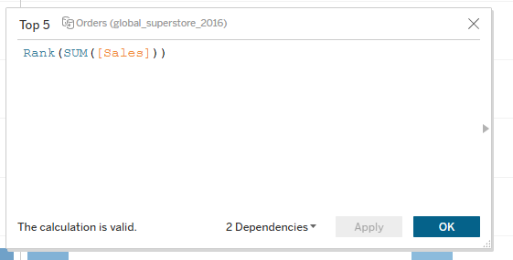
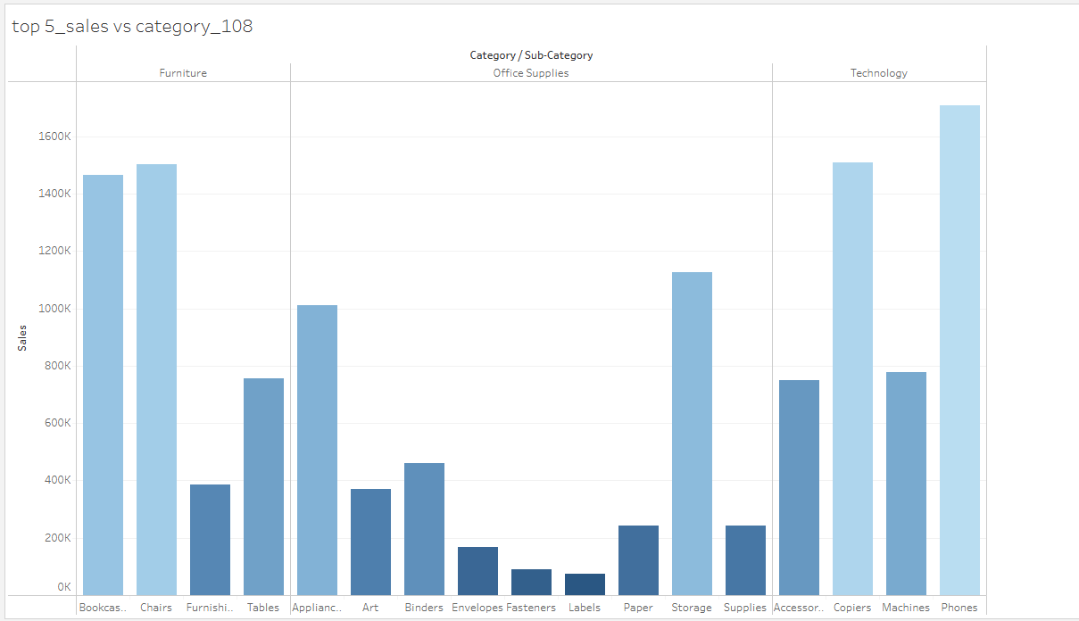
DashBoard: Forecast on Sales and Order Date
- Create each chart separately:
Chart 1: Top 5 Sales by Category/Sub-Category
Chart 2: Shipping Cost by Year
Chart 3: Forecasted Profit and Sales Over Time
Chart 4: Sales by Region with Rankings
- Go to the Dashboard tab:
- Click Dashboard > New Dashboard.
- Drag charts onto the dashboard canvas:
- From the Sheets list on the left, drag each chart into the dashboard area.
- Arrange them side by side or in a grid layout.
- Add Titles and Legends:
- Double-click the titles to rename (e.g., "Top 5 Sales", "Shipping Cost Trends").
- Drag legends (color, size) to where you want them.
- Adjust the size of charts.
- Use consistent fonts and colors.
- Add filters or highlights so selecting data in one chart affects others.
- Save and publish:
- Save your workbook.
- Click File > Export if you need a PDF or image.

Dashboard Description:
This dashboard provides a comprehensive overview of sales performance, cost analysis, and forecast trends across product categories, regions, and time. It brings together critical KPIs—such as top-performing products, shipping cost trends, and future sales forecasts—into one visual interface.
The top sub-category chart helps product managers focus on high-revenue items, while the shipping cost chart assists logistics teams in budgeting and cost control. The forecast line chart supports planning and forecasting, and the sales map helps sales teams target high- and low-performing regions.

Dashboard:
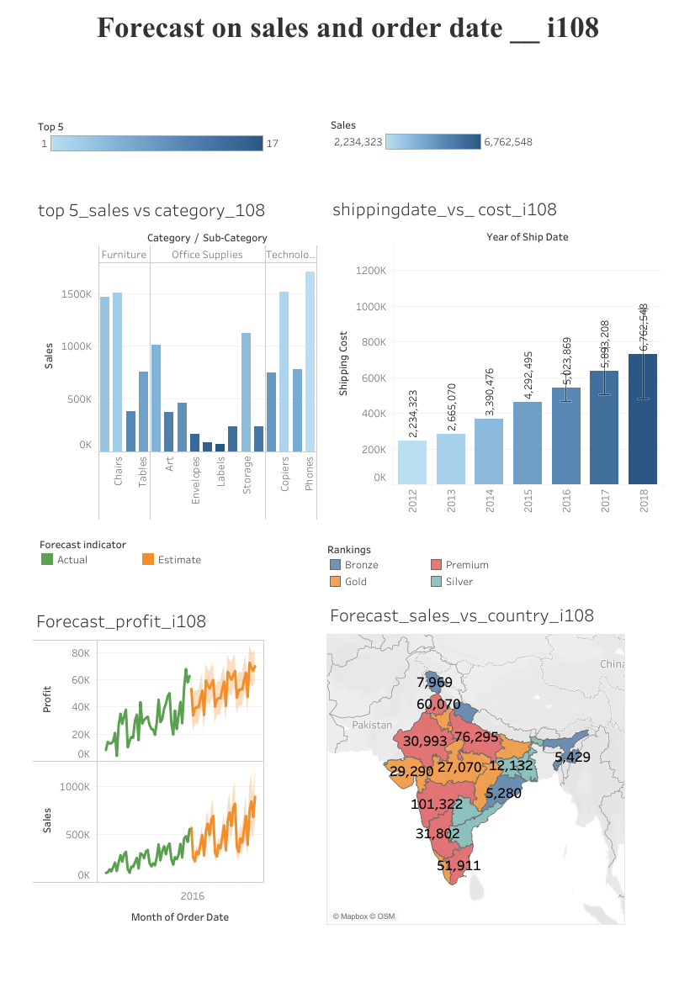

Preparation | 30
Lab performance | 30
Report | 40
Total | 100
Initial of the faculty

RESULT:
Thus the visualization of future trends in the superstore is done successfullyand exported .

