Ex no: 3 | Develop programs incorporating packages, abstract classes, and interfaces to structure code modularly and enforce abstraction.
Date:

Aim:
To implement the following relationship and create a main class to invoke all the methods.

- Write a Java program to implement the following relationship and create a Main class to invoke all the methods.
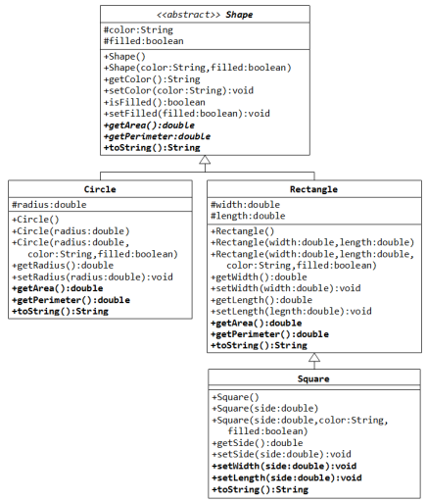

CODE:
public abstract class Shape {
protected String color;
protected boolean filled;
public Shape() {}
public Shape(String color,boolean filled) {
this.color=color;
this.filled=filled;}
public String getColor(){
return color;}
public void setColor(String color) {
this.color=color;}
public boolean isFilled() {
return filled;}
public void setFilled(boolean filled) {
this.filled=filled;}
public abstract double getArea();
public abstract double getPerimeter();
public abstract String toString();}
public class Circle extends Shape{
private double radius;
public Circle(double radius, String color,boolean filled) {
this.radius = radius;
this.color = color;
this.filled=filled; }
public void Circle(double radius) {
this.radius = radius; }
public double getRadius() {
return radius;}
public double getArea() {
return Math.PI * radius * radius;}
public double getPerimeter() {
return (Math.PI * radius * radius);}
public String toString() {
return "Circle[radius=" + radius + ", color=" + color + " ,Perimeter:" + getPerimeter() + " ,Area:" + getArea() + "]"; }
}
//Rectangle Class
public class Rectangle extends Shape{
protected double width;
protected double length;
public Rectangle() {}

public Rectangle(double width,double length){
this.width=width;
this.length=length;}
public double getWidth(){
return width;}
public void setWidth(double width) {
this.width=width;}
public double getLength() {
return length;}
public void setLength(double length) {
this.length=length;}
public double getArea() {
return width*length;}
public double getPerimeter() {
return 2*(length+width);}
public String toString(){
return "Rectangle[Area"+getArea()+",Perimeter"+getPerimeter()+"]" ;}
}
public class Square extends Rectangle{
protected double side;
public Square() {}
public Square(double side) {
this.side=side;}
public Square(double side,String color,boolean filled) {
this.side=side;
this.color=color;
this.filled=filled;}
public double getSide() {
return side;}
public void setSide(double side){
this.side=side;}
public void setWidth(double width) {
this.width=width;}
public void setLength(double length) {
this.length=length;}
public String toString() {
return "Square[Side:"+side*side+"]";}
}

package dhanush;
public class Main {
public static void main(String[] args) {
Shape circle = new Circle(5.5, "red", false);
Shape rectangle = new Rectangle();
Shape square = new Square(3.0, "green", true);
System.out.println(circle);
System.out.println(rectangle);
System.out.println(square);
Circle c = new Circle(0, "green", false);
c.setRadius(2.5);
c.setColor("yellow");
c.setFilled(false);
System.out.println(c);
Rectangle r = new Rectangle();
r.setWidth(2.0);
r.setLength(3.0);
r.setColor("orange");
r.setFilled(true);
Square s = new Square();
s.setSide(4.0);
s.setColor("purple");
s.setFilled(true);
System.out.println(s);
}}
OUTPUT::
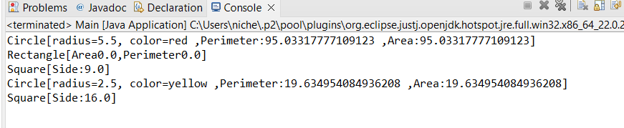
- Identify the relationship between the classes and write a Java program to implement the relationship. Create a test class to calculate the Total Rent,
Total Rent= ((days*rentalrate)/7)+charge.

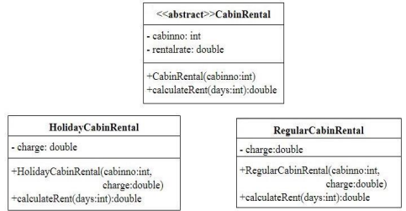
Hint:
1) Rental rate should be assigned based on cabin number. If the cabin number is 1or 2 or 3 then the rental rate is Rs.950 per week. Otherwise Rs.1100 per week.
2) Set HolidayCabinRental Charge as Rs.150 and RegularCabinRental as Rs.100. use getter and setter method wherever necessary.

CODE:
Public abstract class CabinRental {
protected int cabinNo;
protected double rentalRate;
public CabinRental(int cabinNo) {
this.cabinNo = cabinNo;
if (cabinNo == 1 || cabinNo == 2 || cabinNo == 3) {
this.rentalRate = 950;
} else {
this.rentalRate = 1100;}
} public abstract double calculateRent(int days);
}
class HolidayCabinRental extends CabinRental {
private double charge;
public HolidayCabinRental(int cabinNo) {
super(cabinNo);
this.charge = 150; // Holiday cabin charge}
public double calculateRent(int days) {
return ((days * rentalRate) / 7) + charge;}
}
class RegularCabinRental extends CabinRental {
private double charge;
public RegularCabinRental(int cabinNo) {
super(cabinNo);
this.charge = 100; // Regular cabin charge; }
public double calculateRent(int days) {
return ((days * rentalRate) / 7) + charge;}
}
public class CabinRentalTest {
public static void main(String[] args) {
CabinRental holidayCabin = new HolidayCabinRental(10);
System.out.println("Holiday Cabin Total Rent for 10 days: Rs. " + holidayCabin.calculateRent(10));
CabinRental regularCabin = new RegularCabinRental(5);
System.out.println("Regular Cabin Total Rent for 5 days: Rs. " + regularCabin.calculateRent(5));
}}
OUTPUT::
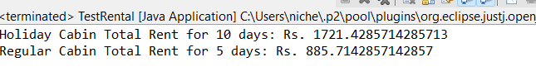

- Write a Java program to implement the following relationship and create a Main class to invoke all the methods.
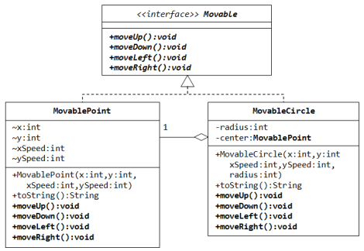
CODE:
Public interface Movable {
void moveUp();
void moveDown();
void moveLeft();
void moveRight();}
class MovablePoint implements Movable {
int x, y;
int xSpeed, ySpeed;
public MovablePoint(int x, int y, int xSpeed, int ySpeed) {
this.x = x;
this.y = y;
this.xSpeed = xSpeed;
this.ySpeed = ySpeed;}
public void moveUp() {
y += ySpeed;}
public void moveDown() {
y -= ySpeed;}
public void moveLeft() {
x -= xSpeed;}
public void moveRight() {
x += xSpeed;}
public String toString() {
return "MovablePoint at (" + x + ", " + y + ") with speed (" + xSpeed + ", " + ySpeed + ")"; }
}
class MovableCircle implements Movable {
private int radius;
private MovablePoint center;
public MovableCircle(int x, int y, int xSpeed, int ySpeed, int radius) {
this.center = new MovablePoint(x, y, xSpeed, ySpeed);
this.radius = radius;}
public void moveUp() {
center.moveUp();}
public void moveDown() {
center.moveDown();}
public void moveLeft() {
center.moveLeft();}
public void moveRight() {
center.moveRight();}
public String toString() {
return "MovableCircle [ radius " + radius + " and center at " + center.toString()+”]”;
}}
public class Main {
public static void main(String[] args) {
MovablePoint point = new MovablePoint(0, 0, 5, 5);
System.out.println(point);
point.moveUp();
point.moveRight();
System.out.println("After moving up and right: " + point);
MovableCircle circle = new MovableCircle(0, 0, 10, 10, 20);
System.out.println(circle);
circle.moveUp();
circle.moveLeft();
System.out.println("After moving up and left: " + circle);}}
OUTPUT::
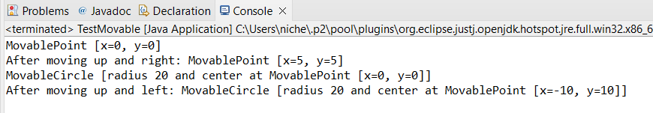

RESULT
Thus, the java program was executed successfully and the output was verified.

