ESC (Electronic Speed Controller) from Scratch - A Documentation
________________
2. Basic working of ESC
This is a document of whatever I have learned and what is required in building and ESC
I won’t be describing everything in detail, everything in here is according to my knowledge and to the point.
- Working of BLDC
A BLDC has a rotor and a stator, like every other motor, the rotor has magnets embedded on it in specific orientation so that the simultaneous poles are not the same
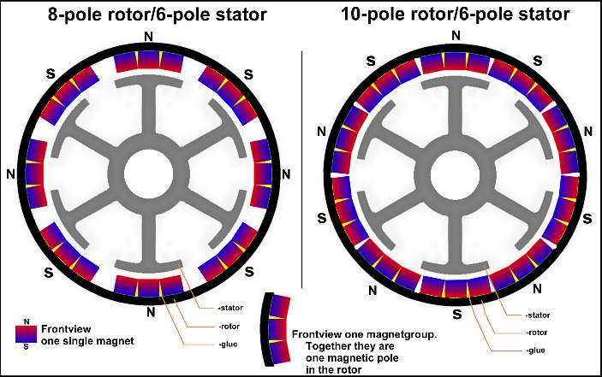
The stator of a BLDC has 12 coils, 4 of those coils are connected to each other in series, the coils which are on opposite ends of the stator have the windings reversed so the pole generated on them are opposite. So to spin the rotor of this motor we have to generate poles on the stator coils by sending signals in a specific pattern i.e Trapezoidal wave or AC waveform. So the sequential generation of poles generates a rotating magnetic field and so it gradually deflects and rotates the rotor to achieve its continuous rotation. the Stator coils are usually in STAR / Delta configuration
IMP – when the 1st and 2nd coil are in energized state i.e the rotor is in between them, the 3rd coil is considered floating
ESC (Electronic Speed Controller) they are basic electronics devices which are used to operate a BLDC motor, The task of an ESC is to generate the signal which needs to be sent to the 3 wires of the BLDC motor, so that the stator generates the rotating magnetic field, the signal generated by the ESC is a Trapezoidal signal which is made to resemble an 3 Phase AC waveform
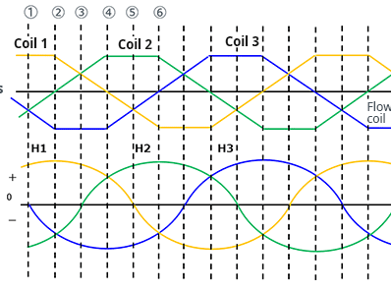
To do this task , ESC contains components like microcontroller (to handle the overall logic and operation) , 3 – phase inverter, gate drivers , BEC (battery elimination circuit), Comparators( to sample the back emf and trigger interrupts)
IMP

The microcontroller is the main brain of the ESC , it handles the sequential triggering of gates i.e MOSFETS, and it also handles the interrupts triggered by the comparator sampling the back emf of the floating coil,
microcontroller has to handle the complex timing of triggering specific MOSFETS to generate the desired signal
3. Work of 3-phase inverter in an ESC
3. Work of microcontroller in an ESC

