Yuting Guo

Assignment #1

CMSC 636

9/23/2019

Matplotlib is very powerful to create 3D plotting, not limited to 2d scatter, line graphs, bar charts. Matplotlib is a Python package, it needs to install on the Python environment. It is available for Python scripts, Python and IPython shells, Jupyter notebooks, Web application servers and four graphical user interface kits With Matplotlib, developers can generate graphs, histograms, power spectra, bar charts, error charts, scatter plots, etc. with just a few lines of code.

Tableau is intelligence software that provides browser-based analysis that anyone can learn and use which makes sharing the latest interactive data visualization content, dashboards, reports and workbooks in the fast and easy way. It helps to vividly analyze any structured data that actually exists to produce charts, coordinate charts, dashboards, and reports in a matter of minutes. With Tableau's easy drag-and-drop interface, we can customize views, layouts, shapes, colors, and so on to help you present your data perspective. Creating a query is as simple as selecting data points from the left-hand menu and Tableau start drawing images using the default view that is most appropriate for those data points. From here, changing the view by dragging and dropping data into the workspace and changing colors, icon types, and even various internal details of the ICONS. The overall view gives a familiar look to the Microsoft interface and Excel style, which should make learning easier for some, but the visualization is more gorgeous than Excel visualization.

After import matplotlib, import the Axes3D when we draw 3D graphics later, the corresponding functions are located on this. fig.gca is the current polar axis in the figure. The resulting ax object is a subclass of Axes3D and will be the entry point for drawing 3D graphics. I adopt Titanic dataset to set x axis as age, y axis as Ticket class and z axis as number of siblings / spouses aboard the Titanic. Three dimensions add one more variable than two dimensions and compare them on one axis at the same time, which can figure out their relationship between three variables. Each red dot represents a life that survived.

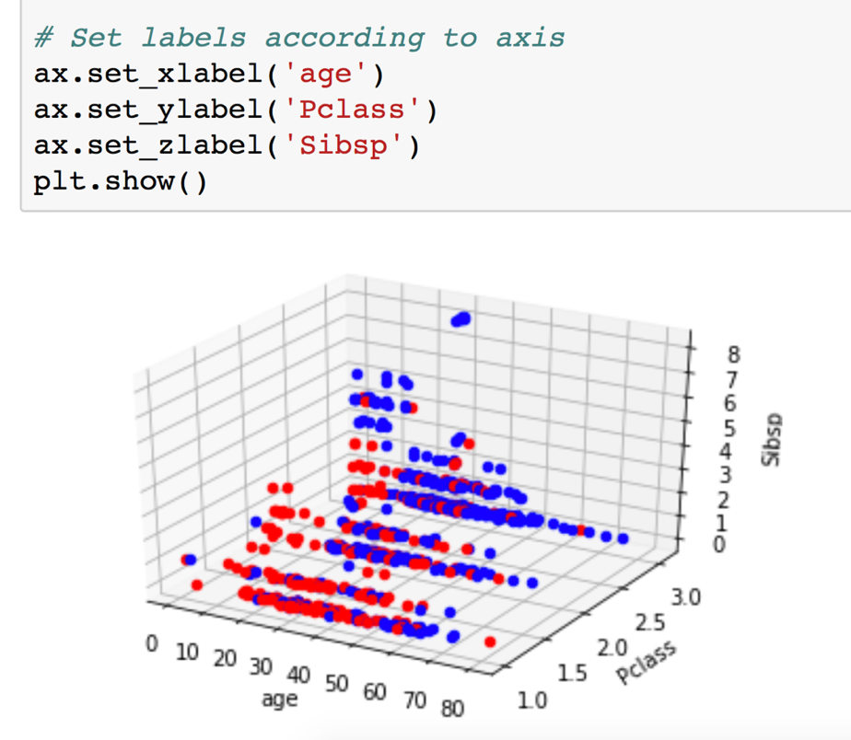

Unlike Tableau public, I try to create a circle marks plot with age dates in Y axis that combines Ticket class and number of siblings / spouses aboard dimensions depicted in the same Y axis. It can see it visually that Tableau’s performance is not satisfactory than matplotlib can express overlapping dataset accurately. Tableau parameter is static, and it always selects a single value as the parameter. These parameters must be updated manually each time the data changes. The x axis in left graph is number of siblings / spouses aboard the Titanic, while right graph is Ticket class in x axis.

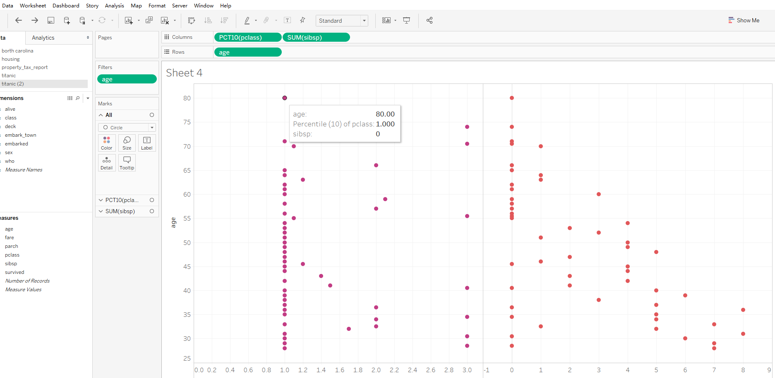

The second dataset I use is a geographic data. I find a data of tornado activity from 1950 to 2015 by different state. Basemap toolkit is one of several Matplotlib toolkits that I will use in this example. I extract latitude and longitude values to put the number of tornados in different year. Adding the three-dimension bar into flat map, you can still easily find the higher number tornadoes as 2-dimension bar which is in Taxes. 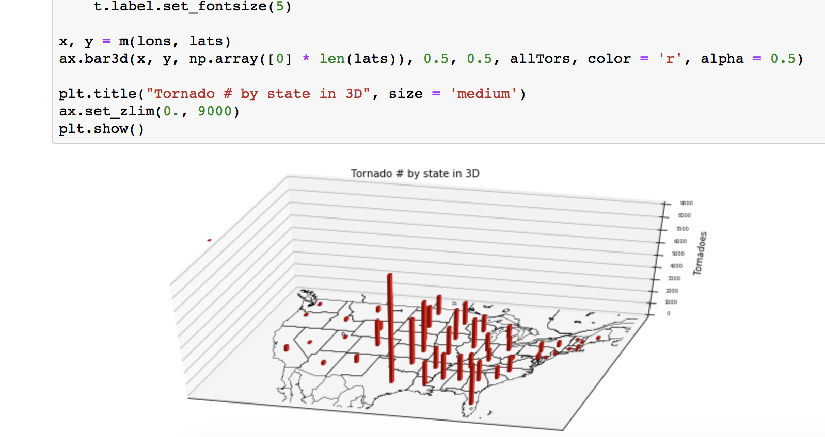

Compare to Tableau public, this map still can visually show the difference, but we can see that the number of tornados concentrate in the central and eastern regions. Tableau is more suit for manual to point out each label price list on map, which pay attention to the user's actual operation experience.

