**National Institute of Technology, Raipur**

s

A Term project report on

Computer programming

Topic:

Bus Reservation System

Btech- 2nd Semester

(2021)

Submitted to: Submitted by:

Dr. Shyam Sundar Tejaswi Ku. Tripathi

Assistant Professor Btech – 2nd Sem.

NIT Raipur. Roll No: 20118107

**ACKNOWLEDGEMENT**

I would like to express my thanks of gratitude to my teacher Dr. Shyam Sundar Sir for his proficient supervision of the term paper on ‘Bus Reservation System’.

I am very grateful to you Sir, for all your guidance and support.

Tejaswi Kumar Tripathi

Roll No.: 20118107

B. Tech

Information Technology

2nd Semester

National Institute of Technology, Raipur

**ABSTRACT**

In this term paper, I have made a basic program which represents a simple Bus Reservation System. This system has been made using C++ programming language. The objective of this system is to enable a user to maintain a database of the available buses, and the reservation and seat availability in the buses.

The user shall be able to enter records for the buses, and then make passenger reservations, and maintain the reservation and vacant seat records efficiently. The system also informs if the user enters an invalid bus number or seat number for reservation. It also tells if a seat is reserved or vacant, and provides information of the buses available, along with their timings.

The program has no errors or warning content, and is very simple to use.

**INTRODUCTION**

The project Bus Reservation System is a simple program made to enable the user to enter the records for buses, make seat reservations, and display bus details and reservation status. The program has been made using the concept of classes and functions. The program provides following options to the user:

1. To enter the records for buses
2. To make seat reservations
3. To display reservation status and bus details
4. To display buses available

The program uses the principles of C++ programming, and concept of classes and functions.

The technical details of the code are as follows:

**Class:** reserve

**Data Members of the class:**

char num[5] – to store bus number

char driver[20] – to store driver’s name

char arrival[5] – to store arrival time of the bus

char departure[5] – to store departure time of the bus

char from[20] – to store boarding city

char to[20] – to store destination city

char seat[8][4][10] – to store and process seat details

**Member functions of the class:**

void getdetails() – to enter details for a new bus

void reservation() – to make passenger reservations

void empty() – to display which seats are empty

void vacancy() – to show reserved and vacant seats in a bus

void display() – to display the details of available buses

void seatstatus(int i) – to see whether a seat is vacant or occupied in a bus

**WORKING**

The code execution begins with the main() function. In main() function a variable **choice** of type **int** has been declared. It is to take entry from the user regarding what task the user wants to perform.

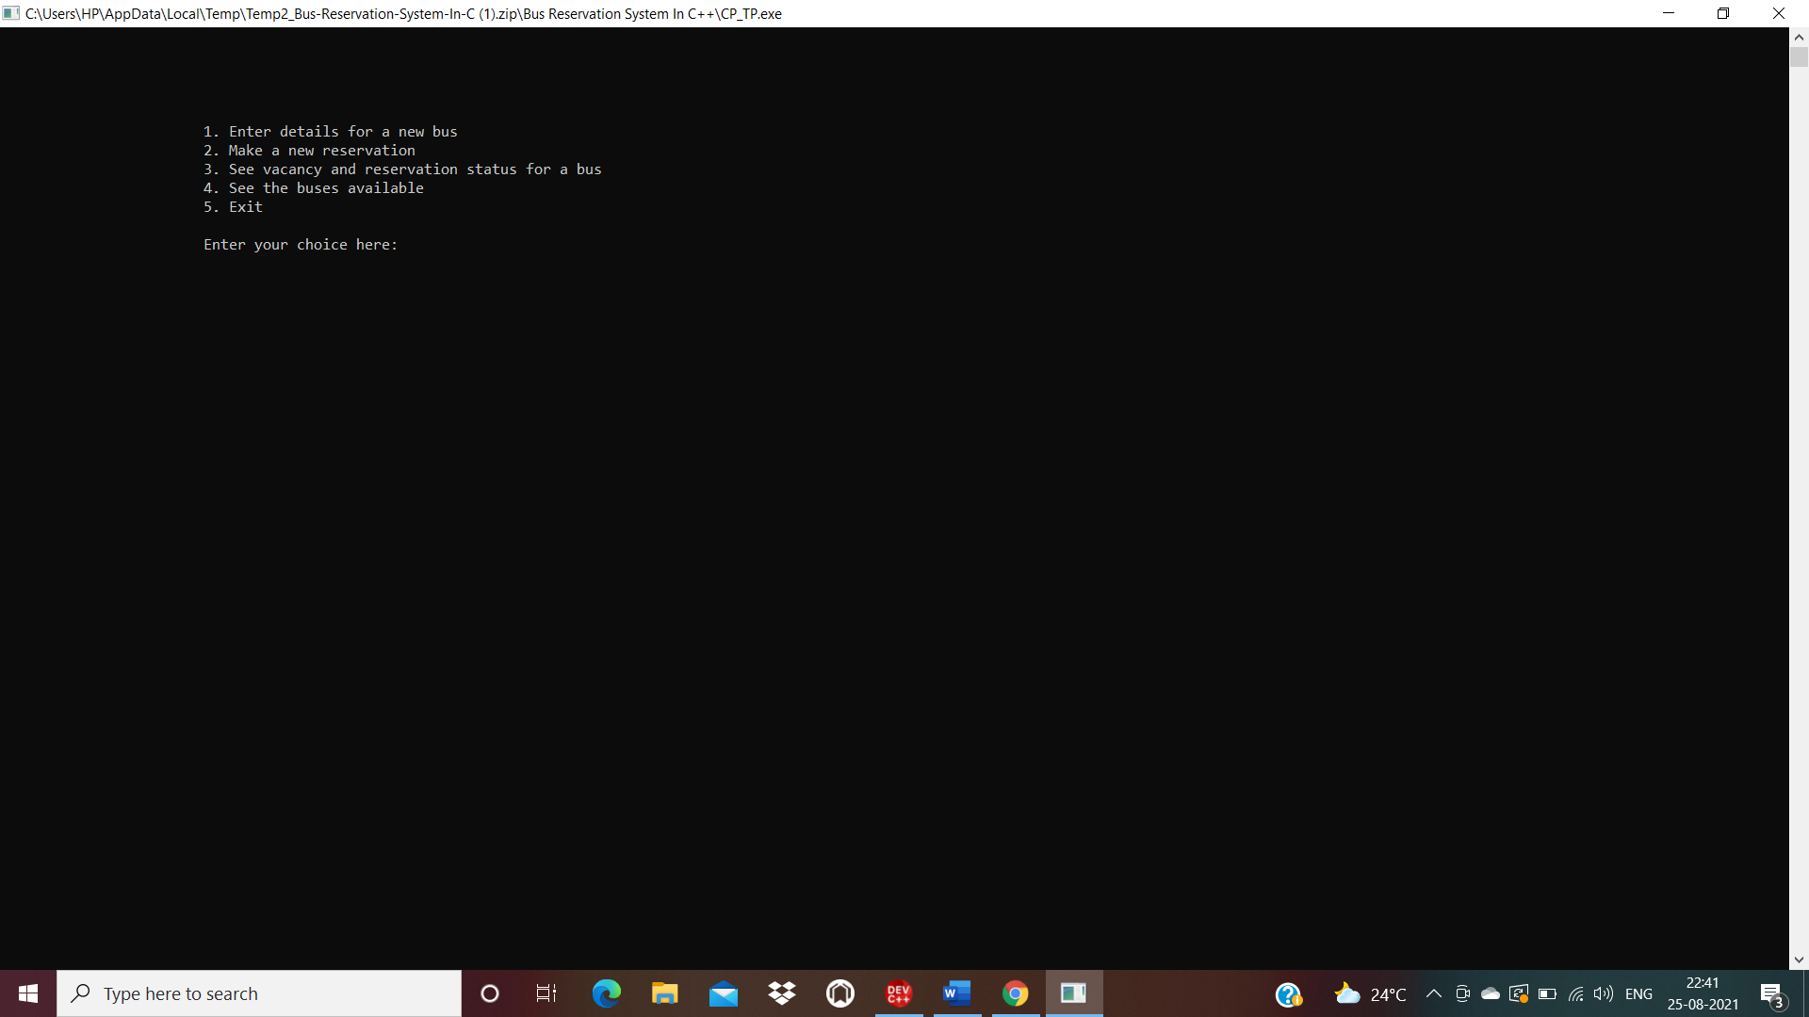

Then using switch statement, the relevant functions of the class reserve, made to perform these tasks are called.

* If the user enters 1, the compiler goes to the getdetails() function which is made to take details for a new bus. It first asks the user to make the required entries and then saves the details.

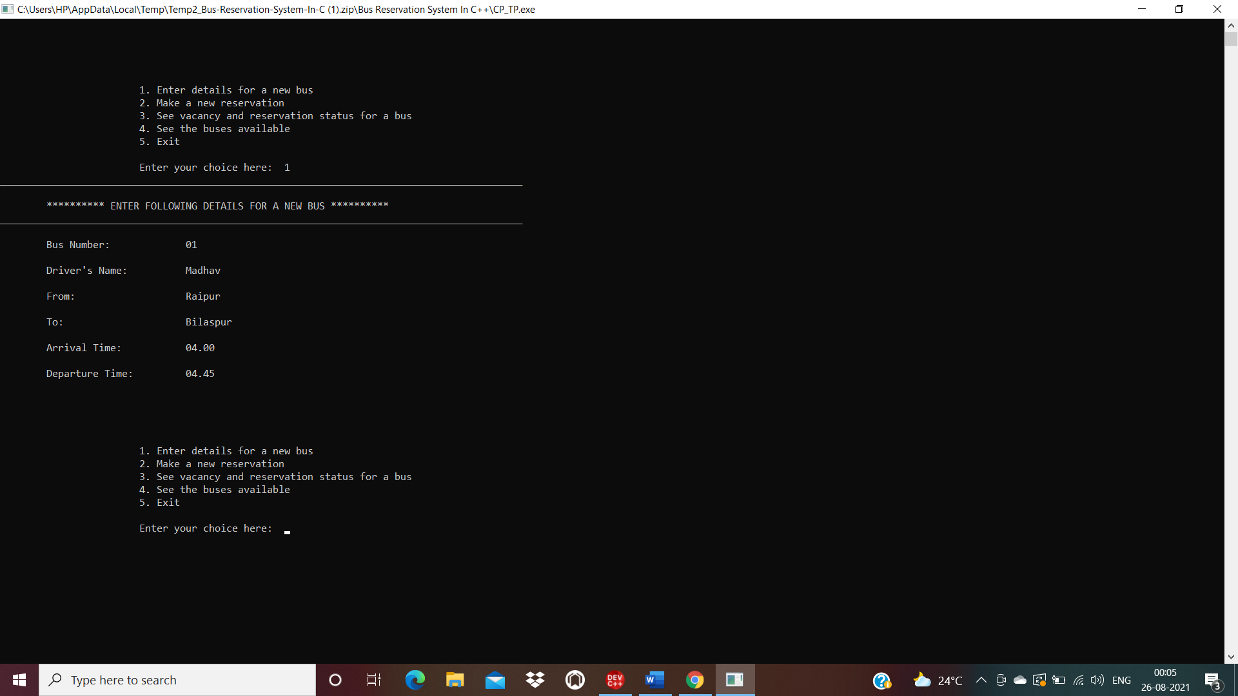

* If the user enters 2, the compiler goes to the function made to make a new seat reservation, i.e., reservation() function. The program then asks the user to enter details such as the bus number, passenger details, and seat choice. After the user makes the required entries, the seat is reserved and the reservation record is updated.

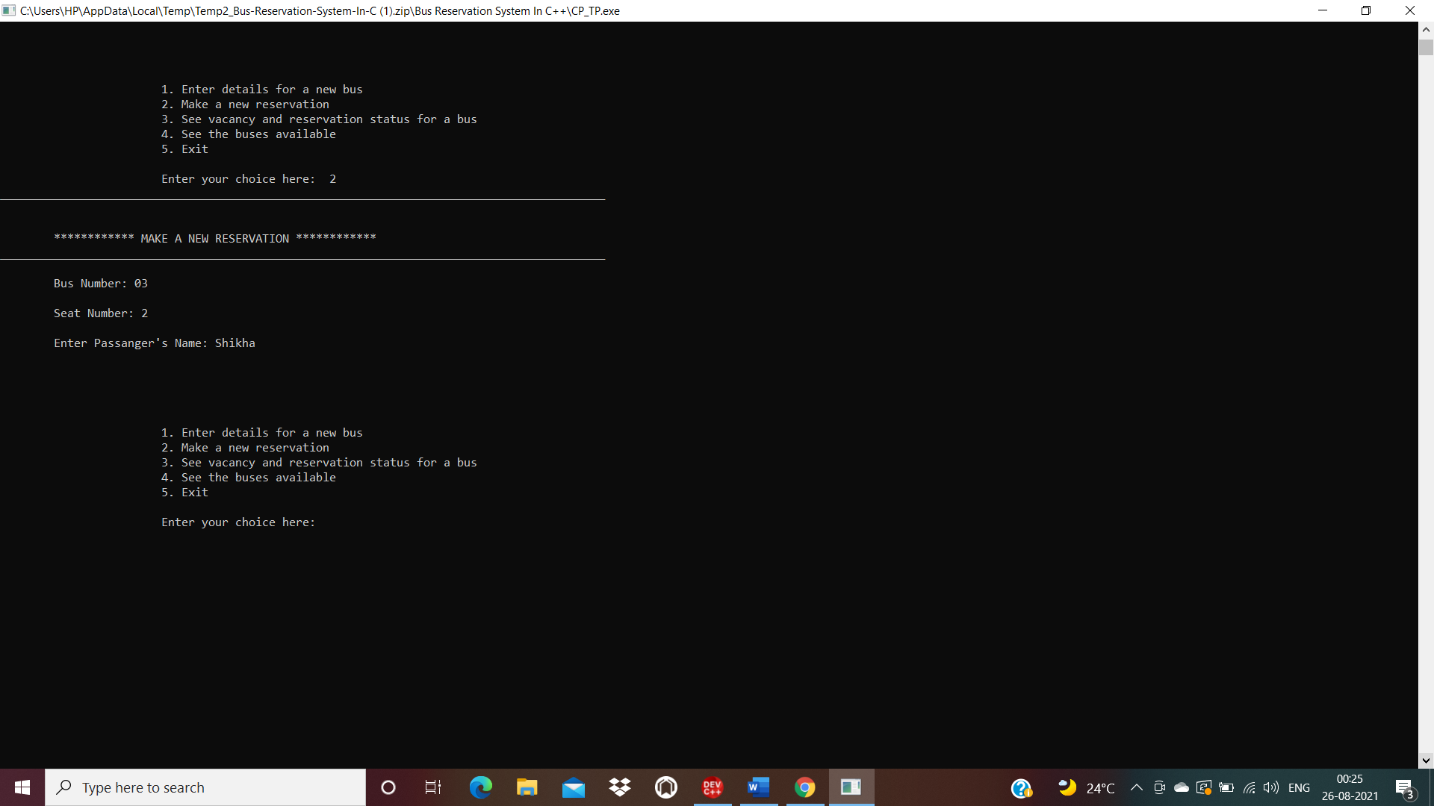

If in the above case, a user chooses a seat number which someone else has reserved already, then the program gives an error message as shown-

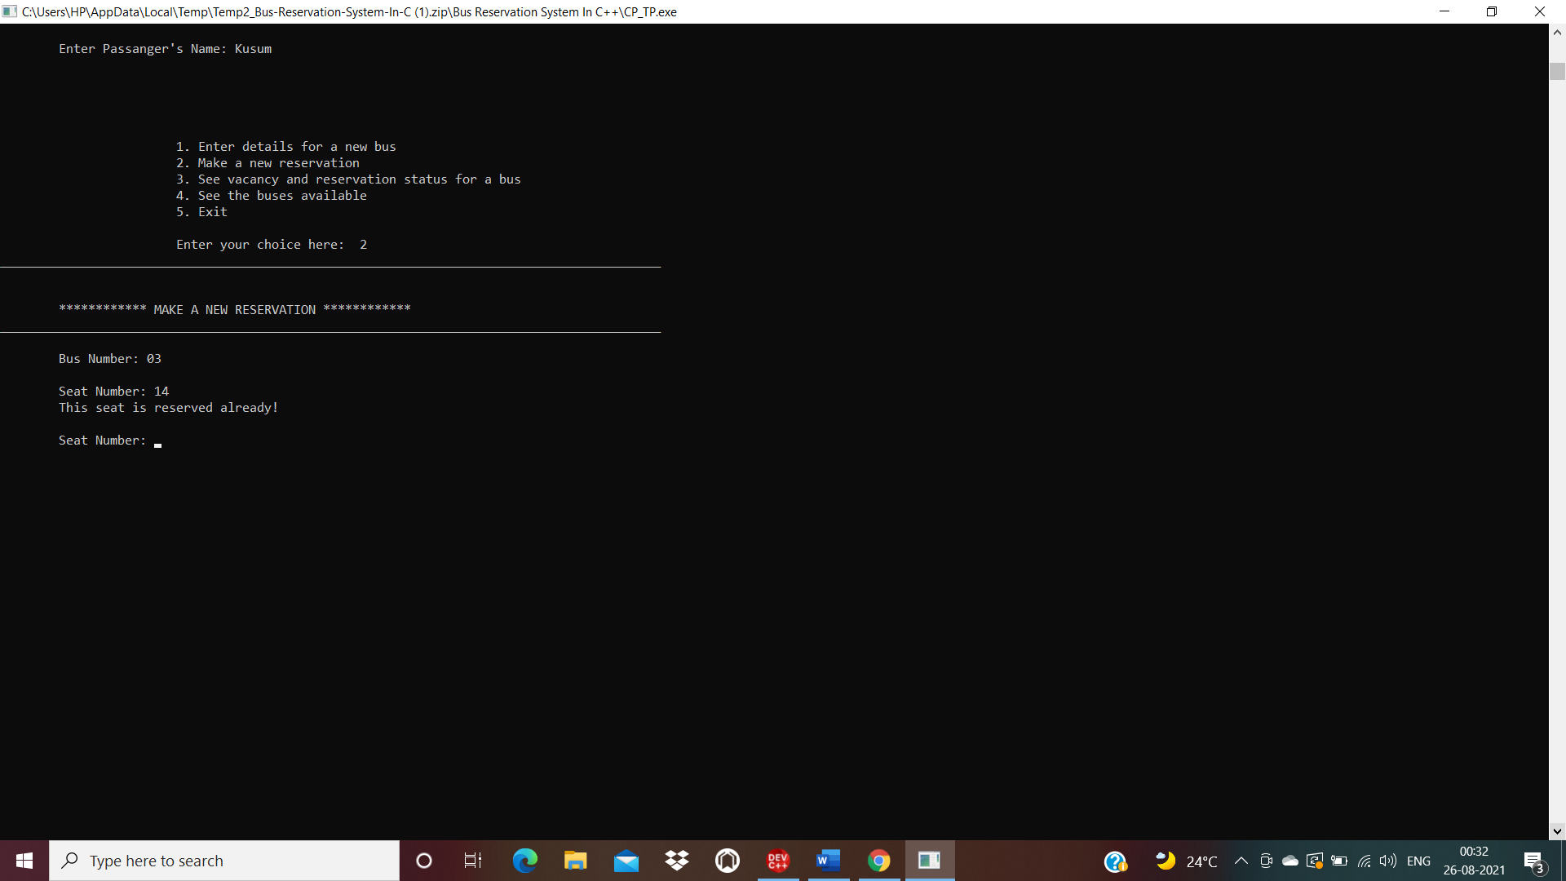

If the user choses a seat number greater than total seats available on that bus, then also an error message is generated by the program. This case is as shown as below-

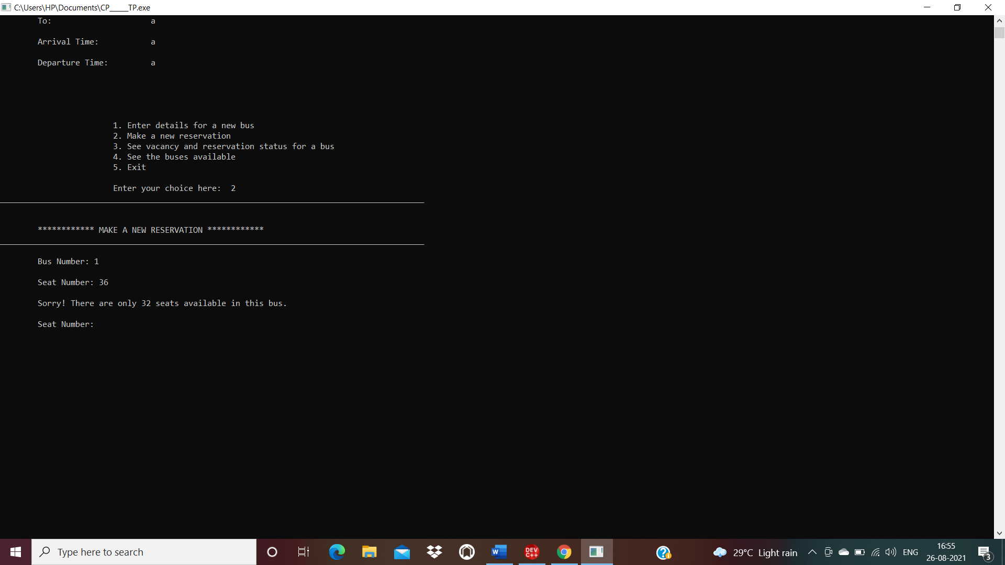

If to make reservation, the user enters a bus number not available on the system, an error message is displayed as follows-

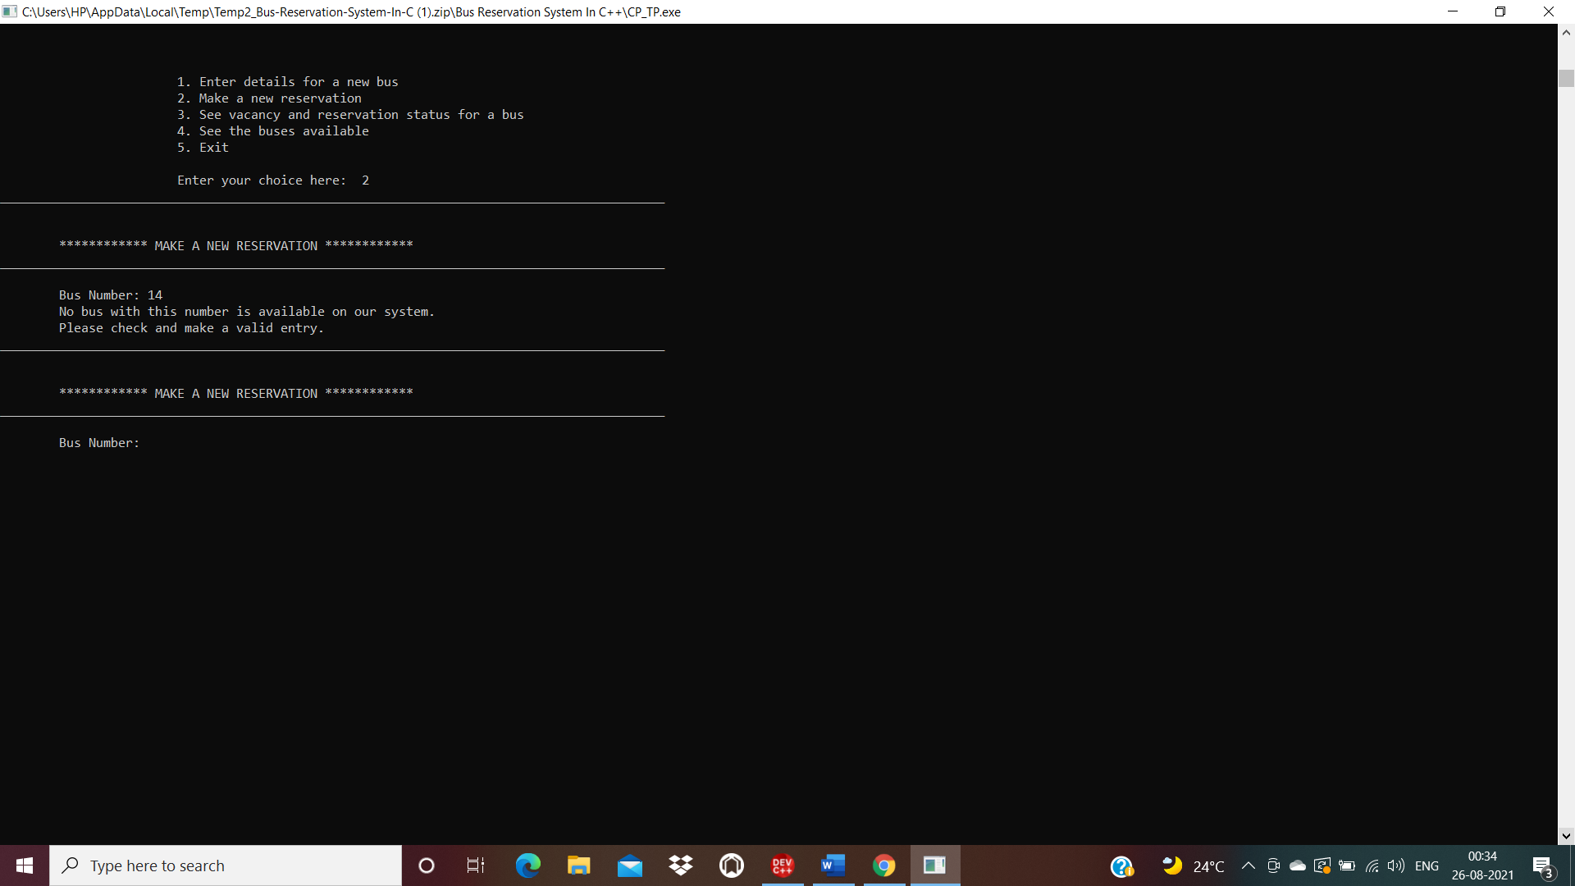

* If the user enters 3, then the compiler calls the function vacancy(), which is made to display the reserved and also the vacant seats on a bus. The program asks the user for the bus number, and then displays the reservation status on it.

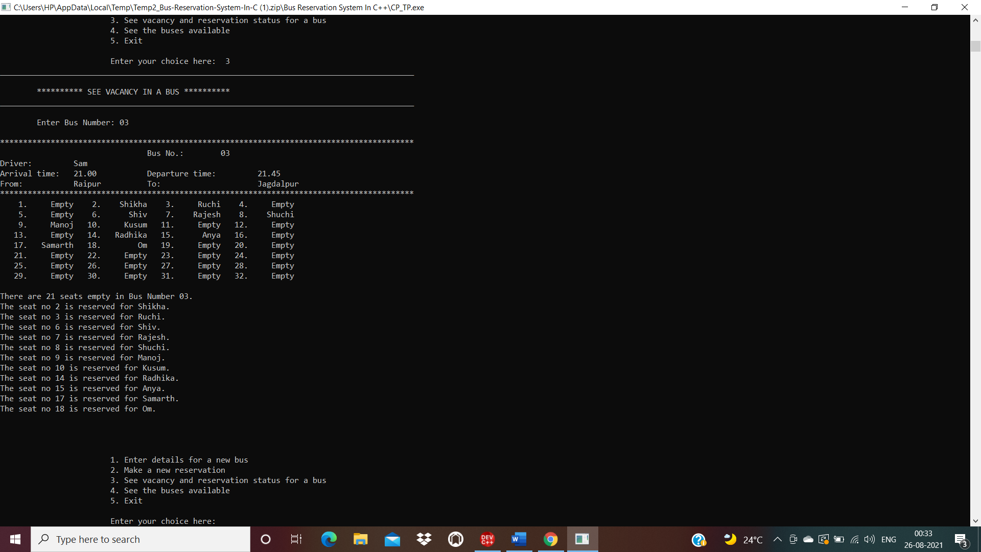

If the user enters a bus number which is not available on the system, then an error message is generated.

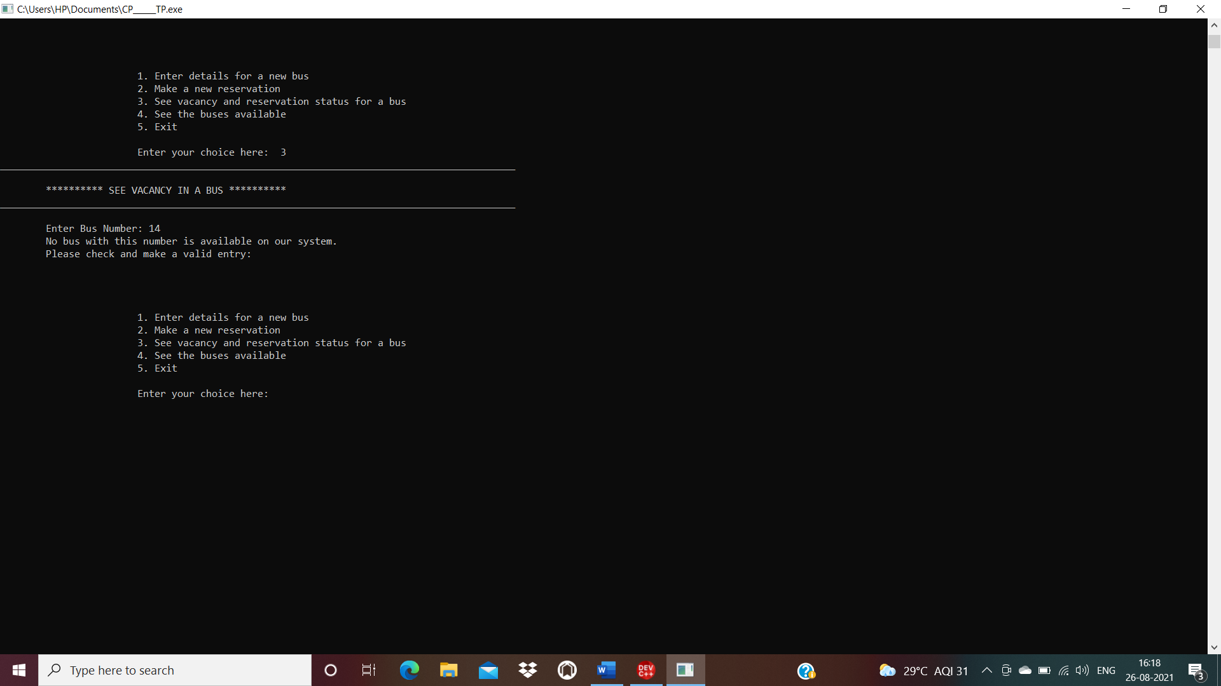

* If the user enters 4, then the compiler calls display function(), which is made to show all the buses available on the system.

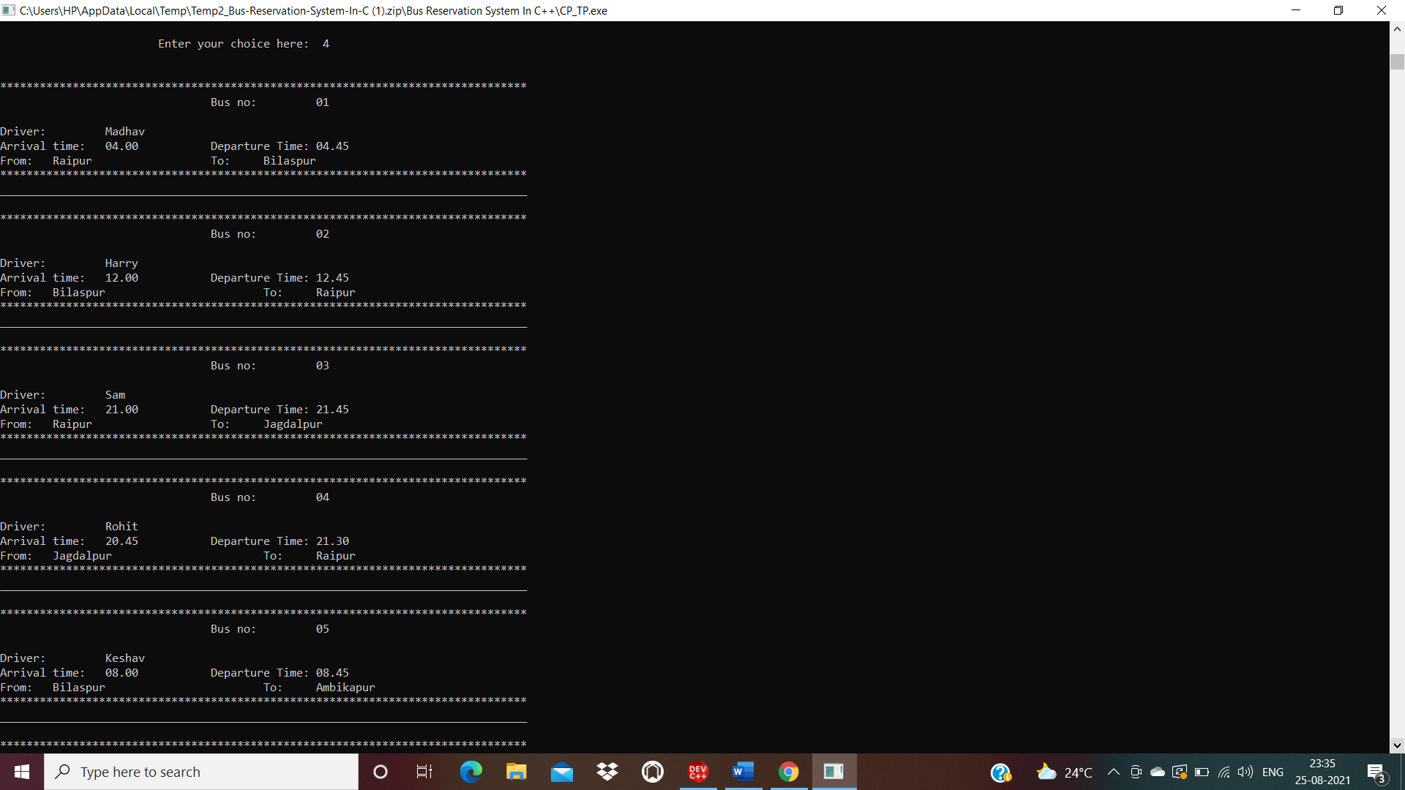

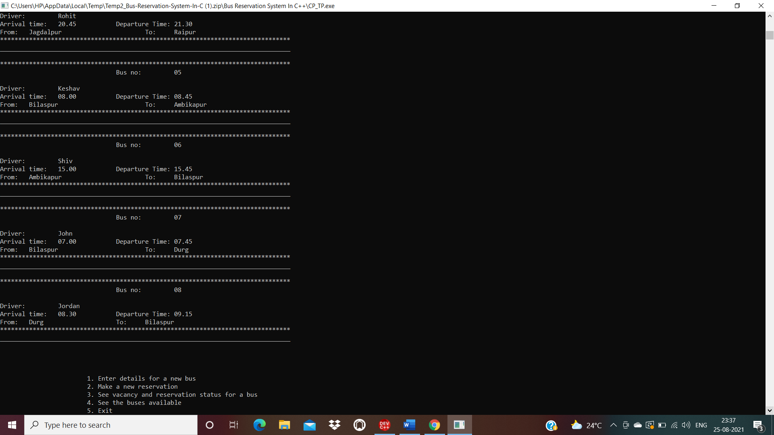

* If the user chooses 5, then the exit() function to exit the program will be called.

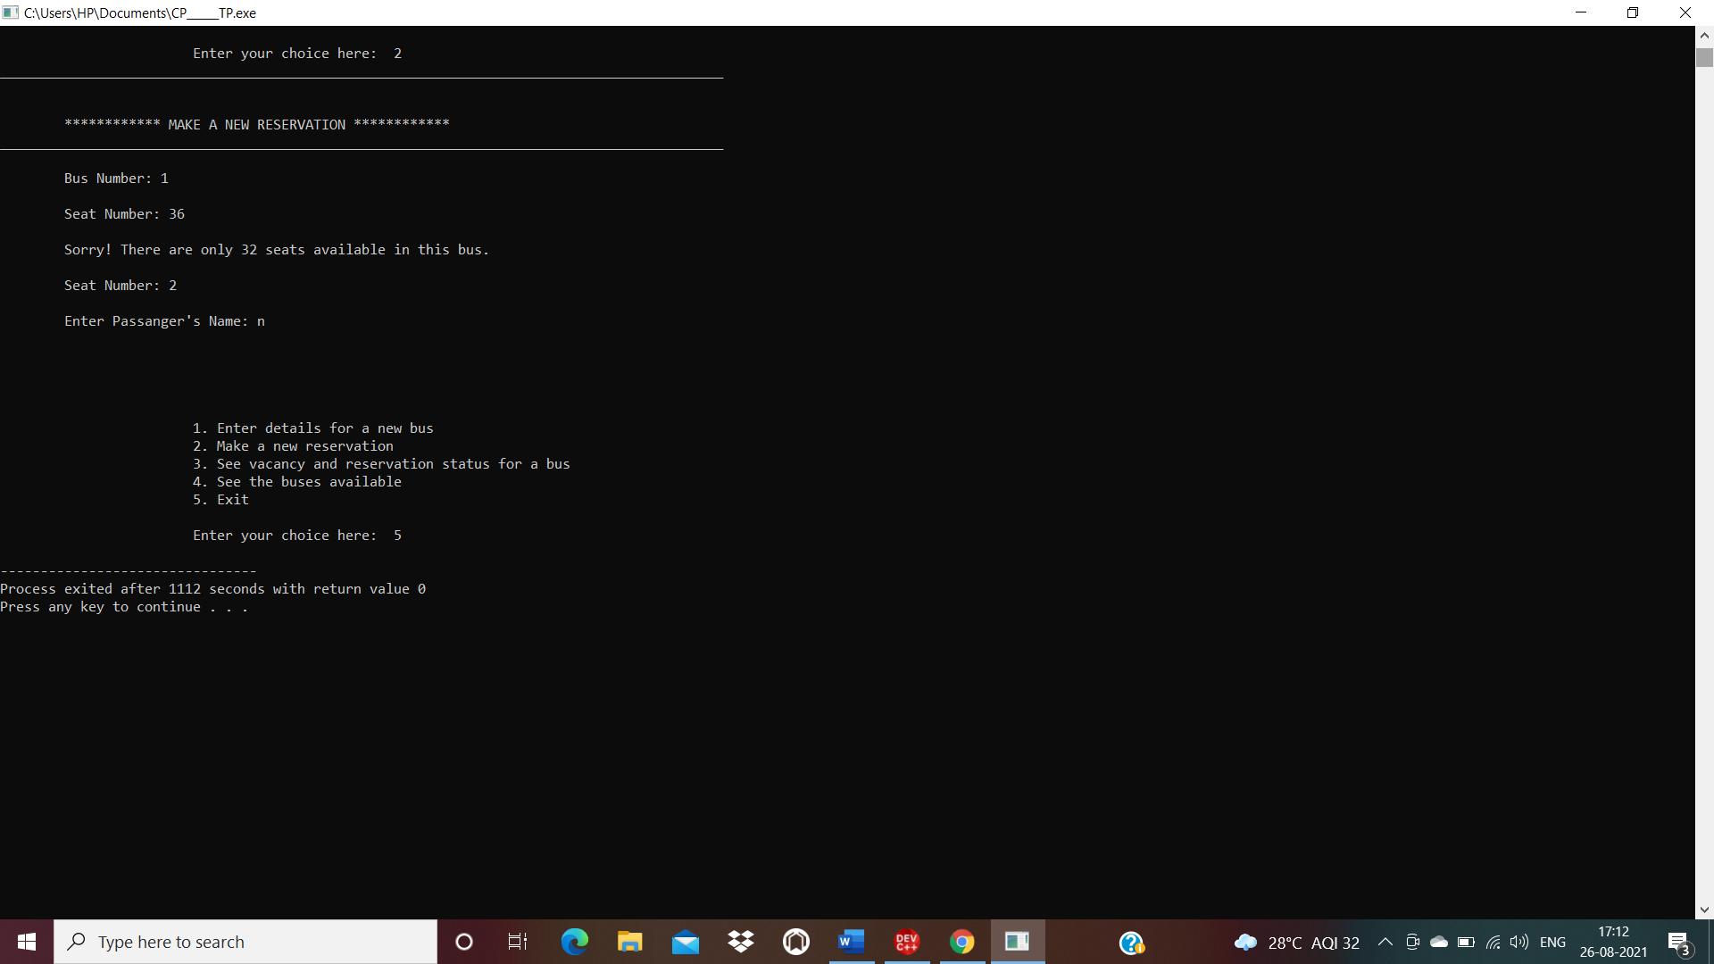

**FLOWCHART**

1. Enter Details
2. Make New Reservation
3. View Seat Details
4. See Available Buses
5. Exit

ENTER CHOICE

START

ENTER DETAILS BASED ON CHOICE

STOP

**CONCLUSION**

Thus, with all the functions working properly, it can be concluded that the program for Bus Reservation System is working efficiently, and if further modified, it can be developed into a proper software, providing many more user applications.