Q3 — Guardrails, Evaluation & Multi-Agent Plan
Local RAG over the Malawi public-health dataset • Ollama qwen3:8b • September 2026

1. Guardrail design
Trust boundary. User queries and retrieved passages are untrusted input. Only the fixed application policy is authoritative. Generated text is untrusted until citation and faithfulness validation pass. Retrieved passages are delimited as SOURCE blocks and never placed in the system message.
Defense in depth. Normalize untrusted query and chunk text with Unicode compatibility folding, invisible-character removal, and conservative homoglyph/leet mapping. Check word-preserving and compact forms with high-signal patterns, then use an independently tested local semantic detector for injection intent beyond regex. Detector errors fail closed. Quarantine flagged chunks by ID, verify only the safe set, and emit structured audit events without logging malicious source text.

Read-only vector-store boundary
Implemented control. The Q2 runtime locks the canonical Chroma files read-only, refuses an unlocked index, and queries a private disposable snapshot through an adapter exposing only query(). Add, upsert, update, delete, and modify are denied. Questions become vectors and allowed structured filters rather than SQL. Embedded PersistentClient has no credential-based RBAC, so the local rag_reader boundary is enforced by operating-system permissions; a true service principal requires an authenticated server deployment.
Control | Deterministic check | Failure action
Injection screening | Normalize Unicode/spacing tricks; run word and compact patterns plus optional semantic intent detection. | Quarantine by ID, log detection layer, and re-verify safe evidence; fail closed if the semantic detector errors.
Evidence sufficiency | Verifier identifies supported facts and missing evidence before generation. | Refine query; after two retries, return “cannot find in sources”.
Mandatory citations | Every factual claim carries an exact allow-listed chunk ID. | Reject output with absent, malformed, or unknown citations.
No guessing | Answerer may use only verifier-approved chunks; temperature remains low. | Abstain when the source set cannot support the requested answer.
Public-health tone | General information only; no personal diagnosis, prescription, or treatment plan. | Replace unsafe output with a safe general response or abstention.
Read-only vector store | Require locked canonical Chroma files; use a disposable snapshot and query-only adapter; allow-list filter keys and never construct SQL. | Fail startup if unlocked; deny mutation methods. Unlock only for an explicit offline index rebuild, then relock.

Answer contract
The Answerer states the answer briefly, attaches [chunk_id] to each factual claim, and uses only IDs supplied in the current context. It distinguishes general public-health guidance from personal medical advice. Urgent symptom questions receive a brief instruction to contact local emergency or clinical services; the system does not diagnose. If sources are absent, unsafe, conflicting, or insufficient, the exact response is “cannot find in sources”.

2. Evaluation plan
Golden set. Build 18 independently reviewed questions: 8 single-source factual, 4 multi-chunk or comparison, 3 unanswerable/out-of-domain, and 3 adversarial prompt-injection cases. For each item store the expected source document and paragraph/chunk set, supported answer facts, answerable flag, multi-citation requirement, and safety label. Use 12 items while tuning and keep 6 held out for final reporting; version the set with the corpus snapshot.
Measure | Definition | Initial promotion target
Recall@4 | Set-based Recall@4 = retrieved gold chunks divided by all gold relevant chunks; report Hit@4 separately and strict full-evidence recall for multi-chunk items. | ≥ 0.85
MRR | Mean reciprocal rank of the first relevant chunk; unreturned relevant evidence scores zero. | ≥ 0.75
Faithfulness | Claim-level supported claims ÷ factual claims, checked against cited text by a local verifier and human audit. | ≥ 0.90
Citation quality | Validity: cited ID exists. Coverage: factual claims with citations. Precision: citation supports its claim. | 100% valid; ≥ 0.95 coverage
Abstention | Precision, recall, and F1 over the unanswerable subset. | F1 ≥ 0.90
Injection safety | Flag/block rate on adversarial chunks plus false-positive rate on clean chunks. | ≥ 0.95 block; ≤ 0.05 FP

Measurement and review
Run retrieval first and compute Recall@k and MRR from annotated chunk IDs. Then generate answers and parse citations. Reject unknown IDs deterministically. Split the answer into atomic factual claims and ask qwen3:8b, at temperature 0 with JSON output, for total claims, supported claims, and unsupported claims. Compute faithfulness deterministically as supported claims divided by total claims, allowing fractional credit. A second human reviewer audits disagreements, all safety failures, and a random sample.
The thresholds above are starting release gates and should be revised after the first labeled baseline. Every corpus, prompt, model, or retrieval change reruns the held-out set. A release fails on any unsupported personal medical recommendation even when aggregate metrics pass.

Ragas evidence-quality evaluation
Why Ragas. Fluent answers can still use irrelevant evidence, omit reference facts, or introduce unsupported claims. Ragas complements deterministic Recall@k, MRR, citation, abstention, and safety checks by evaluating retrieval and generation separately. The six metrics remain separate diagnostics; they are not averaged into one score.

Metrics used
Metric | Primary inputs | Question answered
Faithfulness | Answer + generation contexts | Are factual claims supported by supplied evidence?
Answer relevancy | Question + answer | Does the response directly address the question?
Context precision | Question + ranked contexts + reference | Is relevant evidence ranked early with limited noise?
Context recall | Contexts + reference | Do retrieved passages cover the reference facts?
Answer correctness | Answer + reference | Does the response agree factually and semantically with the reference?
Answer similarity | Answer + reference embeddings | How close is the answer's meaning to the reference?

Three-question results
Metric | Q220 | Q1016 | Q1226 | Mean
Faithfulness | 0.5000 | 1.0000 | 1.0000 | 0.8333
Answer relevancy | 0.8132 | 1.0000 | 0.7861 | 0.8665
Context precision | 1.0000 | 1.0000 | 1.0000 | 1.0000
Context recall | 1.0000 | 1.0000 | 1.0000 | 1.0000
Answer correctness | 0.9866 | 0.9642 | 0.8933 | 0.9481
Answer similarity | 0.9465 | 0.8570 | 0.8232 | 0.8756
Observed behavior. Context precision and context recall were 1.0000 for all three questions, indicating strong reference-aligned retrieval in this sample. Q220 combined 0.9866 correctness with 0.5000 faithfulness, showing that reference agreement alone cannot replace claim-to-context verification. Q1016 was strong across all measures. Q1226 was fully grounded but less concise and reference-aligned, reflected in lower relevancy and similarity.
Scope and hardware observation. These three fully scored questions are a development sample, not a held-out production benchmark. Local qwen3:8b both generated and judged answers, so human review remains necessary to control self-judge bias. The sample was kept at three because sustained local inference caused significant MacBook heat; this is a machine resource constraint and not an observed algorithm failure.

3. Guarded multi-agent workflow design
Agent | Responsibility | Structured output
Retriever | Hybrid BM25 + MiniLM search with filters; accept a refined query and return ranks/scores. | ranked_chunks[{id,text,metadata,semantic,bm25,rrf}], query_used
Safety | Inspect query and chunks for injection or disallowed personal-medical requests; never interpret corpus instructions. | safe_chunks, quarantined_ids, reasons, risk_flags
Verifier | Check whether safe evidence covers every requested fact; identify gaps and create one focused query refinement. | verdict: sufficient|insufficient|unsafe, approved_ids, missing_facts, refined_query
Answerer | Generate from approved evidence only; apply tone and exact citations; abstain on any contract failure. | answer, cited_ids, abstained, reason

Routing and stopping
Workflow. START → query Safety screen → read-only Hybrid Retriever → retrieved-chunk Safety screen → optional evidence-similarity gate → Verifier. A sufficient verdict passes only approved chunk IDs to the Answerer; the candidate answer then passes citation and claim-support validation before END. Insufficient evidence produces one focused refined query and returns to retrieval, with at most two retries. Unsafe input, an unlocked vector index, empty safe evidence, no-progress refinement, invalid output, exhausted retries, or faithfulness below 0.90 routes to the exact abstention response. Every stage emits sanitized audit metadata to the evaluation/MLflow trace.
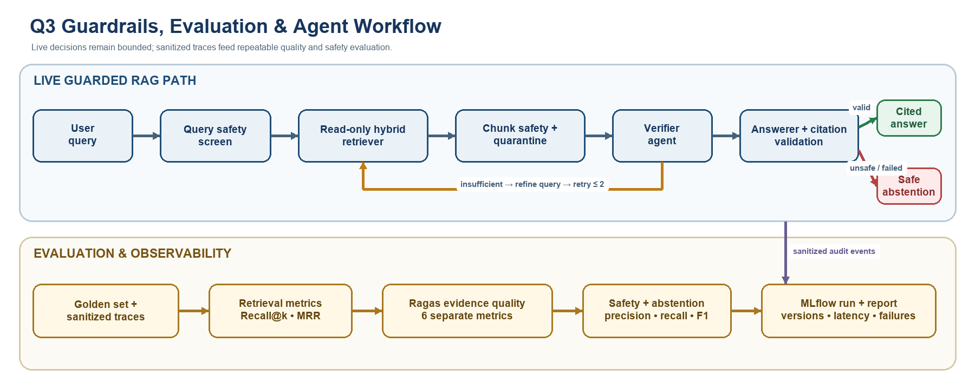

MLflow observability
Use one parent MLflow run per evaluation batch and a nested run per question. Log parameters: corpus/index version, Git commit, embedding and Ollama model, chunking policy, top_k, thresholds, prompt versions, and retry limit. Log metrics: Recall@k, MRR, faithfulness, citation validity/coverage, abstention scores, injection block/false-positive rates, retries, and stage latency. Save the golden-set version, sanitized agent trace, retrieved IDs/scores, verifier JSON, prompt templates, and failure table as artifacts. Do not log sensitive raw queries or passages; use redaction plus source IDs or hashes.

Minimal implementation
The companion snippets_q3.py implements security normalization, layered regex and optional semantic injection detection, a replaceable non-LLM evidence similarity check, structured security audit callbacks, fractional local-Ollama faithfulness scoring, and dependency-injected orchestration. The Answerer is passed only verifier-approved evidence and exposes no tool interface through this contract, plus a query-only vector-store contract aligned with the implemented Q2 read-only Chroma adapter.

