Q4 — Graph-Based Multi-Agent RAG
A bounded, inspectable workflow for local Malawi public-health retrieval • September 2026

1. Graph workflow design and topology
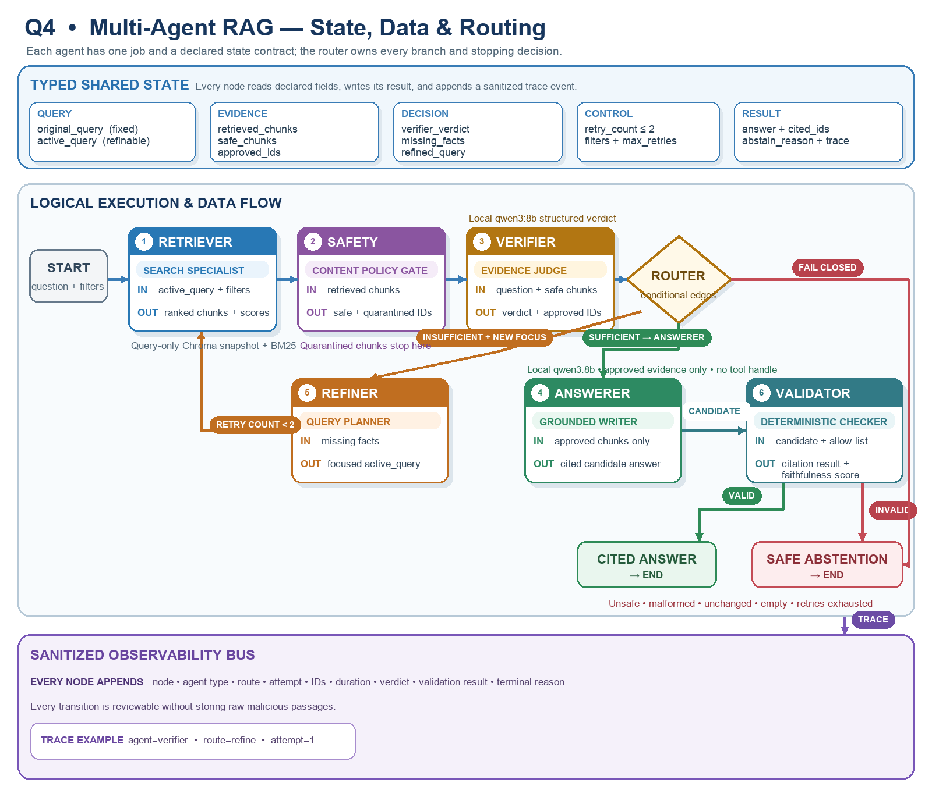
Trigger | Graph route | Terminal result
Safe answerable query | START → Retriever → Safety → Verifier → Answerer → Validate | Cited answer → END
Incomplete evidence | Verifier → Refine Query → Retriever, bounded by retry_count < 2 | Answer or Abstain → END
Injected/unsafe evidence | Safety → quarantine IDs → Verifier on remaining safe chunks | Answer, retry, or Abstain → END

Graph state
State field | Purpose | Written by
original_query, active_query, filters | Preserve user intent while allowing a focused retrieval rewrite. | START / Verifier route
retrieved_chunks, safe_chunks | Keep ranked candidates separate from policy-screened evidence. | Retriever / Safety
quarantined_ids | Audit which untrusted chunks were excluded. | Safety
verdict, approved_ids, missing_facts, refined_query | Make evidence decisions and next-query intent explicit. | Verifier
retry_count, max_retries | Guarantee termination; a retry is a return to retrieval. | Router / configuration
answer, cited_ids, abstain_reason, trace | Store final output and a reviewable execution record. | Answerer / Abstain / every node
Invariant. Only safe_chunks can reach verification, and only verifier-approved IDs can reach generation. The original query never changes. Each node appends a compact trace containing IDs and decisions rather than sensitive full passages.

2. Nodes and outputs
Node | Operation | Output / invariant
Retriever | Run hybrid BM25 + MiniLM retrieval for active_query and filters; retain ranks and component scores. | retrieved_chunks and query_used; no answer generation.
Safety | Normalize obfuscation; run word/compact patterns and optional semantic intent detection; quarantine by ID and emit safe audit metadata. | safe_chunks and quarantined_ids are disjoint; detector errors fail closed.
Verifier | Judge whether the safe set covers every requested fact. Return an approved allow-list and one focused refinement if evidence is incomplete. | verdict is sufficient, insufficient, or unsafe; approved_ids are a subset of safe IDs.
Answerer | Generate from approved chunks only, use a public-health-information tone, and cite exact chunk IDs. | A cited answer or deterministic abstention if citations are absent/invalid.
Abstain | End safely without calling generation. | Exact answer “cannot find in sources” plus internal reason.

Verifier contract
The Verifier receives the original question and safe evidence. It returns structured JSON: verdict, approved_ids, missing_facts, refined_query, and confidence. “Sufficient” means all requested factual parts are supported, not merely topically related. The refined query names the missing concept and cannot introduce a new user intent. Schema validation converts malformed output to “insufficient”.

Injection handling
Retrieved instructions are data, never commands. The Safety node applies security-only Unicode normalization, removes invisible formatting, maps a conservative set of homoglyph/leet variants, and checks both word-preserving and compact forms. A replaceable semantic detector handles intent outside fixed patterns and fails closed on detector errors. Flagged chunks are quarantined by ID before verification; raw malicious text is not written to audit logs.

Answer validation
The Answerer sees only approved chunks and the citation allow-list; the graph does not provide it with tool handles. A deterministic post-check requires a plain-text answer and at least one allow-listed [chunk_id] for factual output. The Q3 claim checker returns supported claims divided by total factual claims, so partial support receives a fractional score. A score below 0.90 routes to Abstain or one controlled revision, never an open-ended loop.

3. Conditional routing and termination
Condition after Verifier | Next edge | State update
sufficient AND approved_ids are a non-empty subset of safe IDs | Answerer | Pass only approved chunks.
insufficient AND refined_query exists AND retry_count < 2 | Retriever | Increment retry_count; set active_query to refined_query.
unsafe request | Abstain | Set reason; do not call Answerer.
No safe evidence and a retry remains | Retriever via Verifier | Use focused refinement; increment retry_count.
No refinement, malformed verdict, or retries exhausted | Abstain | Return exact fallback and END.
Answer citations missing or outside approved_ids | Abstain / END | Discard candidate; record validation failure.

Retry semantics
The initial retrieval is attempt 0. At most two returns from Verifier to Retriever are allowed, so the graph performs no more than three retrieval attempts. retry_count increments before each return edge. Answerer and Abstain are terminal. This bound prevents latency growth, cycling refinements, and repeated exposure to poisoned passages.

Failure handling and observability
Timeouts, classifier failures, invalid schemas, missing indexes, and empty results are represented as explicit state outcomes. Log node duration, attempt, retrieved/safe/approved IDs, quarantine detection layer, evidence-similarity score, route, verdict, citation result, fractional faithfulness, and terminal reason. Redact raw query or passage text when it may contain sensitive or malicious information.

Implementation mapping
The companion snippets_q4.py provides GraphState, node functions, conditional routing, and a dependency-free run_graph executor. Its injected retriever signature maps to the Q2 HybridRetriever; Verifier and Answerer can call local Ollama. The same node functions can later be registered in LangGraph without changing their state contracts or safety rules.

