DRAFT V2 • EVIDENCE-BASED REPORT
Client-Centric Consistency
in Apache Cassandra
Randomized coordinators versus Cassandra token-aware driver routing
Three-node Docker cluster • RF=3 • ONE / QUORUM / ALL
Normal operation • node failure • 2|1 network partition
Evidence snapshot 57,168 structurally eligible main histories from 19 completed runs. The 13 randomized runs are full-profile evidence; the six token-aware runs are reported as exploratory because their saved profile is smoke.
NUS DSA508 – Scalable Distributed Computing
Project group • Member details to be completed before submission
24 September 2026

Executive summary
This project examined whether finite application histories exhibited read-your-writes (RYW), monotonic-reads (MR), monotonic-writes (MW), and writes-follow-reads (WFR) violations on a three-node Apache Cassandra 5.0.9 cluster. The workload varied write and read consistency levels independently across ONE, QUORUM, and ALL, and ran under normal operation, an established node failure, and a bilateral 2|1 internode network partition.
Two coordinator-selection designs were compared without pooling their result populations. The earlier design independently selected a random Cassandra coordinator for each operation. The later design supplied the partition routing key and allowed the Python driver's TokenAwarePolicy(DCAwareRoundRobinPolicy(local_dc="dc1")) to create the query plan. In both designs, the receiving Cassandra node was the coordinator for that request; the coordinator was never a separate service.
Main finding The full-profile randomized evidence contained 194 violations among 7,231 evaluable histories (2.68%), while the exploratory token-aware evidence contained 6 among 26,222 (0.023%). Every observed violation occurred during a network partition. This difference cannot be attributed to stronger consistency from token awareness: 80.58% of randomized histories changed coordinator, compared with 0.77% of token-aware histories.
- Randomized full-profile evidence: 12,780 histories; 7,037 no violation observed, 194 violation, and 5,549 inconclusive.
- Token-aware exploratory evidence: 44,388 histories; 26,216 no violation observed, 6 violation, and 18,166 inconclusive.
- Normal operation produced no violations. Node failure produced no violations but many unavailable histories. Network partitions produced all violations and the largest inconclusive populations.
- Operation errors were classified as inconclusive rather than violations. Unavailable was the dominant error class, matching the replica-response requirements of ALL and minority-side QUORUM requests.
- A no-violation outcome is evidence about one saved history, not proof that Cassandra guarantees the corresponding client-centric model.
Evidence-status note The CSV exporter marks 19 completed runs as structurally eligible. The action plan separately requires smoke tests to be excluded from confirmatory claims. Because all six token-aware runs retain profile=smoke, this V2 report treats their measurements as exploratory and identifies the need for at least one verified full-profile token-aware run before final submission.

Contents
1 Objectives and research questions
2 Cassandra and client-centric consistency
3 Deployment architecture
4 Experimental designs
5 Predictions
6 Method
7 Evidence and analysis method
8 Results
9 Trace case studies
10 Cross-design discussion
11 Limitations and validity
12 Reproduction
13 Conclusion
References and AI-use disclosure
A Included and excluded runs
B Evidence schema and file map
Reading convention Configuration labels are always write consistency/read consistency. Thus ONE/QUORUM means a ONE write followed by a QUORUM read.

1. Objectives and research questions
The project asks how Cassandra's tunable consistency, failure topology, and client routing affect the consistency histories visible to an application. The application supplies data, a partition key, and a consistency level. It does not select a storage node in the token-aware design.
- RQ1. Under which write/read consistency combinations were RYW, MR, MW, or WFR counterexamples observed?
- RQ2. How did node failure and a 2|1 internode partition change evaluability and operation availability?
- RQ3. How did independent random coordinator selection differ from Cassandra-driver token-aware and data-center-aware routing?
- RQ4. Did measured observations agree with predictions derived from RF=3 replica acknowledgement and quorum intersection?
- RQ5. What can the recorded finite histories establish, and what remains outside the experiment's observational reach?
The unit of analysis was one ordered history over a run-scoped key. A history received exactly one primary verdict: violation, no violation observed, or inconclusive. Low-level exceptions were retained as explanatory evidence and did not create additional trial outcomes.
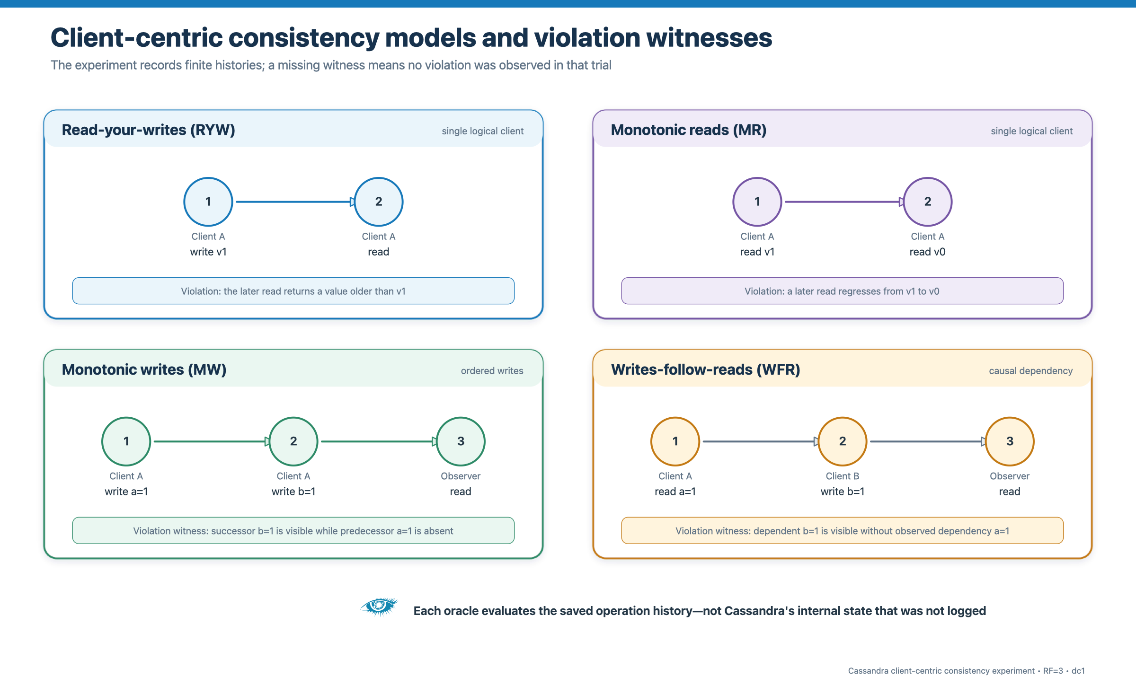
Figure 1. Client-centric consistency models and the finite-history violation witnesses used by the experiment.
Source: Project workload definitions and src/checks.py

2. Cassandra and client-centric consistency

2.1 Replication and the request coordinator
Apache Cassandra partitions data by token and replicates each partition according to the keyspace replication strategy. Any Cassandra node receiving a client request may coordinate it. The coordinator identifies replicas, forwards reads or mutations, and waits for the number of responses required by the selected consistency level [1]. The coordinator is therefore a per-request role, not a permanent leader or fourth service.
The lab keyspace used NetworkTopologyStrategy with replication factor 3 in dc1. Since the cluster also had three nodes, every node was a replica for each experiment key. Cassandra documentation recommends NetworkTopologyStrategy even for a single datacenter [1].

2.2 Tunable consistency
Consistency level | RF=3 responses | Experimental meaning
ONE | 1 replica | Highest fault tolerance among tested levels; may expose a minority-side view.
QUORUM | 2 replicas | Survives one unavailable replica when two replicas remain mutually reachable.
ALL | 3 replicas | Requires every replica; unavailable during an established one-node failure or 2|1 cut.

Table 1 source: Apache Cassandra tunable-consistency documentation [1, 2].
For RF=3, a write and read acknowledgement set must overlap when W + R > 3. QUORUM/QUORUM therefore intersects, while ONE/QUORUM sums to 3 and does not force intersection. This arithmetic supports visibility predictions for acknowledged operations, but it does not by itself prove every causal or session guarantee. Cassandra also sends writes to all replicas; the write consistency level controls how many responses the coordinator waits for [1].

2.3 Conflict resolution and repair
Cassandra resolves ordinary conflicting mutations by timestamp. The experiment supplied explicit increasing timestamps for main histories and used a decreasing-timestamp control to isolate this rule. Read repair was evaluated separately with BLOCKING and NONE tables. Hinted handoff was disabled, so post-fault cluster health could not be treated as proof that a previously missed mutation converged; convergence would require direct data evidence or repair [3, 4].

3. Deployment architecture
The common deployment consisted of three Cassandra services (n1, n2, n3), one client container, one private Docker network named lab, and three persistent Cassandra volumes. Host-side Python orchestration controlled Docker Compose and fault injection. CQL traffic used port 9042; Cassandra internode traffic used ports 7000 and 7001.
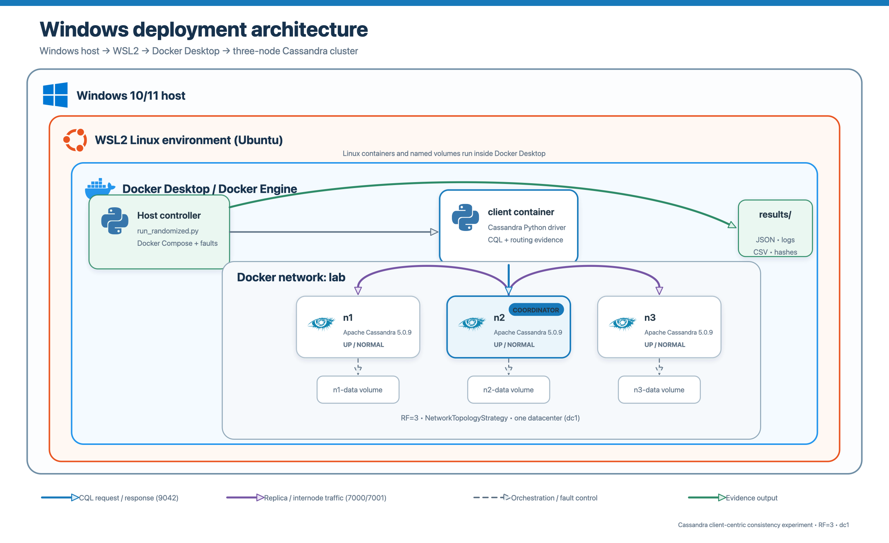
Figure 2. Windows deployment architecture.
Source: compose.yaml and experiment orchestration source
On Windows, Docker Desktop can use WSL2 as the Linux container environment. The host controller invokes Compose and writes evidence through the mounted repository. The client process that issues CQL still executes inside the client container.
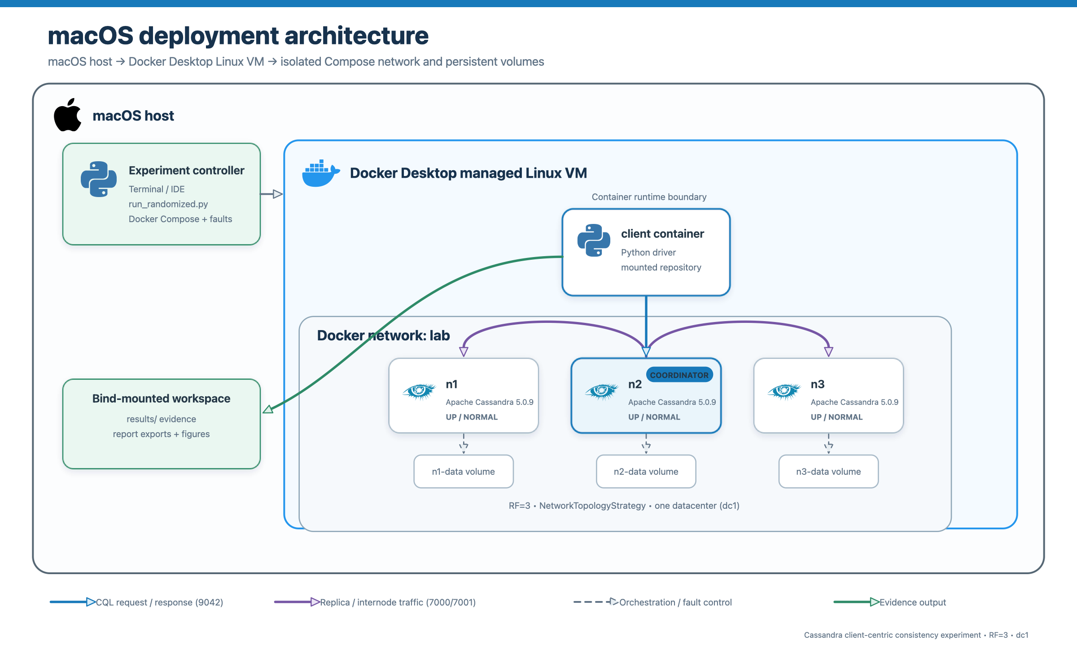
Figure 3. macOS deployment architecture.
Source: compose.yaml and Docker Desktop architecture [6]
On macOS, Docker Desktop runs the Docker Engine and Linux containers inside a managed Linux VM. The command begins on macOS, while the CQL client and Cassandra processes execute inside Docker's Linux environment [6].

4. Experimental designs

4.1 Design A: harness-controlled random coordinator
The earlier design independently sampled an eligible Cassandra node for each operation. This deliberately increased route diversity and the chance that successive operations crossed a network partition. It is useful as a counterexample search but gives the experiment harness control that ordinary applications typically delegate to the driver.

4.2 Design B: Cassandra driver policy
The later design supplied the keyspace and encoded partition routing key on each SimpleStatement. TokenAwarePolicy ranked replicas and DCAwareRoundRobinPolicy(local_dc="dc1") ordered local hosts. The application API could not name a Cassandra node. Retries, consistency downgrades, and speculative execution were disabled, and the actual coordinator and attempted hosts were recorded for each operation. DataStax describes token-aware routing as prioritizing replicas and the load-balancing policy as producing an ordered per-query host plan [5].
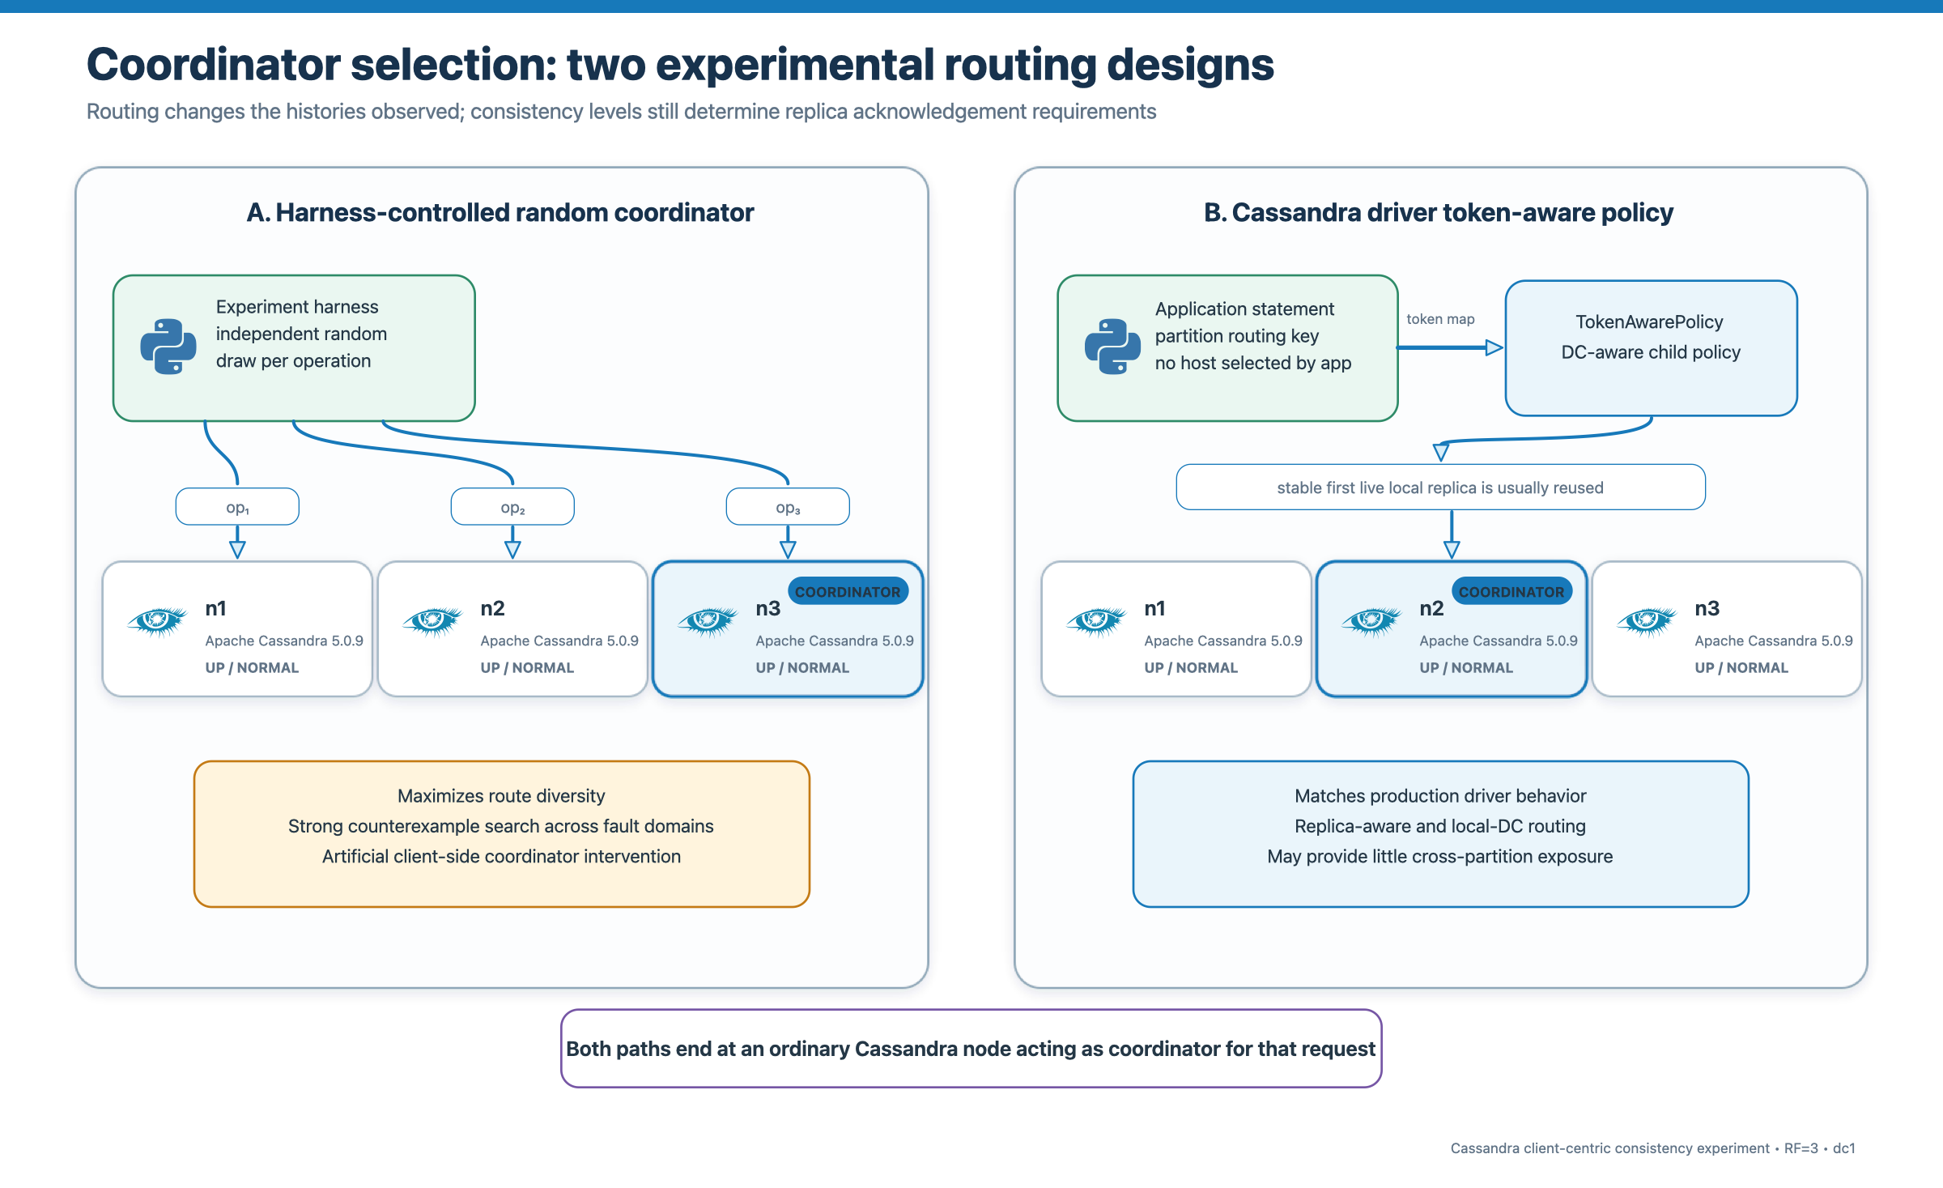
Figure 4. Coordinator-selection designs compared.
Source: random-coordinator-v2 and cassandra-driver-policy-v3 implementations
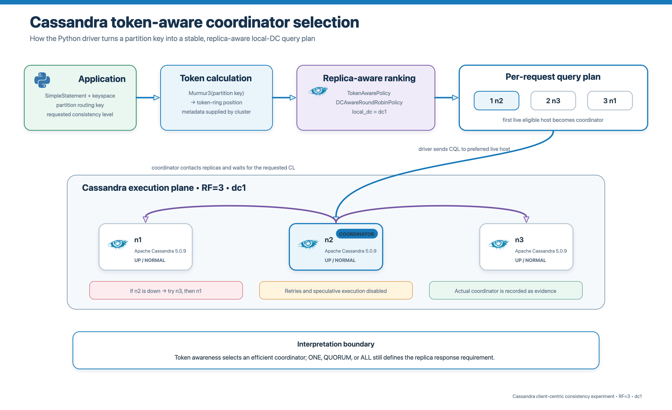
Figure 5. Token-aware driver coordinator selection in detail.
Source: src/worker.py, src/routing.py, and DataStax driver documentation [5]
Interpretation Routing changes which histories are sampled and which failure domains successive operations traverse. It does not change the acknowledgement rule for ONE, QUORUM, or ALL.

5. Predictions
Predictions were registered before interpreting the saved outcomes. They assume one writer per key, no TTL or deletion, explicit increasing timestamps, retries disabled, and the finite-history oracles described in Section 6.
Write/read | W+R>3 | RYW | MR | MW/WFR
ONE/ONE | No | May fail | May regress | Dependency visibility may fail
ONE/QUORUM | No | May fail | Quorum reads should resist regression | No general causal guarantee
ONE/ALL | Yes | Expected if operations complete | Expected if reads complete | No general causal guarantee
QUORUM/ONE | No | May fail | May regress | No general causal guarantee
QUORUM/QUORUM | Yes | Expected for acknowledged write/read | Quorum reads should resist regression | No general causal guarantee
QUORUM/ALL | Yes | Expected if operations complete | Expected if reads complete | No general causal guarantee
ALL/ONE | Yes | Expected if write completes | Stronger visibility | No general causal guarantee
ALL/QUORUM | Yes | Expected if write completes | Stronger visibility | No general causal guarantee
ALL/ALL | Yes | Expected while available | Expected while available | No completed witness expected

Table 2 source: registered predictions in report/predictions.md; mechanism supported by [1–3].

5.1 Scenario predictions
- Normal: operations should usually complete; weak combinations may still admit a counterexample, but the experiment is a finite search.
- Node failure: ONE and QUORUM may remain available on two survivors; ALL should be unavailable while one replica is down.
- Network partition: ONE may complete on either side; QUORUM can complete only through the two-node side; ALL cannot complete until healing.
- Random routing should create more cross-coordinator and cross-partition histories than the stable driver query plan, increasing counterexample exposure.

6. Method

6.1 Factorial workload
Each round combined three scenarios, nine write/read consistency pairs, and four client-centric models, for 108 cells. Repetitions were controlled by the saved plan. The pooled evidence spans runs with 1, 10, 50, or 100 rounds, so the report always states the actual denominator rather than assuming equal cell counts.
Dimension | Values | Count
Write CL | ONE, QUORUM, ALL | 3
Read CL | ONE, QUORUM, ALL | 3
Configuration | Cartesian product of write and read CL | 9
Model | RYW, MR, MW, WFR | 4
Scenario | normal, node_failure, network_partition | 3
Cells per round | 9 × 4 × 3 | 108

6.2 Operation histories and oracles
Model | Ordered history | Violation witness
RYW | client-1 writes a=1; client-1 reads a | Read is missing or a≠1
MR | producer writes a=1; client-1 reads twice | Second successful read is older than first
MW | client-1 writes a=1 then b=1; observer reads | b=1 visible while a≠1
WFR | producer writes a=1; dependent reads a and writes b=1; observer reads | b=1 visible while a≠1, after dependency was observed

If any required operation returned an error, the history was inconclusive. WFR was also inconclusive if the dependent client did not observe the prerequisite; MW was inconclusive if the final observation did not expose the successor. These coverage rules prevent absence of evidence from being counted as safety.

6.3 Fault injection and recovery
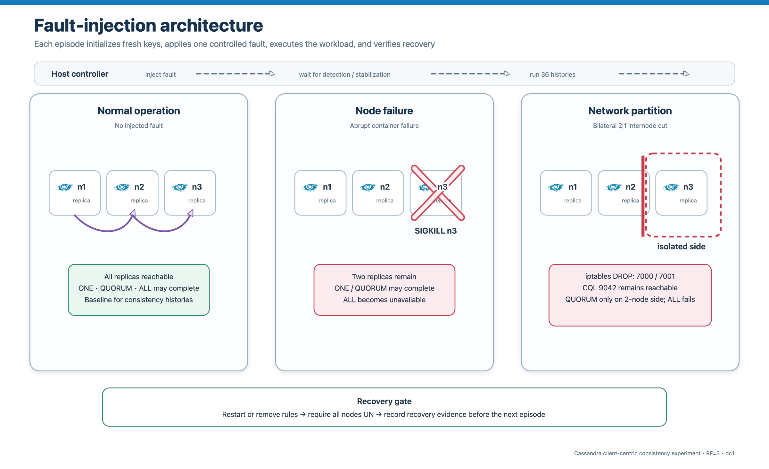
Figure 6. Fault-injection architecture and recovery gate.
Source: experiments/faults.py and docs/execution-guide.md
Node failure used docker compose kill -s SIGKILL on a uniformly sampled victim. The runner recorded its identity, required both survivors to report the exact victim IP as DN in consecutive observations, executed the workload, restarted the same service with its volume, and required every observer to report three UN nodes before continuing.
Network partitioning installed bilateral DROP rules in a project-only LAB_FAULT chain for TCP ports 7000/7001 across a sampled 2|1 cut. Port 9042 remained reachable from the client. The current configuration specifies 15 seconds of stabilization, a 15-second hold, a 20-second post-recovery settle period, a 90-second failure-detection timeout, and a 600-second recovery timeout. Recovery removed only project rules and verified healthy membership.

6.4 Controls
Read-repair controls compared BLOCKING and NONE tables across overlapping quorum components. Timestamp controls issued an ALL write at T+100, then another at T+50, then read at ALL; returning the T+100 value confirmed timestamp ordering. Control results were not pooled with the 57,168 main histories.

7. Evidence and analysis method
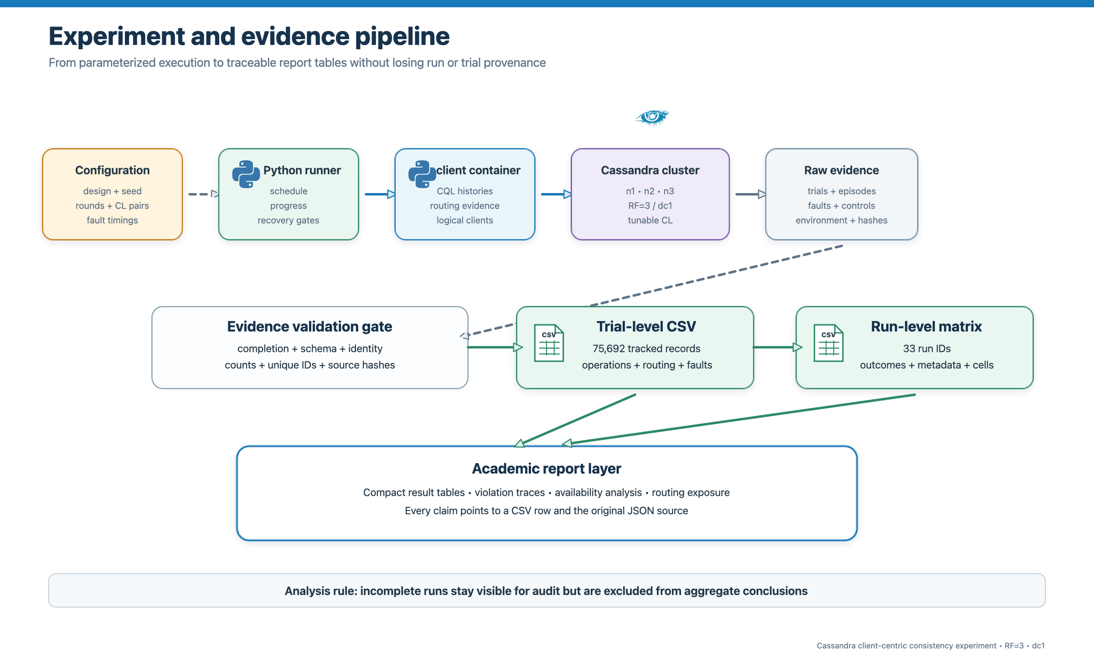
Figure 7. Evidence pipeline from parameterized execution to report tables.
Source: report/report_generation/export_evidence.py and verify_exports.py

7.1 Inclusion and evidence status
The exporter found 33 runs matching the two permitted design/schema pairs. Fourteen incomplete runs were retained for audit and excluded because completion.json recorded completed=false. Nineteen completed runs passed structural checks for identity, expected counts, unique trial IDs, unique keys, and JSON record form. The export verifier reconciled 74,024 main rows plus 1,668 control rows and validated the saved hashes.
Population | Design | Schema | Runs | Main histories | Profile | Use
Random coordinator | random-coordinator-v2 | v3 | 13 | 12,780 | Full | Primary measured population
Token-aware driver | cassandra-driver-policy-v3 | v4 | 6 | 44,388 | Smoke | Exploratory measured population
Excluded incomplete | approved families | mixed | 14 | 16,856 saved main rows | Incomplete | Audit only; excluded from totals

Table 5 source: run_level_violation_matrix.csv and export verifier output.
Profile caveat The exporter's included_in_analysis flag is a structural eligibility flag. It does not override the report action plan's instruction to exclude smoke tests from confirmatory claims. Token-aware measurements remain useful for diagnosis and design comparison, but the final submission should add a verified full-profile token-aware run.

7.2 Outcome vocabulary and denominators
Outcome | Meaning | Rate treatment
Violation | All required observations completed and contradicted the model oracle. | Included in evaluable denominator
No violation observed | Required observations completed and did not contradict the oracle. | Included in evaluable denominator
Inconclusive | An operation failed or an oracle precondition was not exposed. | Excluded from violation-rate denominator

Violation rate is violations divided by evaluable histories. Evaluability rate is evaluable histories divided by all attempted main histories. Both are needed: a configuration can appear safe simply because the required operations rarely completed.

8. Results
Result in one sentence Observed violations were confined to network partitions and weak/non-intersecting visibility paths; failures with stronger replica requirements appeared primarily as inconclusive unavailability.

8.1 Overall outcomes
Setup | Evidence status | Attempted | Evaluable | Violations | Inconclusive | Violation/evaluable | Evaluability
Random coordinator | Primary/full | 12,780 | 7,231 | 194 | 5,549 | 2.683% | 56.58%
Token-aware driver | Exploratory/smoke | 44,388 | 26,222 | 6 | 18,166 | 0.023% | 59.07%

Table 7 source: eligible main_trial rows in trial_level_evidence.csv.
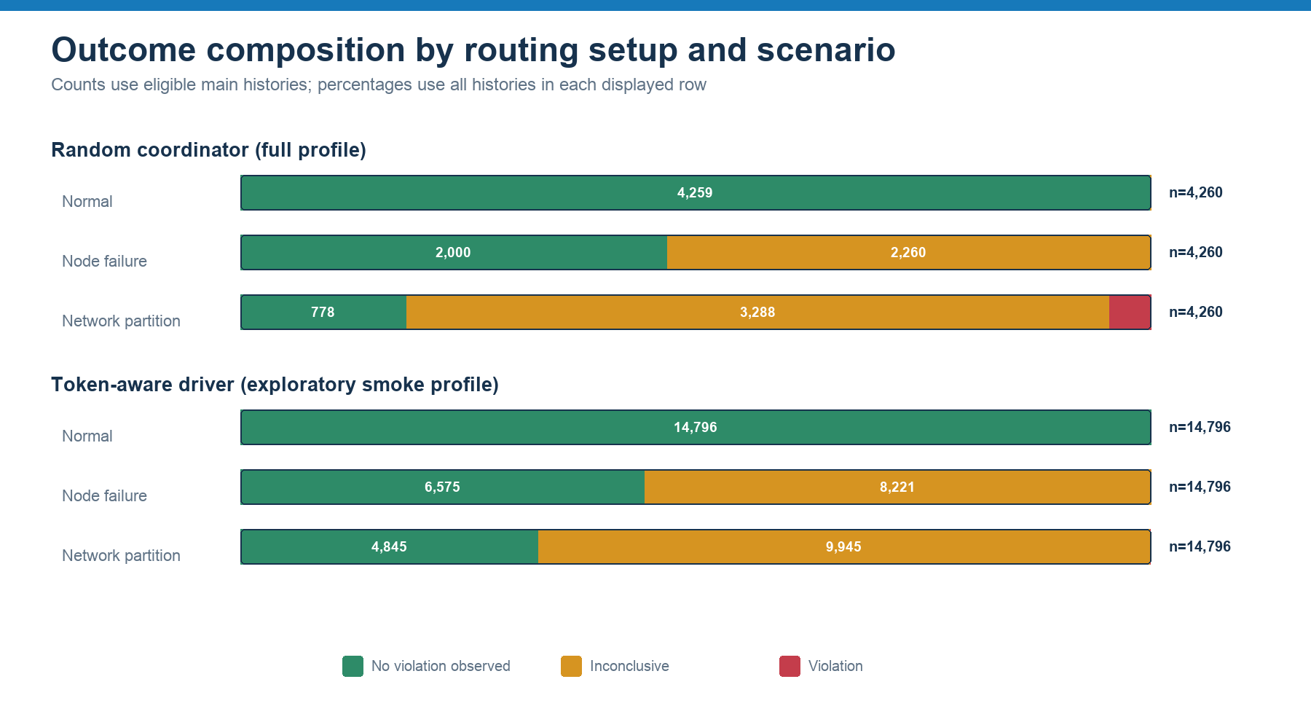
Figure 8. Outcome composition by routing setup and scenario.
Source: trial_level_evidence.csv; 57,168 eligible main histories

8.2 Scenario effects
Setup | Scenario | Attempted | Evaluable | Viol. | Inconcl. | Viol./eval. | Evaluability | Assessment
Random | Normal | 4,260 | 4,259 | 0 | 1 | 0.00% | 99.98% | [x] Expected
Random | Node failure | 4,260 | 2,000 | 0 | 2,260 | 0.00% | 46.95% | [x] Expected
Random | Network partition | 4,260 | 972 | 194 | 3,288 | 19.96% | 22.82% | [~] Plausible
Token-aware* | Normal | 14,796 | 14,796 | 0 | 0 | 0.00% | 100.00% | [x] Expected
Token-aware* | Node failure | 14,796 | 6,575 | 0 | 8,221 | 0.00% | 44.44% | [x] Expected
Token-aware* | Network partition | 14,796 | 4,851 | 6 | 9,945 | 0.12% | 32.79% | [~] Plausible

Normal operation produced zero violations in both populations. One randomized normal WFR history was inconclusive because its dependency was not observed. Node failure produced no consistency violation; instead, 2,260 randomized and 8,221 token-aware histories were inconclusive, overwhelmingly because the requested consistency level could not be satisfied. Network partitions produced all 200 observed violations and most operation errors.

8.3 Model and consistency-level effects
Setup | Model | Evaluable | Violations | Inconclusive | Violation/evaluable
Random | RYW | 1,909 | 92 | 1,286 | 4.819%
Random | MR | 1,862 | 43 | 1,333 | 2.309%
Random | MW | 1,774 | 46 | 1,421 | 2.593%
Random | WFR | 1,686 | 13 | 1,509 | 0.771%
Token-aware* | RYW | 6,549 | 6 | 4,548 | 0.092%
Token-aware* | MR | 6,552 | 0 | 4,545 | 0.000%
Token-aware* | MW | 6,554 | 0 | 4,543 | 0.000%
Token-aware* | WFR | 6,567 | 0 | 4,530 | 0.000%

In the full-profile randomized population, RYW produced 92 violations, MR 43, MW 46, and WFR 13. The token-aware exploratory population produced six RYW violations and none for MR, MW, or WFR. The absence of non-RYW token-aware witnesses coincided with very limited route changes and should not be interpreted as a stronger session guarantee.
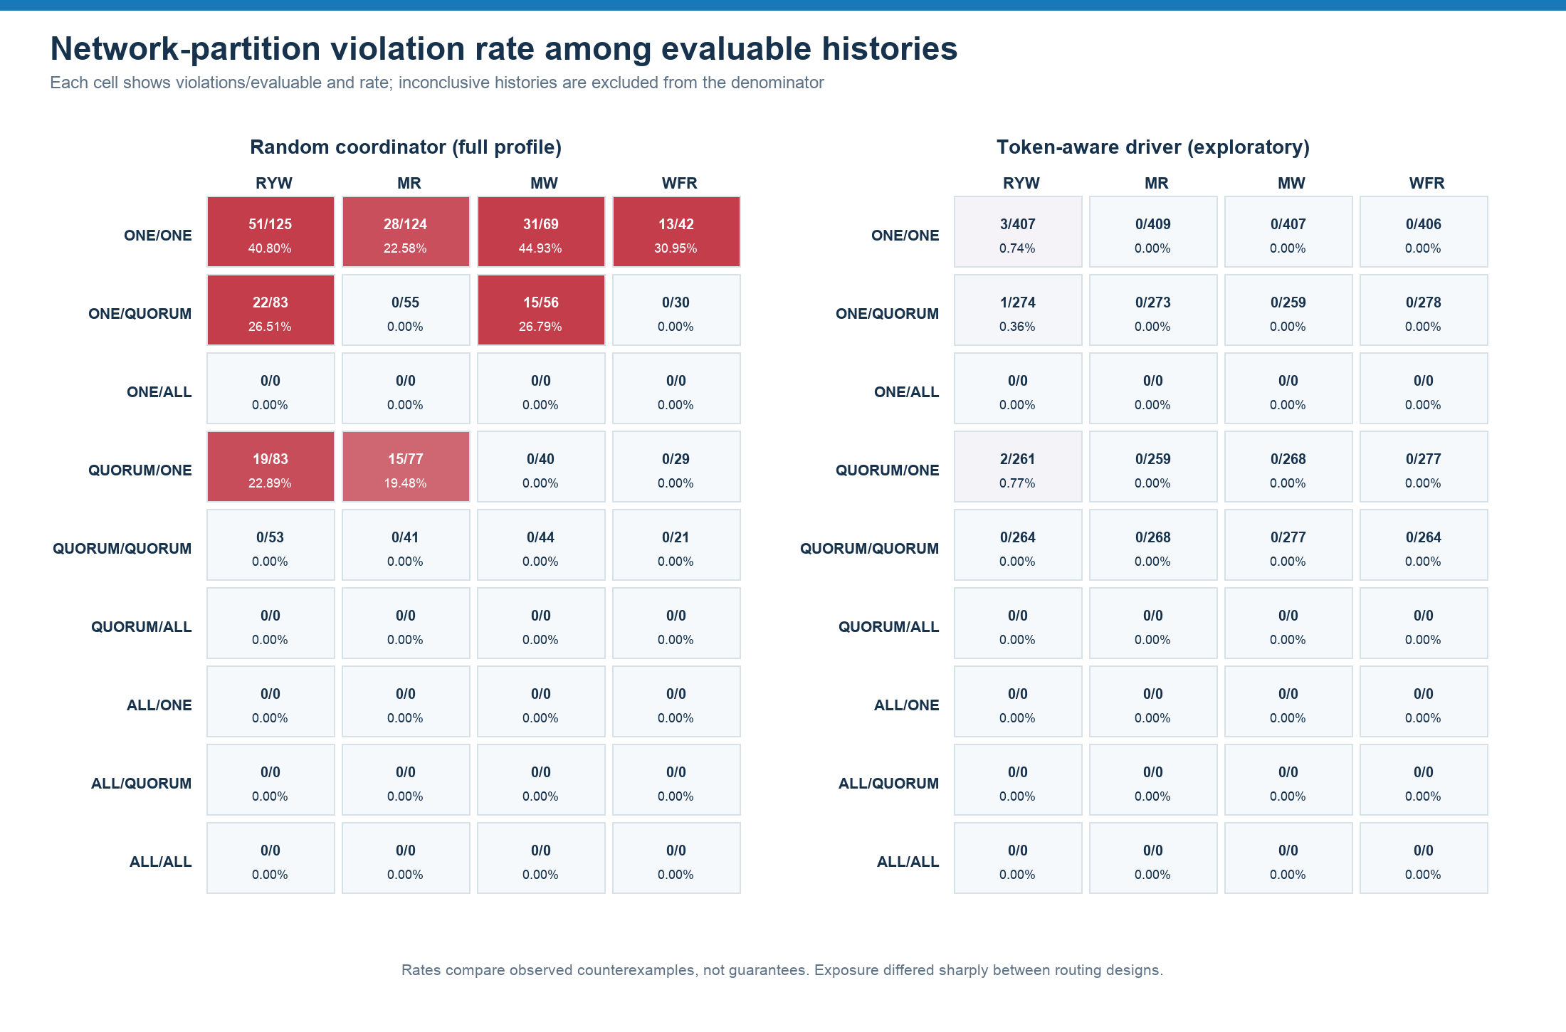
Figure 9. Network-partition violation rates among evaluable histories.
Source: trial_level_evidence.csv; network_partition only
The randomized heatmap concentrates violations in ONE/ONE and the non-intersecting ONE/QUORUM and QUORUM/ONE pairs. No violation was observed in cells containing ALL or in QUORUM/QUORUM. The token-aware exploratory population shows the same broad boundary, with six RYW witnesses in ONE/ONE, ONE/QUORUM, or QUORUM/ONE.

8.4 Routing exposure
Setup | Histories | Changed coordinator | Changed % | Crossed cut (network) | Crossed %
Random coordinator | 12,780 | 10,298 | 80.58% | 2,689 | 63.12%
Token-aware driver* | 44,388 | 344 | 0.77% | 92 | 0.62%

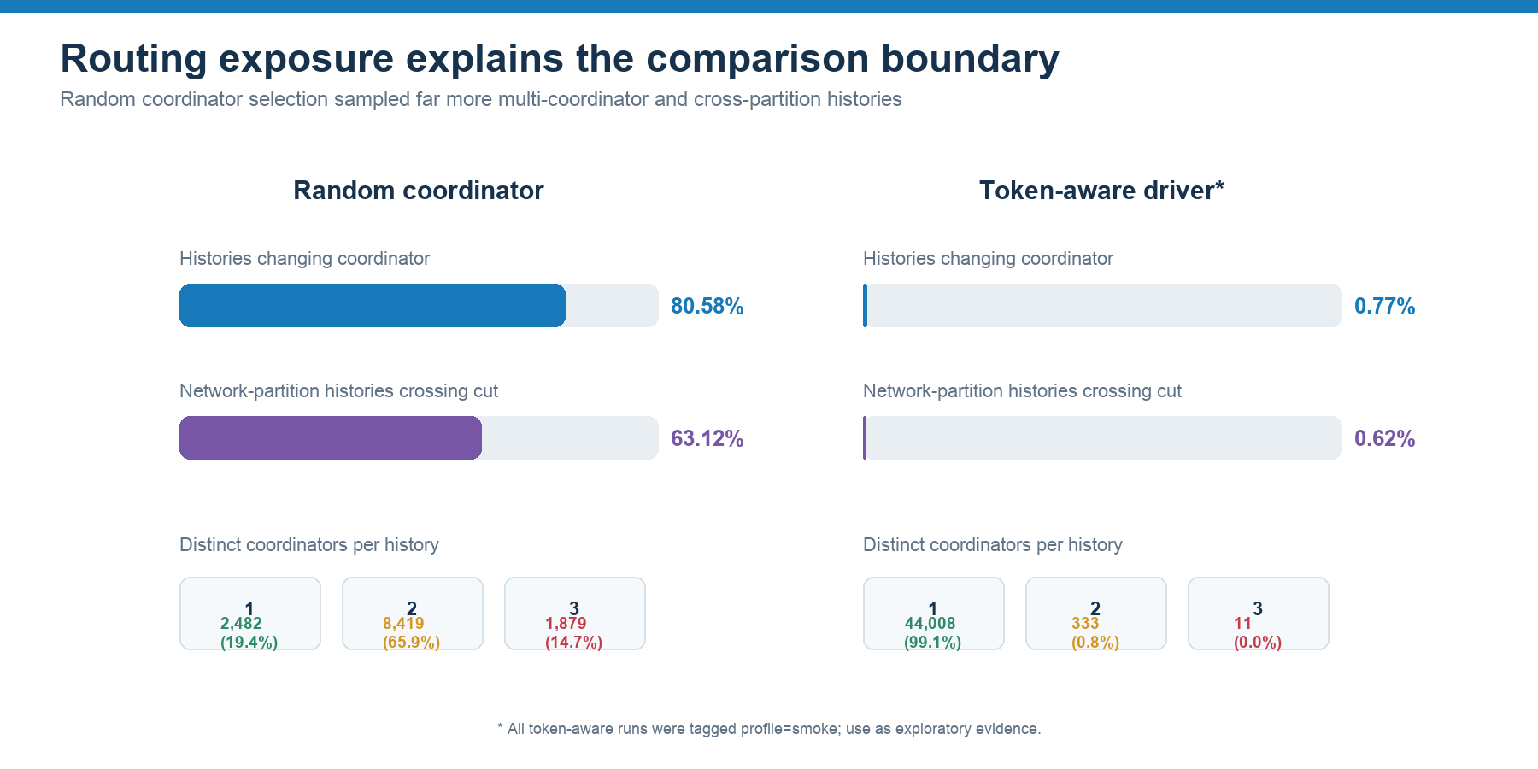
Figure 10. Coordinator and partition-side exposure.
Source: trial_level_evidence.csv routing fields
The random harness changed coordinator in 10,298 of 12,780 histories (80.58%). The driver-policy population changed coordinator in only 344 of 44,388 histories (0.77%). During network partitions, 2,689 of 4,260 randomized histories crossed the cut (63.12%), compared with 92 of 14,796 token-aware histories (0.62%). This exposure gap is large enough to dominate any naive comparison of violation percentages.

8.5 Inconclusive histories and availability
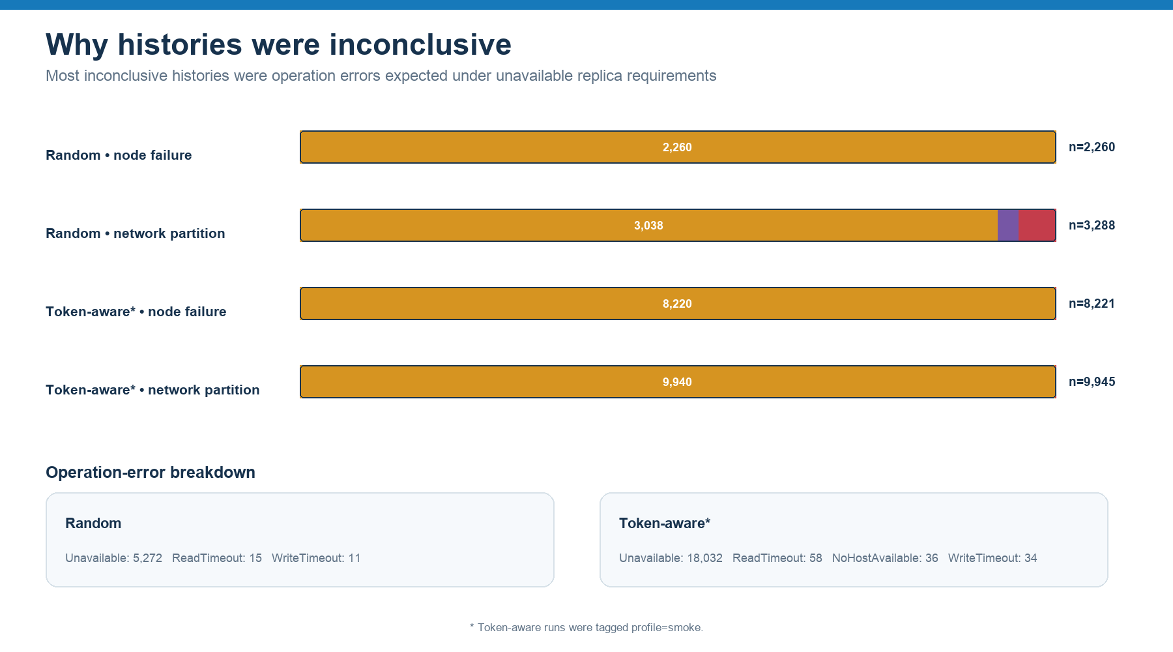
Figure 11. Inconclusive reasons and operation-error classes.
Source: trial_level_evidence.csv reason and exception fields
Setup | Primary first-error class | Histories
Random | Unavailable | 5,272
Random | ReadTimeout | 15
Random | WriteTimeout | 11
Token-aware* | Unavailable | 18,032
Token-aware* | ReadTimeout | 58
Token-aware* | WriteTimeout | 34
Token-aware* | NoHostAvailable | 36

Unavailable dominated because Cassandra could immediately determine that the requested replica count was not alive from the selected coordinator's view. Timeouts were rarer and indicate that the coordinator began waiting but did not obtain enough responses before the deadline. NoHostAvailable appeared only in the exploratory driver runs, when no eligible host completed the request. These are availability outcomes, not consistency violations.

8.6 Control experiments
Setup | Read-repair no regression | Read-repair regression | Read-repair inconclusive | Timestamp expected
Random | 67 | 43 | 140 | 125
Token-aware* | 70 | 49 | 703 | 411

All 536 timestamp controls were classified control_expected. Read-repair controls had substantial inconclusive populations; regression and no-regression counts are therefore mechanism checks rather than main-model rates. The controls are reported separately and do not alter the 57,168-history denominator.

9. Trace case studies

9.1 Token-aware RYW counterexample (exploratory)
Trial 20260921T233512Z_000000000135283f:network_partition:18:ONE/ONE:RYW ran while n3 was isolated. Client-1 wrote at ONE through n2, then read at ONE through n3. Both operations completed, but the read returned the initialized state {a:0,b:0}. The saved coordinator sequence n2→n3 and crossed_partition_cut=true establish that the application moved between partition sides. This is a direct RYW violation witness for the finite history.
Step | Logical client | Operation | CL | Coordinator | Observed result
1 | client-1 | write a=1 | ONE | n2 | ok
2 | client-1 | read a,b | ONE | n3 | {a:0,b:0}

Assessment: [x] Expected ONE/ONE does not force read/write intersection. The trace directly proves a cross-cut route and stale application observation; it does not reveal the internal replica response selected for each operation.

9.2 Random-routing WFR counterexample
Trial 20260919T100850Z_000000000135283b:network_partition:0:ONE/ONE:WFR established the dependency before testing it. The producer wrote a=1 through n2; the dependent client read a=1 through n2; the dependent write b=1 went through n3; and the observer read through n1, returning {a:0,b:1}. The dependent write was visible without the state that triggered it.
Step | Logical role | Operation | CL | Coordinator | Observed result
1 | producer-1 | write a=1 | ONE | n2 | ok
2 | dependent | read a,b | ONE | n2 | {a:1,b:0}
3 | dependent | write b=1 | ONE | n3 | ok
4 | observer-1 | read a,b | ONE | n1 | {a:0,b:1}

Assessment: [x] Expected The dependency was observed before b=1 was issued, and the final read exposed b without a. The four saved coordinators and cross-cut flag make this a strong WFR counterexample for the defined workload.

9.3 Inconclusive availability trace
Trial 20260921T080637Z_00000000000003e9:network_partition:0:ONE/ALL:MR ran with n3 isolated. A producer write at ONE succeeded through n3. Both later reads requested ALL through n3 and returned Unavailable with required_replicas=3 and alive_replicas=1. Since the reads produced no usable values, the MR oracle correctly returned inconclusive rather than violation.
Assessment: [x] Expected ALL cannot be satisfied on either side of a 2|1 partition. The trace demonstrates the intended availability cost of a strong response requirement.

10. Cross-design discussion

10.1 What the results support
The results support three bounded conclusions. First, the normal cluster produced no counterexample in either saved population. Second, established failures converted stronger replica requirements primarily into unavailability rather than successful stale observations. Third, network partitions plus weak or non-intersecting write/read paths created the conditions for every observed counterexample.

10.2 Why routing changed the observed rate
The random design actively moved successive operations among Cassandra coordinators and across the 2|1 cut. The token-aware policy generated a stable first-live-local-replica ordering for most histories. Since every node was a replica at RF=3, token awareness did not narrow the replica set, but driver state and query-plan reuse strongly narrowed actual coordinator transitions. The two designs therefore sampled different histories even when they requested the same consistency levels.
The lower exploratory token-aware violation rate is consistent with lower cross-cut exposure. It is not evidence that TokenAwarePolicy adds RYW, MR, MW, or WFR guarantees. A fairer causal comparison would stratify or match histories by coordinator changes and partition-side crossings, then compare outcomes within those exposure classes.

10.3 Agreement with predictions
Observation | Prediction | Assessment | Comment
No normal-operation violations | Generally expected | [x] Expected | Healthy RF=3 cluster and short sequential histories provided broad visibility.
No node-failure violations | Plausible with errors | [x] Expected | Unavailable histories were not misclassified as violations.
Weak-path partition violations | Predicted | [x] Expected | ONE/ONE and non-intersecting pairs can expose partition-side divergence.
No QQ or ALL-cell violations | Predicted while evaluable | [x] Expected | Intersection/participation blocked completed witnesses; many histories were unavailable.
Much lower token-aware rate | Exposure-sensitive | [ ] Insufficient exposure | Cross-cut histories were 0.62% versus 63.12%, and token runs were smoke-profile.

10.4 Availability versus safety
Safety and availability must be read together. ALL removed many histories from the evaluable denominator during faults. A zero violation count in such cells can mean that the system rejected the operation rather than returned a value satisfying the client-centric model. Conversely, ONE preserved more evaluable histories but allowed minority-side observations. The report therefore avoids a single pass/fail score.

11. Limitations and validity
- Profile validity: all token-aware runs are saved as profile=smoke. Their 44,388 histories are exploratory until a full-profile run passes the experiment-specific verifier.
- Unequal populations: run counts, rounds, and selected cells differ between the two designs; pooled rates are descriptive rather than randomized causal estimates.
- Exposure confounding: routing policy substantially changed coordinator and partition-side exposure. This is part of the design effect but prevents interpreting raw violation-rate differences as a consistency guarantee.
- Single physical host: three containers share Docker Desktop resources, storage, clocks, and failure modes. A container SIGKILL is not identical to loss of an independent server.
- Single datacenter and RF=3: results do not generalize directly to multiple datacenters, larger replica sets, LOCAL_* levels, or different snitches and rack layouts.
- Finite counterexample search: no-violation-observed does not prove a universal session property; rare schedules may be missed.
- Internal response limits: coordinator and attempted-host evidence are recorded, but the exact responding replica set for every successful operation is not always available. Some causal explanations remain plausible rather than proven.
- Hints disabled: healthy membership after recovery does not prove divergent data converged. Direct post-recovery reads or repair evidence would be needed.
- Read repair and timestamp semantics: table settings and client-supplied timestamps shape observations and must accompany any reproduction.
- Environment drift: eligible runs span several Git revisions, Python versions, Docker Compose versions, and macOS/Linux hosts. The run-level CSV retains these values for audit.
Required before final submission Run at least one full-profile token-aware experiment from the final code revision, validate it with scripts/verify_randomized.py, regenerate both CSVs, and rebuild this report. Replace the cover's group-member line and recheck every reported denominator.

12. Reproduction

12.1 Software and deployment parameters
Parameter | Recorded value
Database image | consistency-lab-cassandra:5.0.9
Python Cassandra driver | cassandra-driver 3.29.2
Services | n1, n2, n3, client
Cluster / datacenter / rack | ConsistencyLab / dc1 / rack1
Tokens per node | 16
Keyspace | lab; NetworkTopologyStrategy; dc1 RF=3
Tables | blocking (BLOCKING read repair); no_repair (NONE)
Hints | disabled
Speculative execution | disabled
Network | Docker network lab; CQL 9042; internode 7000/7001

12.2 Main commands
1. python3 -m venv .venv
2. .venv/bin/python -m pip install -r requirements-report.txt
3. python3 scripts/run_randomized.py --config config/cassandra_driver_experiments.json --seed 20260927 --plan-only
4. python3 scripts/run_randomized.py --config config/cassandra_driver_experiments.json --seed 20260927
5. python3 scripts/verify_randomized.py results/cassandra_policy_<run>
6. python3 report/report_generation/export_evidence.py
7. python3 report/report_generation/verify_exports.py

12.3 Reproduction sequence
- Start Docker Desktop or Docker Engine and wait until the daemon is ready.
- Review the registered predictions and final configuration before executing a measured run.
- Run the plan-only command and confirm expected matrix coverage.
- Execute with an explicit seed; do not run concurrent controllers.
- If interrupted, preserve the partial directory and use --recover; use --resume only when the main phase is complete and the runner accepts the checkpoint.
- Validate the exact run directory. Do not edit raw evidence to make a failed run pass.
- Regenerate the two report CSVs, run verify_exports.py, rebuild the V2 report, and inspect the rendered pages.
The complete operational procedure, troubleshooting guidance, schema barriers, fault proof, and recovery semantics are documented in README.md and docs/execution-guide.md. Raw evidence remains under results/<run_id>/ and is linked from both CSVs by source path and SHA-256 fields.

13. Conclusion
The experiment demonstrated that Cassandra's operation-level consistency and an application's client-centric history are related but not interchangeable. In this RF=3 deployment, healthy execution produced no saved counterexample. Established node failure primarily reduced availability for operations requiring unreachable replicas. Network partitions created both high inconclusive rates and every observed RYW, MR, MW, and WFR violation.
The full-profile randomized coordinator design exposed 194 violations, concentrated in ONE/ONE and non-intersecting ONE/QUORUM or QUORUM/ONE paths. The exploratory token-aware design exposed six RYW violations under the same broad conditions. The large difference followed an equally large difference in route exposure: the random design changed coordinator and crossed the partition far more often.
The strongest defensible conclusion is therefore conditional: weak replica-response combinations can expose client-centric counterexamples when successive operations traverse divergent partition views; stronger combinations often trade those observations for unavailability. Token-aware routing reduced the sampled opportunities for those histories, but it did not supply a session guarantee. A final full-profile token-aware run is required before turning the exploratory comparison into a submission-level claim.

References
[1] Apache Cassandra Documentation, “Dynamo: replication and tunable consistency.” https://cassandra.apache.org/doc/stable/cassandra/architecture/dynamo
[2] Apache Cassandra Documentation, “Consistency levels.” https://cassandra.apache.org/doc/stable/cassandra/developing/cql/consistency.html
[3] Apache Cassandra Documentation, “Read repair.” https://cassandra.apache.org/doc/stable/cassandra/managing/operating/read_repair.html
[4] Apache Cassandra Documentation, “Hints.” https://cassandra.apache.org/doc/latest/cassandra/managing/operating/hints.html
[5] DataStax Drivers Documentation, “Load balancing with Cassandra drivers.” https://docs.datastax.com/en/datastax-drivers/managing/balance-load.html
[6] Docker Documentation, “Networking on Docker Desktop.” https://docs.docker.com/desktop/features/networking/
[7] Project repository artifacts: compose.yaml, configuration files, experiment workloads, verifier, raw results, and report-generation CSV exports. https://github.com/whitetiger1399/scalableDistributed

AI-use disclosure
OpenAI Codex was used to review the draft and action plan, calculate aggregate summaries from the project-generated CSV files, create result visualizations, restructure the report, and generate the DOCX layout. The experiments and raw evidence were produced by the project software, not by AI. AI-generated interpretations were constrained to saved measurements and cited documentation. The project group remains responsible for checking the source data, technical claims, citations, group details, and final submission.

Appendix A. Run inventory

A.1 Included structurally eligible runs
Setup | Run ID | Rounds | Main histories | Structural status
Token-aware* | 20260921T080637Z_00000000000003e9 | 1 | 108 | passed
Token-aware* | 20260921T081729Z_000000000135283f | 10 | 1080 | passed
Token-aware* | 20260921T095705Z_000000000135283f | 100 | 10800 | passed
Token-aware* | 20260921T233512Z_000000000135283f | 100 | 10800 | passed
Token-aware* | 20260922T093902Z_000000000135283f | 100 | 10800 | passed
Token-aware* | 20260922T231838Z_000000000135283f | 100 | 10800 | passed
Random | 20260919T094446Z_0000000001352837 | 1 | 60 | passed
Random | 20260919T095446Z_0000000001352839 | 1 | 60 | passed
Random | 20260919T100144Z_000000000135283a | 1 | 60 | passed
Random | 20260919T100850Z_000000000135283b | 1 | 60 | passed
Random | 20260920T035710Z_000000000135283f | 10 | 600 | passed
Random | 20260919T135936Z_e9f0cc36454d5986 | 1 | 60 | passed
Random | 20260920T000159Z_36915629d2b6f5ad | 10 | 1080 | passed
Random | 20260920T010744Z_0977bac4dcb260ac | 10 | 1080 | passed
Random | 20260920T021504Z_dc8094a55ebf425f | 10 | 1080 | passed
Random | 20260920T032029Z_4d1c6194b3309a6b | 10 | 1080 | passed
Random | 20260920T042616Z_b3e212c5ede5c29f | 10 | 1080 | passed
Random | 20260920T061739Z_e6f386623a3b950e | 10 | 1080 | passed
Random | 20260921T000348Z_000000000135283f | 50 | 5400 | passed

* Token-aware runs are structurally eligible but saved as profile=smoke; reported exploratorily.

A.2 Excluded runs
Setup | Run ID | Completed | Status | Reason
Token-aware | 20260921T061911Z_000000000135283f | false | excluded | completion_false
Token-aware | 20260921T064120Z_000000000135283f | false | excluded | completion_false
Token-aware | 20260921T080423Z_000000000135283f | false | excluded | completion_false
Random | 20260919T094231Z_0000000001352837 | false | excluded | completion_false
Random | 20260919T094326Z_0000000001352837 | false | excluded | completion_false
Random | 20260919T095158Z_0000000001352838 | false | excluded | completion_false
Random | 20260919T101330Z_000000000135283f | false | excluded | completion_false
Random | 20260920T124703Z_0000000001352841 | false | excluded | completion_false
Random | 20260920T223912Z_000000000135283f | false | excluded | completion_false
Random | 20260919T145454Z_b46ec5216eb8950d | false | excluded | completion_false
Random | 20260920T053335Z_294f018e9c417b5c | false | excluded | completion_false
Random | 20260920T072816Z_cb13c5a6420fa31f | false | excluded | completion_false
Random | 20260920T085839Z_0623ed68272cbc84 | false | excluded | completion_false
Random | 20260921T041419Z_000000000135283f | false | excluded | completion_false

All 14 exclusions were caused by completion_false. Their partial records remain in the trial-level CSV for audit but were filtered by included_in_analysis=false from every result total in this report.

Appendix B. Evidence schema and file map
Artifact | Role in this report
trial_level_evidence.csv | One row per main history or control, with provenance, verdict, routing, fault, timing, and ordered-operation fields.
run_level_violation_matrix.csv | One row per run, including completion, validation, counts, environment, and complete cell matrix.
v2_analysis_summary.json | Derived aggregate and trace selection used by the V2 builder; reproducible from the two CSVs.
v2_assets/08–11 | Result charts derived from the eligible main-history rows.
figures/png/01–07 | Deployment, routing, fault, evidence, and model diagrams.
results/<run_id>/ | Raw immutable JSON/JSONL evidence referenced by CSV source paths and hashes.

B.1 Main analysis filters
- included_in_analysis == true
- record_type == main_trial
- included_in_main_violation_matrix == true
- setup populations kept separate
- violation rate denominator = violation + no_violation_observed
- controls excluded from main denominators

B.2 Suggested final-submission checks
- Replace project-group metadata on the cover.
- Add and validate a full-profile token-aware run, then regenerate exports and charts.
- Confirm that the final code revision matches the source hashes recorded by the measured run.
- Re-run the exporter and verifier; independently sample at least one violation and one inconclusive history.
- Render the final DOCX/PDF and inspect every page for clipping, table splits, caption placement, and hyperlink correctness.

