**Program: echo**

**Eserver**

import java.net.*;

import java.io.*;

public class EServer

{

public static void main(String args[])throws Exception

{

ServerSocket ss=new ServerSocket(8020);

String line;

DataInputStream dis;

PrintStream ps;

Socket s;

s=ss.accept();

dis=new DataInputStream(s.getInputStream());

ps=new PrintStream(s.getOutputStream());

while(true)

{

line=dis.readLine();

ps.println(line);

}

}

}

**EClient**

import java.net.*;

import java.io.*;

public class EClient

{

public static void main(String args[])throws Exception

{

InetAddress ia=InetAddress.getLocalHost();

Socket c=new Socket(ia,8020);

String line;

DataInputStream is,is1;

PrintStream os;

os=new PrintStream(c.getOutputStream());

is=new DataInputStream(System.in);

is1=new DataInputStream(c.getInputStream());

while(true)

{

System.out.println("Client:");

line=is.readLine();

os.println(line);

System.out.println("Server:"+is1.readLine());

}

}

}

**EServer:**

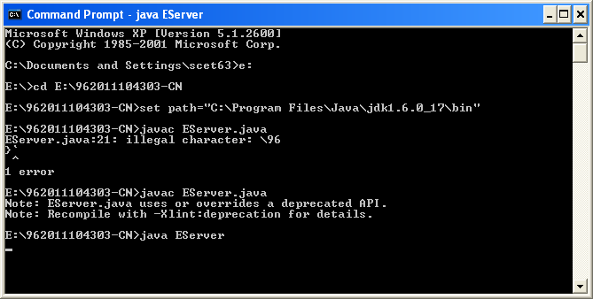

**EClient:**

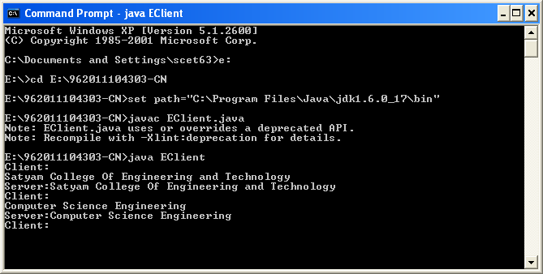

**Program: chat**

**Server**

import java.net.*;

import java.io.*;

public class Server

{

public static void main(String args[])throws Exception

{

ServerSocket ss=new ServerSocket(3000);

Socket s=ss.accept();

System.out.println("My Server is Ready: ");

DataInputStream in=new DataInputStream(s.getInputStream());

PrintStream ps=new PrintStream(s.getOutputStream());

while(true)

{

String st=in.readLine();

System.out.println(st);

st=new DataInputStream(System.in).readLine();

ps.println("Server message= "+st);

}

}

}

**Client**

import java.net.*;

import java.io.*;

public class Client

{

public static void main(String args[])throws Exception

{

InetAddress ina=InetAddress.getLocalHost();

Socket s=new Socket(ina,3000);

System.out.println("My Client is Ready: ");

DataInputStream dis=new DataInputStream(s.getInputStream());

PrintStream ps=new PrintStream(s.getOutputStream());

while(true)

{

String st=new DataInputStream(System.in).readLine();

ps.println("Client message= "+st);

st=dis.readLine();

System.out.println(st);

}

}

}

**Server:**

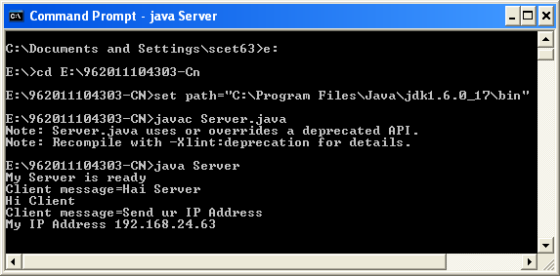

**Client:**

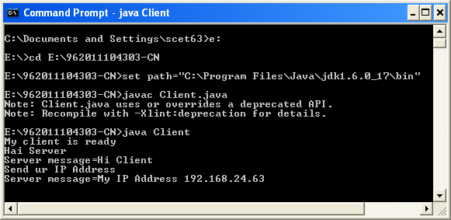

**Program:**

**//ARP SERVER**

import java.io.*;

import java.net.*;

import java.util.*;

class Serverarp

{

public static void main(String args[])

{

try

{

ServerSocket obj=new ServerSocket(139);

Socket obj1=obj.accept();

while(true)

{

DataInputStream din=new DataInputStream(obj1.getInputStream());

DataOutputStream dout=new DataOutputStream(obj1.getOutputStream());

String str=din.readLine();

String ip[]={"165.165.80.80","165.165.79.1"};

String mac[]={"6A:08:AA:C2","8A:BC:E3:FA"};

for(int i=0;i<ip.length;i++)

{

if(str.equals(ip[i]))

{

dout.writeBytes(mac[i]+'\n');

break;

}

}

obj.close();

}

}

catch(Exception e)

{

System.out.println(e);

}

}

}

**//ARP CLIENT**

import java.io.*;

import java.net.*;

import java.util.*;

class Clientarp{

public static void main(String args[]){

try{

BufferedReader in=new BufferedReader(new InputStreamReader(System.in));

Socket clsct=new Socket("127.0.0.1",139);

DataInputStream din=new DataInputStream(clsct.getInputStream());

DataOutputStream dout=new DataOutputStream(clsct.getOutputStream());

System.out.println("Enter the Logical address(IP):");

String str1=in.readLine();

dout.writeBytes(str1+'\n');

String str=din.readLine();

System.out.println("The Physical Address is: "+str);

clsct.close();

}

catch (Exception e)

{

System.out.println(e);

}

}

}

**Server:**

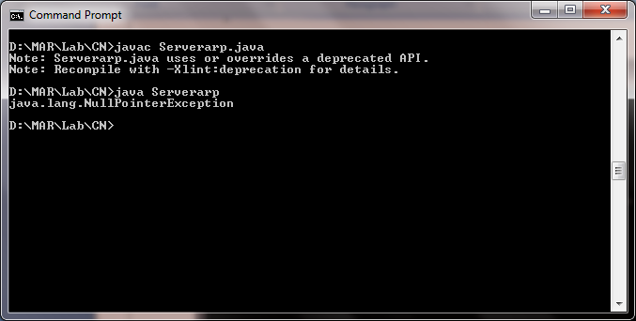

**Client:**

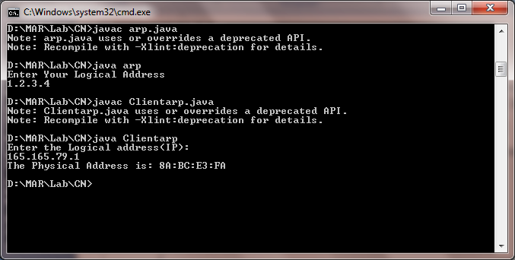

**Program: error**

#include<stdio.h>

char m[50],g[50],r[50],q[50],temp[50];

void caltrans(int);

void crc(int);

void calram();

void shiftl();

int main()

{

int n,i=0;

char ch,flag=0;

printf("Enter the frame bits:");

while((ch=getc(stdin))!='\n')

m[i++]=ch;

n=i;

for(i=0;i<16;i++)

m[n++]='0';

m[n]='\0';

printf("Message after appending 16 zeros:%s",m);

for(i=0;i<=16;i++)

g[i]='0';

g[0]=g[4]=g[11]=g[16]='1';g[17]='\0';

printf("\ngenerator:%s\n",g);

crc(n);

printf("\n\nquotient:%s",q);

caltrans(n);

printf("\ntransmitted frame:%s",m);

printf("\nEnter transmitted frame:");

scanf("\n%s",m);

printf("CRC checking\n");

crc(n);

printf("\n\nlast remainder:%s",r);

for(i=0;i<16;i++)

if(r[i]!='0')

flag=1;

else

continue;

if(flag==1)

printf("Error during transmission");

else

printf("\n\nReceived freme is correct");

}

void crc(int n)

{

int i,j;

for(i=0;i<n;i++)

temp[i]=m[i];

for(i=0;i<16;i++)

r[i]=m[i];

printf("\nintermediate remainder\n");

for(i=0;i<n-16;i++)

{

if(r[0]=='1')

{

q[i]='1';

calram();

}

else

{

q[i]='0';

shiftl();

}

r[16]=m[17+i];

r[17]='\0';

printf("\nremainder %d:%s",i+1,r);

for(j=0;j<=17;j++)

temp[j]=r[j];

}

q[n-16]='\0';

}

void calram()

{

int i,j;

for(i=1;i<=16;i++)

r[i-1]=((int)temp[i]-48)^((int)g[i]-48)+48;

}

void shiftl()

{

int i;

for(i=1;i<=16;i++)

r[i-1]=r[i];

}

void caltrans(int n)

{

int i,k=0;

for(i=n-16;i<n;i++)

m[i]=((int)m[i]-48)^((int)r[k++]-48)+48;

m[i]='\0';

}

**Output:**

Enter the Frame Bits:

1011

The msg after appending 16 zeros:

10110000000000000000

The Transmitted frame is:10111011000101101011

Enter the transmitted Frame

10111011000101101011

Received msg:10111011000101101011

The Remainder is:0000000000000000

Received frame is correct.