KUTXA (Maybe the mobile solution is a better way to go)

1. Login
   1. https://www.bancsabadell.com/cs/Satellite/SabAtl/Empresas/1191332202619/es/

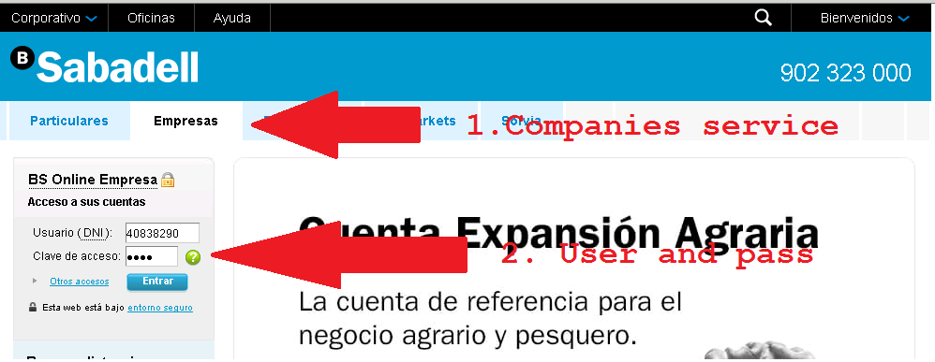

1. Balances and Movements
   1. 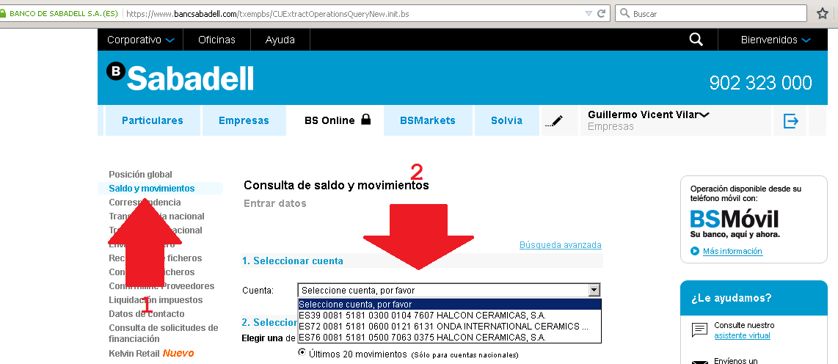
      1. We go to “Saldos y movimientos”
      2. The dropdown Cuenta will provide us the global list of accounts
      3. The description after the IBAN is the OrganizationName to create
         1. Eg. “HALCON CERAMICAS, S.A.
   2. 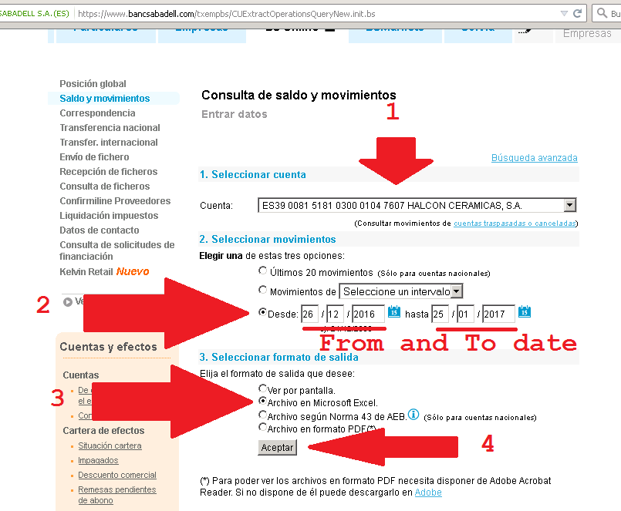
      1. We select each account
      2. Include the period
      3. Export to Excel. The excel file contains all the information we need, so I think is better than screen presentation with pagination.
   3. 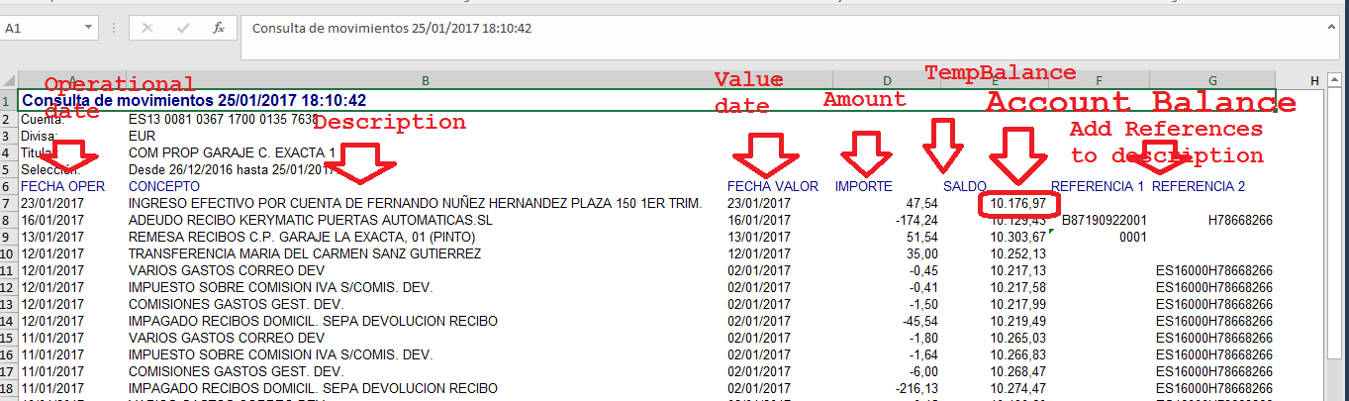
      1. Read Excel information