Oluwole Israel O.

170591101

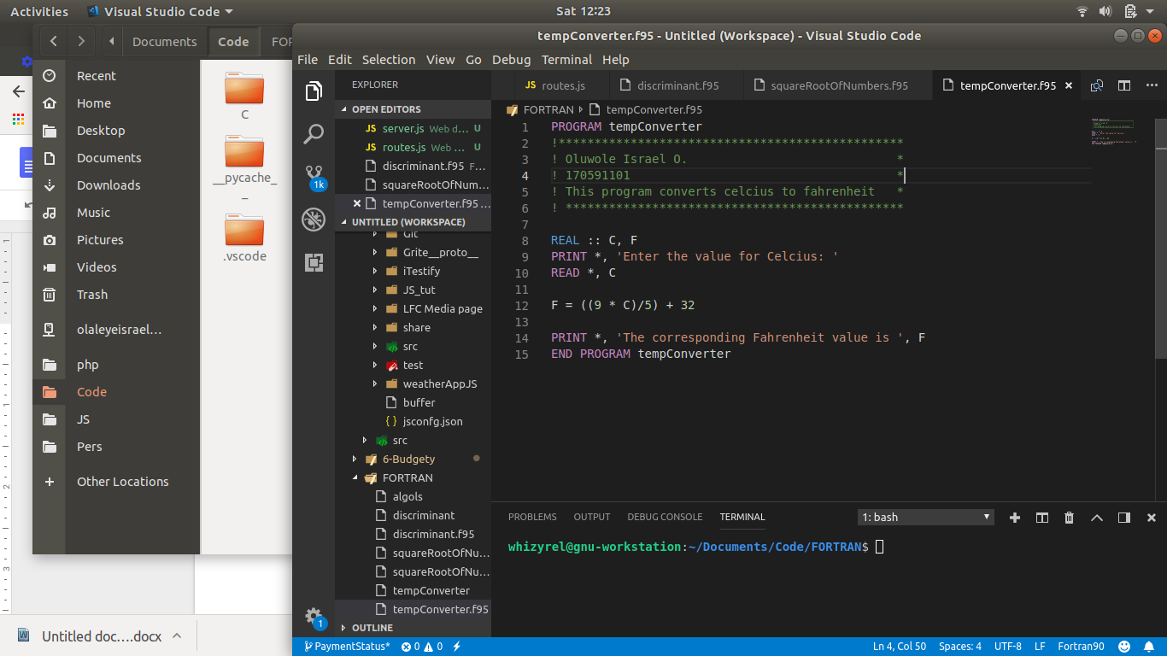

PROGRAM tempConverter

!\*\*\*\*\*\*\*\*\*\*\*\*\*\*\*\*\*\*\*\*\*\*\*\*\*\*\*\*\*\*\*\*\*\*\*\*\*\*\*\*\*\*\*\*\*\*\*\*

! Oluwole Israel O. \*

! 170591101 \*

! This program converts celcius to fahrenheit \*

! \*\*\*\*\*\*\*\*\*\*\*\*\*\*\*\*\*\*\*\*\*\*\*\*\*\*\*\*\*\*\*\*\*\*\*\*\*\*\*\*\*\*\*\*\*\*\*

REAL :: C, F

PRINT \*, 'Enter the value for Celcius: '

READ \*, C

F = ((9 \* C)/5) + 32

PRINT \*, 'The corresponding Fahrenheit value is ', F

END PROGRAM tempConverter

PROGRAM squareRootOfNumbers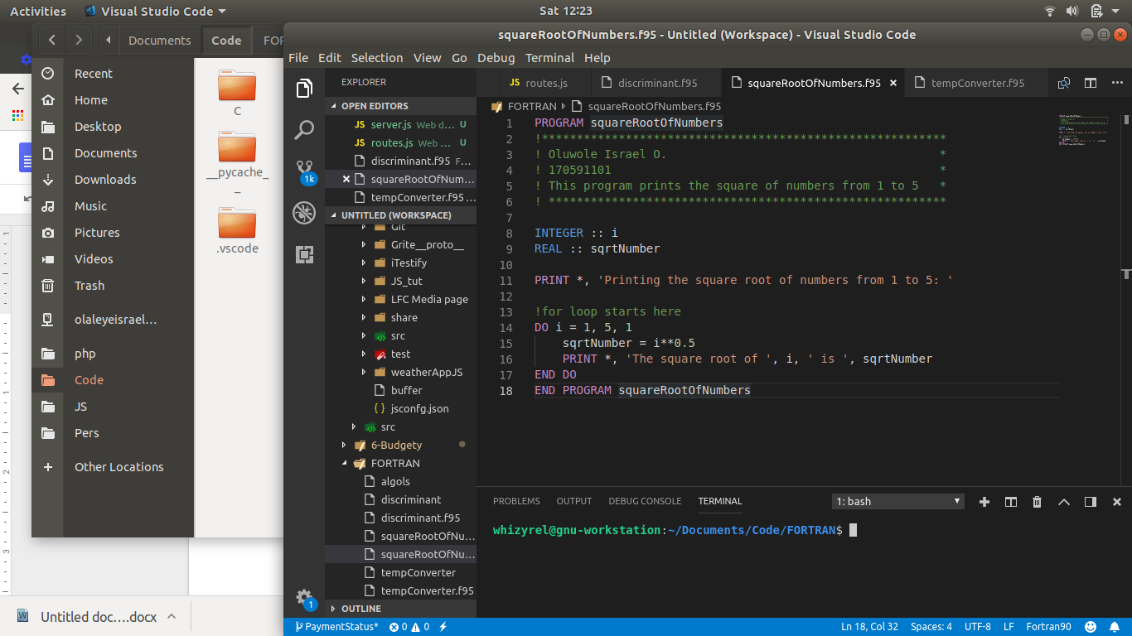

!\*\*\*\*\*\*\*\*\*\*\*\*\*\*\*\*\*\*\*\*\*\*\*\*\*\*\*\*\*\*\*\*\*\*\*\*\*\*\*\*\*\*\*\*\*\*\*\*\*\*\*\*\*\*\*\*\*\*

! Oluwole Israel O. \*

! 170591101 \*

! This program prints the square of numbers from 1 to 5 \*

! \*\*\*\*\*\*\*\*\*\*\*\*\*\*\*\*\*\*\*\*\*\*\*\*\*\*\*\*\*\*\*\*\*\*\*\*\*\*\*\*\*\*\*\*\*\*\*\*\*\*\*\*\*\*\*\*\*

INTEGER :: i

REAL :: sqrtNumber

PRINT \*, 'Printing the square root of numbers from 1 to 5: '

!for loop starts here

DO i = 1, 5, 1

sqrtNumber = i\*\*0.5

PRINT \*, 'The square root of ', i, ' is ', sqrtNumber

END DO

END PROGRAM squareRootOfNumbers

PROGRAM discriminantOfAQuadratic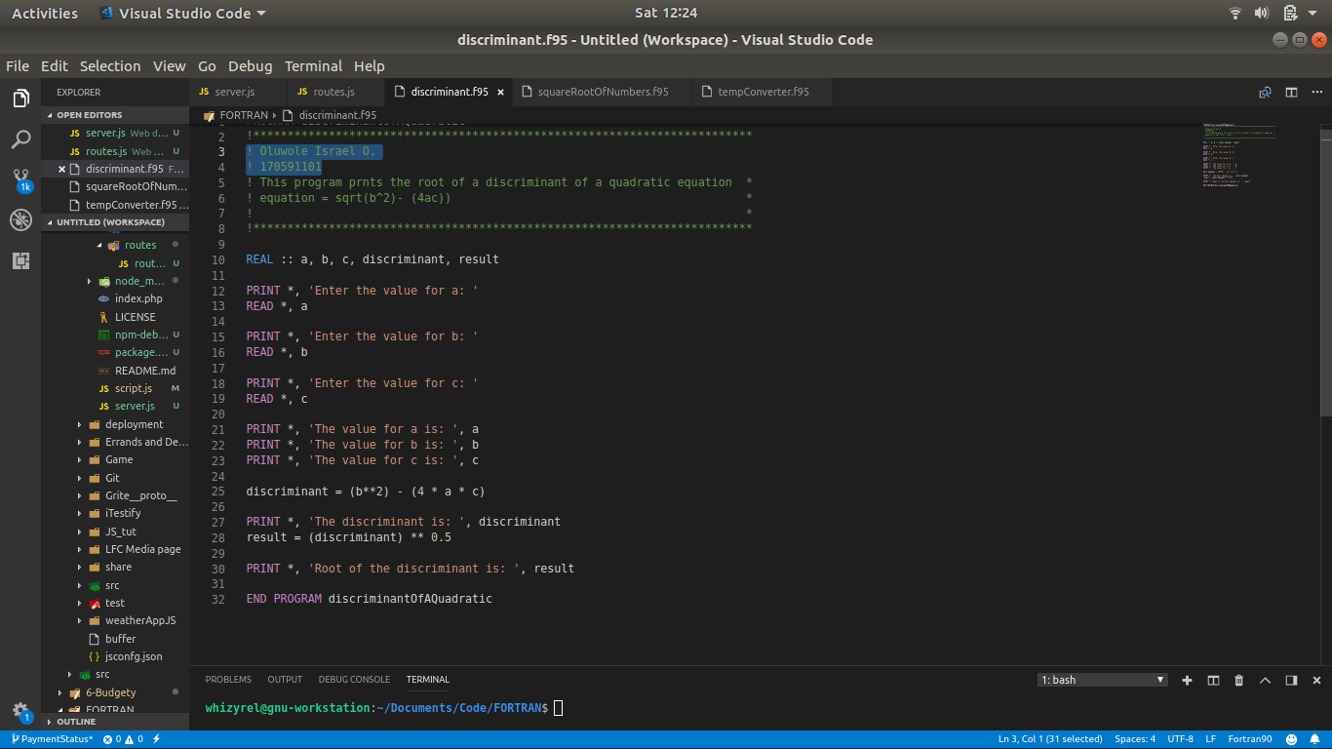

!\*\*\*\*\*\*\*\*\*\*\*\*\*\*\*\*\*\*\*\*\*\*\*\*\*\*\*\*\*\*\*\*\*\*\*\*\*\*\*\*\*\*\*\*\*\*\*\*\*\*\*\*\*\*\*\*\*\*\*\*\*\*\*\*\*\*\*\*\*\*\*\*\*

! Oluwole Israel O. \*

! 170591101 \*

! This program prnts the root of a discriminant of a quadratic equation \*

! equation = sqrt(b^2)- (4ac)) \*

! \*

!\*\*\*\*\*\*\*\*\*\*\*\*\*\*\*\*\*\*\*\*\*\*\*\*\*\*\*\*\*\*\*\*\*\*\*\*\*\*\*\*\*\*\*\*\*\*\*\*\*\*\*\*\*\*\*\*\*\*\*\*\*\*\*\*\*\*\*\*\*\*\*\*\*

REAL :: a, b, c, discriminant, result

PRINT \*, 'Enter the value for a: '

READ \*, a

PRINT \*, 'Enter the value for b: '

READ \*, b

PRINT \*, 'Enter the value for c: '

READ \*, c

PRINT \*, 'The value for a is: ', a

PRINT \*, 'The value for b is: ', b

PRINT \*, 'The value for c is: ', c

discriminant = (b\*\*2) - (4 \* a \* c)

PRINT \*, 'The discriminant is: ', discriminant

result = (discriminant) \*\* 0.5

PRINT \*, 'Root of the discriminant is: ', result

END PROGRAM discriminantOfAQuadratic