**NAME: ISRAEL OLUWOLE O.**

**MATRIC NUMBER: 170591101**

3. Write a Fortran program that will output the quantity of flow in an open channel of rectangular cross-section, given the depth of water in the channel. Assume normal flow and use Manning’s equation as the basis of the flow calculation.

You should decide what the inputs and outputs are and the relevant sequence of flow calculations.

Include in your report a full program listing and the output for a trial set of data (which you can choose for yourself). Also attach screen shot of implementation

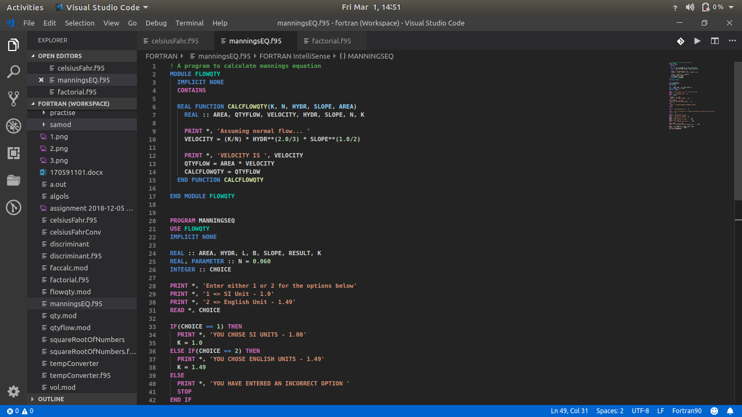

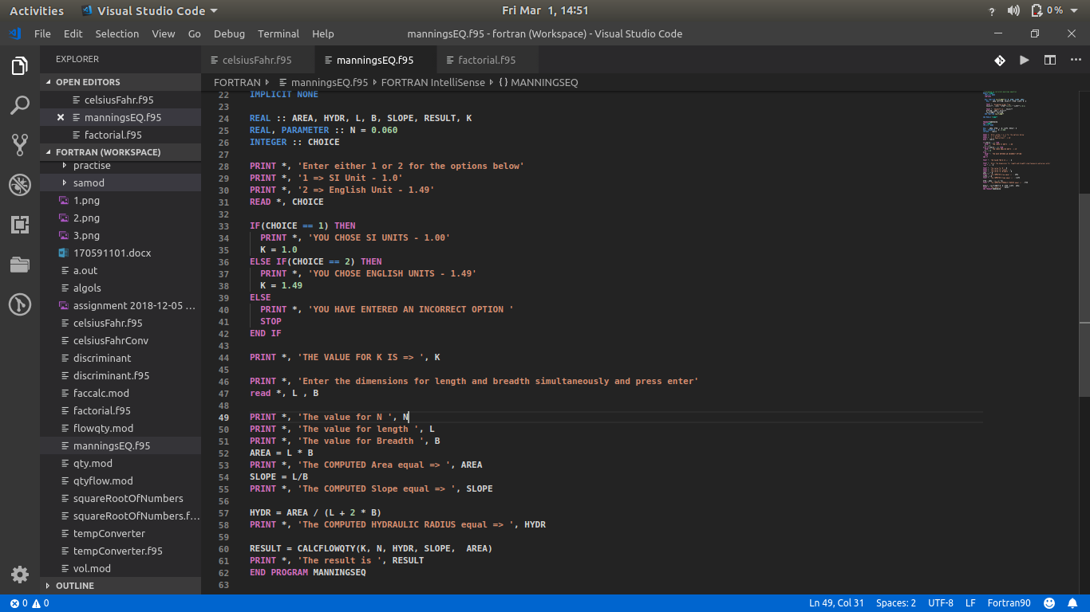

**! A program to calculate mannings equation**

**MODULE FLOWQTY**

**IMPLICIT NONE**

**CONTAINS**

**REAL FUNCTION CALCFLOWQTY(K, N, HYDR, SLOPE, AREA)**

**REAL :: AREA, QTYFLOW, VELOCITY, HYDR, SLOPE, N, K**

**PRINT *, 'Assuming normal flow... '**

**VELOCITY = (K/N) * HYDR**(2.0/3) * SLOPE**(1.0/2)**

**PRINT *, 'VELOCITY IS ', VELOCITY**

**QTYFLOW = AREA * VELOCITY**

**CALCFLOWQTY = QTYFLOW**

**END FUNCTION CALCFLOWQTY**

**END MODULE FLOWQTY**

**PROGRAM MANNINGSEQ**

**USE FLOWQTY**

**IMPLICIT NONE**

**REAL :: AREA, HYDR, L, B, SLOPE, RESULT, K**

**REAL, PARAMETER :: N = 0.060**

**INTEGER :: CHOICE**

PRINT *, 'Enter either 1 or 2 for the options below'

PRINT *, '1 => SI Unit - 1.0'

PRINT *, '2 => English Unit - 1.49'

READ *, CHOICE

IF(CHOICE == 1) THEN

PRINT *, 'YOU CHOSE SI UNITS - 1.00'

K = 1.0

ELSE IF(CHOICE == 2) THEN

PRINT *, 'YOU CHOSE ENGLISH UNITS - 1.49'

K = 1.49

ELSE

PRINT *, 'YOU HAVE ENTERED AN INCORRECT OPTION '

STOP

END IF

PRINT *, 'THE VALUE FOR K IS => ', K

PRINT *, 'Enter the dimensions for length and breadth simultaneously and press enter'

read *, L , B

PRINT *, 'The value for N ', N

PRINT *, 'The value for length ', L

PRINT *, 'The value for Breadth ', B

AREA = L * B

PRINT *, 'The COMPUTED Area equal => ', AREA

SLOPE = L/B

PRINT *, 'The COMPUTED Slope equal => ', SLOPE

HYDR = AREA / (L + 2 * B)

PRINT *, 'The COMPUTED HYDRAULIC RADIUS equal => ', HYDR

RESULT = CALCFLOWQTY(K, N, HYDR, SLOPE, AREA)

PRINT *, 'The result is ', RESULT

END PROGRAM MANNINGSEQ